Investigation of the Formation Mechanisms in High-Internal Phase Pickering Emulsions Stabilised by Cellulose Nanocrystals

Chuanwei Miao, Mani Tayebi, Wadood Y. Hamad*
FPInnovations, 2665 East Mall, Vancouver, BC, Canada V6T 1Z4

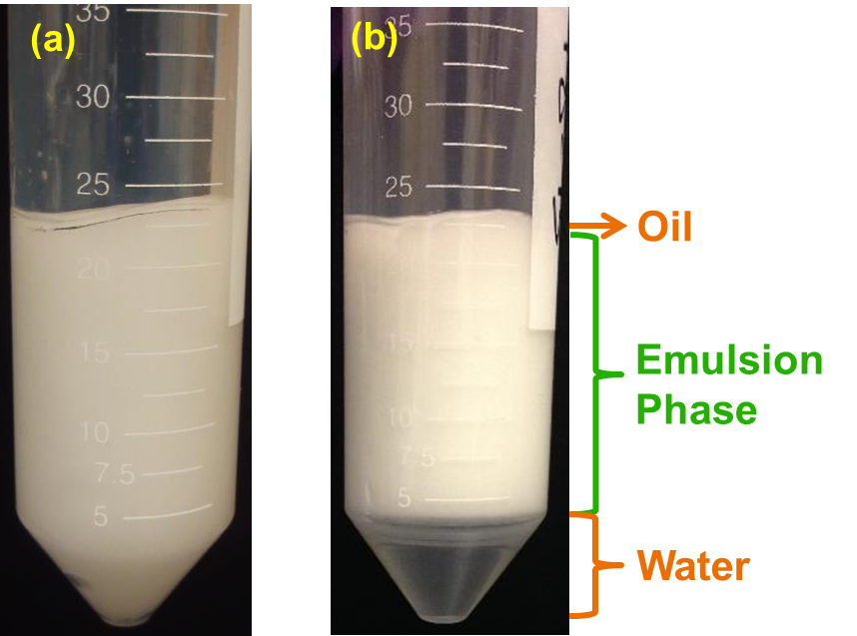
Supplementary Figure 1: Appearance of CNC-stabilised Pickering emulsions before (a) and after (b) centrifugation.

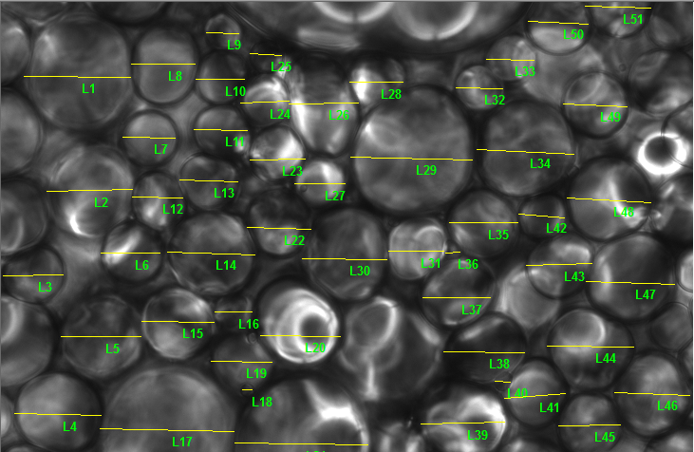
Supplementary Figure 2: Example of oil droplet size analysis using optical light microscopy images. The yellow lines in the image denote manually labelled distance, which the software uses to calculate the diameter of each oil droplet.

Supplementary Table 1: The raw oil droplets size data for Figure 3. The mean diameters (in micrometer) and standard deviations were calculated based on measurements on optical microscopic images from at least 50 oil droplets.
[CNC] in water phase (wt. %) | Mineral oil in water emulsions  (volume percentage of oil phase in emulsions) |  |  |  | Hexane in water emulsions  (volume percentage of hexane in emulsions)
 | 65% | 78% | 83% | 87% | 60% | 65% | 69%
0.6 | 13.8±7.6 | 18.4±7.7 | 21.7±8.3 | 30.1±9.8 | 10.9±4.6 | 11.6±5.0 | 14.8±7.7
1.2 | 14.5±7.8 | 13.3±6.0 | 14.3±6.0 | N/A | 9.2±4.6 | 12.9±8.5 | 13.7±6.6
2.4 | 11.7±8.3 | 14.1±8.6 | 11.8±5.1 | N/A | 11.5±5.0 | 11.9±5.2 | 12.8±5.7

