Supplementary Material

Section S5 Determination of the date at which sufficient data on previous use were available
As we did not have any data about previous use by both the groups and their neighbours prior to the start of the study, we plotted both the previous use by the group and by the neighbours against time and calculated moving averages of the predictors for five days and included them into the plots. By visually inspecting these plots, we determined the date at which both the previous use by the group (figure S5a) and by the neighbours (figure S5b) reached a plateau. We determined October 1st 2012 (five months after the start of the data collection) for both the previous use by the group and by the neighbours as appropriate and hence only included data from October 1st 2012 onward into the respective analysis.

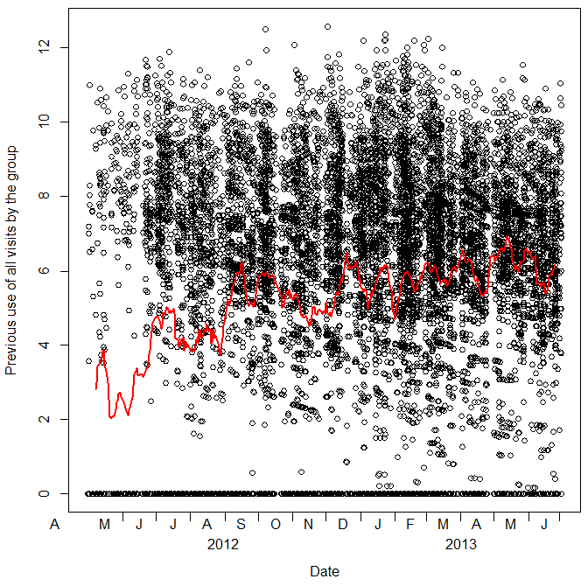
Figure S5a. Determination of the date at which sufficient data on the previous use by the group were available. The previous use by the group is plotted against time. The moving average for five day units of the predictor is shown as a red line.
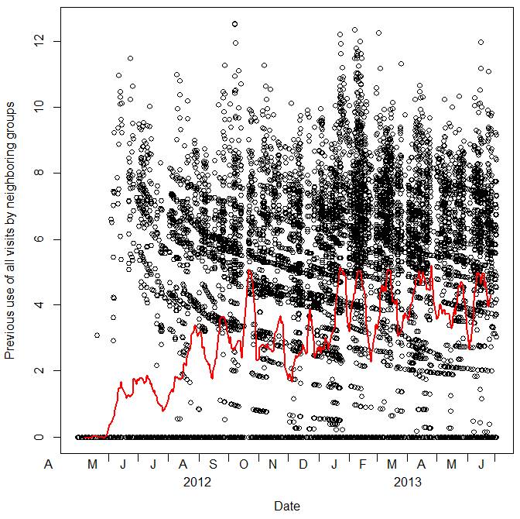
Figure S5b. Determination of the date at which sufficient data on the previous use by neighbouring groups were available. The previous use by neighbouring groups is plotted against time. The moving average for five day units of the predictor is shown as a red line.

