Supplementary Material
Temporal shifts in intraguild predation pressure between beluga whales and Greenland halibut in a changing Arctic
David J. Yurkowski, Nigel E. Hussey, Aaron T. Fisk, Kendra L. Imrie, Ross F. Tallman, Steven H. Ferguson
Materials and methods
Sample collections and stable isotope analysis
Beluga (Delphinapterus leucas) muscle and skin samples were collected from 1982 to 2009 through Inuit subsistence harvests in Cumberland Sound, Nunavut, Canada (65°13′0″N, 65°45′0″W). Greenland halibut (Reinhardtius hippoglossoides) were captured from bottom longlines and subsampled for muscle in September 1996 and both muscle and liver during August 2012. Prey samples included Gonatid squid from September-October in 2001 and 2011, shrimp (Pandalus borealis) and Arctic cod (Boreogadus saida) from October 2000, 2001, 2004 and 2011 from fishing trawls near the entrance to Cumberland Sound. Shrimp (Lebbeus polaris) and capelin (Mallotus villosus) were collected in August 2007-2009. All samples were stored at -20°C prior to analysis. Stable isotope data for both shrimp species, Arctic cod during the 1982-2002 time-period and capelin during the 2004-2012 time-period were obtained from [21] and [22].
Frozen tissue samples were freeze-dried, homogenized and lipid-extracted using a 2:1 chloroform:methanol solvent. Capelin and Arctic cod are part of the same functional group and have similar δ¹³C and δ¹⁵N values and thus were grouped as forage fish and isotope values averaged. The δ¹³C and δ¹⁵N values are expressed in per mil (‰) in delta (δ) notation and were measured by a Thermo Finnigan DeltaPlus mass-spectrometer (Thermo Finnigan, San Jose, USA) coupled with an elemental analyzer (Costech, Valencia, USA) in the Chemical Tracers Lab at the University of Windsor, Windsor, Ontario, Canada. The standard reference material was Pee Dee Belemnite carbonate for CO₂ and atmospheric nitrogen N₂. The NIST standards 8573, 8547 and 8548 for δ¹⁵N and 8542, 8573, 8574 for δ¹³C (n = 55 for all) were ≤ 0.1‰ for δ¹⁵N and ≤ 0.1‰ for δ¹³C from the certified values.
Arctic char stomach content analysis
We sampled and analyzed non-empty Arctic char (Salvelinus alpinus) stomachs from Kipisa (total = 84; 2002 – 27; 2003 – 14; 2004 – 18; 2011 – 25) and Isuituq (total = 96; 2002 – 28; 2003 – 14; 2004 – 11; 2011 – 43) in Cumberland Sound. Stomachs were cut from the oesophagus to the pyloric sphincter and contents were emptied into a petri dish to then identify prey items to the closest taxon possible. Prey were counted based on identifiable hard parts (e.g. amphipod carapaces) and weighed to the closest 0.1 g. Representative specimens of prey items were separated, rinsed, and placed in 95% ethanol in labelled scintillation vials for reference and identification. Frequency of occurrence (%O - percentage of prey-containing stomachs with a particular prey type) and two abundance calculations (percentage by weight (%W) and percentage by numbers (%N)) were recorded [23]. The %W and %N were calculated using the abundance (weight or number) of a specific prey item compared to total prey abundance (weight or number). The importance of each main diet item category was assessed with the Index of Relative Importance (IRI) using the following equation: IRI = %O * (%N + %W). We converted the IRI of each diet category to a percentage of the total [24] to identify changes in the relative importance of different prey items from 2002-2011. The IRI of capelin in Arctic char diet increased over time (Kruskal-Wallis test, χ² = 6.86, p = 0.077). Due to small samples sizes (2 locations and 4 years of sampling), we considered a p < 0.1 to be statistically significant.
Diet-tissue discrimination factors and turnover rates
To quantify prey contributions to beluga and Greenland halibut diet by season and decades, we used known diet-tissue discrimination factors (DTDF) of cetacean muscle and skin (Δ¹³C: 1.3 and 2.4‰, Δ¹⁵N: 1.2 and 3.2‰, respectively) [25]. We estimated the DTDFs for Greenland halibut muscle and liver using a linear model (muscle Δ¹³C: 1.3 and 0.8‰, respectively, Δ¹⁵N liver: 1.7‰) [26], and a scaled Δ¹⁵N for muscle (2.1‰) [27]. The half-lives for δ¹³C and δ¹⁵N of cetacean skin are 14-17 days [9], whereas for an average cetacean weighing 1000kg, the half-life for muscle is ~190 days based on turnover rates relative to body mass [11]. Beluga skin consequently represents prey consumed during the summer whereas muscle, represents averaged dietary contributions over the summer to winter period.
References
- Tomy GT, Budakowski W, Halldorsson T, Helm PA, Stern GA, Friesen K, Pepper K, Tittlemier SA, Fisk AT. 2004 Fluorinated organic compounds in an Eastern Arctic marine food web. Environ. Sci. Technol. 38, 6475–6481.
- Marcoux MM, McMeans BC, Fisk AT, Ferguson SH. 2012 Composition and temporal variation in the diet of beluga whales, derived from stable isotopes. Mar. Ecol. Prog. Ser. 471, 283–291.
- Cortés, E. 1997 A critical review of methods of studying fish feeding based on analysis of stomach contents: Application to elasmobranch fishes. Can. J. Fish. Aquat. Sci. 54, 726-738.
- Grimaldo, LF, Stewart AR, Kimmerer W. 2009 Dietary segregation of pelagic and littoral fish assemblages in a highly modified tidal freshwater estuary. Mar. Coast. Fish. Dynam. Manag. Ecosys. Sci. 1, 200-217.
- Caut S, Laran S, Garcia-Hartmann E, Das K. 2011 Stable isotopes of captive cetaceans (killer whales and bottlenose dolphins). J. Exp. Biol. 214, 538–545.
- Caut S, Angulo E, Courchamp F. 2009 Variation in discrimination factors (Δ¹⁵N and Δ¹³C): the effect of diet isotopic values and applications for diet reconstruction. J. Appl. Ecol. 46, 443–453.
- Hussey NE et al. 2014 Rescaling the trophic structure of marine food webs. Ecol. Lett. 17, 239–250.

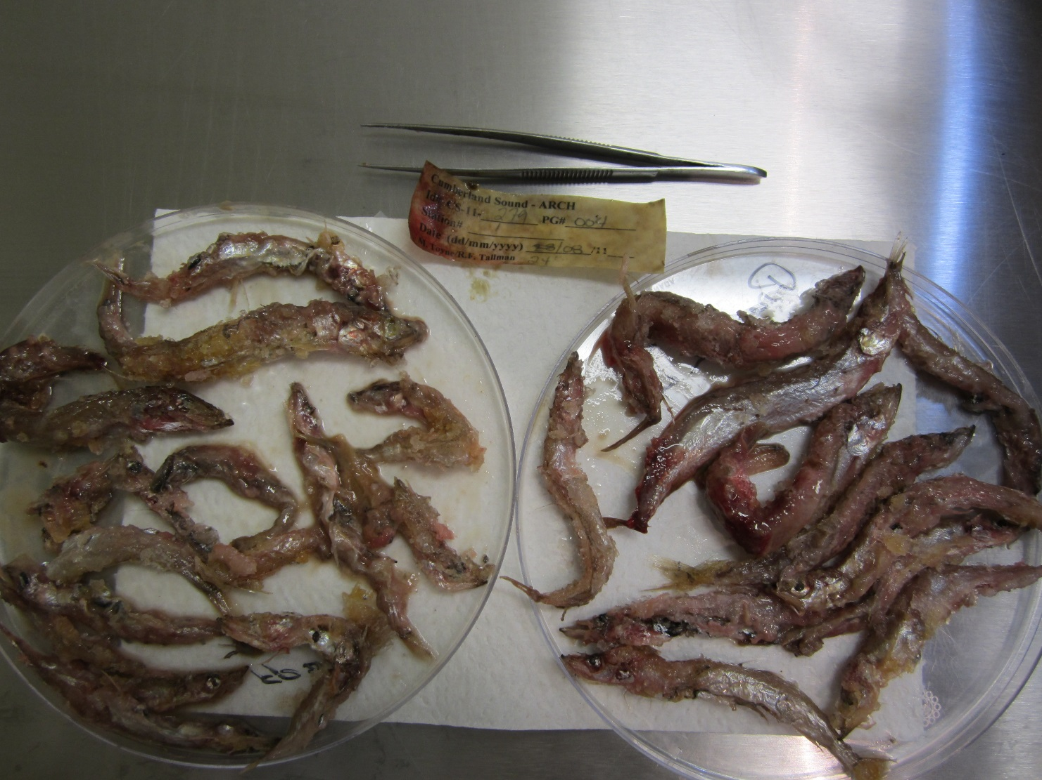
Figure S1. Photograph of capelin (Mallotus villosus) remains from the stomach contents of an Arctic char (Salvelinus alpinus) harvested in Cumberland Sound, Nunavut, Canada in 2011.

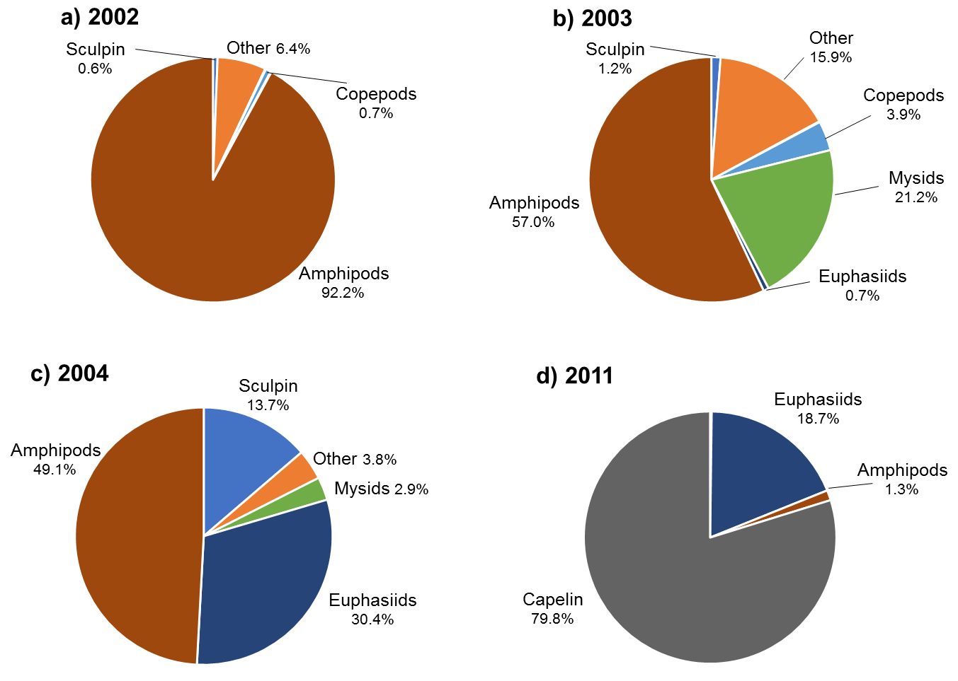
Figure S2. Relative importance (% wet weight) of prey items from stomach contents of Arctic char captured from Kipisa, Cumberland Sound, Nunavut, Canada (66°29’50.27”N, 67°51’36.85”W). Samples sizes (n): 2002 = 27, 2003 = 14, 2004=18 and 2011=25.
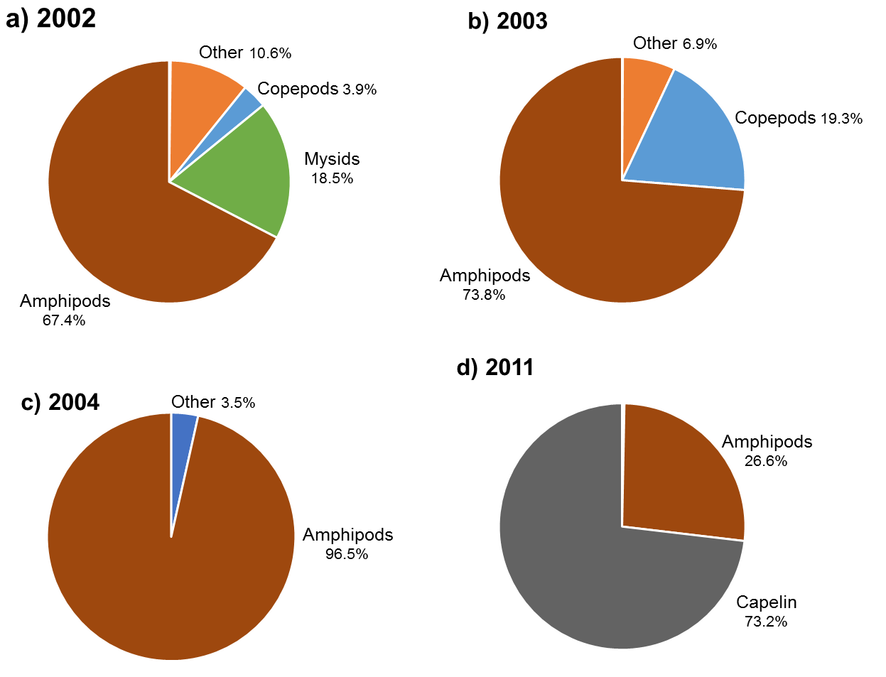
Figure S3. Relative importance (% wet weight) of prey items from stomach contents of Arctic char captured from Isuituq, Cumberland Sound, Nunavut, Canada (66°36’50.15”N, 67°52’31.02”W). Samples sizes (n): 2002 = 33, 2003 = 14, 2004=11 and 2011=43

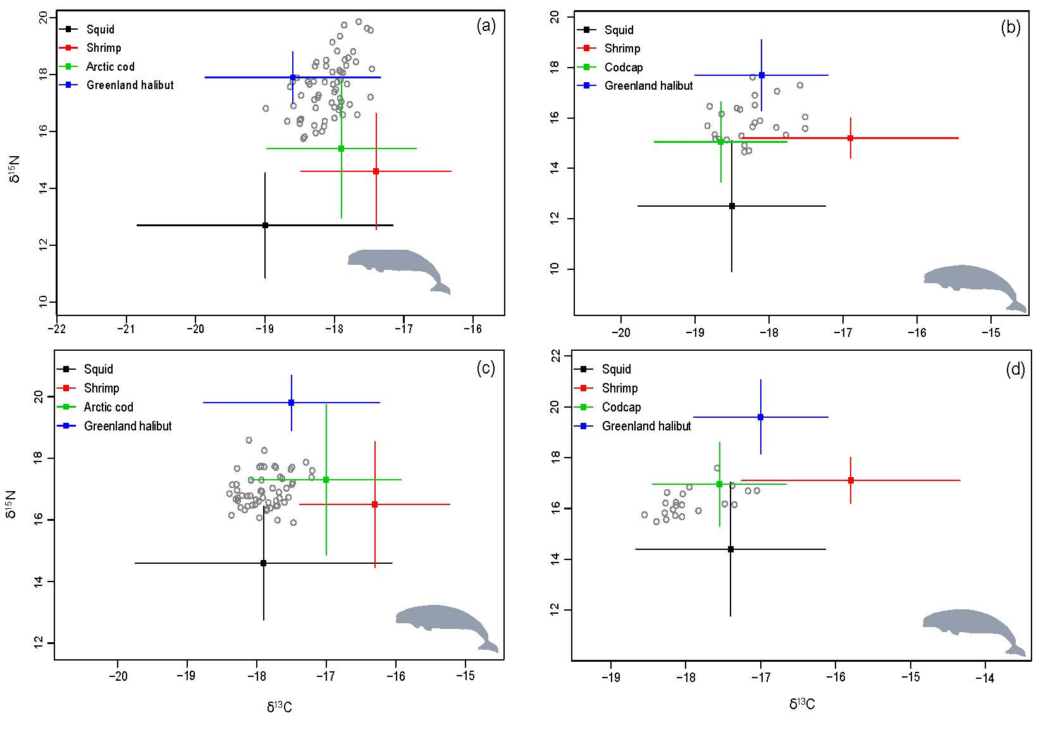
Figure S4. Stable isotope bi-plot of prey sources from stable isotope mixing model analysis (mean ± SD) relative to isotopic values of beluga muscle (a, b) and skin (c, d) corrected by diet-tissue discrimination factors for the 1982-2002 (a, c) and 2004-2012 (b, d) time period in Cumberland Sound, Nunavut, Canada. Codcap: Arctic cod/capelin

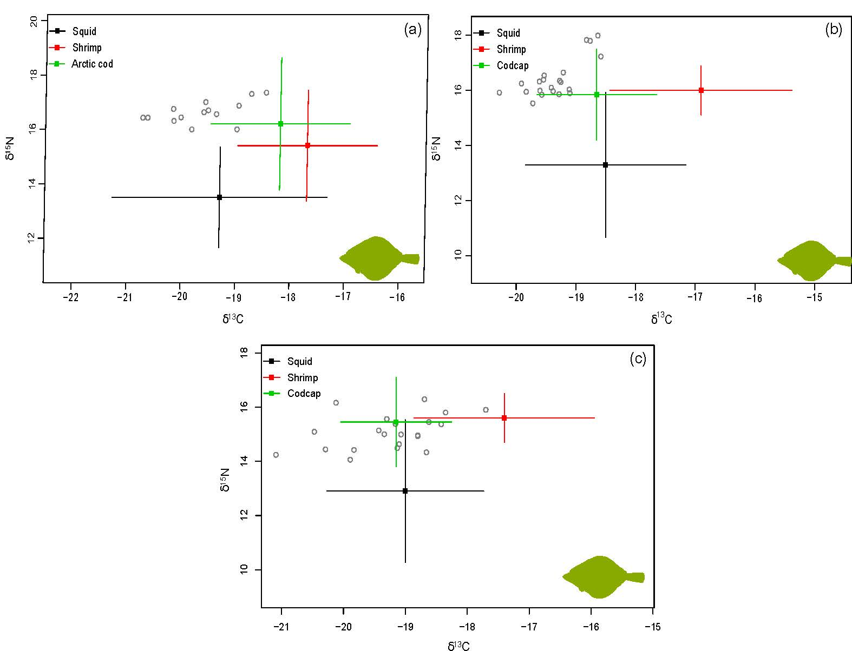
Figure S5. Stable isotope bi-plot of prey sources from stable isotope mixing model analysis (mean ± SD) relative to isotopic values of Greenland halibut muscle (a, b) and liver (c) corrected by diet-tissue discrimination factors for the 1982-2002 (a) and 2004-2012 (b, c) time period in Cumberland Sound, Nunavut, Canada. Codcap: Arctic cod/capelin

