**Electronic supplementary material**

**Mass extinction in tetraodontiform fishes linked to the Paleocene Eocene Thermal Maximum**

**Dahiana Arcila1* & James C. Tyler2**

1Department of Biological Sciences, The George Washington University, 2023 G St. NW, Washington, D.C. 20052, USA

2Department of Paleobiology, National Museum of Natural History, Smithsonian Institution, PO Box 37012, MRC 121, Washington, D.C. 20013, USA

**Contents of PDF:**

Supplementary Results

1. Phylogenetic relationships
2. New and revised character states
3. Comments on particular coding in certain taxa
4. Recent literature on tetraodontiform morphology
5. Materials of Lophiidae examined

figures S1 to S2

tables S1 to S4

References

**Additional Supporting Materials:**

A compressed folder containing all data files is available from Zenodo.org (http://doi.org/10.5281/zenodo.583772). These include the following:

Database S1. MrBayes log files .p

Database S2. MrBayes log files .t

Database S3. Molecular matrix.

Database S4. Expanded morphological matrix, including 52 fossil species.

Database S5. Total evidence tetraodontiform tree estimated with Parsimony

Database S6. List of morphological synapomorphies of tetraodontiform phylogenetic tree estimated under ML.

Database S7. List of morphological synapomorphies of tetraodontiform phylogenetic tree estimated under Parsimony.

Database S8. Complete time-calibrated tree of tetraodontiforms, including grafted trees.

**Supplementary Results**

**1. Phylogenetic placement and morphological coding of newly added fossil species and certain extant species**

**(a) Phylogenetic Relationships.** Conflicting interpretations regarding the sister-group relationships of the Triacanthodidae have been proposed based on alternative sources of myological, molecular, and morphological evidence (1-9) retrieveing Triacanthodidae either as sister to Triacanthidae (1-3, 5, 8) or as sister to all other tetraodontiform families except Triacanthodidae (4, 6, 7, 9). The present study resolves Triacanthodidae as sister to Triacanthidae plus †Moclaybalistidae, but these results should be treated with caution given the uncertain placement of this fossil family, suggesting that further analyses are required to elucidate their relationships.

**(b) New and Revised Character States.** The following is a list of the new and revised character states necessary to accommodate morphological conditions in many of the 16 newly coded fossil tetraodontiform species and in the coding for the representative of the newly added lophiiform outgroup; this new database is expanded and improved upon from that in Santini and Tyler (4).

Character 1, new state 4 ‒ shaft-like and expanded anterolaterally, with a ventral flange deeper than the shaft, to accommodate †*Balkaria histiopterygia.*

Character 8, new state 2 ‒ short to absent in moderately developed and approximately triangular-shaped lateral ethmoid that contacts vomer, to accommodate †*B. histiopterygia.*

Character 28, new state 2 – ascending process of premaxilla much shorter (more than twice as short) than the alveolar process, to accommodate *Lophiodes monodi*.

Character 40, new definitions for states “0” and “1”: state 0 – becomes length of upper jaw 37% or less of length of skull (rather than one-third), to accommodate †*Eotetraodon gornylutshensis;* state 1 – becomes length of upper jaw one-half or more (rather than one-half) of length of skull, to accommodate *L. monodi.*

Character 60, new state 4 – interopercle sturdy, vertically oriented, wide in the middle region, to accommodate *L. monodi.*

Character 81, new state 2 – ceratohyal very elongate, its length eight or more times greater than its least depth, to accommodate *L. monodi.*

Character 132, new state 2 ‒ six vertebrae bifid (all but last abdominal vertebra bifid), probably all but one (seventh abdominal) positioned anterior to first dorsal-fin pterygiophore, to accommodate†*B. histiopterygia.*

Character 134, new definition for state 1 ‒ becomes short to moderate height (rather than just short) and broad (not slender) shafts, and shafts not or only slightly penetrating the interspaces between the pterygiophores, to accommodate †*B. histiopterygia.*

Character 153, new states 4, 5, and 6: state 4 – first spiny dorsal-fin pterygiophore with a long, slender, horizontal shaft situated in the midline of the anterior half of the top of the skull but not sutured to it, to accommodate *L. monodi;* state 5 ‒ long, thick, robust, horizontal shaft attached (sutured) along the midline of the middle region of the top of the skull from about the levels of the anterior end of the orbit to the posterior end of the sphenotic, to accommodate †*B. histiopterygia;* state 6 ‒ long, broad, robust, horizontal shaft broadly attached (sutured) along the midline of the anterior region of the top of the skull from the levels of the anterior end of the cranium to about the anterior region of the orbit, to accommodate †*Ctenoplectus williamsi.*

Character 155, new state 2 ‒ ventral shaft posteriorly to posteroventrally oriented and closely attached to the dorsal surface of the skull from either above or behind the orbit, to accommodate †*B. histiopterygia* and †*C. williamsi.*

Character 156, new state 2 ‒ ventral shafts posteriorly to posteroventrally oriented and closely attached to the dorsal surface of the skull in the region from about the posterior end of the orbit to the posterior end of the skull, to accommodate †*B. histiopterygia* and †*C. williamsi.*

Character 162, new definition for state 2 – becomes four or five (rather than only four) spiny dorsal-fin pterygiophores anterior to the neural spine of the fourth abdominal vertebra, to accommodate *L. monodi.*

Character 169, new state 2 – some dorsal- and anal-fin rays branched, pectoral-fin rays unbranched, to accommodate *L. monodi.*

Character 171, new definition for state 3 and new state 7: state 3 – becomes rayless pterygial element preceding soft dorsal fin an oblique to vertical strut (rather than only oblique), to accommodate †*Gornylistes prodigiosus;* new state 7 – four rayless pterygial elements oriented obliquely vertical and positioned in separate interneural spaces, to accommodate †*Iraniplectus bakhtiari*.

Character 173, new definition for state 1 – becomes dorsal- and/or anal-fin rays (rather than both dorsal and anal rays) widely separated from their basal pterygiophores by a large block of cartilage (versus state 0 being neither dorsal nor anal rays widely separated by a large block of cartilage), to accommodate †*Austromola angerhoferi*.

Character 176, new definition for state 3 – becomes seven or eight (rather than only seven) caudal peduncle vertebrae, to accommodate †*Archaeotetraodon zafaranai*.

Character 182, new definition for state 1 – becomes one epural, either free or fully sutured or fused to the urostylar region, sometimes with a small cartilaginous or ossified nubbin just behind it representing a rudimentary second epural (rather than simply one epural free or fused), to accommodate triacanthodid and triacanthid taxa, as described in Konstantinidis and Johnson (10).

Character 187, new character states 9, 10, and 11: state 9 – multiradiate basal scale plate with a single bifurcate protruding long spinule, bifurcate to the base, to accommodate all six species of †*Archaeotetraodon;* state 10 – moderate (4%) to great (17%) enlargement and aggregation of scales into large plates with increasing specimen size, to accommodate both species of †*Frigocanthus;* state 11 – scaleless, to accommodate *L. monodi.*

Character 202, new state 2 – two actinosts, to accommodate *L. monodi.*

Character 205, new definition for states 2 and 3: state 2 – becomes 13–15 (rather than 13 or 14) caudal vertebrae, to accommodate †*A. zafaranai* and †*I. bakhtiari;* state 3 – becomes 7–10 (rather than 8–10) caudal vertebrae, to accommodate *L. monodi.*

Character 206, new state 6 – one dorsal-fin spine, to accommodate †*Slovenitriacanthus saksidai*.

**(c) Comments on Particular Codings in Certain Taxa.** For *Mola mola,* the three pectoral actinosts as described in Tyler (11) articulate through fibrous tissue and cartilage and are not even lightly sutured or interdigitated with one another or to the scapula or coracoid, so Character 111 for *M. mola* is coded herein as 0 (not sutured) rather than 2 (slightly sutured, as in 4).

Concerning molids in general, we acknowledge that the excellent and important study by Britz and Johnson (12) of the molids *Ranzania laevis* and *Masturus lanceolatus* demonstrated that the early larval first vertebra becomes incorporated indistinguishably with the basioccipital during ontogeny; thus, there is one more abdominal vertebra ontogenetically in these two species of molids than can be determined from larger specimens. Whether similar early larval consolidation of the first vertebra into the basioccipital is more widespread in molids than in just these two species (i.e., whether it also occurs in the two species of *Mola*), or whether it is also present in some other gymnodonts or lower tetraodontiforms remains to be seen; we regret that we do not have early ontogenetic materials for most of the extant taxa included in this and similar studies of tetraodontiforms, and of course there are none for fossils. Thus, our coding is almost always based only on the morphology of late juvenile and adult specimens, and often on small adults that are amenable to the clearing and staining process. In the case of the number of abdominal vertebrae in the extant molids included in the data matrix herein (*Mola mola* and *Ranzania laevis*), no change in coding is required because the values for the number of abdominal vertebrae are within the range (eight or nine abdominals) of state 1 of Character 204, irrespective of whether the larval unit incorporated into the basioccipital in *R. laevis* is counted as an additional abdominal vertebra to that evident in adults. Britz and Johnson (13) interpreted the ontogenetic incorporation of the first larval vertebra with the basioccipital in the two molids they studied as being homologous to the partial fusion of the first two to five vertebrae to one another and to the rear of the skull in ostracioids (aracanids and ostraciids) and thus an indication of a close relationship between these two groups, whereas most phylogenetic analyses place molids as sister to tetraodontids and diodontids, and ostracioids as sister to balistoids and monacanthids. We emphasize that the fusion of the vertebrae in ostracioids (11, 14) is always only partial and externally evident even in adults, and this far more superficial fusion of a larger number of vertebrae may not be homologous to the early larval incorporation of the first vertebra with the basioccipital in at least some molids. We think it more likely that these two conditions are independent specializations: that of ostracioids is associated with its rigid axial skeleton inside an inflexible carapace and a relatively high number of abdominal and total vertebrae (nine or ten abdominal and eight or nine caudal, and a total of 18 in all except one species, *Acanthostracion quadricornis,* with 9+10=19); whereas that of molids is associated with an already low number of adult abdominal vertebrae of eight in a far more flexible and less well-ossified adult vertebral column of 8+8 (*Masturus lanceolatus*), 8+9 (*Mola mola*), and 8+10 (*Ranzania laevis*). The close relationship and deep nesting of molids within gymnodonts and of ostracioids within scleroderms is strongly supported by numerous osteological characters and synapomorphies (2, 4, 11) and by those combining molecular and morphological data (e.g., 8). Exceptional is Leis (15), with ostraciids in a polytomy with Diodontidae and Molidae based on 23 larval characters in eight families, without data for Triodontidae and Aracanidae. Purely molecular analyses have widely divergent proposed relationships of ostracioids, with them variously being sister to different clades within or to both scleroderms and gymnodonts (e.g., 6, 9, 16, 17).

In molids, the large bone in the middle region of the interorbital septum was identified by Tyler (11) as the basisphenoid, and in the phylogenetic analysis of Santini and Tyler (4) its combined size and position are indicated as a unique feature of molids (Character 26, state 2). As a brief aside, in their highly informative study of a small specimen of *Triodon* (see below), Britz and Johnson (12) suggested that the molid basisphenoid of Tyler (11) was probably a highly modified pterosphenoid, without further elaboration. That proposal raises the question as to what is the relatively normal appearing pterosphenoid bone in the roof of the orbit just behind the upper end of the basisphenoid that was identified and illustrated by Tyler as the pterosphenoid in representatives of all three genera of extant molids. Only ontogenetic study of the bones in this region in molids will resolve these issues, but, in any case, the large size and position of the bone in the interorbital septum is a unique feature of molids, and we are comfortable at present to refer to it as the basisphenoid. Fossil molids are not germane to the discussion because the bones of the orbital region are absent in the only relatively complete fossil molid, †*Austromola angerhoferi* (18), as well as in the few incomplete specimens of other fossil molids, such as †*Eomola bimaxillaria* (19), †*Ranzania ogaii* (20), and †*Ranzania* sp. (21).

For †*Triodon antiquus,* the midline articulation between the contra-lateral anteromedial surfaces of the premaxillae as described by Tyler and Patterson (22) are insufficiently exposed to determine whether or not the articulation of these bones is strengthened by interdigitating processes, so Character 31 is coded herein as “?” rather than 0 (without interdigitations, as in 4). For *Triodon macropterus,* the finely detailed ontogenetic study of the caudal skeleton by Britz and Johnson (12), including that of a rare small individual of 20 mm SL, indicates that there are five hypurals, one uroneural, and two epurals (rather than four hypurals, two uroneurals, and one epural, as in 11), so Character 182 is coded herein as 0 (two epurals) rather than 1 (one epural, as in 4); the coding for uroneurals and hypurals in *T. macropterus* is not affected because those characters simply state whether uroneurals are present or not (not the number of uroneurals) and describe the conditions of consolidation of the first to fourth hypurals (not the condition of the fifth hypural). Johnson and Britz (23) had previously described the external features of this small specimen.

For †*Eotetraodon pygmaeus,* Santini and Tyler (4) coded Characters 131 (whether some of the neural spines of the anterior abdominal vertebrae are bifid) and 132 (whether only the first three or four neural spines are bifid versus ten or more bifid) as “?” because they were adhering to an ultra-conservative protocol. That is, the single specimen of the then only known species of the genus is preserved in lateral view and the anterior neural spines cannot be seen in dorsal view, so it could not be determined with absolute certainty if these neural spines were bifid. This protocol relative to bifid neural spines was discussed in detail in Tyler et al. (24). The redescription and reconstruction of *E. pygmaeus* in Tyler and Santini (25), however, illustrated and mentioned that the first four anterior neural spines are broader than those more posteriorly, as in other tetraodontids, a condition correlated with bifid neural spines. In the interim, two more species of †*Eotetraodon* have been described, and for one of these, †*E. gornylutshensis,* Bannikov and Tyler (26) also concluded that the broad, low neural spines of the first four abdominal vertebrae indicated that these spines are bifid. Therefore, the coding for Character 131 in †*E. pygmaeus* is changed herein from “?” to state 1 (neural spines of three or more anterior abdominal vertebrae bifid), and Character 132 is changed from “?” to state 0 (first three or four anterior abdominal vertebrae with bifid neural spines); we code in the same way these two characters in †*E. gornylutshensis* and †*E. tavernei*.

As preserved, the single specimens of both †*E. pygmaeus* and †*E. gornylutshensis* have the abdominal region significantly expanded in a broad convexity, which we think can reasonably be interpreted as evidence of inflatability. Thus, for Character 197 (“0” for inflatability absent, or “1” for inflatability present), we herein code *E. pygmaeus* and†*E. gornylutshensis* as state 1. The belly region is far less convex in †*E. tavernei,* so it is coded “?” because of its uncertain condition. Of the six species of the Oligocene to Miocene genus †*Archaeotetraodon* reviewed by Carnevale and Tyler (27), only one species, †*A. jamestyleri,* has the belly somewhat expanded, but not so dramatically as in some †*Eotetraodon* taxa, and we code it “?” for inflatability.

For †*Ctenoplectus williamsi,* we use the same coding as that given by Close et al. (7), with the following few exceptions. For Characters 153, 155, and 156, concerning the forward placement of the pterygiophores of the spiny dorsal fin and of their relatively posteroventrally (rather than vertically) oriented lower shafts, we utilize the new character states given herein rather than the non-applicable category that is necessary following the options of states available for these characters in (4), as used by Close et al. (7) (and by Bannikov et al. (28), for †*Balkaria* *histiopterygia*, discussed below). For Character 206, Close et al. (7) noted that there were at least four dorsal-fin spines (the basal regions of the third and fourth are preserved, and the articular facets for the first and second are present on the first pterygiophore) but that there was probably at least a fifth spine, and perhaps even a sixth, that were not preserved. Close et al. (7) opted to record this uncertainty as a polymorphic condition with three character states, which was contrary to the protocols of the Santini and Tyler (4) data matrix to which they added the new taxon for phylogenetic analysis. In our opinion, a midline bony element, such as a dorsal spine, of a species with a single known specimen cannot be polymorphic, and the coding for the number of dorsal-fin spines should be either “?” or the value for the most likely condition. Because the dorsal-fin spines in tetraodontiforms taper in length and robustness posteriorly in the series (the single exception being †*Bolcabalistes varii* in which the third (last) spine is only slightly shorter than the second, and is of the same length as the first), and because the basal regions of the preserved third and fourth spines in †*C. williamsi* are equally robust, we consider it likely that a somewhat less robust spine was present posterior to these two spines; thus, there were at least five spines, with the possibility of a sixth, as there are two unoccupied pterygiophores (the fourth and fifth) available for fin support. We code the number of dorsal-fin spines in †*C. williamsi* as being five (Character 206, state 2), the mostly likely demonstrable number, rather than as “?” so as not to devalue the phylogenetic significance of a large, well-developed spiny dorsal fin in this specimen, regardless of how imperfectly preserved. The analyses herein concur with the results of Close et al. (7) that †*C. williamsi* (Ctenoplectidae) is a close relative of the Triodontidae.

For †*Balkaria histiopterygia,* we use the same coding as that given by Bannikov et al. (28) in their phylogenetic analysis, which was based on the Santini and Tyler (4) data matrix, except that we utilize the many new or revised character states given herein that are applicable to it (see above, including for Characters 153, 155, and 156 mentioned relative to †*C. williamsi*). We concur with the assessment by Bannikov et al. (28) that †*Balkaria histiopterygia* is either the sister group of the Diodontidae alone (as herein) or of the Tetraodontidae plus Diodontidae clade.

For †*Eomola bimaxillaria,* we note that the coding in Santini and Tyler (4) was based on only 12 features of the upper jaw (maxillae and premaxillae), but we have added herein six additional coded features that are discernible in the quadrate, interopercle, and coracoid bones preserved alongside the upper jaw, as described by Tyler and Bannikov (19),

Two of the fossil species in the Santini and Tyler (4) matrix, the triacanthid †*Protacanthodes nimesensis* and the diodontid †*Pshekhadiodon parini,* were coded based on the single specimens known for them at that time, but in the interim a new specimen of †*P. nimesensis* and three new specimens of†*P. parini* (including a skull in dorsal view) have become available and have been described and illustrated, respectively, by Tyler and Bannikov (29) and Tyler and Bannikov (30). Many of the characters coded as “?” for †*P. parini* can now be assigned character states, and a few such can be assigned for †*P. nimesensis*, as follows. For†*P. nimesensis,* Character 173 has state 0 (dorsal- and anal-fin rays not widely separated from their basal pterygiophores), Character 182 has state 1 (one epural), and Character 183 has state 0 (epural free, not sutured to caudal skeleton). For †*P. parini,* Character 7 has state 0 (lateral ethmoid large), Character 8 has state 0 (lateral ethmoid with short anterior extension), Character 10 has state 0 (frontal not extending much anterior to articulation of lateral ethmoid and ethmoid), Character 12 has state 1 (frontal without supraocular serrations), Character 13 has state 1 (nasals absent), Character 14 has state 0 (supraoccipital dorsal surface flat), Character 15 has state 0 (supraoccipital without anterior crest), Character 16 has state 0 (supraoccipital with posterior crest), Character 17 has state 0 (supraoccipital posterior crest laterally compressed, in vertical plane), Character 42 has state 3 (palatine large, thickened, massive), Character 43 has state 1 (palatine sutured to ethmoid-vomerine region and pterygoid arch), Character 44 has state 0 (palatine not in contact with frontal), Character 46 has state 2 (ethmoid dorsal surface flat to curved and moderately broad), Character 59 has state 0 (opercle with moderately concave anterior edge), Character 66 has state 1 (skull bones without canals), Character 71 has state 1 (teeth present internal to the main outer series in upper jaw), Character 73 has state 1 (internal series of teeth modified into grinding trituration teeth), and Character 169 has state 0 (dorsal-, anal-, and pectoral-fin rays branched).

For *Lophiodes monodi,* Characters 21, 22, and 23 (various articulation conditions of the ectopterygoid and mesopterygoid) are coded as though the ectopterygoid and mesopterygoid are separate elements closely held to one another along an oblique line separating the anteroventrally oriented ectopterygoid from the mesopterygoid just above it. This complex element is referred to as the pterygoid in lophiids (31, 32). Carnevale and Pietsch (32) discussed in detail the ontogenetic fusion of these two bones along the oblique line that superficially separates them. Whereas we recognize the pterygoid as compound, we code it for the conditions of its two original parts that are still distinguishable.

**(d) Recent Literature on Tetraodontiform Morphology.** The detailed ontogenetic study of dentition in species of the tetraodontid genus *Monotrete* by Fraser et al. (33) documented that the small individual larval teeth are lost in development and are replaced by sequentially stacked, multigenerational, jaw-length, dentine bands, these being what Tyler (11) referred to as the long, thin, rod-like, highly modified teeth parallel to the anterior edges of the jaws, or dental lamellae. It is these elongate, dentine, rod-like teeth that are unique to tetraodontids among gymnodonts, in contrast to the rather small, somewhat rounded tooth elements that are incorporated into the jaws in triodontids and diodontids and noticeable as external surface sculpturing, and also in contrast to the individual tooth elements in molids, which are relatively indistinguishably incorporated into the jaws.

The superlative comparative ontogenetic study of the caudal skeleton in seven of the ten families of tetraodontiforms by Konstantinidis and Johnson (10) detailed many developmental features that cannot be determined from the late juvenile to adult skeleton materials and the fossils used herein. For example, they documented that in larval triacanthodids there are three epurals, just as in many adult percomorphs, but that in subsequent development the third epural disappears and the second epural becomes so reduced that it can scarcely be distinguished from the uroneural remnants. Likewise, developing triacanthids have a second epural that is lost in ontogeny. These are elegant observations that are exceptionally useful to understanding the evolution of the caudal structures in tetraodontiforms, and they help inform our own interpretations of character states based on juvenile to adult materials. For example, Konstantinidis and Johnson (10) showed that there is no parhypural in the larval developmental stages of the only species they studied within the aracanid plus ostraciid clade, but if this absence (Tyler (11) presumed that the parhypural in this clade was fully fused into the highly consolidated caudal plate) is more widespread among this clade then it may be a derived condition shared with molids. Complicating such an interpretation is that the parhypural is also absent developmentally in the only species they studied of a diodontid (11, presumed that the parhypural in this family was fused to either the hypural plate or to the haemal spine of PU2).

The jaw apparatus and suspensorium of numerous tetraodontiforms were comparatively analyzed and described by Konstantinidis and Johnson (34), based on both early developmental stages and adults, in an important and well-documented study. The homology of the pseudocaudal fin (clavus) of molid ocean sunfishes compared with that of a tetraodontid pufferfish was studied in detail and finely described and interpreted in companion papers by Britz and Johnson (35) and Johnson and Britz (36). Their work was based on early developmental stages and adults. These papers greatly advance our knowledge of the clavus of molids and the rear of the vertebral column in gymnodonts.

The diversification and functional anatomy of the skull and jaws of balistid triggerfishes was well described and analyzed by McCord and Westneat (37); in a different paper these authors also assessed balistoid phylogeny and the evolution of BMP4 (37). Similarly, Konstantinidis and Harris (38) provided excellent descriptions and analyses of the development and evolution of the adductor mandibulae muscle in tetraodontiforms.

Chanet et al. (39) comparatively described soft anatomy conditions in tetraodontiforms and lophiiforms that support a close phylogenetic relationship of these two orders, as had previously been indicated by molecular evidence, and Chanet et al. (40) studied the gas bladder of tetraodontiforms, and especially those of tetraodontids and diodontids that, as expected, supports the close relationship of these two families.

We call attention to the paper by Matsuura (41) that provided an extremely useful review of the systematically important literature on tetraodontiform fishes published between 1980 and 2014. This commentary on tetraodontiform literature is a considerable asset to all subsequent workers on this order.

**(e) Materials of Lophiidae Examined.** The coding for a representative lophiiform was based on the two examined specimens of *Lophiodes monodi*. Data presented are the USNM catalog numbers, followed by number of specimens and, for cleared and stained specimens, SL in millimeters.

**Cleared and Stained Materials:**

*Lophiodes kempi*: USNM216977, 1, 61.1

*Lophiodes miacanthus*: USNM 216978, 1, 98.6

*Lophiodes monodi*: USNM 216979, 1, 96.9; USNM 216980, 1, 98.4

*Lophiodes reticulatus*: USNM 213648, 1, 64.0; USNM 216982, 1, 72.0

*Lophiodes spilurus*: USNM 215229, 2, 66.4 and 69.6

*Lophius piscatorus*: USNM 215254, 1 disarticulated specimen, ~140

*Lophius vaillanti*: USNM 216984, 1 disarticulated specimen, ~170.

**Dry Skeletal Materials:**

*Lophius piscatorus*: USNM 031678, 1, upper and lower jaws, vomer, lateral ethmoids, and dentaries; largest dimension of upper jaw ~230 mm; USNM 110874, 3 partially disarticulated skulls; largest dimension ~205–250 mm

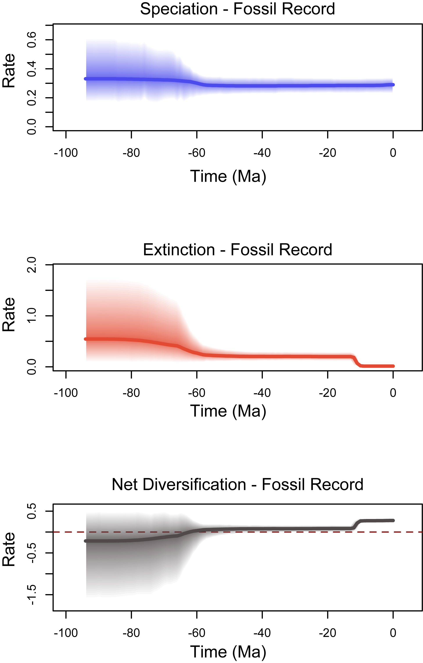

**Fig. S1.** Diversification rates estimated only from the fossil record, including net diversification rates.

../Figures/SFig.1.pdf

**Fig. S2.** Alternative phylogenetic placements of the superfamily †Plectocretacicoidea. (A) Maximum Likelihood analysis; (B) Parsimony analysis (strict consensus with 746 steps; Consistency Index = 0.46, Retention Index = 0.76).

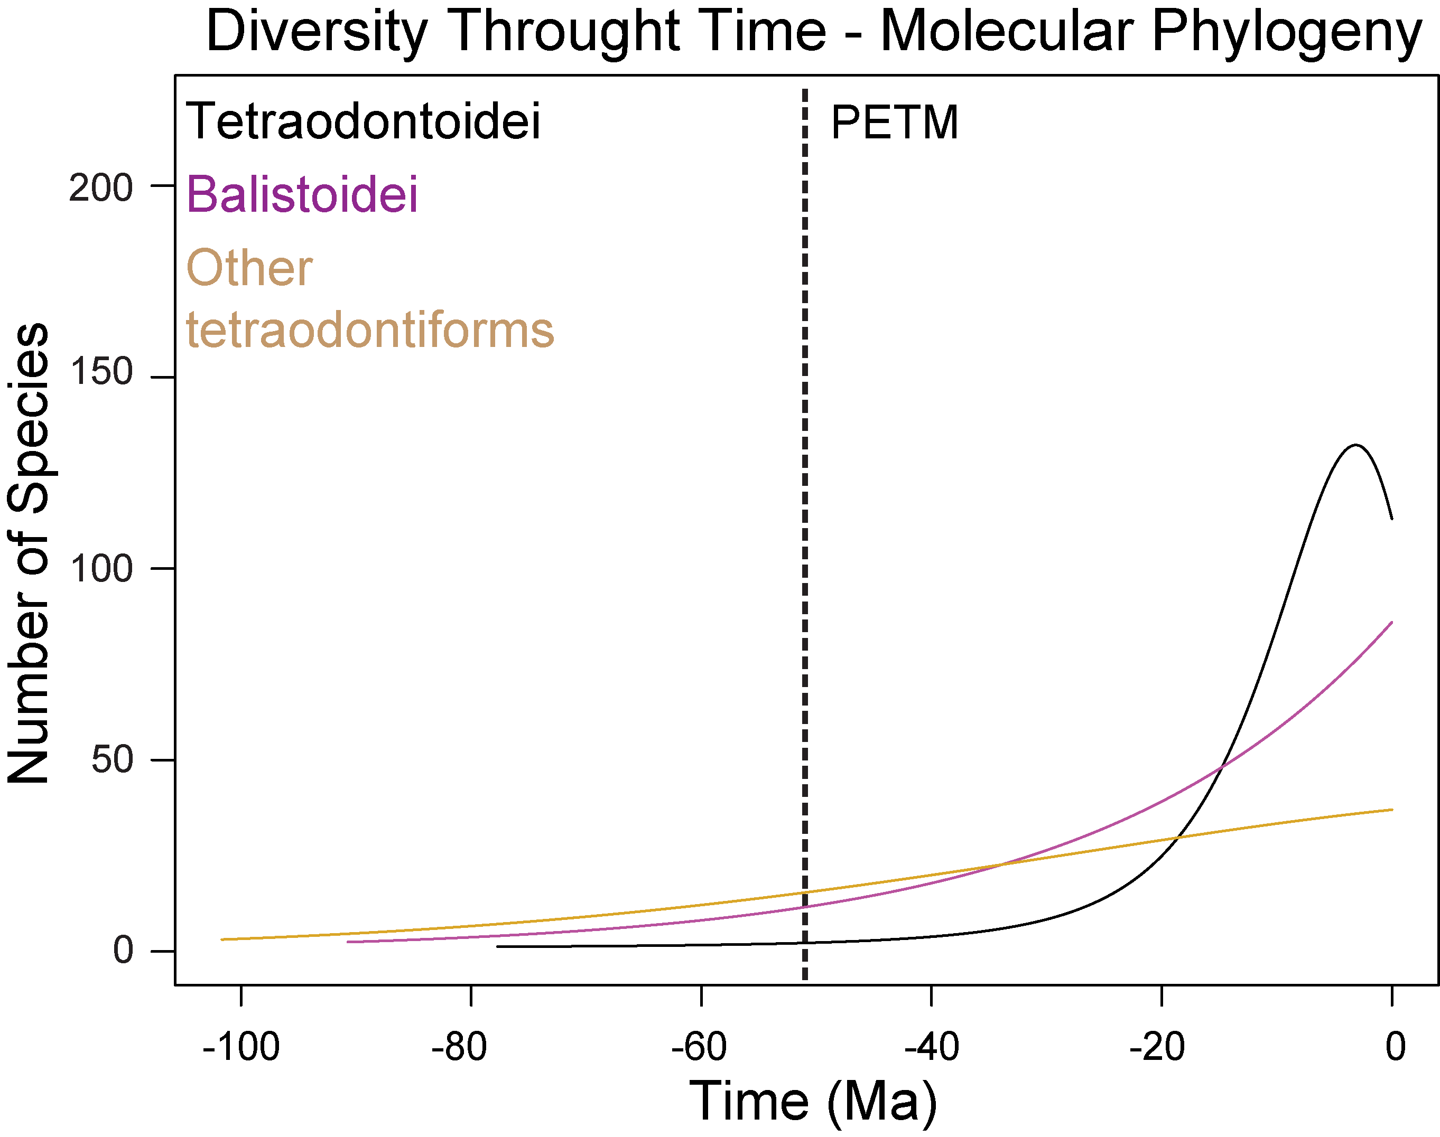

**Fig. S3.** Diversity through time estimated from the molecular phylogeny including only extant species and isolating the largest tetraodontiform suborders using RPANDA.

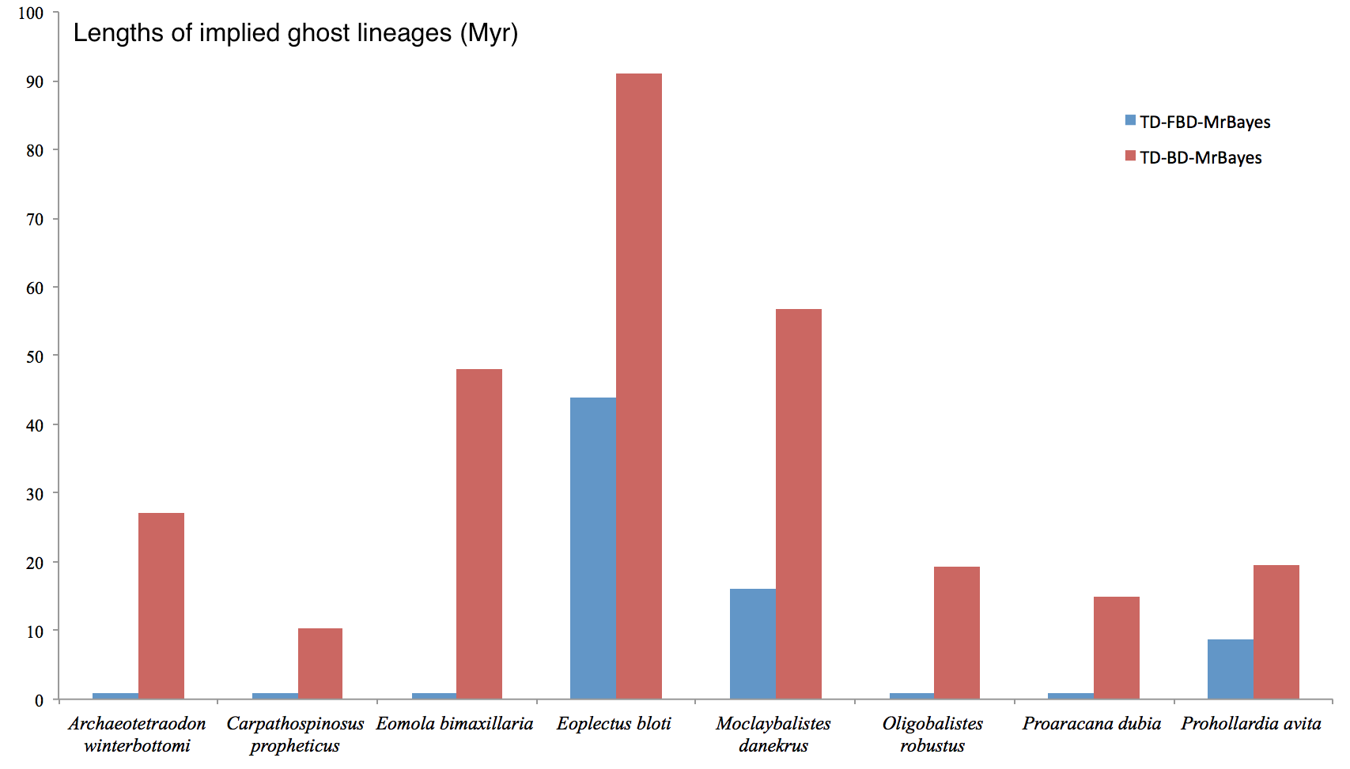

**Fig. S4.** Comparison of ghost lineage lengths estimated with total evidence dating under the fossilized birth death model (in this study) and using the birth death model (Arcila et al. 8) using eight selected fossil species. TD-FDB-MrBayes: total evidence dating using the fossilized birth death model in MrBayes; TD-BD-MrBayes: total evidence dating using the birth death model in MrBayes.

**Table S1.** Marginal likelihoods of the different birth-death models estimated in TESS. Models that exceed the significance threshold (Bayes factors >6) are inferred to be statistically significant.

|  |  |  |  |  |  |
| --- | --- | --- | --- | --- | --- |
| **Uniform Sampling Strategy** | | | **Diversified Sampling Strategy** | | |
| Model 0 | Model 1 | Bayes factors | Model 0 | Model 1 | Bayes factors |
| **ConstBD** | **DecrBD** | **16.5973474** | **MassExtinctionBD** | **EpisodicBD** | **68.021275** |
| EpisodicBD | DecrBD | 16.0318529 | MassExtinctionBD | ConstBD | 65.782637 |
| ConstBD | MassExtinctionBD | 13.7468286 | MassExtinctionBD | DecrBD | 34.73392 |
| EpisodicBD | MassExtinctionBD | 13.1813341 | DecrBD | EpisodicBD | 33.287355 |
| MassExtinctionBD | DecrBD | 2.8505189 | DecrBD | ConstBD | 31.048717 |
| ConstBD | EpisodicBD | 0.5654945 | ConstBD | EpisodicBD | 2.238638 |
| ConstBD | ConstBD | 0 | ConstBD | ConstBD | 0 |
| DecrBD | DecrBD | 0 | DecrBD | DecrBD | 0 |
| EpisodicBD | EpisodicBD | 0 | EpisodicBD | EpisodicBD | 0 |
| MassExtinctionBD | MassExtinctionBD | 0 | MassExtinctionBD | MassExtinctionBD | 0 |
| EpisodicBD | ConstBD | -0.5654945 | EpisodicBD | ConstBD | -2.238638 |
| DecrBD | MassExtinctionBD | -2.8505189 | ConstBD | DecrBD | -31.048717 |
| MassExtinctionBD | EpisodicBD | -13.1813341 | EpisodicBD | DecrBD | -33.287355 |
| MassExtinctionBD | ConstBD | -13.7468286 | DecrBD | MassExtinctionBD | -34.73392 |
| DecrBD | EpisodicBD | -16.0318529 | ConstBD | MassExtinctionBD | -65.782637 |
| DecrBD | ConstBD | -16.5973474 | EpisodicBD | MassExtinctionBD | -68.021275 |

**Table S2.** Different diversification models tested using the entire tetraodontiform phylogeny and after isolating the tree in three major clades (Tetraodontoidei, Balistoidei, and other tetraodontiforms).

|  |  |  |  |  |
| --- | --- | --- | --- | --- |
|  | **Tetraodontiformes** | **Tetraodontoidei** | **Balistoidei** | **Other Tetraodontiformes** |
| **Model** | **AICc** | **AICc** | **AICc** | **AICc** |
| Speciation and extinction rates are constant | **1604.876** | 716.8716 | **321.4981** | 584.0105 |
| Speciation rate varies and extinction rate is constant | 1606.839 | 718.7325 | 323.3497 | 580.4246 |
| Speciation rate is constant and extinction rate varies | 1606.843 | 718.6774 | 323.5414 | **579.8521** |
| Speciation and extinction rates vary | 1608.978 | **716.2509** | 325.0635 | 582.4751 |

**Table S3.** Comparisons of divergence times for major tetraodontiform clades estimated by previous total evidence dating analyses and this study (mean and 95% HPD, in Ma). BD: birth-death model, FBD: fossilized birth-death model.

|  |  |  |  |  |  |
| --- | --- | --- | --- | --- | --- |
| **Study** | **This study** | **Arcila et al. (2015)** | | **Bannikov et al. (2016)** | **Close et al. (2016)** |
| **Number of species** | **149 spp. (95 extant, 52 fossils)** | **132 spp. (95 extant, 36 fossils)** | | **133 spp. (95 extant, 37 fossils)** | **60 spp. (23 extant, 37 fossils)** |
| **Taxon/Clade** | **TD – MrBayes (FBD)** | **TD – MrBayes (BD)** | **TD – BEAST (BD)** | **TD – MrBayes (FBD)** | **TD – BEAST (FBD)** |
| Tetraodontiformes (stem) | 110.2(120.2-102.1) | 119.4(132.8-106.6) | 136.7(150.7-123.5) | 105.3(114.8-97.4) | 118.3(136.0-103.5) |
| Tetraodontiformes (crown) | 101.6(111.5-91.5) | 117.4(130.9-105.0) | 131.3(143.8-115.1) | 88.2(99.6-78.1) | 102.2(121.5-83.6) |
| Triacanthodidae | 44.7(56.8-35.2) | 65.3(89.3-45.0) | 45.0(59.9-32.4) | 37.6(46.1-30.9) | 47.9(73.7-30.6) |
| Triacanthidae (stem) | 59.6(69.9-51.7) | 76.3(101.6-59.1) | 68.1(88.9-51.7) | 52.9(58.8-49.4) | 62.2(78.7-48.9) |
| Triacanthidae (crown) | 19.1(27.7-10.9) | 38.5(59.7-20.2) | 27.2(39.3-15.4) | 17.4(25.1-10.2) | 18.7(33.0-5.6) |
| Monacanthidae and Balistidae | 66.0(81.5-52.3) | 104.1(120.6-87.1) | 97.5(126.4-89.0) | 54.7(66.9-41.9) | 47.2(61.2-34.3) |
| Monacanthidae | 46.4(60.6-33.6) | 91.9(113.4-72.6) | 68.0(84.5-50.7) | 36.8(48.6-25.2) | 33.02(33.9-32.0) |
| Balistidae (stem) | 41.5(41.9-41.0) | _ | 50.2(65.5-36.3) | 30.7(32.0-29.4) | 36.6(46.8-30.2) |
| Balistidae (crown) | 25.9(28.4-21.3) | 77.6(99.9-56.8) | 49.6(56.0-32.4) | 23.2(28.0-17.9) | 16.7(30.4-3.8) |
| Aracanidae and Ostraciidae | 64.2(73.2-56.3) | 90.1(112.6-69.5) | 76.5(96.3-58.6) | 53.7(60.4-49.6) | 59.1(72.3-49.0) |
| Aracanidae | 53.8(59.1-49.9) | 71.8(95.4-49.8) | 70.3(81.8-49.0) | 14.7(23.0-7.5) | 48.4(49.0-47.8) |
| Ostraciidae | 52.2(63.6-51.6) | 74.2(95.0-56.0) | 60.5(74.0-49.0) | 36.6(45.6-28.4) | 53.4(62.6-47.9) |
| Moloidei (stem) | 41.0(41.0-40.0) | _ | _ | 17.5(29.3-7.2) | 48.2(66.5-34.8) |
| Moloidei (crown) | 27.5(34.8-22.3) | 46.8(72.3-19.5) | 37.4(60.0-17.7) | 17.5(29.3-7.2) | 17.4(32.6-3.3) |
| Diodontidae and Tetraodontidae | 77.7(87.0-68.4) | 108.4(124.4-93.7) | 104.7(119.8-87.1) | 65.1(73.5-58.4) | 67.4(81.3-55.1) |
| Diodontidae (stem) | 63.1(72.9-55.1) | 91.2(111.4-70.4) | 78.4(99.6-59.8) | 51.4(57.4-49) | 58.8(69.2-49.4) |
| Diodontidae (crown) | 18.4(28.1-10.4) | 44.9(64.5-27.3) | 29.3(43.4-16.3) | 15.4(22.6-8.9) | 14.9(29.2-2.0) |
| Tetraodontidae (stem) | 69.7(80.0-59.7) | _ | _ | _ | _ |
| Tetraodontidae (crown) | 47.0(59.0-42.0) | 102.4(119.6-86.80) | 84.9(95.5-65.5) | 38.9(43.4-32.3) | 49.4(63.6-36.5) |

**Table S4.** Tetraodontiform fossil taxa included in phylogenetic analyses and age range for divergence time estimation in million years (Ma). Species in bold correspond with species coded in this study. The column % Compl. is based upon the number of characters coded for each of the fossil taxa.

|  |  |  |  |
| --- | --- | --- | --- |
| **Species** | **Age (Ma)** | **Locality of origin** | **% Compl.** |
| *Acanthopleurus collettei* | 33.9-28.4 | Kanton Glarus, Switzerland | 38.5 |
| *Acanthopleurus serratus* | 33.9-28.4 | Kanton Glarus, Switzerland | 42.5 |
| *Acanthopleurus trispinosus* | 33.9-23.03 | Muntele Cozla, Romania | 55.5 |
| ***Aluterus shigensis*** (42) | 13.6-13.1 | Bessaho formation, central Japan | 24.0 |
| ***Archaeotetraodon bannikovi*** (27) | 9.0 | Pecetto di Valenza diatomites, northwestern Italy | 38.5 |
| ***Archaeotetraodon dicarloi*** (27) | 13.3-12.6 | Molisan units, central Italy | 18.5 |
| *Archaeotetraodon jamestyleri* | 16.5-15.0 | Crimea, Ukranie | 40.5 |
| *Archaeotetraodon winterbottomi* | 33.90-32.25 | Caucasus, Ukraine | 31.0 |
| ***Archaeotetraodon zafaranai*** (27) | 7.0-6.0 | Tripoli Formation, Southern Sicily | 36.0 |
| ***Archaeotetraodont cerrinaferoni*** (43) | 6.0 | Chelif Basin, northwestern Algeria | 9.5 |
| ***Austromola angerhoferi*** (18) | 22.0 | Ebelsberg Formation, north central Austria | 28.0 |
| *Balistomorphus orbiculatus* | 33.9-28.4 | Kanton Glarus, Switzerland | 49.0 |
| *Balistomorphus ovalis* | 33.9-28.4 | Kanton Glarus, Switzerland | 54.5 |
| *Balistomorphus spinosus* | 33.9-28.4 | Kanton Glarus, Switzerland | 39.0 |
| ***Balkaria histiopterygia*** (28) | 55.8 | Peri-Tethys of Kheu River Formation, Russia | 57.0 |
| *Bolcabalistes varii* | 55.0-49.0 | Monte Bolca, Italy | 53.5 |
| *Carpathospinosus propheticus* | 29-28 | Przysietnica, Poland | 68.0 |
| *Cretatriacanthus guidottii* | 76.5-70.0 | Nardò, Italy | 53.5 |
| *Cryptobalistes brevis* | 33.9-28.4 | Kanton Glarus, Switzerland | 45.0 |
| ***Ctenoplectus williamsi*** (7) | 53.0 | London Clay Formation, United Kingdom | 31.5 |
| *Eolactoria sorbinii* | 55.0-49.0 | Monte Bolca, Italy | 10.0 |
| *Eomola bimaxillaria* | 42.0-41.0 | Caucasus, Ukraine | 9.0 |
| *Eoplectus bloti* | 55.0-49.0 | Monte Bolca, Italy | 46.0 |
| *Eospinus daniltshenkoi* | 55.8-48.6 | Turkmenistan | 12.0 |
| ***Eotetraodon gornylutshensis*** (26) | 42.0-41.0 | Kuma Horizon, north Caucasus, Russia | 43.5 |
| *Eotetraodon pygmaeus* | 55.0-49.0 | Monte Bolca, Italy | 42.5 |
| ***Eotetraodon tavernei*** (44) | 50.0 | Ypresian/Lutetian of Monte Bolca, northern Italy | 34.5 |
| ***Frigocanthus margaritatus ­*** (45) | 3.1-1.3 | Lower Pleistocene, Italy and Greece | 52.5 |
| ***Frigocanthus stroppanobili*** (45) | 3.1-1.3 | Lower Pleistocene, Italy and Greece | 52.5 |
| ***Gornylistes prodigiosus*** (46) | 42.0-41.0 | Kuma horizon of the north Caucasus, Russia | 35.5 |
| *Heptadiodon echinus* | 55.0-49.0 | Monte Bolca, Italy | 15.5 |
| ***Iraniplectus bakhtiari*** (24) | 29.0-28.0 | Pabdeh Formation, western Iran | 24.5 |

**Table S4. Continued.**

|  |  |  |  |
| --- | --- | --- | --- |
| **Species** | **Age (Ma)** | **Locality of origin** | **% Compl.** |
| ***Leithaodon sandroi*** (47) | 14.0-13.5 | St. Margarethen, Leitha Limestone, eastern Austria | 34.0 |
| *Moclaybalistes danekrus* | 65.5-59 | Mo-clay, Denmark | 36.5 |
| *Oligobalistes robustus* | 33.90-32.25 | Caucasus, Ukraine | 54.5 |
| *Oligolactoria bubiki* | 33.9-28.4 | Moravia, Czech Republic | 17.0 |
| *Plectocretacicus clarae* | 96.9-95.0 | Hakel, Lebanon | 59.0 |
| *Proaracana dubia* | 55.0-49.0 | Monte Bolca, Italy | 20.5 |
| *Prodiodon erinaceus* | 55.0-49.0 | Monte Bolca, Italy | 20.0 |
| *Prodiodon tenuispinus* | 55.0-49.0 | Monte Bolca, Italy | 25.0 |
| *Prohollardia avita* | 27.0-24.0 | Rzeszow, Poland | 68.0 |
| *Protacanthodes nimesensis* | 55.0-49.0 | Monte Bolca, Italy | 59.5 |
| *Protacanthodes ombonii* | 55.0-49.0 | Monte Bolca, Italy | 63.5 |
| *Protobalistum imperialis* | 55.0-49.0 | Monte Bolca, Italy | 16.0 |
| *Protriacanthus gortanii* | 95.5-93.0 | Comen, Slovenia | 51.0 |
| *Pshekhadiodon parini* | 42.0-41.0 | Caucasus, Ukraine | 38.5 |
| ***Slovenitriacanthus saksidai*** (48) | 84.0-82.0 | Lipica Formation, Comen, southwestern Slovenia | 27.5 |
| *Sphoeroides hyperostosus* | 5.3-3.6 | North Carolina, USA | 33.0 |
| *Spinacanthus cuneiformis* | 55.0-49.0 | Monte Bolca, Italy | 22.0 |
| *Triodon antiquus* | 55.8-33.9 | Great Britain | 21.0 |
| *Zignodon fornasieroae* | 55.0-49.0 | Monte Bolca, Italy | 15.0 |
| *Zignoichthys oblongus* | 55.0-49.0 | Monte Bolca, Italy | 34.0 |

**References**

1. Breder CMJ & Clark E (1947) A contribution to the visceral anatomy development, and relationships of the Plectognathi. *American Museum Natural History* (88):287-319.

2. Winterbottom R (1974) The familial phylogeny of the Tetraodontiformes (Acanthopterygii: Pisces) as evidenced by their comparative myology. *Smithson. Contrib. Zool.* 155:1-201.

3. Rosen DE (1984) Zeiformes as primitive plectognath fishes. *Am. Mus. Novit.* (2782):1-45.

4. Santini F & Tyler JC (2003) A phylogeny of the families of fossil and extant tetraodontiform fishes (Acanthomorpha, Tetraodontiformes), Upper Cretaceous to Recent. *Zool. J. Linn. Soc.* 139:565–617.

5. Tyler JC & Sorbini L (1996) New superfamily and three new families of tetraodontiform fishes from the Upper Cretaceous: the earliest and most morphologically primitive plectognaths. *Smithson. Contrib. Paleobiol.* 82:1–59.

6. Alfaro ME, Santini F, & Brock CD (2007) Do reefs drive diversification in marine Teleosts? Evidence from the pufferfish and their allies (Order Tetraodontiformes). *Evolution* 61(9):2104-2126.

7. Close RA, Johanson Z, Tyler JC, Harrington RC, & Friedman M (2016) Mosaicism in a new Eocene pufferfish highlights rapid morphological innovation near the origin of crown tetraodontiforms. *Paleontology* 59(4):499-514.

8. Arcila D, Alexander Pyron R, Tyler JC, Orti G, & Betancur RR (2015) An evaluation of fossil tip-dating versus node-age calibrations in tetraodontiform fishes (Teleostei: Percomorphaceae). *Mol. Phylogenet. Evol.* 82 Pt A:131-145.

9. Yamanoue Y*, et al.* (2008) A new perspective on phylogeny and evolution of tetraodontiform fishes (Pisces: Acanthopterygii) based on whole mitochondrial genome sequences: Basal ecological diversification? *BMC Evol. Biol.* 8(1):212-225.

10. Konstantinidis P & Johnson GD (2012) A comparative ontogenetic study of the tetraodontiform caudal complex. *Acta Zool-Stockholm* (93):98–114.

11. Tyler JC (1980) *Osteology, phylogeny, and higher classification of the fishes of the order Plectognathi (Tetraodontiformes)* (NMFS Circular).

12. Britz R & Johnson GD (2012) The caudal skeleton of a 20 mm Triodon and homology of its components. *Proc. Biol. Soc. Wash.* 125(1):66–73.

13. Britz R & Johnson GD (2005) Occipito-vertebral fusion in ocean sunfishes (Teleostei: Tetraodontiformes: Molidae) and its phylogenetic implications. *J. Morphol.* (266):74-79.

14. Tyler JC (1963) The apparent reduction in number of precaudal vertebrae in trunkfishes (Ostraciontoidea: Plectognathi). *Proc. Acad. Nat. Sci. Phila.* 115(7):153-190.

15. Leis JM (1984) Tetraodontiformes: Relationships. *American Society of Ichthyologists and Herpetologists, Ontogeny and Systematics of Fishes, Special Publication* (1):459-463.

16. Miya M*, et al.* (2003) Major Patterns of higher teleostean phylogenies: A new perspective based on 100 complete mitochondrial DNA sequences. *Mol. Phylogenet. Evol.* 26(1):121–138.

17. Holcroft NI (2004) A molecular test of alternative hypotheses of tetraodontiform (Acanthomorpha: Tetraodontiformes) sister group relationships using data from the RAG1 gene. *Mol. Phylogenet. Evol.* 32(3):749-760.

18. Gregorova R, Schultz O, Harzhauser M, Kroh A, & Coric S (2009) A giant early Miocene sunfish from the north alpine Foreland Basin (Austria) and its implication for molid phylogeny. *J. Vertebr. Paleontol.* 29(2):359–371.

19. Tyler JC & Bannikov AF (1992) New genus of primitive ocean sunfish with separate premaxillae from the Eocene of southwest Russia (Molidae, Tetraodontiformes). *Copeia* 1992(4):1014-1023.

20. Uyeno T & Sakamoto K (1994) Ranzania ogaii, a new Miocene slender Mola from Saitama, Japan (Pisces: Tetraodontiformes). *Bulletin of the National Science Museum, Series C (Geology & Paleontology)* 20(3):109-117.

21. Carnevale G & Santini F (2007) Record of the slender mola, genus Ranzania (Teleostei, Tetraodontiformes), in the Miocene of the Chelif Basin, Algeria. *Comptes Rendus Paleovol* ( 6):321-326.

22. Tyler JC & Patterson C (1991) The skull of the Eocene Triodon antiquus (Triodontidae, Tetraodontiformes): similar to that of the Recent threetooth pufferfish T. macropterus. *Proceedings of the Biological Society of Washington* 104(4):878-891.

23. Johnson GD & Britz R (2005) A description of the smallest Triodon on record (Teleostei: Tetraodontiformes: Triodontidae). *Ichthyol. Res.* (52):176-181.

24. Tyler JC, Mirzaie M, & Nazemi A (2006) New genus and species of basal tetraodontoid puffer fish from the Oligocene of Iran, related to the Zignoichthyidae (Tetraodontiformes). *Boll. Mus. Civ. Stor. Nat. Verona* 30(2006):49-58.

25. Tyler JC & Santini F (2002) Review and reconstruction of the tetraodontiforms fishes from the eocene of Monte Bolca, Italy, with comments on related tertiary taxa. *Museo Civico di Storia Naturale di Verona, Studi e Ricerche sui Glacimenti Terziari di Bolca* 9:47-119.

26. Bannikov AF & Tyler JC (2008) A new species of the pufferfish Eotetraodon (Tetraodontiformes, Tetraodontidae) from the Eocene of the Northern Caucasus. *Paleontological Journal* 42(5):526-530.

27. Carnevale G & Tyler JC (2010) Review of the fossil pufferfish genus Archaeotetraodon (Teleostei, Tetraodontidae), with description of three new taxa from the Miocene of Italy. *Geobios* 43(3):283-304.

28. Bannikov AF, Tyler JC, Arcila D, & Carnevale G (2016) A new family of gymnodont fish (Tetraodontiformes) from the earliest Eocene of the Peri-Tethys (Kabardino-Balkaria, northern Caucasus, Russia). *J. Syst. Palaeontol.*:1-18.

29. Tyler JC & Bannikov AF (2011) New specimen of rare fossil triacanthid fish genus Protacanthodes from Eocene of Monte Bolca, Italy (Triacanthidae, Tetraodontiformes). *Museo Civico di Storia Naturale di Verona, Studi e Ricerche sui Giacimenti Terziari di Bolca* 13(Miscellanea Paleontologica 10):29-35.

30. Tyler JC & Bannikov AF (2009) Phylogenetic implications of some cranial features on the porcupine pufferfish Pshekhadiodon parini (Tetraodontiformes, Diodontidae) from the Eocene of the northern Caucasus. *Journal of Ichthyology (Voprosy Ikhtiologii, Moscow)* 49(9):703–709.

31. Caruso JH (1985) The systematics and distribution of the lophiid anglerfishes: III. Intergeneric relationships. *Copeia* 1985(4):870-875.

32. Carnevale G & Pietsch TW (2012) †Caruso, a new genus of anglerfishes from the Eocene of Monte Bolca, Italy, with a comparative osteology and phylogeny of the teleost family Lophiidae. *J. Syst. Palaeontol.* 10(1):47-72.

33. Fraser GJ, Britz R, Hall A, Johanson Z, & Smith MM (2012) Replacing the first-generation dentition in pufferfish with a unique beak. *PNAS* 109(21):8179-8184.

34. Konstantinidis P & Johnson GD (2012) Ontogeny of the jaw apparatus and suspensorium of the Tetraodontiformes. *Acta Zool-Stockholm* (93):351-366.

35. Britz R & Johnson GD (2005) Leis' conundrum: Homology of the clavus of the ocean sunfishes. 1. Ontogeny of the median fins and axial skeleton of Monotrete leiurus (Teleostei, Tetraodontiformes, Tetraodontidae). *Journal of Morphology* 266:1-10.

36. Johnson GD & Britz R (2005) Leis's conundrum: Homology of the clavus of the ocean sunfishes. 2. Ontogeny of the median fins and axial skeleton of Ranzania laevis (Teleostei, Tetraodontiformes, Molidae). *J. Morphol.* 266:11-21.

37. McCord CL & Westneat MW (2016) Phylogenetic relationships and the evolution of BMP4 in triggerfishes and filefishes (Balistoidea). *Mol. Phylogenet. Evol.* 94(Pt A):397-409.

38. Konstantinidis P & Harris MP (2011) Same but different: ontogeny and evolution of the Musculus adductor mandibulae in the Tetraodontiformes. *Journal of Experimental Zoology (Molecular and Developmental Evolution)* ( 316):10-20.

39. Chanet B*, et al.* (2013) Evidence for a close phylogenetic relationship between the teleost orders Tetraodontiformes and Lophiiformes based on an analysis of soft anatomy. *Cybium* 37(3):179-198.

40. Chanet B, Guintard C, & Lecointre G (2014) The gas bladder of puffers and porcupinefishes (Acanthomorpha: Tetraodontiformes): phylogenetic interpretations. *J. Morphol.* 275(8):894-901.

41. Matsuura K ( 2015 ) Taxonomy and systematics of tetraodontiform fishes: a review focusing primarily on progress in the period 1980 to 2014. *Ichthyol. Res.* 62(Special Publication Number 1):72-113

42. Miyajima Y, Koike H, & Matsuoka H (2014) First fossil occurrence of a filefish (Tetraodontiformes; Monacanthidae) in Asia, from the Middle Miocene in Nagano Prefecture, central Japan. *Zootaxa* 3786(3):382-400.

43. Carnevale G & Santini F (2006) † Archaeotetraodon cerrinaferoni, sp. nov.(Teleostei: Tetraodontidae), from the Miocene (Messinian) of Chelif Basin, Algeria. *J. Vertebr. Paleontol.* 26(4):815-821.

44. Tyler JC & Bannikov AF (2012) A new species of puffer fish, *Eotetraodon taverni,* from the Eocene of Monte Bolca, Italy (Tetraodontidae, Tetraodontiformes). *Museo Civico di Storia Naturale di Verona, Studi e Ricerche sui Giacimenti Terziari di Bolca* 14(Miscellanea Paleontologica 11):51-58.

45. Sorbini C & Tyler JC (2004) Review of the fossil file fishes of the family Monacanthidae Tetraodontiformes, Pliocene and Pleistocene of Europe, with a new genus, Frigocanthus, and two new species related to the recent Aluterus *Boll. Mus. Civ. Stor. Nat. Verona* 28(Geologia Paleontologia Preistor):41-76.

46. Bannikov AF & Tyler JC (2008) A new genus and species of triggerfish from the Middle Eocene of the Northern Caucasus, the earliest member of the Balistidae (Tetraodontiformes). *Paleontological Journal* 42(6):615-620.

47. Carnevale G & Tyler JC (2015) A new pufferfish (Teleostei, Tetraodontidae) from the Middle Miocene of St. Margarethen, Austria. *Paläontologische Zeitschrift* 89(3):435-447.

48. Tyler JC & Križnar M (2013) A new genus and species, Slovenitriacanthus saksidai, from southwestern Slovenia, of the Upper Cretaceous basal tetraodontiform fish family Cretatriacanthidae (Plectocretacicoidea) *Bulletin Museo Civico Storia Naturale Verona* 37(Geologia Preistoria):45-56.