Supplementary Information
Biotransformation of labdane and halimane diterpenoids by two filamentous fungi strains
Afif F. Monteiro,ª Cláudia Seidl,^{b} Vanessa G. P. Severino,^{c} Carmen Lúcia Cardoso,^{b} and Ian Castro-Gamboa^{*a}

^{a.} Núcleo de Bioensaios, Biossíntese e Ecofisiologia de Produtos Naturais (NuBBE), Universidade Estadual Paulista (UNESP), Instituto de Química, Departamento de Química Orgânica, Francisco Degni 55, Araraquara, 14800-900, Brazil
^{b.} Departamento de Química, Grupo de Cromatografia de Bioafinidade e Produtos Naturais, Faculdade de Filosofia, Ciências e Letras de Ribeirão Preto, Universidade de São Paulo, Ribeirão Preto, 14040-901, SãoPaulo, Brazil
^{c.} Universidade Federal de Goiás (UFG), Instituto de Química, Campus Samambaia, Goiânia, 74690-900, Brazil
* Corresponding author: Tel/Fax: +55 16 3301-9664/3301-9692. E-mail: ian.castro@gmail.com

Contents
S1. ¹H NMR (600.13 MHz, CD₃OD) spectrum of Compound 1.
S2. ¹³C NMR (150.9 MHz, CD₃OD) spectrum of Compound 1.
S3. ¹H NMR (600.13 MHz, CD₃OD) spectrum of Compound 2.
S4. ¹³C NMR (150.9 MHz, CD₃OD) spectrum of Compound 2.
S5. HR-ESI-MS spectrum of Compound 3 (negative ion mode).
S6. ¹H NMR (600.13 MHz, CD₃OD) spectrum of Compound 3.
S7. ¹³C NMR (150.9 MHz, CD₃OD) spectrum of Compound 3.
S8. HSQC (600.13 MHz, CD₃OD) spectrum of Compound 3.
S9. HMBC (600.13 MHz, CD₃OD) spectrum of Compound 3.
S10. HR-ESI-MS spectrum of Compound 4 (negative ion mode).
S11. ¹H NMR (600.13 MHz, CDCl₃) spectrum of Compound 4.
S12. ¹³C NMR (150.9 MHz, CDCl₃) spectrum of Compound 4.
S13. HSQC (600.13 MHz, CDCl₃) spectrum of Compound 4.
S14. HMBC (600.13 MHz, CDCl₃) spectrum of Compound 4.
S15. HR-ESI-MS spectrum of Compound 5 (negative ion mode).
S16. ¹H NMR (600.13 MHz, CDCl₃) spectrum of Compound 5.
S17. ¹³C NMR (150.9 MHz, CDCl₃) spectrum of Compound 5.
S18. HSQC (600.13 MHz, CDCl₃) spectrum of Compound 5.
S19. HMBC (600.13 MHz, CDCl₃) spectrum of Compound 5.
S20. HR-ESI-MS spectrum of Compound 6 (negative ion mode).
S21. ¹H NMR (600.13 MHz, CDCl₃) spectrum of Compound 6.
S22. ¹³C NMR (150.9 MHz, CDCl₃) spectrum of Compound 6.
S23. HSQC (600.13 MHz, CDCl₃) spectrum of Compound 6.
S24. HMBC (600.13 MHz, CDCl₃) spectrum of Compound 6.
S25. HR-ESI-MS spectrum of Compound 7 (negative ion mode).
S26. ¹H NMR (600.13 MHz, CD₃OD) spectrum of Compound 7.
S27. ¹³C NMR (150.9 MHz, CD₃OD) spectrum of Compound 7.
S28. HSQC (600.13 MHz, CD₃OD) spectrum of Compound 7.
S29. HMBC (600.13 MHz, CD₃OD) spectrum of Compound 7.
S30. HR-ESI-MS spectrum of Compound 8 (negative ion mode).
S31. ¹H NMR (600.13 MHz, CD₃OD) spectrum of Compound 8.
S32. ¹³C NMR (150.9 MHz, CD₃OD) spectrum of Compound 8.
S33. HSQC (600.13 MHz, CD₃OD) spectrum of Compound 8.
S34. HMBC (600.13 MHz, CD₃OD) spectrum of Compound 8.

S1. ¹H NMR (600.13 MHz, CD₃OD) spectrum of Compound 1.
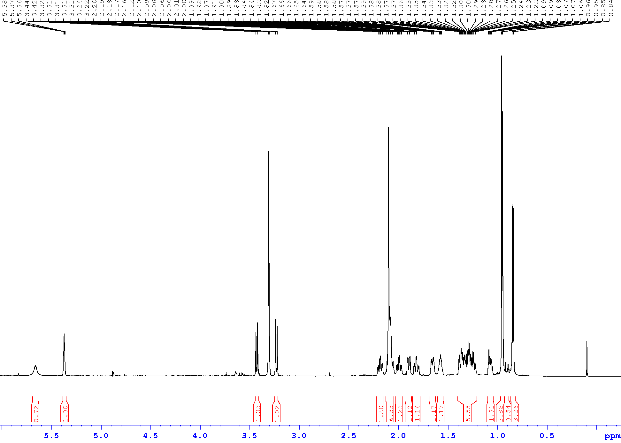
S2. ¹³C NMR (150.9 MHz, CD₃OD) spectrum of Compound 1.
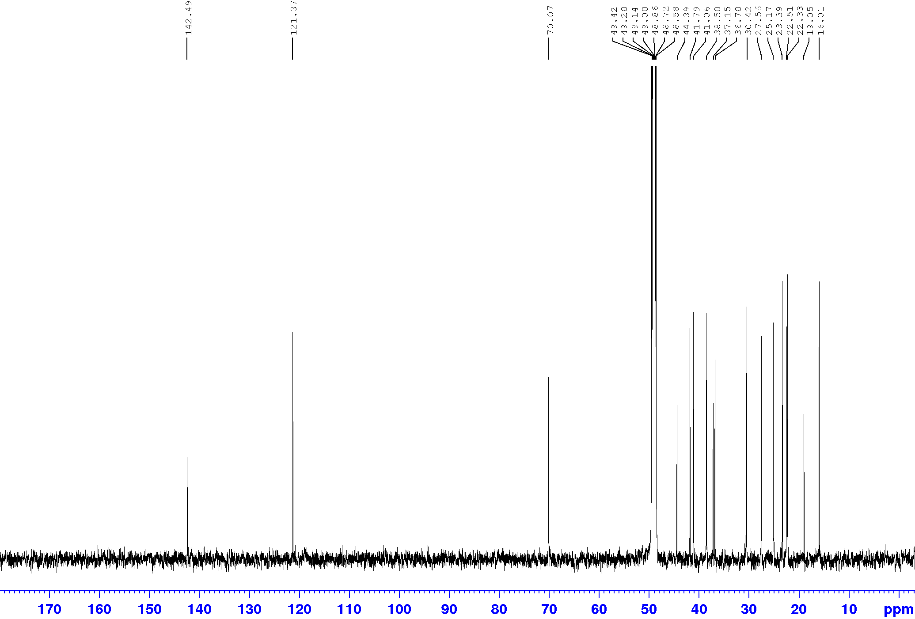
S3. ¹H NMR (600.13 MHz, CD₃OD) spectrum of Compound 2.
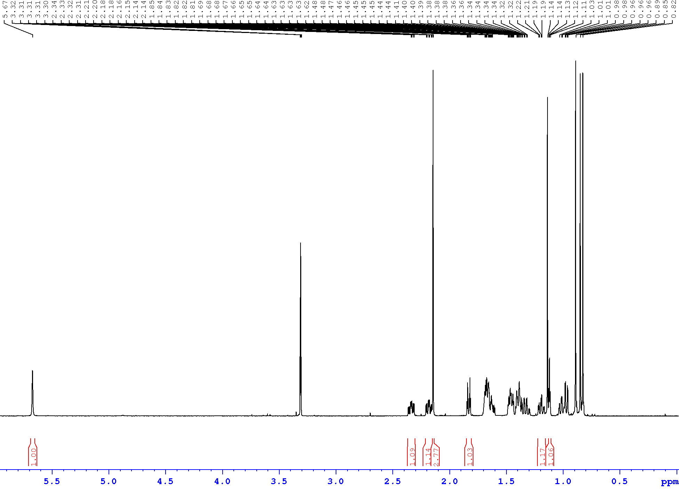
S4. ¹³C NMR (150.9 MHz, CD₃OD) spectrum of Compound 2.
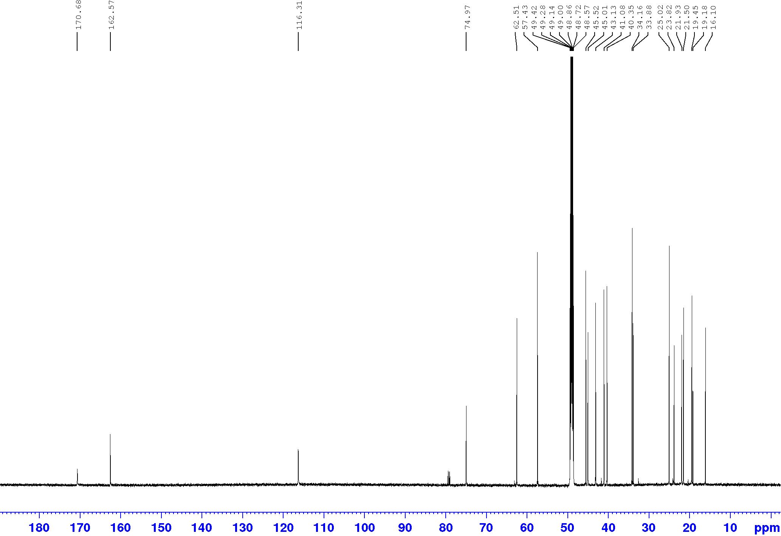

S5. HR-ESI-MS spectrum of Compound 3 (negative ion mode).
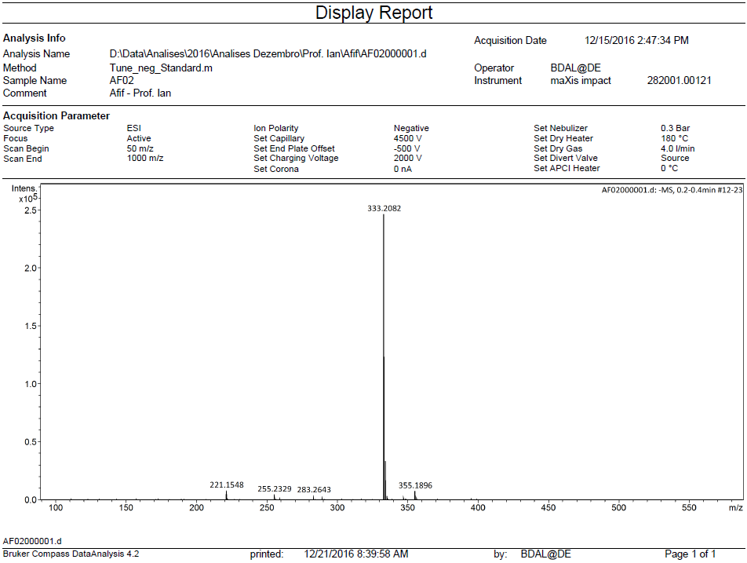

S6. ¹H NMR (600.13 MHz, CD₃OD) spectrum of Compound 3.
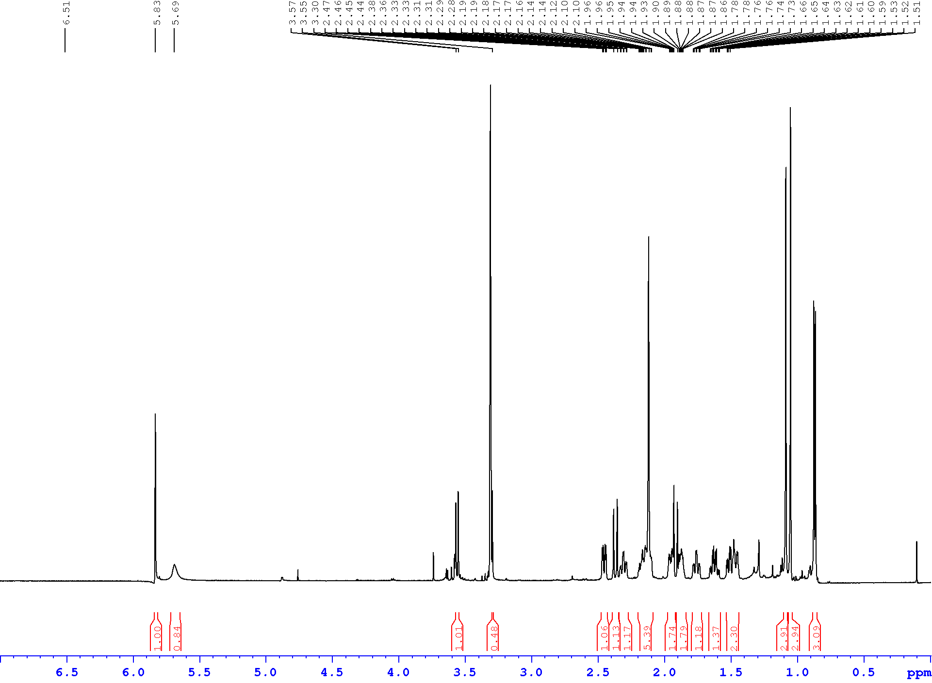
S7. ¹³C NMR (150.9 MHz, CD₃OD) spectrum of Compound 3.
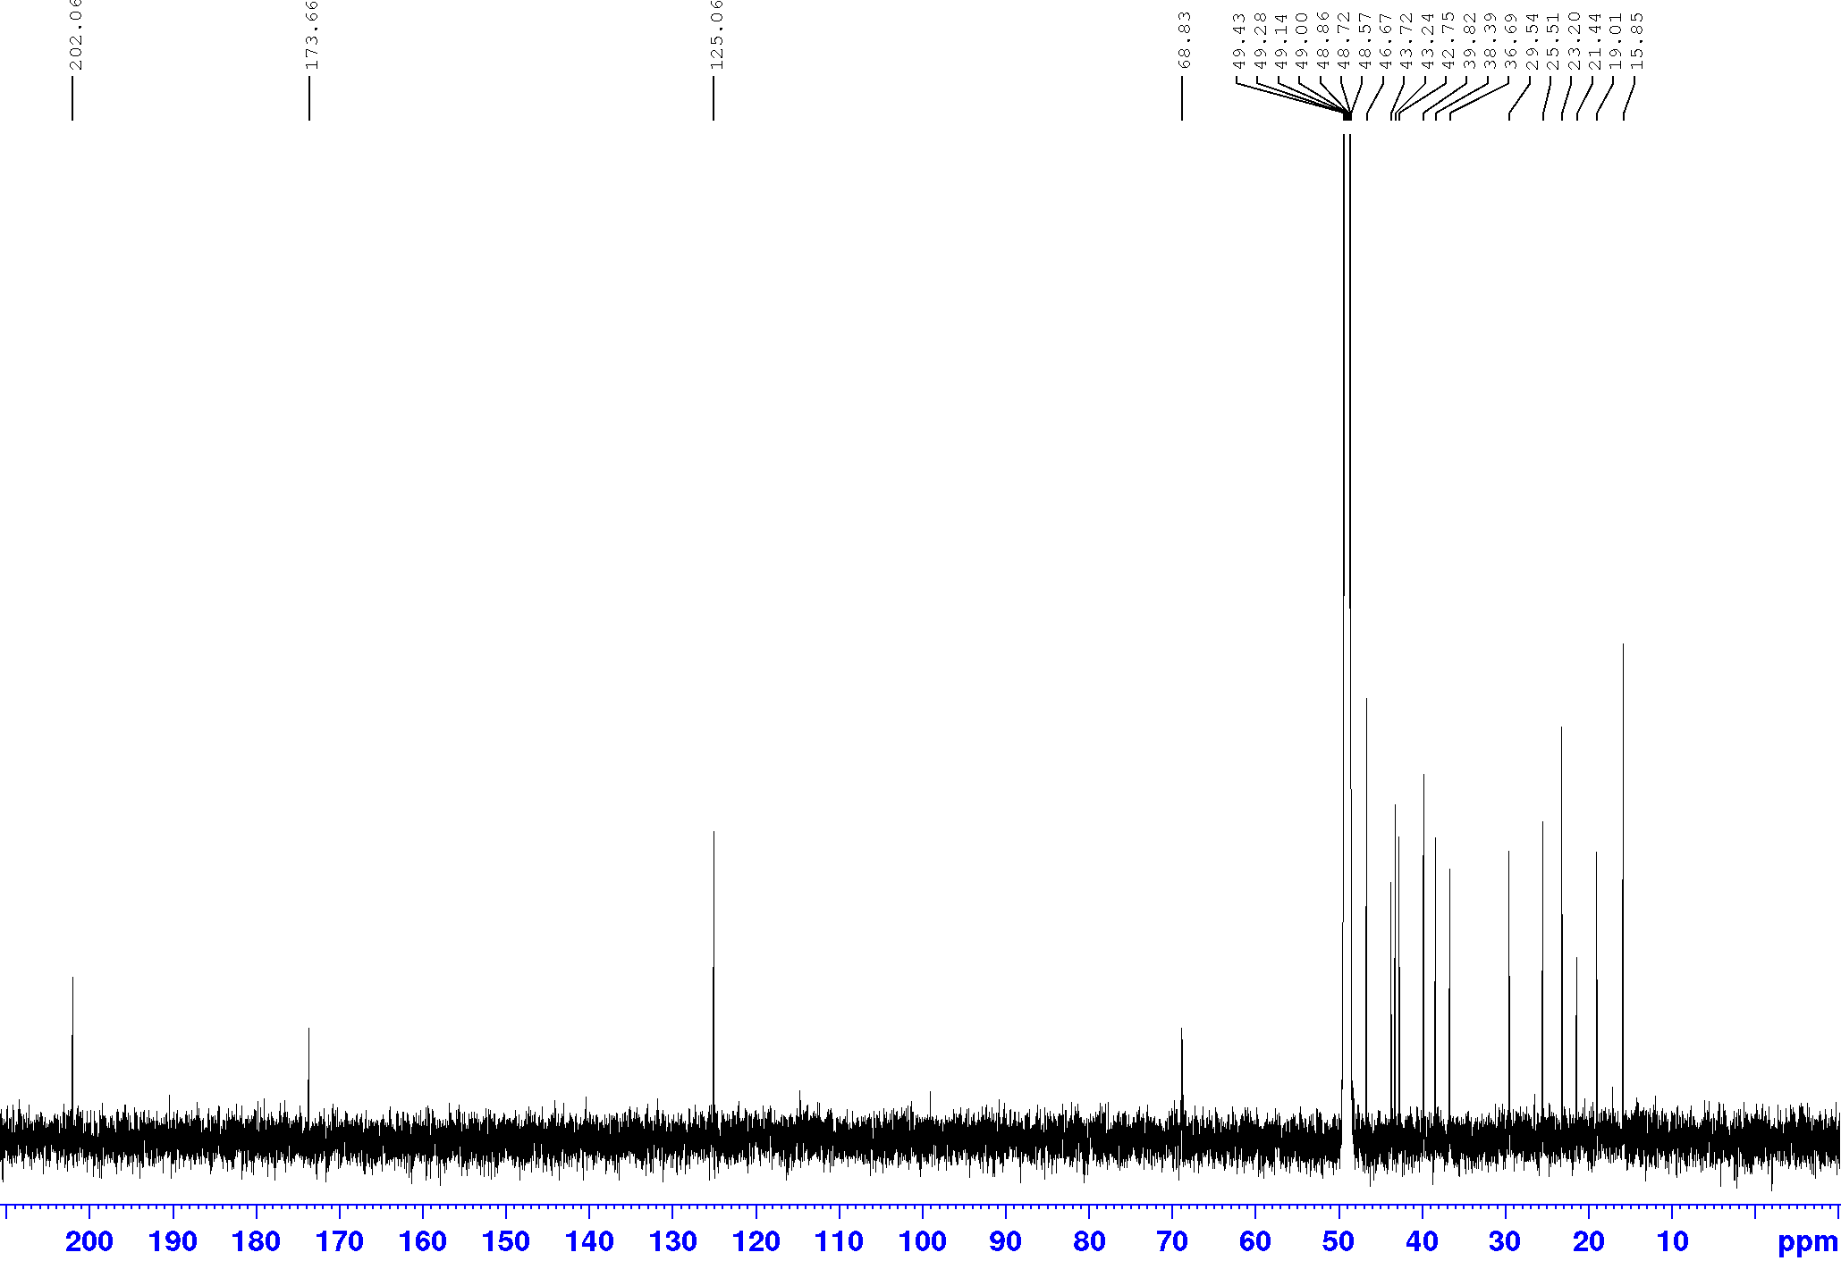
S8. HSQC (600.13 MHz, CD₃OD) spectrum of Compound 3.
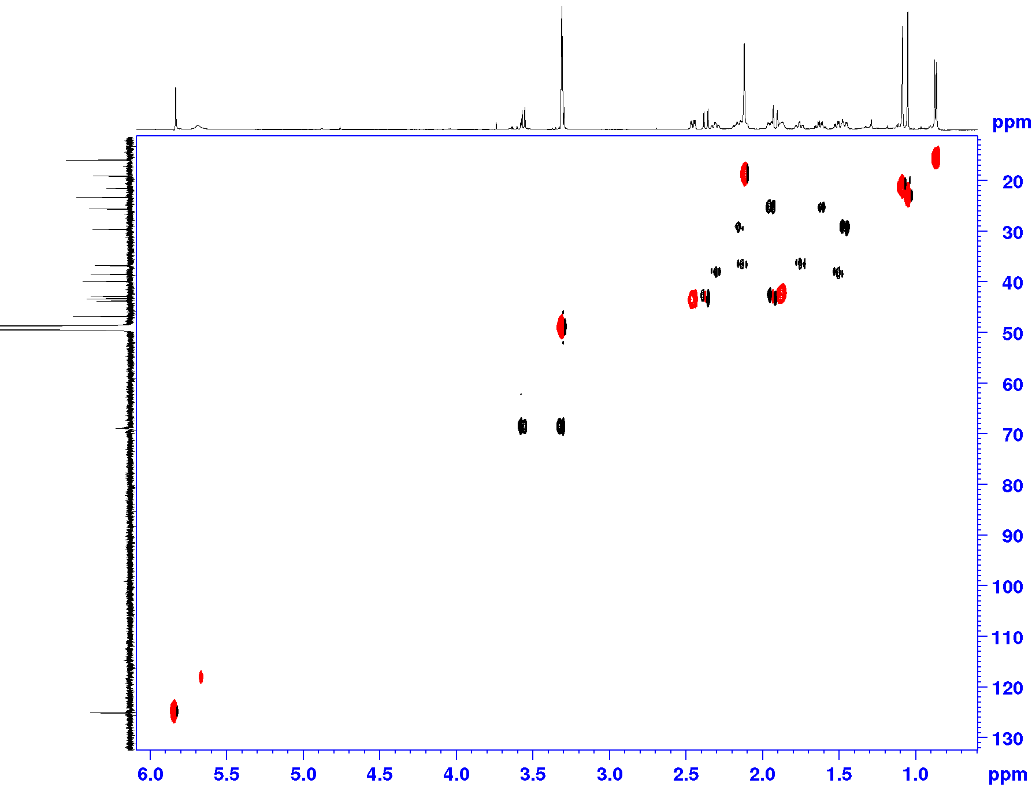
S9. HMBC (600.13 MHz, CD₃OD) spectrum of Compound 3.
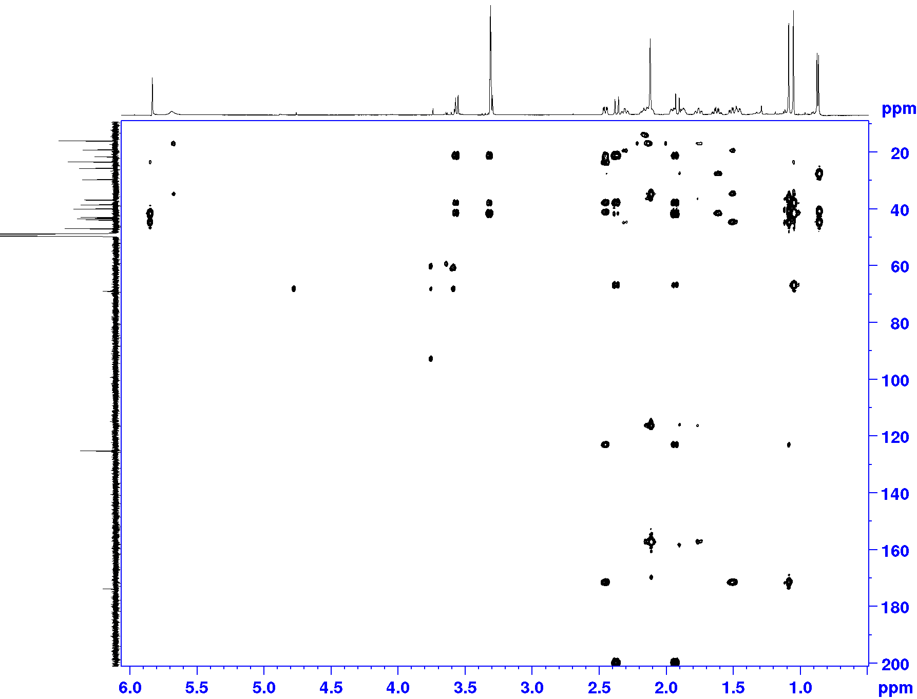
S10. HR-ESI-MS spectrum of Compound 4 (negative ion mode).
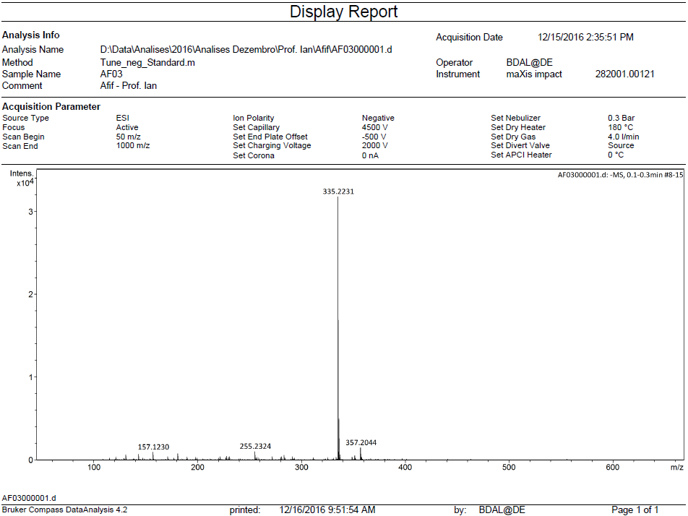

S11. ¹H NMR (600.13 MHz, CDCl₃) spectrum of Compound 4.
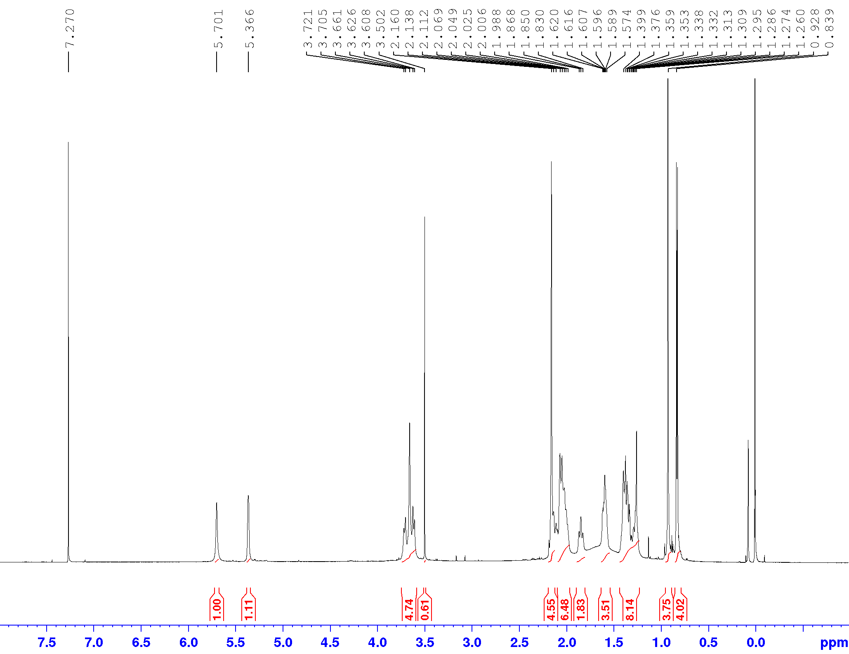
S12. ¹³C NMR (150.9 MHz, CDCl₃) spectrum of Compound 4.
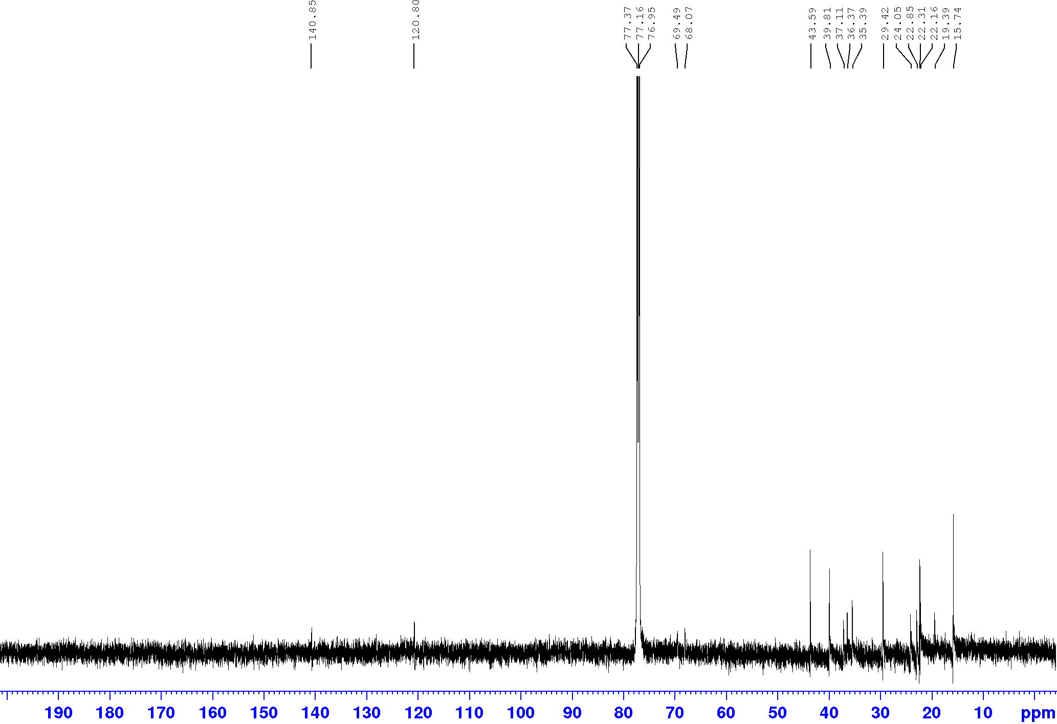
S13. HSQC (600.13 MHz, CDCl₃) spectrum of Compound 4.
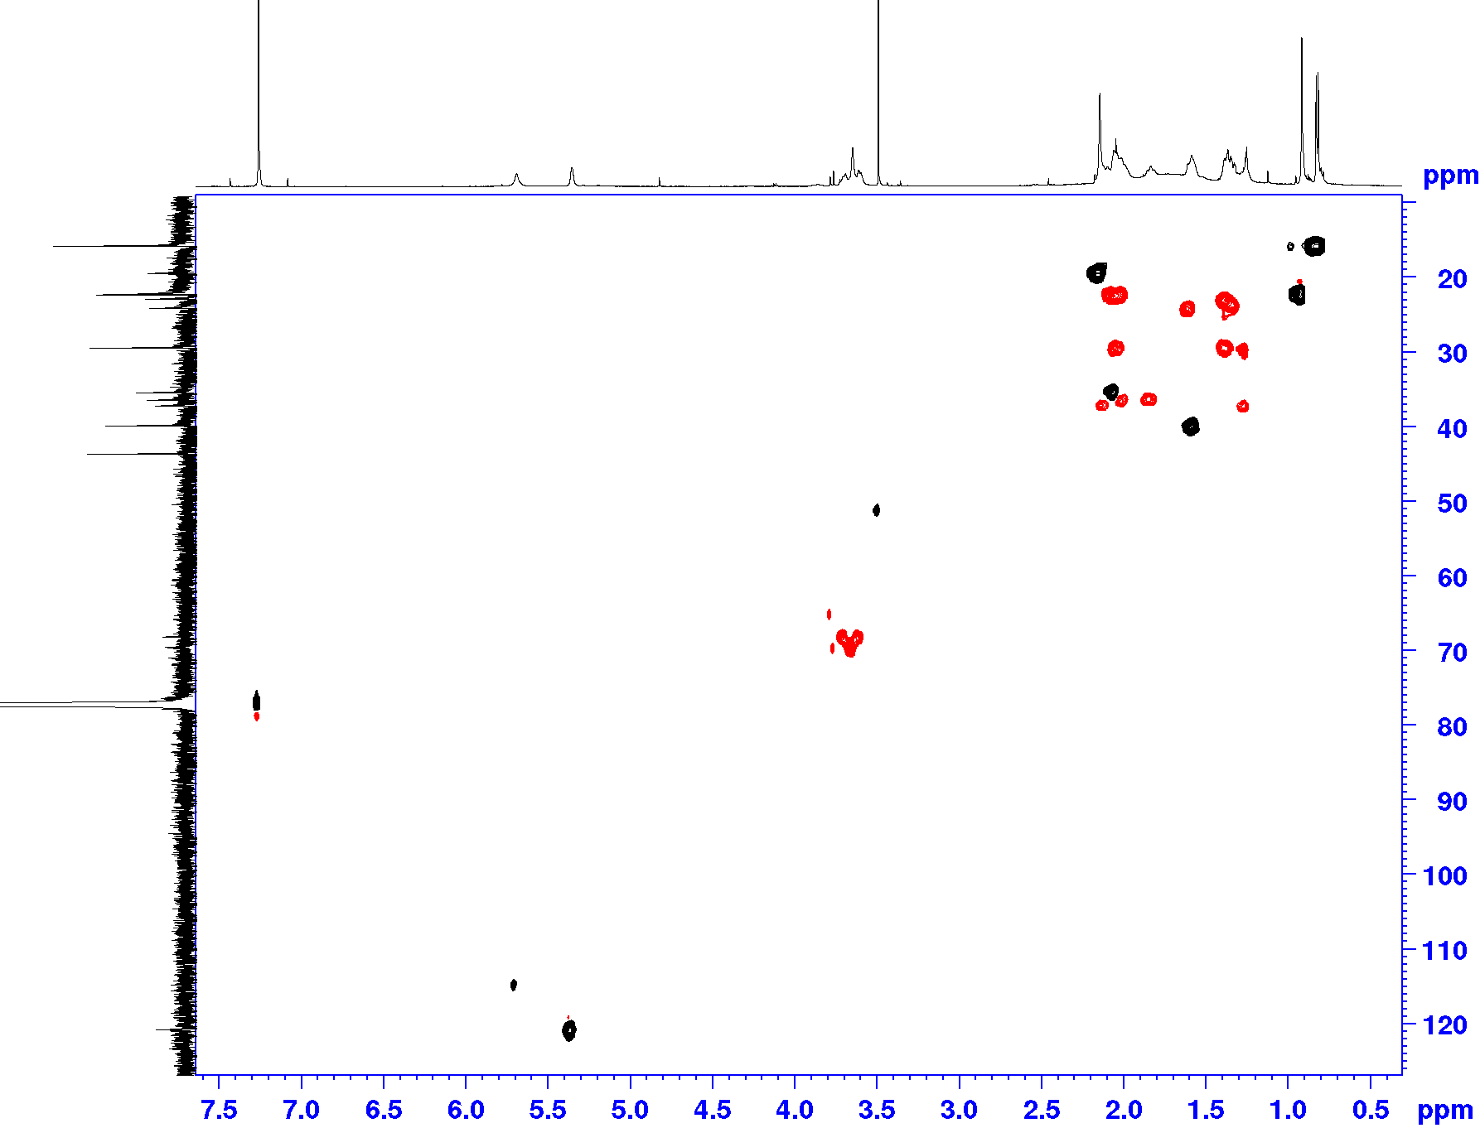
S14. HMBC (600.13 MHz, CDCl₃) spectrum of Compound 4.
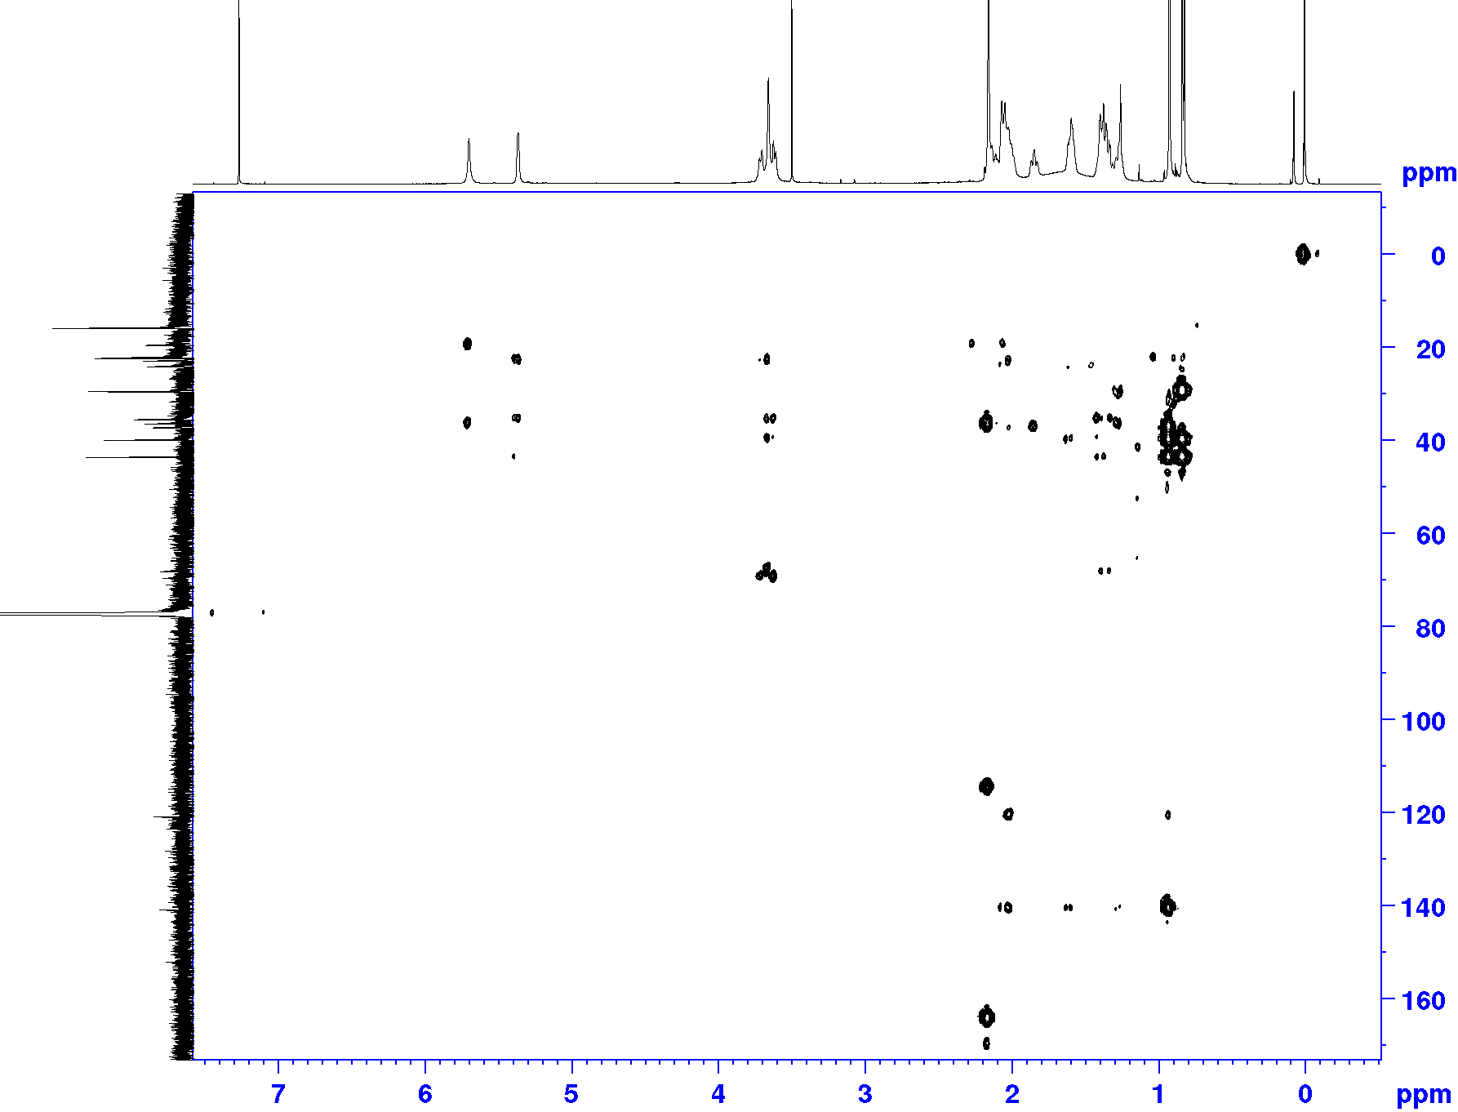
S15. HR-ESI-MS spectrum of Compound 5 (negative ion mode).
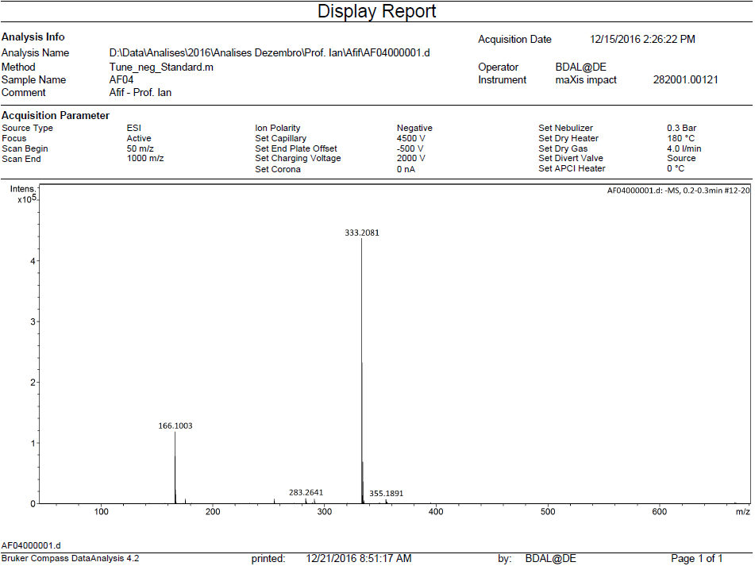

S16. ¹H NMR (600.13 MHz, CDCl₃) spectrum of Compound 5.
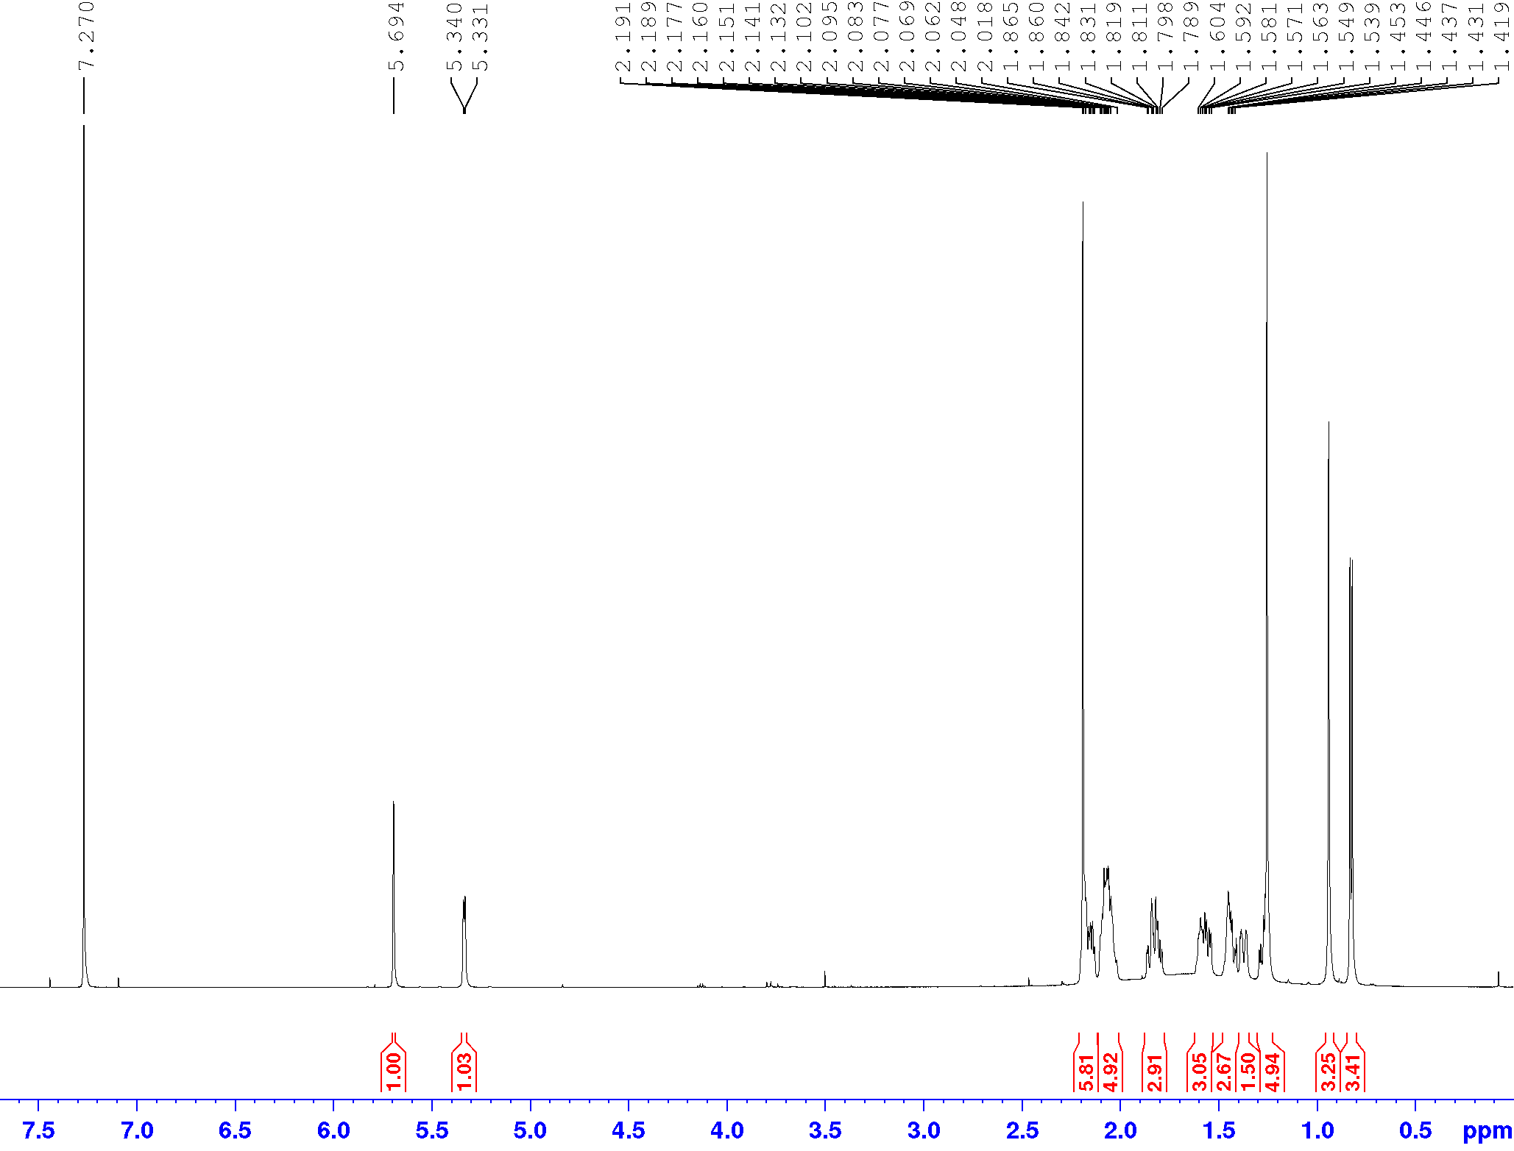
S17. ¹³C NMR (150.9 MHz, CDCl₃) spectrum of Compound 5.
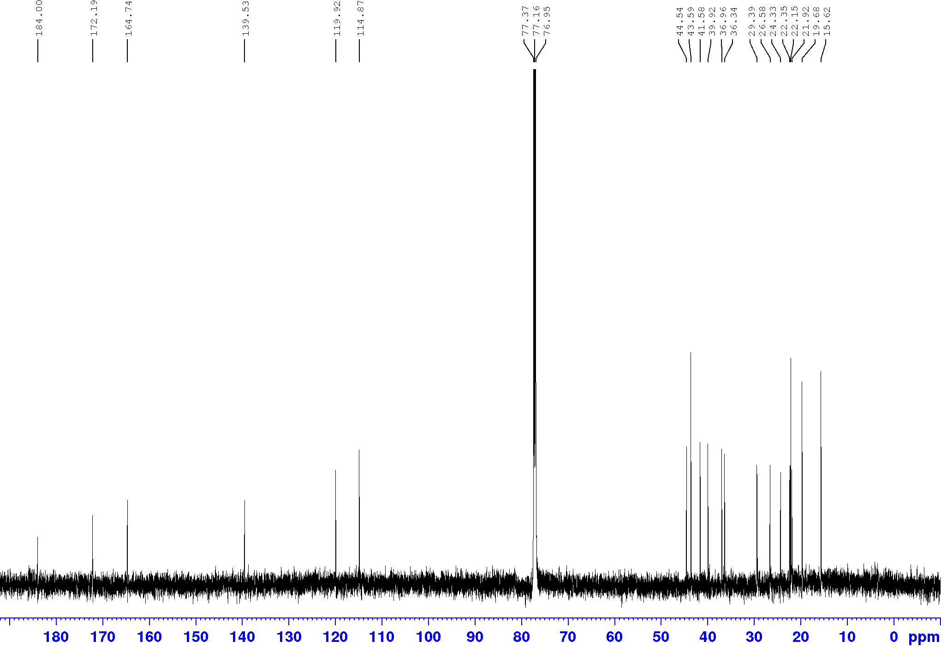
S18. HSQC (600.13 MHz, CDCl₃) spectrum of Compound 5.
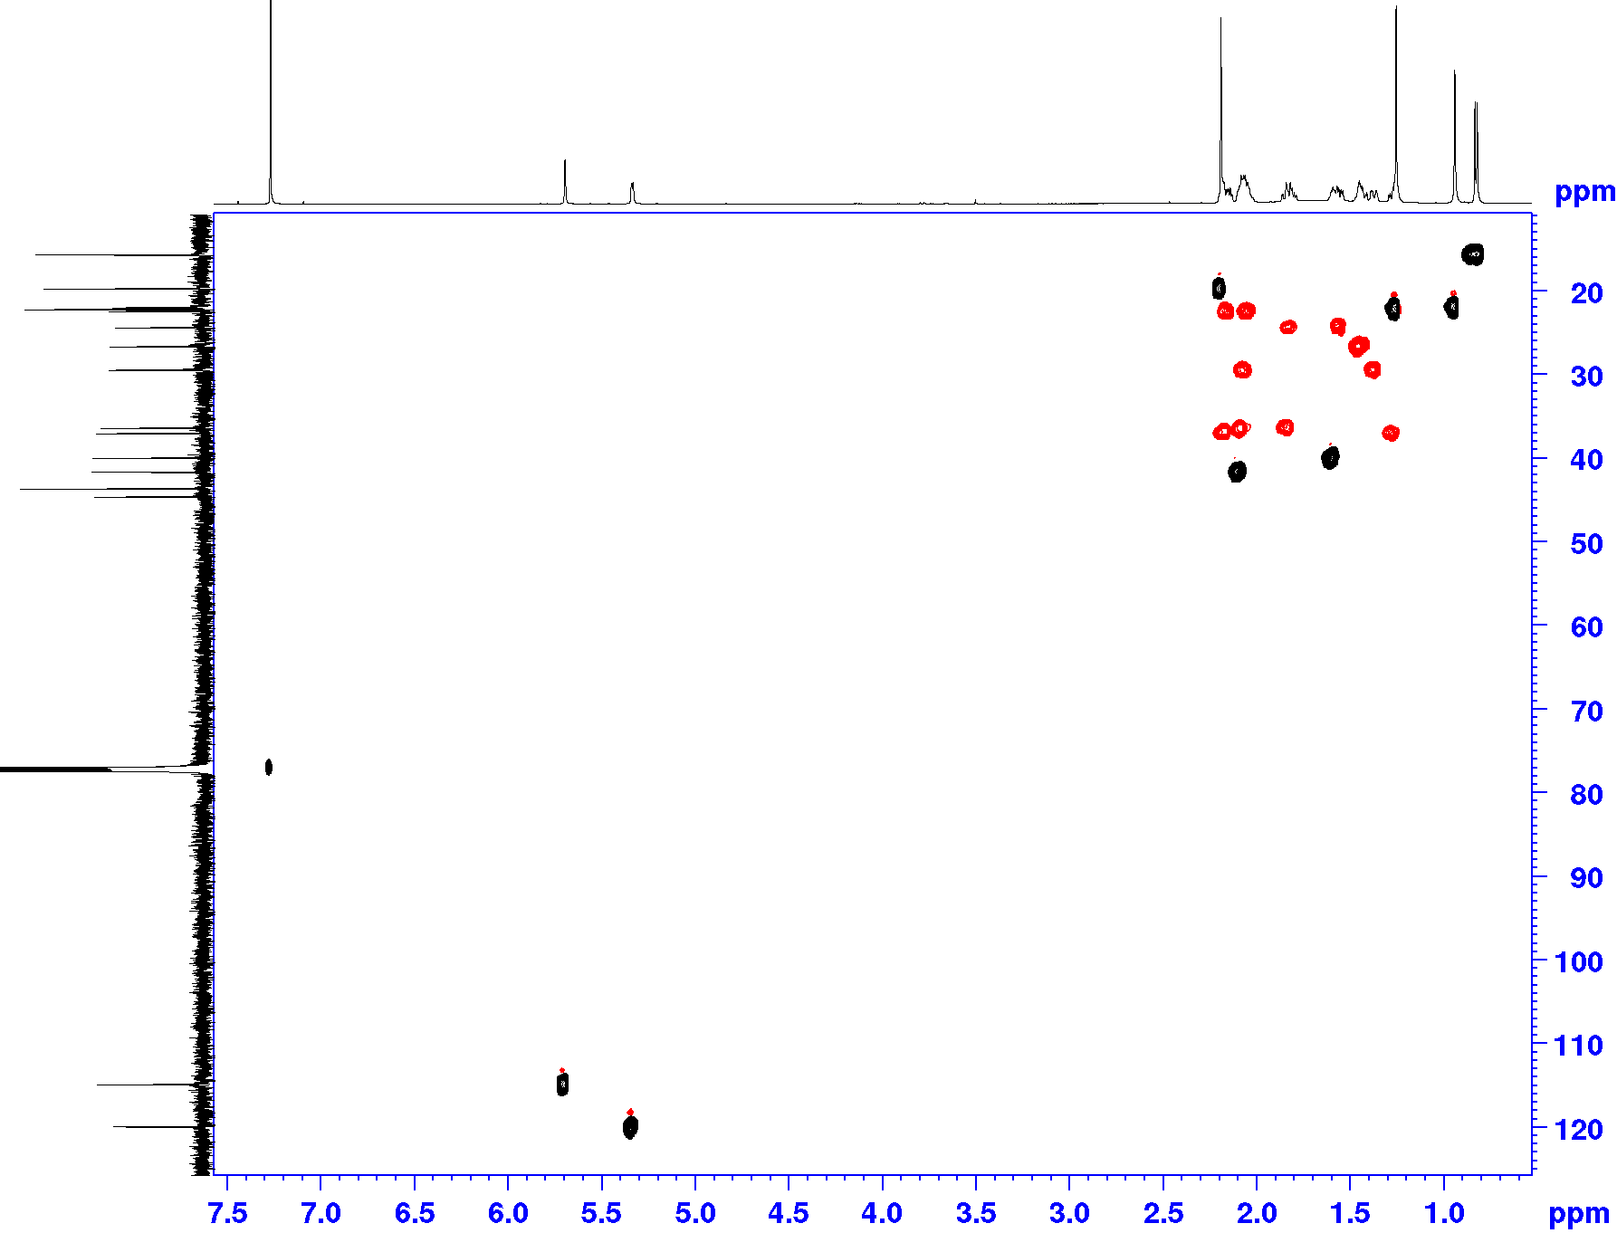
S19. HMBC (600.13 MHz, CDCl₃) spectrum of Compound 5.
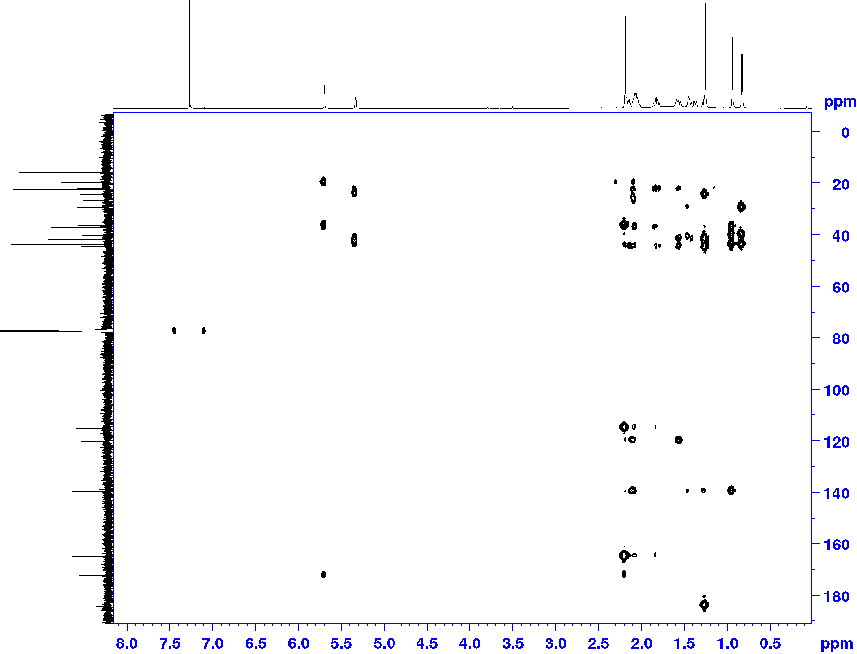
S20. HR-ESI-MS spectrum of Compound 6 (negative ion mode).
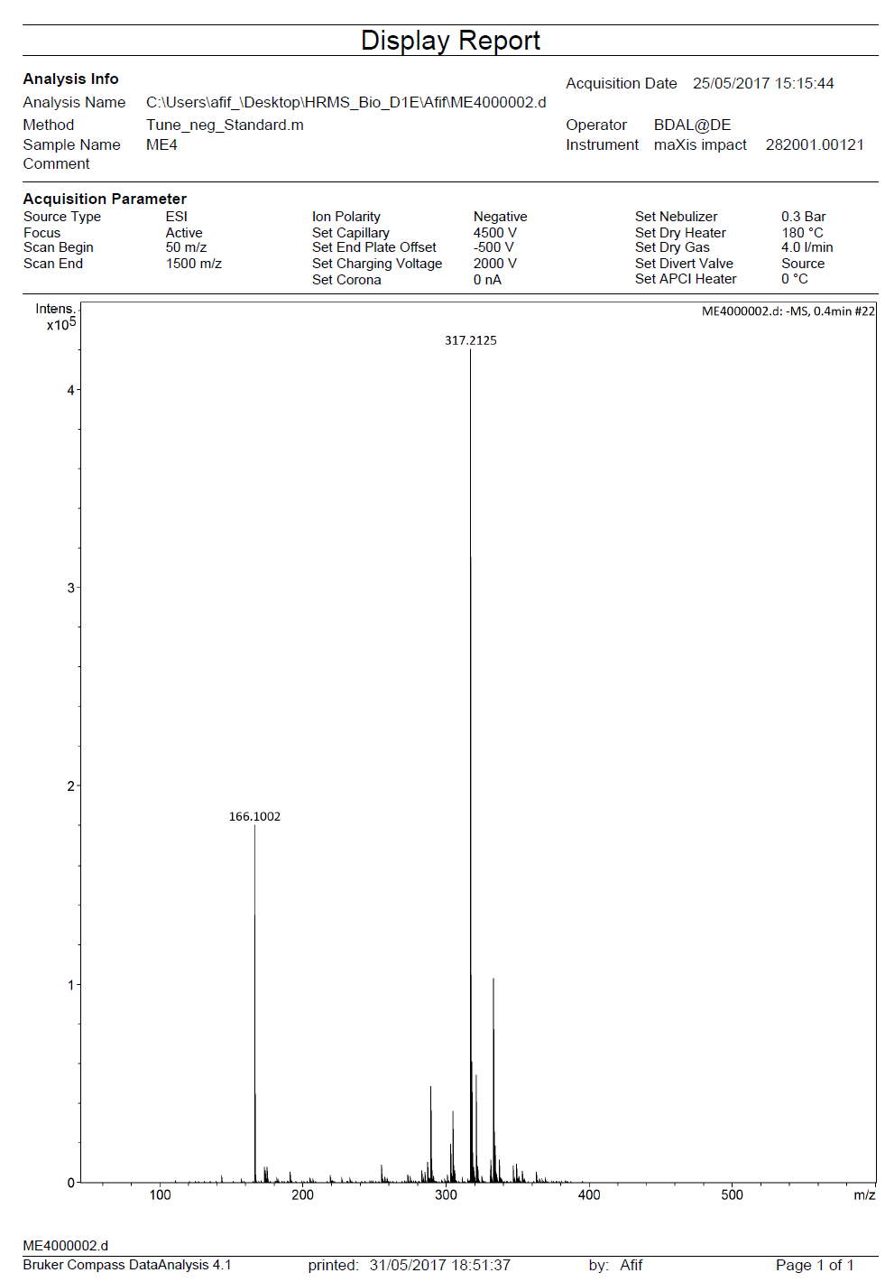
S21. ¹H NMR (600.13 MHz, CDCl₃) spectrum of Compound 6.
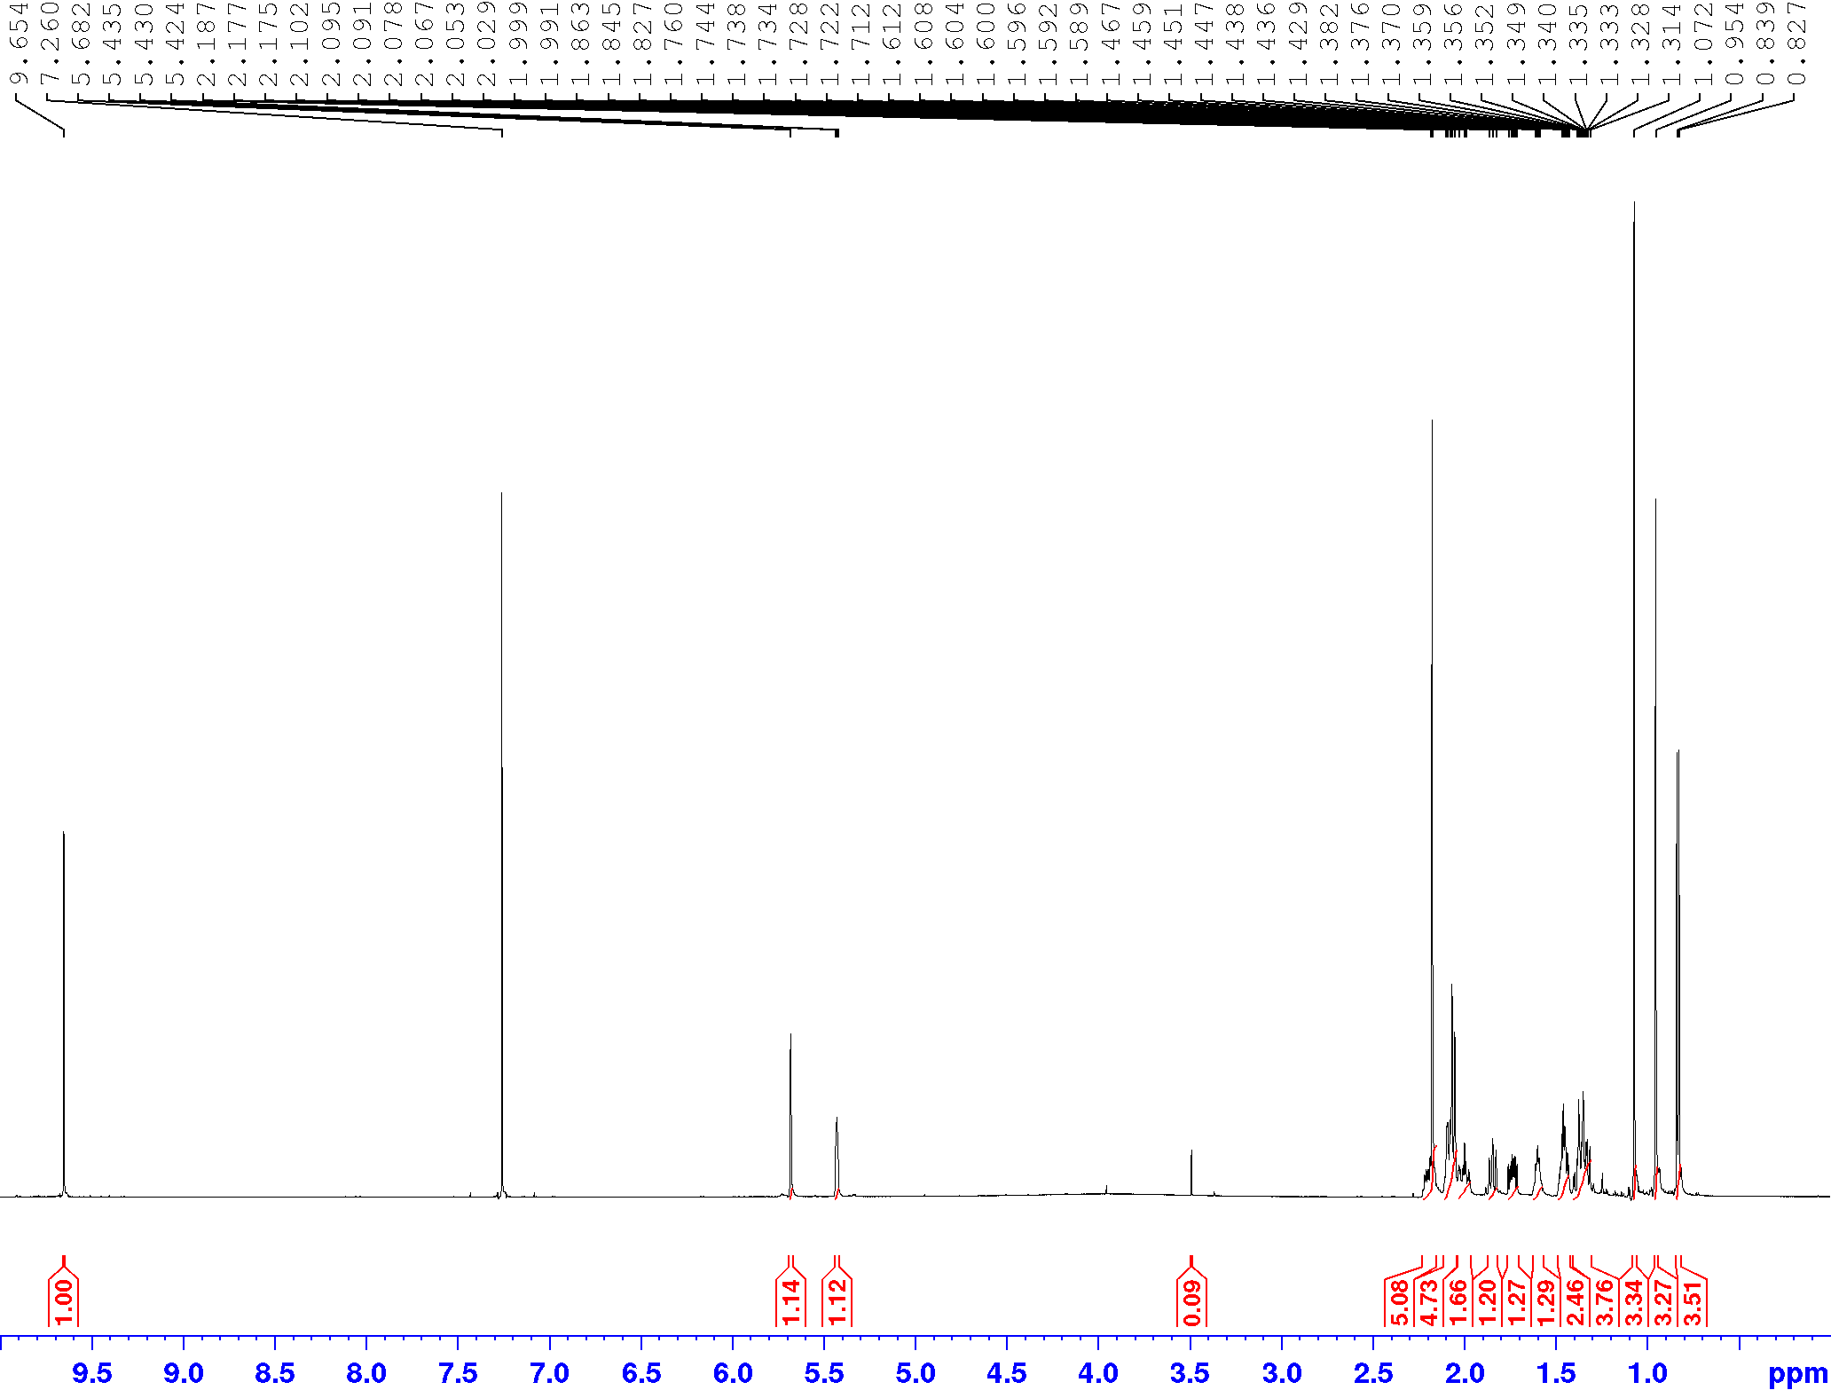
S22. ¹³C NMR (150.9 MHz, CDCl₃) spectrum of Compound 6.
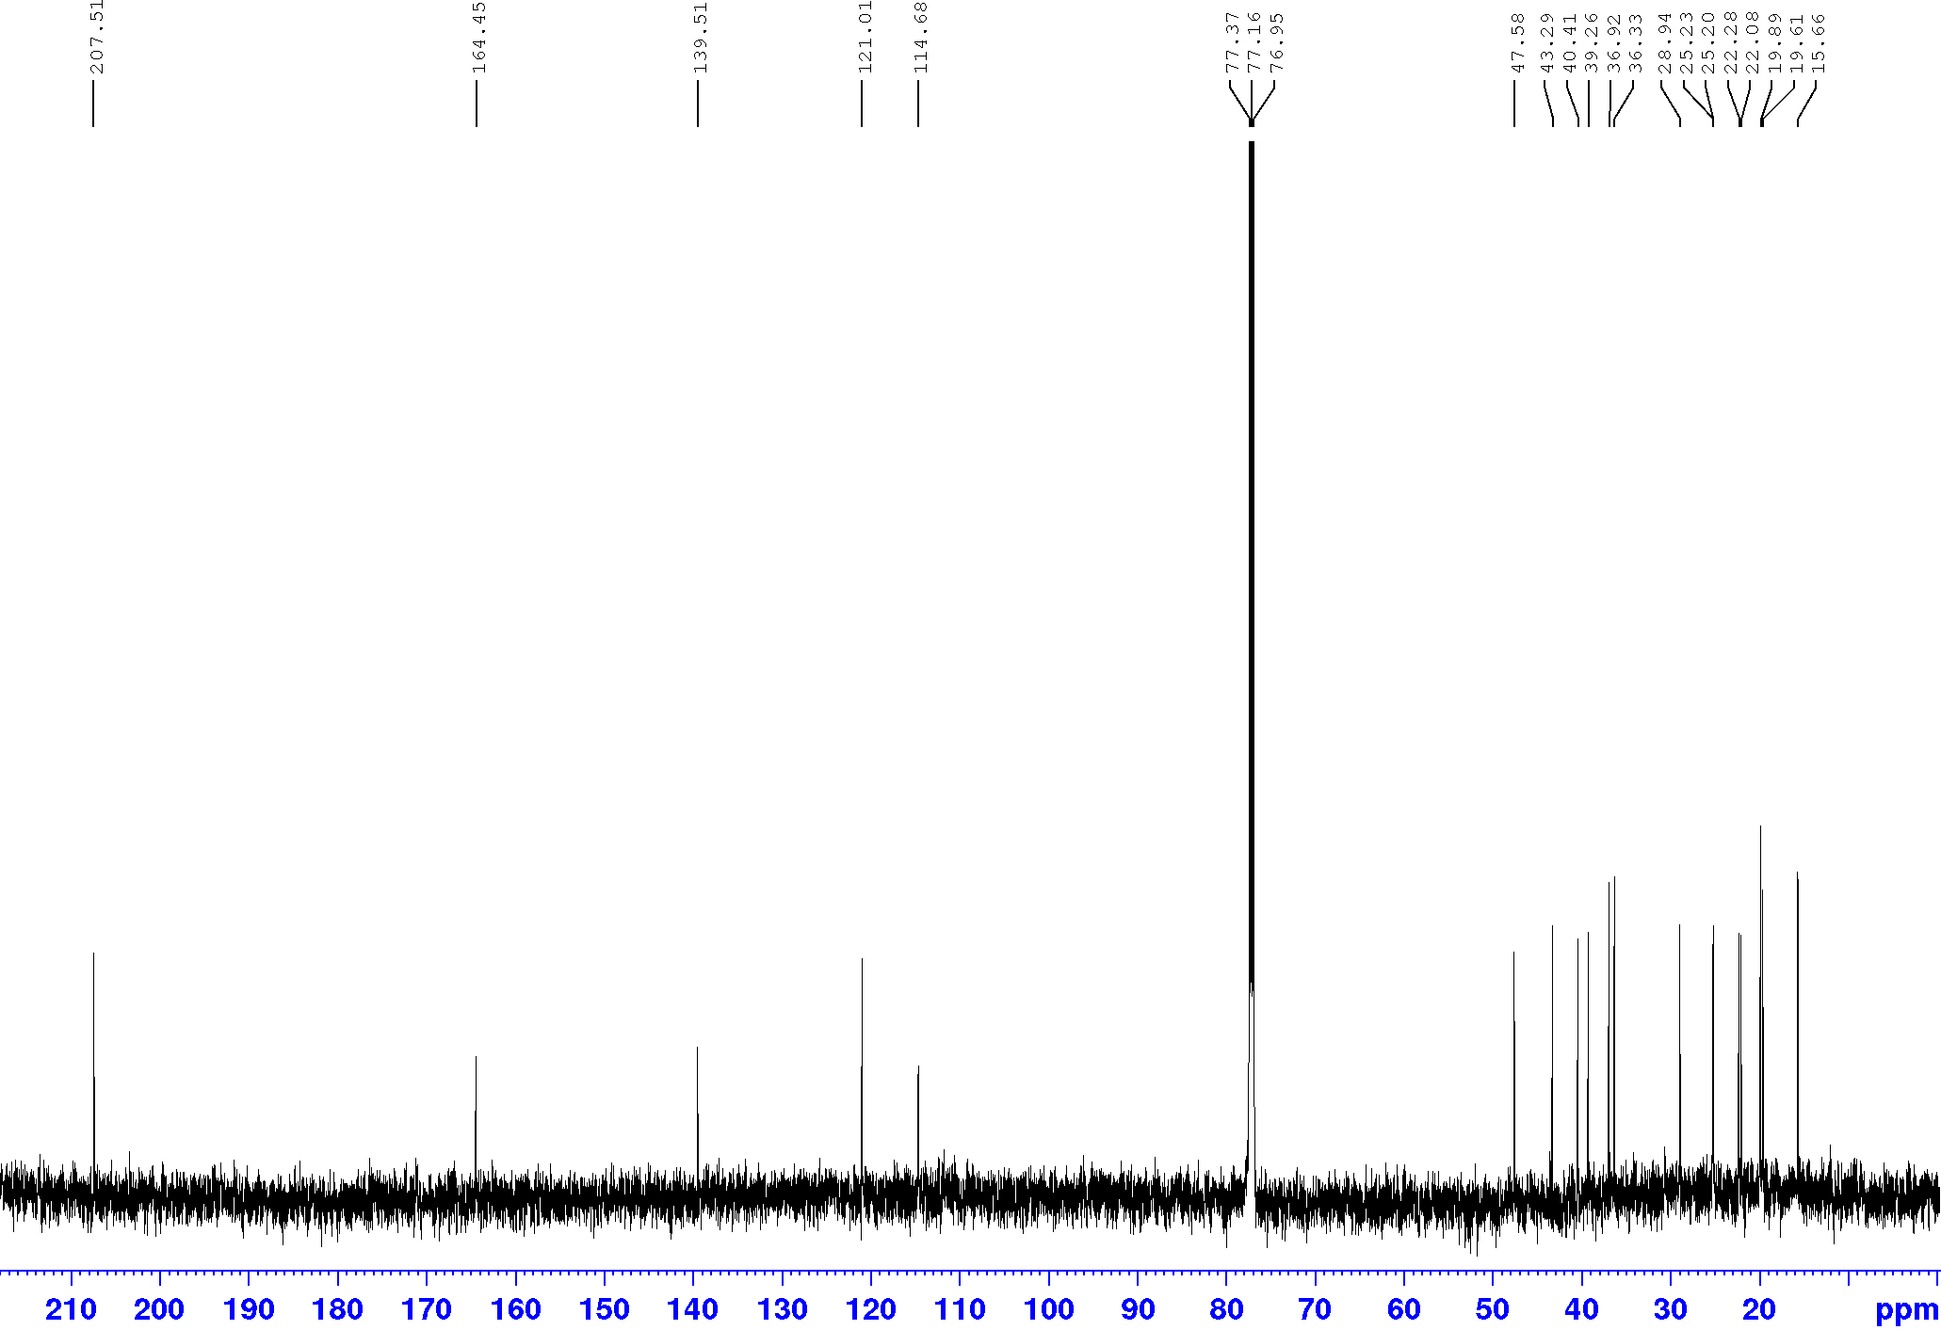
S23. HSQC (600.13 MHz, CDCl₃) spectrum of Compound 6.
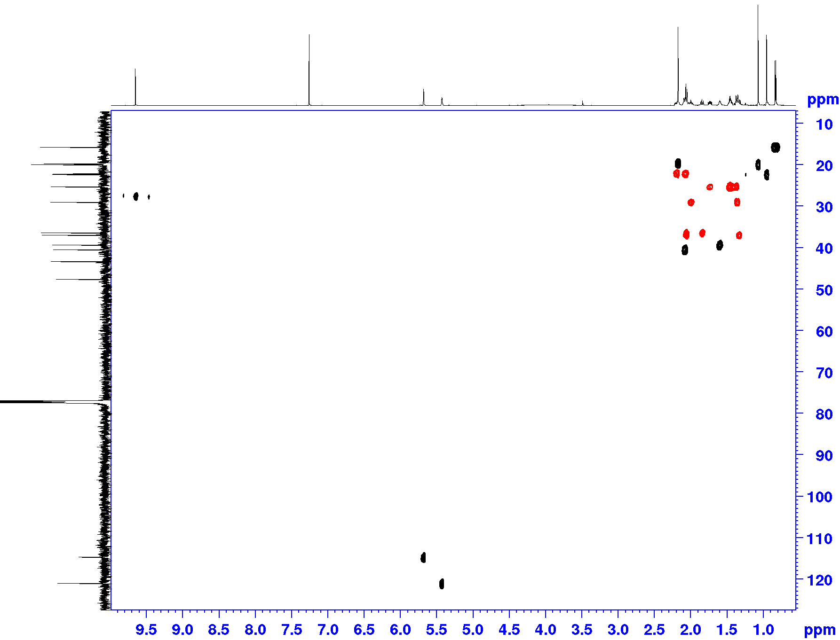
S24. HMBC (600.13 MHz, CDCl₃) spectrum of Compound 6.
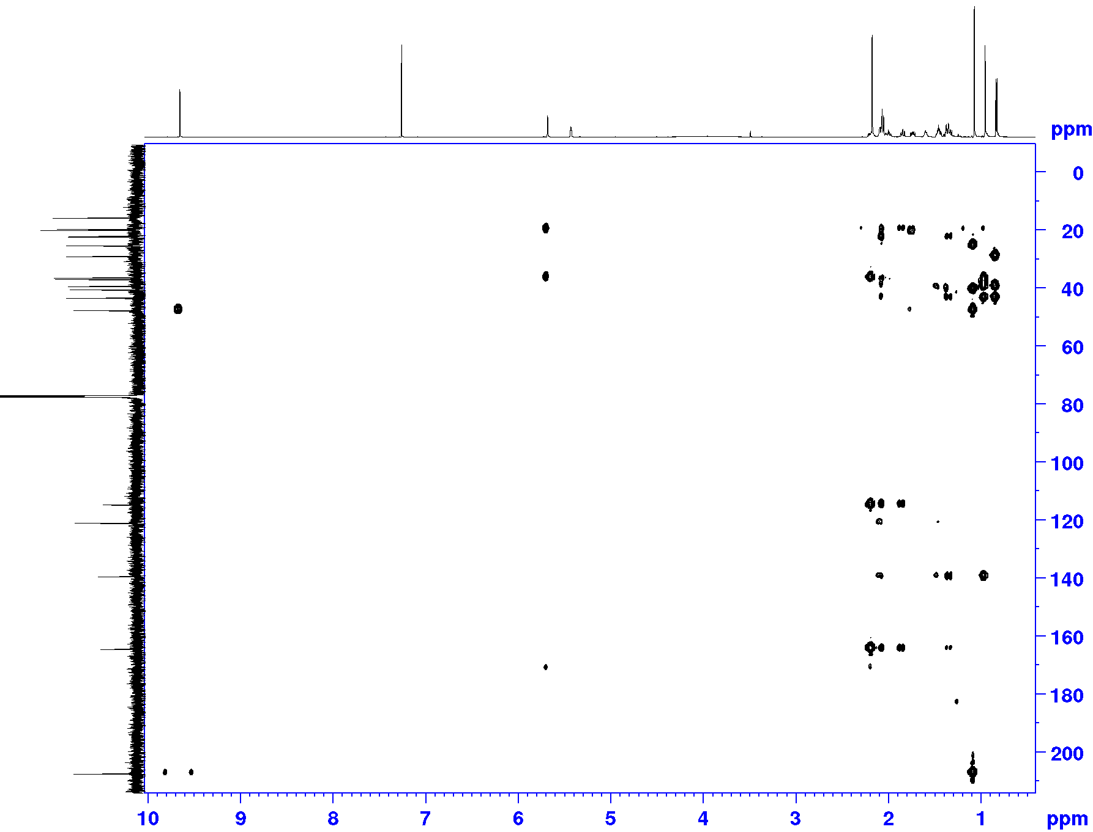
S25. HR-ESI-MS spectrum of Compound 7 (negative ion mode).
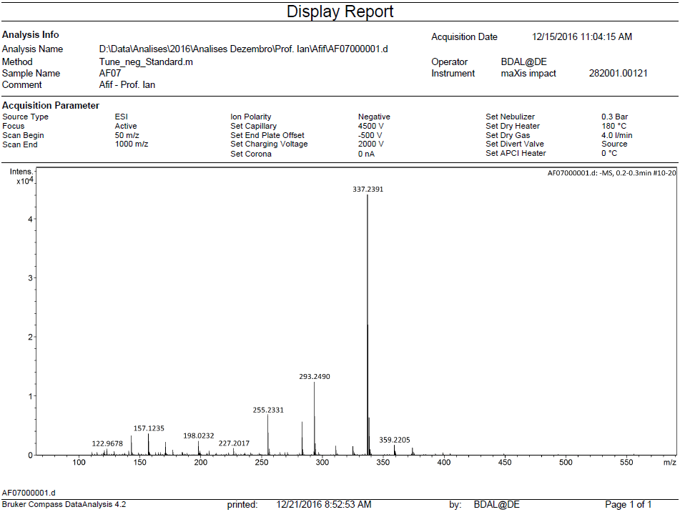

S26. ¹H NMR (600.13 MHz, CD₃OD) spectrum of Compound 7.
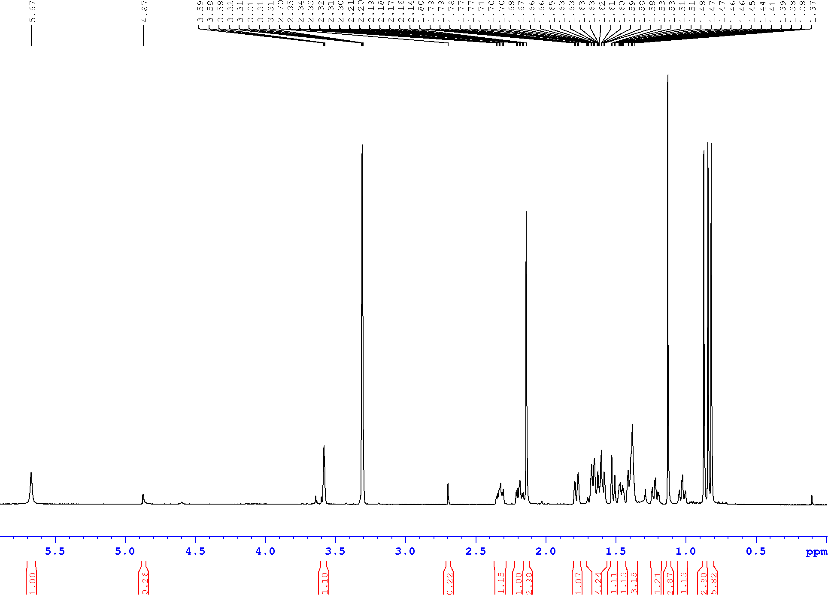
S27. ¹³C NMR (150.9 MHz, CD₃OD) spectrum of Compound 7.
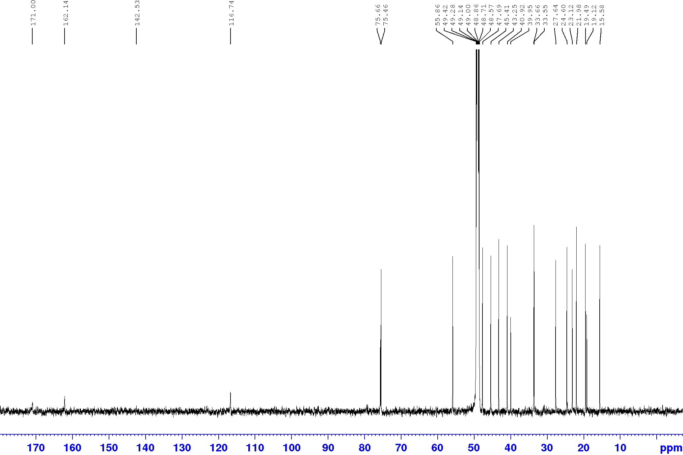
S28. HSQC (600.13 MHz, CD₃OD) spectrum of Compound 7.
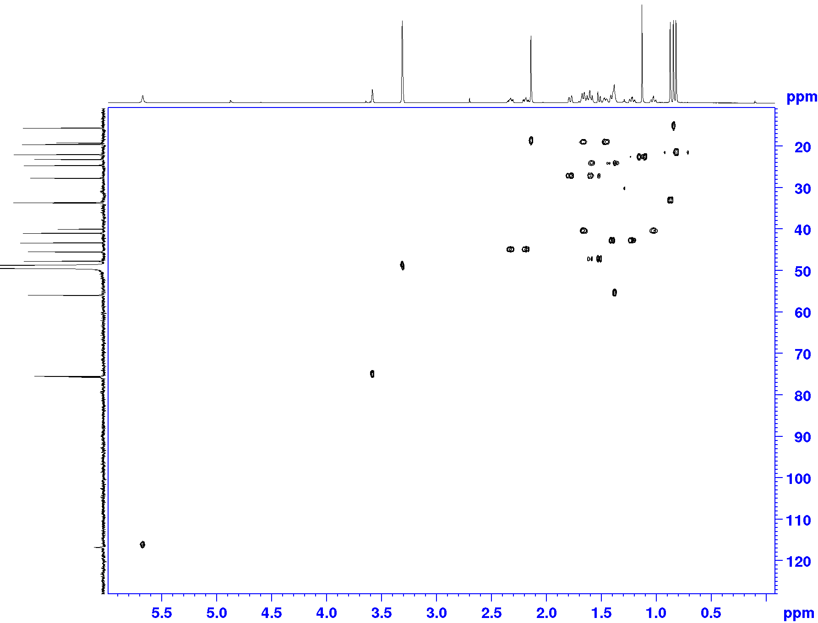
S29. HMBC (600.13 MHz, CD₃OD) spectrum of Compound 7.
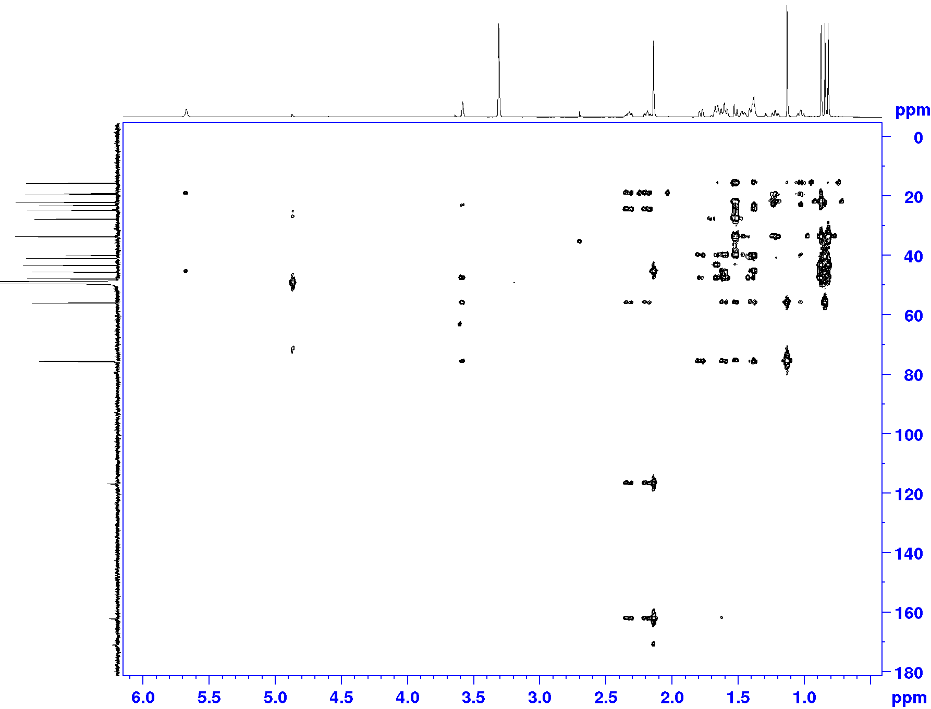
S30. HR-ESI-MS spectrum of Compound 8 (negative ion mode).
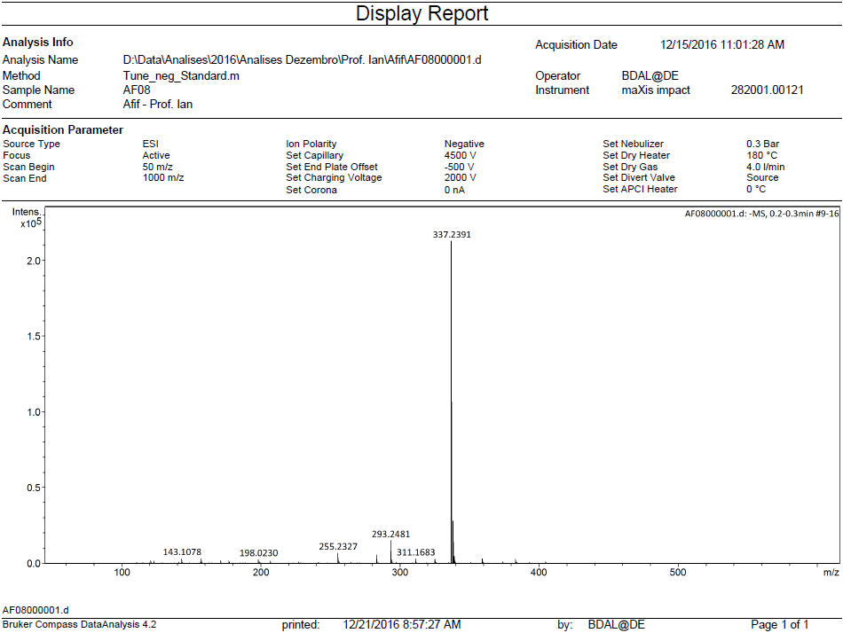

S31. ¹H NMR (600.13 MHz, CDCl₃) spectrum of Compound 8.
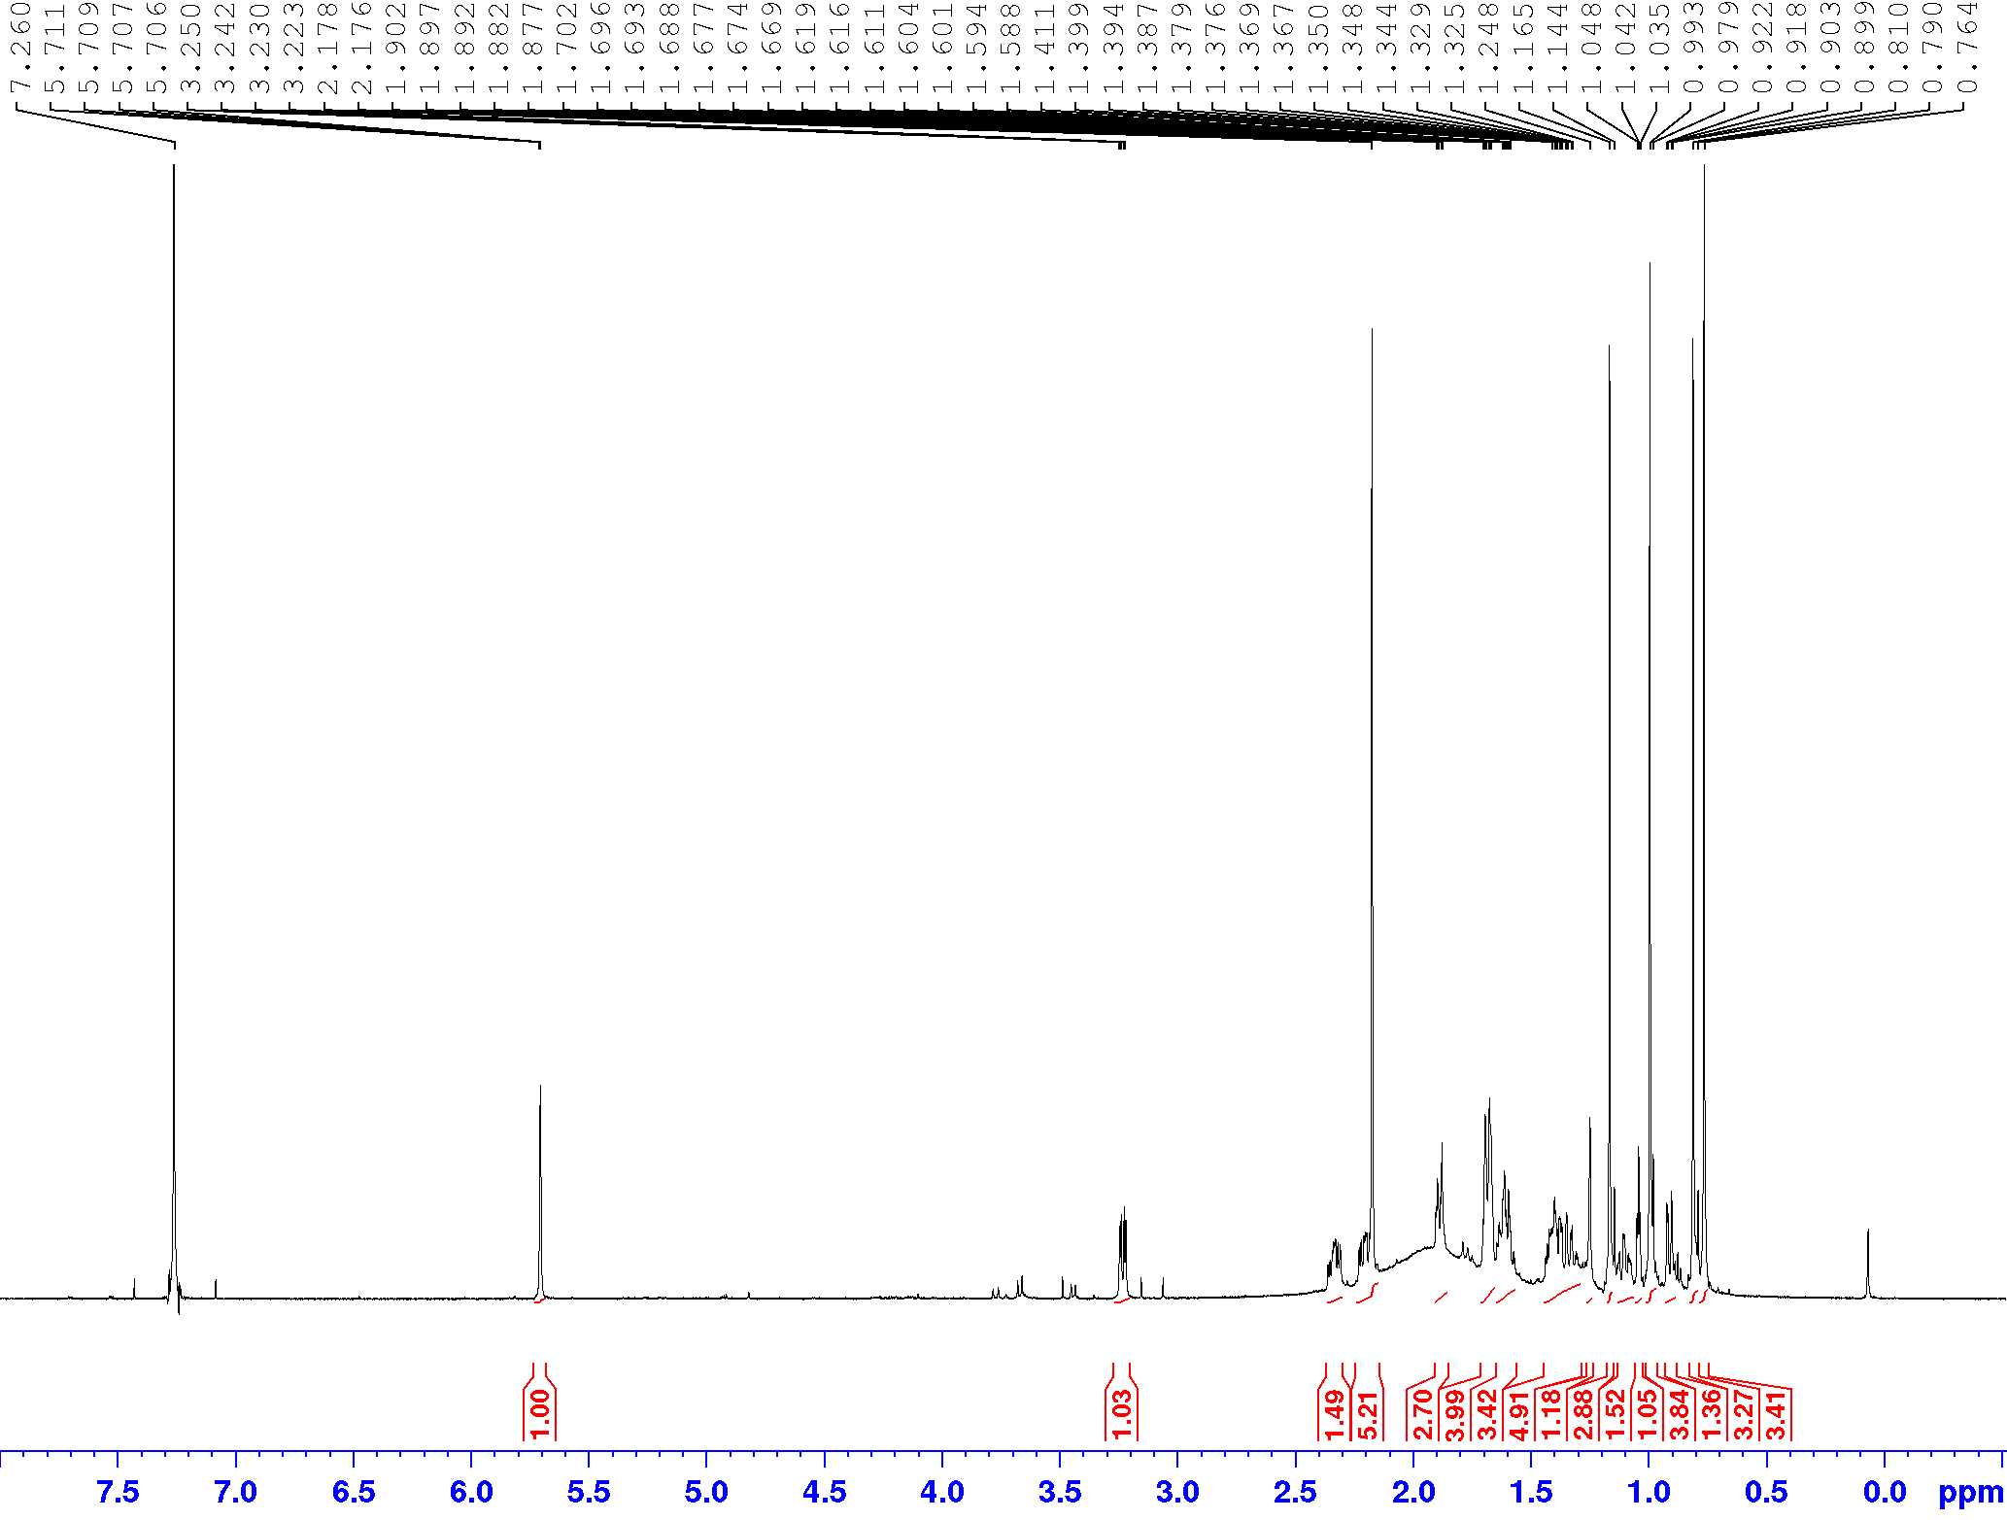
S32. ¹³C NMR (150.9 MHz, CDCl₃) spectrum of Compound 8.
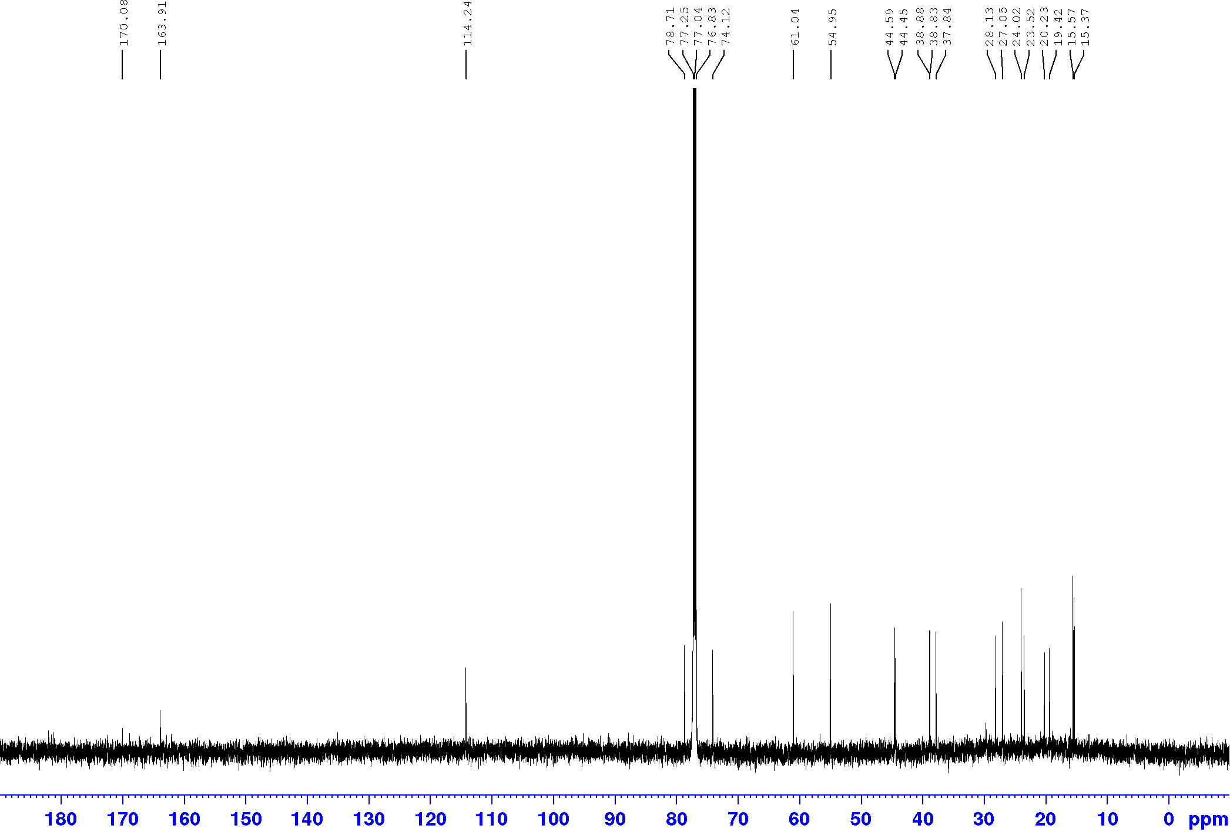
S33. HSQC (600.13 MHz, CDCl₃) spectrum of Compound 8.
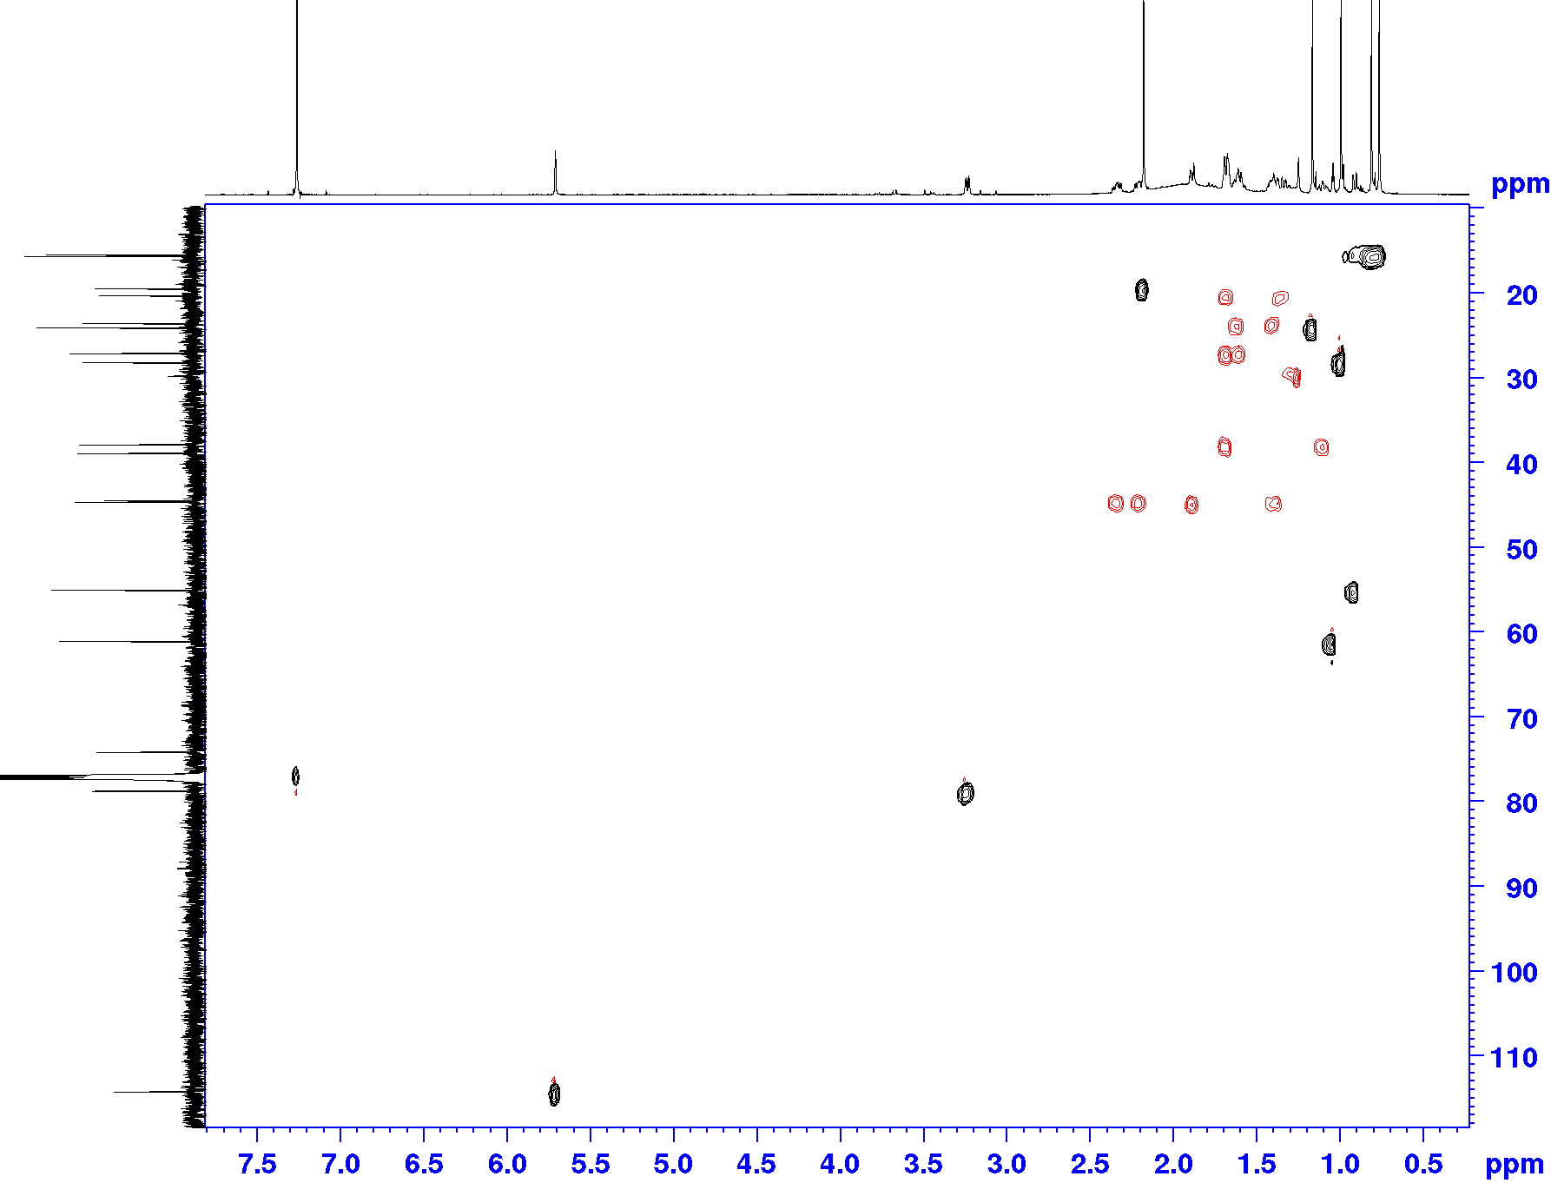
S34. HMBC (600.13 MHz, CDCl₃) spectrum of Compound 8.
