Supplementary methods
We performed several follow-up analyses to assess the behaviour of the phylogenetic SCP models.

Model variability and phylogenetic uncertainty
As the inclusion of phylogenetic uncertainty in SCP has not been trialled before, we decided to assess the contribution of phylogenetic uncertainty to variation between SCP results. We first calculated a Bray-Curtis dissimilarity matrix between 200 runs (20 trees x 10 runs each) of the PD conservation, 10% land area scenario, using the vegdist function in R package vegan [1]. Bray-Curtis distance is usually based on the proportion of species shared between two sites, but here it is based on the proportion of planning units shared between two reserve solutions.
We then performed a non-metric multidimensional scaling (NMDS, function isoMDS in R package MASS, version 7.3 [2]) on the distance matrix. Each solution (potential reserve system) becomes a point in ordination space, with solutions lying close in ordination space if they share most of the same areas selected. We made a plot of the first two axes for this ordination, identifying the tree used in each solution, to show whether solutions derived from the same tree tended to select the same areas. We also represented Bray-Curtis distance matrix as a dendrogram, using hierarchical clustering (hclust function, R Stats Package version 3.3.1). These methods showed clear relationships, but to provide an unambiguous statistical test of the relative contribution to difference in SCP solutions of difference between trees (phylogenetic uncertainty) compared to within trees (model optimization uncertainty), we performed a manova on the ordination of SCP solutions, with tree-used, as the predictor variable.

Effect on EDGE species
The EDGE (evolutionarily distinct, globally endangered) metric [3-5] is used to rank species by their IUCN threat status and their evolutionary distinctness in order to focus conservation efforts on species whose potential extinction would result in a large loss of PD. These species are ranked on the EDGE Project website (edgeofexistence.org/mammals). As a small test of the impact of our phylogenetically informed SCP, we evaluated its performance for the ten highest ranking EDGE species in our study. For each conservation scenario (species or PD targets, and 7 limits for total conservation area) we summarized the average proportion of the area targets achieved. The results were based on 100 runs for each scenario, using just the best run for each of the 100 trees. We compared the performance of species and PD conservation for the ten highest ranking EDGE species in our study, to performance for all species in our study.

Relationship between irreplaceability and current protection
We assessed the relationship between frequency of selection in our PD conservation scenarios (2.5 and 10% land area) and the % of each planning unit which is currently in IUCN category I to IV protected areas, as shown in figure S8.

Comparing area conservation targets to single occurrence targets
Previous studies comparing PD captured in systematic conservation planning which optimises for PD compared to optimizing for species, have found that in most cases the species optimization captures PD as well or almost as well, without considering it explicitly [6-8]. We found a larger benefit of using PD, and suspected that this was because each of these studies considered each component of PD to be protected if a single occurrence was selected, whereas we used area based targets as a function of range size. To test this, and compare to our results for area targets, we reran each of the scenarios (optimizing for PD or species across the range of total protected area, across 100 alternative trees) with a target of one planning unit for each branch, or the total range of the branch if that was less than one PU. We then assessed the resulting protected areas for PD captured under the PD and species optimization.

Supplementary figures

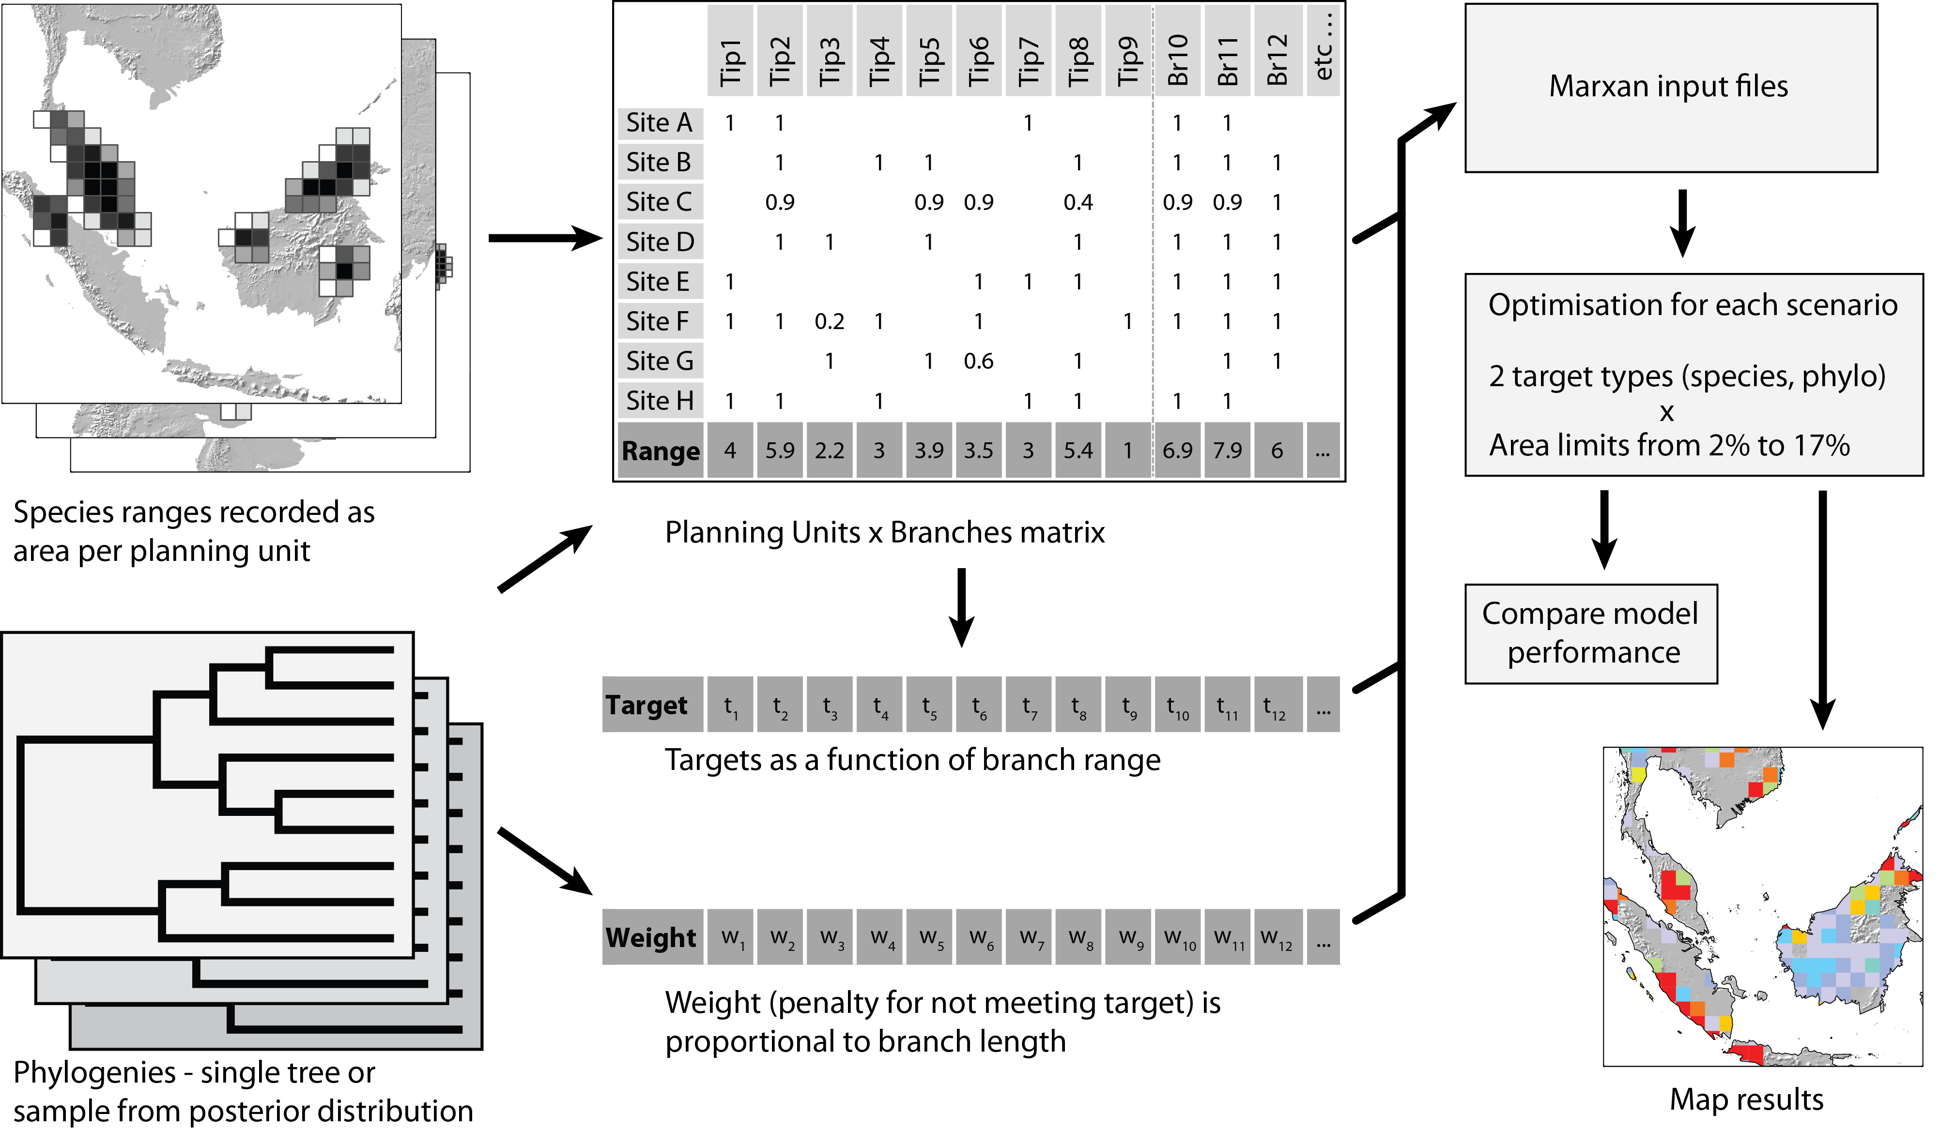
Figure S1. Overview of methods used in this study to generate and evaluate phylogenetic SCP for the world’s mammals. Once species occurrence is recorded for each planning unit, all steps to generate the Marxan input files are automated in R scripts.

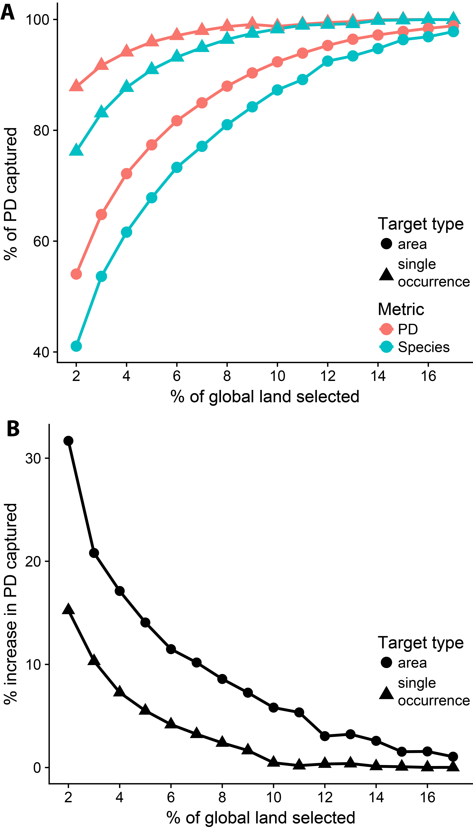
Figure S2. Performance in capturing PD, comparing the percentage area targets used in this study to single occurrence targets. A) shows that for a given total area, single planning unit targets (triangles) are achieved for a higher percentage of PD than is the case for area targets (circles). This is as expected, given that the targets are far lower, but highlights the difference from the many studies of PD conservation based on single occurrences,. For single targets, 5% of land is sufficient to meet targets for over 95% of PD, while the area targets require 13% of land. .The lines results for percentage area targets are the same as in Figure 1.
B) Percentage change in PD captured when optimizing for PD compared to optimizing for species. This is equivalent to Figure 1, but shows the result for both area and single occurrence targets. With single occurrence targets, the benefit of using phylogenetic information is far less, and with > 9% of land selected, the advantage of explicitly optimizing for PD is close to zero.
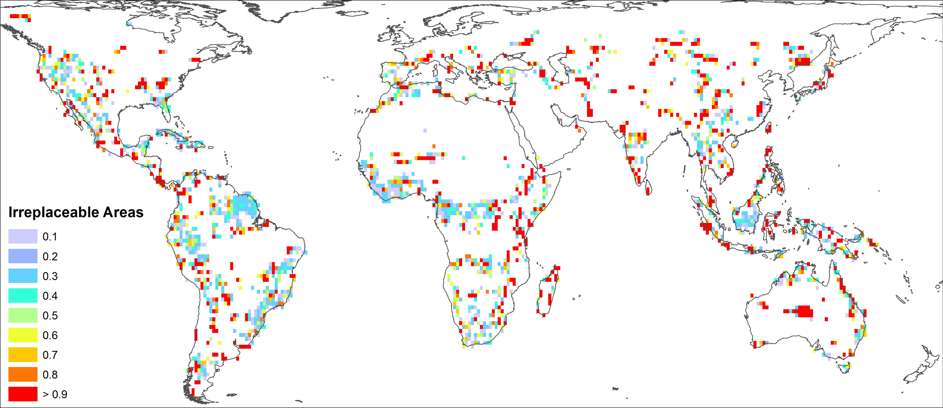
Figure S3. Irreplaceability for conservation of mammal species when constrained to conserving 2.5% of global land area. Red areas were selected with frequency > 90%.
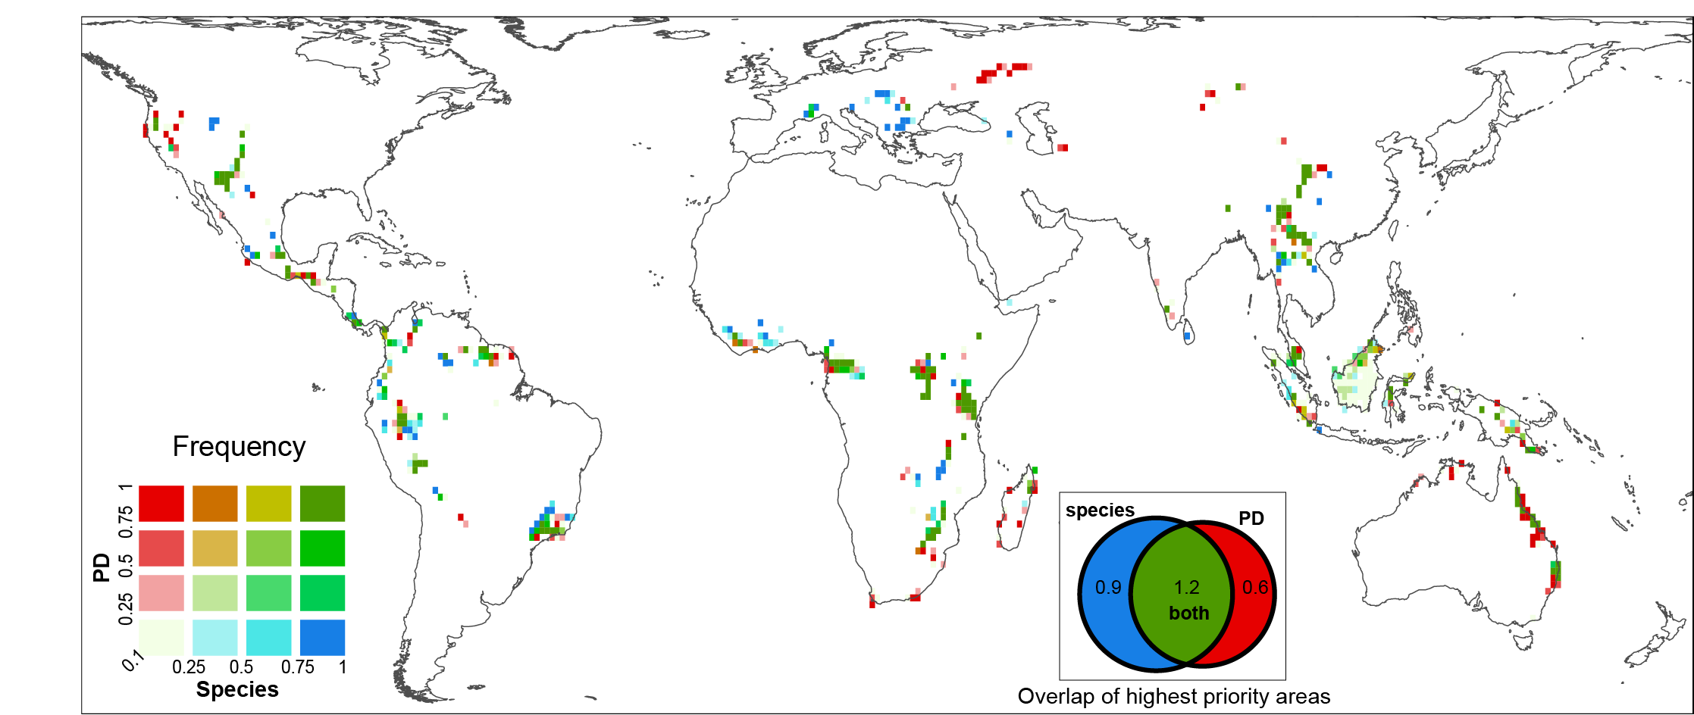
Figure S4. Comparing irreplaceability for mammal conservation by PD and species, constrained to 2.5% of global land area. Red = high irreplaceability for PD only, blue = high irreplaceability for species only. With only 2.5% of land protected, the species and phylogenetic conservation priorities diverge more than for 10% of land protected (figure. 3 in paper).
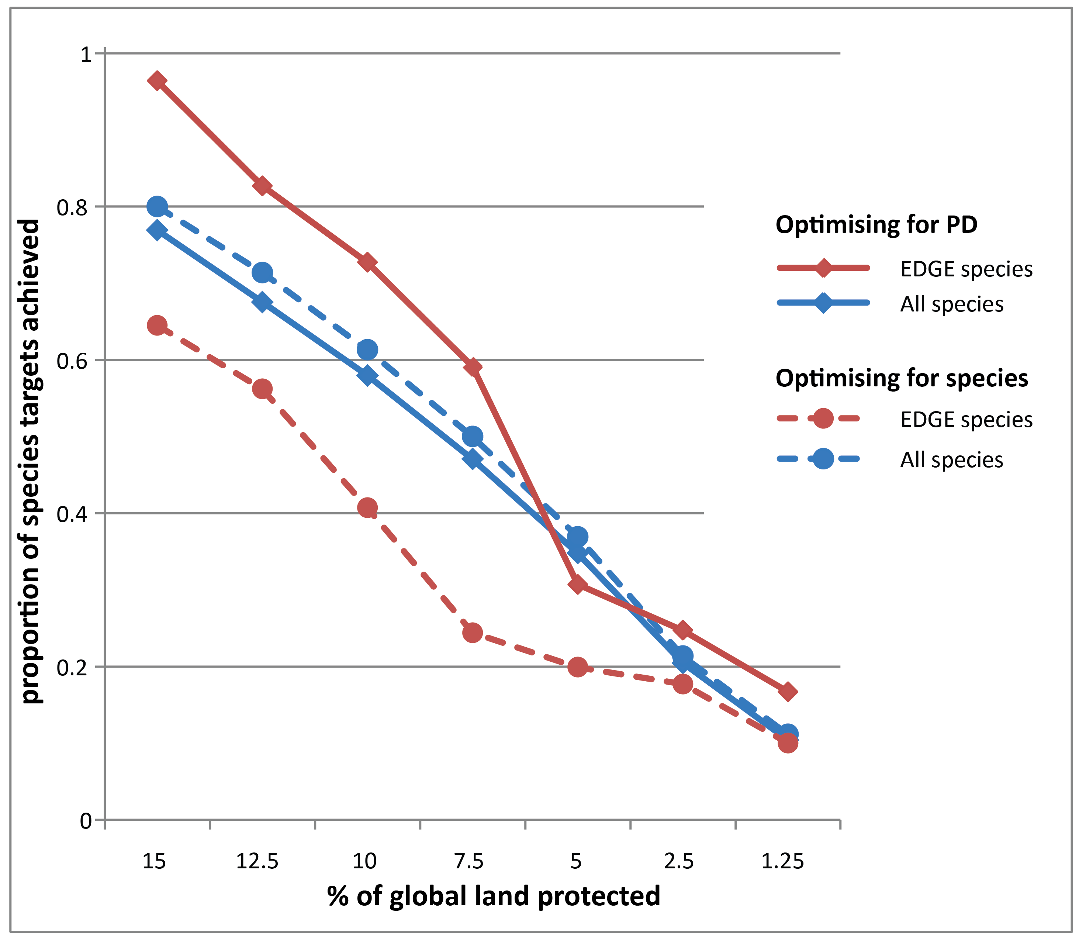
Figure S5. Proportion of species area reservation targets which were met, for the ten highest ranking EDGE species in the study (red) and for all species (blue). This result shows that the conservation scenario which optimises for PD conservation (solid line) meets the target for far more of the most evolutionarily distinct and endangered species, than the species conservation scenario (dashed line) does. In contrast, the performance of the two methods is very similar across all mammal species. Results are averaged across the best run from each of the 100 mammal trees.
This result shows the PD conservation strategy performing as it should, giving higher priority to species which represent more unique evolutionary diversity.

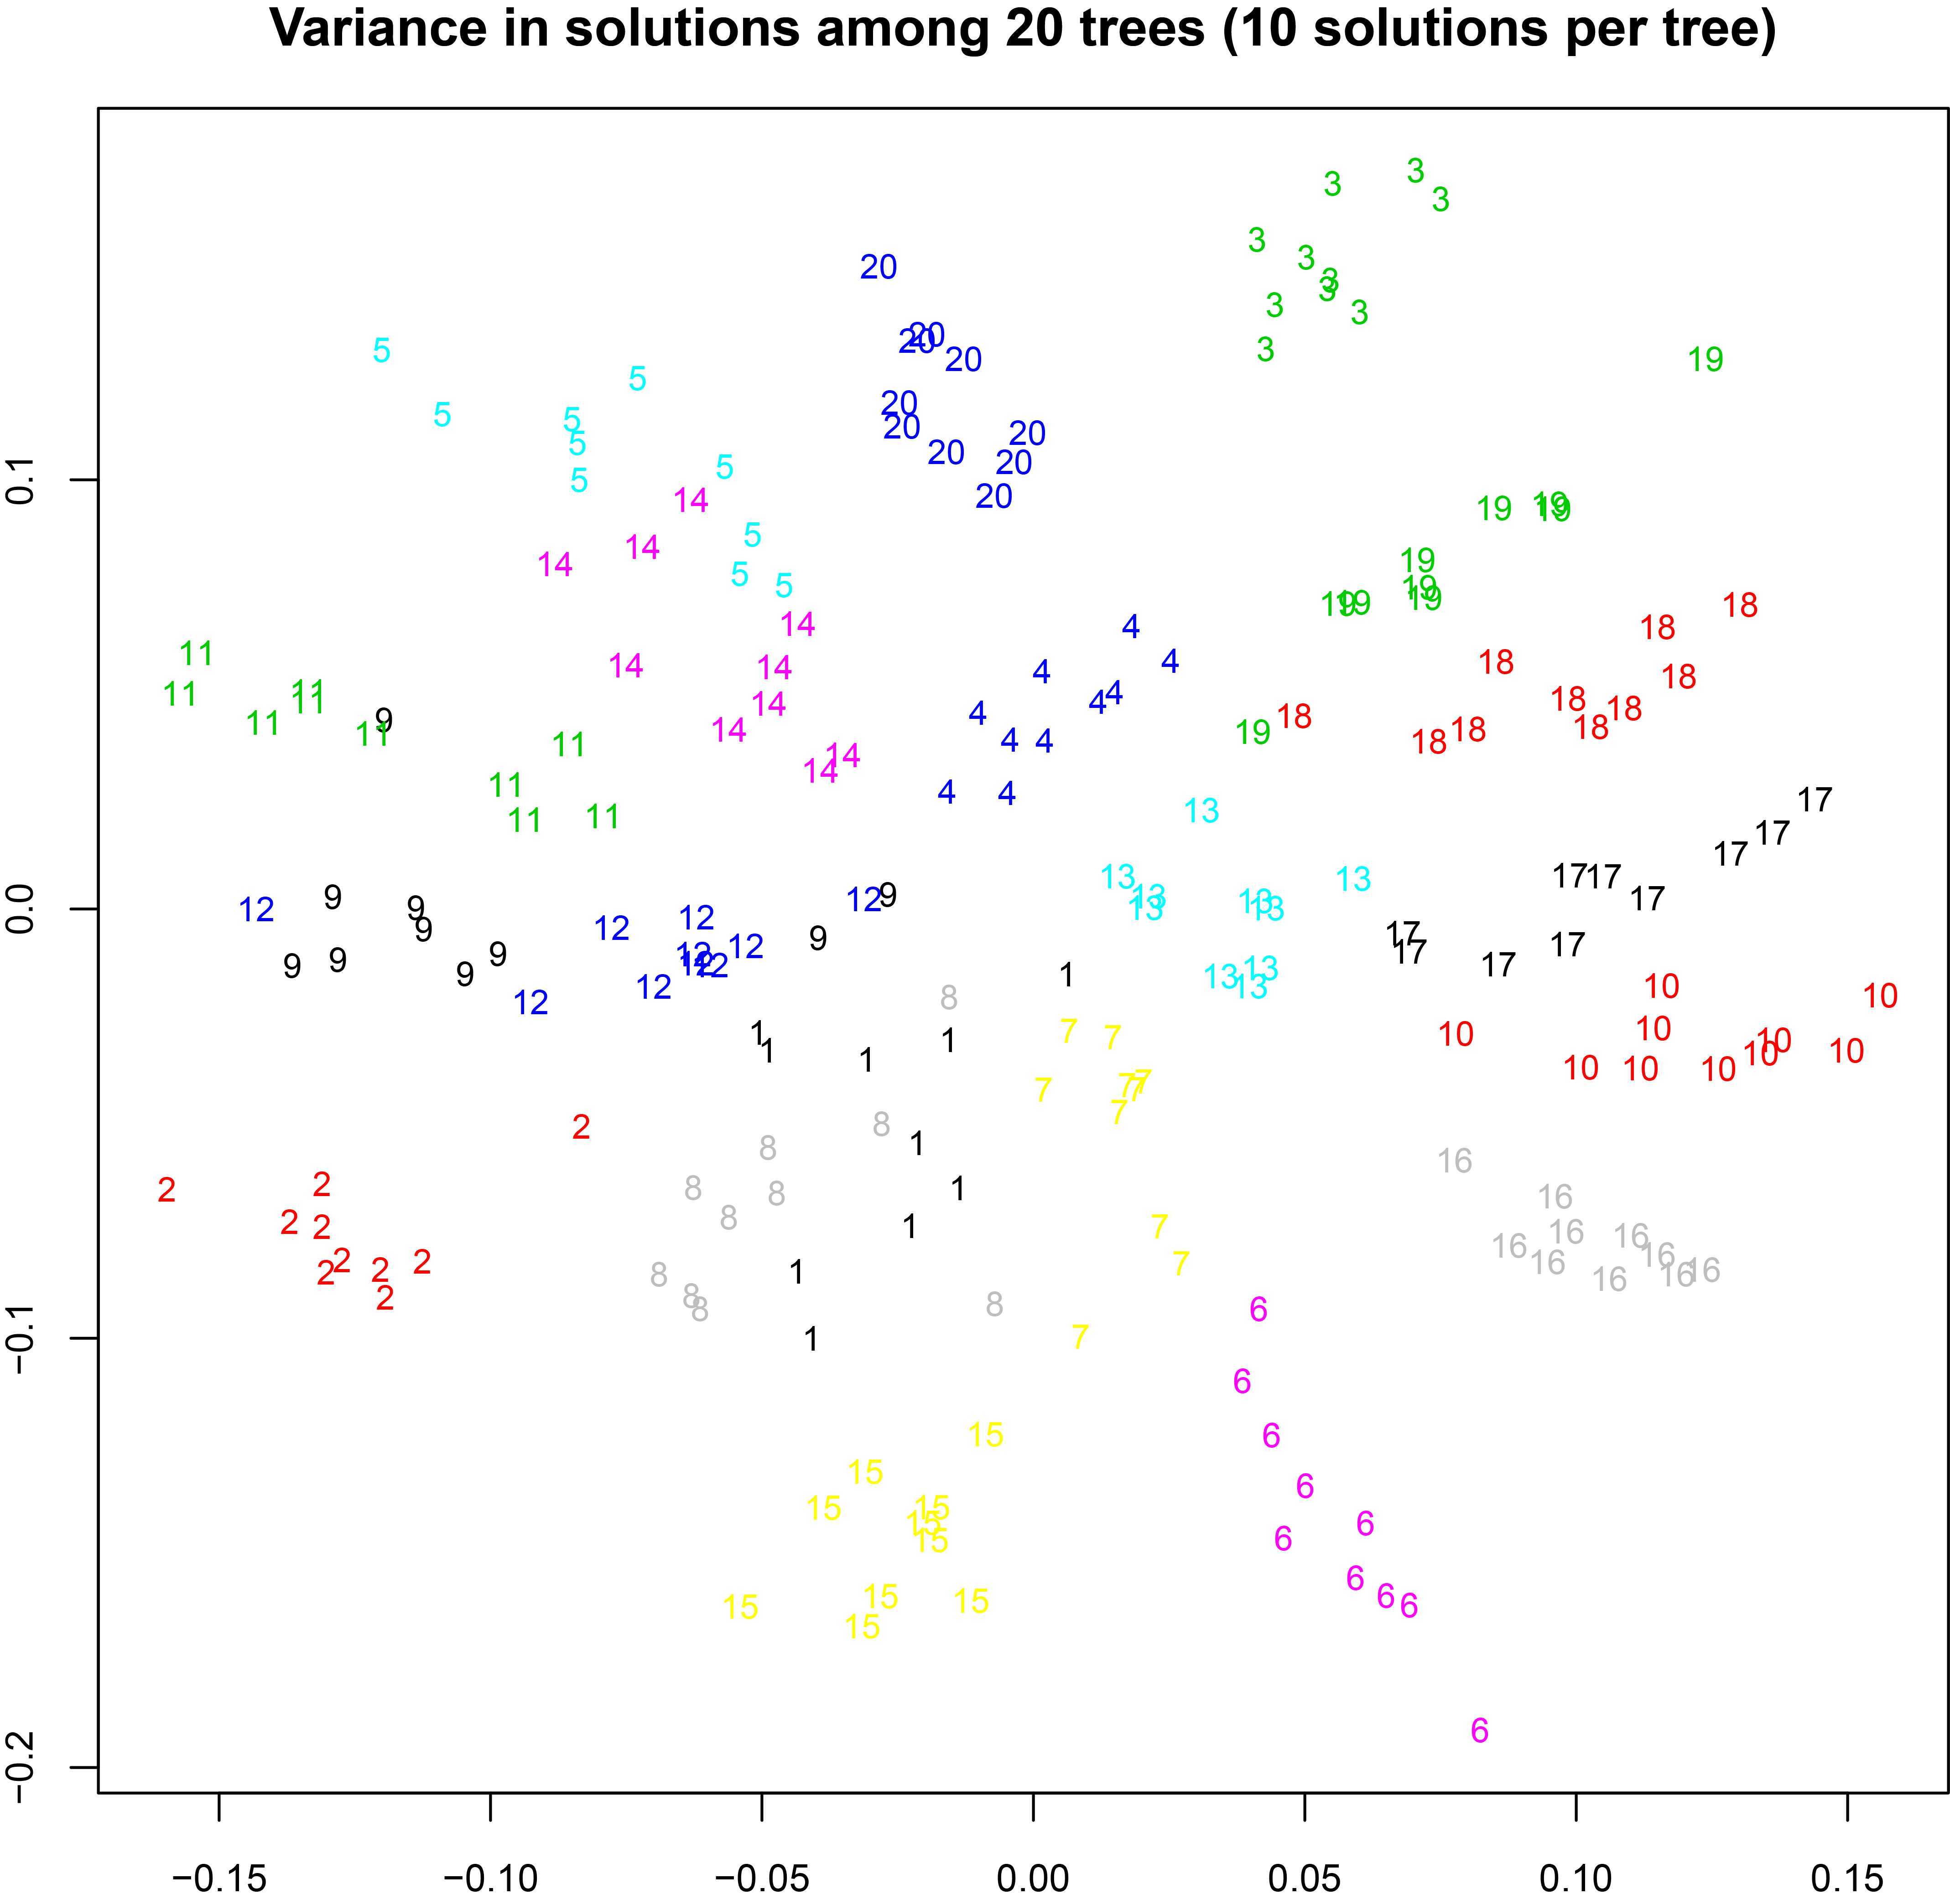
Figure S6. A non-metric multidimensional scaling (NMDS) plot of similarity between the Marxan global mammal reserve solutions (10% land conserved) among 20 trees (10 solutions per tree), in terms of the planning units selected, showing the first two ordination axes. Each different number represents one tree, plotted once for each global protected area solution which used that tree.
Variation between trees indicates the effect of phylogenetic uncertainty, while variation within solutions for each tree is due to the simulated annealing search algorithm used by Marxan. For visual clarity, only results from the first 20 trees (of 100 used) are shown.

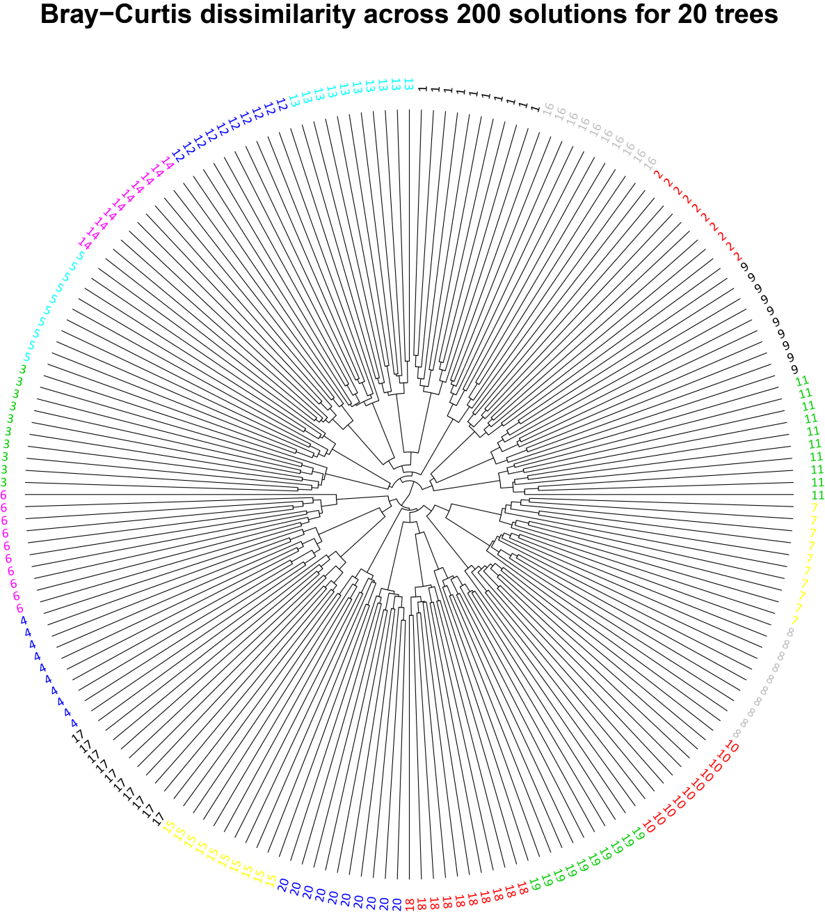
Figure S7. Hierarchical clustering of the Bray-Curtis similarity between Marxan global mammal reserve solutions (10% land conserved), in terms of the planning units selected. Each tip represents one global protected area solution. More closely joined solutions overlap for more planning units.
Colours and numbers both indicate the mammal tree used, from the posterior distribution of trees. Variation between trees indicates the effect of phylogenetic uncertainty, while variation within solutions for each tree is due to the simulated annealing search algorithm used by Marxan. For visual clarity, only results from the first 20 trees (of 100) are shown.
Variation between trees, due to phylogenetic uncertainty, is greater than variation within trees, due to the reserve optimization process.

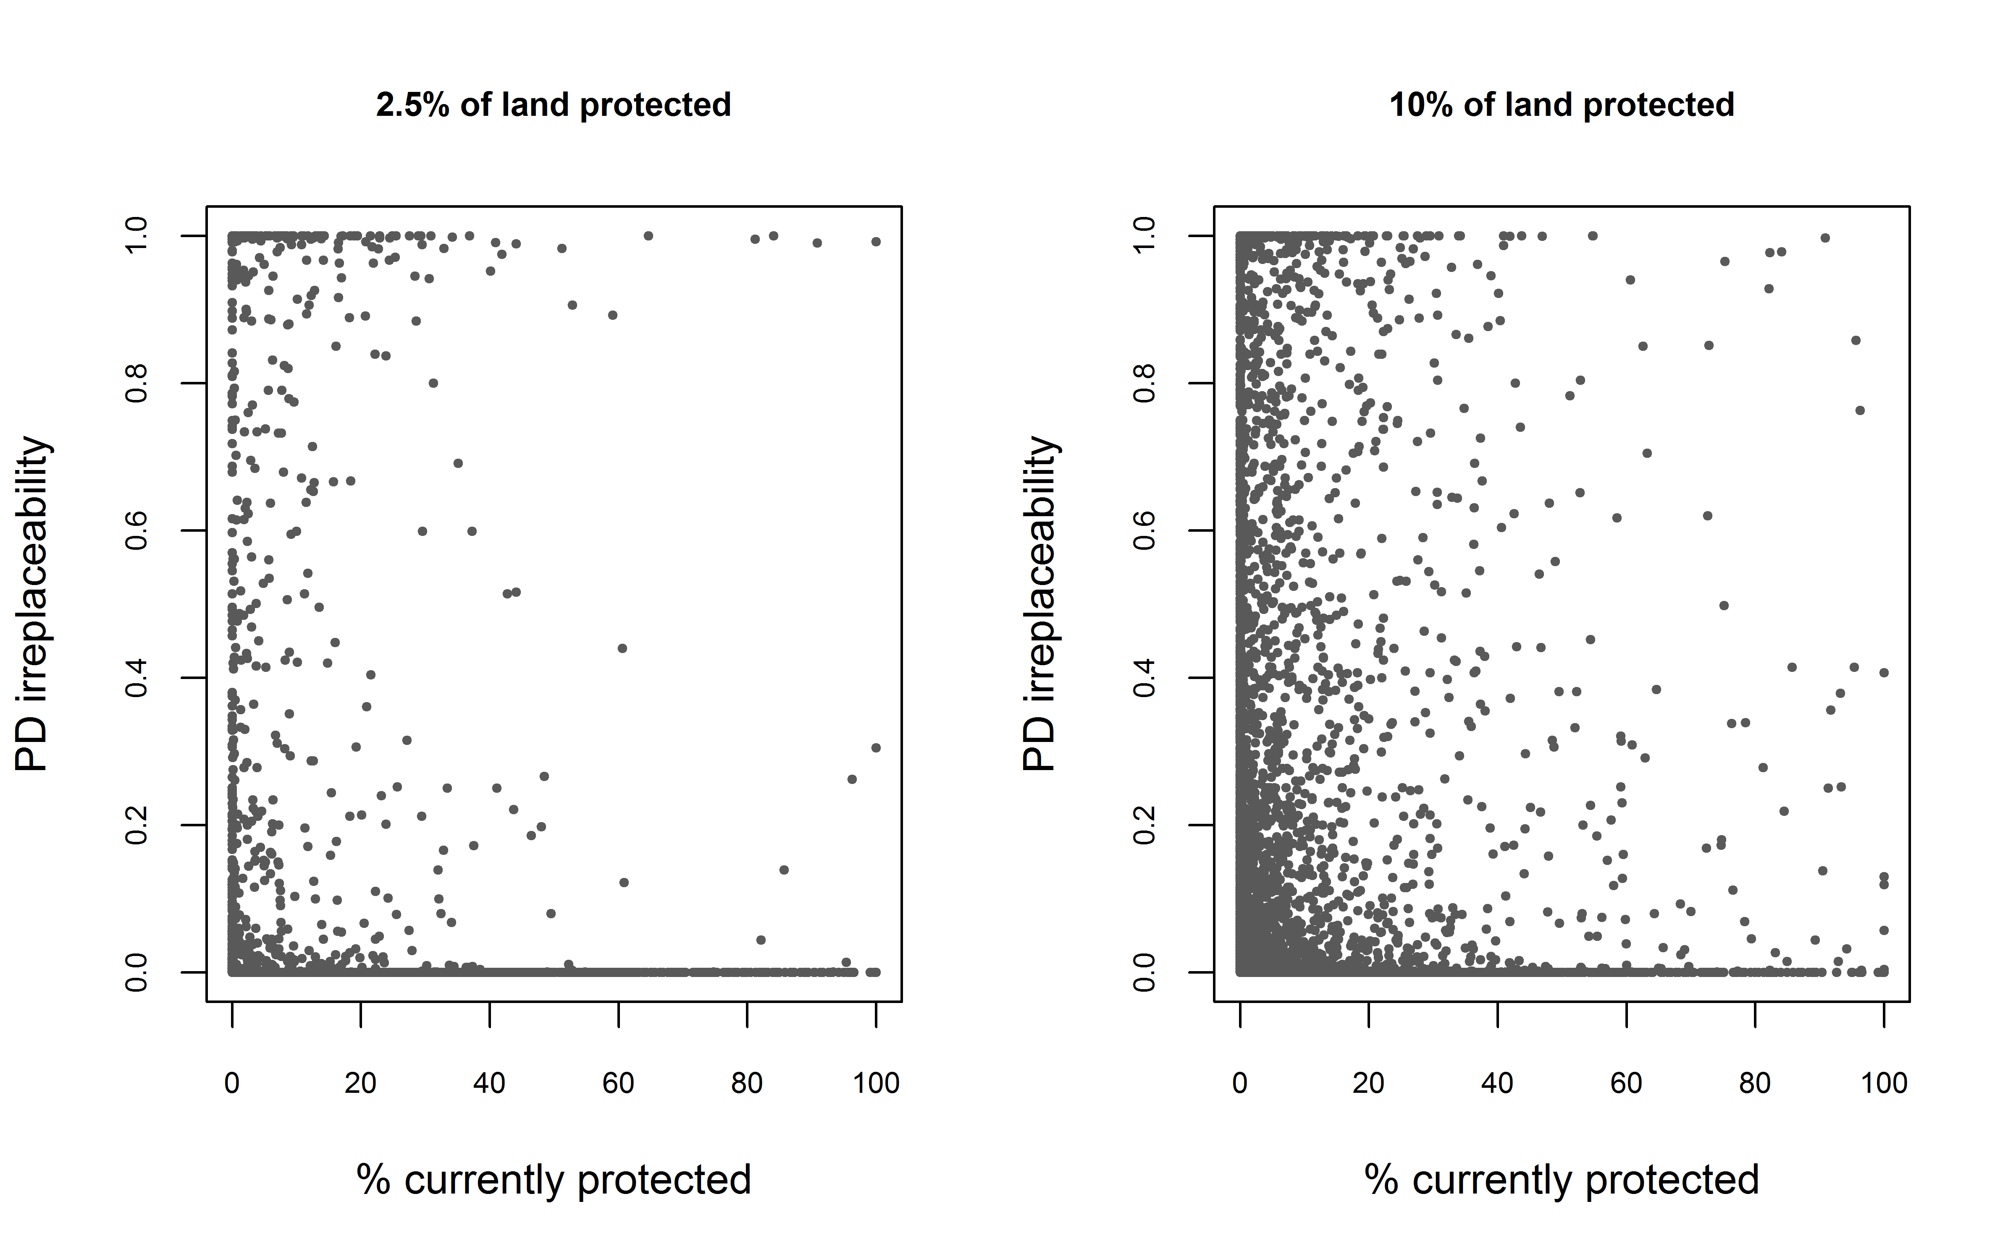
Figure S8. The relationship between the percentage of each planning unit currently protected and the frequency of selection (irreplaceability) in the PD conservation scenarios (2.5% and 10% land area). There is no relationship between current protection and irreplaceability of PD (in linear models r²=0.0004 for the 2.5% scenario and r²=0.0001 for the 10% scenario).

Comparing branch targets to tip targets
One issue discussed in this paper (and debated with interest as part of the review process) is how to determine which branches (and thus how much PD) are conserved in a given conservation outcome. Our approach treated each phylogenetic branch as a separate unit, with its own conservation target, while an approach used in some previous studies focussed on conservation of the tips (eg species).
For clarity, we will refer to the two approaches as:
- tip conservation, in which conservation is sought / assessed for tree tips such as species, with a branch counted as adequately conserved if any of its descendant tips are adequately conserved.
- branch conservation, in which each branch, representing a species or clade of descendants, is counted as conserved based on the degree of conservation across this clade
We used the branch conservation approach to PD, except for an example of tip-conservation added for comparison. We provide an example in support of the branch conservation approach taken in this study.
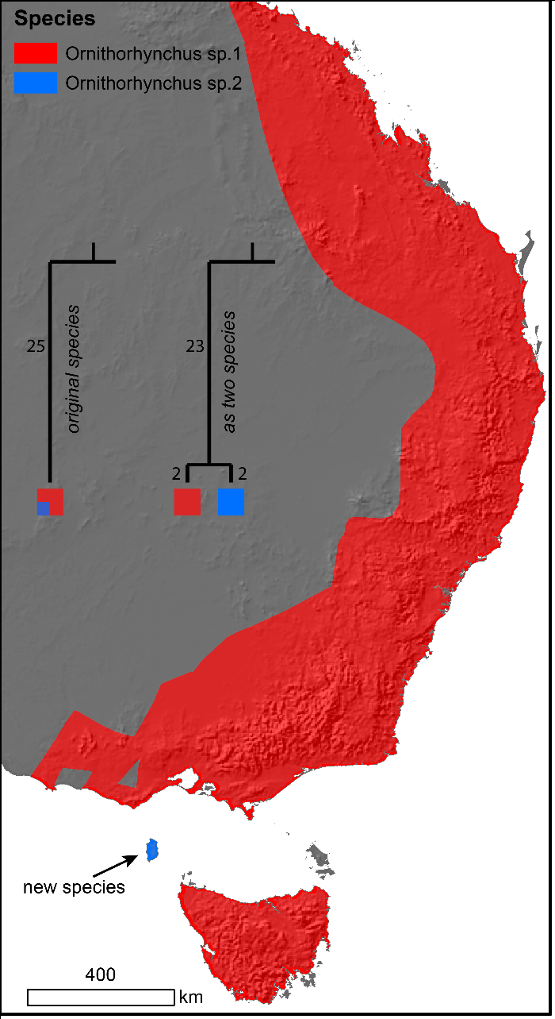
Figure S9: The example uses a real, phylogenetically distinct species, the platypus, but imagines that a distinct form was discovered on a single island and named as a new species. We consider the implications for conservation planning, as either one species comprising the red and blue ranges (before the ‘new species’ was described) or two species. A simple phylogeny is shown for each case.
 | Branch  length | Range  size | Tip  target area | Branch  target area
Single  species | 25 | 100 | 25.0 | 25.0
Species 1 | 2 | 99 | 24.7 | 24.7
Species 2 | 2 | 1 | 1.0 | 1.0
Internal  branch | 23 | 100 | – | 25
For the case where there is a single species, the two methods are identical.
With two species, the difference between the methods is stark, because while the species targets are the same for each method, the consequence of not meeting the targets is very different. The two species have a total PD of 27, but under tip targets, protecting just the blue island (species 2) would count as PD of 25 conserved. The remaining PD of 2 (the terminal branch for species 2) would require an area almost 25 times as large to meet the target for the (red) range of species 2. So for tip targets the solution which conserves only the blue island is vastly cheaper and considered almost as effective as conserving 25% of the total range.
We suggest that a taxonomic split of this type (which is often a judgement call) does not justify a major change to conservation goals. This illustrates an important consequence of the tip targets method.

References
1. Oksanen J., Blanchet F.G., Friendly M., Kindt R., Legendre P., McGlinn D., Minchin P.R., O'Hara R.B., Simpson G.L., Solymos P., et al. 2016 vegan: Community Ecology Package. (2.4-1 ed.
2. Venables W.N.a.R., B.D. 2002 Modern Applied Statistics with S. New York, Springer.
3. Collen B., Turvey S.T., Waterman C., Meredith H.M.R., Kuhn T.S., Baillie J.E.M., Isaac N.J.B. 2011 Investing in evolutionary history: implementing a phylogenetic approach for mammal conservation. Philos Trans R Soc B-Biol Sci 366(1578), 2611-2622.
4. Isaac N.J.B., Turvey S.T., Collen B., Waterman C., Baillie J.E.M. 2007 Mammals on the EDGE: Conservation Priorities Based on Threat and Phylogeny. Plos One 2(3).
5. Zoological Society of London. 2017 Evolutionarily Distinct and Globally Endangered (EDGE) website. (
6. Forest F., Grenyer R., Rouget M., Davies T.J., Cowling R.M., Faith D.P., Balmford A., Manning J.C., Proches S., van der Bank M., et al. 2007 Preserving the evolutionary potential of floras in biodiversity hotspots. Nature 445(7129), 757-760.
7. Rodrigues A.S., Grenyer R., Baillie J.E., Bininda-Emonds O.R., Gittlemann J.L., Hoffmann M., Safi K., Schipper J., Stuart S.N., Brooks T. 2011 Complete, accurate, mammalian phylogenies aid conservation planning, but not much. Philosophical transactions of the Royal Society of London Series B, Biological sciences 366(1578), 2652-2660.
8. Rodrigues A.S.L., Brooks T.M., Gaston K.J. 2005 Integrating phylogenetic diversity in the selection of priority areas for conservation: does it make a difference? In Phylogeny and Conservation (eds. Purvis A., Gittleman J.L., Brooks T.), pp. 101-119. Cambridge, Cambridge University Press.

