**Supplementary Material from “Long-legged bees make adaptive leaps: linking adaptation to coevolution in a plant-pollinator network” by Anton Pauw, Belinda Kahnt, Michael Kuhlmann, Denis Michez, Graham A. Montgomery, Elizabeth Murray and Bryan N. Danforth published in Proceedings of the Royal Society B: Biological Sciences (2017) Vol.** 284**, p. 1-7, DOI 10.1098/rspb.2017.1707.**

Table S1. *Rediviva* traits.

|  |  |  |  |  |
| --- | --- | --- | --- | --- |
| **Species** | **Body (mm)** | **Leg (mm)** | **N** | **Source** |
| *Rediviva emdeorum* | 13.70 | 23.40 | 39 | [1] |
| *Rediviva longimanus* | 13.50 | 20.70 | 59 | [1] |
| *Rediviva micheneri* | 12.20 | 16.70 | 30 | [1] |
| *Rediviva neliana* | 12.50 | 14.86 | 15 | [2] |
| *Rediviva macgregori* | 12.80 | 14.70 | 15 | [1] |
| *Rediviva steineri* | 15.40 | 13.60 | 2 | Pers. obs. |
| *Rediviva gigas* | 16.80 | 12.90 | 10 | [1] |
| *Rediviva colorata* | 12.13 | 12.69 | 8 | [3] |
| *Rediviva peringueyi* | 12.00 | 11.20 | 20 | [1] |
| *Rediviva nitida* | 12.00 | 11.10 | 30 | [1] |
| *Rediviva intermedia* | 12.60 | 11.00 | 20 | [1] |
| *Rediviva aurata* | 10.60 | 10.70 | 30 | [1] |
| *Rediviva brunnea* | 11.80 | 10.70 | 55 | [4] |
| *Rediviva alonsoae* | 11.90 | 9.70 | 10 | [1] |
| *Rediviva intermixta* | 10.70 | 9.40 | 15 | [1] |
| *Rediviva rufipes* | 9.90 | 8.80 | 50 | [1] |
| *Rediviva parva* | 10.50 | 8.70 | 30 | [1] |
| *Rediviva saetigera* | 10.60 | 8.25 | 50 | [5] |
| *Rediviva albifasciata* | 9.00 | 6.90 | 30 | [6] |

Table S2. Floral spur length of oil-secreting flowers.

|  |  |  |  |
| --- | --- | --- | --- |
| **Family** | **Species** | **Spur length (mm)** | **Source** |
| Iridaceae | *Tritoniopsis parviflora* | 0 | Pers. obs. |
| Orchidaceae | *Ceratandra atrata* | 0 | [7] |
| Orchidaceae | *Ceratandra bicolor* | 3 | [7] |
| Orchidaceae | *Corycium carnosum* | 6 | [7] |
| Orchidaceae | *Corycium crispum* | 5 | [7] |
| Orchidaceae | *Corycium deflexum* | 0 | [7] |
| Orchidaceae | *Corycium dracomontanum* | 5 | [7] |
| Orchidaceae | *Corycium nigrescens* | 5 | [7] |
| Orchidaceae | *Corycium orobanchoides* | 8 | [7] |
| Orchidaceae | *Disperis bolusiana ssp. bolusiana* | 6 | [7] |
| Orchidaceae | *Disperis bolusiana ssp. macrocorys* | 13 | [7] |
| Orchidaceae | *Disperis cardiophora* | 5 | [7] |
| Orchidaceae | *Disperis circumflexa ssp. aemula* | 8 | [7] |
| Orchidaceae | *Disperis fanniniae* | 16 | [7] |
| Orchidaceae | *Disperis purpurata ssp. purpurata* | 0 | [7] |
| Orchidaceae | *Disperis renibractea* | 5 | [7] |
| Orchidaceae | *Disperis stenoplectron* | 9 | [7] |
| Orchidaceae | *Disperis tysonii* | 7 | [7] |
| Orchidaceae | *Disperis villosa* | 7 | [7] |
| Orchidaceae | *Disperis wealei* | 5 | [7] |
| Orchidaceae | *Huttonaea fimbriata* | 0 | [3] |
| Orchidaceae | *Huttonaea grandiflora* | 0 | [3] |
| Orchidaceae | *Huttonaea pulchra* | 3.1 | [3] |
| Orchidaceae | *Pterygodium acutifolium* | 0 | [7] |
| Orchidaceae | *Pterygodium alatum* | 0 | [7] |
| Orchidaceae | *Pterygodium caffrum late-flowering* | 2 | [7] |
| Orchidaceae | *Pterygodium caffrum typical form* | 2 | [7] |
| Orchidaceae | *Pterygodium catholicum late-flowering* | 1 | [7] |
| Orchidaceae | *Pterygodium catholicum typical form* | 1 | [7] |
| Orchidaceae | *Pterygodium cooperi* | 0 | [7] |
| Orchidaceae | *Pterygodium hallii northern form* | 0 | [7] |
| Orchidaceae | *Pterygodium hastatum* | 2 | [7] |
| Orchidaceae | *Pterygodium inversum* | 0 | [7] |
| Orchidaceae | *Pterygodium leucanthum* | 2 | [7] |
| Orchidaceae | *Pterygodium magnum* | 4 | [7] |
| Orchidaceae | *Pterygodium pentherianum* | 3 | [7] |
| Orchidaceae | *Pterygodium schelpei* | 7 | [7] |
| Orchidaceae | *Pterygodium volucris* | 7 | [7] |
| Orchidaceae | *Satyrium rhynchanthum* | 6 | [7] |
| Scrophulariaceae | *Alonsoa unilabiata* | 3.3 | [8] |
| Scrophulariaceae | *Colpias mollis* | 0 | Pers. obs. |
| Scrophulariaceae | *Diascia anastrepta* | 9.8 | [9] |
| Scrophulariaceae | *Diascia arenicola* | 5.5 | [10] |
| Scrophulariaceae | *Diascia barberae* | 10.9 | [9] |
| Scrophulariaceae | *Diascia batteniana* | 9.5 | [10] |
| Scrophulariaceae | *Diascia bicolor* | 3.5 | [10] |
| Scrophulariaceae | *Diascia bicornuta* | 17 | [10] |
| Scrophulariaceae | *Diascia capensis* | 5.5 | [10] |
| Scrophulariaceae | *Diascia capsularis* | 14.6 | [2] |
| Scrophulariaceae | *Diascia cardiosepala* | 2.5 | [10] |
| Scrophulariaceae | *Diascia cordata* | 10.9 | [11] |
| Scrophulariaceae | *Diascia decipiens* | 3.5 | [10] |
| Scrophulariaceae | *Diascia diffusa* | 2 | [10] |
| Scrophulariaceae | *Diascia dissimulans* | 6 | [12] |
| Scrophulariaceae | *Diascia ellaphieae* | 4 | [10] |
| Scrophulariaceae | *Diascia elongata* | 1.6 | [10] |
| Scrophulariaceae | *Diascia fetcaniensis* | 7.9 | [2] |
| Scrophulariaceae | *Diascia floribunda* | 15 | [10] |
| Scrophulariaceae | *Diascia fragrans* | 2.7 | [10] |
| Scrophulariaceae | *Diascia grantiana* | 2 | [10] |
| Scrophulariaceae | *Diascia insignis* | 18 | [10] |
| Scrophulariaceae | *Diascia integerrima* | 9.3 | [2] |
| Scrophulariaceae | *Diascia lewisiae* | 5 | [10] |
| Scrophulariaceae | *Diascia longicornis* | 18 | [10] |
| Scrophulariaceae | *Diascia macrophylla* | 18 | [12] |
| Scrophulariaceae | *Diascia megathura* | 10.9 | [11] |
| Scrophulariaceae | *Diascia mollis* | 5 | [13] |
| Scrophulariaceae | *Diascia nana* | 13 | [10] |
| Scrophulariaceae | *Diascia pachyceras* | 4 | [10] |
| Scrophulariaceae | *Diascia parviflora* | 3.5 | [10] |
| Scrophulariaceae | *Diascia patens* | 7 | [10] |
| Scrophulariaceae | *Diascia purpurea* | 13.6 | [11] |
| Scrophulariaceae | *Diascia pusilla* | 2 | [10] |
| Scrophulariaceae | *Diascia racemulosa* | 5 | [13] |
| Scrophulariaceae | *Diascia rigescens* | 6.4 | [2] |
| Scrophulariaceae | *Diascia sacculata* | 3.5 | [10] |
| Scrophulariaceae | *Diascia speciosa* | 3 | [10] |
| Scrophulariaceae | *Diascia stachyoides* | 9.7 | [2] |
| Scrophulariaceae | *Diascia stricta* | 6.1 | [11] |
| Scrophulariaceae | *Diascia tanyceras* | 28 | [10] |
| Scrophulariaceae | *Diascia tenuis* | 15 | [10] |
| Scrophulariaceae | *Diascia tugelensis* | 11 | [11] |
| Scrophulariaceae | *Diascia veronicoides* | 4.7 | [10] |
| Scrophulariaceae | *Diascia vigilis* | 10.9 | [11] |
| Scrophulariaceae | *Diascia whiteheadii* | 22 | [10] |
| Scrophulariaceae | *Hemimeris centrodes* | 12 | [12] |
| Scrophulariaceae | *Hemimeris gracilis* | 5 | [14] |
| Scrophulariaceae | *Hemimeris nana* | 5 | [12] |
| Scrophulariaceae | *Hemimeris racemosa* | 3 | [10] |
| Scrophulariaceae | *Hemimeris sabulosa* | 2 | [10] |
| Scrophulariaceae | *Hemimeris sp. 1* | 2 | [10] |
| Stilbaceae | *Anastrabe integerrima* | 0 | Pers. obs. |
| Stilbaceae | *Bowkeria citrina* | 0 | [9] |
| Stilbaceae | *Bowkeria cymosa* | 0 | Pers. obs. |
| Stilbaceae | *Bowkeria verticillata* | 0 | Pers. obs. |
| Stilbaceae | *Ixianthes retzioides* | 0 | Pers. obs. |

Table S3. Multiple linear regression estimates for the relationship between *Rediviva* leg length evolution, body size evolution and change in the selective environment imposed by the floral spurs of the host plants. The analysis is identical to that presented in table 1 of the printed article, but with contrasts at internal nodes excluded. Thus, the data represent phylogenetically independent contrasts between the seven *Rediviva* sister species pairs only (figure S4). Measurements are mm. Multiple R-squared = 0.9461, Adjusted R-squared = 0.9245, p = 0.0007, df = 5 (figure S5).

|  |  |  |  |  |  |
| --- | --- | --- | --- | --- | --- |
|  | Estimated slope | Std. Error | t- value | P | Sum of Squares (% variance explained) |
| Environment change | 0.5276 | 0.1154 | 4.574 | 0.006 | 292.20 (94.52%) |
| Body evolution | 0.2276 | 0.8149 | 0.279 | 0.791 | 0.26 (0.08%) |

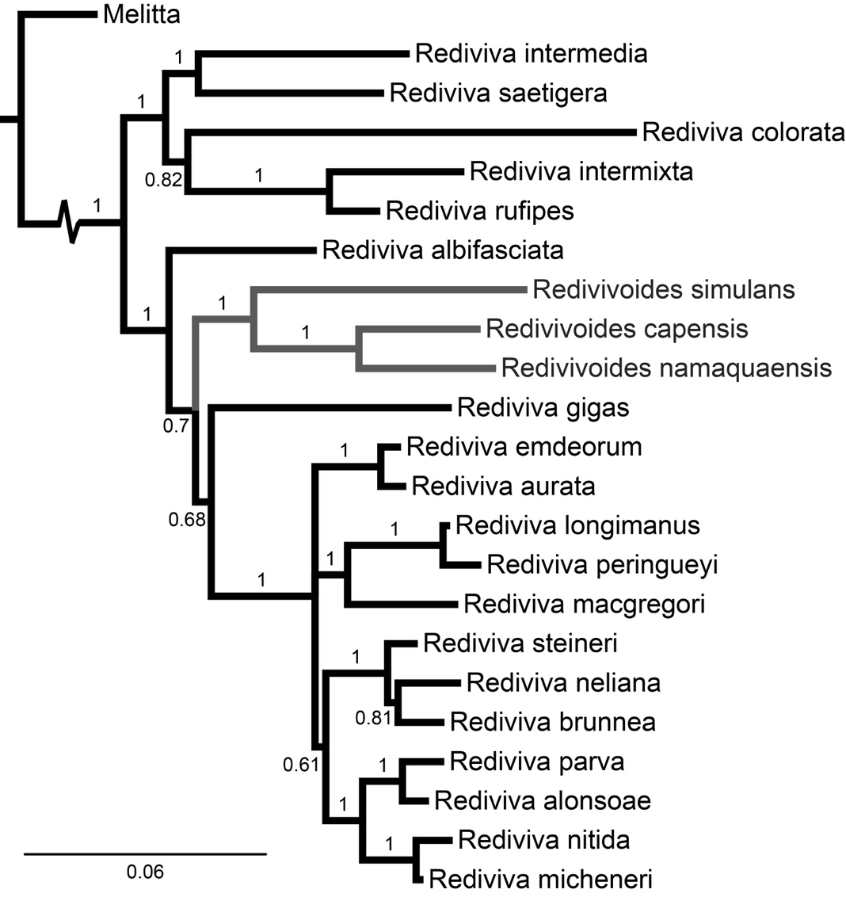

Figure S1. Bayesian inference majority rule consensus phylogeny pruned to include one tip per species, from a full analysis of 90 terminals using seven gene regions (modified from [15]). Posterior probabilities are shown. *Rediviva* is rendered paraphyletic by the inclusion of *Redivivoides*. The sister group genus *Melitta* is drawn with a truncated branch leading to Rediviva. The units of branch length are nucleotide substitutions per site.

phenogram%20body.pdf

Figure S2. A diagram of body length evolution in *Rediviva.* Lines represent relatedness and the position of species along the Y-axis represent foreleg length (mm). Ancestral states are maximum likelihood estimations with considerable uncertainty.

Fig.%20S1.pdf

Figure S3. Histogram of the number of species of interaction partners observed in a network of 26 *Rediviva* species and 97 species of oil-secreting plants (figure 3 of the printed article).

leg,body,spur3.pdf

Figure S4. *Rediviva* trait-environment correlation and trait-trait allometry. (a) The relationship between female leg length and average floral spur length of the interacting oil-secreting plants. (b) The relationship between body length and floral spur length. (c) The relationship between leg length and body length. The data are for the subset of 19 *Rediviva* species included in the phylogeny.

Fig.%20S3.pdf

Figure S5. Phylogenetically independent contrasts between sister clades of *Rediviva* in (a) female leg length, (b) female body length, and (c) average floral spur length of the interacting oil-secreting plants. All units are mm.

Figure S6. Evolutionary change in leg length in *Rediviva* is associated with change in the selective environment imposed by long-spurred flowers. Evolutionary change in body size explains additional variation in leg length evolution. The analysis is identical to that presented in figure 5 of the printed article, but with contrasts at internal nodes excluded. Thus, the data points represent phylogenetically independent contrasts between the seven *Rediviva* sister species pairs only (figure S5). The linear model prediction (table S3) is represented by a plane, which is linked to the data points by vertical lines.

**References**

1. Whitehead VB, Steiner KE. 2001 Oil-collecting bees of the winter rainfall area of South Africa (Melittidae, *Rediviva*). *Ann. South Afr. Mus.* **108**, 143–277.

2. Steiner KE, Whitehead VB. 1990 Pollinator adaptation to oil-secreting flowers - *Rediviva* and *Diascia*. *Evolution* **44**, 1701–1707.

3. Steiner KE. 2010 Twin oil sacs facilitate the evolution of a novel type of pollination unit (meranthium) in a South African orchid. *Am. J. Bot.* **97**, 311–323. (doi:10.3732/Ajb.0900239)

4. Whitehead VB, Steiner KE, Eardley CD. 2008 Oil collecting bees mostly of the summer rainfall area of southern Africa (Hymenoptera : Melittidae : *Rediviva*). *J. Kans. Entomol. Soc.* **81**, 122–141.

5. Whitehead VB, Steiner KE. 1992 Two new species of oil-collecting bees of the genus *Rediviva* from the summer rainfall region of South Africa (Hymenoptera, Apoidea, Melittidae). *Ann. South Afr. Mus.* **102**, 143–164.

6. Steiner KE, Whitehead VB. 2002 Oil secretion and the pollination of *Colpias mollis* (Scrophulariaceae). *Plant Syst. Evol.* **235**, 53–66.

7. Linder HP, Kurzweil H. 1999 *Orchids of southern Africa*. Rotterdam, Netherlands: A. A. Balkema.

8. Steiner KE. 1989 A 2nd Species of the Amphi-Atlantic Genus *Alonsoa* (Scrophulariaceae) in South-Africa. *Ann. Mo. Bot. Gard.* **76**, 1152–1159. (doi:10.2307/2399701)

9. Steiner KE, Whitehead VB. 1991 Oil flowers and oil bees: further evidence for pollinator adaptation. *Evolution* **45**, 1493–1501.

10. Steiner KE. 2012 Scrophulariaceae. In *Plants of the Greater Cape Floristic Region: the Core Cape Flora* (eds J Manning, P Goldblatt), pp. 731–763. Pretoria: SANBI, Biodiversity for Life.

11. Steiner KE, Whitehead VB. 1988 The association between oil-producing flowers and oil-collecting bees in the Drakensberg of southern Africa. *Monogr. Syst. Bot. Mo. Bot. Gard.* **25**, 259–277.

12. Steiner KE. 2013 Scrophulariaceae. In *Plants of the Greater Cape Floristic Region: the Extra Cape Flora* (ed DA Snijman), pp. 453–479. Pretoria: SANBI, Biodiversity for Life.

13. Hilliard OM, Burtt BL. 1984 A revision of *Diascia* section Racemosae. *South Afr. J. Bot.* **50**, 269–340.

14. Grant AL. 1938 A monograph of the genus *Hemimeris*. *Ann. Mo. Bot. Gard.* **25**, 435–453.

15. Kahnt B, Montgomery GA, Murray E, Kuhlmann M, Pauw A, Michez D, Paxton RJ, Danforth BN. 2017 Playing with extremes: origins and evolution of exaggerated female forelegs in South African *Rediviva* bees. *Mol. Phylogenet. Evol.* (doi:http://dx.doi.org/10.1016/j.ympev.2017.07.025)