Offspring telomere length in the long lived Alpine swift is negatively related to the age of their biological father and foster mother

François Criscuolo^{1‡$}, Sandrine Zahn^{1$} and Pierre Bize^{2‡}
¹Université de Strasbourg, CNRS, IPHC UMR 7178, F-67000 Strasbourg, France
²University of Aberdeen, School of Biological Sciences, Aberdeen, AB24 2TZ, United Kingdom

ESM1 Telomere length qPCR measurements using a multiplex monochrome quantitative PCR (MMQPCR) approach
Relative telomere length (RTL) was determined as the relative ratio of telomere repeat copy number to a single copy gene copy (SCG) number (T/S ratio) using the monochrome multiplex quantitative PCR protocol described by Cawthon [1] and adapted for Alpine swift as follows.
Briefly, the rational of developing the multiplex measurement is that both telomere and SCG signals are acquired within the same well, eliminating the pipetting errors of distributing each DNA sample in two different wells for telomere and SCG measurements. To obtain distinct telomere and SCG amplifications within the same well, primers design must lead to the separation of the qPCR amplification curves of the telomere and SCG, i.e. when the SCG amplicon melts at a much higher temperature than the telomere amplicon. Fluorescent signal from the SCG amplicon can then be acquired at a temperature high enough to completely melt the telomere amplicon, eliminating its parasitic contribution to the SCG signal, but low enough to keep the SCG amplicon double-stranded and therefore able to bind a fluorescent dye such as SYBR Green I. Therefore, the differences in melting temperatures between telomere and SCG amplicons allowed two successive fluorescent readings at two different temperatures using a single DNA binding dye in a single well, enabling us to differentiate the copy numbers of the two respective targets within a single qPCR run.
Primer design for telomeres
RTL was measured using a non-homologous primers set for the telomere repeats and a special design primers set for the SCG. In a multiplex design, it is necessary to avoid the generation of a series of products of various sizes during the amplification of the telomere sequence, because those products melt at temperatures high enough to overlap the melting curve of the classical SCG’s amplicon. To solve this problem, we followed Cawthon and coll., who designed a pair of telomere primers specifically for multiplex named telg (ACACTAAGGTTTGGGTTTGGGTTTGGGTTTGGGTTAGTGT) and telc (TGTTAGGTATCCCTATCCCTATCCCTATCCCTATCCCTAACA) that generate a short, fixed-length product [1]. We checked that in our case, the sharp melting curve of the telomere amplicon was consistent with a specific, fixed-length product formation using an agarose gel electrophoresis, which revealed the expected unique 79 bp product (data not shown).
Primer design for the single copy gene
In our study, the SCG primers were designed based on a newly sequenced gene in the alpine swift, the proopiomelanocortin (POMC) gene (Anne-Lyse Ducrest, personal data). The couple of primers for the amplification of the SCG POMc were as follows: GGTGGAACAAGTTTGGTCGGAG (POMc-F) and CCGGTTCCTTGCTCTTCCTCG (POMc-R) (Eurofins Genomics, Ebersberg, Germany) (Figure 1). The unique amplicon product was checked to be of the expected size of 133 bp (data not shown). These primers respect the specificity (i.e. Size: 15 to 30 nucleotides; GC content: 40 to 65%; Sequence specificity to the swift and unique hybridization site; Tm between 45 and 70 ° C), the stability (weak formation of dimers and secondary structures) and compatibility (Difference Tm < 4°C) of commonly chosen primers for qPCR. In addition, the primer sequences were designed ensuring that the SCG amplicon would melt at a much higher temperature than the telomere amplicon (as shown in Figure 2) and that both telomere and SCG amplifications would not occur at the same cycle and temperature. The consequent separation of the telomere vs. SCG melting curves was thus obtained without using the classic addition of GC clamp (therefore avoiding some of their disadvantages).
Figure 1: Alpine swift POMc 443 bp sequence with newly designed primers.

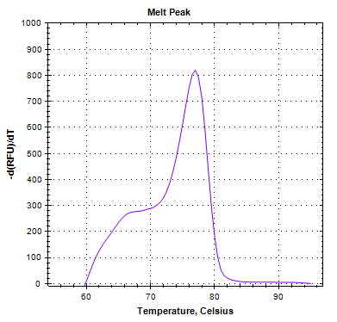
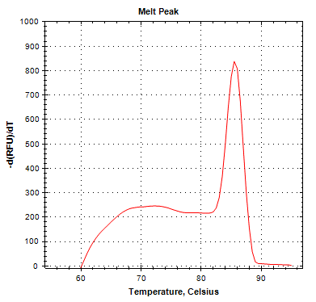
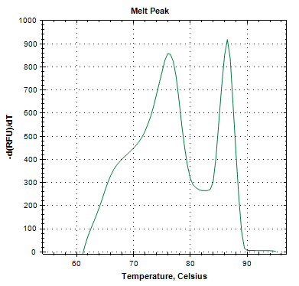
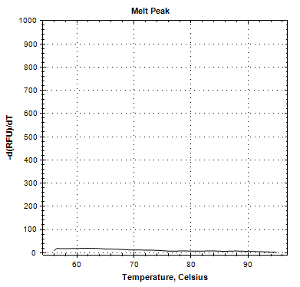

Figure 2: Melting curves of alpine swift DNA obtained from three distinct qPCR amplifications using (1) telomere primers only (blue curve); (2) SCG primer only (red curve); (3) both primer sets (green curve). No template control melting curves are also shown (black curve).

Thermal profile and cycling design
The monochrome multiplex quantitative PCR was performed on CFX384 cycler (Biorad, Marnes-la Coquette, France). PCR reactions were prepared using 2ng of genomic DNA as template, 1x GoTaq qPCR Master Mix (Promega, Charbonnieres les Bains, France), telomeric primers were at a final concentration of 75 nM each, SCG primers at a final concentration of 200 nM each. Based on the protocol described by Cawthon [1], we adapted part of the amplifications conditions (i.e. stage 3, see hereafter) to our species and primers’ design (SCG).
Stage 3 consists in 30 cycles of 15 s at 94°C, 30 s at 59°C with signal acquisition (telomere), 30 s at 78°C, and 20 s at 79°C with signal acquisition (SCG). As shown by the melting profiles presented in figure 2, the 59°C reads detects the telomere product while the SCG product remains low, and the 79°C reads detects only the SCG product. We highlight in Figure 3 that our protocol allowed the detection of both telomere and SCG amplification signals without any overlap. This absence of overlap is also verified when the telomere signal is late, i.e. with the sample characterized by the shortest telomere (Figure 4). Figure 4 also illustrates the validity of the MMQPCR method over the whole range of telomere lengths measured in our experiment. As a conclusion, signal acquisition at 59°C allowed for collection of the telomere Ct values, while acquisition at 79°C provided the SCG Ct values.
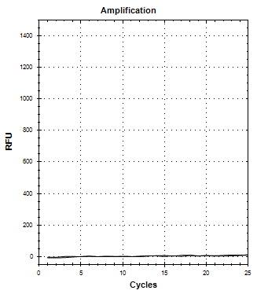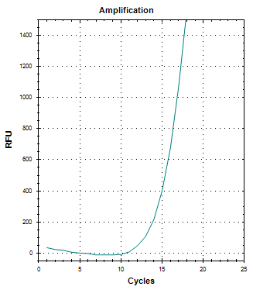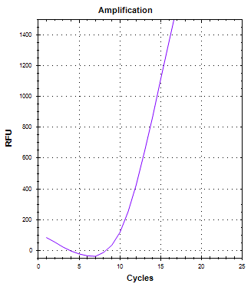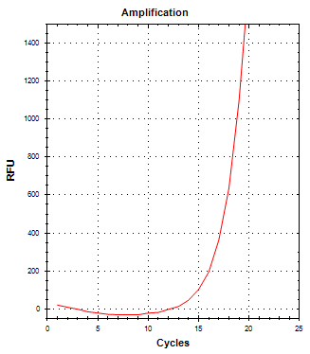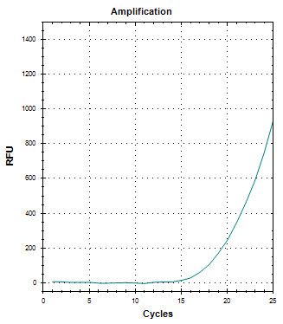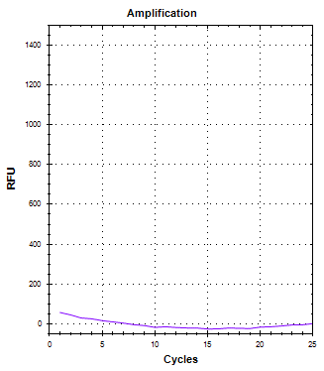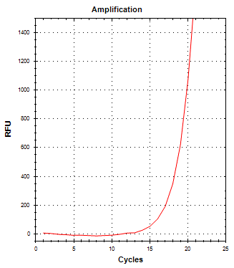
59°C
79°C
Figure 3: Amplification curves of alpine swift DNA at the two temperatures of signal acquisition, shown to be specific of telomere amplification (left panel) and of SCG amplification (right panel). The different curves are obtained after adding in the reaction mix either the telomere primers (blue curve), the SCG primers (red curve) or both primer sets (green curve). No template control melting curves are shown in both cases (black curves).

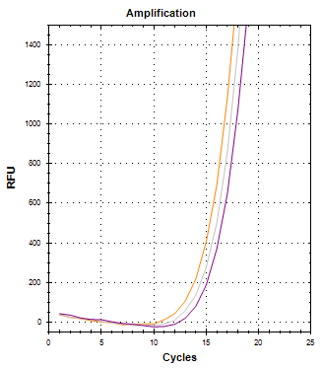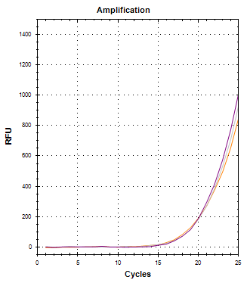
59°C
79°C
Figure 4: MMQPCR of the same amount of DNA using three Alpine swift DNA samples which cover the range of telomere lengths found in our experiment. Different colors characterize long (orange curve), middle-length (grey curve) or short telomeres (purple curve). No template control amplification curves are in black.

Calculation of RTL
All samples were run using two plates of 384 wells. Both plates were prepared using a mix of chick samples collected in 2004 and 2006. In addition, 13 samples were repeated in the second plate. We ran 2 dilution curves (one per year) to verify that there was no bias following potential differences in amplification efficiencies among years. Amplification efficiencies for chick samples in 2004 were of 99.2% (plate 1) and 99.8% (plate 2) (T amplification) and 100.2% (SCG amplification, plates 1 and 2). Amplification efficiencies for chick in 2006 were of 99.5% (T) and 99% (SCG amplification, plate 2). RTL calculations were done using a pool of the dilution curves (one per run) given the similarities of the amplification efficiency values. RTL final value is calculated as a ratio of amplification cycles between the telomere and a SCG signals following [2].
All samples were run in duplicates. Coefficient of variation intra-plates (duplicates) were of 1.50 ± 0.11% (SCG Cq values) and 0.65 ± 0.05% (T Cq values). Inter-plates coefficients of variation were of 1.61 ± 0.16% (SCG Cq values) and 0.92 ± 0.09% (T Cq values) (n=13). Intra- and inter-plate coefficients of variation for final RTL values were of 6.6 ± 0.7 % and 8.7 ± 1.9 %, respectively.

References
- Cawthon RM (2009) Telomere length measurement by a novel monochrome multiplex quantitative PCR method. Nucleic Acids Research 37, e21.
- Pfaffl, M.W. 2001 A new mathematical model for relative quantification in real-time RT-PCR. Nucleic Acids Research 29, 2003-2007.

ESM2. Correlations between parental ages between and within experimental broods
 | n | r | P
Biological father- Biological mother | 54 | 0.192 | 0.165
Biological father - Foster father | 47 | 0.232 | 0.117
Biological mother - Foster mother | 50 | -0.072 | 0.620
Foster father - Foster mother | 53 | 0.188 | 0.179

ESM3. Statistical analyses testing for quadratic effects of parental age, interactive effects of parental age, and nestling parasite load as possible sources of variation in offspring telomere length.
Effects of parental age on offspring telomere length may follow a non-linear relationship. Inspection of the relationships between parental age and offspring telomere length (Figure 1 in the main text) and preliminary exploratory analyses showed however no quadratic effects of parental age on offspring telomere length (biological father age^2: F_{1,46.5} = 0.02, P = 0.89; biological mother age^2: F_{1,49.6} = 0.87, P = 0.36; foster father age^2: F_{1,44.5} = 1.74, P = 0.19; foster mother age^2: F_{1,42.9} = 0.54, P = 0.47). Hence, quadratic terms were omitted from the starting models presented in the article.
Infection and exposure to parasites were reported to influence telomere length [1]. Adult and nestling Alpine swifts are heavily infested by the blood sucking louse-fly Crataerina melba [2]. Hence, variation in louse-fly load among and within Alpine swift nests may explain part of the variation in nestling telomere length. A preliminary analysis showed that nestling louse-fly load at day 50 was not significantly related to nestling telomere length (mean ± s.e. = -0.009 ± 0.007; F_{1, 77.3} = 1.81, P = 0.18). Hence, we did not control for nestling louse-fly load in our final analyses.
Mother investment in egg quality and parental care has been suggested to vary in relation to the quality of their offspring and, in particular, to decline with maternal age influencing egg quality and rearing capacities [3]. Hence, by cross-fostering offspring between old and young mothers, our design may have led to a mismatch between mother parental care and offspring quality which, in turn, may have precluded our ability to detect significant relationships between mother age and offspring telomere length. To address this hypothesis, we tested for an interaction between the age of the biological mother and the age of the foster mother and found no support for this hypothesis (interaction: F_{1, 43.95} = 0.51, P = 0.48).
Offspring telomere length may also be influenced by additive effects of parental age if, for example, effects of parental care on offspring phenotype are mostly apparent when offspring are reared by two old parents when compared to two young parents. However, preliminary analyses showed no significant interaction between parental age in genetic parents (F_{1, 40.2} = 0.10, P = 0.76) and foster parents (F_{1, 43.8} = 3.11, P = 0.08), and thus we did not include these interactions in the starting models presented in the main article. The age of biological and foster parents is confounded for nestlings that were not exchanged between nests (n = 35), preventing a clear interpretation of the interactions between parental age, and thus these analyses were restricted to cross-fostered nestlings (n = 60).

References
- Asghar M. et al. 2015. Hidden costs of infection: chronic malaria accelerates telomere degradation and senescence in wild birds. Science 347, 436-438.
- Bize P. et al. 2003. Parasitism and developmental plasticity in Alpine swift nestlings. Journal of Animal Ecology 72: 633-639.
- Beamonte-Barrientos et al. 2010. Senescence of maternal effects: aging influences egg quality and rearing capacities of a long-lived bird. The American Naturalist 175, 469-480.

ESM4. Picture for cover. Flying Alpine swift. Credits: Pierre Bize

