Supplementary Information for “Social disappointment explains chimpanzees’ behavior in the inequity aversion task”

Methods
Food Preference Test. Prior to the familiarization phases, each subject completed a food preference test comprising of three separate sessions. In the first two sessions, subjects chose between two different food options for ten trials. For each trial, food pieces were placed into two dishes on a sliding platform behind an occluder. To begin the trial, the occluder was removed and the sliding platform was pushed toward the subject. The subject then selected one of the two food options through the testing room mesh and received the selected food. Then non-selected option was placed in a food bucket. Following the completion of a trial, the occluder was placed back on the platform, and preparation for the next trial began. The location of the two food options (left or right side) was randomized and distributed evenly among the ten trials. Food that was selected in at least 80% of the trials for two consecutive sessions was categorized as a high-value food (HV). In a separate session, following the establishment of the HV food, the one piece of the remaining food type from the previously tested pair was presented in a dish for ten trials. If participants consumed the food in each of the ten consecutive trials, the food was classified as low-value (LV) within the pair. All subjects that participated in the study consumed the LV on ten consecutive trials. For every subject except one, pellets and carrots were used as HV and LV foods, respectively (for the remaining subject, Alex, grapes and apples were used).
Familiarization Phase. Following food preference testing and before subjects started the test phase, subjects with established food preferences were introduced to the experimental setup through a sequence of five familiarization phases. Subjects were tested individually and in only one session per day. Apples, identified as a LV food in previous food preference tests, were used in the first three phases, and test foods were used in the fourth and fifth phase.
In phase one, subjects were familiarized with the opt-out apparatus (which was, like the main apparatus, novel to the subjects). The trial began when a piece of apple was placed onto the food platform of the opt-out. The experimenter then handed a tool to the subject. In order for a trial to be successful, the subject had to take the tool, insert it into the opt-out machine, and then eat the apple that was made accessible (all within 120 seconds). If the subject did not spontaneously insert the tool into the opt-out machine, the experimenter drew the subject’s attention to the apparatus. A session consisted of twelve trials. Successful sessions were those in which subjects passed eight out of twelve trials. Subjects that passed two consecutive sessions moved on to the second phase of familiarization. Of the nineteen chimpanzees tested, fifteen passed this phase. Fourteen of this group passed the first two sessions and one chimpanzee passed on the fifth session.
In phase two, subjects were familiarized with the main apparatus. Subjects were randomly divided into either the human or machine condition prior to this familiarization phase and remained in these groups for the remainder of the study (see Table S3). The trial began when one piece of apple was placed on each of the two food platforms of the main apparatus. For the subjects in the human group, once participants removed the tool from the apparatus, the experimenter simultaneously picked up the two pieces of apple and then put one piece into the food trap and the other piece onto the food platform. In the machine condition, the food platforms immediately tilted following tool extraction; one piece of food fell into the hidden food trap and the other fell onto the food platform. During the trial the experimenter sat in the booth and was responsible for making the tool accessible, distributing the food in the human condition, resetting the machine, and re-baiting the machine. A session consisted of twelve trials. Successful trials were those in which the subject took and reinserted the tool, and then consumed the distributed food (within 120 seconds). Subjects passed criterion if eight out of twelve trials were successful in two consecutive sessions. Of the fifteen chimpanzees that attempted this phase, eleven passed the criterion. Ten chimpanzees passed the first two sessions and one chimpanzee passed on the fourth session.
In phase three, both the main apparatus and the opt-out were present, but only one of the apparatuses was baited. Subjects had to decide whether to insert the tool into the main apparatus or into the opt-out and thus learned that they had to make a choice between the two apparatuses Thus, once participants removed the tool from the main apparatus, they received food from either the main apparatus (dispensed by the human or the machine, depending on the condition) or the opt-out apparatus. We counterbalanced where the food was placed such that it was never in the same apparatus more than twice consecutively. A session consisted of twelve trials. Subjects that correctly chose the baited apparatus and consumed the food in eight of twelve trials (within 120 seconds of the tool’s removal) for two consecutive sessions passed this familiarization phase and moved on to phase four. Of the eleven chimpanzees that passed phase two, nine passed phase three. Eight of the nine chimpanzees passed the first two sessions, and one chimpanzee passed in three sessions.
Phase four of familiarization was identical to phase three except that chimpanzees received the HV foods as defined by the food preference test. This phase was included in order for subjects to experience that they could receive the high-value food in this setup. A session consisted of twelve trials. Subjects that correctly chose the apparatus baited with food in eight of twelve trials in one session passed this familiarization phase and moved on to phase five. Of the nine chimpanzees tested in this phase, eight passed the first session. One chimpanzee passed on the second session.
In phase five of familiarization, subjects were introduced to the partner’s side of the apparatus for one session consisting of four trials in which the subjects obtained HV food (either from the machine or the human, depending on the condition). Following the tool release, subjects had 120 seconds to complete the trial. Subjects were required to successfully obtain and consume the food in each trial in order to pass the session. Of the nine chimpanzees tested in this phase, eight passed on the first session. One chimpanzee passed on the second session.
Reset sequence during the study. Following a completed trial, the reset sequence began. In the human condition, E1 stood, left the room, and E2 entered. This process took approximately ten seconds. If the session was in the machine condition, E2 simply waited approximately ten seconds after the end of the trial before entering the room. This was done in order to reduce any intertrial time differences between the two conditions. Once in the testing room, E2 began to reset the apparatuses for the next trial. The reset was done in the following order: First, all remaining food was removed and put out of sight. In the partner conditions, only one piece of food remained in either the subject’s portion of the main apparatus or in the opt-out. In the no-partner conditions, a piece of food remained in both the partner’s portion of the apparatus and in either the subject’s portion of the main apparatus or the opt-out. For these trials, the remaining food in the partner’s portion was removed first, followed by the remaining food in either the subject’s portion or the opt-out. Afterwards, the apparatuses were reset and then re-baited. Both steps were completed when working with the specific apparatus before moving on to the next, and the process always started with the partner’s portion of the apparatus. Then, the subject’s portion of the main apparatus and the opt-out were reset and re-baited. Between the two, the first apparatus to be prepared was counterbalanced. Following the conclusion of the reset sequence, E2 left the room, and the next trial began approximately ten seconds later.

Statistics
Model 1. To test whether the distributor or partner presence had an effect on chimpanzees’ refusal to exchange, we used a Generalized Linear Mixed Model¹. Since the response was binary (yes or no), the model was fitted with a binomial error structure and logit link function². Trial, session, sex, and group were included as fixed effects (test predictors) in the model, as well as the two-way interaction between distributor and partner presence. To control for potential effects of the chimpanzees having their first two sessions with or without a partner, we also included counterbalance as a fixed effect into the model. To keep type I error rates at the nominal level of 0.05 we included random slopes^{3,4} of partner presence, session, and trial within both tested subject and partner, and session and trial within dyad. We did not include correlations between random intercepts and random slopes or correlations among the random slopes to avoid an excessively complex model; additionally, Barr et al.⁴ have shown that neglecting these does not affect type I error rate.
The model was fitted in R (version 3.3.0; R Core Team 2016) using the function glmer of the package lme4⁵. Prior to running the model we z-transformed trial number and session to a mean of zero and a standard deviation of one in order to obtain easier interpretable estimates^{4,5}. To test the effect of our test predictors we compared the deviance of the full model with that of the reduced model but comprising all other terms present in the full model using a likelihood ratio test⁴. We estimated model stability by dropping the levels of the random effects, one at a time, and comparing the estimates derived from the respective reduced data sets with those obtained from the full data set which revealed this model to be stable with regard to the interaction. Additionally, variance inflation factors (VIFs) were investigated in order to rule out collinearity⁶. The largest VIF for the model was 1.48 indicating that collinearity was not an issue. The sample size for this model was 705 trials in 44 sessions, made on 9 subjects with 5 partners (for a total of 7 dyads).
Model 2. To test whether the distributor or partner presence had an effect on chimpanzees’ selection of the opt-out apparatus, we used a second GLMM fitted with a binomial error structure and logit link function. As in Model 1, trial and session (both z-transformed), sex, and group were included as fixed effects (test predictors), as well as a two-way interaction between distributor and partner presence. To control for potential effects of the chimpanzees having their first two sessions with or without a partner, we also included counterbalance as a fixed effect into the model Furthermore, we included random slopes of partner presence, session, and trial within both tested subject and partner, and session and trial within dyad. Otherwise, the model was implemented as Model 1. The sample size for this model was 610 trials in 44 sessions, made on 9 subjects with 5 partners (for a total of 7 dyads).

Table S1. Sex, age, rearing history, and chimpanzee group for each subject that completed the test phase.

Subject | Sex | Age (years) | Rearing History | Group
Alex | Male | 15 | Nursery | B
Alexandra | Female | 16 | Nursery | B
Bangolo | Male | 7 | Mother | A
Frederike | Female | 42 | Unknown | B
Jahaga | Female | 23 | Mother | B
Kofi | Male | 11 | Mother | A
Lobo | Male | 12 | Mother | A
Lome | Male | 15 | Mother | A
Tai | Female | 14 | Mother | A

Table S2. Starting role, starting condition, and partner for each subject.
Subject | Starting Role (as partner or subject) | Starting Condition (partner presence) | Partner
Alex | Subject | Partner Present | Jahaga
Alexandra | Subject | Partner Present | Jahaga
Bangolo | Subject | Partner Present | Lobo
Frederike | Subject* | Partner Absent | Jahaga
Jahaga | Subject | Partner Absent | Frederike
Kofi | Subject** | Partner Absent | Lobo
Lobo | Subject** | Partner Absent | Kofi
Lome | Subject*** | Partner Present | Tai/Lobo
Tai | Subject | Partner Present | Kofi

* Frederike first completed her two partner absent sessions and then participated as Jahaga’s partner (Jahaga’s last partner present session was completed over the course of four testing sessions, due to Frederike’s lack of participation in the partner role). Then, Frederike completed her two partner present sessions with Jahaga as partner.

** As subjects, Kofi and Lobo participated in 8 sessions (4 partner present and 4 partner absent) of 12 trials each due to testing session time constraints. These two subjects also served as each other’s partner. Kofi, after having completed his two partner absent sessions, participated as Lobo’s partner. Lobo then participated as Kofi’s partner for his remaining partner present sessions.

*** Lome initially had Tai as his partner. After having finished 22 trials in his first partner present session, Tai refused to participate. Lobo was then used for 26 trials in Lome’s second partner session.

Table S3. Initiated trials per session for each subject.

Subject | Distributor | Partner Present 1 | Partner Present 2 | Partner Absent 1 | Partner Absent 2
Alex | Machine | 23 | 21 | 24 | 24
Alexandra | Human | 22 | 22 | 19 | 24
Bangolo | Human | 23 | 22 | 17 | 11
Frederike | Machine | 15 | 5 | 21 | 14
Jahaga | Machine | 21 | 22 | 20 | 23
Kofi | Machine | 24 | 16 | 5 | 20
Lobo | Human | 22 | 24 | 24 | 23
Lome | Human | 21 | 18 | 16 | 21
Tai | Machine | 24 | 22 | 15 | 17

Table S4. Number of trials in which subjects refused to exchange, broken down by session.

Subject | Distributor | Partner Present 1 | Partner Present 2 | Partner Absent 1 | Partner Absent 2
Alex | Machine | 0 | 0 | 0 | 0
Alexandra | Human | 12 | 5 | 17 | 2
Bangolo | Human | 0 | 4 | 14 | 8
Frederike | Machine | 0 | 0 | 0 | 0
Jahaga | Machine | 1 | 0 | 0 | 0
Kofi | Machine | 1 | 0 | 1 | 1
Lobo | Human | 2 | 1 | 3 | 6
Lome | Human | 2 | 1 | 9 | 0
Tai | Machine | 2 | 2 | 1 | 0

Figure S1. The sleeping room of the chimpanzees where the current study took place. All information about length is provided in meters. Subjects were located in room 4 and partners in the room between rooms 3 and 4.

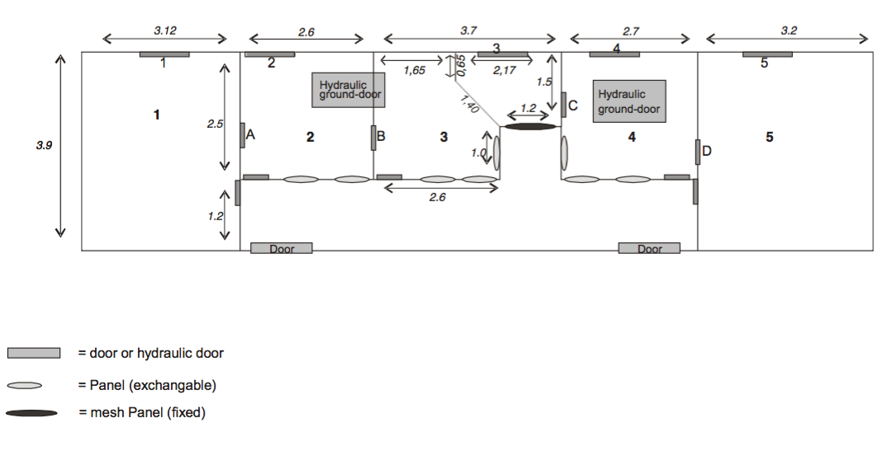

References

1 Baayen, R. H. Analyzing Linguistic Data: A Practical Introduction to Statistics Using R. (Cambridge University Press, 2008).
2 McCullagh, P. & Nelder, J. A. Generalized linear models. (Chapman and Hall, 2008).
3 Schielzeth, H. & Forstmeier, W. Conclusions Beyond Support: Overconfident Estimates in Mixed Models. Behav Ecol 20, 416-420, doi:10.1093/beheco/arn145 (2009).
4 Barr, D. J., Levy, R., Scheepers, C. & Tily, H. J. Random effect structure for confirmatory hypothesis testing: Keeping it maximal. J Mem Lang (2013).
5 Bates, D., Maechler, M., Bolker, B. & Walkers, S. {lme4}: Linear mixed-effects models using Eigen and S4. R package version, 1-7 (2014).
6 Field, A. Discovering statistics using SPSS. 2nd edn, (Sage, 2005).

