Electronic Supplementary Materials
Interacting effects of wildlife loss and climate on ticks and tick-borne disease
Georgia Titcomb^{1,2}, Brian F. Allan^{2,3}, Tyler Ainsworth¹, Lauren Henson⁷, Tyler Hedlund³, Robert M. Pringle^{2,5}, Todd M. Palmer^{2,6}, Laban Njoroge⁴, Michael G. Campana⁷, Robert Fleischer⁷, John Naisikie Mantas², Hillary S. Young^{1,2}

¹ Department of Ecology, Evolution and Marine Biology, University of California, Santa Barbara
² Mpala Research Centre, Box 555, Nanyuki, Kenya
³ Department of Entomology, University of Illinois at Urbana-Champaign, Urbana, IL 61801
⁴ Invertebrate Zoology Section, National Museums of Kenya, Nairobi, Kenya
⁵ Department of Ecology and Evolutionary Biology, Princeton University, Princeton, NJ 08544
⁶ Department of Biology, University of Florida, Gainesville, FL 32611
⁷ Center for Conservation Genomics, Smithsonian Conservation Biology Institute, National Zoological Park, Washington, DC 20008

Corresponding author: georgiatitcomb@gmail.com
Running Head: Defaunation and climate effects on ticks
Keywords: ticks, tick-borne disease, defaunation, climate, exclosure, Coxiella burnetii, Rickettsia

S1. Tick Trapping Methods
To ensure that the tick dragging methods accurately captured the tick community in each plot, we supplemented drags with CO₂ baited traps [1] for two months in July and August of 2014. Five tick traps baited with 250g of dry ice were placed at even intervals along the perimeter of the inner 0.36 hectare of each plot. Ticks were collected after 30 minutes, and traps were reset and rotated to 5 new microsites.
Statistical analyses were conducted on counts of ticks collected using each method for all plots during July and August 2014. We used the metaMDS function in the Vegan package [2] in R [3] to construct ordination plots using non-metric multidimensional scaling (NMDS) for tick communities using Bray Curtis dissimilarity. Collection method, exclosure treatment, and rainfall level were included in an environmental fit of the data.

1. Ginsberg, H. S. & Ewing, C. P. 1989 Comparison of flagging, walking, trapping, and collecting from hosts as sampling methods for northern deer ticks,Ixodes dammini, and lone-star ticks,Amblyomma americanum (Acari: Ixodidae). Exp. Appl. Acarol. 7, 313–322. (doi:10.1007/BF01197925)
2. Oksanen, J. et al. 2016 vegan: Community Ecology Package.
3. R Core Team 2016 R: A language and environment for statistical computing.

Figure S1: Tick and host responses to exclosure plots, by tick species and life stage. Different tick species feed upon certain hosts at each of their distinct life stages, shown by each row in the figure. The UHURU exclosures alter host abundance such that small mammals -- the dominant hosts for larvae and nymphs of R. pravus and R. praetextatus -- increase (green shading), but hosts for adult stages decline (red shading), in Total exclosure plots. This discrepancy may cause a proliferation of adult ticks that are unable to find their final hosts (indicated by arrows). Plots where tick abundance increased are overlaid with a “+”. By contrast, both intermediate and final hosts for R. pulchellus are largely absent in Total exclosures, which may explain why this tick only increased in partial exclosures (Meso and Mega), where slightly larger hosts may be available to immature ticks. Although carnivores are suitable hosts for all three tick species, reliable estimates of their abundance within these plots are not known.
Abundance of Available Hosts Relative to Control Plots [1]
Tick Species | Life Stage | Control Hosts [2,3] | Mega Exclosure | Meso Exclosure | Total Exclosure  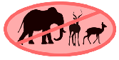
R. pravus  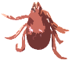 | Larval and  Nymphal | Rodents, elephant shrews
 |  | Hares
 |  | Small carnivores
 | Adult | Variety of ungulates
 |  | Hares
 |  | Carnivores
R. praetextatus | Larval and Nymphal | Rodents
 | Adult | Carnivores
 |  | Some ungulates
 |  | Hares
R. pulchellus | Larval and | Variety of ungulates
 |  | Carnivores
 | Nymphal | Hares
 | Adult | Variety of ungulates
 |  | Carnivores
 | Host Increase  Host Decrease |  | No data | Significant tick increase
 |  |  | No change | Marginally-significant tick increase

1. Kartzinel, T. R., Goheen, J. R., Charles, G. K., DeFranco, E., Maclean, J. E., Otieno, T. O., Palmer, T. M. & Pringle, R. M. 2014 Plant and small-mammal responses to large-herbivore exclusion in an African savanna: five years of the UHURU experiment. Ecology 95, 787–787. (doi:10.1890/13-1023R.1)
2. Walker, J. B., Keirans, J. E. & Horak, I. G. 2000 The Genus Rhipicephalus (Acari, Ixodidae): A Guide to the Brown Ticks of the World. Cambridge, UK: Cambridge University Press.
3. Guerra, A. S. et al. 2016 Host-Parasite Associations in Small Mammal Communities in Semiarid Savanna Ecosystems of East Africa. J. Med. Entomol. (doi:10.1093/jme/tjw048)

Figure S2. Non-metric multi-dimensional scaling plot of tick species collected using both the tick dragging and CO₂ trapping methods. The plot was constructed using Bray-Curtis dissimilarity, and has a stress value of 0.0206. Collection method was not a significant factor using an environmental fit of collection method, exclosure treatment, and rainfall level (R² = 0.0133, P = 0.89). All analyses were performed using the Vegan package in R [1,2].
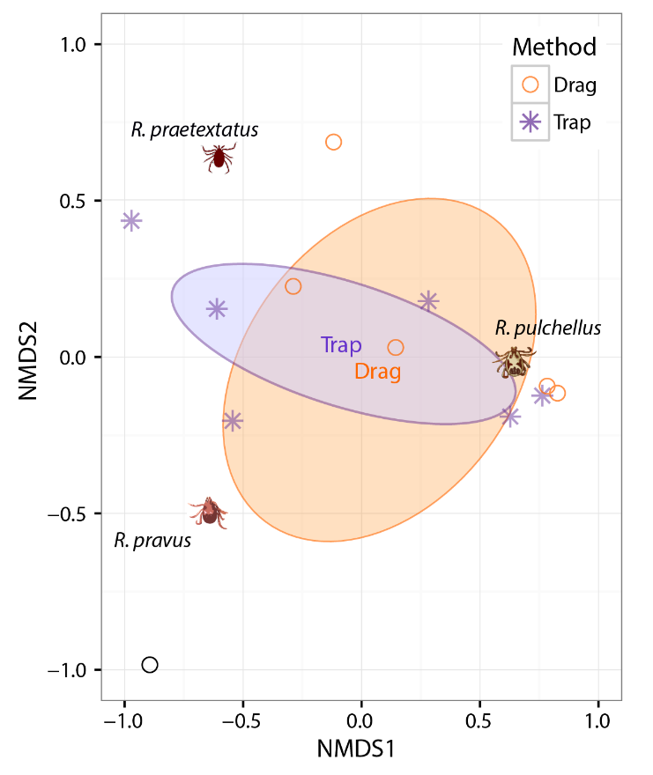

1. Oksanen, J. et al. 2016 Vegan: Community Ecology Package.
2. R Core Team 2016 R: A language and environment for statistical computing.

Figure S3. Non-metric multi-dimensional scaling plot of tick species found in Control and Exclosure plots for both tick traps and drags during July and August. The ordination was constructed using Bray-Curtis dissimilarity, and has a stress value of 0.0206. Tick species composition differed significantly between the plots (R² = 0.3698, P = 0.019), as R. pulchellus, which prefers large mammal hosts, dominated Control plots, while tick communities in Total Exclosures were dominated by ticks that thrive on small mammals. All analyses were performed using the Vegan package in R [1,2].
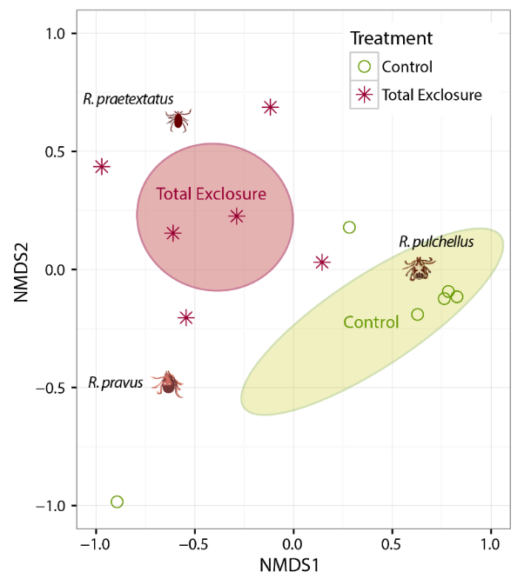

Figure S4: Proportion of infected ticks across rainfall levels, tick species, and experimental treatments.
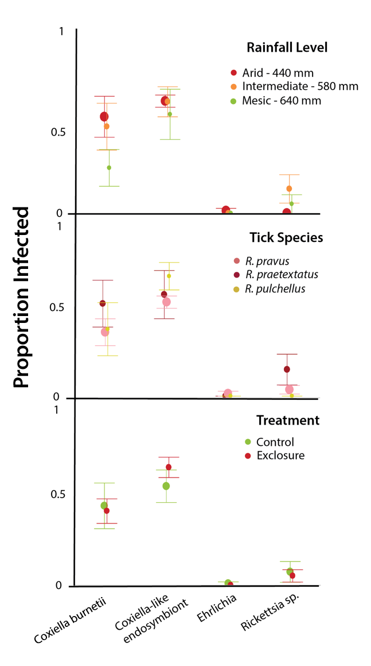

Table S1. Summary of additional climate and productivity variables across the three experimental levels. We ran all analyses using the mean annual rainfall value for each of the three plot locations (indicated in bold). We also ran all tick GLMMs using a categorical variable for each of the three locations (designated as “Mesic,” “Intermediate,” and “Arid”); these results are documented in Tables S2 and S3.
Variable | Source
Rainfall Level | [1] | Mesic  640 mm | Intermediate 580 mm | Arid  450 mm
Location | [1] | South | Central | North
Lat |  | 0.287579 | 0.401731 | 0.480375
Long |  | 36.892248 | 36.912203 | 36.871388
MAP (mm/yr) | [2] | 601-650 | 501-550 | 451-500
Rain Jan - Feb (mm) | [2] | 40.01-60 | 34.81-40 | 34.81-40
Rain Mar - May (mm) | [2] | 220.1-240 | 200.1-220 | 180.1-200
Rain Jun - Sep (mm) | [2] | 180.1 - 200 | 140.1 - 160 | 120.1 -140
Rain Oct - Dec (mm) | [2] | 160.1 - 180 | 140.1 - 160 | 140.1 - 160
Average Temp (ºC) | [2] | 17.5 - 18.5 | 18.6 - 19.5 | 18.6 - 19.5
Temp Jan - Feb (ºC) | [2] | 17.1-18 | 18.1-19 | 18.1-19
Temp Mar - May (ºC) | [2] | 18.1-19 | 18.1-19 | 19.1-20
Temp Jun - Sep (ºC) | [2] | 16.1-17 | 17.1-18 | 17.1-18
Temp Oct - Dec (ºC) | [2] | 16.1-17 | 17.1-18 | 18.1-19
NDVI | [1] | 0.32 - 0.34 | 0.21 - 0.23 | 0.23 - 0.27

1. Goheen, J. R., Palmer, T. M., Charles, G. K., Helgen, K. M., Kinyua, S. N., Maclean, J. E., Turner, B. L., Young, H. S. & Pringle, R. M. 2013 Piecewise Disassembly of a Large-Herbivore Community across a Rainfall Gradient: The UHURU Experiment. PLoS One 8, e55192. (doi:10.1371/journal.pone.0055192)
2. Franz, T. E., Caylor, K. K., Nordbotten, J. M., Rodríguez-Iturbe, I. & Celia, M. A. 2010 An ecohydrological approach to predicting regional woody species distribution patterns in dryland ecosystems. Adv. Water Resour. 33, 215–230.

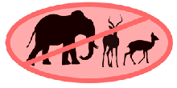
Table S2: All GLMM outputs for ticks collected in Total exclosure and Control plots for the full sampling period, run with a categorical climate variable (“Level”) in lieu of Rainfall. Differences in top models (ΔAICc < 2) from the reported analyses in Table S3 are shown in red; red bolded rows indicate a model that previously did not qualify as a top model, while unbolded red rows show models that are no longer top models.

All tick species:
# | (Int) | Level | Plot | Level*Plot | Df | logLik | AICc | Delta | Weight
8 | 1.906 | + | + | + | 9 | -754.163 | 1527.2 | 0.00 | 0.463
4 | 1.703 | + | + |  | 7 | -756.376 | 1527.3 | 0.09 | 0.443
3 | 2.190 |  | + |  | 5 | -760.053 | 1530.4 | 3.19 | 0.094
2 | 2.061 | + |  |  | 6 | -767.567 | 1547.5 | 20.34 | 0.000
1 | 2.494 |  |  |  | 4 | -771.004 | 1550.2 | 23.00 | 0.000

Rhipicephalus pravus
# | (Int) | Level | Plot | Level*Plot | Df | logLik | AICc | Delta | Weight
8 | -0.9843 | + | + | + | 9 | -444.607 | 908.1 | 0.00 | 0.973
4 | -1.5120 | + | + |  | 7 | -450.379 | 915.3 | 7.21 | 0.026
3 | -0.2214 |  | + |  | 5 | -455.973 | 922.2 | 14.14 | 0.001
2 | -0.5624 | + |  |  | 6 | -479.703 | 971.8 | 63.72 | 0.000
1 | 0.8453 |  |  |  | 4 | -485.971 | 980.1 | 72.04 | 0.000

Rhipicephalus praetextatus:
# | (Int) | Level | Plot | Level*Plot | Df | logLik | AICc | Delta | Weight
3 | 1.157 |  | + |  | 6 | -523.840 | 1060.1 | 0.00 | 0.635
4 | 0.9251 | + | + |  | 8 | -522.724 | 1062.1 | 2.06 | 0.226
8 | 1.0380 | + | + | + | 10 | -521.338 | 1063.7 | 3.67 | 0.101
1 | 1.3200 |  |  |  | 5 | -527.925 | 1066.1 | 6.05 | 0.031
2 | 1.1770 | + |  |  | 7 | -527.297 | 1069.1 | 9.05 | 0.007

Rhipicephalus pulchellus:
# | (Int) | Level | Plot | Level*Plot | Df | logLik | AICc | Delta | Weight
4 | 0.4368 | + | + |  | 8 | -413.114 | 842.9 | 0.00 | 0.579
2 | 0.2540 | + |  |  | 7 | -415.257 | 845.1 | 2.13 | 0.200
3 | 0.8961 |  | + |  | 6 | -416.589 | 845.6 | 2.66 | 0.154
8 | 0.4557 | + | + | + | 10 | -413.078 | 847.2 | 4.31 | 0.067

Table S3: All GLMM outputs for ticks collected in all plots (Total exclosure, Meso, Mega, and Control) for a subset of five months, run with a categorical climate variable (“Level”) in lieu of Rainfall. Differences in top models (ΔAICc < 2) from the reported analyses in Table S3 are shown in red; red bolded rows indicate a model that previously did not qualify as a top model, while unbolded red rows show models that are no longer top models.

All tick species:
# | (Int) | Level | Plot | Level*Plot | Df | logLik | AICc | Delta | Weight
8 | 1.568 | + | + | + | 16 | -547.930 | 1131.2 | 0.00 | 0.853
3 | 1.508 |  | + |  | 8 | -559.338 | 1135.5 | 4.32 | 0.098
4 | 1.250 | + | + |  | 10 | -557.816 | 1136.9 | 5.74 | 0.048
1 | 2.150 |  |  |  | 5 | -580.883 | 1172.1 | 40.91 | 0.000
2 | 1.807 | + |  |  | 7 | -578.970 | 1172.6 | 41.39 | 0.000

Rhipicephalus pravus:
# | (Int) | Level | Plot | Level*Plot | Df | logLik | AICc | Delta | Weight
8 | -0.8994 | + | + | + | 15 | -324.054 | 681.0 | 0.00 | 0.851
4 | -1.9910 | + | + |  | 9 | -332.766 | 684.6 | 3.56 | 0.144
3 | -0.6000 |  | + |  | 7 | -338.328 | 691.3 | 10.27 | 0.005
2 | -0.9794 | + |  |  | 6 | -363.553 | 739.6 | 58.56 | 0.000
1 | 0.6034 |  |  |  | 4 | -369.608 | 747.4 | 66.41 | 0.000

Rhipicephalus praetextatus:
# | (Int) | Level | Plot | Level*Plot | Df | logLik | AICc | Delta | Weight
3 | 0.3003 |  | + |  | 8 | -319.534 | 655.9 | 0.00 | 0.469
8 | 0.6094 | + | + | + | 16 | -310.820 | 657.0 | 1.07 | 0.275
4 | 0.6215 | + | + |  | 10 | -317.948 | 657.2 | 1.29 | 0.247
1 | 0.7115 |  |  |  | 5 | -327.369 | 665.1 | 9.17 | 0.005
2 | 1.0720 | + |  |  | 7 | -325.448 | 665.5 | 9.64 | 0.004

Rhipicephalus pulchellus:
# | (Int) | Level | Plot | Level*Plot | Df | logLik | AICc | Delta | Weight
3 | 0.4632 |  | + |  | 7 | -376.251 | 767.2 | 0.00 | 0.704
4 | 0.2566 | + | + |  | 9 | -375.085 | 769.2 | 2.08 | 0.250
8 | 0.4263 | + | + | + | 15 | -369.842 | 772.6 | 5.46 | 0.046
2 | 0.6806 | + |  |  | 6 | -390.127 | 792.7 | 25.59 | 0.000
1 | 1.0110 |  |  |  | 4 | -392.475 | 793.2 | 26.03 | 0.000

 | R2 | Pr(>r)
Method | 0.0133 | 0.891
Treatment | 0.3698 | 0.019
Rainfall | 0.1795 | 0.420
Table S4: Results of the environmental fit of NMDS ordination plots for tick species (See S1, Figures S1-2). Different collection methods did not capture significantly different tick communities, indicating that drag methods effectively captured the tick species present in the plots. Tick communities differed significantly between treatments, with Control sites featuring a greater proportion of ticks that prefer large mammals (R. pulchellus), while Total Exclosures were dominated by ticks whose immature stages preferentially feed upon small mammals (R. praetextatus and R. pravus). Rainfall level was not a significant factor for this analysis.

Table S5. All GLMM model outputs for analyses of tick abundance in Total exclosure and Control plots for all 14 months sampled.

All tick species:
# | (Int) | Rain | Plot | Rain*Plot | Df | logLik | AICc | Delta | Weight
8 | 2.117 | -0.09213 | + | + | 7 | -760.865 | 1536.3 | 0.00 | 0.749
4 | 2.130 | -0.24400 | + |  | 6 | -763.474 | 1539.3 | 3.08 | 0.160
3 | 2.128 |  | + |  | 5 | -765.099 | 1540.5 | 4.22 | 0.091
2 | 2.464 | -0.26970 |  |  | 5 | -772.804 | 1555.9 | 19.63 | 0.000
1 | 2.464 |  |  |  | 4 | -774.553 | 1557.3 | 21.03 | 0.000

Rhipicephalus pravus (RHPV):
# | (Int) | Rain | Plot | Rain*Plot | Df | logLik | AICc | Delta | Weight
8 | -0.1727 | -0.3041 | + | + | 8 | -448.043 | 912.8 | 0.00 | 0.986
4 | -0.2170 | -0.6850 | + |  | 7 | -453.583 | 921.7 | 8.92 | 0.011
3 | -0.2212 |  | + |  | 6 | -455.973 | 924.3 | 11.57 | 0.003
2 | 0.8444 | -0.7786 |  |  | 6 | -483.057 | 978.5 | 65.73 | 0.000
1 | 0.8454 |  |  |  | 5 | -485.971 | 982.2 | 69.45 | 0.000

Rhipicephalus praetextatus (RHPR):
# | (Int) | Rain | Plot | Rain*Plot | Df | logLik | AICc | Delta | Weight
3 | 1.157 |  | + |  | 6 | -523.840 | 1060.1 | 0.00 | 0.468
4 | 1.158 | -0.1441 | + |  | 7 | -523.011 | 1060.6 | 0.48 | 0.368
8 | 1.155 | -0.1564 | + | + | 8 | -522.998 | 1062.7 | 2.61 | 0.127
2 | 1.320 |  |  |  | 5 | -527.925 | 1066.1 | 6.05 | 0.023
1 | 1.313 | -0.0982 |  |  | 6 | -527.367 | 1067.1 | 7.05 | 0.014

Rhipicephalus pulchellus (RHPU): The following models were the only ones to converge.
# | (Int) | Rain | Plot | Rain*Plot | Df | logLik | AICc | Delta | Weight
3 | 0.8961 |  | + |  | 6 | -416.589 | 845.6 | 0.00 | 0.477
4 | 1.8760 | -0.001790 | + |  | 7 | -415.733 | 846.0 | 0.42 | 0.386
8 | 1.6860 | -0.001443 | + | + | 8 | -415.693 | 848.1 | 2.50 | 0.137

Table S6: All GLMM model outputs for analyses of tick abundance in all treatment plots for a subset of months (January, June, July, August, September, October).

All tick species:
# | (Int) | Rain | Plot | Rain*Plot | Df | logLik | AICc | Delta | Weight
8 | 1.424 | 0.2193 | + | + | 11 | -551.182 | 1125.9 | 0.00 | 0.995
3 | 1.466 |  | + |  | 7 | -561.610 | 1137.9 | 11.94 | 0.003
4 | 1.472 | -0.1464 | + |  | 8 | -560.773 | 1138.4 | 12.45 | 0.002
2 | 2.132 | -0.2021 |  |  | 5 | -579.994 | 1170.3 | 44.40 | 0.000
1 | 2.132 |  |  |  | 4 | -581.215 | 1170.7 | 44.72 | 0.000

Rhipicephalus pravus (RHPV):
# | (Int) | Rain | Plot | Rain*Plot | Df | logLik | AICc | Delta | Weight
8 | -0.5108 | -0.2276 | + | + | 12 | -329.782 | 685.4 | 0.00 | 0.927
4 | -0.5730 | -0.6998 | + |  | 9 | -336.033 | 691.1 | 5.69 | 0.054
3 | -0.5708 |  | + |  | 8 | -338.176 | 693.2 | 7.76 | 0.019
2 | 0.6006 | -0.8713 |  |  | 6 | -366.765 | 746.0 | 60.58 | 0.000
1 | 0.6034 |  |  |  | 5 | -369.608 | 749.6 | 64.13 | 0.000

Rhipicephalus praetextatus (RHPR):
# | (Int) | Rain | Plot | Rain*Plot | Df | logLik | AICc | Delta | Weight
8 | 0.1586 | 0.4991 | + | + | 12 | -313.187 | 652.2 | 0.00 | 0.781
3 | 0.3003 |  | + |  | 8 | -319.534 | 655.9 | 3.67 | 0.125
4 | 0.2794 | 0.1813 | + |  | 9 | -318.726 | 656.5 | 4.27 | 0.092
1 | 0.7115 |  |  |  | 5 | -327.369 | 665.1 | 12.84 | 0.001
2 | 0.7113 | 0.1681 |  |  | 6 | -326.730 | 665.9 | 13.70 | 0.001

Rhipicephalus pulchellus (RHPU):
# | (Int) | Rain | Plot | Rain*Plot | Df | logLik | AICc | Delta | Weight
3 | 0.4632 |  | + |  | 7 | -376.251 | 767.2 | 0.00 | 0.463
4 | 0.4697 | -0.1364 | + |  | 8 | -375.383 | 767.6 | 0.45 | 0.369
8 | 0.4632 | 0.0129 | + | + | 11 | -372.804 | 769.2 | 2.03 | 0.168
2 | 1.007 | -0.1965 |  |  | 5 | -390.852 | 792.0 | 24.90 | 0.000
1 | 1.0110 |  |  |  | 4 | -392.475 | 793.2 | 26.03 | 0.000

Table S7: All GLMM outputs for pathogen infection in ticks:
Coxiella burnetii:
# | (Int) | Species | Rain | Plot | Rain*Plot | Df | logLik | AICc | Delta | Weight
1 | -0.4177 |  |  |  |  | 2 | -91.365 | 186.8 | 0.00 | 0.256
3 | -0.1178 | + |  |  |  | 4 | -89.714 | 187.7 | 0.91 | 0.162
2 | 0.3553 |  | -0.1699 |  |  | 3 | -90.899 | 188.0 | 1.16 | 0.143
5 | 0.3441 |  |  | + |  | 3 | -90.960 | 188.1 | 1.28 | 0.099
4 | -0.4567 | + | -0.1677 |  |  | 5 | -89.278 | 189.0 | 2.20 | 0.096
6 | -0.2967 |  | -0.1800 | + |  | 4 | -90.448 | 189.2 | 2.38 | 0.083
7 | -0.4625 | + |  | + |  | 5 | -89.629 | 189.7 | 2.90 | 0.037
14 | 0.3370 |  | -0.3326 | + | + | 5 | -90.165 | 190.8 | 3.97 | 0.036
8 | -0.4779 | + | -0.1720 | + |  | 6 | -89.175 | 191.0 | 4.18 | 0.017
16 | 0.3189 | + | -0.3229 | + | + | 7 | -88.901 | 192.7 | 5.86 | 0.016

Rickettsia sp.:
# | (Int) | Species | Rain | Plot | Rain*Plot | Df | logLik | AICc | Delta | Weight
4 | -2.444 | + | 1.1560 |  |  | 5 | -22.212 | 54.9 | 0.00 | 0.352
2 | -3.372 |  | 1.0930 |  |  | 3 | -25.035 | 56.2 | 1.36 | 0.178
8 | -2.163 | + | 1.1360 | + |  | 6 | -22.169 | 57.0 | 2.10 | 0.123
3 | -2.015 | + |  |  |  | 4 | -24.786 | 57.9 | 2.99 | 0.079
6 | -3.812 |  | 1.1880 | + |  | 4 | -24.830 | 58.0 | 3.08 | 0.075
16 | -1.919 | + | 0.5972 | + | + | 7 | -21.817 | 58.5 | 3.62 | 0.058
14 | -3.281 |  | 0.5145 | + | + | 5 | -24.116 | 58.7 | 3.81 | 0.052
1 | -2.914 |  |  |  |  | 2 | -27.585 | 59.3 | 4.37 | 0.039
7 | -1.762 | + |  | + |  | 5 | -24.739 | 59.9 | 5.05 | 0.028
5 | -3.157 |  |  | + |  | 3 | -27.493 | 61.2 | 6.28 | 0.015

Table S6. Results from additional GLMMs with long-term averages of rodent abundance (from Kartzinel et al. 2014) as sole predictors of tick abundance. Replicate plot and period are random effects. Rodent abundance is positively correlated with abundance of R. pravus and R. praetextatus, whose immature stages frequently parasitize these small mammals. Rodent abundance is negatively correlated with R. pulchellus abundance, whose immature stages are rarely found on rodents (Walker 2000).
Tick Species | Coefficient | Estimate | Std. Error | z-value | Pr(>|z|)
R. pravus | Intercept | - 0.9761 | 0.6399 | -1.53 | 0.13
 | Rodents | 0.2324 | 0.0353 | 6.59 | < 0.001
R. praetextatus | Intercept | 0.4621 | 0.5260 | 0.88 | 0.3797
 | Rodents | 0.0820 | 0.0258 | 3.17 | < 0.01
R. pulchellus | Intercept | 1.3993 | 0.2960 | 4.73 | < 0.001
 | Rodents | - 0.1155 | 0.0299 | -3.86 | < 0.001

