Supplementary Materials

Supplementary Methods

Data compilation
Data compilation was carried out according to species name. NCM species were identified through reference to [11] and then grouped according to the classification of [6], into GNCMs (protists which acquire plastids from a variety of prey), pSNCMs (protists which acquire plastids from specific prey) and eSNCMs (protists which enslave entire specific autotrophic prey as symbionts). Unless otherwise indicated, where sampling was conducted at different depths in the water column, a depth integrated value of biomass and/or abundance was used. Where required, data from published plots were extracted using GetData Graph Digitizer (http://getdata-graph-digitizer.com/).
The Ocean Biogeographic Information System database (OBIS; http://www.iobis.org/) and the Coastal & Oceanic Plankton Ecology, Production, & Observation Database (COPEPOD; http://www.st.nmfs.noaa.gov/copepod/) were examined for qualitative data; COPEPOD did not provide any data further to those compiled from OBIS (table S2). The bibliographic survey, conducted in the electronic database ISI Web of Science on 13 March 2016, targeted quantitative data on numeric abundance/biomass of protists with acquired phototrophy and was also used to complement the OBIS and COPEPOD surveys.
Nearly 1,000 records reporting distribution of NCM species were obtained from over 180 articles (table S3). For the quantitative data, we targeted works on which the contribution of mixotrophs to the microzooplankton assemblage could be estimated. Estimating the contribution of heterotrophic dinoflagellates engaging in acquired phototrophy to the total dinoflagellate abundance/biomass during sampling is particularly challenging because they are difficult to distinguish from autotrophic dinoflagellates [20]. In contrast, it is relatively easy to separate groups of mixotrophic ciliates and Rhizaria.
Quantitative data for mixotrophic ciliates were obtained from > 45 articles (table S4). These articles comprised works which specifically targeted mixotrophy; these included field work that undertook analysis using epifluorescence microscopy (thus enabling identification of ciliates with algal plastids), and works which did not specifically target mixotrophy but reported data on microzooplankton species composition. There is a likely underestimation of mixotrophy using this methodology because not all ciliate records are identified down to species level.
The relative contribution of mixotrophic Rhizaria (eSNCMs) to the planktonic assemblage within the topmost 100m of the water column was estimated from a recent work which used a non-destructive in situ imaging system [18]. Rhizaria data are available in the PANGAEA database [32]. Among the Rhizaria groups investigated in [18], all Acantharia and Collodaria were considered mixotrophic.

Spatial analysis
The biogeographic analysis was oriented by division of the ocean into subsets defined by 54 biogeographic provinces (figure S1 and table S1) according to Longhurst [17]. The Longhurst provinces assume that pelagic biogeography is dictated by seasonal and spatial variation of primary production, which, in turn, is mirrored by physical forcing (e.g., light, wind, temperature). Biomes and provinces are defined according to observed discontinuities in physical processes and analysis of satellite images of surface chlorophyll. Grids corresponding to Longhurst provinces used in the maps were obtained from http://www.marineregions.org/. Geographic coordinates corresponding to the exact location where the mixotrophic species were found were aligned with biogeographic provinces; at least one record was necessary to assume that one of the three NCM groups occurred in the province.
A presence-absence matrix based on the 54 Longhurst biogeographic provinces was constructed to explore the dissimilarities between the mixotrophic species using an ordination technique (non-metric multidimensional scaling – NMDS) [34]. The number of records available for each species was highly variable (table S2). Thus, only species with a minimum of 50 records were included in the analysis; species for which datasets were not considered robust enough to represent their distribution over the provinces were excluded. In addition, species with over 10,000 records were randomly subsampled down to a maximum of 2,000 records to decrease sampling bias among species. A total of 34 species were selected for analysis. The distance matrix used in the NMDS analysis was calculated using the Jaccard distance. Ordination was performed using the metaMDS function (vegan package in R; [19]) with progressively higher number of dimensions in order to select the number which provided low stress value while keeping a low number of dimensions [34].
We applied the NMDS ordination technique to explore similarities between the different species within the NCM functional groups across their biogeographies. The NMDS also enabled ordination of the provinces according to their dissimilarities; these are based on the species which occur within each province (figure S3). Plotting the ordination of species and provinces in the same NMDS space allows us to explore the relationship between the different mixotrophic species (thence functional groups) and the provinces based on their proximity.

Temporal analysis
The seasonal progression of mixotrophic biomass across different biomes was investigated for mixotrophic oligotrich ciliates (GNCMs), Mesodinium (pSNCMs), and mixotrophic Rhizaria (eSNCMs). We analysed both absolute and relative (i.e., mixotrophs vs heterotrophs) biomass. The 54 Longhurst biogeographic provinces were aligned within the following biomes prior to the NMDS analysis: Coastal Seas, Equatorial Upwelling, Mediterranean Sea, Oligotrophic Gyres, Polar Seas, Temperate Seas, and Coastal Upwelling. Temporal resolution was represented according to seasonality: late June – early September (Boreal summer/Austral winter), late September – early December (Boreal autumn/Austral spring), late December – early March (Boreal winter/Austral summer), and late March – early June (Boreal spring/Austral autumn). Data were not homogenously distributed across biomes, nor across seasons. Data for the complete seasonal cycle were available for all functional groups in the Coastal Seas and Mediterranean Sea biomes, and for mixotrophic Rhizaria (eSNCMs) in the Oligotrophic Gyres and Equatorial Upwelling biomes. No data were available for the Coastal Upwelling biome.
Two-Way ANOVAs were conducted to compare mixotrophic biomass (relative and absolute values) across time and space. Residuals and residuals variance were checked for normal distribution and homogeneity, respectively, through graphical visualization. If necessary, biomass (absolute) data were transformed using log (x + 1) to meet the assumptions of normality.

Supplementary Results and Discussion
“Evidence of absence” vs “Absence of evidence”
We also explored reasons for the total absence of data on mixotrophs from some of the provinces. In some instances there was a lack of data providing information on acquired phototrophy amongst microzooplankton; there is an absence of evidence because these organisms were not targeted (unmarked white provinces in figure 1). In other instances, researchers have specifically searched for presence of these organisms and found none [20, 35, 36]; here there is evidence of absence (provinces marked with * in figure 1), though such claims can never be certain. To resolve such matters, sampling for, and monitoring of, mixotroph groups needs to become routine.
Nutrient load, system variability and NCMs biogeography
Our results suggested that the main difference between the biogeography of mixotrophic ciliates and eSNCMs is that the first are related to systems characterized by meso- and eutrophic waters, while the second predominate in oligotrophic systems with low abiotic variability (figure 2a). To explore it quantitatively, we applied the annual average and variance of net primary productivity (NPP) to characterize the nutrient load and the system variability, respectively, of each biogeographic province, and related it to the observed relative biomass (%) of NCMs within each location. NPP data were obtained from [17] for each province (derived from SeaWIFS data from 1997 to 2002).
The relative biomass of mixotrophic ciliates was minimum in less productive waters or in systems with low variability, while the opposite was observed for mixotrophic Rhizaria (eSNCMs) (figure 2b and c). Low prey availability may limit the success of GNCMs which rely on frequent feeding to acquire essential nutrients and to replace old and non-functional chloroplasts [5, 11, 37]. In contrast, eSNCMs can survive in oceanic systems relying on their endosymbionts [20, 25]. The biogeography of pSNCMs is similar to that of GNCMs and somewhat restricted to neritic regions; pSNCMs are more commonly encountered during periods of high nutrients and thrive in upwelling zones, largely due to the pronounced phototrophic capabilities of Mesodinium and Dinophysis acuminata [23, 24, 37].
References in addition to those in the main text
33. Biard T et al. 2016 Biomass of large protists from the Infrakingdom Rhizaria in the global ocean. (doi: 10.1594/PANGEA.858156)
34. Legendre P, Legendre L. 1998 Numerical Ecology. Second Edition. Amsterdam: Elsevier
35. Estrada, M., Delgado, M., Blasco, D., Latasa, M., Cabello, A. M., Benítez-Barrios, V., Fraile-Nuez, E., Mozetič, P. & Vidal, M. 2016 Phytoplankton across tropical and subtropical regions of the Atlantic, Indian and Pacific oceans. PLoS One 11, 1–29. (doi:10.1371/journal.pone.0151699)
36. Gómez, F. 2007 Trends on the distribution of ciliates in the open Pacific Ocean. Acta Oecologica 32, 188–202. (doi:10.1016/j.actao.2007.04.002)
37. Johnson MD. 2011 Acquired phototrophy in ciliates: a review of cellular interactions and structural adaptations. J. Eukaryot. Microbiol. 58(3), 185–195. (doi:10.1111/j.1550-7408.2011.00545.x)
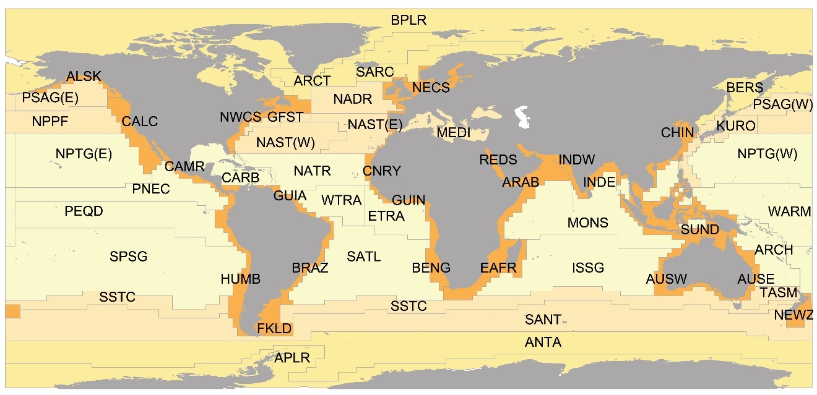
Figure S1. Longhurst division of the ocean in 54 biogeographic provinces [17]. Colours highlight the different biomes; from lighter to darker colours: Trade Wind, Westerly Wind, Polar, and Coastal biomes. Abbreviations are given in table S1.
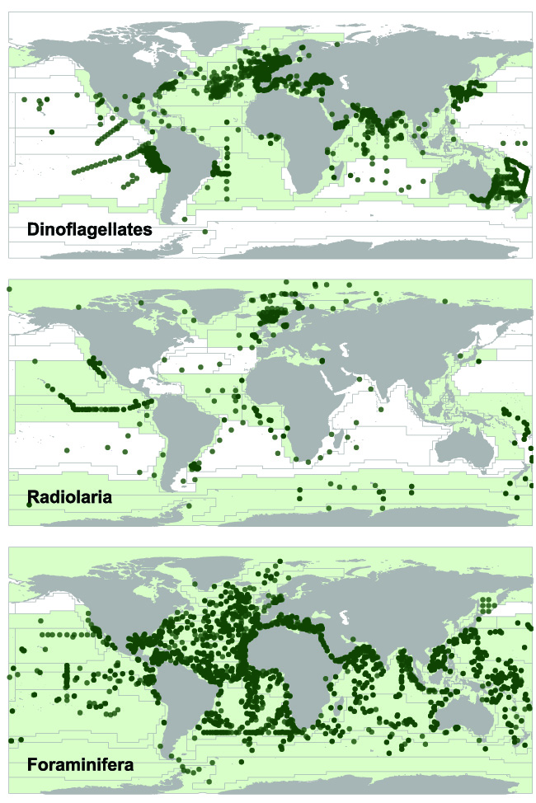
Figure S2. Global distribution of protists which enslave entire autotrophic prey (eSNCMs: dinoflagellates, Radiolaria, and Foraminifera). Symbols correspond to the exact location where mixotrophic species/taxa were found (over 60,000 records). Overlaid is a grid that represents biogeographic provinces [17]. Colour-cast provinces indicate the presence of NCMs and white provinces correspond to absence.
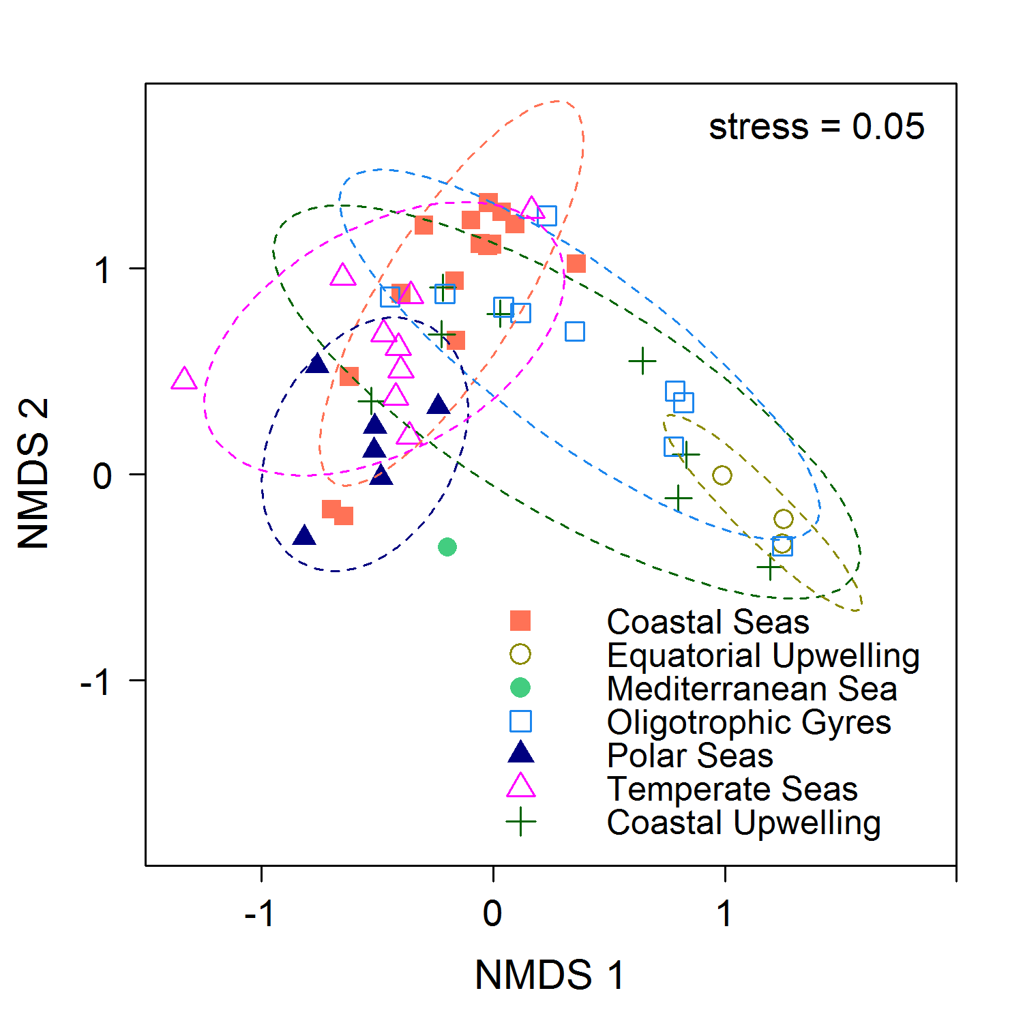
Figure S3. Additional results from the NMDS analysis (to complement figure 2) showing the distribution of biogeographic provinces in a two-dimensional space and their grouping in seven larger biomes. Each symbol represents a biogeographic province and different symbols were used for different biomes; the dashed ellipses represent the biome clusters at 70% confidence interval.

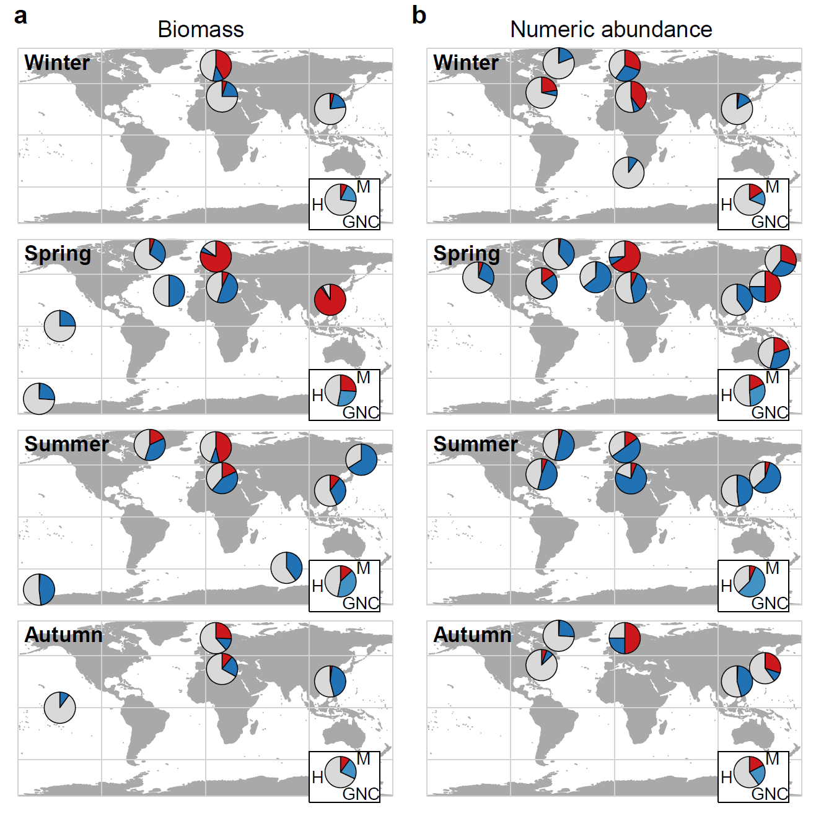
Figure S4. Seasonal relative contribution of GNCMs and Mesodinium to total ciliate biomass (a) and numeric abundance (b) over the globe. Pies highlighted within rectangles represent global means. GNC: GNCMs, M: red-pigmented Mesodinium spp., and H: heterotrophic ciliates.
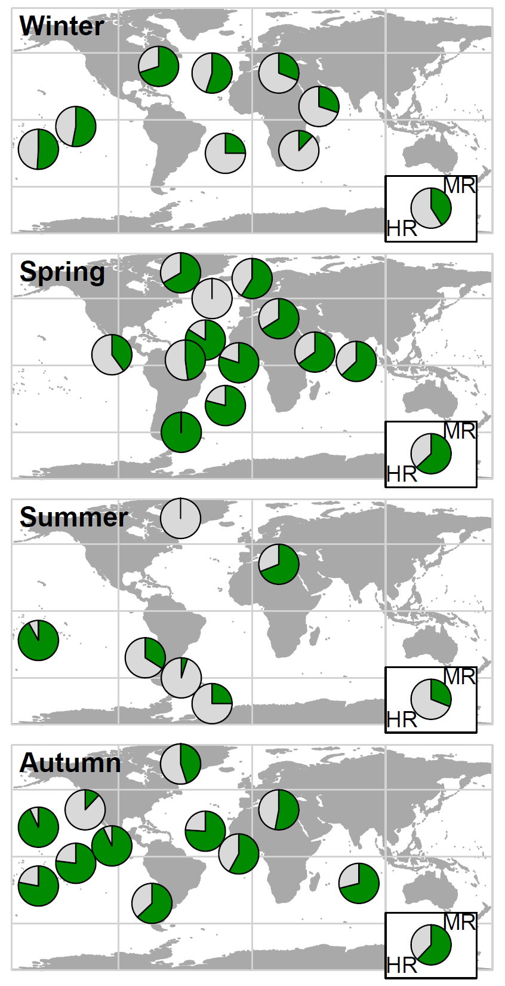
Figure S5. Seasonal relative contribution of mixotrophic Rhizaria (Collodaria and Acantharia) to total Rhizaria biomass over the globe. Pies highlighted within rectangles represent global means. MR: mixotrophic Rhizaria and HR: heterotrophic Rhizaria.
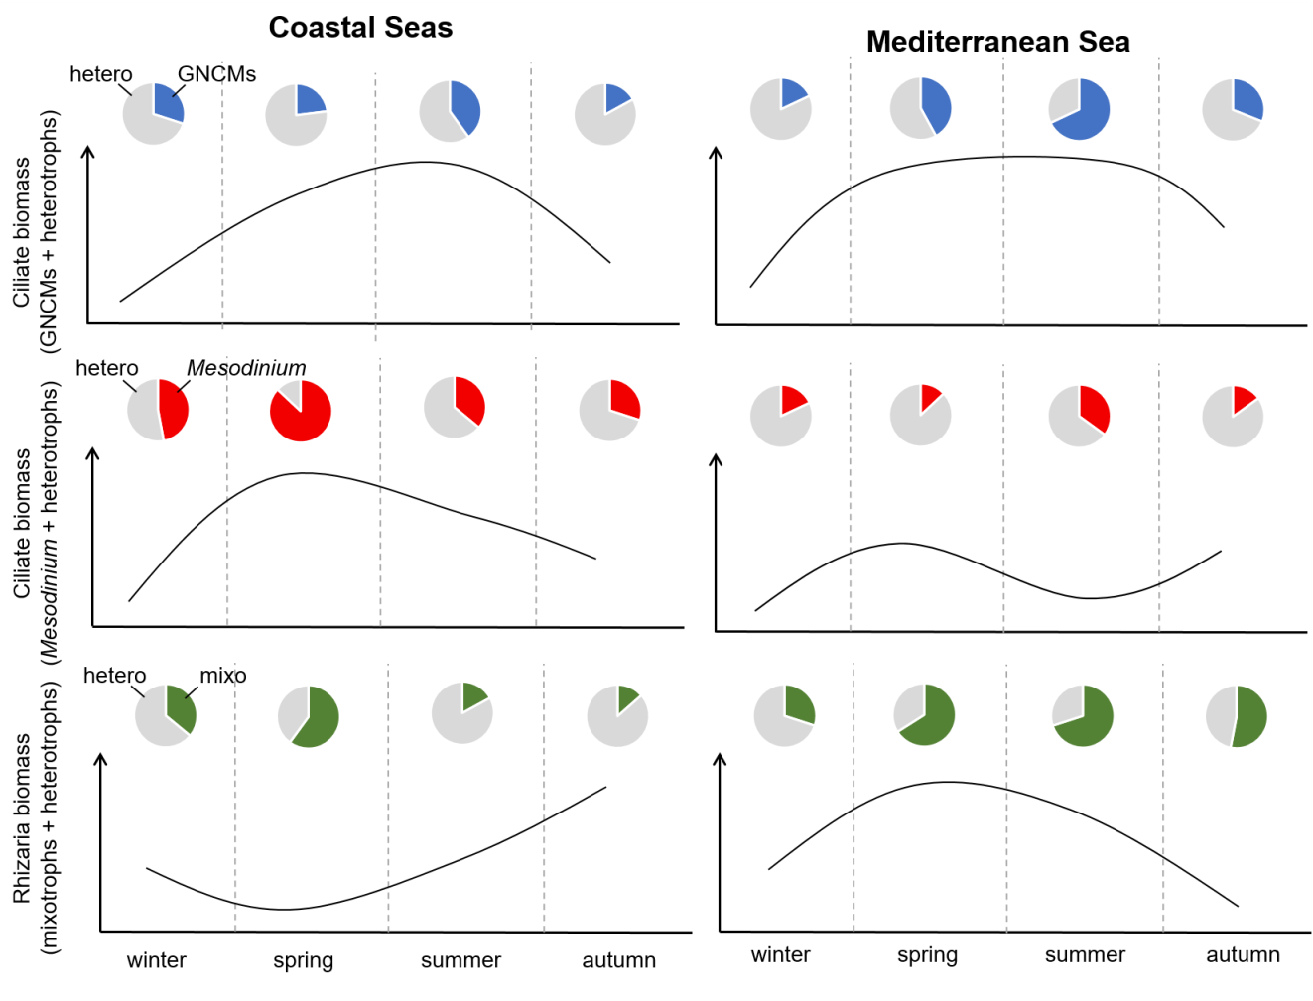
Figure S6. Schematics for selected biomes (Coastal Seas and Mediterranean Sea) comparing the seasonal progression of the relative contribution of mixotrophs (blue, GNCMs; red, pSNCM Mesodinium; green, eSNCM Rhizaria) versus heterotrophs (grey) to the total biomass (heterotrophs + mixotrophs) within each functional group. Solid lines indicate the trend for the absolute biomass variation over the year.

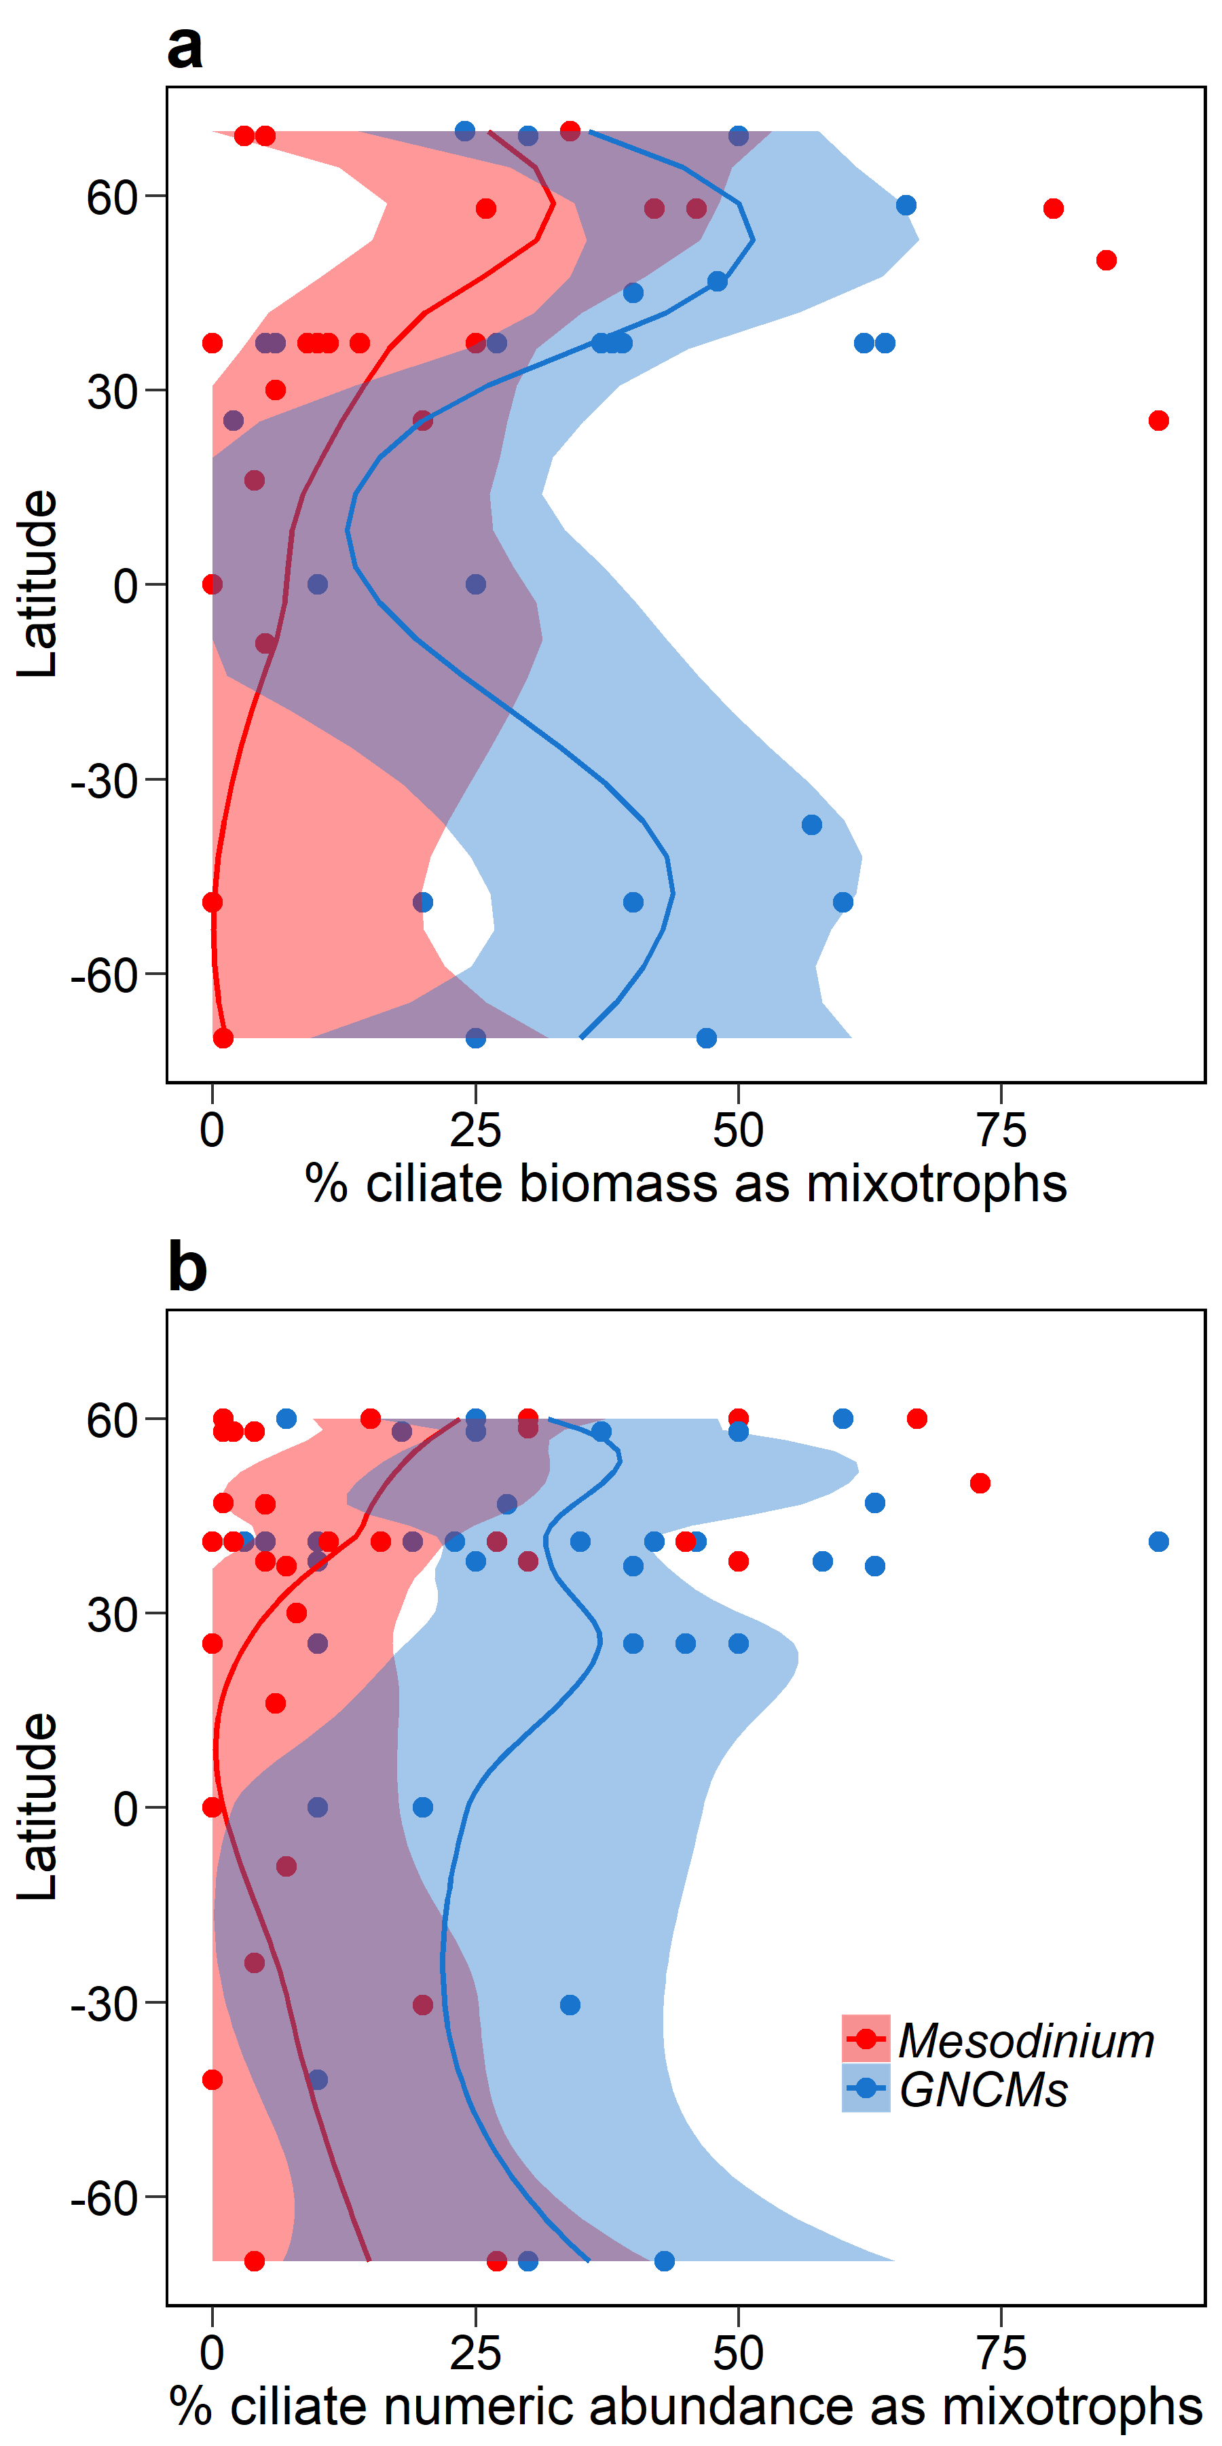
Figure S7. Latitudinal gradients for the relative contribution of mixotrophic ciliates to total ciliate biomass (a) and to total ciliate numeric abundance (b). GNCMs are indicated in blue and the red-pigmented Mesodinium spp. in red. Loess regressions were fitted to data using R package ggplot2; 95% confidence intervals are shown. Note that data were unequally distributed across latitude and period of the year.
Table S1 Longhurst’s biogeographic provinces [17]; these were grouped into seven principal biomes according to primary production and physical forcing.
Oceanic Basin | Abbreviation | Province | Biome
Antarctic | ANTA | Antarctic | Polar Seas
 | APLR | Austral | Polar Seas
 | SANT | Subantarctic Water Ring | Polar Seas
 | SSTC | South Subtropical Convergence | Temperate Seas
Arctic | ARCT | Atlantic Arctic | Polar Seas
 | BERS | North Pacific Epicontinent | Polar Seas
 | BPLR | Boreal | Polar Seas
 | SARC | Atlantic Subarctic | Polar Seas
Atlantic | BENG | Benguela Current | Coastal Upwelling
 | BRAZ | Brazil Current | Coastal Seas
 | CNRY | Eastern Canary | Coastal Seas
 | EAFR | Eastern Africa | Coastal Seas
 | FKLD | Southwest Atlantic Shelves | Coastal Seas
 | GUIA | Guianas | Coastal Seas
 | GUIN | Guinea Current | Coastal Upwelling
 | NECS | Northeast Atlantic Shelves | Coastal Seas
 | NWCS | Northwest Atlantic Shelves | Coastal Seas
 | GFST | Gulf Stream | Temperate Seas
 | MEDI | Mediterranean Sea, Black Sea | Mediterranean Sea
 | NADR | North Atlantic Drift | Temperate Seas
 | NAST (E) | North Atlantic Subtropical Gyre (East) | Temperate Seas
 | NAST (W) | North Atlantic Subtropical Gyre (West) | Temperate Seas
 | CARB | Caribbean | Oligotrophic Seas
 | ETRA | Eastern Tropical Atlantic | Oligotrophic Seas
 | NATR | North Atlantic Tropical Gyre | Oligotrophic Seas
 | SATL | South Atlantic Gyre | Oligotrophic Seas
 | WTRA | Western Tropical Atlantic | Oligotrophic Seas
Indian | ARAB | Northwestern Arabian Upwelling | Coastal Upwelling
 | AUSW | Australia-Indonesia | Coastal Seas
 | INDE | Eastern India | Coastal Seas
 | INDW | Western India | Coastal Seas
 | REDS | Red Sea, Persian Gulf | Coastal Seas
 | ISSG | Indian South Subtropical Gyre | Oligotrophic Seas
 | MONS | Indian Monsoon Gyres | Oligotrophic Seas
Pacific | ALSK | Alaska Downwelling | Coastal Seas
 | AUSE | East Australia | Coastal Seas
 | CALC | California Current | Coastal Upwelling
 | CAMR | Central America | Coastal Upwelling
 | CHIN | China Sea | Coastal Seas
 | HUMB | Humboldt Current | Coastal Upwelling
 | NEWZ | New Zealand | Coastal Upwelling
 | SUND | Sunda-Arafura Shelves | Coastal Seas
 | KURO | Kuroshio Current | Temperate Seas
 | NPPF | North Pacific Transition Zone | Temperate Seas
 | PSAG (E) | Pacific Subarctic Gyre (East) | Temperate Seas
 | PSAG (W) | Pacific Subarctic Gyre (West) | Temperate Seas
 | TASM | Tasman Sea | Coastal Seas
 | ARCH | Archipelagic Deep Basins | Oligotrophic Seas
 | NPTG (E) | North Pacific Tropical Gyre (East) | Oligotrophic Seas
 | NPTG (W) | North Pacific Tropical Gyre (West) | Oligotrophic Seas
 | PEQD | Pacific Equatorial Divergence | Equatorial Upwelling
 | PNEC | North Pacific Equatorial Countercurrent | Equatorial Upwelling
 | SPSG | South Pacific Subtropical Gyre | Oligotrophic Seas
 | WARM | Western Pacific Warm Pool | Equatorial Upwelling

Table S2 Number of distribution records for protistan microzooplankton species with enslaved phototrophy obtained through OBIS survey. The list of species includes those which are known to be mixotrophic. Those which were not found within the databases for oceanic provinces are indicated with “no data”.
Functional type | Species name | Number of records
GNCM | Laboea strobila | 2754
GNCM | Laboea pulchra | no data
GNCM | Cyrtostrombidium spp | 3
GNCM | Strombidium acutum | 342
GNCM | Strombidium capitatum | 47
GNCM | Strombidium chlorophilum | 1
GNCM | Strombidium conicum | 2014
GNCM | Strombidium crassulum | 101
GNCM | Strombidium delicatissimum | 574
GNCM | Strombidium elegans | 1
GNCM | Strombidium oculatum | 34
GNCM | Strombidium purpureum | 1
GNCM | Strombidium reticulatum | 44
GNCM | Strombidium stylifer | 1
GNCM | Pseudotontonia cornuta | 23
GNCM | Tontonia appendiculariformis | 8
GNCM | Tontonia gracillima | 208
GNCM | Tontonia ovalis | 201
GNCM | Tontonia poopsia | 2
GNCM | Tontonia simplicidens | no data
pSNCM | Mesodinium rubrum (= Myrionecta rubra) | 20533
pSNCM | Dinophysis acuminata | 21250
pSNCM | Dinophysis fortii | 497
pSNCM | Dinophysis infundibulus | 63
pSNCM | Dinophysis mitra | 182
pSNCM | Amphidinium latum | 13
pSNCM | Amphidinium poecilochrom | 1
pSNCM | Amylax triacantha | 1363
pSNCM | Cryptoperidiniopsis spp | 6
pSNCM | Kleptodinium spp | no data
pSNCM | Pfiesteria piscicida | 3
eSNCM | Dinothrix paradoxa | 3
eSNCM | Durinskia baltica | 20
eSNCM | Durinskia capensis | no data
eSNCM | Galeidinium rugatum | no data
eSNCM | Kryptoperidinium foliaceum | 169
eSNCM | Noctiluca scintillans | 17120
eSNCM | Peridinium quinquecorne | 688
eSNCM | Histioneis spp. | 121
eSNCM | Amphisolenia spp. | 1552
eSNCM | Triposolenia spp. | 20
eSNCM | Ornithocercus spp. | 3148
eSNCM | Acanthmetra pellucida | no data
eSNCM | Amphilonche elongata | 30
eSNCM | Lithoptera mulleri | no data
eSNCM | Didymocyrtis tetrathalamus | 186
eSNCM | Spongodrymus spp | 1
eSNCM | Tetrapetalon elegans | no data
eSNCM | Spongostaurus spp | no data
eSNCM | Dictyocoryne truncatum | 54
eSNCM | Spongodrymus spp | 1
eSNCM | Thallassolampe margarodes | no data
eSNCM | Spongodiscus biconcavus | no data
eSNCM | Acanthosphaera | 216
eSNCM | Actinomma spp | 428
eSNCM | Plegmosphaera spp | 80
eSNCM | Haxacontium | no data
eSNCM | Spongotrochus | 155
eSNCM | Collozoum spp | 216
eSNCM | Collosphaera spp | 239
eSNCM | Sphaerozoum spp | 38
eSNCM | Acrosphaera spinosa | 96
eSNCM | Thalassicolla spp | 3
eSNCM | Pterocorys zancleus | 94
eSNCM | Pterocanium muelleri | no data
eSNCM | Heliodiscus spp | 93
eSNCM | Phorticium pylonium | 45
eSNCM | Ceratospyris hyperborea | no data
eSNCM | Androcyclas gamphonyca | no data
eSNCM | Globigerinella siphonifera | 23863
eSNCM | Globorotalia merardii | 16429
eSNCM | Pulleniatina obliqueloculata | no data

Table S3 Results from the bibliographic survey - Distribution records of non-constitutive mixotrophs (NCMs: GNCMs, pSNCMs, and eSNCMs). Geographic coordinates from each record were used to identify the corresponding biogeographic province and biome [17].

This table is presented in ESM File TableS3.xlsx

Table S4 Results from the bibliographic survey - Abundance and biomass data of the total ciliate assemblage and the relative contribution (%) of heterotrophs and mixotrophs (GNCMs and red-pigmented Mesodinium spp.). Period of the year (season), sampling depth (punctual or range), and type of study (fm – fluorescence microscopy or lm – light microscopy) are also given. Geographic coordinates from each record were used to identify the corresponding biogeographic province and biome [17].

This table is presented in ESM File TableS4.xlsx

Table S5 Mean (± SE) biomass of GNCMs (i.e., mixotrophic oligotrich ciliates) and Mesodinium over seasons and across biomes in comparison with the biomass of heterotrophic ciliates; n indicates number of observations; nd indicates no data.
 | Ciliate biomass (ng C mL⁻¹) |  |  | Ciliate biomass (ng C mL⁻¹)
 | GNCMs | Heterotrophs | n | Mesodinium | Heterotrophs | n
Season
winter | 0.7 ± 0.1 | 4.7 ± 1.3 | 4 | 2.1 ± 1.1 | 4.7 ± 1.3 | 4
spring | 5.2 ± 2.0 | 7.1 ± 3.1 | 15 | 4.1 ± 2.3 | 6.2 ± 2.8 | 17
summer | 8.4 ± 3.4 | 4.9 ± 1.4 | 12 | 5.5 ± 3.6 | 5.3 ± 1.4 | 12
autumn | 3.0 ± 1.6 | 6.0 ± 2.0 | 5 | 1.0 ± 0.3 | 5.0 ± 1.9 | 6
Biome
Coastal Seas | 3.6 ± 1.8 | 5.2 ± 1.7 | 8 | 10.9 ± 4.7 | 4.9 ± 1.4 | 11
Equatorial Upwelling | 0.02 ± 10⁻³ | 0.1 ± 0.06 | 2 | 0 | 0.1 ± 0.06 | 2
Mediterranean Sea | 8.1 ± 2.7 | 8.3 ± 2.6 | 17 | 1.4 ± 0.4 | 7.8 ± 2.5 | 18
Oligotrophic Gyres | nd | nd | nd | 0.005 ± 10⁻³ | 0.1 ± 10⁻³ | 2
Polar Seas | 6.5 ± 2.4 | 6.4 ± 1.6 | 4 | 1.4 ± 0.9 | 7.0 ± 2.2 | 3
Temperate Seas | 0.9 ± 0.2 | 1.0 ± 0.4 | 4 | 0.006 ± 0.006 | 0.6 ± 0.2 | 3

Table S6 Mean (± SE) biomass of mixotrophic Rhizaria over seasons and across biomes in comparison with the biomass of heterotrophic Rhizaria; n indicates number of observations.
 | Rhizaria biomass (mg C m⁻²)
 | Mixotrophs | Heterotrophs | n
Season
winter | 376 ± 141 | 295 ± 88 | 33
spring | 291 ± 82 | 110 ± 39 | 97
summer | 86 ± 13 | 38 ± 5 | 244
autumn | 341 ± 50 | 713 ± 138 | 255
Biome
Coastal Seas | 205 ± 51 | 1544 ± 307 | 109
Equatorial Upwelling | 1457 ± 427 | 956 ± 259 | 11
Mediterranean Sea | 93 ± 13 | 40.7 ± 4.8 | 252
Oligotrophic Gyres | 400 ± 61 | 95 ± 18.7 | 216
Polar Seas | 5 ± 2 | 45 ± 26 | 34
Temperate Seas | 65 ± 48 | 61 ± 39 | 7

Table S7 Two-way ANOVA statistical analysis within 95% confidence interval on biomass (relative and absolute) data for GNCMs, Mesodinium (pSNCM), and mixotrophic Rhizaria (eSNCMs). Due to lack of data, only the following biomes were included in the analysis for both GNCMs and Mesodinium: Coastal Seas, Mediterranean Sea, Temperate Seas, and Polar Seas.
Dependent Variable | Factor | Degrees of freedom | Sum of squares | Mean square | f-value | p-value
Relative contribution of GNCMs to | Season | 3 | 3,732 | 1,244 | 2.9428 | < 0.05
total ciliate assemblage | Biome | 3 | 1,663 | 554 | 1.3116 | 0.29
(GNCMs + heterotrophic ciliates) | Season × Biome | 5 | 1,110 | 222 | 0.5256 | 0.75
 | Residuals | 21 | 8,878 | 422
Relative contribution of Mesodinium to | Season | 3 | 901 | 300 | 0.9931 | 0.41
total ciliate assemblage | Biome | 3 | 8,845 | 2,948 | 9.7410 | < 0.001
(Mesodinium + heterotrophic ciliates) | Season × Biome | 4 | 6,794 | 1,698 | 5.6116 | < 0.01
 | Residuals | 24 | 7,264 | 302
Relative contribution of mixotrophic | Season | 3 | 55,331 | 18,444 | 15.6696 | < 0.0001
Rhizaria to total Rhizaria assemblage | Biome | 5 | 223,689 | 44,738 | 38.0086 | < 0.0001
(mixotrophic Rhizaria + heterotrophic Rhizaria) | Season × Biome | 11 | 57,739 | 5,249 | 4.4595 | < 0.0001
 | Residuals | 609 | 716,820 | 1,177
Absolute biomass of GNCMs | Season | 3 | 5 | 1.7110 | 1.5461 | 0.23
 | Biome | 3 | 5 | 1.7841 | 1.6121 | 0.22
 | Season × Biome | 5 | 1 | 0.1293 | 0.1168 | 0.99
 | Residuals | 21 | 23 | 1.1067
Absolute biomass of Mesodinium | Season | 3 | 1 | 0.3169 | 0.3870 | 0.76
 | Biome | 3 | 9 | 3.2163 | 3.9272 | < 0.05
 | Season × Biome | 4 | 4 | 1.0245 | 1.1509 | 0.31
 | Residuals | 24 | 19 | 0.8189
Absolute biomass of mixotrophic Rhizaria | Season | 3 | 63 | 21 | 4.8636 | < 0.01
 | Biome | 5 | 437 | 87 | 20.358 | < 0.0001
 | Season × Biome | 11 | 103 | 9 | 2.1785 | < 0.05
 | Residuals | 609 | 2,616 | 2

