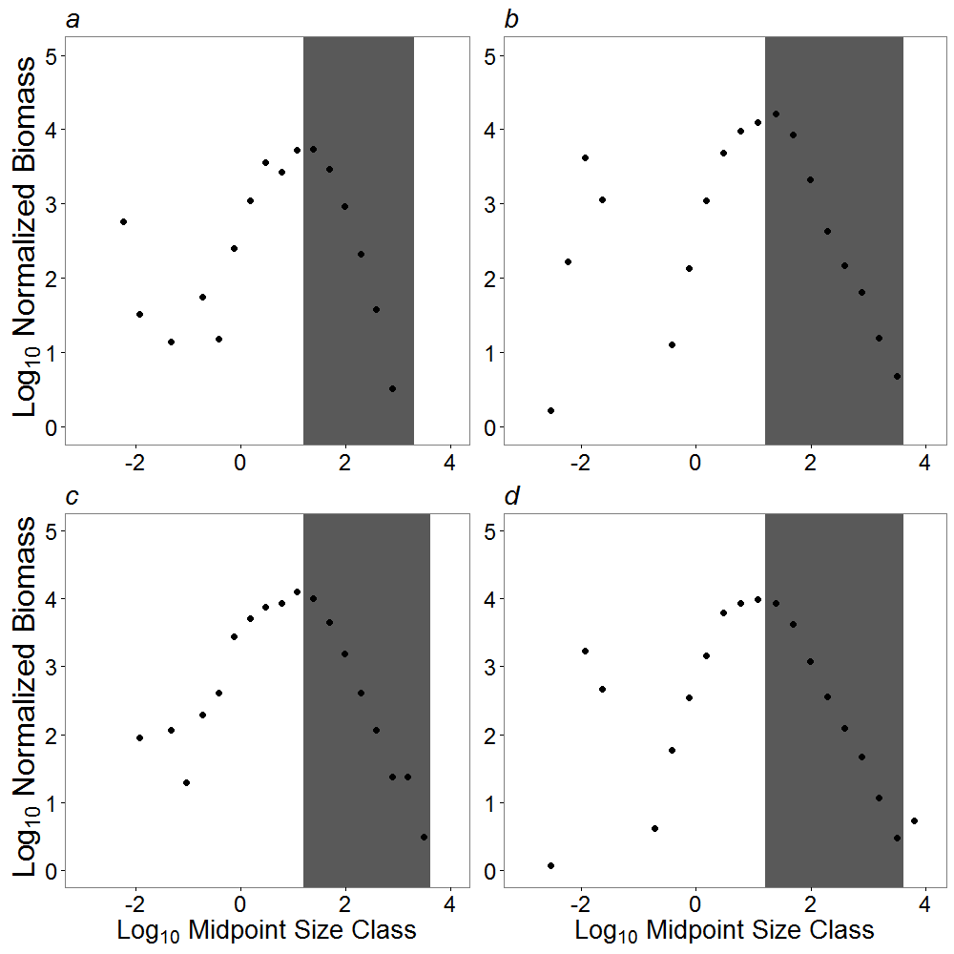
Figure S1. Log₁₀ normalized biomass plotted against log₁₀ midpoint size class for the entire size range of trawl catch. Range used in this study marked by grey rectangle. a: Non-indigenous species in the years 1990-1994. b: Indigenous species in the years 1990-1994. c: Non-indigenous species in the years 2008-2012. d: Indigenous species in the years 2008-2012. The increase in biomass with size for species <8g is associated with net size-selectivity.

