Supplement to:
Tyrannosauroid integument reveals conflicting patterns of gigantism and feather evolution.

Phil R. Bell¹, Nicolás E. Campione², W. Scott Persons IV³, Philip J. Currie³, Peter L. Larson⁴, Darren H. Tanke⁵, Robert T. Bakker⁶.

¹University of New England, Armidale 2351, NSW, Australia. ²Department of Earth Sciences, Uppsala University, Villavägen 16, SE 752 36 Uppsala, Sweden. ³University of Alberta, Edmonton, Alberta T6E 4S6, Canada. ⁴Black Hills Institute of Geological Research, Inc., Hill City, South Dakota 57745, USA. ⁵Royal Tyrrell Museum of Palaeontology, Drumheller, Alberta, Canada. ⁶Houston Museum of Natural Science, Houston, Texas 77030, USA.

This file contains:
- Supplementary descriptions of tyrannosaurid skin
- Extended analytical methods
- Extended results
Table S1. Data set used in ancestral state reconstruction.
Table S2. Palaeotemperature estimates for key tyrannosauroid localities.

(a) Supplementary descriptions of tyrannosaurid skin

Dinosauria Owen, 1842
Saurischia Seeley, 1888
Theropoda Marsh, 1881
Tetanurae Gauthier, 1986
Coelurosauria Huene, 1914
Tyrannosauroidea Walker, 1964
Tyrannosauridae Osborn, 1905
Albertosaurus Osborn, 1905
Albertosaurus sarcophagus Osborn, 1905

Material. Albertosaurus sarcophagus (RTMP [Royal Tyrrell Museum of Paleontology, Drumheller, Alberta, Canada] 1994.186.0001); partial postcranial skeleton including a number of vertebral fragments, ribs, gastralia, and hindlimb fragments, including a well-preserved astragalus; uppermost Horsethief Member (upper Campanian) of the Horseshoe Canyon Formation exposed near the city of Edmonton, Alberta, Canada.
Taxonomic assignment. Among the recovered elements, the astragalus is the most taxonomically informative. The condyles face anteriorly and the tall ascending process is nearly as mediolaterally wide as the distal condylar region, typical of tyrannosaurids and other basal coelurosaurs [1, 2]. The anterior margin between the lateral and medial condyles is deeply concave in distal view and the lateral condyle is separated from the concave trochlear surface by a distinct notch. This notch is peculiar to Alioramus and Albertosaurus sarcophagus among tyrannosaurids [2]. Considering A. sarcophagus is the only large coelurosaur known from the Horseshoe Canyon Formation [3, 4], we assign this specimen to that taxon.
Description. Two patches of skin are preserved. The first patch occurs in association with several gastral ribs and the impression of an unidentified long bone (Fig. S1A–D), suggesting the skin comes from the abdominal region of the animal. The patch of skin measures roughly 10 x 8 cm although the impressions extend further into the matrix and under the gastralia. The skin consists of pebbly, subcircular basement scales (mean diameter = 1.4 mm; range = 1.4–1.6 mm) preserved in bold relief, and which grade into larger (mean diameter = 2.3 mm; range = 2.0–2.5 mm) vaguely hexagonal scales. Six adjacent scales regularly surround each scale. Also preserved are two conical feature scales (sensu [5]), 7 mm in diameter, 2.5 mm high and situated 45 mm apart (Fig. S1B, D). Weak corrugations radiate from the apex of the feature scale but do not extend to the apex itself. Although feature scales are present on a variety of ceratopsids, hadrosaurids, stegosaurids, and titanosaurid sauropods, they have been previously identified in theropods only in the albelisaurid Carnotaurus sastrei [6]. Not enough is preserved to determine whether or not the feature scales were randomly distributed or arranged into rows as in Carnotaurus [6]. A transverse fold in the skin clearly illustrates the original pliability of the integument. Interestingly, the integument along the length of the fold contrasts with the surrounding closely packed pebbly scales. Instead, the integument here is pockmarked with 1mm wide divots spaced 3–5 mm apart. A second patch of skin, from an unknown part of the body measures 7 x 12 cm, and comprises a uniform basement of diamond-shaped scales in negative relief. The scales measure 4 x 3 mm in dimension and are neatly arranged with each scale surrounded by six of its neighbours (Fig. S1E).

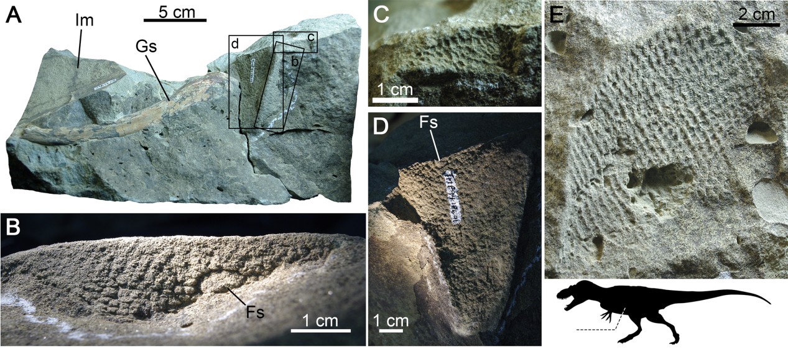
Fig. S1. Albertosaurus sarcophagus (TMP 1994.186.0001) skin with inset showing approximate location (dashed line) on the body. A. Skin associated with a gastral rib (Gs) and impression of an unidentified limb element (lm). B–D, close ups of A showing skin architecture and feature scales (Fs). B is rotated approximately 180° from the view in A. E. Skin from an unidentified area of the body showing uniformly polygonal basement scales. Silhouette by Stephen O’Connor and T. Michael Keesey, obtained from Phylopic.org.

Daspletosaurus Russell, 1970
Daspletosaurus torosus Russell, 1970
Material. TMP 2001.036.0001; skull and skeleton; Milk River Formation (lower Campanian), Manyberries, Alberta, Canada.
Description. TMP 2001.036.0001 preserves traces of integument; however, the actual specimens could not be relocated at the time of writing suggesting they may still remain in unprepared jackets [7]. From the available field photos taken by one of us (P.J.C.), the scales formed a uniform basement of small (approx. 3 mm) irregular polygons, similar to other tyrannosaurids (Fig. S2).
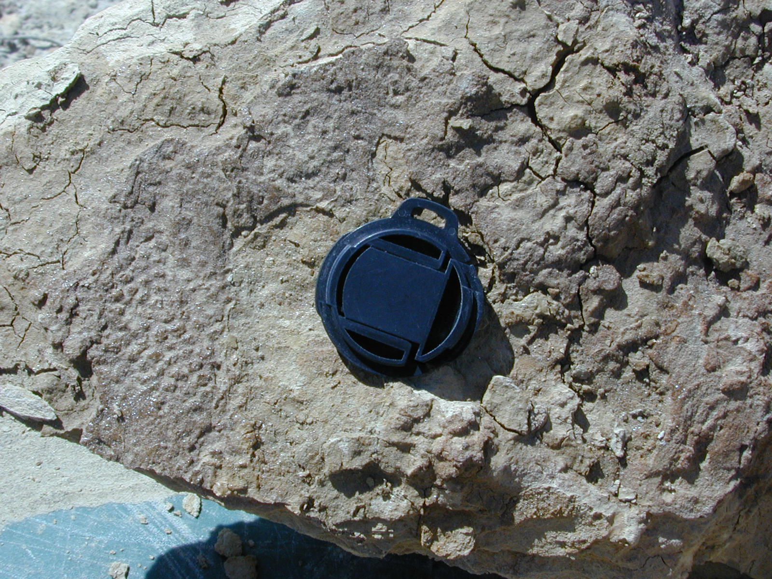
Fig. S2. Field photograph of Daspletosaurus torosus (TMP 2001.036.0001) integument. Lens cap is approximately 30 mm in diameter. Photo: P.J. Currie.

Gorgosaurus Lambe, 1914
Gorgosaurus libratus Lambe, 1914
Material. CMN (Canadian Museum of Nature, Ottawa, Ontario, Canada) 11593; partial postcranial skeleton; Dinosaur Park Formation (upper Campanian), Dinosaur Provincial Park, Alberta, Canada.
Description. An incomplete postcranial skeleton of Gorgosaurus libratus (CMN 11593) preserves a small (2x2 cm) patch of skin on the ventrolateral surface of one of the haemal spines from the middle one-third of the tail. The scales show no relief and are visible only as colour variations within a dark mineral rind (Fig. S3A,B). The undifferentiated basement scales are polygonal or subcircular, although the faintly demarcated edges of many of the scales make it difficult to clearly discern their shape. Individual scales have an average diameter of 3.6 mm with a range of 2.5–4.9 mm. The scales are light-coloured at their edges with a darker central region, which appears variably as a spot or as a series of concentric rings. Each scale is demarcated by a narrow band of dark-coloured interstitial tissue <0.5 mm wide. Currie and Koppelhus [7] also noted small patches of skin that were found on the holotype of Gorgosaurus libratus (CMN 2120) during restoration of the specimen in the 1980’s; however, these were later covered over with plaster and the moulds taken of the skin could not be relocated at the time of writing.

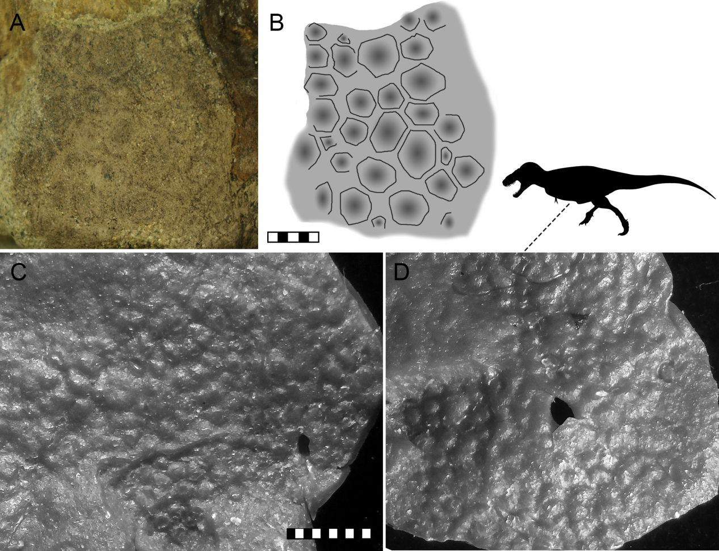
Fig. S3. Tyrannosaurid skin. A, B, Photograph and interpretive illustration of Gorgosaurus libratus (CMN 11593) polygonal basement scales found superficial to one of the haemal spines. C, D, Tarbosaurus baatar (RTMP 2009.141.0002, cast) pebbly skin from the thoracic region as indicated by the silhouette. Scale bar increments in millimetres. Photograph in A by J. Mallon. Silhouette by Scott Hartman, obtained from Phylopic.org.

Tarbosaurus Maleev, 1955
Tarbosaurus bataar Maleev, 1955
Material. MPC (Mongolian Palaeontology Centre, Ulan Bataar, Mongolia) 107/6A and RTMP 2009.141.0002 (cast); frontals and skin impressions from a poached and heavily damaged skull and skeleton (not collected); Bugin Tsav, Nemegt Formation (upper Campanian-lower Maastrichtian), Mongolia.
Description. Two small, dislocated patches of integument (Fig. S3C,D) were found in the thoracic region of MPC 107/6A although extensive damage by poachers makes the exact position of these remains indeterminable. This specimen was originally noted by Currie et al. [8], who briefly described the skin. The largest patch measures 6 x 8 cm and the smaller patch measures 5 x 7 cm. Both patches are composed of a uniform basement of raised, smooth, subcircular pebbles. They appear neatly arranged with each scale surrounded by five-to-seven of its neighbours. Individual scales do not differ notably in size between the two samples (large patch: mean scale diameter = 2.1 mm, range = 1.3–2.9 mm; small patch: mean scale diameter = 1.9 mm; range 1.7–2.3 mm).

(b) Extended Analytical Methods.
Given the low sample size available for tyrannosauroids with known integument (N=7) and size data (N=15), a sophisticated model-fitting technique (e.g., [13, 14]), in particular, those accommodating for different evolutionary regimes [15], could not be carried out here. As a result, we adopt a more simplistic exploratory approach, by which we qualitatively assess the relative timing of changes in body size and integument. Following the hypothesis that feathers are lost as a result of large body size, we predict that, if so, body size should increase first, followed by or simultaneous with the loss of feathers.
In order to assess the relative timing of character changes within a phylogenetic context, we adopt a similar approach to that of VanBuren et al. [16] in which ancestral state estimates are generated for characters of interest and plotted onto the same phylogeny. Femoral length is used as a proxy for size, which, although not ideal [17], provides the largest possible sampling of the tyrannosauroid tree. The tyrannosauroid phylogeny follows that of Brusatte and Carr [18], pruned for taxa for which we could obtain femoral lengths and/or integument data. We added Tanycolagreus as the sister-taxon to all other tyrannosauroids based on Brusatte et al. [19]. The analyses were run under both topologies presented by Brussatte and Carr [18], which were based on either a parsimony or Bayesian analysis and vary in the phylogenetic position of Dryptosaurus. All analyses were carried out in R v.3.2.3 [20] using various packages (See Source Code file). The time scaling of the tree was carried out in paleotree v.2.7 [21] in which zero-length branches were modified using two methods: 1) the equal method (adding 1Ma to the root and then shared throughout the tree) and 2) the minimum branch length (mbl) method (which makes all zero-length branches 1Ma or greater). Use of both methods serves as a simple test of the sensitivity of the results to variations in branch lengths. The equal approach tends to generate longer terminal branches and shorter internodes, while the mbl approach does the opposite (Fig. S4). Ancestral state estimates and plotting were carried out in ape v.3.3 and phytools v.0.5-00 [22, 23].

(c) Extended Results.
The results outlined in the main document are robust to the alternate topologies and branch scaling technique explored in this study (Fig. S4). In all cases filaments are primitive for tyrannosaurids and are lost no earlier than in the clade comprising Gorgosaurus, Albertosaurus, Daspletosaurus, Tarbosaurus, and Tyrannosaurus. The only notable difference in the body size evolution analysis is in the effect that Xiongguanlong has on the ancestral state it shares with tyrannosaurids. Under the mbl scaling approach, there is an apparent decrease in body size in the lineage leading to Tyrannosauridae. Regardless, all analyses indicate independently-derived large body sizes between tyrannosaurids and Yutyrannus.
C
D
E
F
G
H
B
A
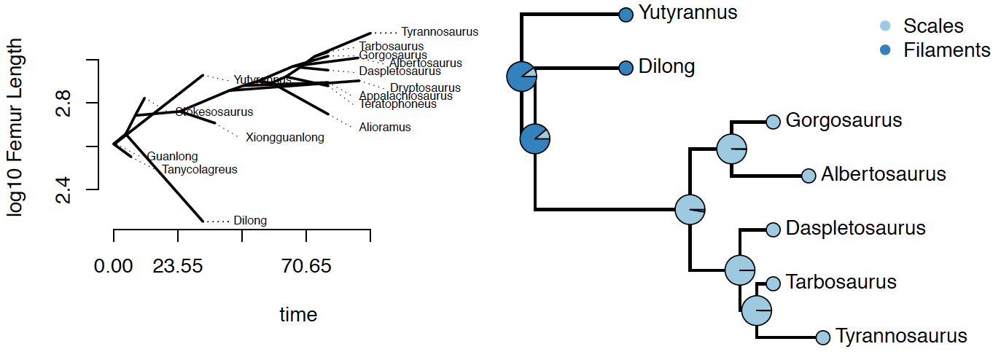

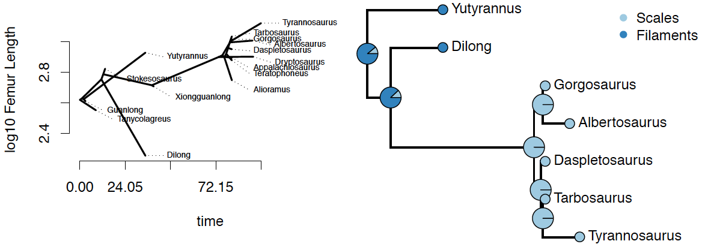

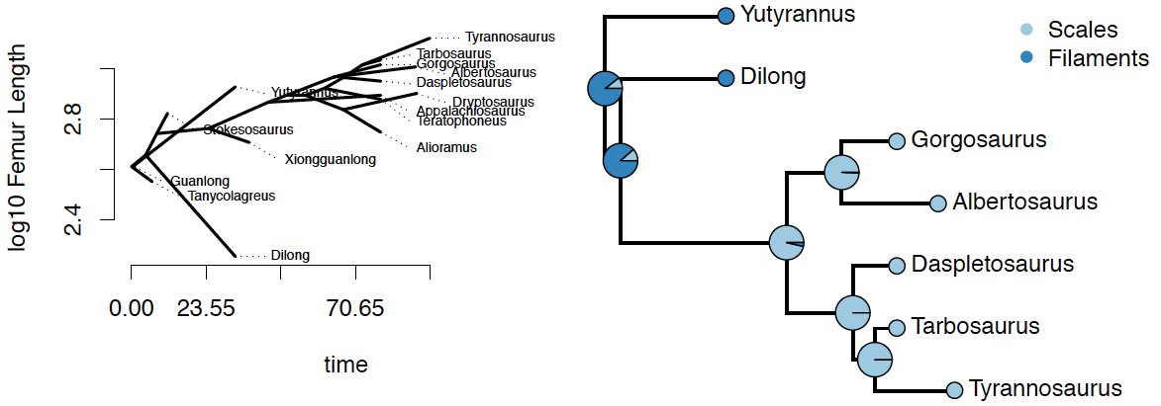

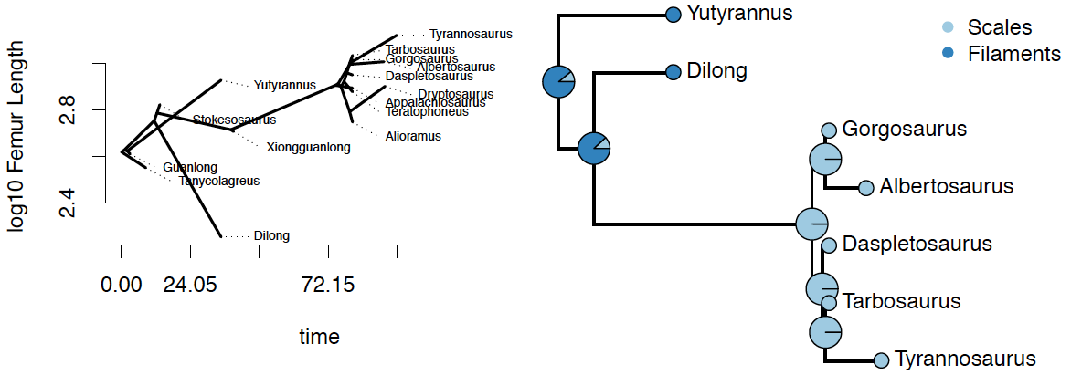
Fig. S4. Results of the body size and integument ancestral state reconstructions under different parameters. A, C, E, G, body size evolution in Tyrannosauroidea; B, D, F, H, ancestral state likelihoods for the evolution of integument. A–D, are based on the maximum parsimony tree of Brusatte and Carr [18], E–H, are based on the Bayesian tree. A, B, E, F, follow the equal approach for handling zero-length branches, and C, D, G, H, using the mbl approach (see text above for more details).

Table S1. Data set used in ancestral state reconstruction.
Genus | Femur Length (mm) | Integument | FAD | LAD
Albertosaurus | 1020 | 0 | 72.5 | 68
Alioramus | 560 |  | 83.5 | 66
Appalachiosaurus | 786 |  | 83.5 | 72.1
Daspletosaurus | 895 | 0 | 83.5 | 72.1
Dilong | 179 | 1 | 129.4 | 125
Dryptosaurus | 800 |  | 72.1 | 66
Gorgosaurus | 1040 | 0 | 83.5 | 72.1
Guanlong | 408 |  | 161.2 | 155.7
Stokesosaurus | 667 |  | 150.8 | 145.5
Tanycolagreus | 356 |  | 155.7 | 145.5
Tarbosaurus | 1087 | 0 | 83.5 | 66
Teratophoneus | 757 |  | 83.5 | 72.1
Tyrannosaurus | 1327 | 0 | 68 | 66
Xiongguanlong | 510 |  | 125 | 99.6
Yutyrannus | 850 | 1 | 129.4 | 125

Table S2. Palaeotemperature estimates for key tyrannosauroid localities.
Formation | MAAT | Reference
Nemegt | 10–14°C | [9]
Horseshoe Canyon | 9–11°C | [10]
Hell Creek | 10°C; up to 23°C in the upper 20 m part of the formation | [11]
Yixian | 10 ± 4°C | [12]

References

1. Brusatte S.L., Benson R.B.J., Norell M.A. 2011 The anatomy of Dryptosaurus aquilunguis (Dinosauria: Theropoda) and a review of its tyrannosauroid affinities. American Museum Novitates 3717, 53 pp.
2. Brusatte S.L., Carr T.D., Norell M.A. 2012 The Osteology of Alioramus, A Gracile and Long-Snouted Tyrannosaurid (Dinosauria: Theropoda) from the Late Cretaceous of Mongolia. Bulletin of the American Museum of Natural History 366, 1-197. (doi:10.1206/770.1).
3. Eberth D.A., Evans D.C., Brinkman D.B., Therrien F., Tanke D.H., Russell L.S., Sues H. 2013 Dinosaur biostratigraphy of the Edmonton Group (Upper Cretaceous), Alberta, Canada: evidence for climate influence. Canadian Journal of Earth Sciences 50(7), 701–726.
4. Bell P.R., Currie P.J. 2014 Albertosaurus (Dinosauria: Theropoda) material from an Edmontosaurus bonebed (Horseshoe Canyon Formation) near Edmonton: clarification of palaeogeographic distribution. Canadian Journal of Earth Sciences 51(11), 1052-1057. (doi:10.1139/cjes-2014-0050).
5. Bell P.R. 2012 Standardized Terminology and Potential Taxonomic Utility for Hadrosaurid Skin Impressions: A Case Study for Saurolophus from Canada and Mongolia. PLoS ONE 7(2), e31295. (doi:10.1371/journal.pone.0031295).
6. Bonaparte J.F., Novas F.E., Coria R.A. 1990 Carnotaurus sastrei Bonaparte, the horned, lightly built carnosaur from the middle Cretaceous of Patagonia. Los Angeles County Natural History Museum Contributions in Science 416, 1–42.
7. Currie P.J., Koppelhus E.B. 2015 The significance of the theropod collections of the Royal Tyrrell Museum of Palaeontology to our understanding of Late Cretaceous theropod diversity. Canadian Journal of Earth Sciences 52(8), 620-629. (doi:10.1139/cjes-2014-0173).
8. Currie P., Badamgarav D., Koppelhus E. 2003 The First Late Cretaceous Footprints from the Nemegt Locality in the Gobi of Mongolia. Ichnos 10(1), 1-13. (doi:10.1080/10420940390235071).
9. Golovneva L.B. 2000 The Maastrichtian (Late Cretaceous) climate in the Northern Hemisphere. In Climates: Past and Present (ed. Hart M.B.), pp. 43-54. London, U.K, Geological Society, London Special Publications.
10. Quinney A., Therrien F., Zelenitsky D.K., Eberth D.A. 2013 Palaeoenvironmental and palaeoclimatic reconstruction of the Upper Cretaceous (late Campanian–early Maastrichtian) Horseshoe Canyon Formation, Alberta, Canada. Palaeogeography, Palaeoclimatology, Palaeoecology 371, 26-44. (doi:10.1016/j.palaeo.2012.12.009).
11. Johnson K., Wilf P. 1996 Paleobotanical temperature curve for the Cretaceous-Tertiary boundary interval and a scenario for the revegetation of North America after the terminal Cretaceous event. In Geological Society of America Abstracts with Programs (p. 225.
12. Amiot R., Wang X., Zhou Z., Wang X., Buffetaut E., Lécuyer C., Ding Z., Fluteau F., Hibino T., Kusuhashi N., et al. 2011 Oxygen isotopes of East Asian dinosaurs reveal exceptionally cold Early Cretaceous climates. Proceedings of the National Academy of Sciences 108(13), 5179-5183. (doi:10.1073/pnas.1011369108).
13. Benson R.B.J., Campione N.E., Carrano M.T., Mannion P.D., Sullivan C., Upchurch P., Evans D.C. 2014 Rates of Dinosaur Body Mass Evolution Indicate 170 Million Years of Sustained Ecological Innovation on the Avian Stem Lineage. PLoS Biol 12(5), e1001853. (doi:10.1371/journal.pbio.1001853).
14. Harmon L.J., Losos J.B., Jonathan Davies T., Gillespie R.G., Gittleman J.L., Bryan Jennings W., Kozak K.H., McPeek M.A., Moreno‐Roark F., Near T.J. 2010 Early bursts of body size and shape evolution are rare in comparative data. Evolution 64(8), 2385-2396.
15. Beaulieu J.M., Jhwueng D.C., Boettiger C., O’Meara B.C. 2012 Modeling stabilizing selection: expanding the Ornstein–Uhlenbeck model of adaptive evolution. Evolution 66(8), 2369–2383.
16. VanBuren C.S., Campione N.E., Evans D.C. 2015 Head size, weaponry, and cervical adaptation: Testing craniocervical evolutionary hypotheses in Ceratopsia. Evolution 69(7), 1728-1744. (doi:10.1111/evo.12693).
17. Campione N.E., Evans D.C. 2012 A universal scaling relationship between body mass and proximal limb bone dimensions in quadrupedal terrestrial tetrapods. BMC Biology 10(1), 60.
18. Brusatte S.L., Carr T.D. 2016 The phylogeny and evolutionary history of tyrannosauroid dinosaurs. Scientific Reports 6, 20252. (doi:10.1038/srep20252).
19. Brusatte Stephen L., Lloyd Graeme T., Wang Steve C., Norell Mark A. Gradual Assembly of Avian Body Plan Culminated in Rapid Rates of Evolution across the Dinosaur-Bird Transition. Current Biology 24(20), 2386-2392. (doi:10.1016/j.cub.2014.08.034).
20. R Development Core Team. 2015 R: a language and environment for statistical computing. v. 3.2.3. See www.R-project.org.
21. Bapst D.W. 2015 paleotree: Paleontological and Phylogenetic Analyses of Evolution. v. 2.3. See https://github.com/dwbapst/paleotree.
22. Paradis E. 2012 Analysis of Phylogenetics and Evolution with R. 2nd ed. New York, NY, Springer.
23. Revell L.J. 2012 phytools: an R package for phylogenetic comparative biology (and other things). Methods in Ecology and Evolution 3(2), 217-223. (doi:10.1111/j.2041-210X.2011.00169.x).

