Electronic Supplementary Material for:
“Inference of facultative mobility in the enigmatic Ediacaran organism Parvancorina

Authors: Simon A. F. Darroch, Imran A. Rahman, Brandt Gibson, Rachel A. Racicot and Marc Laflamme

ESM 4. In all the CFD simulations, the domain was meshed using free tetrahedral elements. The mesh size varied depending on the size and complexity of the model. Moderate meshes used in the simulations for models of the original Parvanocrina morphotypes consisted of: 357343 elements, a maximum element size of 6.17 mm, and a minimum element size of 1.84 mm for Parvancorina minchami [South Australia]; 443942 elements, a maximum element size of 11 mm, and a minimum element size of 3.28 mm for Parvancorina minchami [White Sea]; and 437304 elements, a maximum element size of 1.9 mm, and a minimum element size of 0.567 mm for Parvancorina sagitta. To test whether the results were independent of mesh size, we repeated simulations with the models oriented at 0° to the current using fine (573748 elements, maximum element size of 4.88 mm, and minimum element size of 0.92 mm for Parvancorina minchami [South Australia]; 698115 elements, maximum element size of 8.62 mm, and minimum element size of 1.63 mm for Parvancorina minchami [White Sea]; and 707788 elements, maximum element size of 1.5 mm, and minimum element size of 0.283 mm for Parvancorina sagitta), coarse (152495 elements, maximum element size of 9.2 mm, and minimum element size of 2.76 mm for Parvancorina minchami [South Australia]; 200717 elements, maximum element size of 16.3 mm, and minimum element size of 4.88 mm for Parvancorina minchami [White Sea]; and 185772 elements, maximum element size of 2.83 mm, and minimum element size of 0.85 mm for Parvancorina sagitta) and extra coarse (47900 elements, maximum element size of 18.4 mm, and minimum element size of 4.6 mm for Parvancorina minchami [South Australia]; 61154 elements, maximum element size of 32.5 mm, and minimum element size of 8.13 mm for Parvancorina minchami [White Sea]; and 54691 elements, maximum element size of 5.67 mm, and minimum element size of 1.42 mm for Parvancorina sagitta) meshes. See Supplementary Figure 5 for mesh sizes for Parvancorina minchami [South Australia].
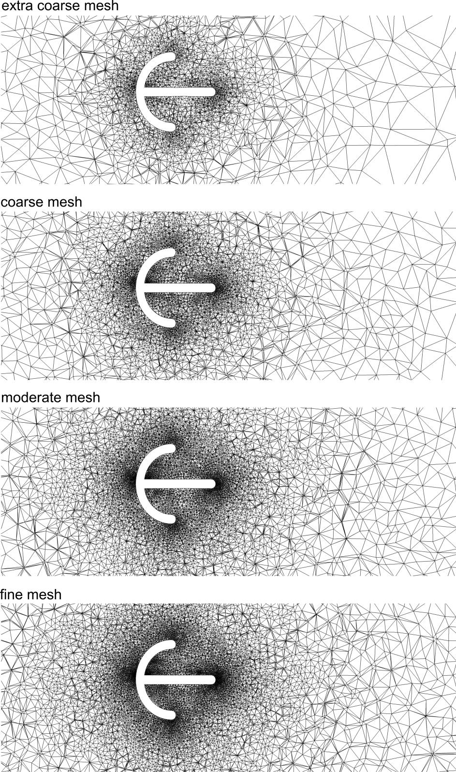

Supplementary Figure 5. Four different mesh sizes used in CFD simulations for Parvancorina minchami [South Australia]. Meshed domain shown in horizontal cross-sections.

The overall magnitude of flow velocity increased as increasingly finer meshes were utilized, with the flow velocity generally lowest in the simulations using extra coarse meshes and highest in the simulations using fine meshes. Additionally, the patterns of recirculating flow around the models were much less well developed in the simulations with extra coarse and coarse meshes than they were in those with moderate or fine meshes. Importantly, the differences between the simulations using moderate and fine meshes were relatively minor when compared to any other pairs of mesh sizes. We therefore selected moderate meshes for use in our study because the resulting flow patterns were very similar to those obtained when using fine meshes, guaranteeing computational accuracy, and using moderate meshes greatly reduced the simulation times and thereby enhanced the computational efficiency of the study.

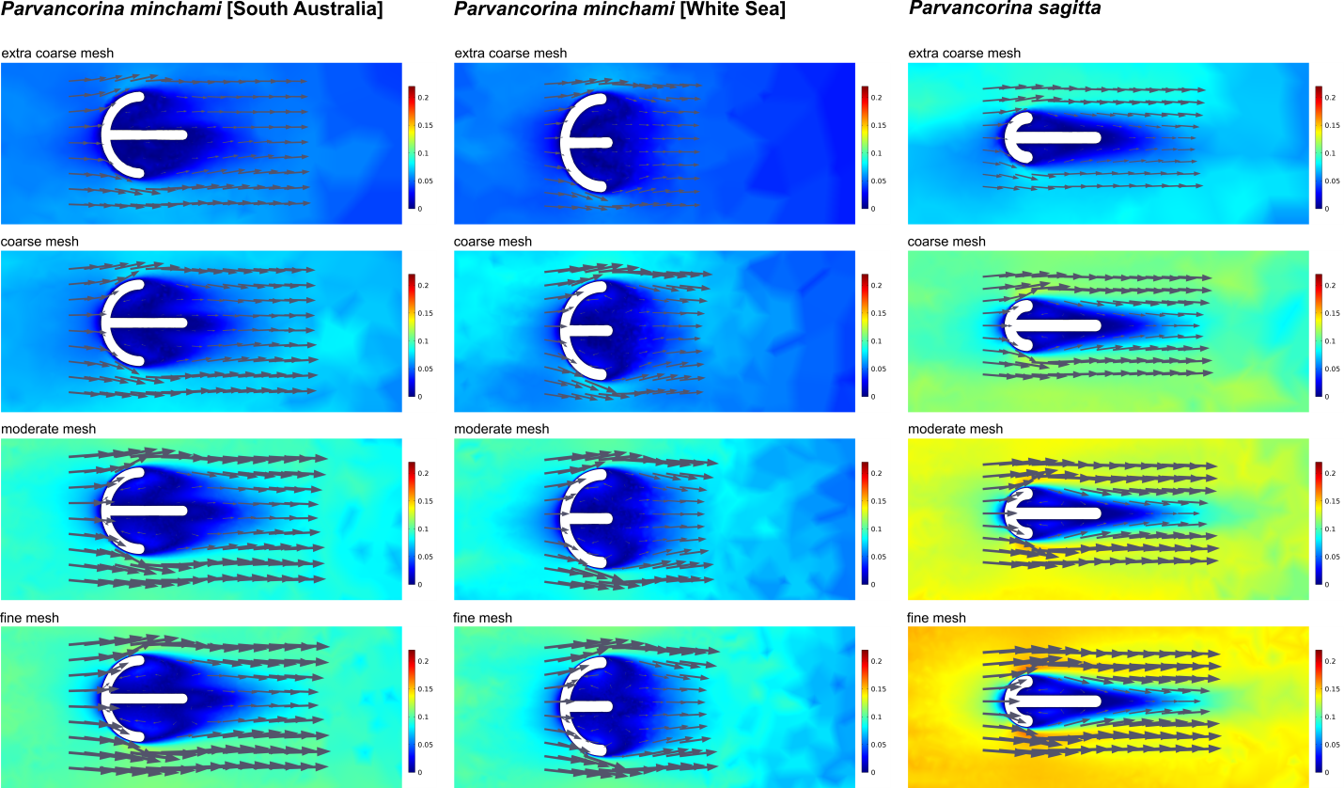

Supplementary Figure 6. Computer simulations of water flow around Parvancorina models using different mesh sizes. Results of CFD simulations visualized as two-dimensional plots (horizontal cross-sections) of flow velocity magnitude with flow vectors (arrows). Ambient flow from left to right (uniform inlet velocity of 0.2 m/s).

Online references

1S: Rahman IA, Lautenschlager S. 2017. Applications of three-dimensional box modeling to paleontological functional analysis. In Virtual Paleontology (eds. L. Tapanila, IA Rahman). The Paleontological Society Papers 22, 119–132. (doi:10.1017/scs.2017.11).

2S: Gehling JG. 1999 Microbial mats in Terminal Proterozoic siliciclastics: Ediacaran death masks. Palaios 14, 40–57. (doi:10.2307/3515360)

3S: Schieber J. 2003 Simple gifts and buried treasures—implications of finding bioturbation and erosion surfaces in black shales. The Sedimentary Record 1, 4–8.

4S: Hall CM, Droser ML, Gehling JG, Dzaugis ME. 2015 Paleoecology of the enigmatic Tribrachidium: new data from the Ediacaran of South Australia. Precambrian Research 269, 183–194. (doi:10.1016/j.precamres.2015.08.009)

