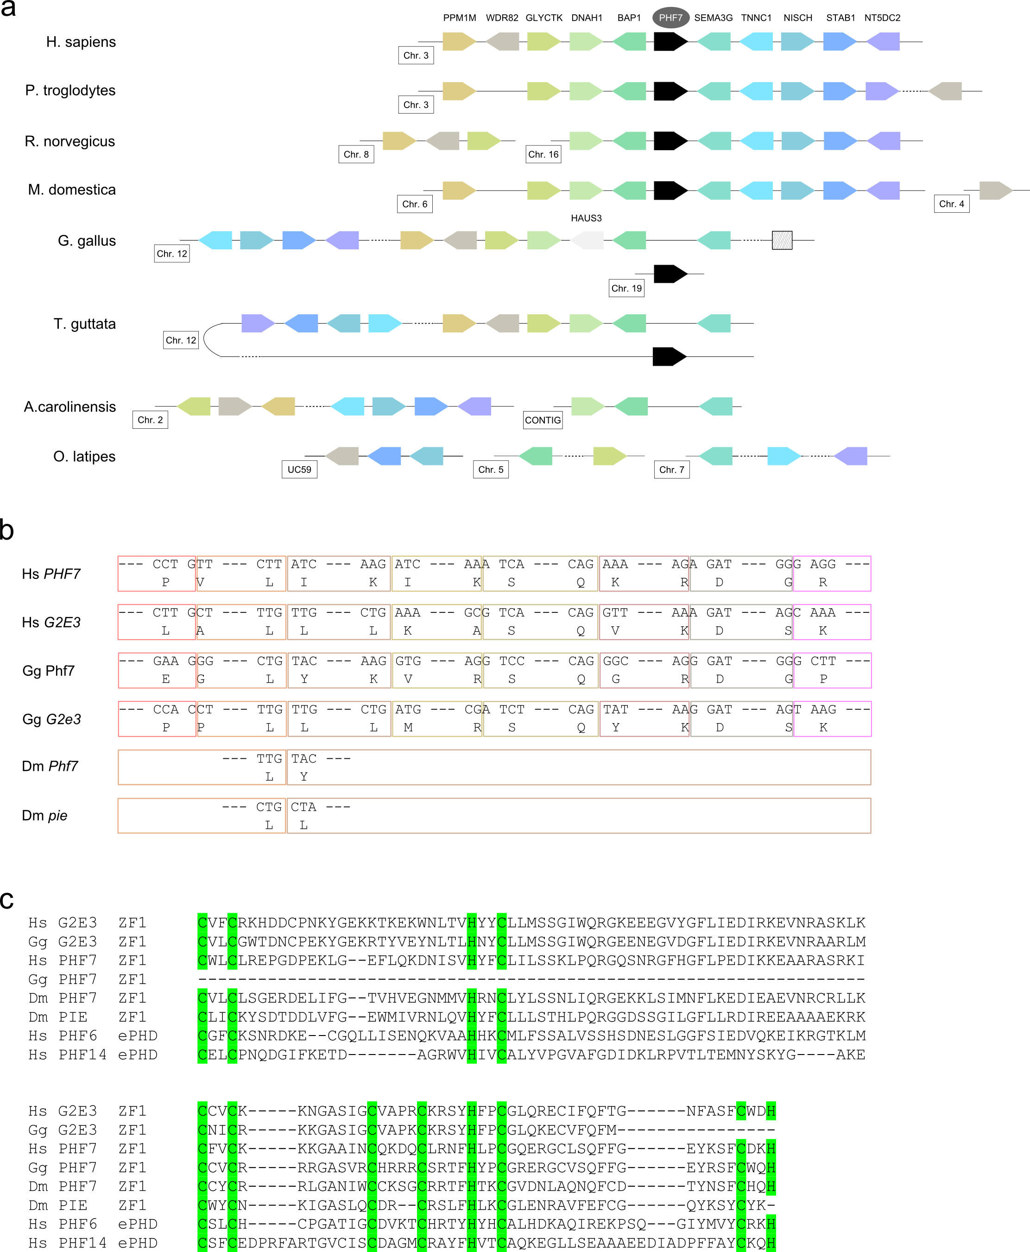
Figure S3. Comparisons of Phf7 and G2e3 in different species. a, synteny of genes around Phf7 in select mammals, birds, reptiles, and fish. The species names are listed on the left and the genes surrounding Phf7 are depicted on the right. Each gene is depicted with the same color. Directionality for each gene as well as the chromosome it is on are as labeled. In chicken there is a partial gene fragment homologous to Phf7 downstream of Sema3g and is indicated with a square with hatched pattern. CONTIG, unplaced contig; UC59, ultracontig 59. b, conservation of exon structures in Phf7 and G2e3 homologs in H. sapiens, G. gallus, and D. melanogaster. The homologous regions of these six proteins are depicted based on their alignment and the codons and amino acids at exon junctions are indicated. The colored boxes, which are not drawn to scale, represent individual exons and dashed lines indicate sequences in the middle of exons. c, alignment of the first zinc fingers from PHF7 and G2E3 of H. sapiens, G. gallus, and D. melanogaster to the extended PHD domain from PHF6 and PHF14 from H. sapiens. The C/H residues that make up the extended PHD domains are highlighted in green.

