**Supplementary Material**

Photography

The upper part of the uniform (shirt or jacket) was placed on a horizontal plastic board mounted on a tripod and the top back side was photographed from above. This provided the most continuous (i.e. without seams and ripples) surface of the pattern. Shelter-halves (wearable, single-person tents) did not have an obvious orientation and were positioned based on images from photographic references. Creases were reduced by smoothing the uniforms to cover a 46.8 x 42.8 cm rigid plastic board and attaching clothes pegs (**Fig. 1a**). Certain uniforms had elastic sewn into the fabric, resulting in unavoidable ripples. Although these ripples distort the original structure of the graphic design, they become part of the ‘realised’ visual appearance of the pattern. The same applies to uniforms with major seams, where a large, uninterrupted surface is not available.

Images were taken from 119 cm directly overhead with a Canon EOS 650D camera mounted on a tripod with a horizontally adjusted centre column. Controlled lightning was provided by a Meike MK-14EXT Macro TTL ring flash set to power level 1/1. This bright illuminant combined with a short exposure (1/200 s) reduced the influence of ambient light to negligible levels. Focal length was fixed at 24 mm and the aperture set to f18, which enabled the uniform to span the whole image while remaining in focus. Camera sensitivity was set to ISO 100, and a remote trigger was used to remove camera shake. Camera and flash settings were chosen through trial and error to avoid clipping of any of the colours in the sample, from those of dark uniforms (e.g. South-East Asian jungle patterns) to light (e.g. winter and desert patterns). An X-rite ColorChecker Passport with 24 reference colours was placed in the corner of each image. Images were taken in RAW format and later converted to TIFF using Canon Digital Photo Professional 3.14. Images were then calibrated to sRGB reference colour space using the 24 ColorChecker colours and a 3rd order polynomial transformation written in MATLAB. For each pattern a square equivalent of 384 x 384 mm was cropped and resized to 512 x 512 pixels using bicubic interpolation, where 1 pixel equalled 1⅓ mm (**Fig. S1b**). The size of the square was selected to maximise available pattern surface.

Dating

Patterns with exact issue year unavailable were allocated into four groups based on the documented temporal range of issue relative to the decade. Patterns with an ‘early’ tag were assigned to the third year of the decade, ‘mid’ to the sixth, ‘late’ to the ninth, while in cases where only the decade was known, also to the sixth year. For example, temporal tags of early 1990’s, mid-1970’s, late 1980’s, and 1960’s were represented as 1992, 1975, 1988, and 1965, respectively. In rare cases where even the decade was uncertain (e.g. 1960’s-1970’s), the first decade was selected with the assumption that early prototypes have likely predated the observed patterns. The earliest pattern in the database was issued in 1929, and the most recent one in 2013. Therefore, the temporal span of pattern database is approximately 85 years.

Pre-processing and segmentation

Most camouflage uniform patterns are assemblages of well-defined colour patches. Pixel values of patches with the same colour often slightly vary on images due to manufacturing artefacts, ripples, or contamination. Clean texture segmentation is required for two reasons: first, textile artefacts (e.g. ripples and seams) can distort the final image by introducing false edges. Secondly, structural analysis should be carried out independently of colour; however, the dynamic range of ‘sibling’ patterns can vary substantially. For example, many arid patterns have the same structural composition as their temperate counterparts, but with highly reduced contrast between colours. When analysing texture, the transition between shapes should not be affected by their relative contrast, only the transition itself should be recorded.

**Step 1.** The majority of camouflage patterns feature dull, unsaturated colours resembling the average colours of their destined environments. To enhance the contrast between patches within patterns, we used contrast limited adaptive histogram equalisation (CLAHE) [1] on images transformed into CIELab colour space [2]. CLAHE divides the image into small regions (tiles) and adjusts the contrast of each of them. Tiles are enhanced to have a histogram of a predefined distribution, which was set to a uniform distribution. CLAHE enhances the difference between two similarly coloured objects, which enables accurate separation of texture regions. However, as a side-effect it can also emphasise textile artefacts. To address this issue, seven enhanced images were created by pattern, with CLAHE applied to combinations of CIELab channels (L\*; a\*; b\*; L\* and a\*; L\* and b\*; a\* and b\*; L\*, a\*, and b\*) while the remaining channels were averaged. This step enabled segmentation carried out based on the most informative combination of channels for each pattern. For example, while a pattern with two shades of green and two shades of brown can be segmented using the a\* and b\* channels (discarding the L\* channel, which is most sensitive to textile creases), an urban pattern with three shades of grey can be more accurately segmented based on its L\* channel only. CLAHE was implemented by using the *adapthisteq* function in MATLAB 2014b with clip limit of 0.02 and [2,2] as the number of tiles (both settings experimentally derived). The adjustment of parameters to produce the ‘desired’ segmentation may seem subjective; however, the vast majority of camouflage patterns have clear segmentation, or historical, records that specify how many colours were used in the design.

**Step 2.** Each of the seven contrast enhanced images per pattern was segmented using parametric kernel graph cuts [3-7]. Graph cuts in machine vision work by interpreting the image as a graph network and partitioning it into segments where the distance between the nodes of two separate segments are above a specified threshold. The graph cut algorithm requires each image being accompanied with the number of regions (colours) on the image and a smoothness term α, which controls for boundary preservation. The number of colours per pattern was carefully selected by the authors and was a number ranging between two and seven. The algorithm was initialised by k-means clustering [8]. The centroids of clusters are then updated using the pixel values currently allocated to the clusters. Clustering is iterated till the algorithm converges. K-means clustering is highly sensitive to noise (e.g. boundaries of two large regions where the colours mixed), which poses a problem when regions with high contrast, but low total area need to be detected (e.g. black spots on German *Flecktarnmuster*). To attenuate this problem, we ran the k-means algorithm 20 times and selected the set of colours with the maximum contrast between colours, i.e. the set with the highest sum of pair-wise distances between colours.

A low smoothness term is ideal to segment images with numerous, small regions (e.g. pixelated camouflage), while an increased value can result in more accurate partitioning of large patterns (e.g. US M81 Woodland and derivatives) by reducing the speckled noise around region boundaries. In order to find the best smoothness term for each pattern, we performed the graph cuts on each CIELab combination using three α values (0.01, 0.05 and 0.1) resulting in 21 segmented images altogether. To find the best segmentation map, each of the 21 maps were applied to the original contrast enhanced image with the colour of each segmented object being averaged (as on the final result each feature should have a uniform colour). The resulting images were then compared to the original contrast enhanced image by using mean squared errors and the one with the minimum distance was chosen as the best segmentation map.

**Step 3.** Camouflage patterns often have features from a wide distribution of spatial scales, where finding the right combination of colour channels and smoothness term cannot be performed without compromises. As the best segmentation map is chosen by minimising errors, the segmentation will be biased towards large objects. Small objects with relatively low contrast to their surroundings can be easily underrepresented and therefore discarded. This problem can be solved by adding a third step to the segmentation process, which we refer to as ‘scavenging’. After the best segmentation map is chosen in step 2, we record the boundaries of every object on the selected map. For every object, we evaluate whether any of the same areas cut out on the other 20 segmentation maps provide a better fit when compared to the original contrast enhanced image. Objects described better by other maps are then updated. This step can be iterated for further segmentation, however we found that a single run was sufficient for adequate results (**Fig. 1c**). If the segmentation failed to provide acceptable results for some reason (e.g. the pattern was too faded), the colour channel(s) and smoothing constant were selected manually. In a few cases the methods still produced unacceptable results, and the pattern was manually redrawn in Adobe PhotoshopTM CS6 [9].

Texture analysis

The Log-Gabor filter bank was composed of six scales (wavelength of 4, 8, 16, 32, 64, and 128 pixels) and four orientations (0°, 45°, 90°, and 135°), totalling 24 filters. Filter responses are affected by the contrast difference of two neighbouring regions, which is undesirable as the response should purely depend on texture, without the influence of luminance and chromaticity. To avoid this problem, logical maps were created for each image (**Fig. S1c**), where only one colour was ‘active’ per map. Each pattern had as many maps as colours, with the exception of 2-colour patterns where one map was sufficient (as the perfect inverse of the other). The Log-Gabor filters were then applied to each logical map per image. Log-Gabor filter responses can be interpreted as a set of complex numbers for each pixel on an image. Taking the absolute of a complex number gives the magnitude of the signal (i.e. how strong is the filter response), while the phase angle in this instance indicates whether the change is from black to white, or vice versa. For this analysis, only the former is informative (**Fig. S1d**); the aim is to gather information about the size and orientation of texture elements without their relative contrast to surroundings. Therefore, only the power spectrum (squared amplitude of the signal) was recorded for each map. Map responses (**Fig. S1e**) were then concatenated by taking the maximum value for each pixel across map responses. The ‘maximum maps’ were summed, resulting in one value for each scale and orientation per image. The 24 values for each image can be understood as dimensions; that is each camouflage pattern was realised in a 24-dimension texture space.

After performing z-score normalisation, principal component analysis was applied in order make the dimensions orthogonal and potentially reduce their number. We selected the first five principal components (PC) as their standard deviation was greater than one (e.g. the Kaiser criteria) [10], i.e. explain more variation than the original texture variables. The derived distance metric between images was the Euclidean distance based on the PC scores.

Colour analysis

**Average colour**. First, the average CIELab [4] colour for each pattern was calculated by taking the mean L\* (luminance), a\* (green vs. red), and b\* (blue vs. yellow) values, weighted by their relative areas (**Fig. S1g**). This provides a good approximation how the pattern would look from a distance when the shapes are blended together into a monotone [11]. Most perceptual colour distances are primarily designed to capture minute differences between very similar colours and perform poorly with medium or large distances. For example, the recommended range of comparison of CIEDE2000, which is generally considered as the state-of-art perceptual colour distance, is only up to 5 CIELab units [12]. However, we found that the measured CIELab mean colour distances of camouflage patterns can be up to 70 units. Pele and Werman have recently proposed a new colour distance called COLDIST [5], which first allocates colours to basic colour terms of the English language before calculating the distance between them using CIEDE2000 colour difference [28]. As this method is more appropriate for a wider range of colour differences, pair-wise distances between average colours were derived by using COLDIST.

**Quantised colour**. The second method was based on quantised colours. This involved expressing each pattern as a histogram of its segmented colours and corresponding percentages of area (**Fig. S1h**). Distances between histograms can be readily calculated using the Earth Mover’s Distance (EMD) [13]. The name of the method comes from an intuitive demonstration of the concept; histograms can be thought of as piles of dirt, and the distance between two histograms is the minimum amount of dirt needed to be transferred from one to another to make them identical. Piles have a ‘ground distance’ between them, which was chosen to be pair-wise COLDIST distances between the quantised colours of camouflage patterns (**Fig. S2**).

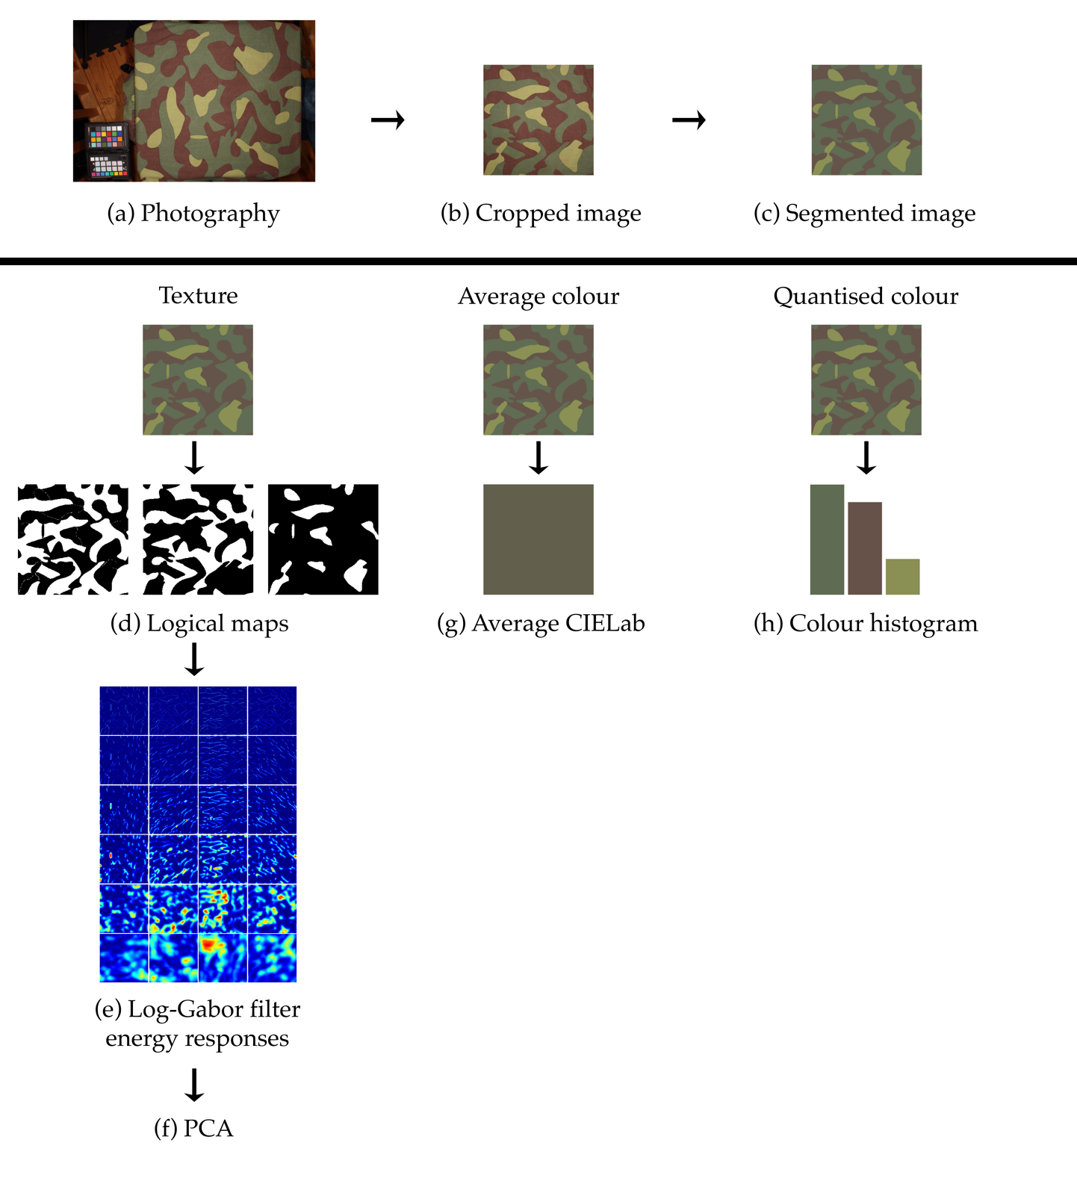

**Figure S1.** Flow chart of image processing used to derive inter-pattern distances for texture, average and quantised colour. Following (a) photography, images are (b) cropped, (c) pre-processed and segmented. Texture analysis involves (d) creating logical maps of individual colours and (e) applying a Log-Gabor filter bank to them. Filter responses are then concatenated across pixel locations by taking the maximum energy response. The sum of energy is calculated for each filter response and z-score normalisation is performed across patterns. Finally, (e) principal component analysis is applied to reduce the texture space. (f) The distance space for average colour is created by taking the mean of each channel followed by calculating inter-pattern distances using COLDIST. (h) Segmented images are represented as a histogram of their colours in the quantised colour analysis. The distance between histograms are measured by taking the Earth Mover’s Distance between them and using COLDIST to calculate inter-colour distances.

../../../../Desktop/Figure_S2.pdf

**Figure S2.** An example for the paired comparison between the colour histograms of two hypothetical patterns. (a) Pattern A has colours A1, A2, and A3, while (b) pattern B contains colours B1 and B2. To compare the two, we create two histograms where the colours of both patterns are represented. Earth Mover’s Distance between the two histograms can now be readily computed by taking the COLDIST distance between the five colours (i.e. the bins of the histograms).

|  |  |  |  |
| --- | --- | --- | --- |
| ../../Dropbox/SHOWCASE/PATTERNS/CANPAT_001_orig_512.JPG  Canada | ../../Dropbox/SHOWCASE/PATTERNS/USAMRW_001_orig_512.JPG  USA | ../../Dropbox/SHOWCASE/PATTERNS/JORK2D_001_orig_512.JPG  Jordan | ../../Dropbox/SHOWCASE/PATTERNS/HRVDNV_002_orig_512.JPG  Croatia |

**Figure S3.** Example pixelated (“digital”) camouflage patterns. Modern Jordanian and Croatian patterns feature the outlines of their countries. The silhouette of Jordan is observable in the bottom right corner of the pattern; a small black patch over a tan background. On the Croatian Navy pattern, the silhouette has a light grey background, situated towards the top left corner from the middle.

References cited in Appendix

1. Zuiderveld K. 1994 Contrast Limited Adaptive Histogram Equalization. In P. Heckbert, ed. *Graphics Gems IV*, 474–485.

2. Wyszecki G, Stiles W. 1982 *Color Science: Concepts and Methods, Quantitative Data and Formulae*. 2nd ed. New York: Wiley.

3. Boykov Y, Veksler O, Zabih R. 2001 Fast approximate energy minimization via graph cuts. *IEEE Trans. Pattern Anal. Mach. Intell*. **20**, 1222–39. (doi:10.1109/34.969114)

4. Boykov Y, Kolmogorov V. 2004 An experimental comparison of min-cut/max-flow algorithms for energy minimization in vision. *IEEE Trans. Pattern Anal. Mach. Intell*. **26**, 1124-37. (doi:10.1109/TPAMI.2004.60)

5. Kolmogorov V, Zabih R. 2004 What energy functions can be minimized via graph cuts? *IEEE Trans. Pattern Anal. Mach. Intell*. **26**, 147–59. (doi:10.1109/TPAMI.2004.1262177)

6. Bagon S. 2006 *Matlab Wrapper for Graph Cut* [Internet]. [cited 16 May 2014]. Available from: <http://www.wisdom.weizman.ac.il/~bagon>

7. Salah BM, Mitiche A, Ayed IB. 2001. Multiregion image segmentation by parametric kernel graph cuts. *IEEE Trans. Image Process.* **20**, 545–557. (doi: 10.1109/TIP.2010.2066982)

8. Forgy EW. 1965 Cluster analysis of multivariate data: efficiency versus interpretability of classifications. *Biometrics* **21**, 768-9.

9. Adobe Photoshop CS6, Adobe Systems, San Jose.

10. Kaiser HF. 1960 The application of electronic computers to factor analysis. *Educ. Psychol. Meas.* **20**, 141–51. (doi:10.1177/001316446002000116)

11. Ramsley AO, Bushnell WB. 1981 *Development of the U.S. Woodland Battle Dress Uniform*. Report No.: NATICK/TR-81/008. Natick: United States Army.

12. Sharma G, Wu W, Dalal EN. 2005 The CIEDE2000 color‐difference formula: Implementation notes, supplementary test data, and mathematical observations. *Color Res. Appl.* **30**, 21–30. (doi:10.1002/col.20070)

13. Tomasi C, Rubner Y, Guibas LJ. 1998 A metric for distributions with applications to image databases. In *Proceedings of the Sixth International Conference on Computer Vision*, 59–66. (doi:10.1109/ICCV.1998.710701)