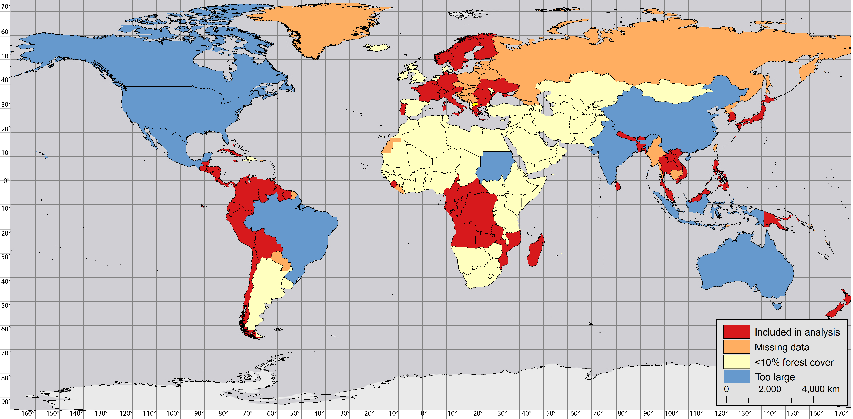

Supplementary Material 3. The 60 countries used in our analysis (in red). From an initial group of 192 nations, countries were excluded if: (i) area was greater than 1.5 million km² or less than 625 km² (in blue), (ii) less than 10% of area was forested in 1990 (according to satellite-derived metrics of forest cover, in yellow), (iii) population, GNI, or climate data were unavailable (in orange). Map courtesy of Maggie Klope.

