Supplementary material for
Inferring cellular forces from image stacks
Jim H. Veldhuis¹, Ahmad Ehsandar¹, Jean-Léon Maître², Takashi Hiiragi³, Simon Cox⁴, G. Wayne Brodland^{1,5}*

Philosophical Transactions B
Special Issue
Systems Morphodynamics: Understanding the development of tissue hardware

¹Department of Civil and Environmental Engineering
University of Waterloo
Waterloo, ON N2L 3G1
Canada

²Department of Genetics and Developmental Biology
Institut Curie
26 rue d'Ulm
75248 Paris Cedex 05, France

³Developmental Biology Unit
European Molecular Biology Laboratory
Meyerhofstraße 1
69117 Heidelberg, Germany

⁴Department of Mathematics
Aberystwyth University
Aberystwyth, Ceredigion, SY23 3BZ
United Kingdom

⁵Centre for Bioengineering and Biotechnology
University of Waterloo
Waterloo, ON N2L 3G1
CANADA

*Corresponding Author
brodland@uwaterloo.ca
Phone (519) 888-4567 x36211

Overview
This documents outlines the basic ideas behind force inference (see also Supplementary Movie 1 – Force Inference Explained), relates CellFIT-3D to earlier associated approaches, and details the factors that affect solution accuracy. It also briefly describes the Surface Evolver (SE) software used to generate synthetic data for testing, and it provides details about the murine embryo experiments.

Force inference basics
Finite element (FE) models – which are used extensively in engineering, physics and other fields because they provide a reliable framework for developing computational representations of physical systems [1] – have shown that bulk tissue motions such as neural plate reshaping and large-scale sorting of tissues are largely deterministic. Individual cell positions and most other mesoscale features, in contrast, depend on neighbor changing and other stochastic factors and are more variable [2,3]. Inter-cellular contact angles between these cells, however, are again essentially deterministic [4,5].
Our first force inference approach [6] was inspired by FE models wherein a vector of nodal motions $\dot{u}$ is related to applied nodal forces f and a viscous matrix C by the equation [7]
C$\dot{u}$ = f. (S1)
In many cellular systems, these forces arise from tensions t along the cell edges. These tensions can be resolved into equivalent nodal forces f using a matrix of direction cosines D and, if for ease of explanation intracellular pressure differences [8] are ignored, give rise to the relationship
C$\dot{u}$ = f = Dt. (S2)
In a typical FE model, C, D and t are known and $\dot{u}$ is found. We conjectured that if cell motions $\dot{u}$ were ascertained from time lapse images, edge tensions t could be computed. We investigated some of the mathematical aspects of this idea under the name “cinemechanometry” [9] before developing an experimental implementation, called “Video Force Microscopy (VFM),” that was able to provide detailed spatial and temporal maps of the forces that drive ventral furrow formation in Drosophila [6].
A new inference method called CellFIT was then developed, and because it assumes cell boundaries to be curved and uses the actual triple junction angles rather than estimating them from chordal edge approximations, is applicable to a much broader range of biological systems. Serendipitously, it is also able to analyze quasi-static systems. CellFIT focusses on edge tensions and the angles that the membranes carrying them form at each triple junction. Force balances in the x- and y-directions [8], can be written for each triple junction, (such as Point A in Supplementary Fig. 1), and solved to yield the ratios γ₁:γ₂:γ₃ that the edge tensions must have for that triplet to be in equilibrium. For simplicity, one could assume the interfacial tension γ₁ to be of unit strength and then calculate the values of γ₂ and γ₃. One could then assume the force along boundary AB to be constant, construct a pair of force balance equations at Point B, and uniquely determine γ₄ and γ₅. CellFIT carries out calculations of this kind, but does so simultaneously in a least-squares manner so as to resolve incompatibilities and minimize error. Edges that involve lamellipodia or boundary-related machinery (Supplementary Fig. 1) do not require special treatment provided the generated forces are parallel to the plane of the sheet and fully contributing (γ_{p}), or normal to it and thus non-contributing (γ_{n}).
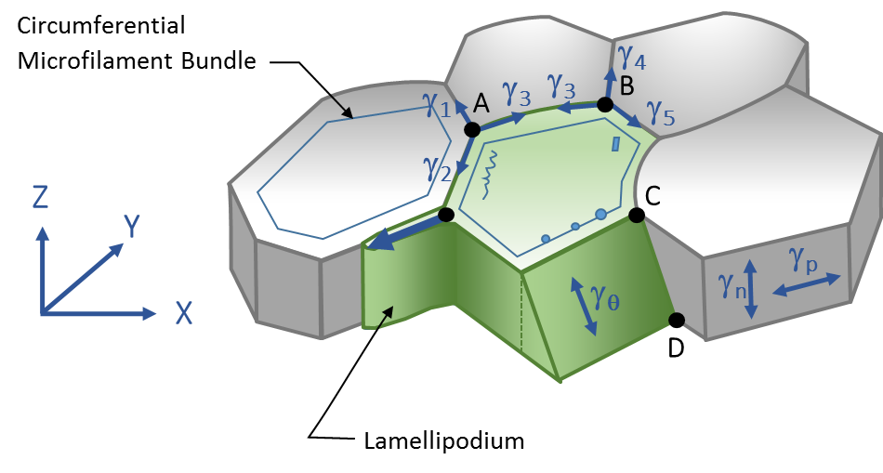
Supplementary Figure 1 – From CellFIT-2D to 3D. When a tissue is planar and all tractioned edges are normal to the sheet plane, a 2D analysis can be appropriate. Angled transverse edges, like CD, however, may require a 3D approach. The γ values indicate interfacial tensions.

From 2D to 3D
If a particular triple junction (CD in Supplementary Fig. 1) is oblique to the sheet, its angles as seen in the image plane will not generally be true dihedral angles, and force-balance calculations based on apparent apical angles will be in error. Alternatively, one could argue that faces oblique to the tissue plane, like the one carrying force γ_{θ}, generate in-plane forces not properly accounted for by an analysis of the apical surface alone. CellFIT-3D overcomes these issues by constructing planes normal to each triplet and writing the force balance equations in terms of those planes (Fig. 1m).
In 2D, collected images are homologous with the epithelia they visualize, and their pixels are dense in both in-plane directions. In 3D, serial sections are typically spaced apart by distances corresponding to many pixels widths, and the virtual layers of voxels between such sections are unsampled. Validation tests (Fig. 2) showed that many triplets and interfacial boundaries reside completely in spaces between sections, appearing in none of them. This missing information can go unnoticed in 3D because a false impression is left by the many other boundaries and triple junctions that are seen. While sufficient reduction of slice spacing would address this problem, practical considerations such as photobleaching and image collection time make doing so unworkable. In principle, contact angle information for triplets that do not appear in any serial sections could be obtained by noting the offsets of their associated edges in successive sections, but triplets that appear in sections generally provide more than sufficient data.

Surface evolver
Synthetic data consisting of precise, least-energy geometries for virtual aggregates with known interfacial tensions were needed to test CellFIT-3D. FE models were used in the past [4] to generate this kind of data, but they do not easily provide the precision possible with Surface Evolver (SE) [10]. SE was designed to model foams and other systems whose equilibrium geometry is governed by interfacial tensions and volume constraints [11], and it provided the ground truth models needed here.
Surface Evolver input consisted of a set of connected cells from a 3D Voronoi tessellation [12], and the interfacial tensions were assigned individual values that typically had a physiological range of 30%. The SE software tessellates each surface with small triangles and uses gradient descent, subject to cell volume constraints, to successively reduce the total energy through repeated simultaneous adjustments of every vertex in the system. The total energy is defined as the sum of the products of the individual surface areas times the tension they carry. A typical model with 8 cells involved approximately 20,000 triangles and required some 1000 minimization steps to achieve energy minimization to six figures. We consider the resulting configuration a highly-accurate description of the geometry of an idealized cell aggregate.
The "slice_view" function of SE was then used to generate synthetic serial sections with various section spacings and image resolutions based on these geometries. Sections were stored as image files and henceforth treated as images from experimental samples.

Equations and unknowns
Solution of matrix Equation 3 in the main article is contingent on the relative number of equations and unknowns, and the higher this ratio, the more confidence can be placed in the solution. In CellFIT-3D, each included triple edge (TE) generates two equations while every tension γ_{i} that appears in at least one of those equations generates one unknown.
A series of SE models with varying numbers of whole and partial cells were generated to examine their equations to unknowns ratios (EURs). For comparison purposes, data for 2D systems were generated using polyline FE models [5]. In general, uncut 3D cell-cell boundaries have 5 to 8 TEs around their perimeters, while cut boundaries have truncated perimeters and contribute fewer equations. Individual boundaries in 2D, an even more extreme example, have at most two associated triple junctions. Supplementary Fig. 2 shows that aggregates with no cut edges have EURs as high as 5 while excised ones surrounded by transected edges still have ratios greater than 3. Both have EURs substantially higher than 2D systems, and even they solve without difficulty.
In practise, some TEs do not transect sufficient sections that reliable equations can be obtained, and some boundaries appear in none of the force balances. These deletions affect the EURs (Supplementary Fig. 2), but one can show that there are always sufficient equations [8].

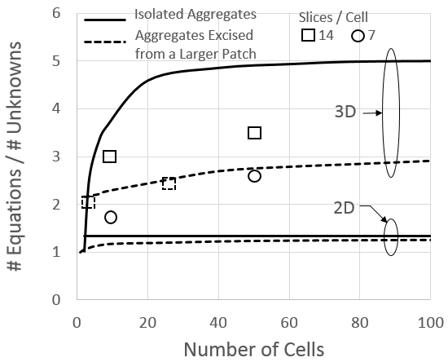
Supplementary Figure 2 – Are there adequate equations? To address this question, a series of synthetic aggregates were created using Surface Evolver and the ratio of the number of equations (two per TE) to the number of unknowns (the number of boundaries involved in the equations) plotted. In 2D there are often just enough equations, while in 3D there are often many times more equations than unknowns, making the resulting systems highly overdetermined. Solid curves correspond to aggregates surrounded by medium while those associated with the dashed one are excised from a larger aggregate and involve cut edges (see text). The square and circle symbols show the numbers of equations and unknowns in 3D synthetic aggregates where some TEs and boundary surfaces lie entirely in the space between two adjacent serial sections.

Slice spacing effects
As the number of slices per cell increases, individual TEs appear in more sections (Supplementary Fig. 3). Statistical benefits from averaging of dihedral equations along any particular triplet are strengthened, and less reliable data from sections strongly oblique to those triplets (see main text) can be ignored.
When the SE model with 8 cells shown in Fig. 2 was analyzed using all of the available 14 sections per cell, 13% of the TEs still appeared in no sections, and only 58% had the ideal minimum of at least 3 sections per TE. Even so, the tensions CellFIT calculated from these images were within 1.6% of the ground truth values (Supplementary Fig. 4). The condition number of G was 6.01, the normalized RMS residual was 0.023, and the standard error was 1.3%. When half of the slices were used, corresponding to 7 slices per cell, 25% of the TEs were unseen and only 34% of the triplets appeared in at least 3 junctions. Remarkably, the standard error was still only 3.2%, a credit to the robustness of the method. Supplementary Fig. 4 shows how tension error decreases with slice density and how calculations based on TEs with at least 3 useable sections rather than 2 are noticeable more accurate.

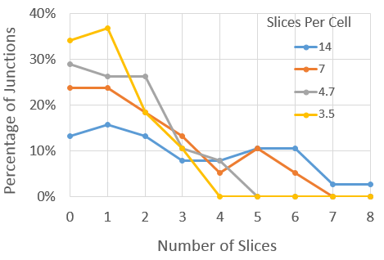
Supplementary Figure 3 – Slice spacing affects the number of sections per triple edge. As the average number of sections per cell increases, the number of successive sections in which a particular TE appears increases. TEs that appear in fewer than 2 sections are unusable in 3D as they do not allow the angle of the TE to the imaging plane to be ascertained. TEs that appear in at least 3 sections are computationally desirable, and a reasonable number of them arise when there are at least 7 or 8 slices per cell. Note, that even when there are 14 slices per cell, some 13% of the total TEs appear in none of the images.

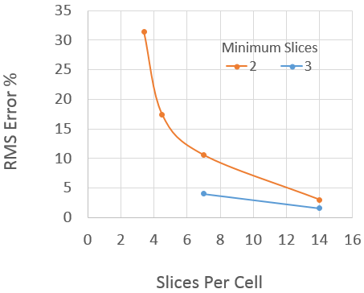
Supplementary Figure 4 – Slice spacing affects error. Error considerations show the need for a minimum of 7 or 8 slices per cell (solid orange curve). When TE averages are based on a minimum of 3 slices (blue curve), error is reduced.

Noise sensitivity
The governing CellFIT-3D equation (Equation (2) in the main text) derives from the topology of the aggregate and the dihedral angles between cells. To test its robustness to noise, these angles were adjusted stochastically by adding error to the averaged dihedral approach directions (angles). Various levels were applied in angular degrees corresponding to the amounts indicated in Fig. 3, and noise levels of 5 were deemed typical of experimental data having approximately 150 pixels per cell diameter [8]. Errors relative to ground truth are shown for an SE model with 14 slices per cell, as are the associated residuals (the L2 norm of R in Equation (3) of the main text) and the average standard errors. When the number of slices was halved, the errors approximately doubled. CellFIT-2D, despite its different topology [13], has a similar noise response.
The curves in Fig. 3 show that residual and standard error correlate with noise level and solution error. Thus, if these measures, which are internal to the calculations, are computed as part of a particular analysis, they signal the degree of noise in the averaged dihedral angles (the input data) and the confidence intervals on the calculated tensions (the output).
As noted in the main text, image resolution can also affect solution accuracy, evidently by affecting on the accuracy of approach angles calculated from pixelated boundaries.

Murine embryos
Embryos were isolated from superovulated, male-mated female mice induced by intraperitoneal injection of 5 international units (IU) pregnant mare’s serum gonadotropin (PMSG, Intervet Intergonan) followed 44-48 hours later by intraperitoneal injection of 5 IU human chorionic gonadotropin (hCG, Intervet Ovogest 1500). Two-cell-stage (embryonic day 1.5; E1.5) embryos were recovered by flushing oviducts from plugged females with 37°C FHM (Millipore, MR-024-D) using a custom-made syringe (Acufirm, 1400 LL 23).
Embryos were maintained in KSOM (Millipore, MR-121-D) supplemented with 0.1% BSA (Sigma, A3311) in 10 µL droplets covered in mineral oil (Sigma, M8410 or Acros Organics) in a 37°C incubator with humidified atmosphere and 5% CO₂. Embryos were handled using an aspirator tube (Sigma, A5177-5EA) equipped with a glass pipette pulled from glass micropipettes (Blaubrand intraMark), and were imaged in 5 cm glass-bottom dishes (MatTek). Plasma membranes were visualized using mTmG mice (Gt(ROSA)26Sor^{tm4(ACTB-tdTomato,-EGFP)Luo}) [14]. To visualize nuclei, H2B-GFP mice are used [15]. The Zona Pellucida was removed from the embryos mechanically at the 4-cell stage.
As described previously [16](Maître et al, 2015), a microforged micropipette coupled to a microfluidic pump (Fluigent, MFCS) was used to measure the surface tension of cells. In brief, micropipettes of radii 7-8 µm were used to apply step-wise increasing pressures on blastomeres until reaching a deformation which has the radius of the micropipette (R_{p}). At steady-state, the surface tension γ₁ of the blastomeric cells were calculated using the Young-Laplace law
γ₁ = P_{c} / 2 (1/R_{p} - 1/R_{c}), (S3)
where P_{c} is the pressure used to deform the cell to radius R_{c}.
Tension measurements were performed on an inverted Zeiss Observer Z1 microscope with a CSU-X1M 5000 spinning disc unit. Excitation was achieved by a 561 nm laser line through a 40x/1.2 C Apo W DIC III water immersion objective. Emission was collected through 629/62 nm band filters onto an EMCCD Evolve 512 camera. The microscope was equipped with a chamber providing a 37°C, humidified, 5% CO₂ atmosphere.

References
1. Zienkiewicz, O. C. & Taylor, R. L. 2005 The Finite Element Method for Solid and Structural Mechanics. Oxford: Elsevier.
2. Davies, J. T. & Rideal, E. K. 1963 Interfacial phenomena, 2dth edn. New York: Academic Press.
3. Brodland, G. W. 2004 Computational modeling of cell sorting, tissue engulfment, and related phenomena: A review. Appl Mech Rev 57, 47-76.
4. Viens, D. & Brodland, G. W. 2007 A three-dimensional finite element model for the mechanics of cell-cell interactions. J BioMech Eng 129, 651-657.
5. Perrone, M. C., Veldhuis, J. H. & Brodland, G. W. 2015 Non-straight cell edges are important to invasion and engulfment as demonstrated by cell mechanics model. Biomech. Model. Mechanobiol (DOI 10.1007/s10237-015-0697-6 )
6. Brodland, G. W., Conte, V., Cranston, P. G., Veldhuis, J., Narasimhan, S., Hutson, M. S., Jacinto, A., Ulrich, F., Baum, B. & Miodownik, M. 2010 Video force microscopy reveals the mechanics of ventral furrow invagination in Drosophila. Proc. Natl. Acad. Sci. U. S. A. 107, 22111-22116. (DOI 10.1073/pnas.1006591107)
7. Chen, H. H. & Brodland, G. W. 2000 Cell-level finite element studies of viscous cells in planar aggregates. J BioMech Eng 122, 394-401.
8. Brodland, G. W., Veldhuis, J. H., Kim, S., Perrone, M., Mashburn, D. & Hutson, M. S. 2014 CellFIT: a cellular force-inference toolkit using curvilinear cell boundaries. PLoS One 9, e99116. (DOI 10.1371/journal.pone.0099116; 10.1371/journal.pone.0099116)
9. Cranston, P. G., Veldhuis, J. H., Narasimhan, S. & Brodland, G. W. 2010 Cinemechanometry (CMM): A Method to Determine the Forces that Drive Morphogenetic Movements from time-lapse Images. Ann Biomed Eng (DOI 10.1007/s10439-010-9998-1)
10. Brakke, K. A. 1992 The Surface Evolver 1, 141-165. (DOI 10.1080/10586458.1992.10504253)
11. Durand, M., Kraynik, A. M., van Swol, F., Kafer, J., Quilliet, C., Cox, S., Ataei Talebi, S. & Graner, F. 2014 Statistical mechanics of two-dimensional shuffled foams: geometry-topology correlation in small or large disorder limits. Phys. Rev. E. Stat. Nonlin Soft Matter Phys. 89, 062309.
12. de Berg, M. 2008 Computational geometry: algorithms and applications, 3rd edn. Berlin: Springer.
13. Hutson, M. S., Brodland, G. W., Yang, J. & Viens, D. 2008 Cell sorting in three dimensions: topology, fluctuations, and fluidlike instabilities. Phys Rev Lett 101, 148105.
14. Muzumdar, M. D., Tasic, B., Miyamichi, K., Li, L. & Luo, L. 2007 A global double-fluorescent Cre reporter mouse. Genesis 45, 593-605. (DOI 10.1002/dvg.20335)
15. Balbach, S. T., Esteves, T. C., Houghton, F. D., Siatkowski, M., Pfeiffer, M. J., Tsurumi, C., Kanzler, B., Fuellen, G. & Boiani, M. 2012 Nuclear reprogramming: kinetics of cell cycle and metabolic progression as determinants of success. PLoS One 7, e35322. (DOI 10.1371/journal.pone.0035322)
16. Maitre, J. L., Niwayama, R., Turlier, H., Nedelec, F. & Hiiragi, T. 2015 Pulsatile cell-autonomous contractility drives compaction in the mouse embryo. Nat. Cell Biol. 17, 849-855. (DOI 10.1038/ncb3185)
© The Authors under the terms of the Creative Commons Attribution License http://creativecommons.org/licenses/by/3.0/, which permits unrestricted use, provided the original author and source are credited.

