ELECTRONIC SUPPLEMENTARY MATERIAL

Methods: Experimental Protocol
Intermediate stages of the MA experiment were archived at -80° C in 15% glycerol every 5 days. If colony growth was not visible after 24 h for a given population during its propagation, then we incubated the population for another 24 hours; if no growth was visible at 48 hours, the population was provisionally considered to have gone extinct and was restarted from its previously frozen time point. After three consecutive failed restarts, no further attempt was made to propagate the population and it was considered to have gone extinct. Populations that did not go extinct were propagated for a total of 50 daily transfers, corresponding to approximately 1250 generations of binary fission based on daily growth from 1 to ~3 x 10⁷ cells.

Methods: Fitness Measurement
Plates were incubated at 37° C with shaking over a 24-hour period in an automated plate reader (Thermo-Fisher Multiskan-GO); every 2 min during this incubation, absorbance at 600 nm was estimated by the plate reader as a proxy for cell density. As an additional assay of fitness at the end of the MA experiment, we carried out dilution and plating of 24 h liquid cultures of the ancestral strain and the endpoint MA populations (grown in LB or DM broth) in order to estimate viable cell densities via counts of colony-forming units (CFUs).

Methods: Mutation Rates
Description of fluctuation assay: We used a derived form of the fluctuation assay, first carried out by Luria and Delbrück (1). Frozen isolates were grown in the appropriate media (Luria Broth for the LB populations and Davis Minimal medium for the Minimal Glucose populations) overnight and these overnight cultures were diluted appropriately (a dilution factor of 10⁶ was used) and these dilutions were used to inoculate 3 replicates flasks containing 30 ml of fresh medium. These replicate cultures were grown at 37 °C in a shaking incubator for 48 hours and thereafter plated to estimate population size and number of streptomycin/nalidixic acid resistant mutants. The final concentration of nalidixic acid and streptomycin employed in these fluctuation tests was 30 ug/ml and 100 ug/ml. A fixed fraction of each culture was plated for enumeration of mutant individuals. Maximum likelihood mutation rates and 95% confidence intervals from these assays were calculated with software kindly provided by Dr. Philip Gerrish (2).

Methods: Strain Information
The ancestral strain utilized for this study was constructed for and employed by a previous study (3) that investigated the fates of super-mutators in the short term. The ancestral strain carries defective alleles of both the mismatch repair gene mutL and the DNA proofreading subunit of the polymerase III, dnaQ. The mutations in these alleles are listed in Table S6. Even though the dnaQ allele carries five different point mutations, only one of these mutations is non-synonymous.. Ongoing sequencing work in our laboratory has found that all of the original point mutations in the mutator alleles are present in the evolved lines. Thus, we can rule out reversion of the original mutL and dnaQ mutations as an explanation for the evolution of reduced mutation rates in most surviving populations.

SUPPLEMENTARY FIGURES:

S1. Fitnesses measured in the evolving MA populations. Maximum growth rates and final absorbance values (600 nm) of LB (A-B) and minimal glucose (C-D) MA populations propagated for 24 h on liquid media as described in the preceding section on experimental methods. The decline in maximum growth in LB and MG and final density in LB and MG are statistically significant (LB final density p-value=1.098X10⁻¹⁰, LB maximum growth rate p-value=0.00036, MG final density p-value = 0.0029, MG maximum growth rate p-value=5.480X10⁻⁵).

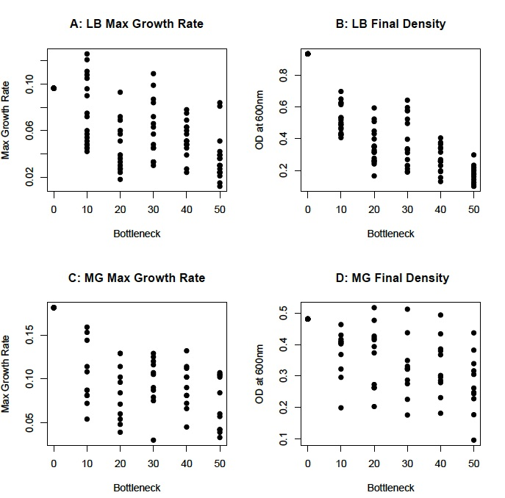

S2. Among line variance over time for all MG and LB populations, using both maximum growth rate and final density as proxies for fitness. The regression of variance with time is not significant in all cases (p > 0.05, see table S10 for detailed p-values).

S3. Comparison of two independent fluctuation assays carried out on all the LB and MG populations to estimate the nalidixic acid mutation rate. In both the LB and MG, the estimates obtained from the two independent tests are significantly correlated (p<0.05, see table S8 for complete details).

S4. COMPUTER SIMULATION RESULTS:

The computer simulations were carried out in C++ (code available upon request). They are individual based, with exponential growth starting from 1 individual (at every bottleneck) and increasing in size to 4 x 10⁷ (~23 generations) before being bottlenecked again. Both deleterious and beneficial mutations are included in the simulations, and the mutation rate to deleterious mutations is ~0.9 per genome per generation, akin to that estimated for the hypermutable strain we employed for the MA experiment. The computer simulations also include mutator and antimutator mutations, both of which have equal strength in terms of change in mutation rate, 100- fold (i.e the mutator mutation will further increase the mutation rate by 100- fold whereas the antimutator will decrease the mutation rate by 100-fold). We assumed that antimutator mutations are rarer than mutator mutations (100-fold rarer), and found that in our simulations, for 30 replicates, the antimutator “allele” fixed 10 times and the mutator “allele” fixed only 1 time.

S5. EFFECT OF TETRACYCLINE ON MUTATION RATES

To test if the presence of tetracycline in the medium had any effect of mutation rates, we measured mutation rates of the ancestral strain in the presence and absence of tetracycline in DM1000 (Davis Minimal medium supplemented with 1000 mg of glucose per liter) and found that the mutation rate in the presence of tetracycline was 4.48E-7 (95% CI : 3.36-5.97 E-7) and in the absence of tetracycline was 6.02e-7 (95% CI : 4.55 – 7.97E -7). We conclude that these mutation rates are not significantly different and therefore there is no significant effect of tetracycline on the estimates of mutation rate.

SUPPLEMENTARY TABLES

S6. Specific mutations that confer high mutation rate in the ancestral hypermutable strain used for our MA study.

POSITION | GENE | NUCLEOTIDE CHANGE | AMINO ACID CHANGE | SNP TYPE
4,397,769 | mutL | G→A | A120T (GCC→ACC) | Non-synonymous
236,110 | dnaQ | C→T | T15I (ACC→ATC) | Non-synonymous
236,435 | dnaQ | T→C | T123T (ACT→ACC) | Synonyymous
236,483 | dnaQ | C→T | P139P (CCC→CCT) | Synonymous
236,516 | dnaQ | T→C | A150A (GCT→GCC) | Synonymous
236,549 | dnaQ | G→A | L161L (CTG→CTA) | Synonymous

S7. Correlation between two independent estimates (FT1 and FT2) of the nalidixic acid mutation rate, carried out as independent fluctuation assays.

COMPARISON | NO OF PAIRED OBSERVATIONS | PEARSON CORELLATION COEFFICIENT | p-VALUE
LB Streptomycin vs. LB nalidixic acid mutation rates | 17 | 0.12006 | 0.64625
MG Streptomycin vs. MG nalidixic acid | 14 | 0.83906 | 0.00018
LB+MG Streptomycin vs. LB+MG nalidixic acid (surviving and extinct pooled) | 31 | 0.41978 | 0.02159*
LB+MG Streptomycin vs. LB+MG nalidixic acid mutation rates (pooled surviving only) | 24 | 0.34571 | 0.09799

S8. Correlation between two independent estimates (FT1 and FT2) of the nalidixic acid mutation rate, carried out as independent fluctuation assays.

Population | Comparison | t-statistic | p-value
LB | Nalidixic Acid  FT1 vs. FT2 | 2.58612 | 0.02259*
MG | Nalidixic Acid  FT1 vs. FT2 | 2.58411 | 0.03625*

S9. Correlation between fitness proxies (CFU, maximum growth rate and final density) and mutation rates to nalidixic acid and streptomycin resistance for both LB and MG populations.

Comparison | Pearson Correlation | p-value
LB 24h CFU vs. nalidixic acid mutation rates | -0.50737422 | 0.0448*
LB 24h CFU vs. streptomycin mutation rates | -0.42887419 | 0.11068
MG 24h CFU vs. nalidixic acid mutation rates | 0.049469179 | 0.89943
MG 24h CFU vs. streptomycin mutation rates | -0.39073021 | 0.29845
LB final density vs Naliixic Acid Mutation rates | -0.19087508 | 0.47887
LB final density vs. Streptomycin Mutation rates | -0.23044433 | 0.39053
LB Max growth rate vs. Nalidixc acid Mutation rates | -0.21955290 | 0.38138
LB Max growth rate vs. Streptomycin Mutation rates | 0.027627757 | 0.9191
MG final density vs. Nalidixic Acid Mutation rates | 0.554872889 | 0.12098
MG final density vs. Streptomycin Mutation rates | 0.269735398 | 0.48274
MG max growth rate vs. Nalidixic acid Mutation rates | 0.085034075 | 0.82781
MG max growth rate vs. Streptomycin Mutation rates | -0.32968347 | 0.38627

S10. Regression of variance over time vs. time, for all two fitness proxies (maximum growth rate and final density) for both the LB and MG populations.

Variance in Fitness | R² | p-value
LB max growth rate | 0.00073 | 0.9596
LB final density | 0.00949 | 0.85434
MG max grrowth rate | 0.09889 | 0.54385
MG final density | 0.47517 | 0.12978

References

1. Luria SE, Delbrück M. Mutations of Bacteria from Virus Sensitivity to Virus Resistance. Genetics. 1943;28(6):491–511.
2. Gerrish P. A simple formula for obtaining markedly improved mutation rate estimates. Genetics. 2008;180(3):1773–8.
3. Gentile CF, Yu S-C, Serrano SA, Gerrish PJ, Sniegowski PD. Competition between high- and higher-mutating strains of Escherichia coli. Biol Lett. 2011;7(3):422–4.

