SUPPLEMENTARY INFORMATION

Gas Adsorption and Structural Diversity in a Family of Cu(II) Pyridyl-isophthalate Metal-Organic Framework Materials

Jamie A. Gould,¹ Harprit Singh Athwal,¹ Alexander J. Blake,¹ William Lewis,¹ Peter Hubberstey,¹ Neil R. Champness¹* and Martin Schröder^{1,2}*

- School of Chemistry, University of Nottingham, Nottingham NG7 2RD
- School of Chemistry, University of Manchester, Oxford Road, Manchester M19 3PL

CONTENTS

Materials and Measurements S2
Single Crystal X-ray Structure Determinations S3
Powder X-Ray Diffraction S5
Structural Analysis S9
Thermogravimetric analysis S13
References S14

Materials and Measurements
All reagents and solvents were purchased from commercial suppliers and used without further purification. Nuclear magnetic resonance (NMR) spectra were collected on a Bruker DPX400 NMR spectrometer. Mass spectra (MS) were measured on a LC-TOF spectrometer in ESI mode. Elemental analyses (C, H, and N) were carried out on a CE-440 elemental analyzer. 3,5-bis(ethoxycarbonyl) phenylboronic acid¹ and 4-pyridyl pinacol boronic ester² were synthesised following literature procedures.
The N₂ isotherm at 77 K was carried out using the volumetric method on a Quantachrome Autosorb instrument with the adsorption pressure set in a range of 0-1 bar. The H₂ and CO₂ isotherms were carried out gravimetrically on a Hiden IGA system. To ensure no loss of crystallinity, samples were stored suspended in solvent in a sealed vial. Prior to all gas adsorption measurements the solvent of the samples were exchanged with fresh acetone twice daily for 5 days, and the samples activated under vacuum at 100 °C for 20 h directly prior to measurement For H₂ adsorption experiments, ultra-pure grade H₂ (99.9995 %) was purified further by passing through a zeolite to remove trace impurities before entering the sample chamber.
The heats of adsorption (Q_{st}) were calculated using the Clausius-Clapeyron equation (1) for CO₂ for isotherms at 273K and 293K and were solved by a virial-type equation (2).

$\frac{dln\left(p\right)}{d\left(\frac{1}{T}\right)}=-\frac{ΔH}{R}$ (1)

where p is the pressure, T is the temperature, R is the real gas constant;

$\ln\left(\frac{n}{p}\right)=A_{0}+A_{1}n+A_{1}n^{2}+.$..... (2)

where p is the pressure, n is the amount adsorbed, A_{i} is Virial coefficients, and i represents the number of coefficients required to adequately describe the isotherms with low uptake.

Single Crystal X-ray Structure Determinations
[Cu(L¹)]
Single crystal diffraction data were collected on an Oxford Diffraction SuperNova using mirror monochromated Cu Kα radiation. Details of the data collection are included in the CIF. The structure was solved by direct methods and developed by difference Fourier techniques, both using the SHELXTL software package.¹ The hydrogen atoms of the ligands were placed geometrically and refined using a riding model. The unit cell volume includes a large region of disordered solvent which could not be modelled as discrete atomic sites. We therefore employed PLATON/SQUEEZE^{2,3} to treat the disordered free solvent in the voids. 4064 electrons per unit cell were found which corresponds to 5 DMF and 2 H₂O in the asymmetric unit. These solvent molecules have been included into the formula and subsequent calculations.

[Cu(L²)]
Single crystal diffraction data were collected on Beamline I19 of Diamond Light Source, Oxford, UK. Details of the data collection are included in the CIF. The structure was solved by direct methods and developed by difference Fourier techniques, both using the SHELXTL software package.¹ The hydrogen atoms of the ligands were placed geometrically and refined using a riding model. The unit cell volume includes a large region of disordered solvent which could not be modelled as discrete atomic sites. We therefore employed PLATON/SQUEEZE^{2,3} to treat the disordered free solvent in the voids. 899 electrons per unit cell were found which corresponds to 1 DMF and 1 H₂O in the asymmetric unit. These solvent molecules have been included into the formula and subsequent calculations.

[Cu(L³)]-I
Single crystal diffraction data were collected on Beamline I19 of Diamond Light Source, Oxford, UK. Details of the data collection are included in the CIF. The structure was solved by direct methods and developed by difference Fourier techniques, both using the SHELXTL software package.¹ The hydrogen atoms of the ligands were placed geometrically and refined using a riding model. The unit cell volume includes a large region of disordered solvent which could not be modelled as discrete atomic sites. We therefore employed PLATON/SQUEEZE^{2,3} to treat the disordered free solvent in the voids. 224 electrons per unit cell were found which corresponds to 0.5 DMF and 0.5 H₂O in the asymmetric unit. These solvent molecules have been included into the formula and subsequent calculation.

[Cu(L³)]-II
Single crystal diffraction data were collected on an Agilent GV1000 using mirror monochromated Cu Kα radiation. Details of the data collection are included in the CIF. The hydrogen atoms of the ligands were placed geometrically and refined using a riding model. The unit cell volume includes a large region of disordered solvent which could not be modelled as discrete atomic sites. We therefore employed PLATON SQUEEZE^{2,3} to treat the disordered free solvent in the voids.

[Cu(L³)]-III
Single crystal diffraction data were collected on an Agilent GV1000 using mirror monochromated Cu Kα radiation. Details of the data collection are included in the CIF. The hydrogen atoms of the ligands were placed geometrically and refined using a riding model. The unit cell volume includes a large region of disordered solvent which could not be modelled as discrete atomic sites. We therefore employed PLATON SQUEEZE^{2,3} to treat the disordered free solvent in the voids.

Powder X-ray Diffraction
Powder X-ray diffraction (PXRD) data were collected on a Panalytical X’pert diffractometer using Cu K_{α} radiation. The Le Bail fit was completed using the software package FULLPROF.⁴ The powder diffraction patterns were indexed using the program CHEKCELL,⁵ using a least squares refinement on the observed unit cell parameters determined from single crystal X-ray diffraction as a starting point.

[Cu(L¹)]

Figure S1. Le Bail fitting for [Cu(L¹)] performed using FULLPROF.
Refined cell parameters (as-synthesised): a = b = 19.135(2) c = 45.007(3) Å
Single crystal cell parameters (90K): a = b = 18.9144(3) c = 44.9901(9) Å

Figure S2. PXRD patterns for the as-synthesised and the post-desolvated [Cu(L¹)].

The as-synthesised experimental pattern can be indexed in the space group R-3m, with the following unit cell parameters: a = b = 19.096(10), c = 44.994(24) Å and volume = 14209.8(147) Å³. The powder pattern of the desolvated material (at 100 ºC in vacuo) can also be indexed in the same space group (R -3m), with the following unit cell parameters a = b = 19.1415(31), c = 45.0792(1) Å and volume 14304.02(238) Å³.

Supramolecular Isomers of [Cu(L³)]
The three supramolecular isomers [Cu(L³)]-I, -II and –III were isolated from the same reaction mixture. Using the single crystal structure, the following predicted powder patterns were generated.

Figure S3. The predicted powder X-ray diffraction patterns of the [Cu(L³)] supramolecular isomers.

Comparing the PXRD pattern for the as-synthesised material with the predicted pattern demonstrates that [Cu(L³)]-I gives the best fit.

Figure S4. The PXRD pattern of [Cu(L³)], and the predicted powder pattern for [Cu(L³)]-I. Note the similarity in the peak positions of the two patterns.

Using the unit cell parameters as a starting position, it is possible to index the powder diffraction pattern to: a = 14.5322(154), b = 12.6367(264) and c = 30.1044(331). The index using the program CHEKCELL is displayed below.

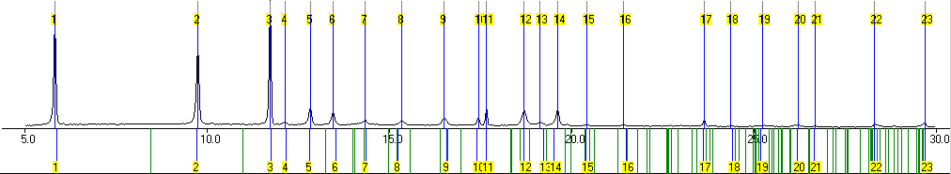

Figure S5. The index of the PXRD pattern of bulk [Cu(L³)] using the program CHEKCELL. The blue lines indicate the indexed lines. An angular tolerance of 0.1 ° was used.

Structural Analysis
All of the structures are derived from the same two nodes; a [Cu₂(O₂CR)₄N₂] paddlewheel as a 6-centred node via coordination of four carboxylates and two pyridyl moieties, and the ligand L²⁻ as a 3-centred node with each ligand bound to three distinct copper clusters (Figure S6).

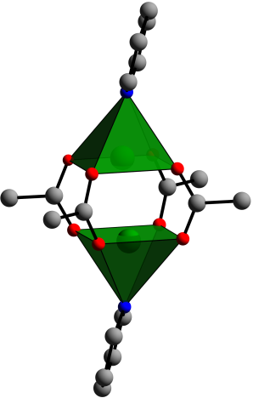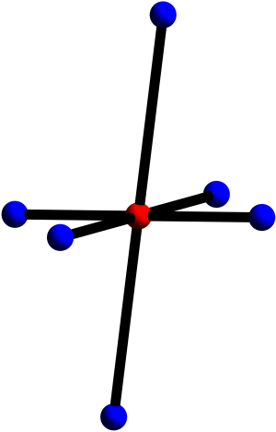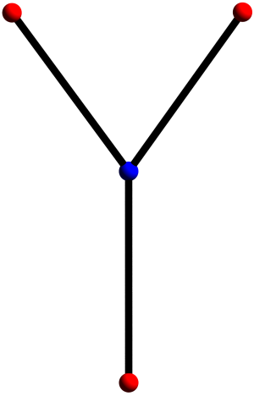
6-centred node
3-centred node

Figure S6. The 6-centred node of the pseudo-octahedral cluster and the 3-centred node of the ligand coordination.

Further description of [Cu(L¹)]
As noted in the main text, the Cu cluster/isophthalate bridging motif forms a Kagomé net, comprised of tessellated triangles and hexagons. These are then stacked in an ABCA formation (Figure S7 (a)) with the layers A and B rotated by 180 ° with respect to each other. Connecting the ligands between the triangles at the centre of the A and B layers leads to the formation of a small polyhedral cage (Figure S7 (b)). The ligand forms a triangular face derived from joining the vertex of one layer with the edge of an adjacent layer. The linking of the edges/vertices within the BCA layers leads to the formation of a larger polyhedral cage (Figure S7 (c)). The structure is completed from the two polyhedra sharing common faces.
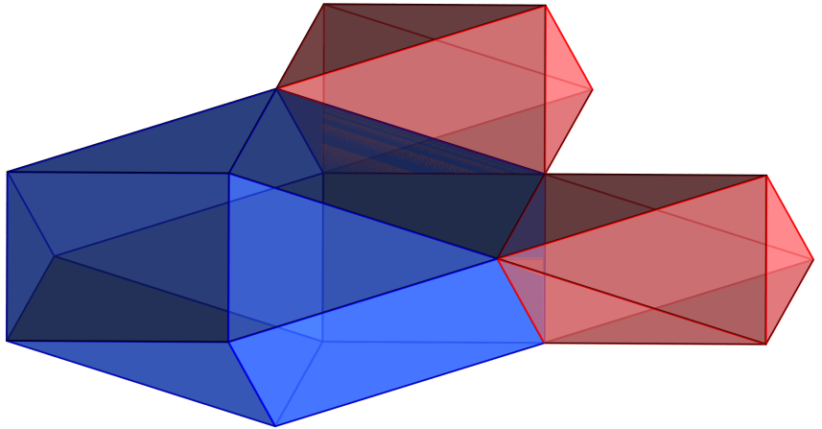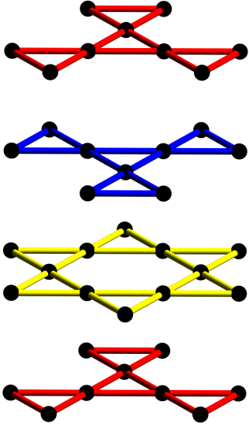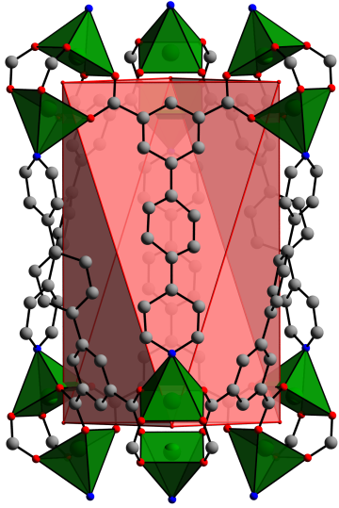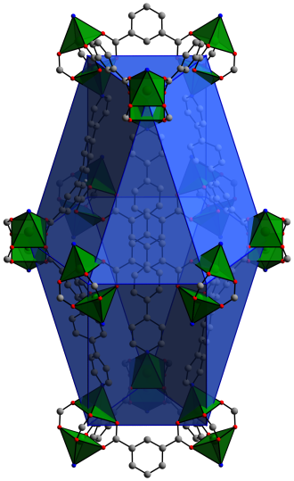
A
B
C
A
B
A
C
A
(a)
(b)
(c)
(d)

Figure S7. (a) View of stacking ABCA leading to two types of polyhedral cages (b) and (c) in [Cu(L¹)]. The polyhedra share common faces to form the overall 3D structure (c).

Further description of [Cu(L²)]
Changing the length of the ligand has a drastic effect upon the observed structure of the MOF. The Kagomé layers become distorted (Figure S8 (a)), and the ligands intercalate (Figure S8 (b)). This can be best observed through the build-up of the polyhedral cages as described above. Unlike [Cu(L¹)], where the triangular faces from the Kagomé layer combine to form a small cage, the ligand intercalation leads to two interpenetrated polyhedra (Figure S8 (c)). The larger polyhedral cage is highly distorted (Figure S8 (d)), arising from a rotation of the Cu-isophthalate triangle with respect to the Kagomé hexagon in the adjacent layer. This has the effect of minimising the void space, and closing the apertures.

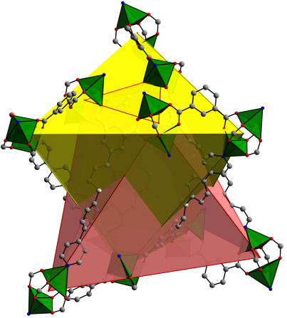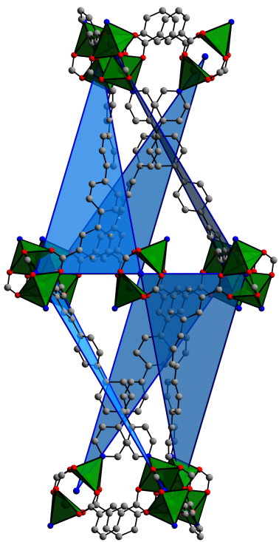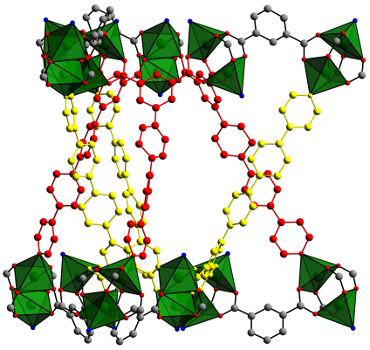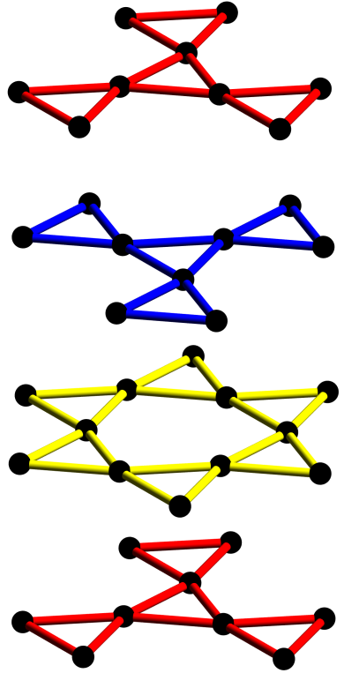
(c)
(d)
(b)
(a)
A
B
C
A

Figure S8. View of (a) the distorted ABCA stacking in [Cu(L²)], (b) the interweaving ligands between layers A and B leading to (c) two interpenetrated polyhedra. View of (d) the rotation of the Cu-isophthalate triangles in B and A with respect to the Kagomé hexagon in layer C leads to a distorted polyhedron. The close proximity of the ligands minimises the voids and the apertures within the structure.

Further description of [Cu(L³)]-I and [Cu(L³)]-II
The two supramolecular isomers form 2D square layers from the Cu-isophthalate interactions, with each layer offset by 0.5a and 0.5b along the c-axis. The difference between the two isomers arises from the connectivity of the pyridyl groups to the Cu(II) [Cu₂(O₂CR)₄N₂] paddlewheel of each successive layer, which causes the change in topology, and modulates the porosity.

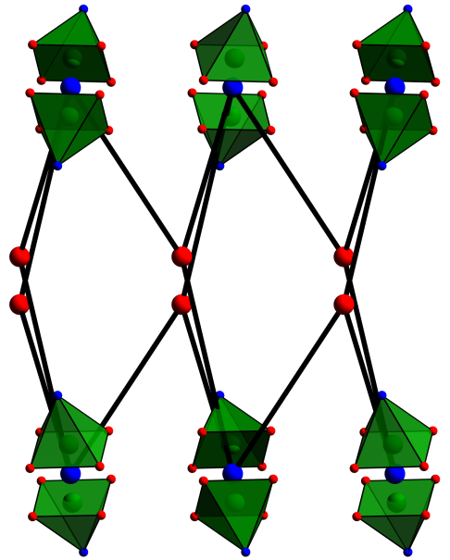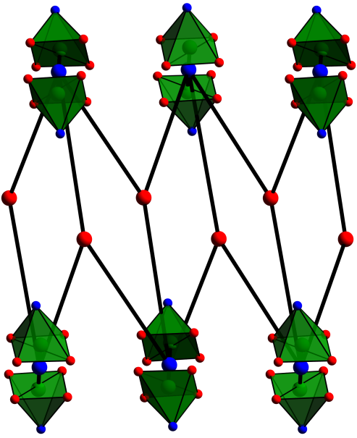
[Cu(L³)]-I
(pyrite topology)
[Cu(L³)]-II
(rutile topology)

Figure S9. The connectivity of the two square-layered based supramolecular isomers of [Cu(L³)], and the topological nets they are derived from.

Thermogravimetric analysis
Thermogravimetric analyses were performed under a dynamic N₂ flow with a heating rate of 5 °C min⁻¹ using a Perkin Elmer Pyris 1 thermogravimetric analyser. The formula for [Cu(L¹)] is [Cu(C₁₉H₁₃NO₄)]•DMF_{0.85}. The plateau for the solvent loss occurs at 86% demonstrating that 14% of the mass of the framework is due to guest molecules intercalated within the structure. The molecular mass of [Cu(C₁₉H₁₃NO₄)] is 382.86 gmol⁻¹. Using the graph above we can estimate that the mass of guest and framework combined is 445.19 gmol⁻¹ (445.19 x 0.86 = 382.86). This means that the total mass of solvent is 62.33, which is equivalent to 0.85 DMF molecules.

Figure S10. The thermogravimetric analysis plot for [Cu(L¹)] performed in an atmosphere of dynamic N₂.

References
1. G. M. Sheldrick, SHELXS97 and SHELXL97. Acta Crystallogr., Sect. A., 2008, 64, 112–122.
2. A. L. Spek, Acta Crystallogr. Sect. C, 2015, 71, 9–18.
3. A. L. Spek, Acta Crystallogr. Sect. D, 2009, 65, 148–155.
4. J. Rodríguez-Carvajal, Physica B., 1993, 192, 55–69.
5. Chekcell - http://www.ccp14.ac.uk/tutorial/lmgp/achekcelld.htm.

