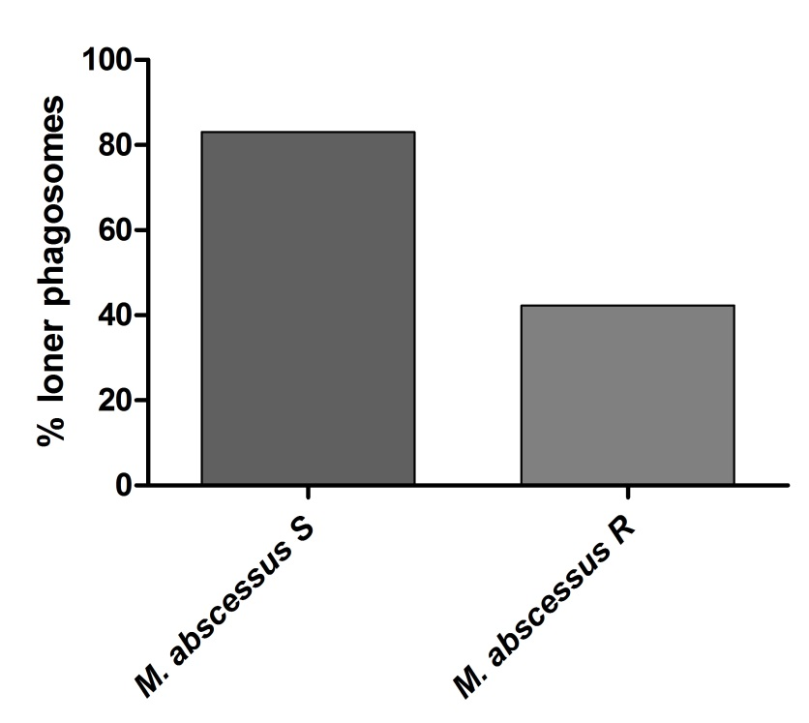

Sup. Figure 1: Preferential location of S variants of M. abscessus in loner phagosomes within BMDM.

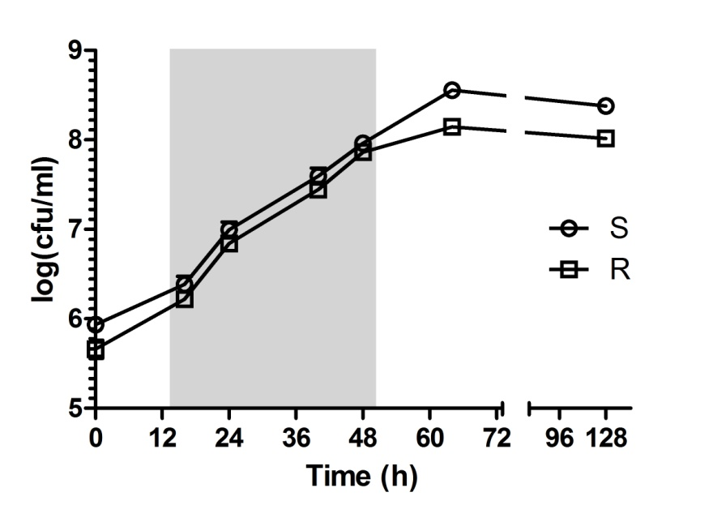

Sup. Figure 2: In vitro growth of the S and R variants of M. abscessus.

A | B
ns

Sup. Figure 3: Comparative intracellular growth of the S (A) and R (B) variants in wild type and ΔF508 murine Mф respectively.

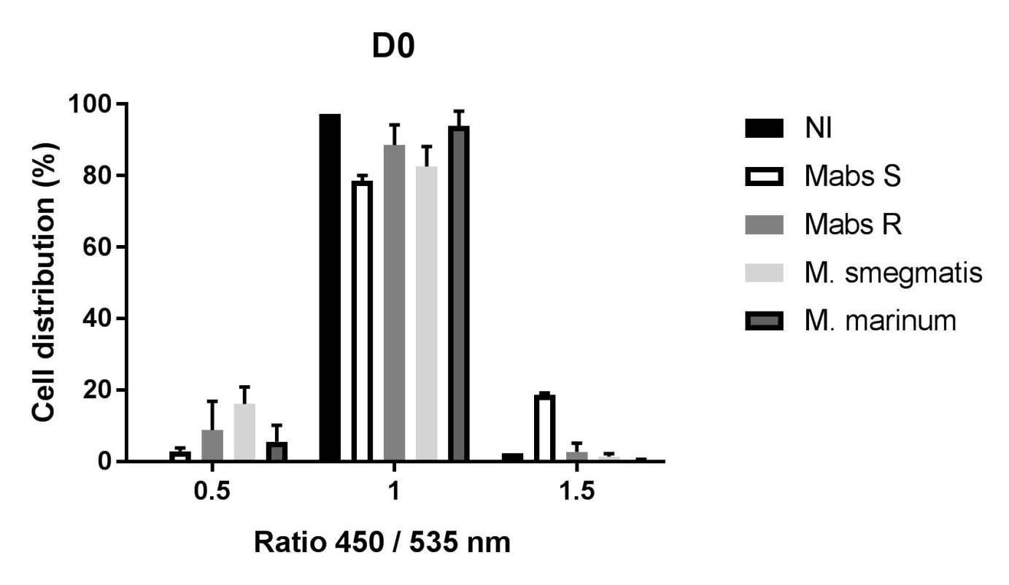

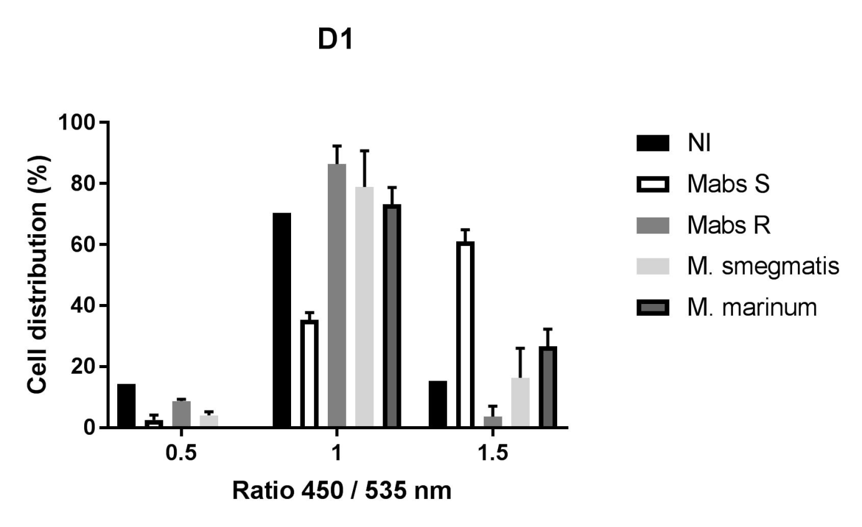

Sup. Figure 4: M. abscessus S variant is able to damage the phagosome membrane of THP-1 cells as assessed by FRET.

