High Resolution Mass Spectrometry

The molecular structures of the two references, orcein powder and an extract from a naturally dyed
silk (Lasallia pustulata), were obtained by HPLC-HRMS, for more details please see 2.3 and 3.1.1.
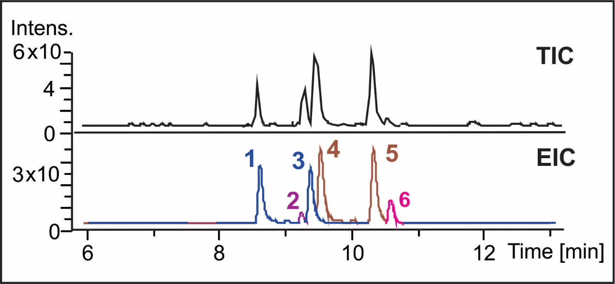
Supplementary Figure 1: Total ion chromatogram obtained in the HR-ESI positive mode of a commercial orcein power. Extracted ion chromatograms; (1 and 3) β- and γ-aminoorcein, m/z 485.1722; (2) α-aminoorcein, m/z 363.1320; (4 and 5)β- and γ-hydroxyorcein, m/z 486.1560; (6) α-hydroxyorcein, m/z 364.1179.

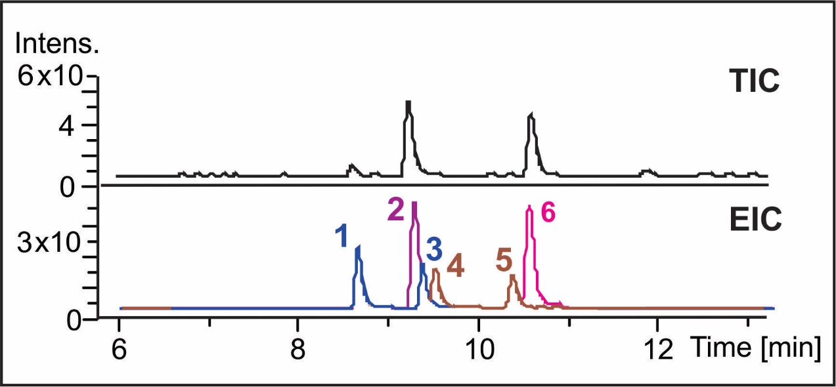
Supplementary Figure 2: Total ion chromatogram obtained in the HR-ESI positive mode of an extract from a naturally dyed silk (Lasallia pustulata). Extracted ion chromatograms: (1 and 3) β- and γ-aminoorcein m/z 485.1772; (2) α-aminoorcein, m/z 363.1320; (4 and 5) β- and γ-hydroxyorcein, m/z 486.1560; (6) α-hydroxyorcein, m/z 364.1160.

Supplementary Table 1: Accurate mass measurement data for orcein reference samples acquired by QqTOF using internal calibration.
Peak | Rt (min) | Measured mass | Ion Formula | Accurate mass | Δ (ppm)
1 | 8.5 | 485.1722 | C₂₈H₂₅N₂O₆ | 485.1707 | 3.0
2 | 9.1 | 363.1320 | C₂₁H₁₉N₂O₄ | 363.1339 | 5.2
3 | 9.2 | 485.1720 | C₂₈H₂₅N₂O₆ | 485.1707 | 2.7
4 | 9.4 | 486.1559 | C₂₈H₂₄NO₇ | 486.1547 | 2.5
5 | 10.3 | 486.1560 | C₂₈H₂₄NO₇ | 486.1547 | 2.6
6 | 10.5 | 364.1160 | C₂₁H₁₈NO₅ | 364.1179 | 5.1

Multi-analytical characterization of purple and pink paints

Supplementary information for the brazilwood pigments lakes and orcein colour paints.

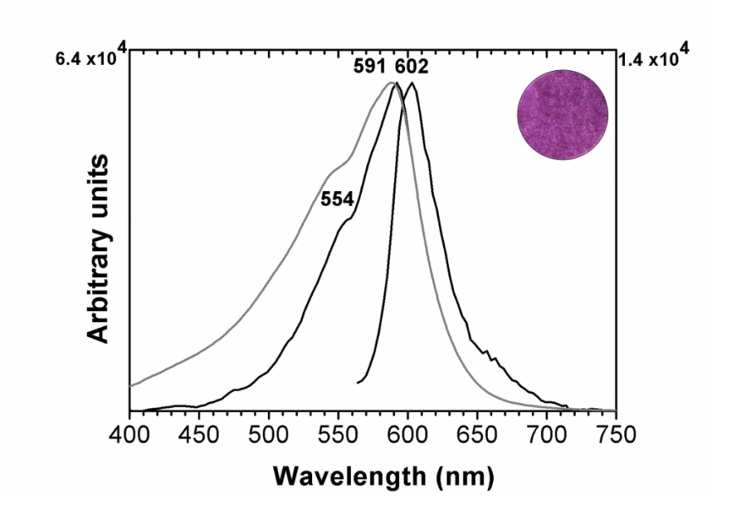
Supplementary Figure 3: Apparent absorption (in grey), excitation and emission spectra (in black) from orcein proteinaceous paint reference (glair, pH=9).

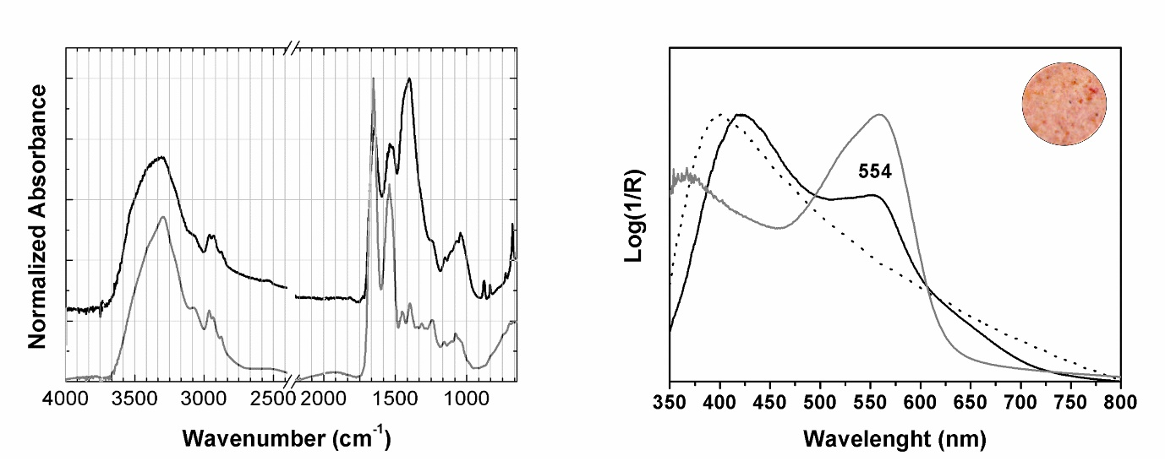
(a)
(b)
Supplementary Figure 4: Molecular characterization of brazilwood lake pigments in the Ajuda Songbook: a) infrared spectra of the pink colour from fol. 17 (in black) and glair reference (in grey); b) apparent absorption spectra of fol. 59 (in black), brazilwood lake reproduction and parchment reference (dashed line) [1].

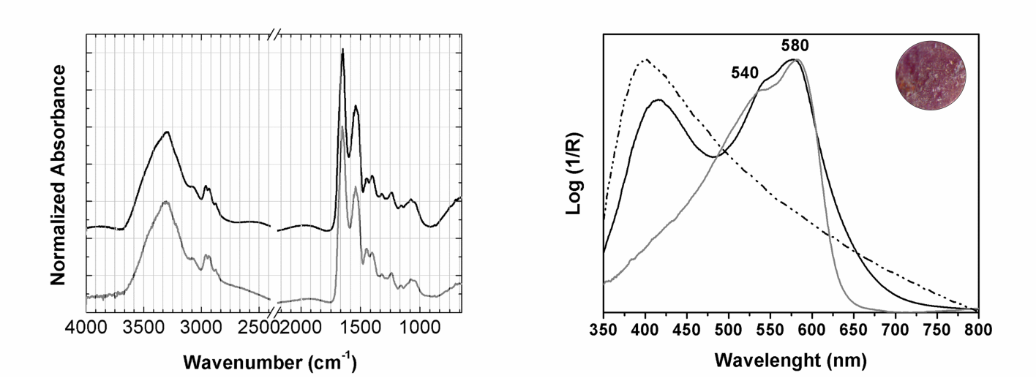
(b)
(a)
Supplementary Figure 5: Molecular characterization of the purple colour in the Lineage book: a) infrared spectra of the manuscript from page 12 (in black) and glair reference (in grey); b) absorbance spectra of page 12 (in black), orcein dyed silk reference (in grey) and parchment (dashed line).

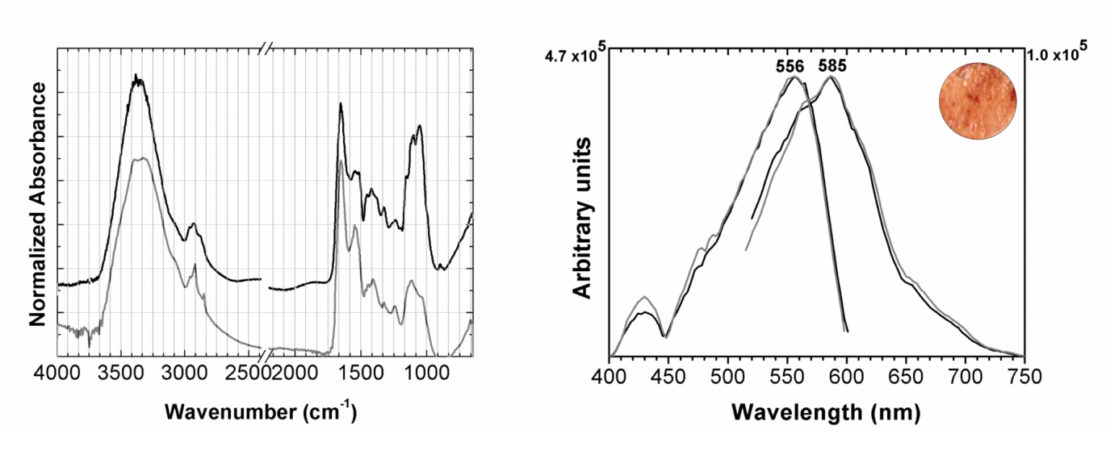
(b)
(a)
Supplementary Figure 6: Molecular characterization of brazilwood lake pigments in the winter Breviary, Alc. 54: infrared (a) and excitation and emission (b) spectra of the pink colour from fol. 92 (in black) and brazilwood pink from the book of hours Cofre No. 22 (fol. 76v) (in grey) [2].
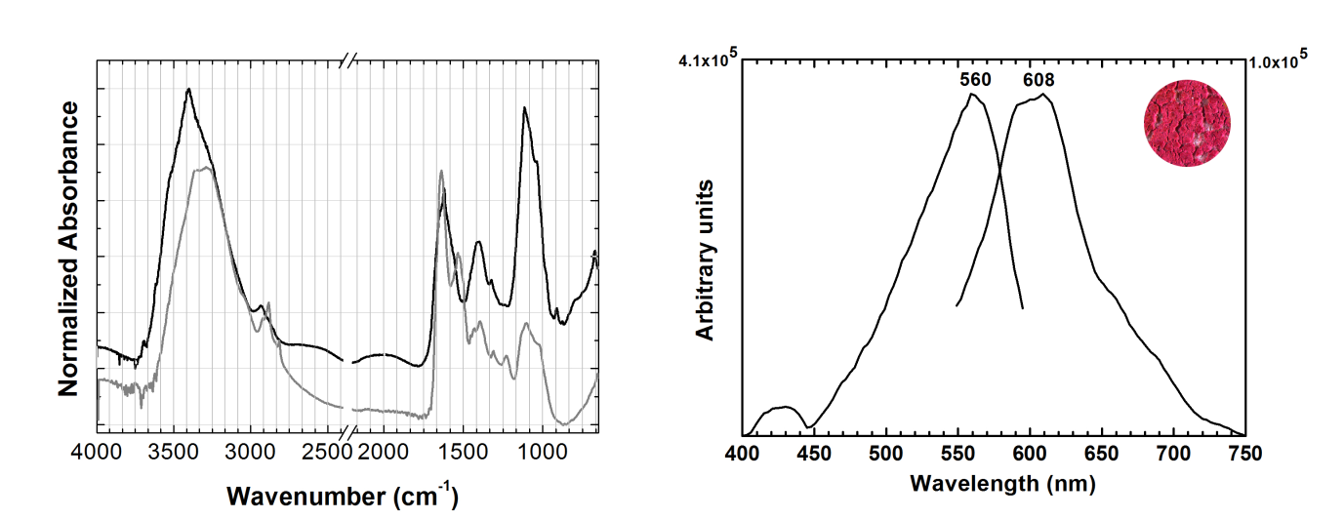
(b)
(a)
Supplementary Figure 7: Molecular characterization of brazilwood lake pigments in the Fernão Vaz Dourado Atlas: a) infrared spectra of the pink colour from map 16 (in black) and protein + polysaccharide reference (in grey), see [1] for spectra of brazilwood lake reference; b) excitation and emission spectra from map 16.

References

- Vitorino T, Melo MJ, Carlyle L, Otero V. 2016 New insights into brazilwood manufacture through the use of historically accurate reconstructions. Stud. Conservat. (DOI: 10.1179/2047058415Y.0000000006)
- Melo MJ, Otero V, Vitorino T, Araújo R, Muralha VSF, Lemos A, Picollo M. 2014 Three Books of Hours from the 15th century: a multi-analytical and interdisciplinary approach. App Spec. 68, 434-444. (DOI: 10.1366/13-07253).

