Supplementary Materials
Figures S1 and S2
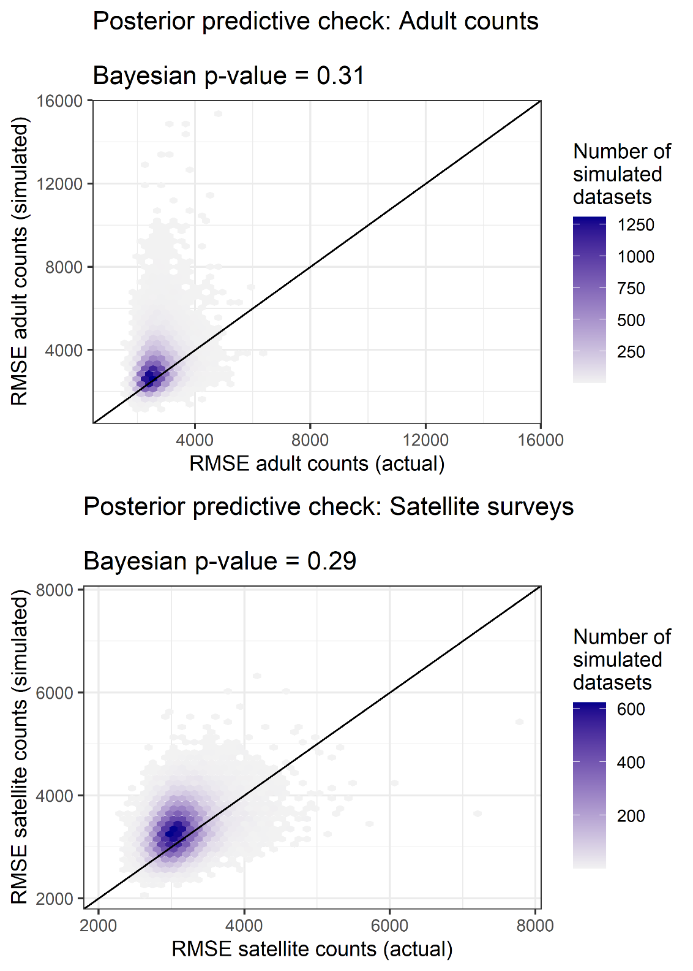
Figure S1. 2-D density plot, illustrating results of Bayesian posterior predictive checks to evaluate goodness-of-fit. Darker shades indicate a larger number of Monte Carlo simulations.

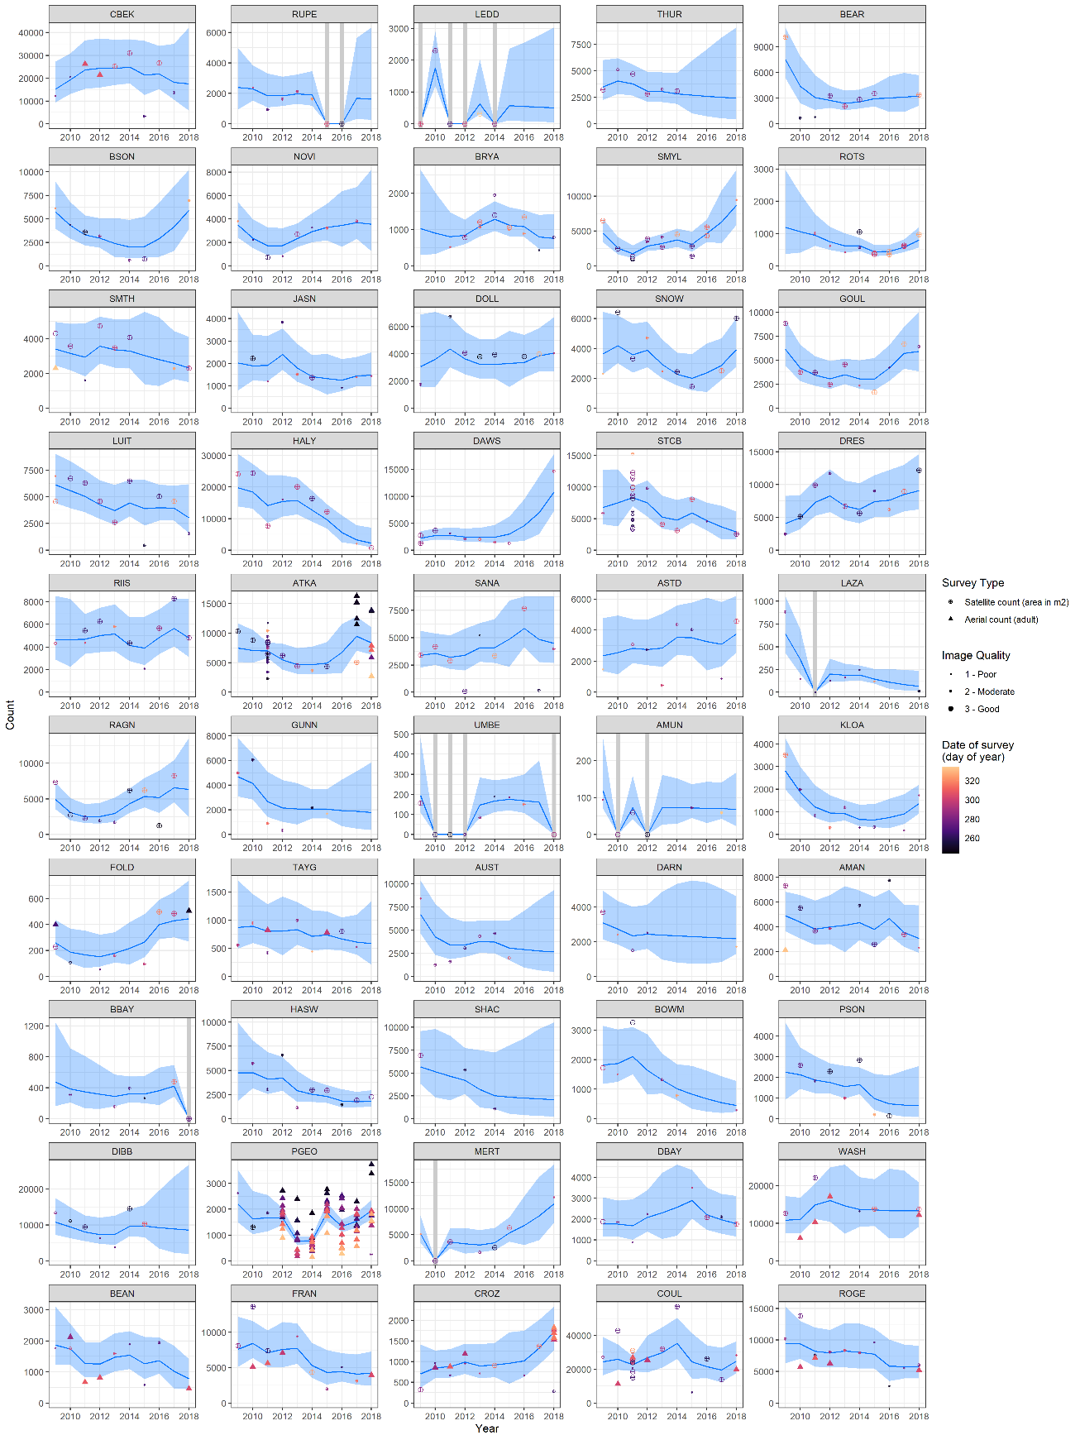
Figure S2. Comparison of raw (observed) data and modeled indices of abundance at 50 emperor penguin colonies.

Tables S1 to S4
Table S1. Description of emperor penguin population model. Colony indexed by j, year by y, observation event i.
Description | Equations
Population process model
Abundance of adults ($N_{j,y}$) is the product of a colony-level presence/absence process ($z_{j,y}$) and a stochastic exponential growth process ($X_{j,y}$).  $N_{j,y}$ measures expected (i.e., mean) daily number of adults in the colony during survey period (Sep – Nov). | $$N_{j,y}= {z_{j,y}X}_{j,y}$$ | (1)
Colony presence is a Bernoulli process controlled by a “probability of presence” parameter $p$ | $$z_{j,y}\sim Bernoulli(p)$$ | (2)
When colonies are present, they fluctuate according to a stochastic exponential Markov chain process, with a colony-specific mean annual change $r_{j}$. | $$X_{j, y} \sim Lognormal\left( {log⁡(X}_{j, y-1}\right)+r_{j} , σ_{process}^{2})$$ | (3)
Aerial survey observation model
Counts of adults from aerial surveys ($A_{j,y,i}$) are centered on the expected count (${z_{j,y}X}_{j,y}$), adjusted by an effect of day-of-year of the survey (${DOY}_{j,y,i}$) | $A_{j,y,i} \sim Poisson(z_{j,y}λ_{j,y,i})$, where  $$λ_{j,y,i} \sim Lognormal\left({log⁡(X}_{j, y})+α×{DOY}_{j,y,i}-\frac{1}{2}σ_{aerial_obs}^{2} ,σ_{aerial_obs}^{2}\right)$$ | (4)
Satellite survey observation model
Satellite counts are potentially biased ($β$), have error proportional to colony abundance, and depend on the day-of-year of the survey (DOY). | $$S_{j,y,i} \sim Normal\left({βN}_{j,y}exp(α×{DOY}_{j,y,i}) ,{ ω}_{j,y}^{2}\right)$$ | (5)
Table S2. Parameter symbols correspond to those in Table S1.
Prior | Rationale
$$p \sim Uniform(0,1)$$ | Diffuse prior for probability that colony is present each year.
$${\overline{X}}_{1}\sim Uniform(0,50000)$$  $$\frac{1}{σ_{logX_{1}}^{2}} \sim Gamma(0.001,0.001)$$ | Diffuse prior for median baseline abundance (i.e., the median across all colonies). The baseline abundance at each colony is a random effect, varying around ${\overline{X}}_{1}$.
$$\overline{r} \sim Normal(0,1)$$  $$\frac{1}{σ_{r}^{2}}\sim Gamma(0.001,0.001)$$ | Weakly informative prior for $\overline{r}$; values of $\overline{r}$ extremely far from 0 are biologically impossible.  Diffuse prior for variance in colony-level growth rates.
$$\frac{1}{σ_{process}^{2}}\sim Gamma(0.001,0.001)$$ | Diffuse prior for lognormal temporal variance in population indices
$$\frac{1}{σ_{aerial}^{2}}\sim Gamma(0.001,0.001)$$ | Diffuse prior for lognormal standard deviation of aerial observations.
$$β \sim Normal(1, 0.2)$$ | Weakly informative prior for the relationship between number of adult penguins and ground area of pixels classified as penguins. The relationship should have a near 1:1 relationship given the coarseness of satellite resolution (~1 m), so we centered prior on 1. Bias of more than +/- 20% should be moderately unlikely, and bias more than +/- 40% should be extremely unlikely, so we specified a standard deviation of 0.2 for the prior.
$${CV}_{satellite} \sim Uniform(0,2)$$ | Diffuse prior for coefficient of variance in satellite counts. Values of CV greater than 2 are unlikely and subsequent evaluation of posterior confirms that CV is far less than 2.
$$α \sim Normal(0,0.2)$$ | Weakly informative prior for the fixed effect of day-of-year on which observation was collected.

Table S3. Summary of parameter estimates governing population dynamics. Parameter symbols correspond to those described in Tables 1 and 2. ESS denotes the effective sample size of posterior samples resulting from the MCMC sampler in JAGS.
Parameter | Mean | SE | 2.5% | 25% | 50% | 75% | 97.5% | $$\hat{R}$$ | ESS
Parameters describing population process
$$p$$ | 0.96 | 0.01 | 0.94 | 0.95 | 0.96 | 0.97 | 0.98 | 1.00 | 30000
$$\overline{r}$$ | -0.033 | 0.02 | -0.073 | -0.046 | -0.032 | -0.019 | 0.007 | 1.00 | 17204
$$σ_{r}$$ | 0.040 | 0.02 | 0.018 | 0.029 | 0.037 | 0.048 | 0.076 | 1.00 | 30000
log(${\overline{X}}_{1})$ | 8.07 | 0.19 | 7.70 | 7.94 | 8.07 | 8.19 | 8.43 | 1.00 | 30000
$$σ_{{logX}_{1}}^{2}$$ | 1.16 | 0.13 | 0.93 | 1.07 | 1.15 | 1.24 | 1.45 | 1.00 | 21739
$$σ_{process}$$ | 0.35 | 0.04 | 0.27 | 0.32 | 0.35 | 0.38 | 0.43 | 1.00 | 30000
Parameters describing observation process
$$σ_{aerial}$$ | 0.44 | 0.04 | 0.37 | 0.41 | 0.43 | 0.46 | 0.51 | 1.00 | 30000
$${CV}_{satellite}[quality=1)$$ | 0.42 | 0.05 | 0.34 | 0.39 | 0.42 | 0.45 | 0.52 | 1.00 | 18556
$${CV}_{satellite}[quality=2)$$ | 0.49 | 0.04 | 0.42 | 0.46 | 0.49 | 0.52 | 0.58 | 1.00 | 14284
$${CV}_{satellite}[quality=3)$$ | 0.35 | 0.03 | 0.29 | 0.33 | 0.35 | 0.37 | 0.41 | 1.00 | 30000
$$β_{satellite}[quality=1)$$ | 0.88 | 0.08 | 0.74 | 0.82 | 0.87 | 0.93 | 1.03 | 1.00 | 11375
$$β_{satellite}[quality=2)$$ | 0.89 | 0.08 | 0.74 | 0.83 | 0.88 | 0.94 | 1.04 | 1.00 | 6168
$$β_{satellite}[quality=3)$$ | 1.07 | 0.08 | 0.91 | 1.01 | 1.07 | 1.12 | 1.24 | 1.00 | 5624
$$α$$ | -0.004 | 0.001 | -0.006 | -0.004 | -0.004 | -0.003 | -0.001 | 1.00 | 30000

Table S4. List of emperor penguin colony locations with apparent colony absences over the study period (2009 to 2018), including the name of the colony, the Catalog ID, which is the unique identifier of the VHR image on which the absence was observed (courtesy Maxar Technologies), the date of the image, and relevant notes about observations.
Site ID | Colony | Catalog ID | Date (MM/DD/YYY) | Notes about image
AMUN | Amundsen Bay | 101001000C67CB00 | 10/08/2010 | No penguins were evident
AMUN | Amundsen Bay | 103001001B5D6900 | 09/10/2012 | No penguins were evident
BBAY | Barrier Bay | 103001000FBFAF00 | 11/26/2011 | Cannot see birds
BBAY | Barrier Bay | 1020010079BE4100 | 09/30/2018 | Ice shelf looks like it is breaking up
BEAN | Beaufort Island | 101001001073DA00 | 10/17/2012 | Ice has broken out already
LEDD | Ledda Bay | 101001000A842D00 | 10/27/2009 | No fast ice
LEDD | Ledda Bay | 103001000D47DA00 | 09/23/2011 | Fast ice available
LEDD | Ledda Bay | 10504100002F7500 | 10/22/2012 | No fast ice
LEDD | Ledda Bay | 1030010036A28700 | 10/13/2014 | Fast ice available, no birds
LEDD | Ledda Bay | 103001004C94D400 | 11/13/2015 | Fast ice available, no birds
LEDD | Ledda Bay | 1020010052041500 | 08/25/2016 | No fast ice
MERT | Mertz Glacier | 102001000F512400 | 10/02/2010 | Location for Mertz after glacier broke off
RUPE | Rupert Coast | 1040010013AFB500 | 10/29/2015 | No evidence of birds anywhere
RUPE | Rupert Coast | 104001002153B400 | 09/13/2016 | No evidence of birds anywhere
SANA | Sanae | 102001001D7ACE00 | 09/24/2012 | No penguins were evident
UMBE | Umbeosi | 101001000C4F6A00 | 09/19/2010 | No penguins were evident
UMBE | Umbeosi | 101001000E11BC00 | 09/06/2011 | No penguins were evident
UMBE | Umbeosi | 101001001050A300 | 09/27/2012 | No penguins were evident
UMBE | Umbeosi | 1030010087AE1800 | 10/17/2018 | No penguins were evident

