Supplementary Information for “Behavioral responses of fin whales to military mid-frequency active sonar”

HMMs

We conducted preliminary analyses focused on baseline models without random effects or sound exposure covariates to inform the subsequent design of HMM analyses reported in the paper. The baseline model results are presented here (Fig. S1 below).

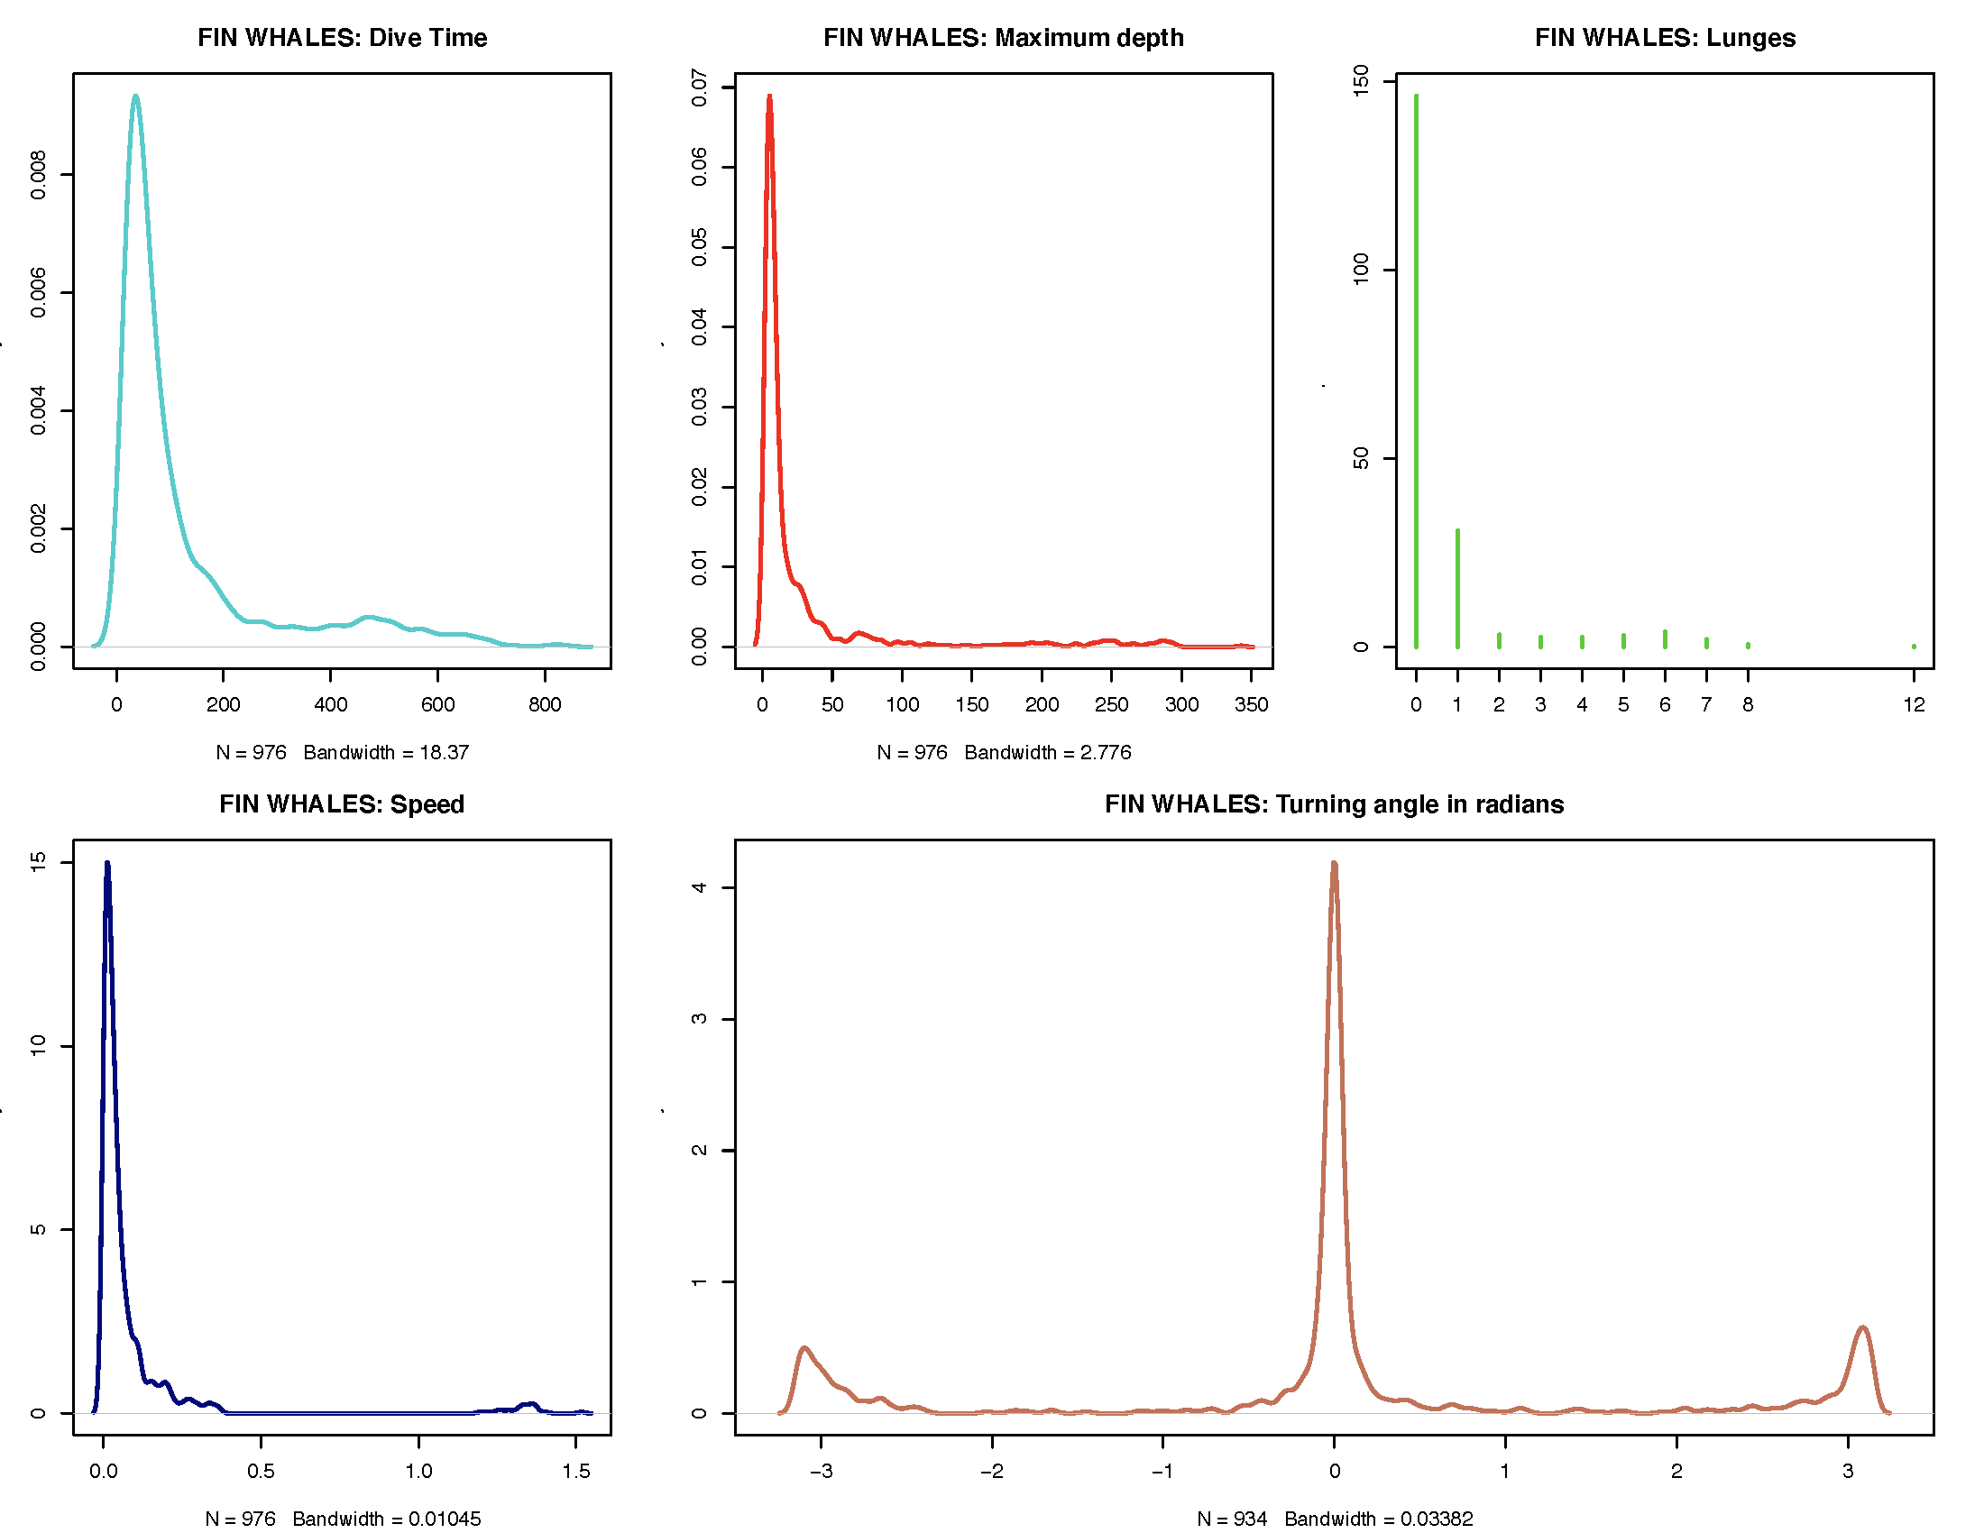
Figure S1. Baseline models from diving and foraging data from all fin whales (prior to MFAS exposure) without random or noise exposure effects.

Expert Elicitation – Behavioral Response Scoring

For the expert elicitation and behavioral response scoring for each CEE, the following data were provided to each of the (2) independent groups of experts. Examples of time-annotated maps and data panels provided are given below (Figs. S2-S4). Maps and data panels for all subjects are available on request from the corresponding author.
  - Time-annotated map showing corrected pseudotrack with focal follow points for whale (all 3 phases) and sound source position. An example map for CEE #2010_13 with subject bp10_247a is provided below (Fig. S2).
  - Data panels from DTAG/Acousonde and focal follow-informed pseudotrack with parameters listed below. An example data panel for CEE #2010_13 with subject bp10_247a is provided below (Fig. S3).
    - Depth (lunges in red, calls in yellow on track); tag-derived
    - Heading (median for each minute); tag-derived
    - Horizontal speed – derived from (by-second) location on pseudotrack. Ptrack is continuous adjustment of the location using GPS observations since speed estimates, accelerometer, magnetometer, currents produce errors in the location of the animal. Bayesian Melding of the dead-reckoning (DR) path used to account for errors in DR path and GPS observations
    - Minimum Specific Acceleration (MSA); tag-derived
  - Mahalanobis Distance data panels. An example data panel for CEE #2010_13 with subject bp10_247a is provided below (Fig. S4).
    - Depth (with lunges in green); tag-derived with lunges from auto-detector
    - Lunges/hr; calculated as lunges within sliding 15-min windows (determined as typical max dive time) transformed into a rate/hr
    - Variance in heading; tag-derived
    - Minimum Specific Acceleration (MSA); tag-derived
    - Horizontal and vertical speed; calculated from flow noise-derived instantaneous speed (determined by individual using flow-noise and orientation corrected depth rate) multiplied by pitch cosine (horizontal component) or sine (vertical)
    - Mahalanobis distance; calculated utilizing all variables above (other than depth)

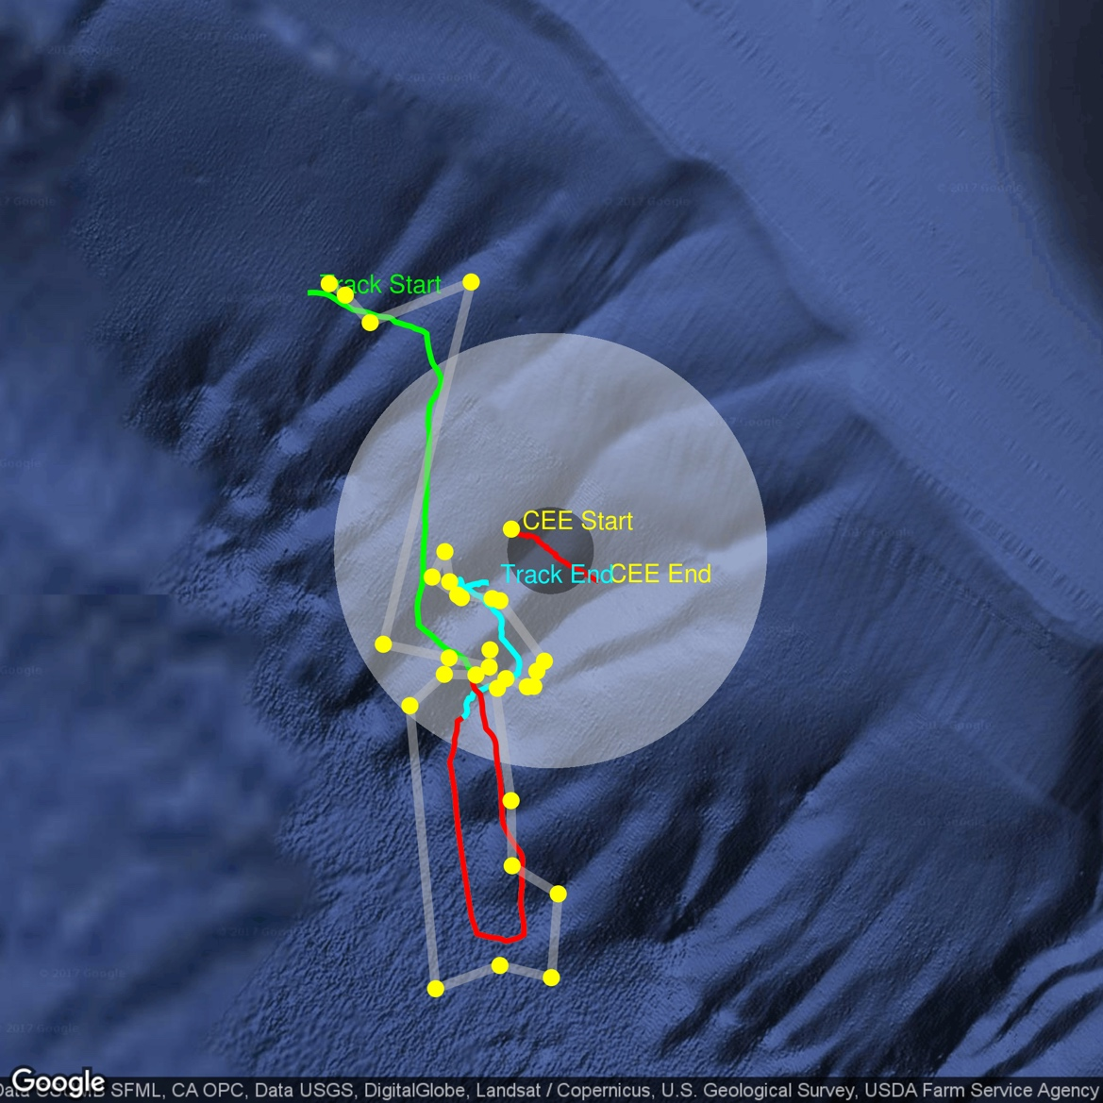

Figure S2. Time-annotated map for bp10_247a during exposure phases before (green), during (red), and after (blue) PRN exposure in CEE# 2010_13.

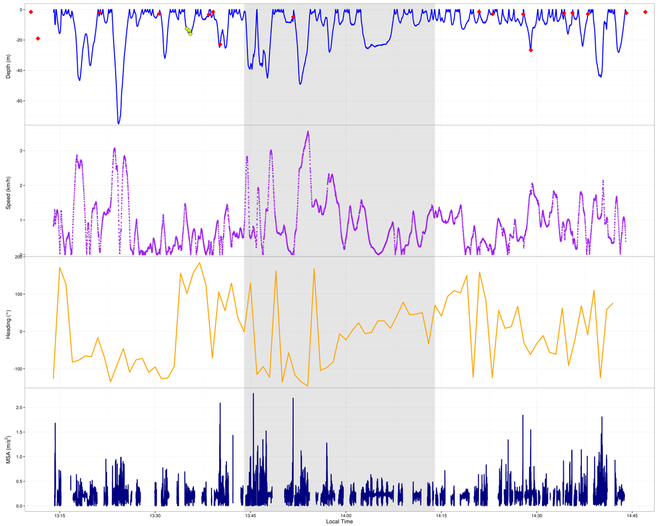

Figure S3. Tag- and focal-follow-derived data panels for bp10_247a during exposure phases before, during (shaded), and after PRN exposure in CEE# 2010_13.

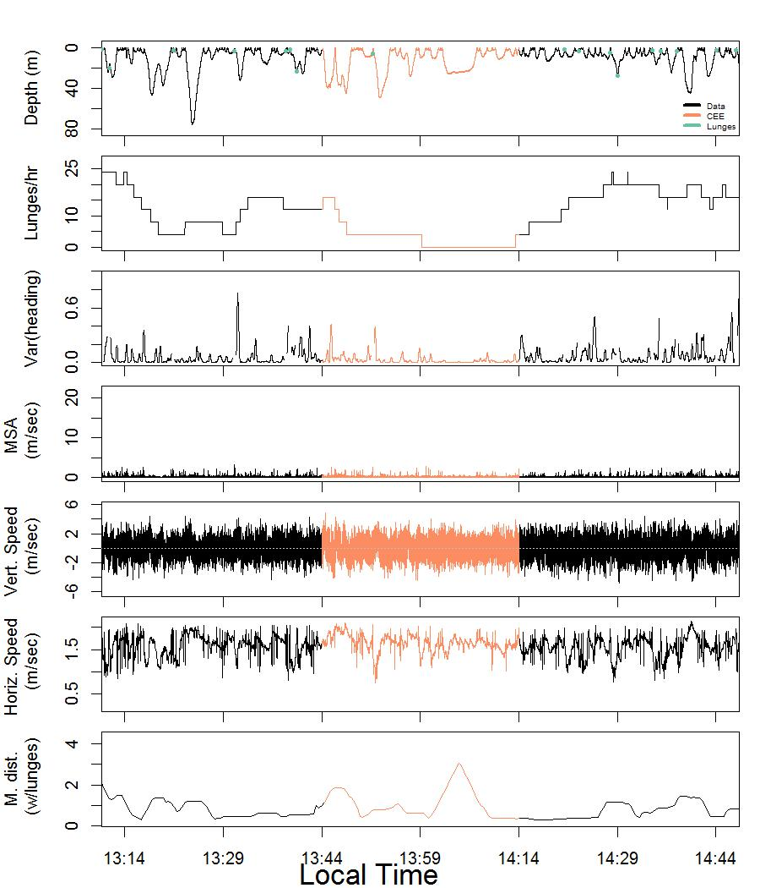

Figure S4. Tag- and focal-follow-derived data panels for bp10_247a during exposure phases before, during (orange), and after PRN exposure in CEE# 2010_13.

