Body Mass Index does not decline during winter for the sedentary marine gastropod Crepidula fornicata
Amanda M. Franklin, Alberto Rivera, Justin Robbins, Jan A. Pechenik

Supplementary Figures

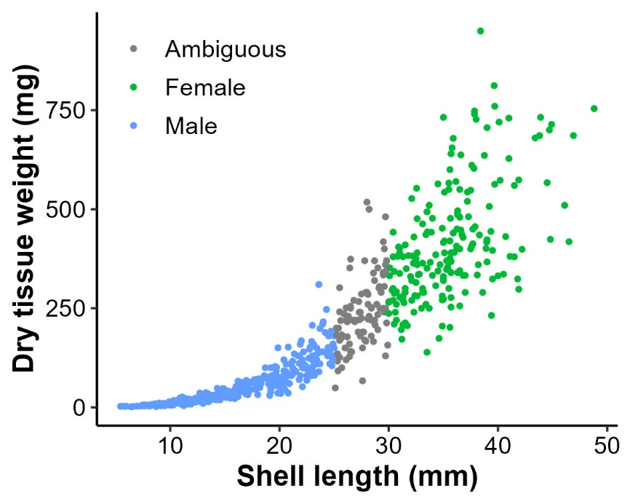

Fig. S1. Relationship between shell length (mm) and dry tissue weight (mg) for Crepidula fornicata collected over a 10-year period in this study. Color indicates size classification for males (blue), females (green) or individuals that were not classified (grey).

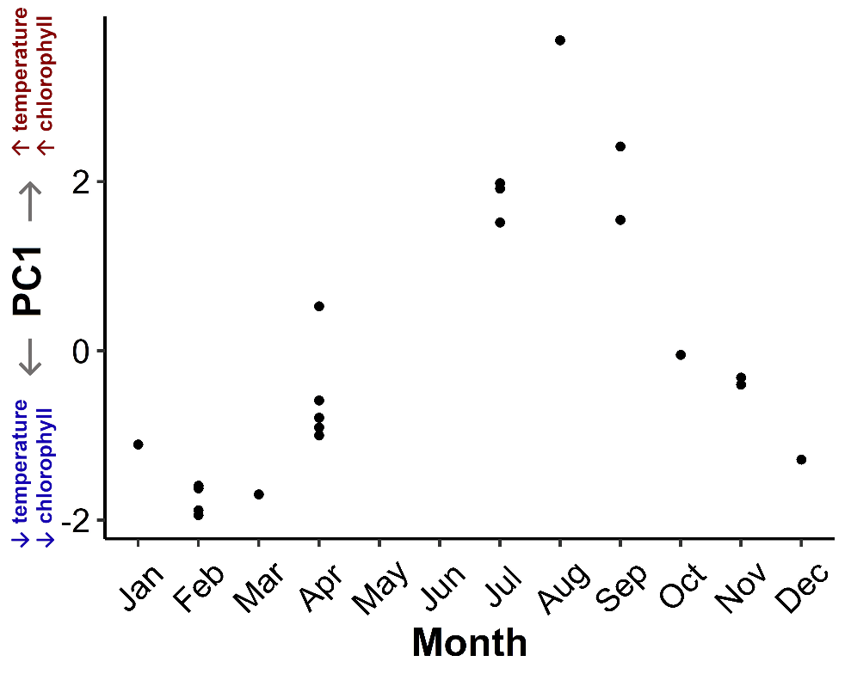
Fig S2. Relationship between PC1 values and month of year. Larger values of PC1 indicate higher sea surface temperature, air temperature and chlorophyll concentration, characteristic of Summer and early Fall conditions in Massachusetts and Rhode Island.

Table S1: Details of Crepidula fornicata used in the laboratory experiment. Snails were divided into three groups: those measured shortly after collection (field), those that were fed daily in the lab at 6 °C (food) and those that received no food at 6 °C throughout the 3-week experiment.

Experiment year | Shell length  Mean, Range | Sample size
 |  | Field | Food | No Food
2016 | 18.1 mm,  7.3 – 31.2 mm | n = 10 | n = 10 | n = 10
2018 | 23.4 mm,  17.5 – 29.4 mm | n = 11 | n = 6 | n = 8
2022 | 25.8 mm,  23.3 – 28.9 mm | n = 8 | n = 6 | n = 7

