Supplemental Information

Supplementary Figure 1. Proportion missing genotypes for each individual for the two filtering schemes.
(a) Original dataset after filtering out genotypes with quality <30. (b) After filtering out loci with >40% missingness in the Canada 1940 population.
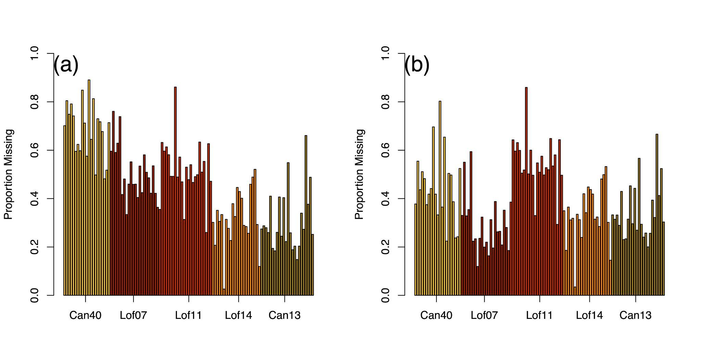

Supplementary Figure 2. Convergent correlations for each linkage group in the original dataset (without additional filtering) from Pinsky et al. 2021. ConvCor1 (Canada 1940-2013, Norway 1907-201) is shown in blue, ConvCor2(Canada 1940-2013, Norway 1907-2014) in green, ConvCor3(Norway 1907-2011, Norway 1907-2014) in purple, and ConvCor4(Canada 1940-2013, Norway 2011-2014) in orange. Points represent the overall value for each linkage group, and lines represent bootstrap 95% confidence interval.
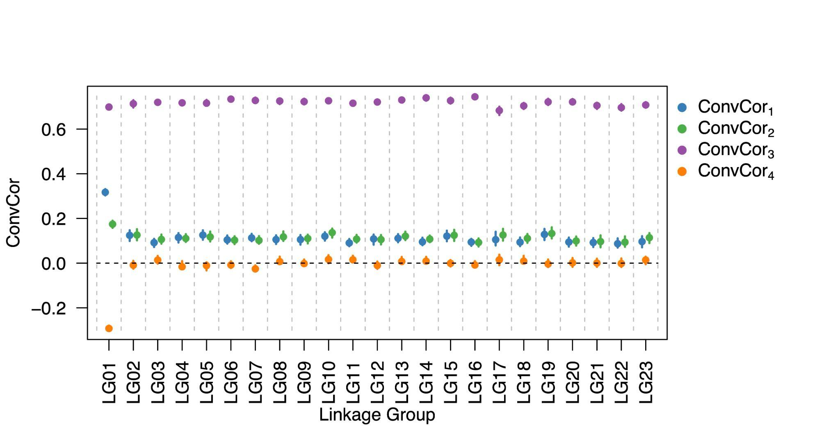

Supplementary Figure 3. Convergent correlations for groups of loci inside and outside known genomic inversions, as well as for SNPs in coding regions and all SNPs overall, in the unfiltered dataset. ConvCor1 (Canada 1940-2013, Norway 1907-201) is shown in blue and ConvCor2(Canada 1940-2013, Norway 1907-2014) in green. Points represent the overall value for each linkage group, and lines represent bootstrap 95% confidence interval.
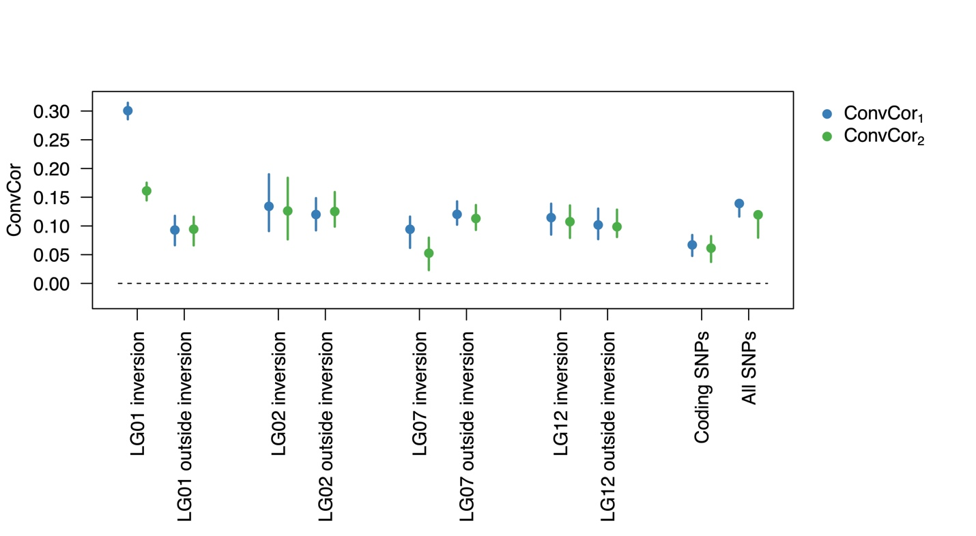

Supplementary Figure 4. Box-and-whisker plots showing distributions of simulated spatial and temporal F_{ST} values for different migration scenarios. Dotted lines show values observed for the cod dataset from Pinsky et al. (2021).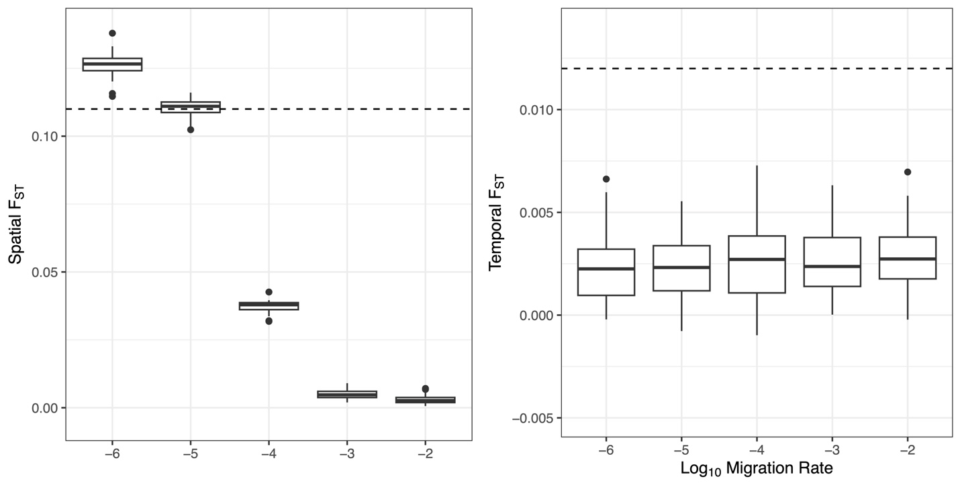

Supplementary Figure 5. (a) Age of simulated mutations still segregating at the end of the simulation (the present time) and their frequency at the end. Neutral mutations are shown in gray, QTL mutations are shown in blue, and deleterious mutations are shown in orange. The date of the split between the two simulated populations is shown as a dotted line. (b) Density plots of the distributions of fitness effects for deleterious mutations occurring either before or after the split between the two simulated populations and still segregating at the end of the simulation. (c) Density plots of the distributions of the additive phenotypic effects for QTL mutations occurring either before or after the split between the two simulated populations and still segregating at the end of the simulation.
