Supplementary information for “Mesocosm experiment reveals scale-dependence of movement tendencies in sticklebacks”

A. Ramesh, J. Gismann, T.G.G. Groothuis, F.J. Weissing and M. Nicolaus
Supplementary information 1: Description of the mesocosm and the tracking setup
Experiment-1
Within-pond movements
On the morning of testing (~10 a.m.), one test group of each origin was released into the first pond that was temporarily disconnected from the other ponds by a cap blocking the entrance to the corridor. There was no water flow when recording within-pond movement tendencies. Five circular antennas were placed upright on the bottom of the pond (“bottom antennas”), and four antennas were placed just below the water surface (“surface antennas”) (Fig. 1). To assess within-pond movements, we computed crosses that an individual made between bottom antennas or the surface antennas separately. Crosses that were made between a bottom and surface antenna were excluded as these hardly occurred. The experiment lasted for five hours.
Between-pond movements
After five hours, we gently removed all antennas from the first pond. At this point we also turned on the flow in the system to create a cue for migration (Fig. 1c). Fish were given 30 minutes to recover from the disturbance caused by removing the antennas after which the connection from pond 1 to the other ponds was gently opened. We then recorded the movement of fish between the five connected ponds (“crosses”) for the next 16.5h (~3.30 p.m. -8 a.m.). At the end of the experiment, fish were returned to their original smaller housing ponds. Testing all 5 migrant and 6 resident groups took place over a week (temperature ranged between 12⁰C and 15⁰C). All fish were checked at the end of the experiment to see if they still carried the tags and if the tags functioned correctly.

Experiment-2
Between-pond movements
Two weeks after we finished recording each individual for movement tendencies as above, we created one large group each of migrant and resident by combining all the fish (Nmig = 1 groups, 45 individuals; Nres = 1 group, 52 individuals) and monitored only the movement tendencies between-ponds simultaneously for the two groups and continuously for four consecutive days. During the study period, we furthermore alternated days with and without water flow (flow turned on / off at 10:00 AM each day and hence kept in that condition for ~24 hours). The flow treatment allowed testing whether the populations react differently to the presence of a migration cue.

Supplementary information 2: Study populations and housing of fish
We caught incoming migrants at a sea lock at the mouth of a river in Nieuwe Statenzijl (“NSTZ”; 53013’54.49’’, 7012’30.99’’), and resident sticklebacks in an adjacent land-locked polder (“LL-A”; 53017’56.14’’, 702’1.28’’) in the province of Groningen, The Netherlands (1). Fish were caught at the onset of inland migration, over a period of four weeks in March and April 2020. Fish of ≥4 cm in total length (from the tip of the snout to the tip of the tail) were transported to the lab in aerated plastic bags within two hours of capture. After acclimatization, fish were housed in groups of 25, separated by their origin (migrant or resident), for a week prior to experimentation in small holding ponds (~ 100 L tanks filled with freshwater from a nearby ditch) under natural temperature and light conditions. Fish were fed a mixture of brine shrimps and bloodworms (3F Frozen Fish Food bv.), once a day, ad libitum. Fish were tagged with 8 mm Passive Integrated Transponders (PIT tag; Trovan, Ltd., Santa Barbara, California) for individual identification, under anaesthetization in buffered MS-222 solution (0.25 – 0.3 g/L, pH=7.5-8.0). PIT tags were injected in the abdominal cavity (following (2)). Before experiments, all fish were allowed at least five days of recovery in the housing pond with the same group. The mortality rate after PIT tagging was very low (<1% in the first week). In addition, we did not find evidence for differences in the effect of PIT tags in regard to the size of fish, when performing our daily check on the welfare and behaviour of fish.

Supplementary information 3: Consistency of between-pond movements across ecological and social context.
To quantify individual consistency in between-pond movements across ecological contexts (i.e., individuals’ movement under flow vs no-flow conditions), we ran univariate generalised linear mixed models (GLMMs) with Poisson errors using the dataset from Experiment-2 and the lme4 package (3) and calculated repeatabilities using the ‘rptR’ package (4). For repeatability across social context (i.e., individuals’ movement in small vs large groups), we combined the data on the number of pond crosses from Experiment-1 (small group) with days 1 and 3 (which had water flow, thus excluding differences in ecological context) of Experiment-2 (large group).
We used the number of crosses between ponds as the response variable, with origin (resident vs. migrant), treatment (social context: small vs large group size or ecological context: flow vs no-flow in two separate models) and their interaction (origin × treatment) as a fixed factors and individual-ID as a random effect. In addition, we added Obs as observation-level random effects to control for over-dispersion (OLRE, (5)). We used these ‘full’ and ‘simplified’ models (omitting all the fixed effects) to calculate ‘adjusted’ and ‘raw’ repeatabilities respectively. Repeatabilities are defined as the ratio of among-individual variance (Vind) to total variance (Vtotal = Vind + Vresidual). We calculated repeatabilities in their original scale of measurement (not log scale), along with their confidence intervals using the ‘rpt’ function with 1000 bootstraps using the ‘rptR’ package (4). We were not able to calculate repeatabilities for different social contexts due to lack of model convergence. Hence, we resorted to using Spearman correlation to quantify consistency of pond crosses in the small group vs first day in the large group. All analyses were carried out in R v. 4.1.0, R Core Team (2019).
Between-pond movement was moderately repeatable across ecological contexts (Adjusted R (95% CI) = 0.42 (0.34, 0.51) and Raw R (95% CI) = 0.38 (0.30, 048)). Across social context, individuals were not very consistent with low correlation coefficients (Spearman ρ = 0.35, p < 0.001). This could be because the timescale and the sample size were not balanced between Experiment-1 and -2. While repeated data were collected over consecutive days in Experiment-2, single data points were collected a month apart in Experiment-1. However, we see that the residents were consistently moving less than migrants in all contexts.
Additionally, in order to investigate the relationship between measurements in the laboratory and in the mesocosm, we calculated the Spearman rank correlation coefficient between activity as measured in a classical lab test and across-pond movement in the mesocosm (Fig. S1) on a separate set of fish (F1 sticklebacks raised in the lab from (1)).

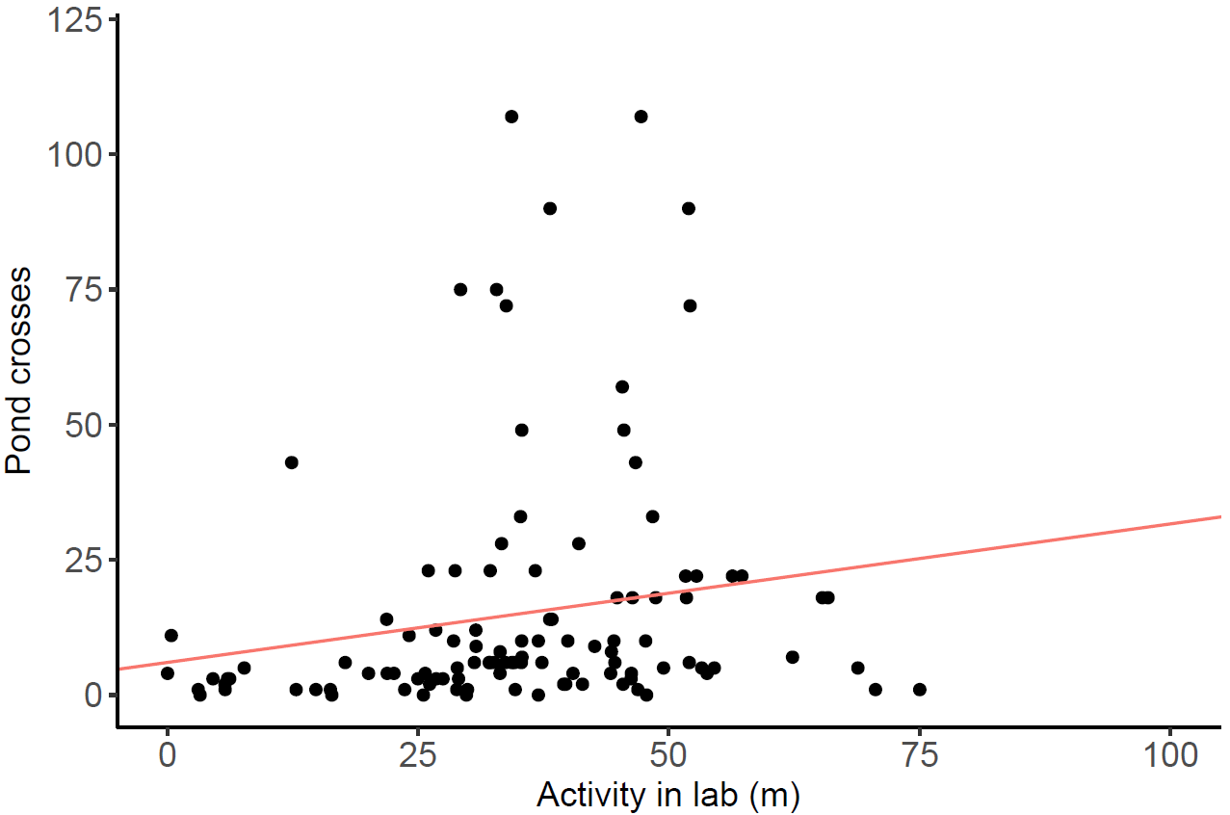
Figure S1: Correlation of movement tendencies measured of lab-raised F1 sticklebacks tested in the lab and in the mesocosm. In a separate experiment and on a separate set of fish, (F1 sticklebacks of migrant, resident and hybrid backgrounds raised in the lab from (1)), we performed both, an activity assay in the lab, where individual fish were assessed for general movement tendencies for 20 minutes in their home tank (30 x 16 x 18 cm (L x W x H)) (according to methods in (6)) and movement tendencies across-ponds in the mesocosm as in Experiment-1. The red line is the ordinary least squares regression line. Lab-based activity (total distance covered in meters in 20 mins) and number of pond crosses in the mesocosm were positively correlated. Since the data were not normally distributed, we calculated the Spearman rank correlation coefficient; ρ = 0.33, p < 0.01.

References
1. Ramesh A, Groothuis TGG, Weissing FJ, Nicolaus M. Habitat fragmentation induces rapid divergence of migratory and isolated sticklebacks. Behav Ecol. 2022;33(1):167-77.
2. Cousin X, Daouk T, Pean S, Lyphout L, M S, M B. Electronic individual identification of zebrafish using radio frequency identification (RFID) microtags. J Exp Biol. 2012;215:2729–34.
3. Bates D, Mächler M, Bolker B, Walker S. Fitting Linear Mixed-Effects Models Using lme4. J. Stat. Soft. 2015;67(1):1-48
4. Stoffel MA, Nakagawa S, Schielzeth H. rptR: Repeatability estimation and variance decomposition by generalized linear mixed‐effects models. Methods in Ecology and Evolution. 2017;8(11):1639-44.
5. Harrison XA. Using observation-level random effects to model overdispersion in count data in ecology and evolution. PeerJ. 2014;2:e616.
6. Ramesh A, Domingues MM, Stamhuis EJ, Groothuis TGG, Weissing FJ, Nicolaus M. Does genetic differentiation underlie behavioral divergence in response to migration barriers in sticklebacks? A common garden experiment. Behav Ecol Sociobiol. 2021;75(12):1-2.

