Photoelectrochemical Performance of BiOI/TiO₂ Nanotube Arrays (TNAS) p-n Heterojunction synthesized by SILAR-Ultrasonication-Assisted Methods
Sherly Kasuma Warda Ningsih^{a,b}, Rahmat Wibowoª, Jarnuzi Gunlazuardi^{a*}
ªDepartment of Chemistry, Faculty of Mathematics and Natural Sciences (FMIPA), Universitas Indonesia, Depok, 16424, Indonesia
^{b}Department of Chemistry, Faculty of Mathematics and Natural Sciences (FMIPA), Universitas Negeri Padang, Kampus Air tawar, Padang 25130, Indonesia

*jarnuzi@ui.ac.id
†Department of Chemistry, Faculty of Mathematics and Natural Sciences (FMIPA), Universitas Indonesia, Depok, 16424, Indonesia

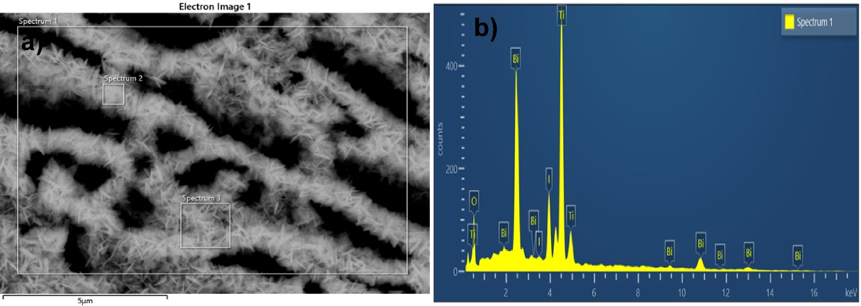
Figure S1. a) Electron image and b) EDX spectrum of BiOI/TNAs prepared with 7 mM of cationic and anionic precursors

Table S1. Composition of BiOI/TNAs prepared with 7 mM of cationic and anionic precursors
Element | Line Type | Weight % | Weight % Sigma | Atomic %
O | K series | 14.81 | 1.18 | 48.45
Ti | K series | 32.18 | 0.77 | 35.16
I | L series | 19.24 | 0.69 | 7.93
Bi | M series | 33.77 | 0.99 | 8.46
Total |  | 100.00 |  | 100.00

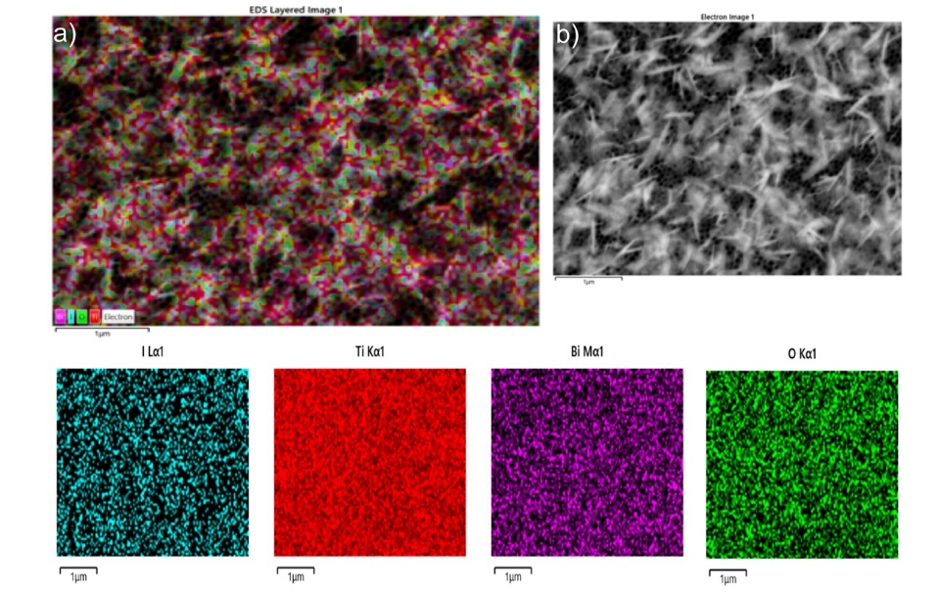
Figure S2. EDX mapping of BiOI/TNA prepared with 5 mM of cationic precursor and 3mM of anionic precursor a) EDX layer image and b) Electron image

Figure S3. EDX Spectra of BiOI/TNA prepared with 5 mM of cationic precursor and 3mM of anionic precursor

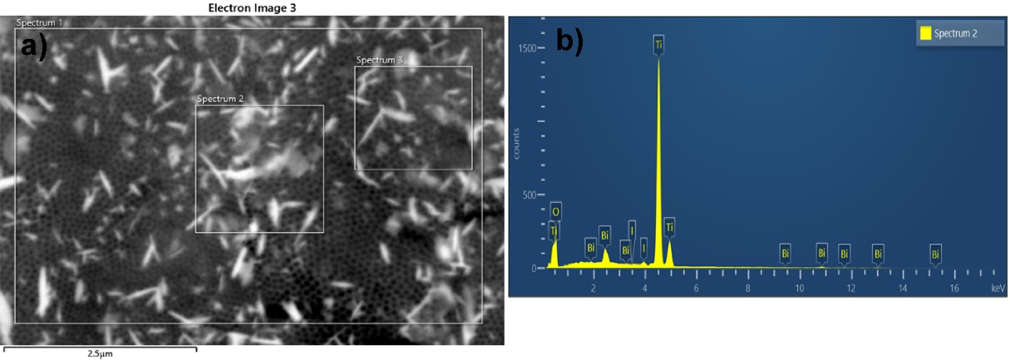
Figure S4. EDX Spectra of BiOI/TNA prepared with 1 mM of cationic and anionic precursor

Table S2. Composition of BiOI/TNAs prepared with 1 mM of cationic and anionic precursor
Element | Line Type | Weight % | Weight % Sigma | Atomic %
O | K series | 39.81 | 1.07 | 68.40
Ti | K series | 53.20 | 0.99 | 30.53
I | L series | 1.79 | 0.25 | 0.39
Bi | M series | 5.19 | 0.47 | 0.68
Total |  | 100.00 |  | 100.00

