Electronic Supplementary Materials
to accompany

Coalitionality Shapes Moral Elevation:
Evidence from the U.S. Black Lives Matter Protest and Counter-protest Movements

Colin Holbrook, Daniel M. T. Fessler, Adam Maxwell Sparks, Devin L. Johnson, Theodore Samore & Lawrence I. Reed

Table of Contents

Tables:

- Table S1. Descriptive statistics for idealistic attitudes toward police and Black Lives Matter

- Table S2. Correlation matrices for political orientation, police idealism, police funding preferences, and state elevation, by video condition (Study 1).

- Table S3. Correlation matrices for political orientation, police idealism, BLM idealism, police funding preferences, and state elevation, by video condition (Study 2).

Figures:

- Figure S1. The association between political orientation and state elevation (folk affect emotion terms subscale) by video condition.

- Figure S2. The association between political orientation and state elevation (somatic symptoms subscale) by video condition.

- Figure S3. The association between political orientation and state elevation (prosocial behavioral motives subscale) by video condition.

- Figure S4. The association between idealism toward police and state elevation by video condition.

- Figure S5. The association between idealism toward BLM protesters and state elevation by video condition.

- Figure S6. Police funding preferences by video condition.

Additional Analyses:

- Pilot study methods and results
- Mediation analyses: State elevation mediates preference for decreased Police funding following BLM video relative to control video

The full survey instruments and data are archived at https://osf.io/kdeg6/
Table S1
Descriptive Statistics for Idealistic Attitudes Toward Police and Black Lives Matter
Context |  |  |  |  | M |  | SD
Study 1 | Police Idealism |  |  |  |  | 4.73 | 1.49
Study 2 | Police Idealism |  |  |  |  | 4.82 | 1.50
 | BLM Protesters Idealism |  |  |  |  | 4.71 | 1.76
Note. Higher ratings indicate appraisals of greater trustworthiness and potential for cooperation.

Table S2
Correlation Matrices for Political Orientation, Police Idealism, BLM Idealism, Police Funding Preferences, and State Elevation, by Video Condition (Study 1).
 | 2 | 3 | 4
Neutral Control Video

1. Political Issues Index | .53 [.54] | .63 [.66] | .16 [.13]
2. Police Idealism | - | .56 [.58] | .08 [.06]
3. Police Funding |  | - | .21 [.17]
4. Elevation |  |  | -
Black Lives Matter Video

1. Political Issues Index | .44 [.41] | .61 [.62] | -.36 [-.32]
2. Police Idealism | - | .53 [.52] | -.12 [-.09]
3. Police Funding |  | - | -.27 [-.30]
4. Elevation |  |  | -
Note. N = 856. All correlations are significant at the .05 level, unless given in bold. Nonbracketed correlations reflect Pearson’s coefficients; nonparametric Spearman’s rank correlations (rho) given in brackets.

Table S3
Correlation Matrices for Political Orientation, Police Idealism, Police Funding Preferences, and State Elevation, by Video Condition (Study 2)
 | 2 | 3 |  | 4 |  | 5
Neutral Control Video

1. Political Issues Index | .54 [.52] |  | -.63 [-.58] |  | .65 [.67] |  | .19 [.18]
2. Police Idealism | - |  | -.36 [-.33] |  | .60 [.61] |  | .10 [.06]
3. BLM Idealism |  |  | - |  | -.48 [-.45] |  | .18 [.10]
4. Police Funding |  |  |  |  | - |  | .26 [.22]
5. Elevation |  |  |  |  |  |  | -
Black Lives Matter Video

1. Political Issues Index | .51 [.50] |  | -.64 [-.62] |  | .67 [.71] |  | -.40 [-.38]
2. Police Idealism | - |  | -.31 [-.28] |  | .59 [.59] |  | -.30 [-.19]
3. BLM Idealism |  |  | - |  | -.48 [-.52] |  | .68 [.67]
4. Police Funding |  |  |  |  | - |  | -.30 [-.32]
5. Elevation |  |  |  |  |  |  | -
Back the Blue Video

1. Political Issues Index | .50 [.48] |  | -.62 [-.59] |  | .62 [.64] |  | .57 [.58]
2. Police Idealism | - |  | -.33 [-.30] |  | .61 [.56] |  | .47 [.49]
3. BLM Idealism |  |  | - |  | -.46 [-.45] |  | -.28 [-.27]
4. Police Funding |  |  |  |  | - |  | .61 [.63]
5. Elevation |  |  |  |  |  |  | -
Note. N = 1,316. All correlations are significant at the .05 level, unless given in bold. Nonbracketed correlations reflect Pearson’s coefficients; nonparametric Spearman’s rank correlations (rho) given in brackets.

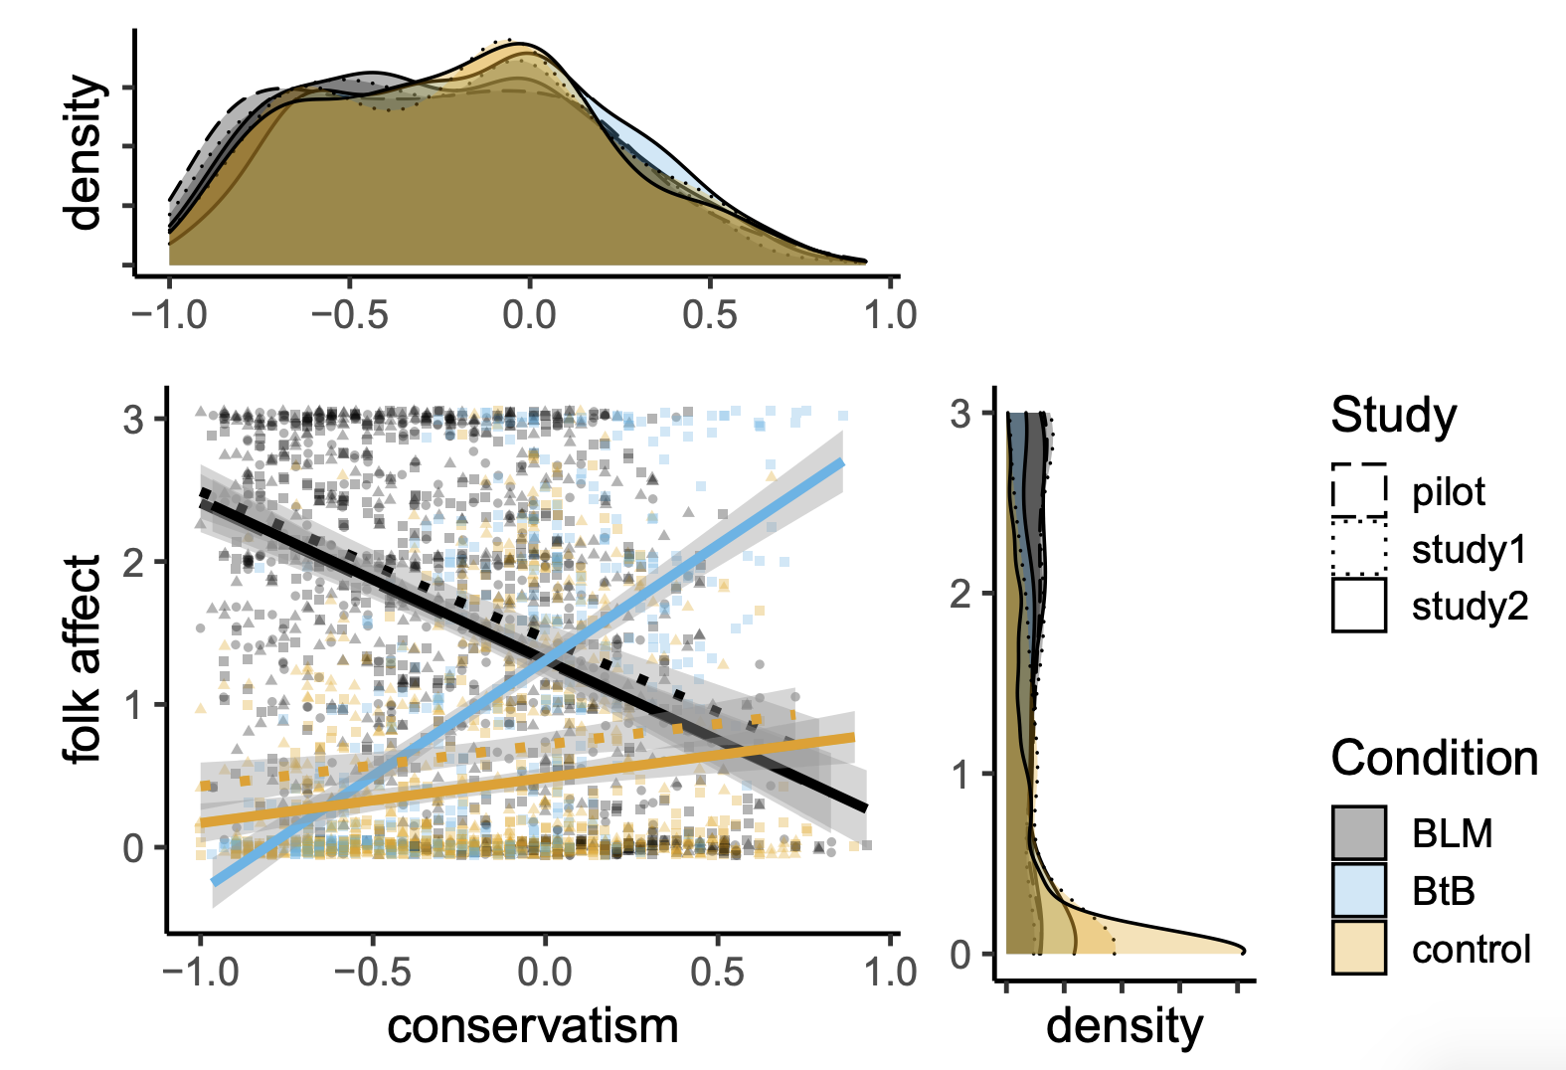

Figure S1. The association between political orientation and state elevation (folk affect emotion terms subscale) by video condition. BLM = Black Lives Matter; BtB = Back the Blue. Note that the pilot study included only the BLM video condition, and that the neutral control videos used in Studies 1 and 2 differed.

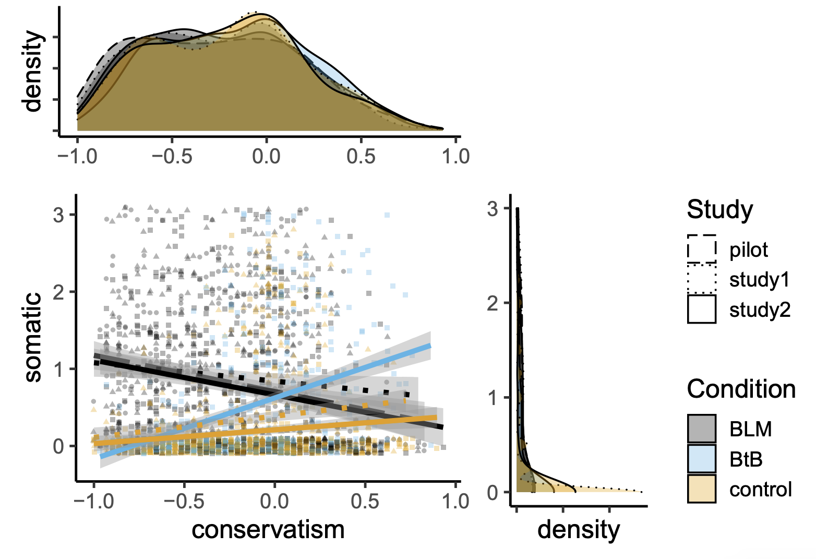
Figure S2. The association between political orientation and state elevation (somatic symptoms subscale) by video condition. BLM = Black Lives Matter; BtB = Back the Blue. Note that the pilot study included only the BLM video condition, and that the neutral control videos used in Studies 1 and 2 differed.

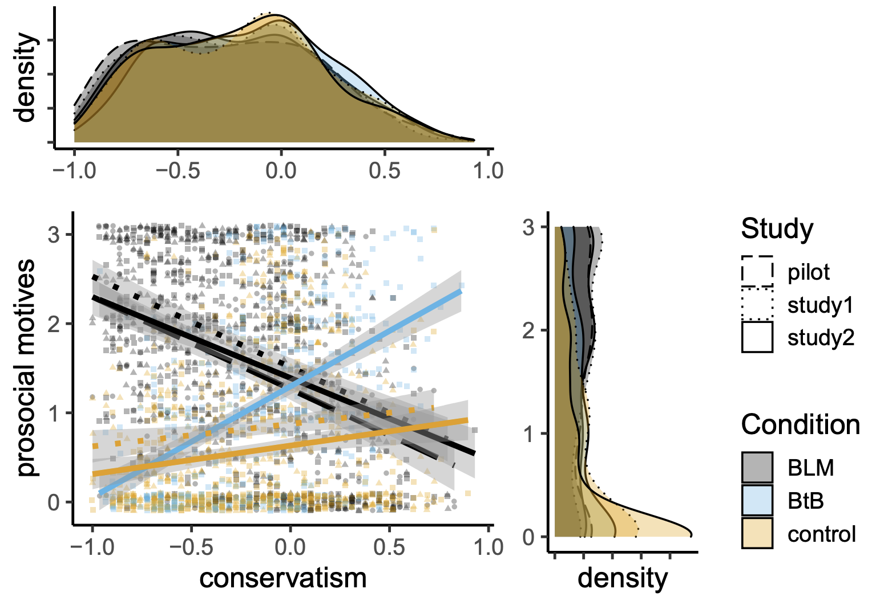
Figure S3. The association between political orientation and state elevation (prosocial behavioral motives subscale) by video condition. BLM = Black Lives Matter; BtB = Back the Blue. Note that the pilot study included only the BLM video condition, and that the neutral control videos used in Studies 1 and 2 differed.

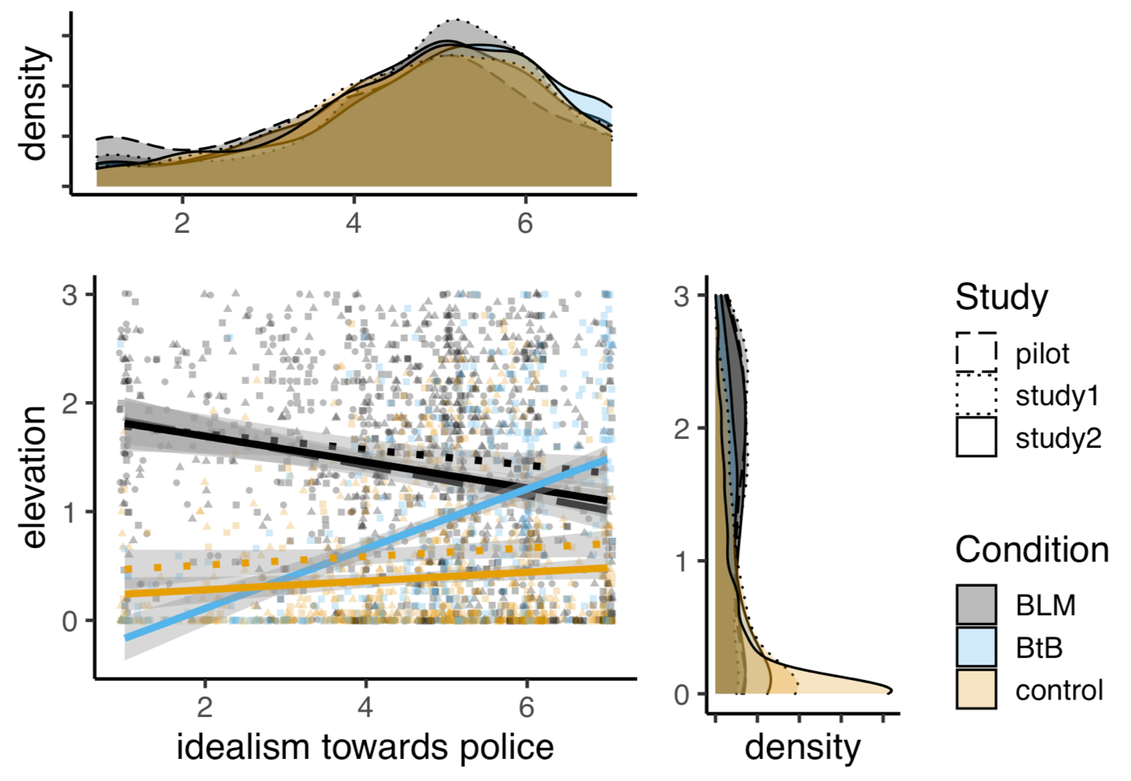

Figure S4. The association between idealism toward police and state elevation by video condition. BLM = Black Lives Matter; BtB = Back the Blue. Note that the pilot study included only the BLM video condition, and that the neutral control videos used in Studies 1 and 2 differed.

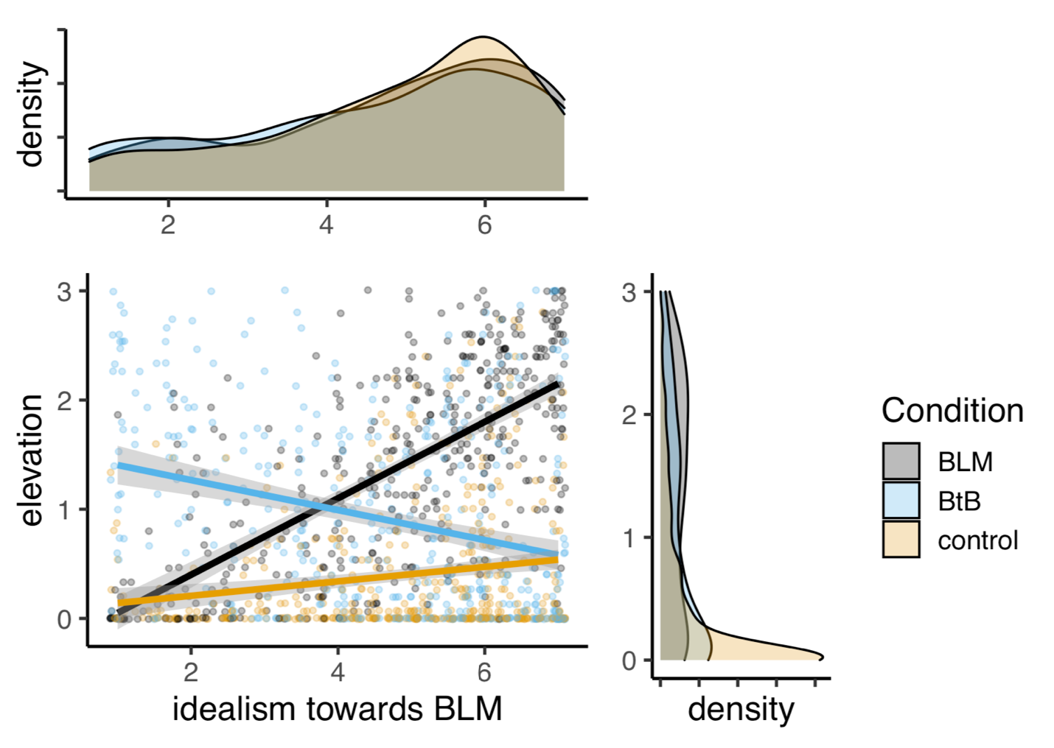

Figure S5. The association between idealism toward BLM protesters and state elevation by video condition. BLM = Black Lives Matter; BtB = Back the Blue. Note that only Study 2 included the measure of idealism toward BLM protesters.

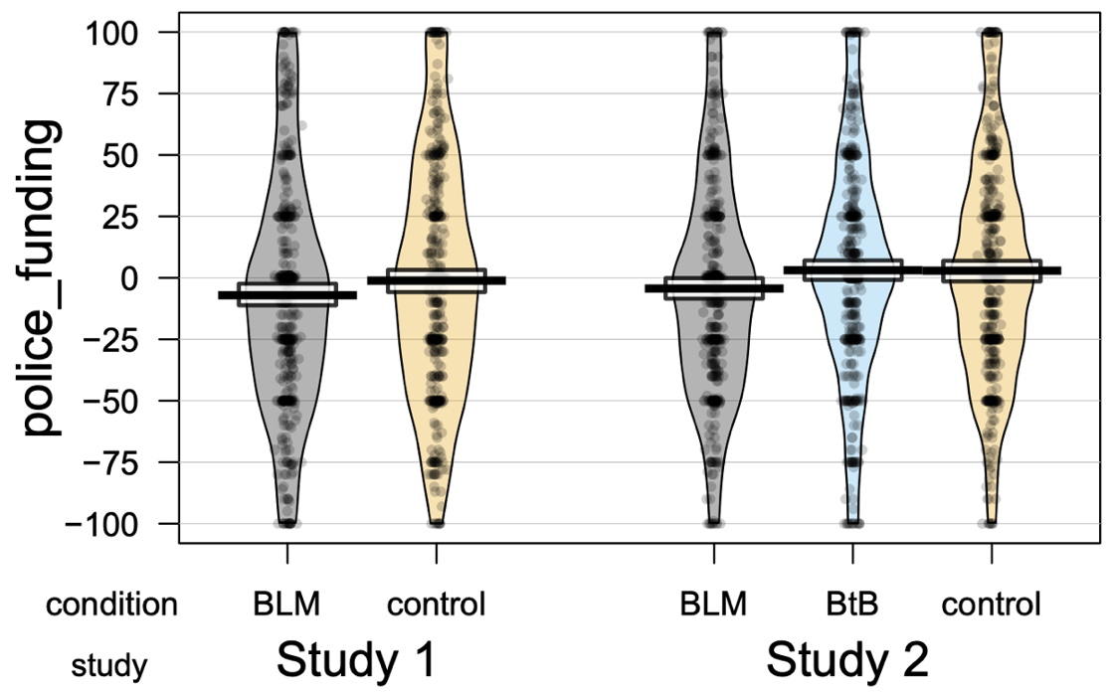

Figure S6. Police funding preferences by video condition. State elevation by video condition (top: Study 1, bottom: Study 2). BLM = Black Lives Matter; BtB = Back the Blue. Note that the neutral control videos used in Studies 1 and 2 differed.

Pilot Study Methods and Results
Participants. Based on prior work (Sparks et al., 2019), we targeted a sample size of 400, recruited via Amazon Mechanical Turk (500+ completed assignments, 99% approval, located in the U.S.) in exchange for U.S. $1.25 on June 24th, 2020. Data were prescreened as in the main text. The final sample consisted of 352 participants (42% female, M_{age} = 38.8 years, SD = 11.5, 71.3% white, 23.5% Republicans, 49.4% Democrats, 22.1% Independents). The study was approved by the UCLA Institutional Review Board.
Design. Participants were presented the same BLM protest video used in the studies reported in the main text, then completed the self-report 15-item elevation scale using 4-point Likert scales (0 = Not at all; 1 = Slightly; 2 = Moderately; 3 = Strongly; α = .97; Sparks et al. [2019]). Next, participants reported their preferences with regard to police funding (from a 100% reduction to a 100% increase), then completed the modified version of Dodd et al.’s (2012) political issues index (α = .91). Finally, participants were thanked, compensated, and debriefed. The pilot study also included exploratory measures not discussed here (e.g., self-reports of online engagement about the protest movement, perceptions of issues orthogonal to racial inequities in policing) which involve additional framing and are currently being prepared for separate publication. In addition, we had intended to assess potential associations between state elevation following the BLM video and support for destructive modes of protest (e.g., burning down police stations), but were unable to conduct such analyses as endorsement of destructive tactics was at floor levels. Accordingly, we do not discuss this measure in the current report.
Results
Conservative attitudes were negatively correlated with state elevation, r(350) = -.40, p < .001, and elevation was correlated with preferences to defund the police, r(350) = -.34, p < .001.
Mediation Analyses: State Elevation Mediates Preference for Decreased Police Funding Following BLM Video Relative to Control Video
The police funding preference ratings appears to reflect a political attitude, whereas the theoretical behavioral outputs of elevation concern prosocial helping. This distinction was not clear to us when pre-registering the experiment. At that time, conceptualizing funding preference as tokening a willingness to cooperate with the protesters depicted in the video stimulus, we predicted that participants in the BLM video condition of Studies 1 and 2 would favor reallocating police funds to other social services relative to the neutral control condition, and that this difference would be mediated by an increase in state elevation elicited by the BLM video. Likewise, we expected that participants in the BtB video condition of Study 2 would favor increasing police funds relative to the control condition, and that this difference would be mediated by an increase in state elevation elicited by the BtB video relative to the control condition. As is reported in the mediation analyses that follow, partial support for these predictions was obtained with respect to the effect of the BLM video manipulation. Nonetheless, we do not consider shifts in funding preference to fall within the proper domain of elevation (i.e., helping others at a cost to oneself), and instead to reflect an orthogonal relationship between the emotional impact of the video and a mild degree of persuasion / attitude updating. We provide the mediation models here, but caution readers not to interpret these results as directly relevant to the relationship between elevation and coalitional prosociality, for which measures of willingness to sacrifice in service of coalitional aims would be illuminating.

Study 1

Using the R package Mediation (Tingley et al., 2014), the total relationship between condition (BLM versus Control) and funding preferences was negative and approaching significance (B = -5.96, SE = 3.31, t(854) = -1.80, p = .072 [two-tailed]). We tested the indirect effect using bootstrapping procedures. Unstandardized indirect effects were computed for each of 1,000 bootstrapped samples, and the 95% confidence interval was computed by determining the indirect effects at the 2.5th and 97.5th percentiles. The bootstrapped unstandardized indirect effect was -3.41, and the 95% confidence interval range was from -7.02 to .09. The indirect effect was near significance (p = .056). After accounting for the indirect effect, the direct relationship between condition and funding preferences was non-significant (B = -2.50, p = .516). In sum, although the effect of condition and the indirect effect of elevation on funding preferences were both relatively small and merely approached significance, the overall pattern was consistent with a mediational role for elevation.

Condition (BLM vs. Control)

Police funding preference
State elevation
-5.96† (-3.50)
.90***
-3.73†

Study 2

The contrast between police funding preferences in the BLM condition attained conventional statistical significance at the .05 level (two-tailed) in Study 2, with no comparable shift in funding preference shift in the BtB condition. Again using the R package Mediation (Tingley et al., 2014), we tested whether state elevation mediated the relationship between the BLM and neutral video conditions and police funding preferences, omitting the BtB condition from the model. The total relationship between condition (BLM) and funding preferences was negative and significant (B = -7.24, SE = 3.02, t(876) = -2.40, p = .017), the bootstrapped unstandardized indirect effect was -3.94, and the 95% confidence interval range was from -7.67 to -.28. The indirect effect was significant (p = .030), and after accounting for the indirect effect the direct relationship between condition and funding preferences was non-significant (-3.21, p = .350). In sum, the effect of BLM versus control condition on police funding preferences was fully mediated via state elevation.

Condition (BLM vs. Control)
Police funding preference

State elevation
-6.91* (-3.21)
.97****
-4.06*

