Biology Letters

Shared stressful experiences affect social proximity in Merino sheep

Hamideh Keshavarzi, Caroline Lee, Tim R. Dyall, Mark Johnson, and Dana L.M. Campbell

Supplementary Figure 1
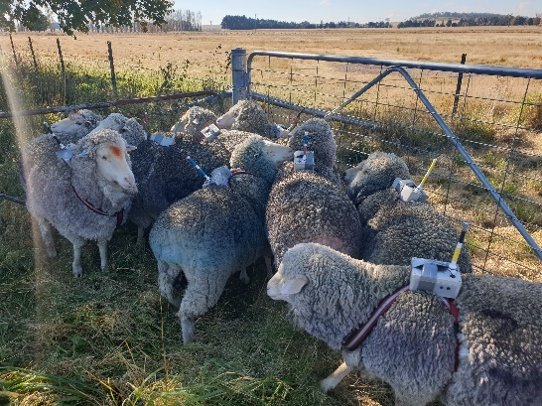

Figure S1: RTK rovers fitted to the backs of experimental sheep.

