**Supplementary Information for**

**Quantitative biomechanical assessment of locomotor capabilities of *Euparkeria capensis***

Oliver E. Demuth1,2,*, Ashleigh L. A. Wiseman1,3 & John R. Hutchinson1

1Structure and Motion Laboratory, Department of Comparative Biomedical Sciences, The Royal Veterinary College, Hatfield, UK. 2Department of Earth Sciences, University of Cambridge, Cambridge, UK. 3 McDonald Institute for Archaeological Research, University of Cambridge, Cambridge, UK

*Correspondence: [oed24@cam.ac.uk](mailto:oed24@cam.ac.uk)

**SUPPLEMENTARY FIGURES**

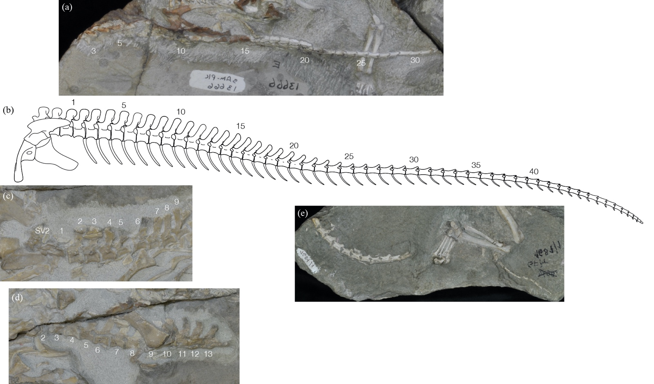

**Supplementary Figure S1. Tail reconstruction of *Euparkeria capensis*.** Preserved tails of SAM PK 13666 (a), SAM PK K8050 specimen 1 (c), SAM PK K8050 specimen 2 (d) and GPIT 1681.1. SAM PK 13666 and GPIT 1681.1 have been mirrored for comparison. The specimens are not to scale and have each been scaled to match the tail reconstruction. Numbers indicate the serial position of each vertebra.

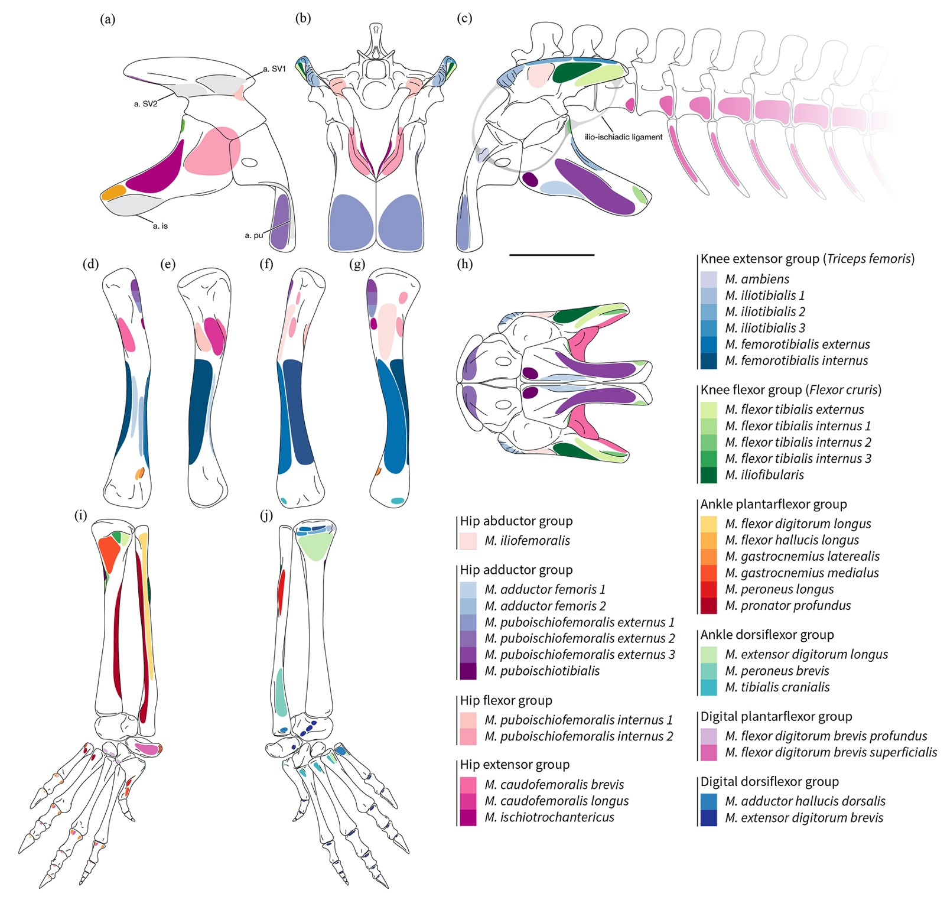

**Supplementary Figure S2. Myological reconstruction ofthe *Euparkeria capensis* pelvis and hindlimb.** Inferred origin and insertion attachment sites for all major pelvic and hindlimb muscles. Pelvis and tail reconstruction in medial (a), cranial (b), lateral (c), and ventral view (h). Right femur muscle attachments in caudal (d), left medial (e), cranial (f) and left lateral view (g). Muscle attachments on the right crus and pes in caudal/plantar (i) and cranial/dorsal view (j) respectively. Note that the *M. puboischiofemoralis internus 2* is reconstructed in the plesiomorphic saurian condition here, with its origin on the medial ischium, before its origin moved to the posterior dorsal vertebrae somewhere in early archosaurs based on the character state estimation in Mesquite. Abbreviations: a., articular surface; is, ischium; pu, pubis; SV, sacral vertebra. Muscle homologies of the lower limb follow Hattori and Tsuihiji [1].

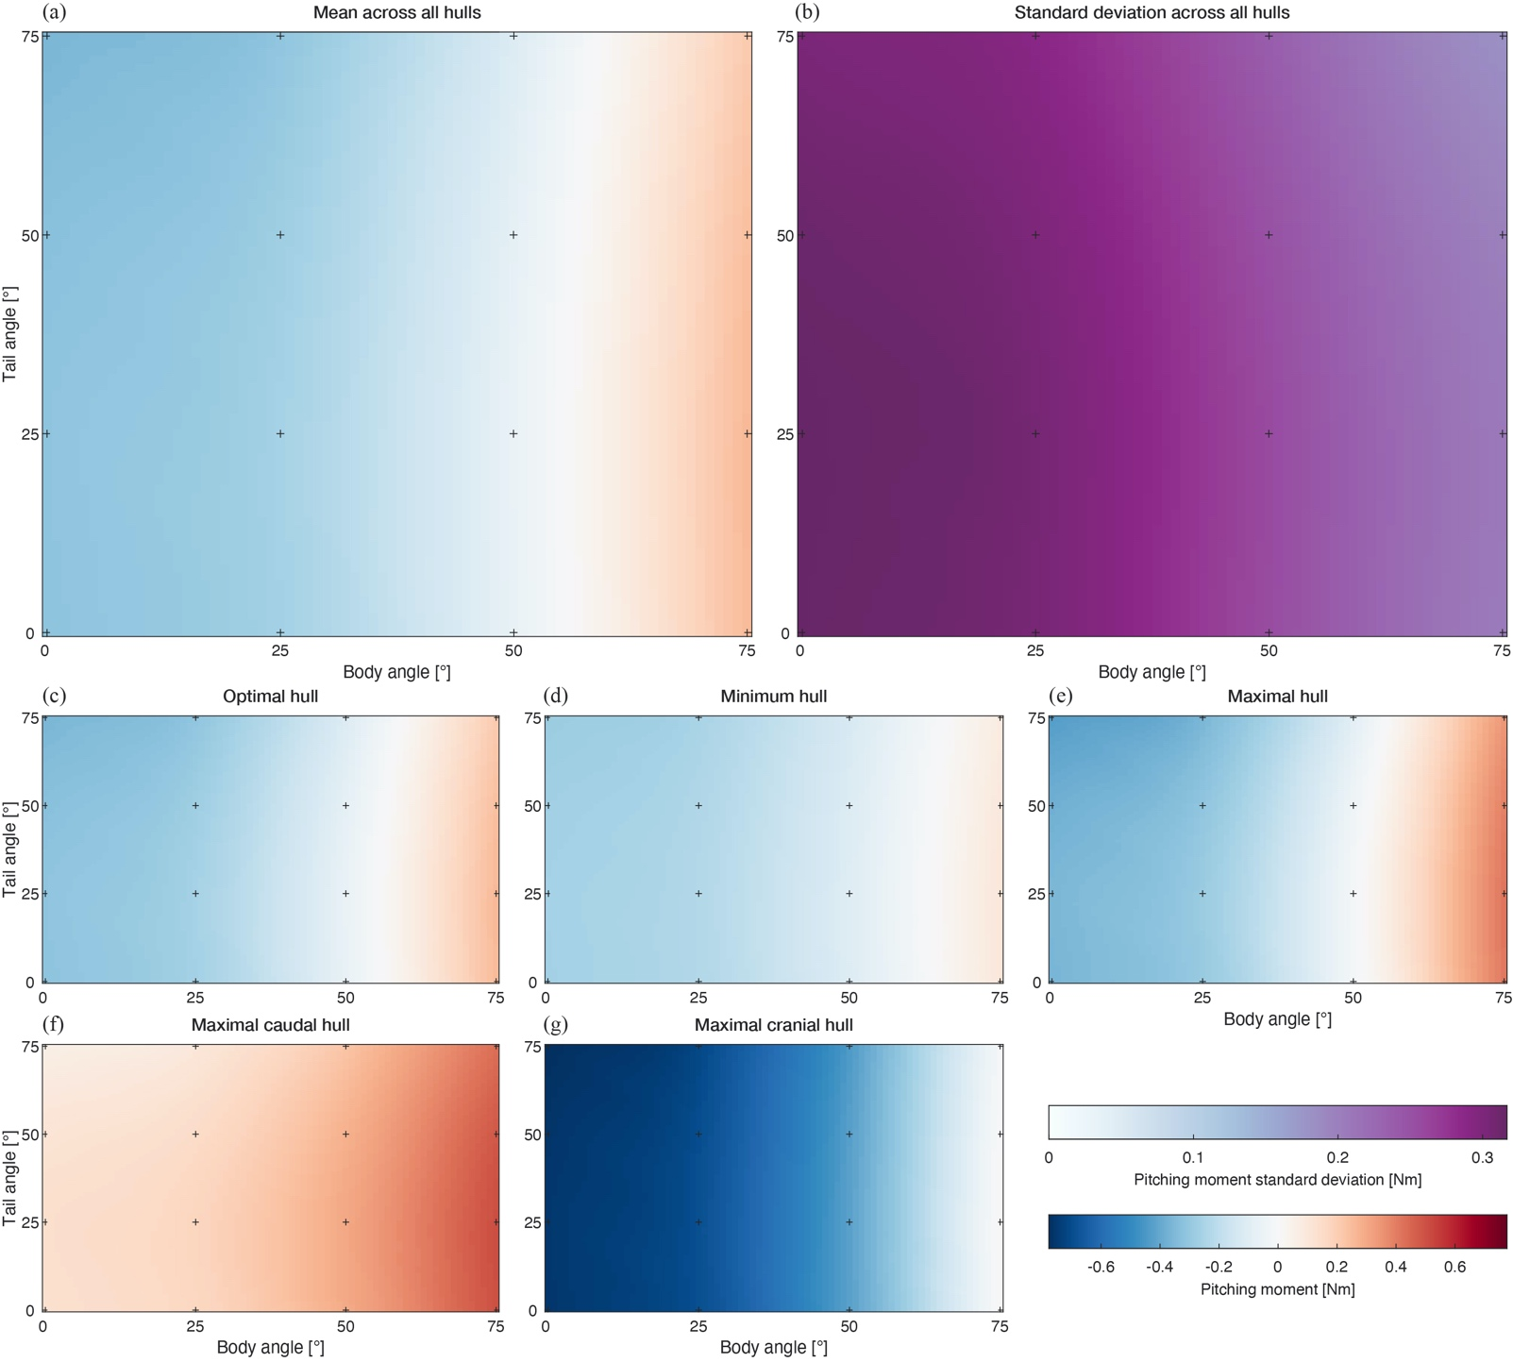

**Supplementary Figure S3. Pitch moment sensitivity analysis.** (a) Mean of the pitch moments across all hull models and their corresponding standard deviation (b). (c) Optimal hull model as figured in the main text. (d) Pitch moments for the minimum hull with the hull shape modified by -20%. (e) Pitch moments for the maximal hull model a with the hull shape modified by +20%. (f) Pitch moments for the maximal caudal hull model, where the minimal hull models were used for the torso, neck, head and forelimbs and the maximal hull models for the hindlimbs and tail. (g) Pitch moments for the maximal cranial hull model, which was the opposite of the maximal caudal model. The individual moments and the absolute and percentage difference between the mean and the optimal model can be found in the Supplementary Information S3.

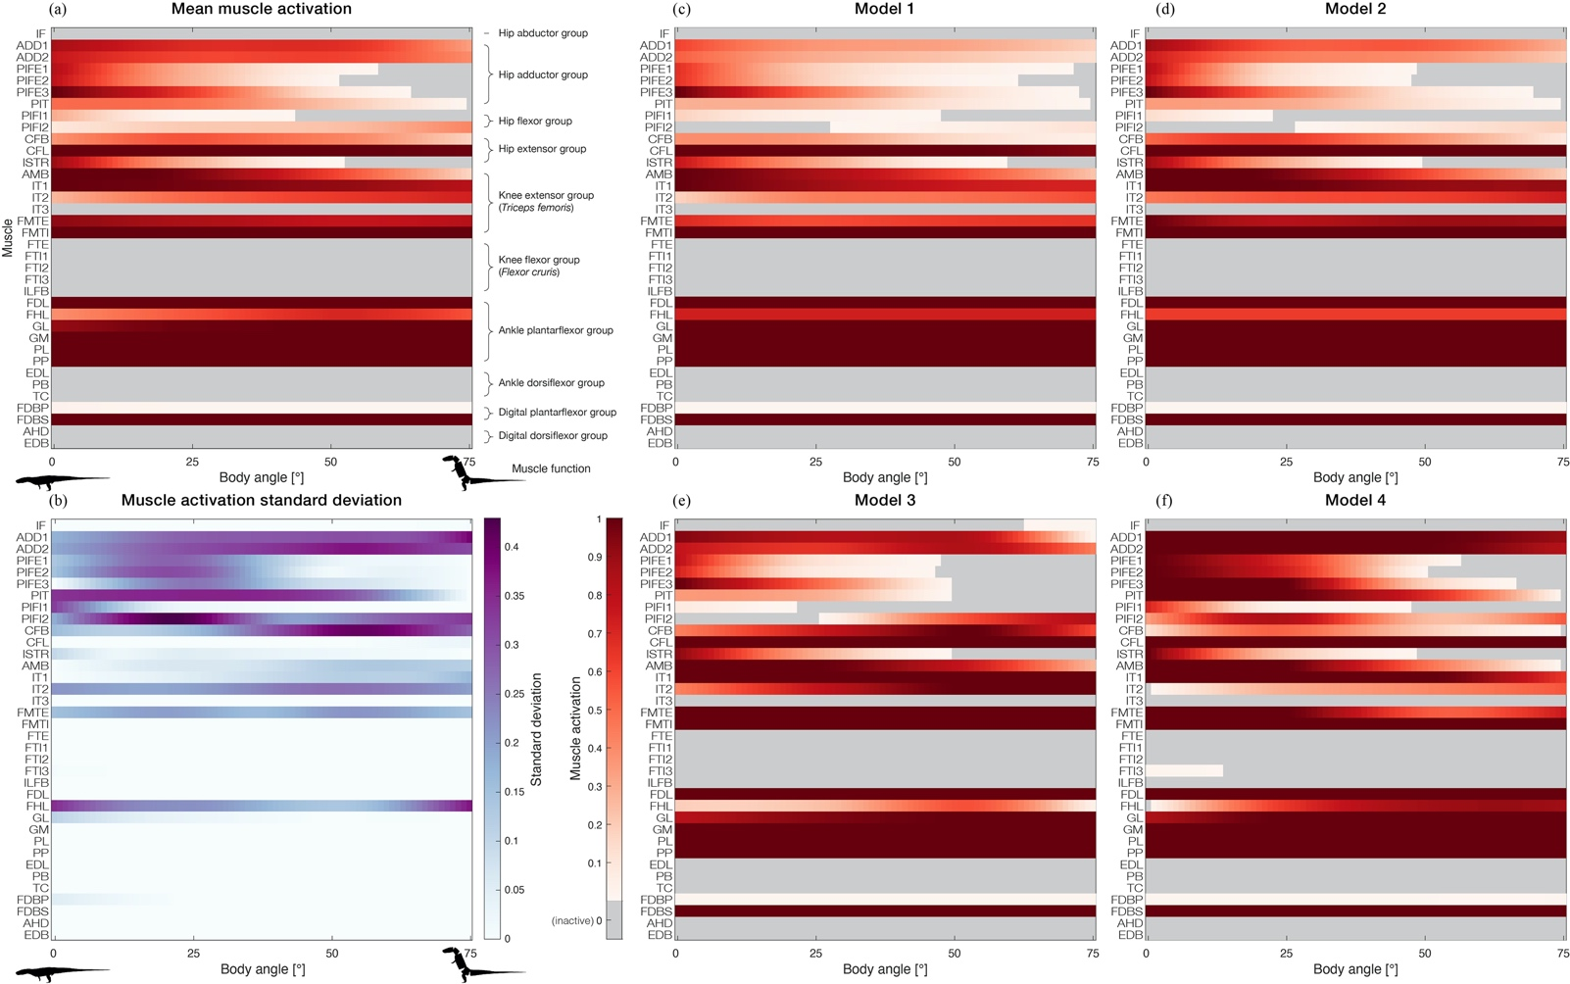

**Supplementary Figure S4. Muscle activations for the four musculoskeletal models based on the different muscle parameter estimation methods.** Mean muscle activation (a) across all four models and the corresponding standard deviation (b). Muscle activations for Model 1 (arithmetic centroid; c), Model 2 (convex hull centroid; d), Model 3 (arithmetic centroid; 3) and Model 4 (volumetric muscle reconstruction; f).



**Supplementary Figure S5. Time calibrated ancestral state reconstruction of bipedality within Archosauria for the ‘Ezcurra tree’ for two character states using an ‘equal rates’ model.** The phylogenetic tree was assembled based on Ezcurra [2], Garcia et al. [3] and Müller and Garcia [4]. Red circles indicate bipedality and blue ones quadrupedality. AIC score of 49.70.



**Supplementary Figure S6. Time calibrated ancestral state reconstruction of bipedality within Archosauria for the ‘Ezcurra tree’ for three character states using an ‘all rates different’ model.** The phylogenetic tree was assembled based on Ezcurra [2], Garcia et al. [3] and Müller and Garcia [4]. Red circles indicate bipedality, yellow circles facultative bipedality and blue ones quadrupedality. AIC score of 63.54.



**Supplementary Figure S7. Time calibrated ancestral state reconstruction of bipedality within Archosauria for the ‘Nesbitt tree’ for two character states using an ‘equal rates’ model.** The phylogenetic tree was assembled based on Nesbitt [5], Nesbitt et al. [6], von Baczko et al. [7], Ezcurra et al. [8] and Foffa et al. [9]. Red circles indicate bipedality and blue ones quadrupedality. AIC score of 49.69.



**Supplementary Figure S8. Time calibrated ancestral state reconstruction of bipedality within Archosauria for the ‘Nesbitt tree’ for three character states using an ‘all rates different’ model.** The phylogenetic tree was assembled based on Nesbitt [5], Nesbitt et al. [6], von Baczko et al. [7], Ezcurra et al. [8] and Foffa et al. [9]. Red circles indicate bipedality, yellow circles facultative bipedality and blue ones quadrupedality. AIC score of 63.91.

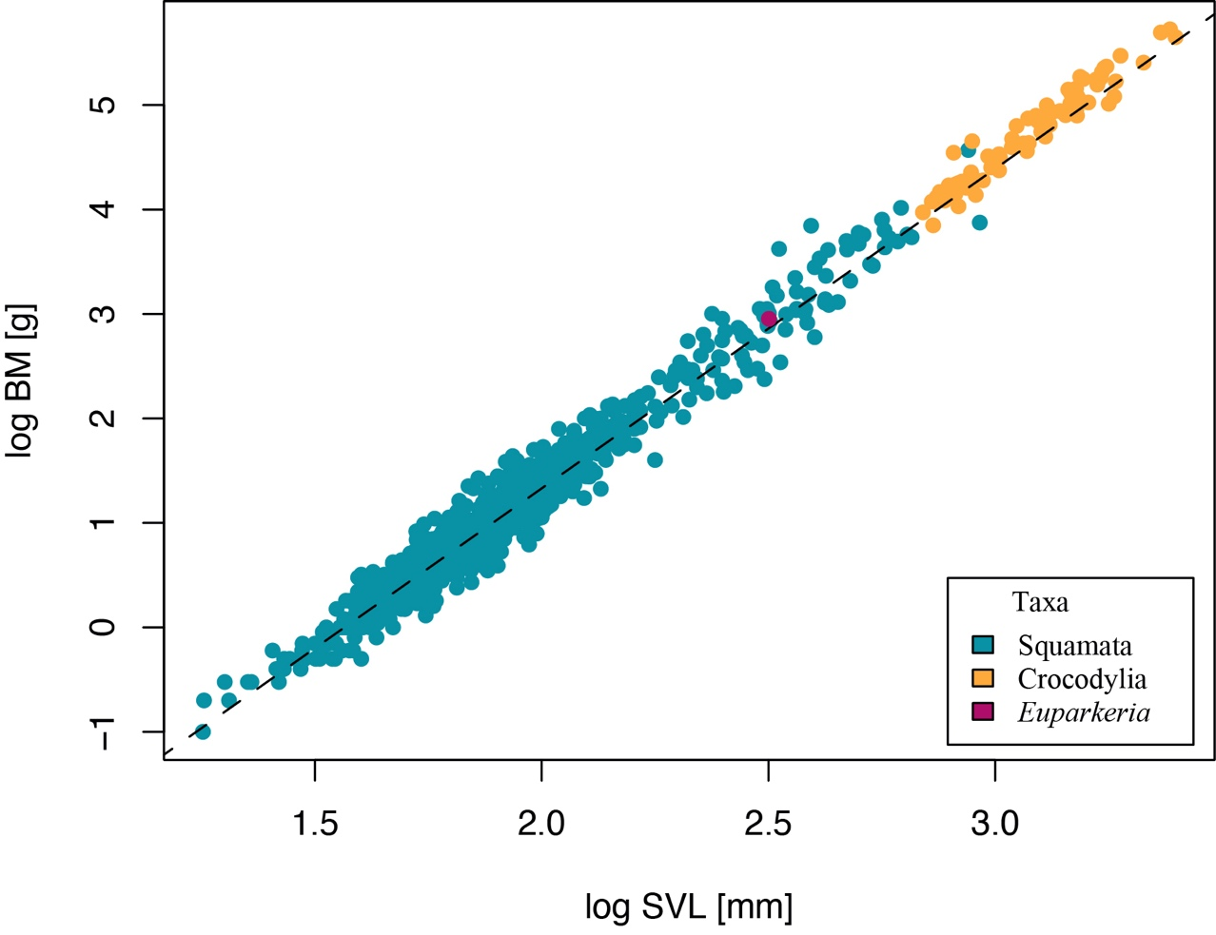

**Supplementary Figure S9. Saurian mass-length relationship.** Snout-vent length (SVL) and body mass data for saurians are based on the dataset of legged lizards from Meiri [10] and data for crocodylians are from O’Brien et al. [11]. For *Euparkeria* the SVL (317 mm) is plotted against the mass of the optimal model (899.8 g). BM and SVL were log-transformed (log10).

**SUPPLEMENTARY TABLES**

|  |  |  |  |  |  |  |
| --- | --- | --- | --- | --- | --- | --- |
| GRF [BW] | 2.9 | 3 | 3.1 | 6.7 | 7.3 | 7.4 |
| Hip FE | 0.727 | 0.752 | 0.777 | 1.688 | 1.839 | 1.865 |
| Hip ABAD | -0.161 | -0.167 | -0.173 | -0.384 | -0.419 | -0.425 |
| Hip LAR | 0.164 | 0.170 | 0.176 | 0.385 | 0.417 | 0.425 |
| Knee FE | 0.116 | 0.120 | 0.124 | 0.271 | 0.296 | 0.300 |
| Knee ABAD* | 0.197 | 0.204 | 0.211 | 0.458 | 0.500 | 0.507 |
| Knee LAR* | -0.054 | -0.056 | -0.057 | -0.124 | -0.135 | -0.137 |
| Ankle FE | -0.251 | -0.260 | -0.268 | -0.580 | -0.632 | -0.641 |
| Ankle ABAD* | -0.098 | -0.101 | -0.104 | -0.225 | -0.246 | -0.249 |
| Ankle LAR* | -0.064 | -0.066 | -0.068 | -0.148 | -0.161 | -0.163 |
| Models: Simulation | M1: 0, 25, 50, 70 M3: 0 | M2: 0, 25, 50, 75 M3: 25, 75 | M3: 50 | M4: 0 | M4: 25 | M4: 50, 75 |

**Supplementary Table S1.** ***Euparkeria* hindlimb joint moments.** Joint moments in Nm for the different maximal GRF of the different simulations. Note, joints denoted with an asterisk (*) were locked in the simulations and not actuated by muscle force.

|  |  |  |  |  |
| --- | --- | --- | --- | --- |
| Tree | Character states | Model | log-likelihood | AIC |
| Nesbitt | 2 | EQ | -21.845 | 49.690 |
| 2 | ARD | -21.837 | 51.675 |
| 3 | EQ | -35.304 | 80.608 |
| 3 | SYM | -32.604 | 77.209 |
| 3 | ARD | -23.956 | 63.913 |
| Ezcurra | 2 | EQ | -21.851 | 49.702 |
| 2 | ARD | -21.850 | 51.699 |
| 3 | EQ | -35.301 | 80.602 |
| 3 | SYM | -32.497 | 76.995 |
| 3 | ARD | -23.771 | 63.542 |

**Supplementary Table S2.** **Likelihood of different models for the ancestral state reconstruction.** See Supplementary Figures S5-S8 for the most likely models for two- and three-character state ancestral state reconstructions. Abbreviations: EQ, equal rates; ARD, all rates different; SYM, symmetrical rates.

**Supplementary References**

1. Hattori S, Tsuihiji T. 2021 Homology and osteological correlates of pedal muscles among extant sauropsids. *J. Anat.* **238**, 365–399. (doi:10.1111/joa.13307)

2. Ezcurra MD. 2016 The phylogenetic relationships of basal archosauromorphs, with an emphasis on the systematics of proterosuchian archosauriforms. *PeerJ* **4**, e1778. (doi:10.7717/peerj.1778)

3. Garcia MS, Müller RT, Da-Rosa ÁAS, Dias-da-Silva S. 2019 The oldest known co-occurrence of dinosaurs and their closest relatives: A new lagerpetid from a Carnian (Upper Triassic) bed of Brazil with implications for dinosauromorph biostratigraphy, early diversification and biogeography. *J. South Am. Earth Sci.* **91**, 302–319. (doi:10.1016/j.jsames.2019.02.005)

4. Müller RT, Garcia MS. 2020 A paraphyletic ‘Silesauridae’ as an alternative hypothesis for the initial radiation of ornithischian dinosaurs: Early evolution of Ornithischia. *Biol. Lett.* **16**. (doi:10.1098/rsbl.2020.0417rsbl20200417)

5. Nesbitt SJ. 2011 The Early Evolution of Archosaurs: Relationships and the Origin of Major Clades. *Bull. Am. Museum Nat. Hist.* **352**, 1–292. (doi:10.1206/352.1)

6. Nesbitt SJ *et al.* 2017 The earliest bird-line archosaurs and the assembly of the dinosaur body plan. *Nature* **544**, 484–487. (doi:10.1038/nature22037)

7. Baczko MB von, Desojo JB, Ponce D. 2020 Postcranial anatomy and osteoderm histology of Riojasuchus tenuisceps and a phylogenetic update on Ornithosuchidae (Archosauria, Pseudosuchia). *J. Vertebr. Paleontol.* **39**, e1693396. (doi:10.1080/02724634.2019.1693396)

8. Ezcurra MD *et al.* 2020 Enigmatic dinosaur precursors bridge the gap to the origin of Pterosauria. *Nature* **588**, 445–449. (doi:10.1038/s41586-020-3011-4)

9. Foffa D *et al.* 2022 Scleromochlus and the early evolution of Pterosauromorpha. *Nature* **610**, 313–318. (doi:10.1038/s41586-022-05284-x)

10. Meiri S. 2010 Length–weight allometries in lizards. *J. Zool.* **281**, 218–226. (doi:10.1111/j.1469-7998.2010.00696.x)

11. O’Brien HD, Lynch LM, Vliet KA, Brueggen J, Erickson GM, Gignac PM. 2019 Crocodylian Head Width Allometry and Phylogenetic Prediction of Body Size in Extinct Crocodyliforms. *Integr. Org. Biol.* **1**. (doi:10.1093/iob/obz006)