ELECTRONIC SUPPLEMENTARY MATERIAL
Branching coral morphology affects physiological performance without colony integration
Peter J. Edmunds, Kelly W. Johnson, Scott C. Burgess
Methods
Collection of corals and preparation of corals
In both years, colonies (~ 12-cm diameter) of Pocillopora spp. were haphazardly collected from 10-m depth at a common site on the forereef. Colonies were selected to have a common phenotype with ~ 11 branches on each colony, and were removed from the substratum with a hammer and chisel, bagged, and returned to the lab immersed in seawater. Working in a shallow tray of flowing seawater on the day of collection, half the colonies were left intact, and half were dismantled into branches (~2–4-cm long) using bone sheers. From each colony, a single branch was attached to a plastic base (a nubbin [10]), and 10 branches were attached to another plastic base with spacing resembling a natural colony. Branches were attached to bases using adhesive (Cg Coral Glue, Ecotech, USA), and when the glue had cured, the nubbins, aggregates, and intact colonies were transferred to a ~ 1,000 L tank where they were positioned on a rotating table (2 revolutions day⁻¹) to adjust to laboratory conditions for 3–9 days. This tank was maintained at 28.9 ± 0.1°C (mean ± s.e., n = 22) and a photon flux density (PFD) of 511 ± 7 µmol photons m⁻² s⁻¹ (2019) or 563 ± 60 µmol photons m⁻² s⁻¹ (2022) (mean ± s.e., n = 6 days), recorded using a 4-π quantum sensor Li-Cor LI-193) and supplied with four LED lamps (Aquaillumination, SOL white in 2019 and Hydra 64 in 2022). The PFD chosen was close to the value recorded at noon at 10-m depth on the fore reef (~ 645 µmol photons m⁻² s⁻¹). The light was supplied on a 12:12 h photoperiod, with 4 hr ramping up beginning at 06:00 hrs and 4 hr ramping down beginning at 14:00 hrs. The nubbin and the aggregate stood upright on plastic bases, intact colonies were in PVC cups, and all were moved daily within the tanks to avoid position effects.
Maintaining treatments
The mesocosm is described elsewhere [e.g., 18], but in brief, consists of twelve, 150 L tanks that are independently regulated. Tanks were supplied with sand filtered (pore size ~ 450–550 μm) seawater from 8-m depth in Cook’s Bay at ~ 150 mL min⁻¹. A subset of these tanks was used for each Trial, with half supplied with CO₂ gas to create a reduced pH treatment as described below. Each tank was illuminated with a single LED lamp (SOL white in 2019 and Hydra 64 in 2022, Aquaillumination) that were operated on a 12:12 light:dark photoperiod, with 4 hr ramping up beginning at 06:00 hrs and 4 hr ramping down beginning at 14:00 hrs.
P_{CO2} treatments
In 2019, P_{CO2} treatments were created by bubbling ambient air (~ 400 µatm P_{CO2}) or pure CO₂ gas into the tanks. The supply of CO₂ gas was regulated by a solenoid-controlled valve (Model A352, Qubit Systems, Kingston, ON, Canada) operated through an Apex Classic Aquacontroller (Neptune Systems, Morgan Hills, CA, USA) that recorded seawater pH in the tanks using pH electrodes (lab grade, Neptune Systems, Morgan Hills, CA, USA). These electrodes were calibrated in NBS buffers, but were cross-calibrated in the tanks with a high-precision electrode (Mettler DIG115-SC) attached to a hand-held meter (Orion 3 star meter, Mettler-Toledo, LLC, Columbus, OH, USA) and calibrated on the total scale using Tris/HCl buffers (SOP6 [53]).
The trial lasted 21 days, during which the physical and chemical conditions in the tanks were monitored with the data used to adjust the control systems to maintain treatment conditions close to target values. Seawater temperature was recorded daily (using a certified thermometer [± 0.05°C], model 15-077, Fisher Scientific, Pittsburgh, PA, USA), and daily measurements were taken for salinity using a conductivity meter (YSI 3100, YSI Inc., Yellow Springs, OH, USA), pH using a hand-held meter (Orion 3 star meter, Mettler-Toledo, LLC, Columbus, OH, USA) fitted with a Mettler DG115-SC probe, and light using a 4-π quantum sensor (Li Cor, LI-193) attached to a meter (LiCor LI-1400). Seawater samples (50 mL) were collected every 2–3 days for the analysis of A_{T} using potentiometric titrations (after SOP3b [53]) conducted using an open cell, automatic titrator (Model T50, Mettler-Toledo, Columbus, OH, USA) fitted with a pH probe (Mettler DG115-SC) that was calibrated on the total scale using Tris/HCl buffers [53] and operated with certified HCl acid (A. Dickson, Scripps Institution of Oceanography). The accuracy and precision of the titrations was determined using certified reference materials (CRMs, batches 151, 158, and 172) from A. Dickson (Scripps Institution of Oceanography). The accuracy of the pH measurements obtained with the hand-held meter were determined by periodic comparison with values determined using m-Cresol Purple dye (no. 211761, Sigma-Aldrich, St Louis, MO, USA) according to SOP7 [53]. The measurements of seawater pH and A_{T} were used to calculate dissolved inorganic carbon (DIC) parameters using Seacarb [54] running in the R software environment (R Foundation for Statistical Computing).
In 2022, P_{CO2} treatments were established with the same system of electrodes and solenoids as used in 2019, but they were operated with an Apex Head Unit (Neptune Systems, Morgan Hills, CA, USA). The physical and chemical conditions in the tanks were monitored as described above, except that seawater salinity was recorded using a refractometer (Agriculture Solutions, Xin Da Ching, China), and titrations were completed with a Mettler T5 autotitrator (Mettler-Toledo, Columbus, OH, USA). The accuracy and precision of the titrations were evaluated using certified reference materials (CRMs, batch 189) from A. Dickson (Scripps Institution of Oceanography).
Weighing corals
Net calcification of the corals was determined by buoyant weighing the corals [6] before and after the treatments, and converting the change in buoyant weight into dry mass using an empirical measure of seawater density (~1.0233 mg cm⁻³), and the density of aragonite (2.93 g cm⁻³). Nubbins and aggregates were weighed to ± 1 mg beneath a Mettler PB303-S balance, and whole colonies were weighted to ± 10 mg beneath a Core (model CQT 2602) balance.
Results
Treatment conditions
In 2019, the tanks were precisely maintained, and created a contrast of the main effect of P_{CO2} (Table S1). Treatments created a mean temperature of 28.9 ± < 0.1°C under a PFD of 561 ± 2 µmol photons m⁻² s⁻¹ and an A_{T} of 2,317 ± 2 µmol kg⁻¹ (all ± s.e., n = 8), and contrasted a mean P_{CO2} of 414 ± 3 µatm versus 1,041 ± 7 µatm (both ± s.e., n = 4). When corals were collected in April 2019, a bleaching event was beginning, and corals on the reef were paler than normally encountered at this time of year. Incubation in the mesocosms at ~ 1°C lower than the ambient temperature on the fore reef was associated with the colonies regaining their brown color as their Symbiodineacea algae increased in population size. None of the corals in the 8 tanks died or lost tissue during the incubations, and all maintained normal polyp expansion at night.
In 2022, the physical and chemical conditions in the tanks again were precisely maintained to create a contrast of the main effect of P_{CO2} (Table S1). The treatments established a mean temperature of 28.75 ± < 0.01°C under a PFD of 484 ± 7 µmol photons m⁻² s⁻¹ and an A_{T} of 2319 ± 3 µmol kg⁻¹ (± s.e., n = 144), and contrasted a mean (± s.e.) P_{CO2} of 1073 ± 23 µatm versus 444 ± 11 µatm (± s.e., n = 36). All colonies remained alive throughout the study and often maintained normal polyp expansion at night.
Growth rates
When two outliers were dropped from the growth analysis (values < 0.1 mg cm⁻² d⁻¹), the statistical analyses distinguished the growth of Nubbins from Aggregates (p = 0.043) and Colonies (p = 0.002), but Aggregates did not differ from Colonies (p = 0.462) (Fig. S1).
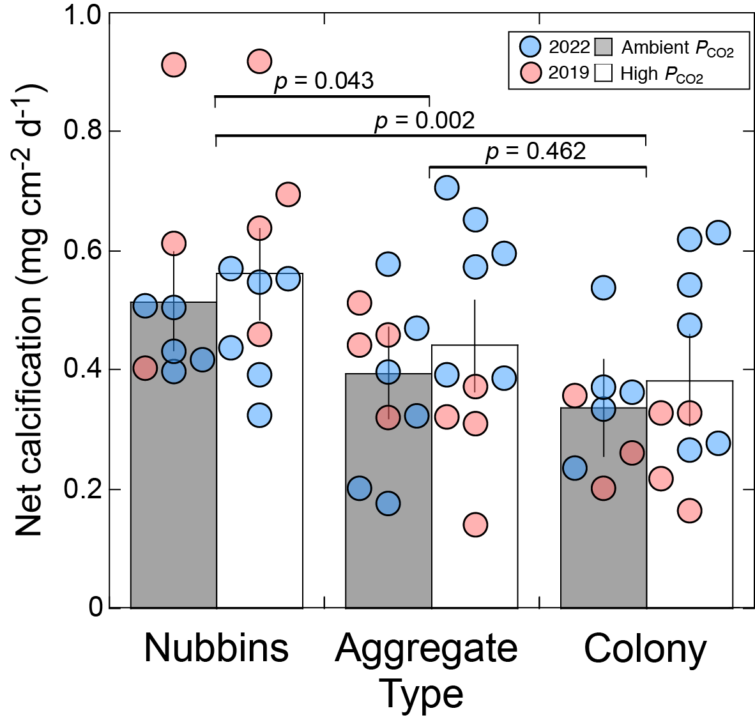
Fig. S1. Area-normalized net calcification of Pocillopora spp. incubated at ~ 400 µatm or ~ 1,000 µatm P_{CO2} in 2019 (red) and 2022 (blue). Two low outliers (figure 2) were dropped from the analysis. Bars show the mean and vertical lines show the 95% confidence interval (n = 8–10 for all treatments). Across two trials, net calcification differed among colony types (𝜒² = 12.024, d.f. = 2, p = 0.003), but not between P_{CO2} treatments (𝜒² = 1.222, d.f. = 1, p = 0.269), and there was no interaction between the main effects (𝜒² = 0.079, d.f. = 2, p = 0.961). Net calcification differed between Nubbins and Aggregates and between Nubbins and Colonies (horizontal lines and p-values).

Table S1. Physical and chemical conditions during the two trials in 2019 and 2022. In 2019, the temperature was targeted at slightly below ambient seawater on the fore reef, and P_{CO2} targeted ~ 400 μatm (Ambient, AC) and ~ 1000 μatm (High, HC); conditions in 2022 were selected to closely approximate those used in 2019. The concentration of dissolved inorganic carbon (C_{T}), partial pressure of CO₂ (P_{CO2}), and the saturation state of aragonite (Ω_{arag}) were calculated from measured pH_{T}, total alkalinity (A_{T}), temperature (T), and salinity (S) using the R package Seacarb [54]. Values are mean ± s.e. (n = sample size, †: values ≤ 0.01 (pH_{T}), ≤ 0.1°C (temperature), or < 0.1 (salinity)). pH_{T}, n = 20 in 2019 and 12 in 2022; A_{T}, n = 9 in 2019 and 24 in 2022; C_{T}, P_{CO2}, and Ω_{arag}, n = 20 in 2019 and 12 in 2022; T, n = 62 in 2019 and 2022; S, n = 20 in 2019 and n = 22 in 2022; Light, n = 20 in 2019 and n = 8 in 2022.
Trial | Tank # | Treatment | pH_{T} | A_{T}  (μmol kg⁻¹) | C_{T}  (μmol kg⁻¹) | P_{CO2}  (μatm) | Ω_{arag} | T  (°C) | S | Light  (μmol m⁻² s⁻¹)
2019 | 6 | AC | 8.03 ± † | 2318 ± 9 | 1991 ± 5 | 420 ±10 | 3.78 ± 0.05 | 28.9 ± † | 35.4 ± † | 569 ± 4
 | 9 | AC | 8.03 ± † | 2314 ± 9 | 1984 ± 6 | 409 ± 9 | 3.81 ± 0.05 | 28.9 ± † | 35.4 ± † | 553 ± 2
 | 7 | AC | 8.03 ± † | 2312 ± 9 | 1981 ± 6 | 410 ± 8 | 3.81 ± 0.04 | 29.0 ± † | 35.4 ± † | 558 ± 2
 | 8 | AC | 8.03 ± † | 2323 ± 9 | 1993 ± 6 | 415 ± 10 | 3.80 ± 0.05 | 28.9 ± † | 35.4 ± † | 560 ± 3
 | 4 | HC | 7.70 ± † | 2324 ± 9 | 2168 ± 4 | 1029 ± 19 | 2.05 ± 0.03 | 28.9 ± † | 35.4 ± † | 553 ± 3
 | 1 | HC | 7.70 ± † | 2317 ± 9 | 2164 ± 5 | 1032 ± 18 | 2.02 ± 0.03 | 28.9 ± † | 35.5 ± 0.1 | 566 ± 2
 | 5 | HC | 7.69 ± † | 2318 ± 9 | 2168 ± 4 | 1060 ± 15 | 2.00 ± 0.02 | 29.0 ± † | 35.4 ± † | 559 ± 3
 | 11 | HC | 7.69 ± † | 2310 ± 9 | 2159 ± 3 | 1041 ± 13 | 2.01 ± 0.02 | 28.9 ± † | 35.4 ± † | 569 ± 4
2022 | 4 | AC | 8.01 ± 0.02 | 2336 ± 4 | 2015 ± 10 | 445 ± 20 | 3.67 ± 0.10 | 28.73 ± 0.02 | 35.7 ± 0.2 | 482 ± 21
 | 11 | AC | 8.01 ± 0.02 | 2316 ± 6 | 2001 ± 12 | 444 ±18 | 3.60 ± 0.10 | 28.53 ± 0.02 | 35.5 ± 0.1 | 530 ± 17
 | 12 | AC | 8.01 ± 0.02 | 2327 ± 5 | 2009 ± 11 | 443 ±20 | 3.65 ± 0.10 | 28.61 ± 0.02 | 34.9 ± 0.5 | 485 ± 13
 | 1 | HC | 7.65 ± † | 2287 ± 12 | 2149 ± 15 | 1136 ± 41 | 1.84 ± 0.05 | 28.84 ± 0.03 | 36.2 ± 0.3 | 451 ± 22
 | 3 | HC | 7.69 ± † | 2314 ± 7 | 2159 ± 11 | 1033 ± 26 | 2.02 ± 0.04 | 28.94 ± 0.02 | 35.5 ± 0.2 | 456 ± 17
 | 10 | HC | 7.69 ± 0.02 | 2332 ± 4 | 2177 ± 11 | 1049 ± 46 | 2.04 ± 0.06 | 28.89 ± 0.03 | 35.3 ± 0.1 | 497 ± 7

References
53. Dickson AG, Sabine CL, Christian JR, Bargeron CP, North Pacific Marine Science Organization, editors. 2007 Guide to best practices for ocean CO₂ measurements. Sidney, BC: North Pacific Marine Science Organization.
54. Lavigne H, Gattuso J (2010) Seacarb: seawater carbonate chemistry with R. R package version 2.4.10. Available at: http://CRAN.Rproject. org/package=seacarb

