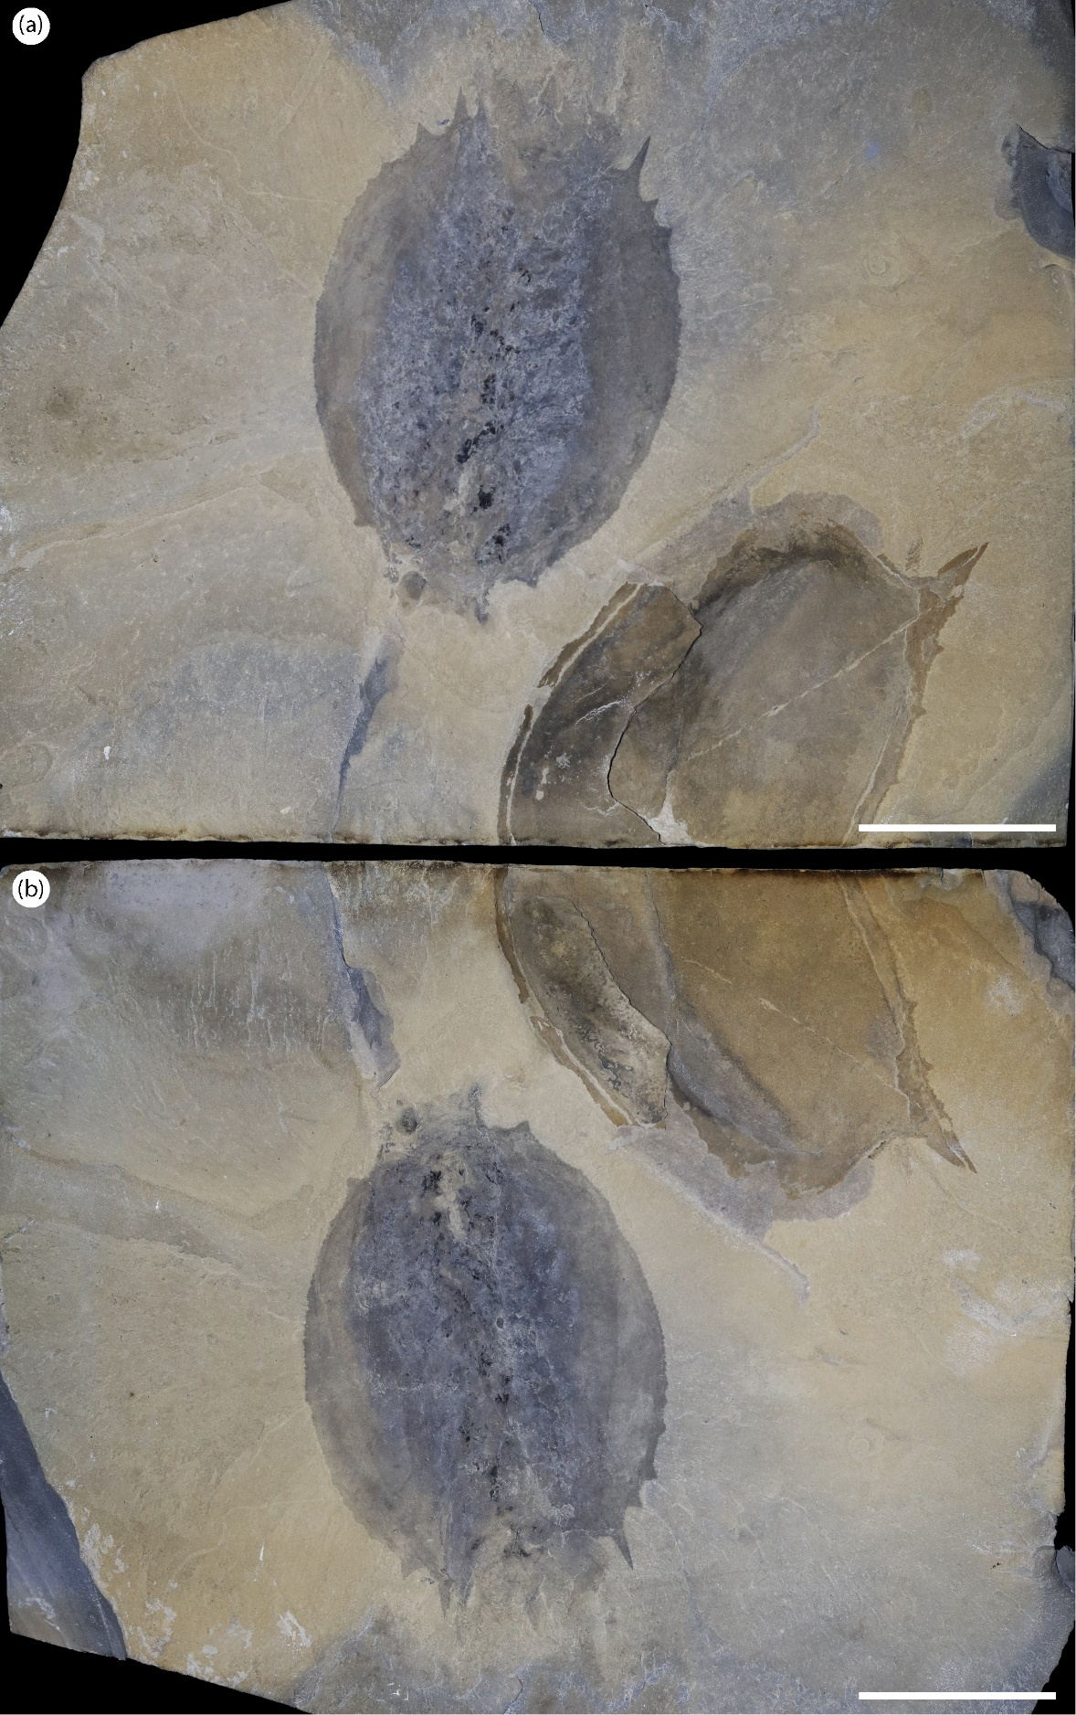
Figure S1: Marble Canyon specimens with soft tissues. a,b) part and counterpart of ROMIP 66176.1 (in ventral view) and ROMIP 66176.2 (in lateral view) (T. cf. burgessensis). Scales: (a,b)=50 mm.

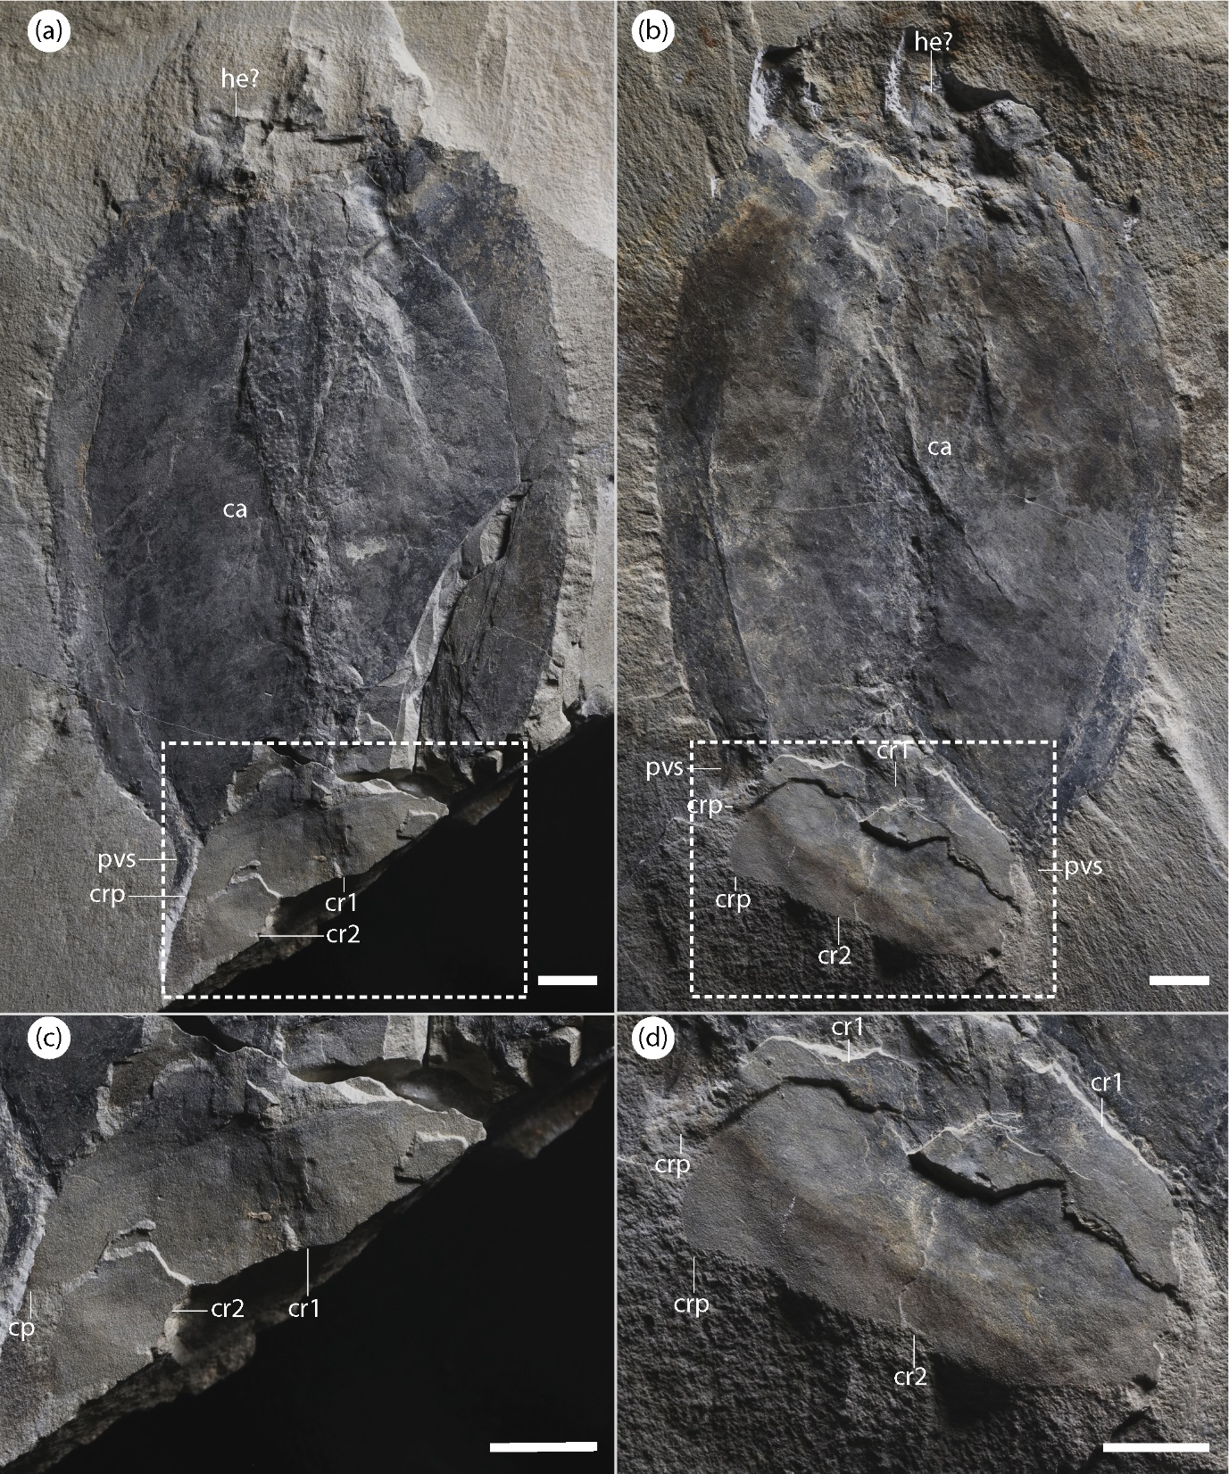
Figure S2: Specimen in dorsal view showing the components of the tail fan. a) part and (b) counterpart of a specimen in dorsal view (ROMIP 65087, T. cf. burgessensis), showing unidentified tissues close to the head and the tail fan; c,d) close-up on the tail fan. Note how (c,d) clearly shows two pairs of caudal rami, one on top of the other, of a similar size. Scales: 10 mm. Abbreviations: ca, carapace; he, head; c.r1-2, caudal rami; crp, caudal rami process; pvs, postero-ventral spine.
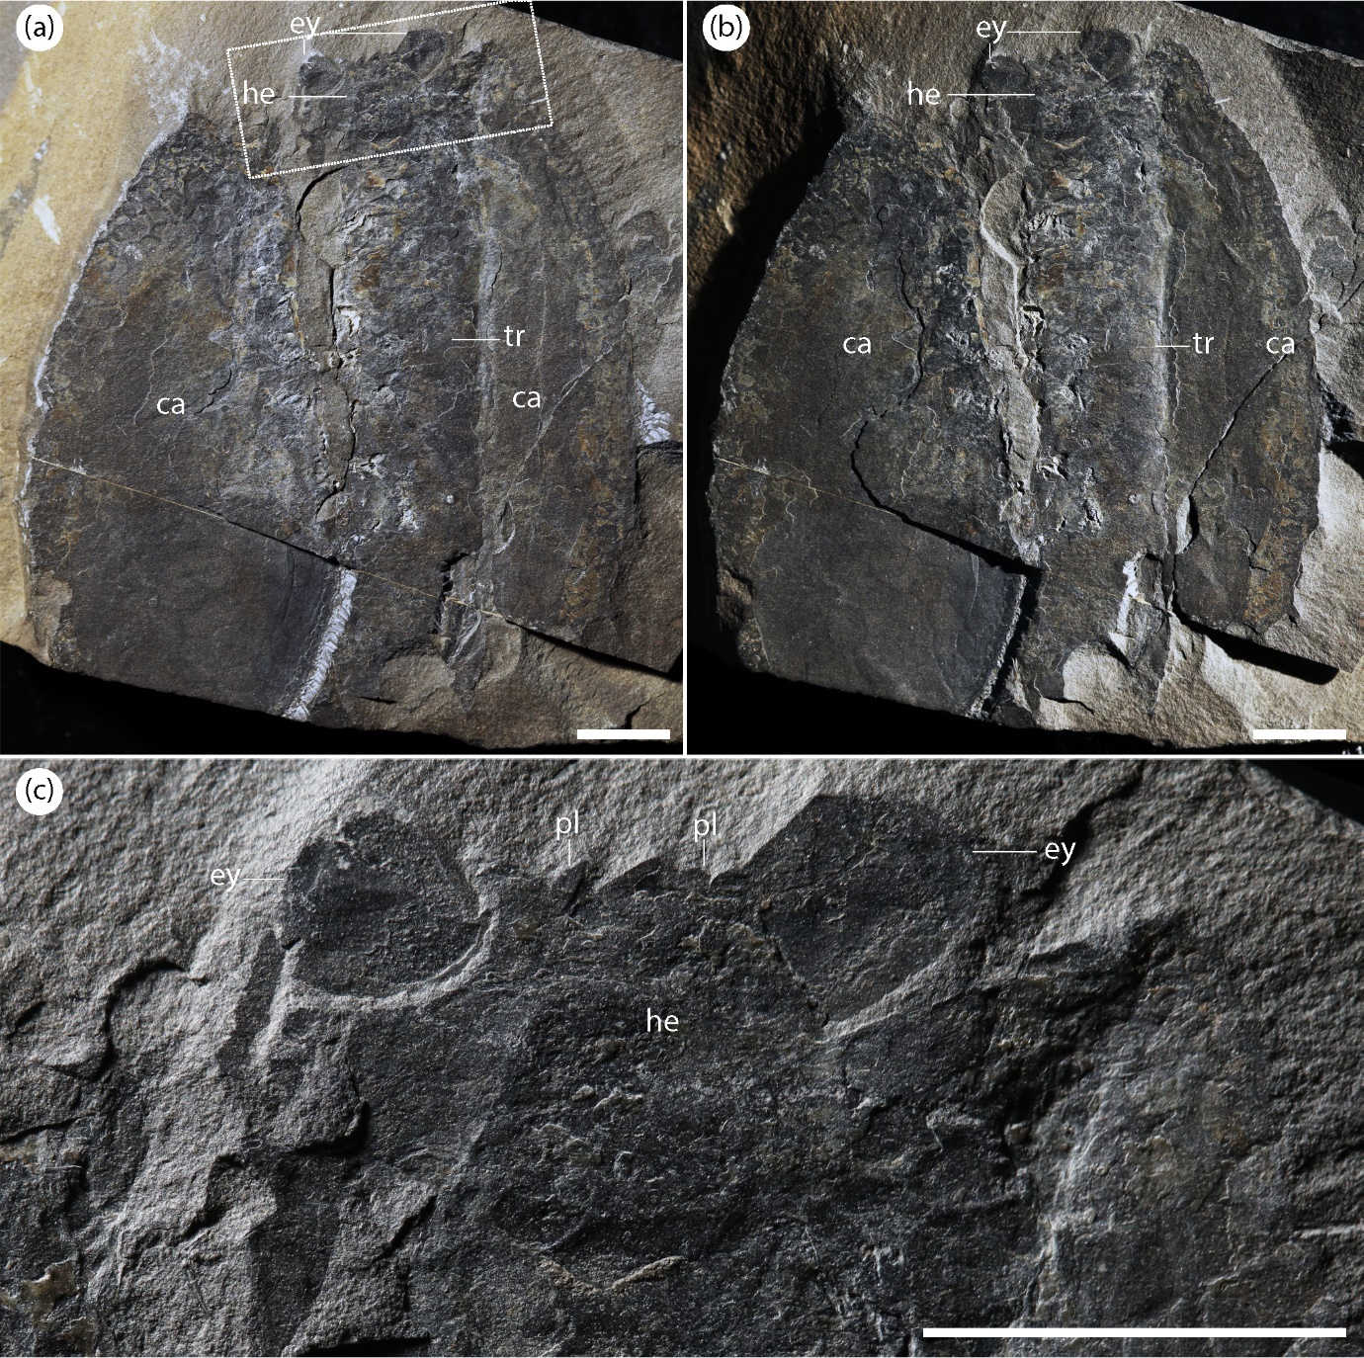 Figure S3: Specimen in ventral view with soft tissues. a) full view of the specimen under cross-polarized (a) and direct light (b) (ROMIP 57560, T. retifera), with a close-up of the head (c), showing how the eyes integrate strongly into the head, and the presence of two peduncular lobes between the eyes. Scales: (a-c)=10 mm. Abbreviations: ca, carapace; ey, eye; he, head; pl, peduncular lobe; tr, trunk.

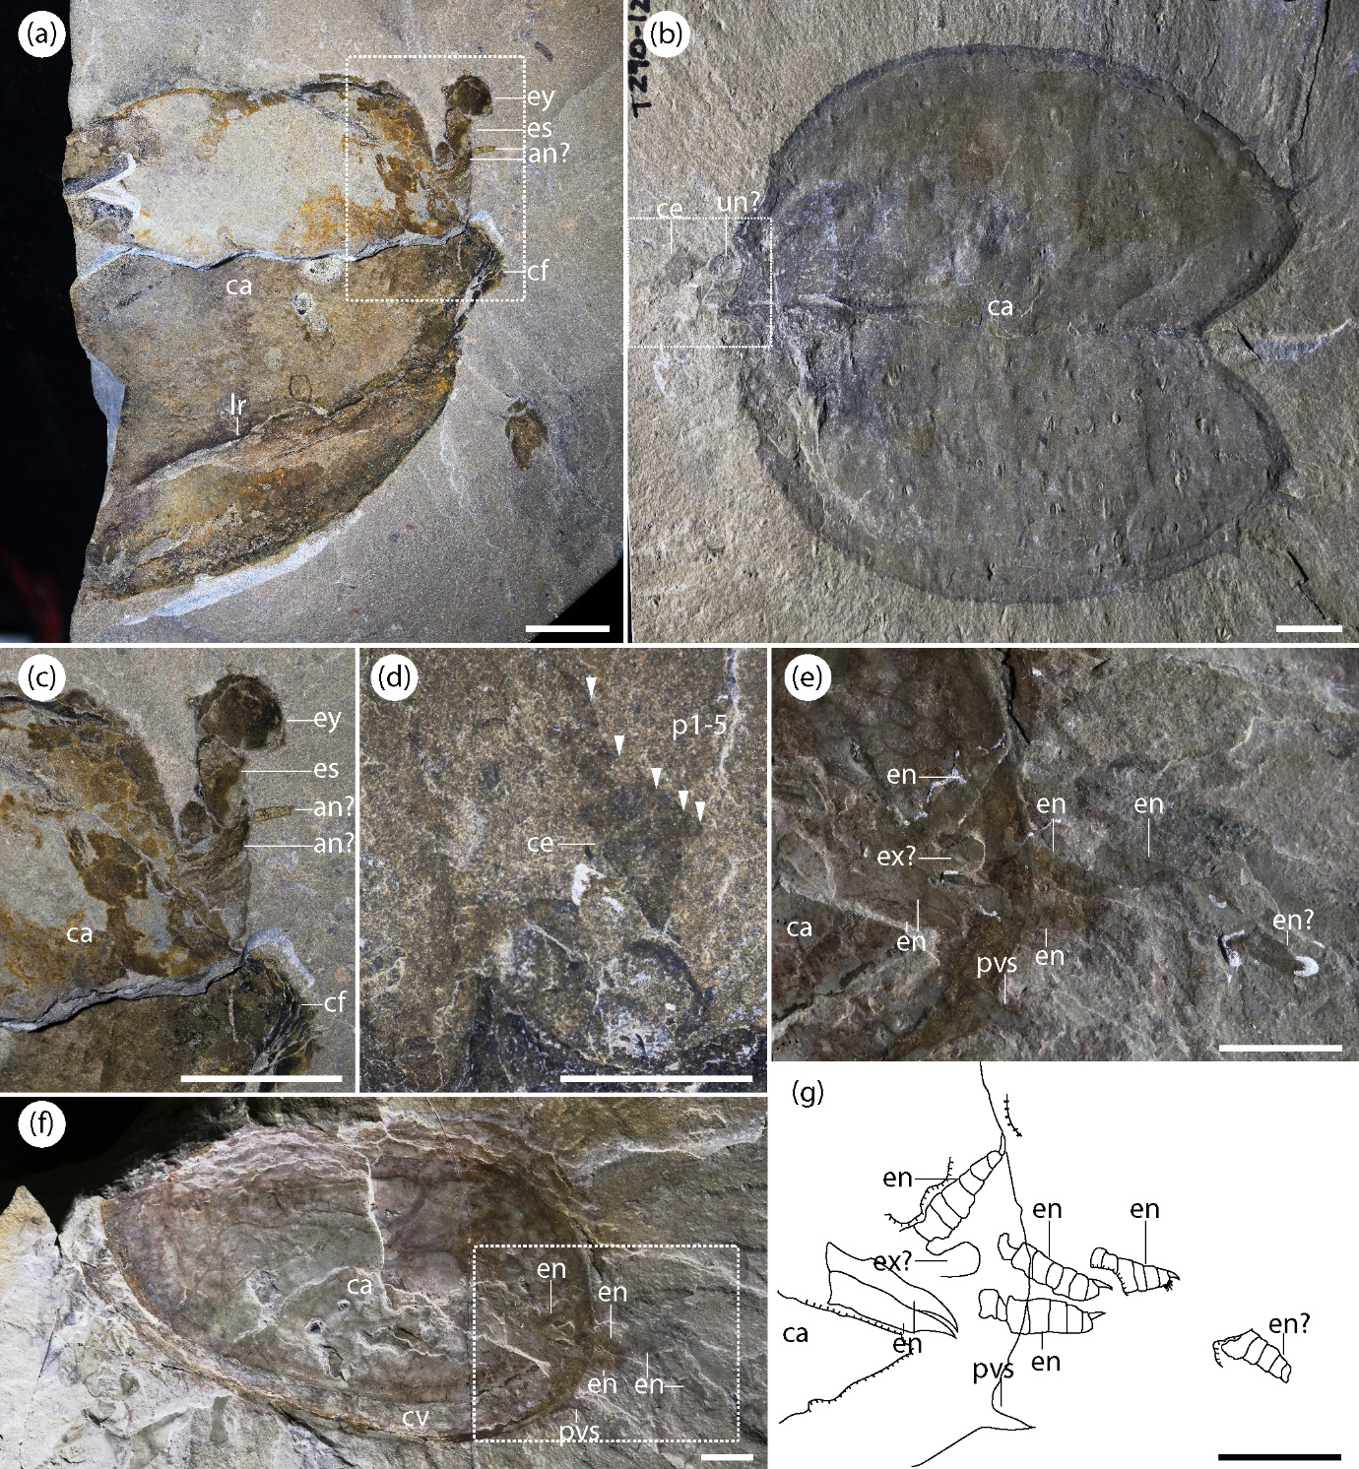
Figure S4: Details of the head and legs. a) specimen in lateral view (ROMIP57561, T. retifera) with a close-up showing an eye and eye stalk (c), the black section on the anterior side of the carapace is not an eye, but the result of the lateral ridge highly compressed against the carapace. A series of exopod setae were identified by Vannier et al., 2007 on this specimen, but these have not been observed, here; b) specimen in dorsal view (ROMIP57557, T. burgessensis) showing a cephalothoracic leg, in close-up (d) showing spinose podomeres and distal claw; f) specimen in lateral view (ROMIP64835, T. retifera), with a close-up of the posterior section of the specimen showing multiple trunk legs (e) and camera lucida reconstruction (g). Scales: 10 mm. Abbreviations: an, antenna; ca, carapace; ce, cephalothoracic leg; cf, compression fold; cv, carapace valve; en, endopod; es, eye stalk; ex, exopod; ey, eye; lr, lateral ridge; un, unknown; p*, podomere; pvs, posteroventral spine.
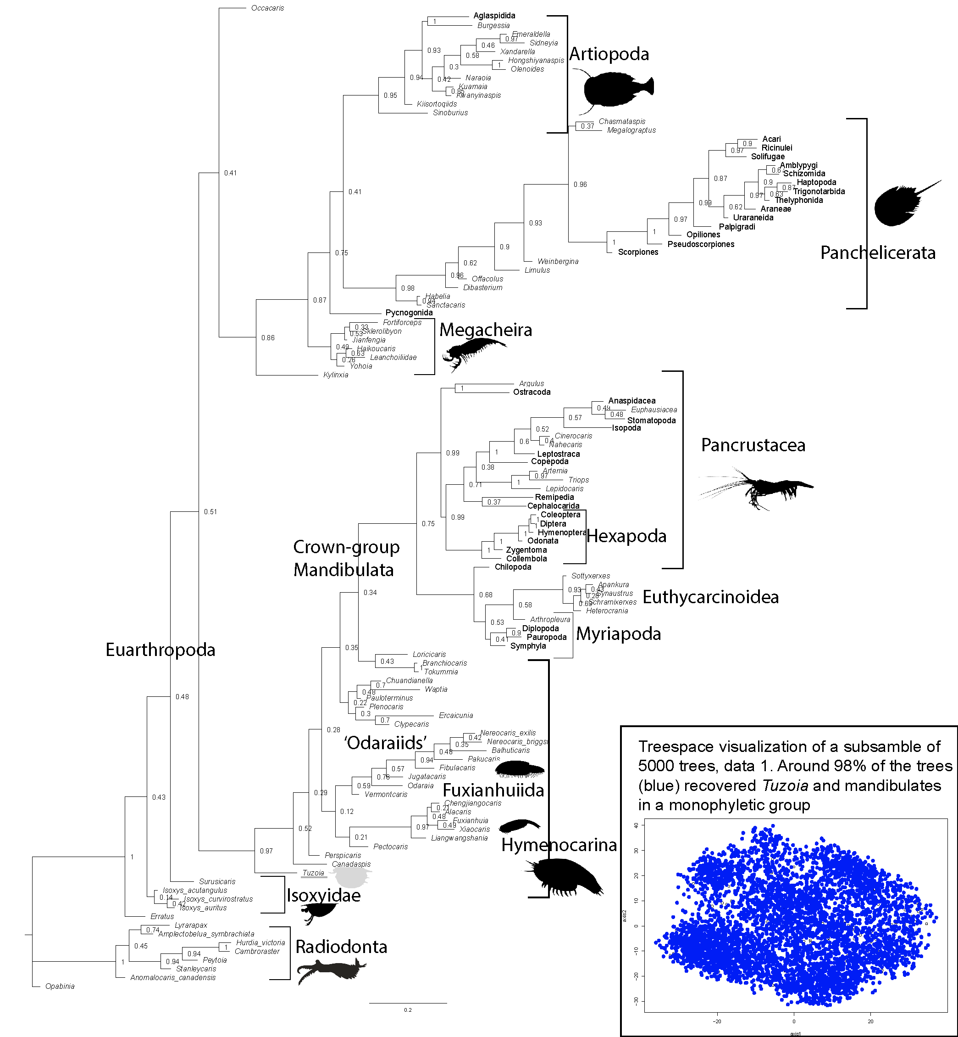
Figure S5: Results of the phylogenetic analysis using dataset 1 and treespace visualization. Bayesian inference with MK model for 114 taxa and 300 characters. Tuzoia places within a paraphyletic Hymenocarina as early mandibulates. Treespace results show that the majority of trees recover Tuzoia and mandibulates in a monophyletic group.
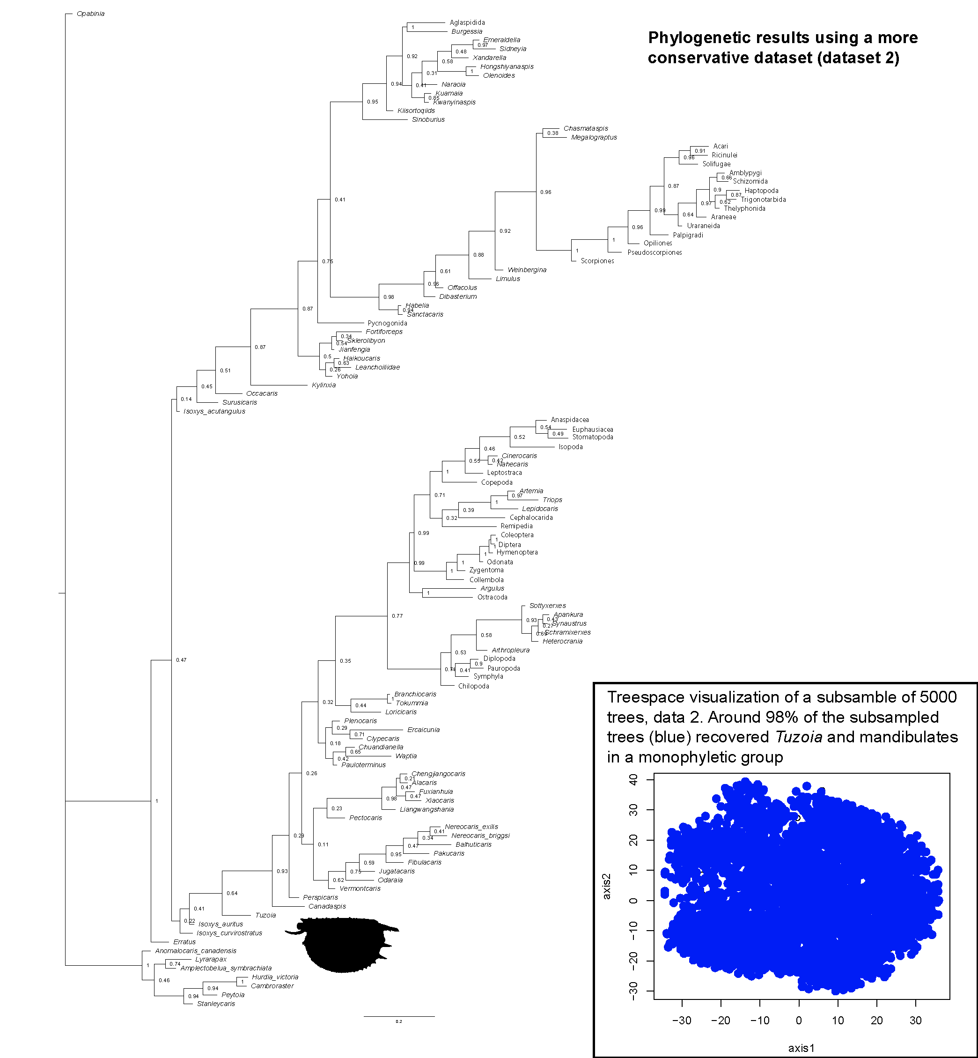
Figure S6: Results of the phylogenetic analysis using dataset 2, and treespace visualization. Bayesian inference with MK model for 114 taxa and 300 characters. Tuzoia places within a paraphyletic Hymenocarina as early mandibulates but isoxyids appear as a polyphyletic group within Euarthropoda. Treespace results show that the majority of trees recover Tuzoia and mandibulates in a monophyletic group.

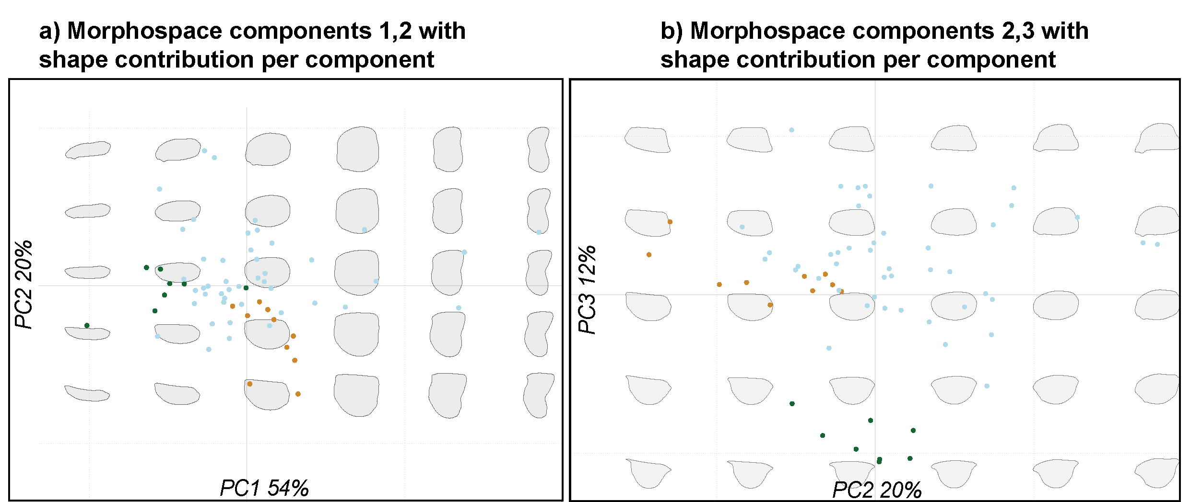
Figure S7: Additional analyses morphospace. a) Morphospace showing first and second component and shape contribution across the morphospace, b) morphospace showing second and third component and shape contribution across the morphospace. Isoxys (green), Tuzoia (orange), other hymenocarines (blue).
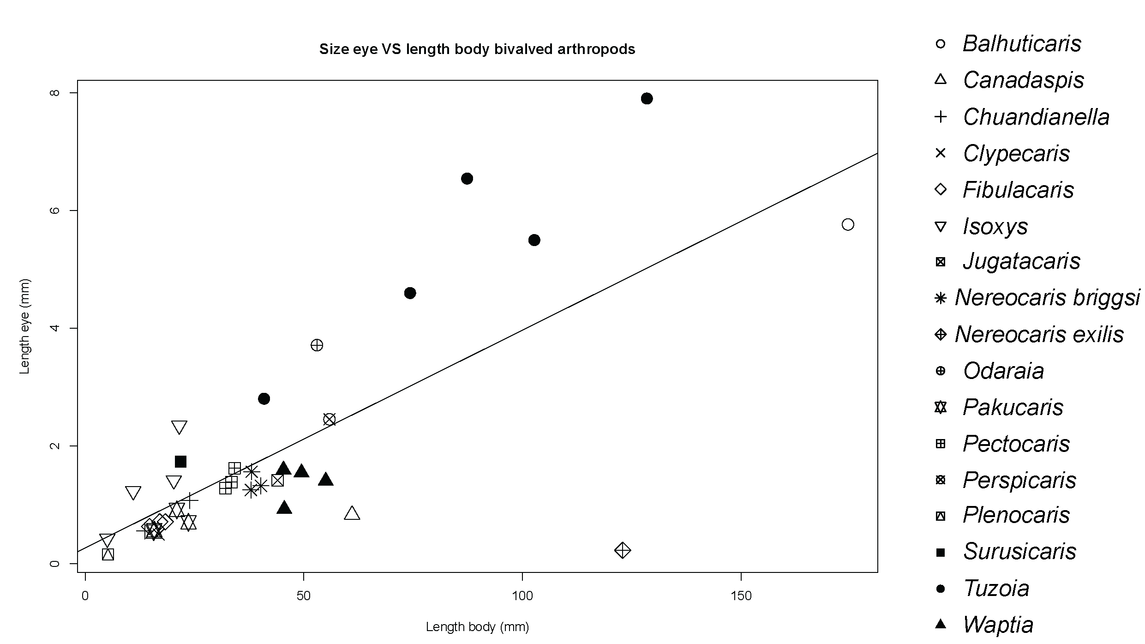
Figure S8: Eye size related to body size in bivalved arthropods. Eye size measured as the mean between the length and width of the eye. Body length for Tuzoia measured without considering tail-fan. Dataset includes isoxyids (Isoxys and Surusicaris) and hymenocarines, (total N=38). Line representing a linear regression. Isoxyids, Tuzoia and Odaraia have larger eyes than other bivalved arthropods.

Supplementary Material, contents
- Supplementary Information
1.1. Specimens of Tuzoia used in the study pg2
1.2. Species of Tuzoia, morphology and distribution pgs.3-7
- Supplementary Analyses
2.1. Carapace morphospace pg.8
2.2. Relative size of the eyes in bivalved arthropods pgs.8-9
2.3. Treespace analysis pg.9
- Supplementary Discussion; phylogenetic Analysis
3.1. Explanation of character coding for Tuzoia pgs.9-11
3.2. Characters shared between Tuzoia and other groups pgs.11-12
3.3. Species included in the dataset pgs.12-15
3.4. List of characters pgs.15-59
- References pgs.59-64

Supplementary Information

Specimens of Tuzoia used in the study
Table S1: Specimens of Tuzoia used in this study, with their identification and locality
Specimen (ROMIP)/field number | Species | Locality | Soft tissues | Figured
ROMIP57446/  90-1140 | T. cf. canadensis | TZ layer at Fossil Ridge, 1990 (1) | Ceph.legs, Legs, m.palp, endites | F4
ROMIP57557/  90-1285 | T. burgessensis | TZ layer at Fossil Ridge, 1990 (1) | Ceph.legs | SF4b,d
ROMIP57560/  75-5676 | T. retifera | Greater Phyllopod Bed, 1975 (2) | Head, ped. lob | SF3  Vannier etal07
ROMIP57561/  92-833 | T. retifera | Raymond Quarry, 1991-92 (3) | Eye, stalk, antenna? | SF4a, c  Vannier etal07
ROMIP57562/  91-364 | T. burgessensis | Raymond Quarry, 1991-92 (3) | Soft tissue on the head | Not figured  Vannier etal07
ROMIP59978/  08-213 | T. retifera | Thin Stephen Formation of the Stanley Glacier, 2008 (4) | Head, eyes, ped.lob, antenna, legs, labrum? | F3, F5a-c  Caron etal10
ROMIP63709/  14-1000 | T. cf. burgessensis | Marble Canyon, 2012-14 (5) | No soft tissues, biggest | Not figured
ROMIP64835/  08-265 | T. retifera | Thin Stephen Formation of the Stanley Glacier, 2008 (4) | Full complete leg, spines, basipod, legs | F5d-i
ROMIP65087/  18-156 | T. cf. burgessensis | MC adjacent outcrops 2016-18 (6) | Tail complete with 2 pairs of c.rami | F1i-k, SF2
ROMIP66176.1/  14-1429 | T. cf. burgessensis | Marble Canyon, 2012-14 (5) | Full specimen, head, soft tissue exopod imprints, c.rami | F1a-g, SF1
ROMIP66176.2/  14-1429_2 | T. cf. burgessensis | Marble Canyon, 2012-14 (5) | Antenna? | F1a,h, SF1
ROMIP66300/  90-866 | T. sp. | UE | Full specimen, labrum (s.p)? soft tissue exopod imprints, c.rami | F2
ROMIP66302/  14-729 | T. burgessensis  MC morph-has a medio-anterior spine not usually present in this species. | Marble Canyon, 2012-14 (5) | No soft tissues, MC morph | Not figured. Used for reconstruction carapace F6,7

1.2. Species of Tuzoia, morphology and distribution

Table S2. Main carapace topologies, seen from dorsal view, with both valves open. Dotted lines indicated both the hinge line and anterior or posterior carapace processes, when applicable. Main shapes are adapted from (7).
Proplete | Amplete | Posplete

Table 3. Current list of species of Tuzoia, with their locality and diagnostic features. List of species based on the work of Vannier et al., 2007, which revised all species of Tuzoia and additional new species discovered since that revision. Abbreviations: acp) anterior carapace process, ann) anterior notch, ds) dorsal spines, L/H ratio) length-height ratio, ma) margin, mas) medio-anterior spine, mps) medio-posterior spine, pcp) posterior carapace process, pms) posterior marginal spine, pvs) postero-ventral spine, sms) additional small marginal spines, sms1) small marginal spine above the mps, sms2) small marginal spine just below pvs. References for diagnostic features: C17 (8), L06 (9), P22 (10), S15 (11) V07 (12), W19 (13).
Species | Localities, references | Diagnostic features*
Tuzoia australis Glaessner, 1979 | -Emu Bay Shale, Australia (Stage 4)  (14)  (15) | *V07  -L/H ratio:1.55  -Carap. shape: Amplete to slightly posplete  -Shape of processes: acp and pcp small  -Spines: pvs  -Dorsal margin: smooth  -Anterior notch: small  -Lateral ridge: unknown
Tuzoia bispinosa Yuan and Zhao, 1999 | -Balang Formation,  China (Stage 4)  (13)  -Kaili Formation,  China (Wuliuan)  (16,17) | *V07, W19  -L/H ratio: 1.52  -Carap. shape: slightly posplete  -Shape of processes: acp long, pcp short  -Spines: pvs, mps  -Dorsal ma.: with four medium-sized spines and sometimes other few spines posteriorly  -Lateral ma.: smooth or with few spines  -Anterior notch: medium-sized  -Lateral ridge: possibly eight spines
Tuzoia burgessensis Resser, 1929 | -Burgess Shale,  Canada (Wuliuan)  (12) | *V07  -L/H ratio:1.39  -Carap. shape: Amplete to slightly posplete  -Shape of processes: acp short and broad, pcp small  -Spines: pvs, mps  -Dorsal ma.: serrate with up to 3 bigger spines.  -Lateral/ventral ma.: crenate or smooth  -Anterior notch: big  -Lateral ridge: up to 10 spines
Tuzoia canadensis Resser, 1929 | -Burgess Shale, Canada (Wuliuan)  (12) | *V07  -L/H ratio:1.46  -Carap. shape: slightly amplete  -Shape of processes: acp short, sometimes oblique, pcp short to long.  -Spines: mas, sms, sms2, pvs, mps, sms1  -Dorsal ma.: with multiple spines more or less at equal intervals. At least 3-4 spines are double the size of the rest  -Lateral ma.: dentate, with multiple sms spines.  -Anterior notch: medium-sized.  -Lateral ridge: seven broad spines
Tuzoia guntheri Robison and Richards, 1981  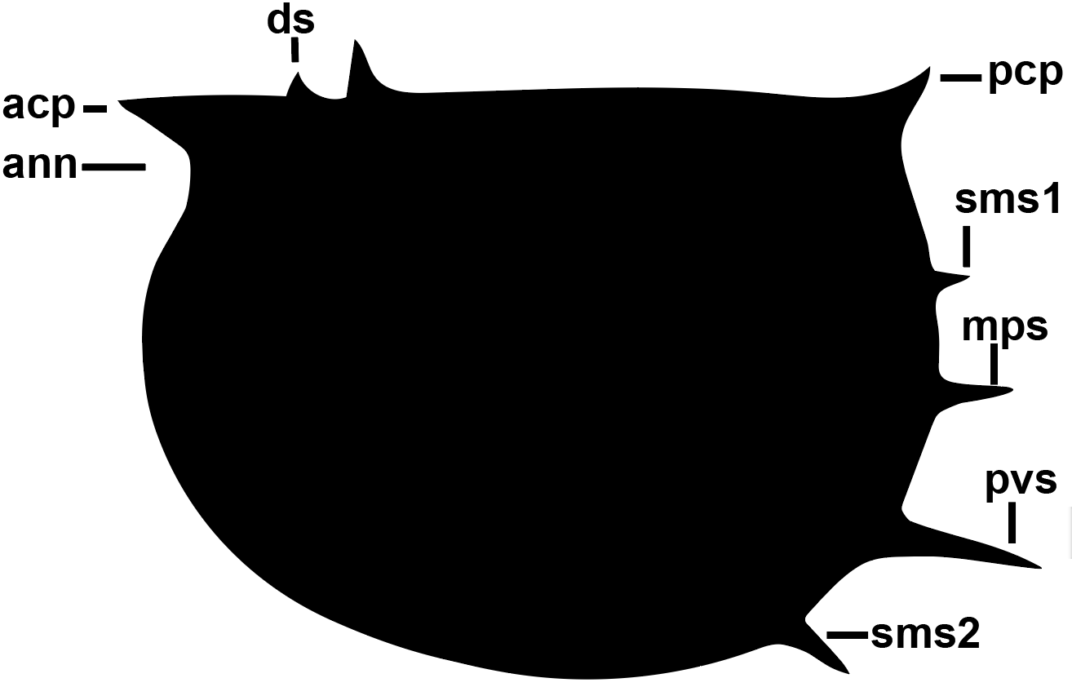 | -Marjum Formation. USA (Drumian Stage)  (19)  -Pioche Formation. USA (Stage 4) (20) | *V07  -L/H ratio:1.35  -Carap. Shape: posplete  -Shape of processes: acp and pcp short, pcp oblique  -Spines: sms2, pvs, mps, sms1  -Dorsal ma.: smooth with two spines  -Lateral ma.: smooth  -Anterior notch: medium-sized  -Lateral ridge: low relief, oblique (unclear)
Tuzoia jianheensis Chen et al., 2017 | -Tsinghsutung Formation, China (Stage 4) (8) | *C17  -L/H ratio: 1.34-1.57  -Carap. Shape: postplete  -Shape of processes: acp long, pcp short, oblique  -Spines: mas, sms 1 (many), sms2 (2), pvs, mps, other sms  -Dorsal ma.: smooth with ca. 7 or more spines  -Lateral ma.: with strong spines, number indet  -Anterior notch: small-sized  -Lateral ridge: unknown
Tuzoia lazizhaiensis Wen et al., 2019 | -Balang Formation, China (Stage 4)  (13) | *W19  -L/H ratio: 1.73  -Carap. Shape: amplete  -Shape of processes: acp long, pcp short  -Spines: mas, sms, sms2, pvs, pms, mps, sms1  -Dorsal ma.: smooth with 6-10 differently sized spines  -Lateral ma.: smooth with at least 4 anterior marginal spines and  -Anterior notch: medium-sized  -Lateral ridge: 7-13 spines radiating slightly backward
Tuzoia manchuriensis Resser and Endo, 1937 (in Endo and Resser, 1937) | -Manto Formation (Drumian)  (11)  -Tangshih Formation  (Wuliuan)  (21)  -Linyi laggerstätte  (Wuliuan)  (22) | *S15  -L/H ratio:0.71  -Carap. Shape: amplete  -Shape of processes: acp broad base, long, pcp small  -Spines: pvs, mps, sms1 (sometimes)  -Dorsal ma.: smooth, with at least 2 small spines on the frontal section  -Lateral ma.: crenate on the frontal side  -Anterior notch: strong  -Lateral ridge: unknown
Tuzoia multispinosa Zhao 2015*  *This species was described in a Master Thesis based on 3 specimens, and later redescribed in W22. Many of its features remain unclear | -Guanshan Biota,  China (Stage 4) (23)  -Wulongqing Form., China (Stage 4)  (Pan, 1957) | *W22  -L/H ratio:1.68  -Carap. Shape: posplete  -Shape of processes: acp and pcp small  -Spines: mps, pvs, multiple sms (not clear)  -Dorsal ma.: 10 small spines present  -Lateral ma.: dentate  -Anterior notch: small  -Lateral ridge: slightly oblique, with at least 31 small spines
Tuzoia polleni Resser, 1929 | -Eager Formation,  Canada (Stage 4)  -Kinzers Formation,  USA (Stage 4)  -Pioche Formation,  USA (Wuliuan)  -Wheeler Formation,  USA (Drumian)  -Parker Quarry,  USA (Stage 3-4)  (10) | *V07, P22  -L/H ratio:1.45  -Carap. Shape: slightly amplete to posplete  -Shape of processes: acp broad base, short, pcp almost absent  -Spines: sms2, pvs, mps, sms1  -Dorsal ma.: smooth, straight to convex with 5 to seven dorsal spines  -Lateral ma.: crenate to spinose  -Anterior notch: small  -Lateral ridge: oblique with 7 to 9 spines
Tuzoia retifera Walcott, 1912 | -Burgess Shale, Canada (Wuliuan)  (12)  -Spence Shale,  USA (Wuliuan)  (24)  -Guanshan Biota,  China (Stage 4) (23) | *V07  -L/H ratio:1.45  -Carap. Shape: amplete to slightly posplete  -Shape of processes: acp broad base, short. Pcp short  -Spines: pvs, mps  -Dorsal ma.: smooth, straight to convex  -Lateral ma.: smooth  -Anterior notch: small  -Lateral ridge: parallel to dorsal margin, with ca.6 short spines, very smooth
Tuzoia sinensis Pan, 1957 | -Wulongqing Form., China (Stage 4)  (Pan, 1957)  -Balang Formation, China (Stage 4)  (13)  -Guanshan Biota,  China (Stage 4) (23) | *W19  -L/H ratio:1.67  -Carap. Shape: amplete to slightly posplete  -Shape of processes: acp and pcp short  -Spines: pvs, mps and multiple sms along the ventral and posterior margin  -Dorsal ma.: serrate, with multiple spines  -Lateral ma.: serrate  -Anterior notch: small  -Lateral ridge: parallel to dorsal margin, multiple spines with different sizes
Tuzoia tylodesa Luo & Hu 2006 in (9)*  *Reconstruction based on the description by Luo et al., 2006 and the specimens in W19. The image resolution and specimens provided, though, do not allow for a very accurate representation of this species.  ． | -Wulongqing Form., China (Stage 4)  (9)  -Balang Formation, China (Stage 4)  (13)  -Guanshan Biota,  China (Stage 4) (23) | *L06, W19  -L/H ratio:0.55  -Carap. Shape: amplete  -Shape of processes: both highly reduced  -Spines: ams, sms2, pvs, mps, sms1  -Dorsal ma.: serrate, straight to convex  -Lateral ma.: serrate  -Anterior notch: almost not existent  -Lateral ridge: convex towards the ventral side  -Carapace with node-like structures

Supplementary analyses

2.1. Carapace morphospace
A carapace morphospace was constructed, which includes 20 genera and 63 shapes, with most genera being represented with at least 2 shapes. Outlines we drawn on clear carapace shapes from photographs of previously published material. The morphospace was constructed using the packages Momocs (25) and geomorph (26) in R V4.1.2 (27). A Fourier analysis was used to obtain the shape of the carapace valves, given that the carapaces are too variable to have stable landmarks. Using the calibrate_harmonicpower_efourier, the number of harmonics used to perform the Fourier transformation was 25, which accounted for 99.9% of the total variation. Silhouettes were centred, scaled and stacked previous to the Fourier transformation. A principal component analysis was performed on this dataset, and three components were chosen that accounted for 86% of the total variation: first component accounting for 54%, second for 20% and third for 12% of the total. In order to assess whether the shape of the carapace of Tuzoia was closer to isoxyids or to hymenocarines, a clustering analysis was performed. This used the cascadeKM function of the vegan package (28), providing an optimal clustering of seven groups. e also subdivided the dataset for visual inspection into hymenocarine subgroups, these being the traditional families (see a review in (29)). These subgroups were: canadaspidids (Canadaspis), clypecaridids (Clypecaris, Ercaicunia, Plenocaris), odaraiids (Balhuticaris, Fibulacaris, Jugatacaris, Nereocaris, Odaraia, Pakucaris, Vermontcaris), pectocaridids (Pectocaris), perspicaridis (Perspicaris), protocaridids (Branchiocaris, Tokummia), tuzoiids (Tuzoia) and waptiids (Pauloterminus, Waptia). Isoxyids included multiple species of Isoxys. This classification is displayed in figures 9c,d. A principal component analysis including the weights of each shape through the morphospace is displayed in figures S7a,b. Shapes from the Fourier analyses can be found in the supplementary materials as a .rda file.
Isoxyids appeared consistently as a differentiated group from the remaining hymenocarines. Extreme morphologies (e.g, the carapace shape of Balhuticaris) also represent most of the variation across the dataset (figure 9a). Tuzoia always clusters within hymenocarines, and also clusters as a differentiated group from other hymenocarines when seven clusters are considered (figure 9). The carapace morphospace also provides interesting outcomes about the evolution of hymenocarines. First, is worth noting that most carapace shapes are morphologically quite similar: the standard deviation regarding carapace shape is low in the three main components and extreme morphotypes such as Isoxys or Balhuticaris carapace generate most of the variation. Another genus with an extreme morphotype is Fibulacaris. When included with its spine in the first iterations of this analysis, Fibulacaris accounted for most of the variation in the first component, and thus, subsequent analyses manually removed the spine to reduce its signal. Some groups of bivalved arthropods show a wide disparity in their carapace shapes, including isoxyids, clypecaridids (Ercaicunia, Clypecaris (30) and ‘odaraiids’ (e.g., Balhuticaris, Fibulacaris, Nereocaris (31)). Carapace shape appears to be prone to cases of convergent evolution, such as Ercaicunia appearing closer to Isoxys curvirostratus in the first component, or Balhuticaris and Clypecaris, with wider than longer. Despite this, the carapace shape can still be phylogenetically informative, and separates groups such as Canadaspidida (the group that contains the monotypic Canadaspididae and Perspicarididae, with Canadaspis and Perspicaris as their only genera, respectively (32)) or waptiids (Waptia, Chuandianella, Pauloterminus (29)) in the first component. The second component, in turns separates groups such as ‘odaraiids’ and tuzoiids. Overall, a higher sample size may be necessary to reduce intraspecific variation and carapace shape variation due to deformation, and elucidate further patterns of carapace evolution across hymenocarines.

Table S4. K-means classification of the taxa in the morphospace (k=7). In general, each cluster is almost restricted to one genus, although some genera are included into several clusters (e.g., Pectocaris) and some genera are the most abundant in two different clusters (Tuzoia). In the case of Tuzoia, the different species plot either into a Tuzoiid cluster (cluster 7) or into cluster 2, which groups multiple other hymenocarine genera.
File_name | Genus | Group | Cluster
Balhuticaris_177 | Balhuticaris | Odaraiid | 3
Balhuticaris_2012_517 | Balhuticaris | Odaraiid | 3
Balhuticaris_681 | Balhuticaris | Odaraiid | 3
Branchiocaris_B76_P2F2 | Branchiocaris | Protocaridid | 4
Branchiocaris_A17_EF6 | Branchiocaris | Protocaridid | 5
Branchiocaris_USNM80483 | Branchiocaris | Protocaridid | 5
Canadaspis_B75_P2 | Canadaspis | Canadaspid | 2
Canadaspis_B75_P3 | Canadaspis | Canadaspid | 5
Canadaspis_B75_P4 | Canadaspis | Canadaspid | 2
Chuandianella_O20_F1 | Chuandianella | Waptiid | 2
Chuandianella_O20_S1 | Chuandianella | Waptiid | 2
Clypecaris_Y16_F2 | Clypecaris | Clypecariid | 6
Clypecaris_Y16_F2B | Clypecaris | Clypecariid | 6
Clypecaris_Y16_F2C | Clypecaris | Clypecariid | 6
Ercaicunia_Z19 | Ercaicunia | Clypecariid | 4
S_Fibulacaris_ns1 | Fibulacaris | Odaraiid | 1
S_Fibulacaris_ns2 | Fibulacaris | Odaraiid | 1
Isoxys_acutangulus_GB57906 | Isoxys | Isoxyiid | 4
Isoxys_acutangulus_GB57912 | Isoxys | Isoxyiid | 4
Isoxys_acutangulus_GB57913 | Isoxys | Isoxyiid | 4
Isoxys_acutangulus_GB57914 | Isoxys | Isoxyiid | 4
Isoxys_acutangulus_GB59871 | Isoxys | Isoxyiid | 4
Isoxys_acutangulus_L13_F2 | Isoxys | Isoxyiid | 4
Isoxys_auritus_F13_F2 | Isoxys | Isoxyiid | 2
Isoxys_curvirostratus_F11_F2 | Isoxys | Isoxyiid | 4
Jugatacaris_F11_F3 | Jugatacaris | Odaraiid | 5
Jugatacaris_F11_F7 | Jugatacaris | Odaraiid | 5
Jugatacaris_F11_F12 | Jugatacaris | Odaraiid | 5
Loricicaris_L14_F1 | Loricicaris | Odaraiid | 2
Nereocaris_briggsi_L14_F4 | Nereocaris_briggsi | Odaraiid | 2
Nereocaris_briggsi_L14_F5 | Nereocaris_briggsi | Odaraiid | 2
Nereocaris_briggsi_ROM62165 | Nereocaris_briggsi | Odaraiid | 4
Nereocaris_exilis_L12_F1 | Nereocaris_exilis | Odaraiid | 5
Odaraia_B80_Draw | Odaraia | Odaraiid | 4
Pakucaris_M1 | Pakucaris | Odaraiid | 1
Pakucaris_M1B | Pakucaris | Odaraiid | 1
Pakucaris_M1C | Pakucaris | Odaraiid | 4
Pakucaris_m2 | Pakucaris | Odaraiid | 1
Pauloterminus_T02_F1 | Pauloterminus | Waptiid | 2
Pauloterminus_T02_F2 | Pauloterminus | Waptiid | 5
Pectocaris_H04_F1 | Pectocaris | Pectocaridid | 2
Pectocaris_H04_F1B | Pectocaris | Pectocaridid | 5
Pectocaris_H04_F1C | Pectocaris | Pectocaridid | 2
Perspicaris_2 | Perspicaris | Perspicarid | 2
Perspicaris_3 | Perspicaris | Perspicarid | 2
Perspicaris_B77_F1 | Perspicaris | Perspicarid | 2
Tokummia_A17_draw | Tokummia | Protocaridid | 4
Tokummia_A17_F1 | Tokummia | Protocaridid | 4
Tuzoia_bispinosa_W19_F15 | Tuzoia | Tuzoiidae | 7
Tuzoia_burgessensis_213 | Tuzoia | Tuzoiidae | 2
Tuzoia_burgessensis_364 | Tuzoia | Tuzoiidae | 7
Tuzoia_burgessensis_57526 | Tuzoia | Tuzoiidae | 7
Tuzoia_burgessensis_57529 | Tuzoia | Tuzoiidae | 2
Tuzoia_canadensis_57536 | Tuzoia | Tuzoiidae | 7
Tuzoia_guntheri_KUMIP | Tuzoia | Tuzoiidae | 7
Tuzoia_lazizhaiensis_W19_F8 | Tuzoia | Tuzoiidae | 2
Tuzoia_retifera_281 | Tuzoia | Tuzoiidae | 2
Tuzoia_retifera_57313 | Tuzoia | Tuzoiidae | 2
Vermontcaris_C00 | Vermontcaris | Odaraiid | 4
Vermontcaris_P22 | Vermontcaris | Odaraiid | 2
Waptia_V19_F1 | Waptia | Waptiid | 6
Waptia_V19_F3 | Waptia | Waptiid | 5
Waptia_V19_F9 | Waptia | Waptiid | 6

2.2 Relative size of the eyes in bivalved arthropods
Eye size was measured on 35 specimens of 17 bivalved arthropod species (hymenocarines and isoxyids), obtained from previously published material and fossil material present at the ROMIP collections. Two measures were performed: eye length and eye height, and the mean between both measurements was taken as the final approximation to eye size. The total length of each specimen was also measured. This length was always measured on specimens with soft tissues, from the frontalmost section of the head to the distalmost section of the tail. The relation between body length and eye size was subsequently plotted (figure S7). All measurements, the origin of the images and R code to perform the plot and K-means clustering can be found in the Supplementary Files.

2.3. Treespace analysis
A treespace analysis was conducted using the packages ape (33) and phangorn (34) from the statistical software R. The treespace analysis was conducted for both the main dataset and the more conservative dataset (dataset2). Given limitations in computing power, a subsample of trees was chosen. These represent 50% of the total trees combining both runs. A burn-in of 25% was applied. Trees were plotted through a principal coordinate analysis using the cmdscale function. The position of Tuzoia relative to isoxyids was tested by looking at the number of trees that had Tuzoia inside a monophyletic isoxyidae or any tree in which Tuzoia was the sister group to at least one isoxyid.
None of the trees subsampled could recover Tuzoia within Isoxyidae or closely related to an isoxyid species. On the other hand, around 98% of the subsampled trees recovered Tuzoia within a monophyletic Mandibulata, containing hymenocarines. This was the same for both types of datasets. The treespace for datasets 1-2 are available in figure S5, S6.

Phylogenetic analysis

3.1. Explanations of character coding for Tuzoia.
The following explains in detail the coding opted for Tuzoia, only including relevant characters for a potential hymenocarine or isoxyids affinity.
Ch7. Relative diameter of compound eyes compared with length of bivalved carapace: bigger than 5% of the total body length (only bivalved arthropods). Explanation: isoxyids have been recognized as presenting large eyes, a potential consequence of a pelagic predatory ecology (35). Large eyes in arthropods, though, are not exclusive of this lifestyle. The position in the water column of isoxyids has also been inferred based on the shape of the carapace (36), alternatively. The presence of large eyes in bivalved arthropods, therefore, can both represent a potential pelagic ecology or isoxyid affinity. The character here is a version of that by Zeng et al., 2021 (37), simplified to only include bivalved arthropods and differentiate isoxyids from most hymenocarines based on the size of their eyes. In order to code this character, eye size was measured across isoxyids and most hymenocarine species (figure S7). The results show that the size of the eyes in Tuzoia is similar to that in isoxyids. This was equally coded in the main dataset and dataset 2.

Ch21. Peduncular lobes: present. Explanation: peduncular lobes are lobe-like inter-ocular structures. Several specimens of Tuzoia show morphologically similar structures. Among bivalved arthropods these structures have only been observed in hymenocarines. This was equally coded in the main dataset and dataset 2.

Ch24. Somites defining anteriormost tagma: unknown. Explanation: the number of cephalic appendages in Tuzoia is poorly known. Whether the structure observed in figure 4b,e-g is a mandibular palp is taken here cautiously, as is the incorporation of the two frontal pairs of appendages into the head. This character, then, acknowledges the lack of a clear cephalic conformation. This was equally coded in the main dataset and dataset 2.

Ch25. Tergite of the ocular (protocerebral) somite: present. Explanation: the presence of a tergite is inferred in Tuzoia based on the presence of a lobe-like structure between the eye peduncles, in the middle of the peduncular lobes. The position of this structure is the same as in other species in which a protocerebral tergite has been observed more confidently (ie., Waptia (38)). As explained in Discussion, the structure itself has not been observed directly, but can be inferred based on specimens with their head observable from a ventral view, showing that the head extends between the eye peduncles into a lobe, representing soft-tissues underneath the tergite (figures 1d). Two specimens show a sclerotic elongated structure that could represent the same tergite (figures 2, 3e-h) or, alternatively, part of the labrum sensu (39). An ocular tergite is known in multiple hymenocarines but has not been identified in isoxyids, yet. Coded as unknown in dataset 2.

Ch26. Shape of the ocular tergite: rounded. Explanation: as of Ch25. Coded as unknown in dataset 2.

Ch67. Sternites: unknown. Explanation: given that the presence of true segments (as in Euarthropoda) is not visible in the specimens obtained for Tuzoia, but also taking into account that the preservation of those fully-body specimens is poor, this character is coded as unknown. This was equally coded in the main dataset and dataset 2.

Ch69. Labrum: unknown. Explanation: despite the presence of a putative labral plate, and given that the identity of this structure is unclear, this is coded as unknown. The same coding is used for any character related to the labrum. This was equally coded in the main dataset and dataset 2.
Ch71. External interocular organs: presence. Explanation: as of Ch21. We consider that interocular organs are present in Tuzoia and that they are peduncular lobes. This was equally coded in the main dataset and dataset 2.
Ch90. Podomeres of frontalmost appendage: unknown. Explanation: given that the exact podomeres of the frontalmost appendages are not clearly observable in Tuzoia, this is coded as unknown. This was equally coded in the main dataset and dataset 2.
Ch127. Frontal appendage antenniform: appendage thin, podomeres almost identical, antenniform. Explanation: the frontal appendage of Tuzoia is most probably antenniform, based, for example, on figure 3e-h. While this is more commonly found in euarthropods, the isoxyid Isoxys auritus was similarly coded with an antenniform appendage. This was equally coded in the main dataset and dataset 2.
Ch132. Maximum podomere number in head: <7. Explanation: the presence of a reduced cephalic appendage is contemplated here, and is therefore coded as <7. This character is coded as unknown in dataset 2 to acknowledge the possibility that the reduced cephalic appendage inferred on the head of Tuzoia rather represents a series of endites belonging to another cephalic or thoracic appendage.
Ch134. All cephalic endopods posterior to frontalmost appendage pair well-developed (seven-segmented or more): absent. Explanation: same reasoning and coding in dataset2 as Ch132.
Ch136. Endopod of third appendage pair: present. Explanation: same reasoning and coding in dataset 2 as Ch132.
Ch147. Repeated morphology in Tagma I: absent. Explanation: same reasoning and coding in dataset2 as Ch132.
Ch150. Arthrodized post-antennular appendage expressed: unknown. Explanation: given that the cephalic conformation of Tuzoia is not clear, this character is coded as unknown. This was equally coded in the main dataset and dataset 2.
Ch164. Mandibular palp: unknown. Explanation: in the Discussion section we argue for the presence of a potential mandibular palp, observed, in figure 4b. We acknowledge the difficulties in the interpretation of this structure, and thus, have coded this character as unknown in the phylogenetic matrix. This was equally coded in the main dataset and dataset 2.
Ch183. Type of circumoral structures: arthrodized limbs. Explanation: the presence of at least one potential post-antennular cephalic appendage implies that the circumoral structures are, as in euarthropods, appendages. The possibility of an isoxyid affinity, and consequently, that the legs may not be circumoral, this character is coded as unknown in dataset 2.
Ch211. Thorax: present. Explanation: the presence of the two frontal differentiated thoracic limbs, implies the presence of a thorax. This is irrespective of the interpretation of these limbs. If these limbs are considered cephalic (as in isoxyidae), the more posterior limbs would be considered thoracic. If, on the other hand, the limbs are considered cephalothoracic, the presence of a thorax still remains. In isoxyids, the thorax is considered absent given that segmentation (40) and limb sclerotization (41) are considered absent. In Tuzoia, segmentation is unclear, but limbs are clearly sclerotized and fully arthropodized. This was equally coded in the main dataset and dataset 2.
Ch213. & Ch215: characters coded in Tuzoia, but not coded in isoxyids, given that a thorax is considered absent in the latter. This was equally coded in the main dataset and dataset 2.
Ch216. Number of core trunk segments: 10-14 core trunk segments. Explanation: same reasoning as for Ch213-Ch215. This was equally coded in the main dataset and dataset 2.
Ch224. Tergo-pleural rings: unknown. Explanation: segmentation is not clear on the specimens available of Tuzoia, but given that the legs are fully arthropodized, segmentation is highly possible, under several leg evolution scenarios (e.g., (42)). This was equally coded in the main dataset and dataset 2.
Ch235. Podomere number in endopods of tagma II: 7. Explanation: the number of podomeres of the endopod in all biramous limbs is seven, a condition not present in isoxyids. This was equally coded in the main dataset and dataset 2.
Ch241. Basipod: present. Explanation: a basipod can be clearly observed in several specimens of Tuzoia. In isoxyids, the presence of a differentiated basipod is sometimes considered dubitative (42) and is therefore coded here as unknown for this group.
Ch279. Sclerotization of termination: present. Explanation: several specimens of Tuzoia (e.g.,) show a highly sclerotized posterior structure that is interpreted here as part of the tail-fan. In contrast, the tail-fan of isoxyids has been homologized to the tail flukes of radiodonts (43) and thus, whether they represent sclerotized structures can be put to question. As a result, Ch280-286 are coded in Tuzoia, but not in isoxyids. This was equally coded in the main dataset and dataset 2.
Ch287. Caudal rami: present. Explanation: following Ch279, the tail-fan of Tuzoia is considered to be a pair of caudal rami. However, the fact that there appears to be two pairs of caudal rami, aligns this structure closer to the several pairs of tail flukes in isoxyids than to any other structure in hymenocarines. It is for this reason that Ch294-296 (related to the flukes) are coded both for isoxyids and Tuzoia. This was equally coded in the main dataset and dataset 2.

3.2. Characters shared between Tuzoia and other groups
Characters shared between Tuzoia and isoxyids, and that are highly characteristic (although not exclusive) of isoxyids
7- Relative diameter of compound eyes compared with length of bivalved carapace >5%
33-Symmetry of the carapace in the axial axis. Note: mostly, also applicable to some hymenocarines.
37-Covering of the type II bivalved carapace, covering two thirds of the body. Note: mostly, also applicable to some hymenocarines.
42-Frontal carapace process present. Note: mostly, also applicable to some hymenocarines.
45-Posterior carapace process present Note: mostly, also applicable to some hymenocarines.
294-Caudal ramus is a single fused paddle
295-Additional caudal processes present
296-Several lateral tail flaps present
Characters shared between hymenocarines and Tuzoia
21-Peduncular lobes.
25- Presence of the tergite of the ocular somite
34-Dorsal margin extension: lateral margin extends beyond dorsal margin (evaginates). Note: only present in a few hymenocarines.
91-Absence of ventral spinose outgrowths on the frontalmost appendages
127-Frontal appendage antenniform
132-Maximum number of podomeres in the head (post antennae) smaller than 7. Note: cephalic conformation is not known for most hymenocarines, though.
134-All cephalic appendages are not well-developed. Note: cephalic conformation is not known for most hymenocarines, though, although the condition in Tuzoia highly indicates a mandibulate affinity.
136-The endopod of the third appendage pair is reduced. Note: cephalic conformation is not known for most hymenocarines, though. Furthermore, it is unclear whether the reduced cephalic appendage of Tuzoia corresponds to a mandibular palp or a post-mandibular appendage. We coded this trait for this character, given that the presence of mandibles in hymenocarines is more constant than the presence of maxilla).
150-Post-antennular segment not expressed. Note: based on the position of hymenocarines, and the potential presence of mandibles, this may represent a mandibulate apomorphy. Given that this cannot be observed directly (could only be observed through developmental data), this character remains controversial (30).
243-Basipod multi-segmented (only cephalothoracic limbs in Tuzoia)
244-Multiple endites on basipod (see above) (only cephalothoracic limbs in Tuzoia)

3.3. Species included in the dataset
Table S5. Species included in the phylogenetic analysis
Species from Aria 2020 and Aria 2021
Genus and species | Group | References
Opabinia | Opabiniidae | (44)
Kylinxia | NA | (39)
Fortiforceps | Megacheira | (44)
Haikoucaris | Megacheira | (44)
Jiangengia | Megacheira | (44)
Leanchoiliidae | Megacheira | (44)
Sklerolibyon | Megacheira | (44)
Yohoia | Megacheira | (44)
Aglaspida | Artiopoda | (44)
Burgessia | Artiopoda | (44)
Emeraldella | Artiopoda | (44)
Kuamaia | Artiopoda | (44)
Kwanyinaspis | Artiopoda | (44)
Naraoia | Artiopoda | (44)
Sidneyia | Artiopoda | (44)
Xandarella | Artiopoda | (44)
Hongshiyanaspis | Artiopoda | (44)
Olenoides | Artiopoda | (44)
Chasmataspis | Panchelicerata | (44)
Dibasterium | Panchelicerata | (44)
Habelia | Panchelicerata | (44)
Megalograptus | Panchelicerata | (44)
Offacolus | Panchelicerata | (44)
Pycnogonida | Panchelicerata | (44)
Sanctacaris | Panchelicerata | (44)
Weinbergina | Panchelicerata | (44)
Acari | Panchelicerata | (44)
Amblypygi | Panchelicerata | (44)
Araneae | Panchelicerata | (44)
Haptopoda | Panchelicerata | (44)
Limulus | Panchelicerata | (44)
Opiliones | Panchelicerata | (44)
Palpigradi | Panchelicerata | (44)
Schizomida | Panchelicerata | (44)
Scorpiones | Panchelicerata | (44)
Solifugae | Panchelicerata | (44)
Thelyphonida | Panchelicerata | (44)
Trigonotarbida | Panchelicerata | (44)
Uraraneida | Panchelicerata | (44)
Pseudoescorpiones | Panchelicerata | (44)
Ricinulei | Panchelicerata | (44)
Sottyxerxes | Euthycarcinoidea | (39)
Apankura | Euthycarcinoidea | (39)
Synaustrus | Euthycarcinoidea | (39)
Schramixerxes | Euthycarcinoidea | (39)
Heterocrania | Euthycarcinoidea | (39)
Chengjiangocaris | Fuxianhuiida | (39)
Fuxianhuia | Fuxianhuiida | (39)
Liangwangshania | Fuxianhuiida | (39)
Alacaris | Fuxianhuiida | (39)
Xiaocaris | Fuxianhuiida | (39)
Arthropleura | Myriapoda | (44)
Chilopoda | Myriapoda | (44)
Diplopoda | Myriapoda | (44)
Pauropoda | Myriapoda | (44)
Symphyla | Myriapoda | (44)
Anaspidacea | Eucrustacea | (44)
Argulus | Eucrustacea | (44)
Artemia | Eucrustacea | (44)
Cephalocarida | Eucrustacea | (44)
Cinerocaris | Eucrustacea | (44)
Copepoda | Eucrustacea | (44)
Euphausiacea | Eucrustacea | (44)
Isopoda | Eucrustacea | (44)
Lepidocaris | Eucrustacea | (44)
Leptostraca | Eucrustacea | (44)
Nahecaris | Eucrustacea | (44)
Ostracoda | Eucrustacea | (44)
Remipedia | Eucrustacea | (44)
Stomatopoda | Eucrustacea | (44)
Triops | Eucrustacea | (44)
Coleoptera | Hexapoda | (44)
Collembola | Hexapoda | (44)
Diptera | Hexapoda | (44)
Hymenoptera | Hexapoda | (44)
Odonata | Hexapoda | (44)
Zygentoma | Hexapoda | (44)
Species recoded after Aria 2020 and Aria 2021
Genus and species | Group | References
Anomalocaris canadensis | Radiodonta | (45)
Hurdia victoria | Radiodonta | (45)
Kiisortoqiids | Kiisortoqiids | (46)
Branchiocaris | Hymenocarina | (31)
Tokummia | Hymenocarina | (31)
Canadaspis | Hymenocarina | (31)
Clypecaris | Hymenocarina | (31)
Perspicaris | Hymenocarina | (31)
Waptia | Hymenocarina | (31)
Species added in this analysis
Genus and species | Group | References
Amplectobelua symbrachiata | Radiodonta | (45)
Cambroraster | Radiodonta | (45)
Peytoia | Radiodonta | (45)
Stanleycaris | Radiodonta | (45)
Erratus | Isoxyidae | (47)
Isoxys acutangulus | Isoxyidae | Here
Isoxys auritus | Isoxyidae | Here, (43)
Isoxys curvirostratus | Isoxyidae | Here, (40)
Tuzoia | Tuzoiidae, Hymenocarina? | Here
Balhuticaris | ‘odaraiidae’, Hymenocarina | (31)
Fibulacaris | ‘odaraiidae’, Hymenocarina | (31)
Jugatacaris | ‘odaraiidae’, Hymenocarina | (31)
Pakucaris | ‘odaraiidae’, Hymenocarina | (31)
Vermontcaris | ‘odaraiidae’, Hymenocarina | (10)
Chuandianella | Hymenocarina | (30,31)
Ercaicunia | Hymenocarina | (31)
Loricicaris | Hymenocarina | (31)
Plenocaris | Hymenocarina | (31)
Pauloterminus | Hymenocarina | (31)
Pectocaris | Hymenocarina | (31)
Sinoburius | Artiopoda | (48)

3.4. List of characters
List of datasets used: [AC]-(49), [Aetal20]-(44), [AC21]-(39), [AIL&JBC22]-(31), [B14]-(50), [ER99]-(51), [E00]-(52), [GD11]-(53), [M18]-(6), [MC21]-(54), [MC22]-(45), [RS11]-(55), [W18]-(56), [Y18]-(42), [Z20]-(37).
Other references:

General characters
- Type of body segmentation [AC:3]
- Sclerotized
- Arthrodized (=tergal)
Description: arthrodization refers to the presence of sclerites articulating via arthrodial membranes. Radiodonts have typically been considered to lack arthrodization (but see [MC22]).

- Calcified cuticle [AC:4]
- Absent
- Present
Description: some euarthropods have their cuticles calcified (e.g., Stomatopoda)

- Visual surface with calcified lenses, bounded by circumocular suture [M18:2, ER99:5]
- Absent
- Present
Description: in Trilobita, the lenses are calcified and the whole eye can be separated from the rest of the cephalon by a circumorcular suture involved in ecdysis.

- Holometaboly [AC:6]
- Absent
- Present
Description: only present in hexapods that undergo a full-body metamorphosis

Radiodont characters

- External anteriorization restricted to a single pair of frontalmost appendages [AC:7]
- Absent
- Present
Description: modified from [AC] given the lack of lobopods in the current dataset. Only applicable for radiodonts, given that in other arthropods anteriorization comprises several pairs of limbs.

- Flap-like lateral limbs [AC:10]
- Absent
- Present
Description (new): flap-like post-cephalic structures typical of radiodonts and opabiniids

Visual organs
- Relative diameter of compound eyes compared with length of bivalved carapace: [Z20:33]
- <= 5%;
- > 5%
Description: only for bivalved arthropods, diameter of the eye greater than 5% of the length of the carapace. Present in isoxyids and Tuzoia

- Median eyes [AC:19]
- Absent
- Present
Description: second group of eyes, secondarily developed. Can be compound or not. Based on [AC], ostracods are coded to have median eyes as their compound eyes are not homologous to the lateral eyes of other arthropods.

- Number of median eyes [Aetal20:20]
- 2
- 3
- 4
Description: number of median eyes, depending on previous character.

- Multiple median eyes pedunculate, large relatively to head size and forming cluster [AC21:21]
- Absent
- Present
Description as in [AC21:21]: Opabiniid apomorphy also present in Kylinxia (Zeng et al. 2020). The smaller size and lack of pedunculation (or at least “protrusion” in the case of Kylinxia) makes this character absent in spiders and pancrustaceans. Only applicable for taxa with more than 2 median eyes.

- Rhabdomeric lateral eye [AC:21]
- Very reduced or absent
- Present and well developed
Description: whether the lateral eyes are developed or not (can be secondarily lost).

- Type of lateral eyes [Aetal20:22]
- Few and simple lenses with cup-shaped retina
- Faceted (compound)
- Stemmata
Description: type of lateral eyes. Stemmata are characteristic of Diplopoda. Eyes considered absent in Tokummia and Branchiocaris.

- Type of corneagenous cells [AC:23]
- Many
- Two
Description: in pancrustaceans there are two types of corneagenous cells (cells present below the corneal lenses, that exhibit finger-like projections)(57), while in other arthropods there are many.

- Tetraconate condition [AC:24]
- Absent
- Present
Description: in pancrustaceans, there are 4 cone cells (tetraconate), although the exact number can differ a bit among different crustacean groups (58).

- Number of nested optic neuropils [AC:25]
- 1
- 2
- 3
Description: following the coding of (59), the number of nested optic neuropils varies across taxa. In fuxianhuiids, is 3 (at least in Fuxianhuia).

- Multi-layered rhabdomeres [AC:26]
- Absent
- Present
Description: The rhabdom is a transparent tube at the central axis of the ommatidium made from the photoreceptor cells (retinula) and can be separated into several rhabdomeres. While most crustaceans and insects have a limited number (e.g. 7 in Drossophila), Chilopoda and Diplopoda have around 60 retinal cell, considered multi- layered rhabdomeres (57).

- Star-shaped rhabdomeres [AC:26, GD11:96]
- Absent
- Present
Description as in [GD11:96]: The rhabdomes of Xiphosura and Scorpiones share a distinct, star-like shape, whereas those of the remaining arachnids have a net-like arrangement.

- Lateral compound eye topology [Aetal20:28, M18:11]
- Projecting laterally beneath the head shield or through a notch
- Projecting dorsally and embedded within the shield
- Projecting latero-ventrally close to the medial axis, possibly accommodated with bulges in shield
Description: describes the insertion of the eyes with respect to the head shield.

- Opthalmic ridges [AC:28]
- Absent
- Present
Description: ophthalmic ridges are discrete ridges on the carapace bearing the eyes. Only applicable in species that have the eyes embedded within the shield.

- Lateral eyes pedunculate [AC:29]
- Absent
- Present
Description: whether the eyes are pedunculate or not. Not codable for species with eyes embedded onto the cephalic shield, which are always not pedunculate in this dataset.

- Peduncular lobes [AC:67]
- Absent
- Present
Description: Interocular lobe-like structures, probably sensorial and protocerebral (60). Not to be confused with frontal filaments.

- Pedunculate eye part of a prominent ocular segment projecting anteriorly [AC:30]
- Absent
- Present
Description: Edited from Aria2017, to include only the ocular segment projecting anterodorsally (the eye size is an independent character, coded previously). This is a typical character of several hymenocarines and fuxianhuiids, in which the ocular segment is enlarged and extends widely beyond the carapace length.

Head and tergites
- Somital head (as tagma I) defined by series of appendages and/or external segmentation [AC:31]
- Absent (only anteriormost defines head)
- Present
Description: whether there is a clear separation of the head and thorax based on appendages or dorsal segmentation. Coded as unknown for Radiodonta. Info from [AC]: It has not always been accepted that the euchelicerate prosoma could be called a head, as opposed to a cephalothorax, but since such a condition would be an apomorphy equivalent to coding a state for six pairs of prosomal limbs in the anteriormost tagma, we adopt the latter approach. The fact that a cephalon with six pairs appendages could not be called a head, however, seems contradicted by habeliids (49).

- Somites defining anteriormost tagma [Aetal20:34]
- 4
- 5
- 6
- 7
- 8
Description: number of somites defining the tagma. Somites usually recognized by their appendages. Ocular segment counted, as well as intercalary segments not expressed in myriapods and hexapods. Habeliidans and relevant synziphosurines are coded for octasomitic heads following (49). For fuxianhuiids and hymenocarines, it is coded as unknown, except for those hymenocarines in which the full head conformation has been recovered (Branchiocaris, Tokummia, Ercaicunia). In Waptia, its cephalothorax prevents knowing the exact number of somites.

- Tergite of the ocular (protocerebral) somite [Aetal20:35]
- Absent
- Present
Description: anterior sclerite present on the ocular segment (H-element in radiodonts). Can be fused to the labrum in the epistome-labrum, but otherwise is dorsofrontal to the labrum. Info from [Aetal20]: the chelicerate epistome is homologous to other types of frontal sclerites among euarthropods.

- Tergite of the ocular (protocerebral) somite, type [AC21:37]
- Rounded
- Sub-triangular
- Large, elliptical to sub-triangular
Description: in [AC] recognize two main types of tergites: triangular and rounded. The sub-triangular condition is typical of chelicerates. A new condition is added here to reflect the condition of Balhuticaris, in which the tergite is exceptionally big and has an elliptical shape. While this may be an enlarged rounded tergite, hymenocarines show both rounded and triangular structures, and thus is more adequate to have a unique condition just for this genus.

- P-element [AC21:38]
- Absent
- Present
Description: Multiple radiodonts show a central tergite that covers their head. Only present in radiodonts. The euarthropod head shield is not considered homologous to this structure, here.

- Supernumerary frontal sclerite attached to the ocular tergite [AC:128, Aetal20:37]
- Absent
- Present
Description from [Aetal20]: This character codes for the so-called epipharyngeal sclerite attached to the epistome in some chelicerates.

- Tergal sclerotization of the post-ocular somite [AC:33]
- Absent
- Present
Description: apomorphy of euarthropods. Given that the origin of the H and P-elements is unknown, sclerotization is coded absent in radiodonts.

Carapace
- Tergal sclerotization type [AC34]
- Tergites with posterior expansion over at least some trunk segments (carapace)
- Tergites with limited expansion, cephalic tergites all fused and articulating or connecting with first trunk segment (shield)
Description: all euarthropods show a segmental fusion of their head, considered a head shield (61). Other groups show an extension of the head shield covering at least one to several trunk segments. This is considered a carapace (62). Both traits are homologous in euarthropods, but the carapace is an important apomorphy in some groups (hymenocarines) and thus, is useful to differentiate both traits.

- Carapace type [AC35]
- Bivalved
- Plate
Description: whether the carapace has the structure of a singular plate or is subdivided into two plates (bivalved) the division may not be entirely evident. While some carapaces show a clear ridge that divides them (Fuxianhuia), in others the bivalved condition is only visible when they are Type II carapaces (see below).

- Bivalved carapace type [Aetal20:41]
- Type I: Sub-straight cross-section, covering body dorsally
- Type II: Convex cross-section, enveloping body laterally
Description: separates the flattened carapaces (Fuxianhuia) from the Type II carapace typical of hymenocarines and other bivalved arthropods, in which the carapace is clearly divided into two valves that envelop the body laterally.

- Symmetry carapace in the axial axis (Type II) [New]
- Symmetrical
- Asymmetrical
- Variable
Description: dividing the carapace from the axial (vertical) axis, in lateral view, the sides of the carapace can be symmetrical, asymmetrical or variable (if there is too much variation).

- Dorsal margin extension (without the process) (Type II) [New]
- Dorsal margin extends beyond lateral margin (carap invaginates)
- Lateral margin extends beyond dorsal margin (carap evaginates)
- Dorsal margin equal length as lateral margin (frontal margin straight)
Description: shape of the lateral edges of the carapace valves, in comparison to the dorsal margin.

- Dorsal margin shape (Type II) [New]
- Straight
- Dome-like shape
Description: whether the valves create a dome-like shape dorsally or their attachment is direct (so that dorsally the margin is also straight).

- Ventral closure of carapace [Aetal20:43]
- Absent
- Present
Description from [Aetal20]: in ‘Odaraiids’ (Odaraia and Nereocaris briggsi) the carapace valves fully enclose the body, with ventral margins extensively covering the underside of the body.

- Covering of the type II bivalved carapace (when body fully extended antero-posteriorly) [AC:37-Adapted]
- Cephalic and proximal thoracic segments
- Cephalothorax
- Two thirds of the body
- Encapsulates the body completely
Description: Adapted from [AC]. Codes for the coverage of the carapace with respect to the body. Considers a third condition in which the carapace envelopes most of the body, but not the full body length (e.g., in Fibulacaris).

Dorsal side carapace
- Presence of hinge line [AIL&JBC22:19]
- Absent
- Present
Description from [AIL&JBC22]: Some bivalved arthropods have a transversal hinge dividing the carapace into two valves. The tissue at the transversal hinge may represent weaker carapace tissue that may be related to their preservation. However, some species seem to have a completely dorsally fused carapace, but still have a hinge line (e.g., Loricicaris, Odaraia).
- Keel-like structure [AIL&JBC22:20]
- Absent
- Present
Description from [AIL&JBC22]: Codes for the elevation of the midline of a Type II bivalved carapace, creating a transversal crest or keel (e.g., Jugatacaris, Nereocaris).

- Anterior fusion of the carapace [AIL&JBC22:21]
- Absent
- Present
Description from [AIL&JBC22]: Carapaces can extend anteriorly, completely covering the frontal part of the cephalon (e.g., Fibulacaris, Pakucaris).

- Anterior margin carapace serrate [AIL&JBC22:22]
- Absent
- Present
Description from [AIL&JBC22]: Some bivalved arthropods present a serrated margin on the anteroventral part of the carapace (e.g., Clypecaris, Ercaicunia, Nereocaris briggsi).

- Frontal carapace process [AIL&JBC22:27]
- Absent
- Present
Description from [AIL&JBC22]: Codes for the presence of an anterior or frontal carapace process (also referred as rostrum), as seen in several hymenocarines (e.g. Pakucaris) or isoxyids. The thin structure in Plenocaris is considered a thin frontal carapace process, as it is found in an exuviae of the carapace (pers. obsv).

- Shape frontal carapace process [B14:2-Adapted]
- Straight
- Curved
Description: This differentiates the straight rostrum in Branchiocaris or Tuzoia from the rostrum that appears as a continuation of the keel, dorsally convex, in Fibulacaris or Pakucaris.

- Anterolateral carapace process [AIL&JBC22:29]
- Absent
- Present
Description from [AIL&JBC22]: Some carapaces show a pair of anterolateral carapace processes that extend ventrally, and can be recurved (N. exilis), or frontally oriented (Pakucaris). The presence of these processes aligns with the placement of the serrate margin seen in e.g., Ercaicunia. However, we don’t consider these structures homologous. The carapace of Fibulacaris may also include anterolateral carapace processes fused to its frontal process.

- Posterodorsal carapace process [AIL&JBC22:31]
- Absent
- Present
Description from [AIL&JBC22]: Some hymenocarines present a small process on the posterodorsal part of their carapace (Branchiocaris, Canadaspis, Odaraia).

- Carapace reticulation [Y18:26]
- Absent
- Present
Description: Some bivalved arthropods can exhibit reticulation on their carapace. The reticulation may be obvious in some taxa (Tuzoia), but in others it may appear in only a few specimens. Variations in reticulation could be due to preservation bias or intraspecific variation (Isoxys, Loricicaris, Perspicaris, Tokummia).

Cephalic shield

- Frontal and lateral extensions of cephalic shield [Aetal20:46]
- Limited; tergites not raised or expanding laterally
- Distinct and well-developed; shield forms anterior and/or lateral extensions
Description: whether the shield does not have ornamentation or extensions (e.g., Kylinxia) or has them (e.g., most trilobites).

- Articulation of posterior margin of shield with first trunk segment [AC:39]
- Tergal overlap
- Occipital closure
Description from [AC]: Shields articulate with the first trunk segment through overlapping more posterior tergites or form a closed occipital margin with limited freedom of movement. Example for tergal overlap: isopods, trilobites, megacheirans. Example of occipital closure: chelicerates, myriapods.

- Segmental impression in shield [AC:40]
- Absent
- Present
Description: whether segments can be seen on the shield- seen in trilobites (glabella) but also prosoma with segments clear.

- Occipital lobe [AC:41]
- Absent
- Present
Description: refers to the dorsal lobes of the shield found in Xiphosura and Trilobites, which usually accommodate the eyes.

- Pair of occipital carinae [AC:42]
- Absent
- Present
Description: carinae creating a slope on the shield.

- Anterior reduction of segments and/or appendages [AC:43]
- Absent
- Present
Description from [AC]: length of tergites and appendages can be dramatically reduced compared to posterior segments. Feature shared among mandibulates, but also present in early chelicerates.

- Compaction of the cephalic unit [AC:44]
- Absent
- Present
Description from [AC]: cephalization is sometimes associated with the extreme reduction of the cephalic shield in a distinct anteriormost unit. This condition characterizes, for instance, insects, but also isopods. This is implemented in previous iterations of this dataset as a potential importance as a “local” synapomorphy.

- Cephalic doublure [AC:45]
- Absent
- Present
Description: ventral plate extending backwards to at least the junction between the back of the cephalon and the first thoracic somite or farther (63). Following this definition, the labral complex in Tokummia does not form part of a doublure.

- Cephalic kinesis [AC:46, RS11:88]
- Absent
- Present
Description: movable ophthalmic and antennular segments and an articulated rostrum present in Leptostraca and Stomatopoda, but not other crustaceans.

- Well-developed pair of genal spines on cephalic shield [Aetal20:55]
- Absent
- Present
Description: genal spines originating from the ventrolateral edge of the head shield, typical of trilobites.

- Cephalic shield overlapping first trunk sternite, pair of trunk appendages, or trunk caeca [Aetal20:56]
- Absent
- Overlap of sixth body somite
- Overlap of eighth body somite
Description: the cephalic shield overlaps (or is fused) to other ventral structures, like sternites or appendages.

- Dorsal facial sutures [Aetal20:57]
- Absent
- Present
Description: codes for the facial sutures present in trilobites that are used for ecdysis.

Neural system characters
- Ganglia of post-oral cephalic appendages fused into single nerve mass [AC:47, RS11:64]
- Absent
- Present
Description: fusion of anterior ganglia characteristic of chelicerates.

- Trunk ganglia individually expressed [AC20:59, W18:146]
- Absent
- Present
Description from [W18]: In some arachnids there is a tendency to consolidate the ganglia of the central nervous system (CNS) anteriorly into the prosoma, effectively forming a unitary brain. In other taxa ganglia remain along the length of the CNS into the opisthosoma. The fusion is basically an apomorphy of only some chelicerate groups.

- Contiguity of the first two post-protocerebral ganglia [AC:48]
- Absent
- Present
Description: in some mandibulates, the deutocerebral and triterocerebral ganglia are separated from more anterior ganglion, the protocerebrum.

- Fan-shaped body in brain [AC:49, RS11:49]
- Absent
- Present
Description: Fan-shaped structure with neurons extending laterally into protocerebral lobes (64). Synapomorphy of crustaceans and hexapods, but this has not observed directly in all crustacean groups.

- Position of midline neuropil [AC:50]
- Superficial to protocerebrum
- Embedded within protocerebral matrix
Description: A neuropil is an area of the nervous system composed of mostly unmyelinated axons that forms a synaptically dense region, such as the brain. The position of the midline neuropil differs with respect to the protocerebrum (65). The neuropil embedded within protocerebral matrix is unique to the mandibulates.

- Olfactory lobes linked to a lateral component of protocerebrum by olfactory globular tract [AC:51]
- Absent
- Present
Description: brain structure found in some crustaceans and insects. See (65).

- Deutocerebral olfactory lobe with glomeruli [AC:52]
- Absent
- Present
Description: glomeruli present on the deutocerebral olfactory lobes.

- Protocerebral bridge [AC:53]
- Absent
- Present
Description: in (38) and subsequent iterations of this phylogeny, this character was incorrectly described. We refer back to [AC].

Sternites (CEPHALON)

- Sternites [AC:54]
- Absent
- Present
Description: euarthropods have sternites on the cephalon by definition. In isoxyids, these are generally considered absent.

- Endosternum (or endosternite) [AC:55, E99:141]
- Absent
- Present
Description as in [E99:141]: ventral tendons fused into prosomal endosternum.

Labrum, hypostome and associated structures
- Labrum [Aetal20:68]
- Absent
- Present
Description from [Aetal20]: Characters describing the hypostome-labrum complex have been reorganized and expanded compared to Aria and Caron (2017). Here, we code the labrum as a common feature shared by all euarthropods, which arguably originates from the protocerebral somite (Scholtz & Edgecombe 2006). Classically, in mandibulates, the “labrum” covers the mouth and such pre-oral structure generally takes two forms: the typical fleshy protrusion of oligostracans, anostracans and other crustaceans, and the sclerotic plates encountered in myriapods, malacostracans and hexapods—which are commonly designated as either “epistome-labrum” or “clypeo-labrum” depending on the group of interest. Pre-labral sclerites in mandibulates are often distinct from the labrum per se and are usually closely associated with the insertion of the antennules. For this reason, the pre-labral sclerite is sometimes referred to as the “hypostome,” a common term from the pre-oral sclerite used among extinct euarthropods, especially trilobites and their allies. Such a terminology has been used for instance for Cephalocarida (Olesen et al 2011) but arguably applies to all other crustaceans, including copepods, (Schram 1986) leptostracans (Olesen & Walossek 2000) and stomatopods (Haug et al 2012a). Herein (chars. 62-64), we therefore harmonize the terms “epistome,” “clypeus” and “hypostome” under the same concept of “hypostome.”

- Labrum expression and location [Aetal20:69]
- Expressed frontally
- Expressed as a postero-ventral structure separate from frontalmost organs
Description from [Aetal20]: This character fundamentally distinguishes the anteriormost chelicerate “epistome-labrum” from ventral structures characteristic of Mandibulata. Hymenocarines and ostracods are considered to belong to the first group (38).

- External inter-ocular sensory organs [Aetal20:70]
- Absent
- Present
Description from [Aetal20]: The analogous nature of sensory organs and paired inter-ocular projections in panarthropods is discussed in (60). Our aim here is to test local cases of homology, and we therefore code this character as present when known. This character can encompass different potentially homologous structures, including peduncular lobes or frontal filaments.

- Type of ventral labrum [Aetal20:71]
- Single fleshy protrusion
- Plate with underlying soft tissues
Description: differentiates between a fleshy protrusion close to the mouth as in many eucrustaceans from a plate-like structure.

- Labral plate, type [Aetal20:72]
- Bilobate lip with partial fusion to the hypostome
- Free bilobate or wide lip
- Expanded subtriangular or subrectangular lip
Description from [Aetal20]: This character codes for variations in labral shape amongst mandibulates. Most crustaceans possess state 2, whereas myriapods possess state 0. State 1 is derived and found in pterygotes.

- Hypostome [Aetal20:73]
- Absent
- Present
Description from [Aetal20]: The hypostome is here defined on the basis of the artiopodan hypostome, that is, as a pre-oral sclerotic structure associated with the insertion of the anteriormost appendages.

- Hypostome attachment [Aetal20:74]
- Conterminant
- Natant
Description from [Aetal20]: Natant referrers to the hypostome not in contact with the doublure, while conterminant is in contact (66).

- Disposition of contiguous hypostome and labrum plates [AC21:78]
- Appressed flat on ventral side of head
- Articulating fronto-ventral
Description from [AC21]: Fuxianhuiids and euthycarcinoids both have a hypostome and labral plates occupying the ventral cephalic area, by contrast to extant myriapods having these sclerites expressed fronto-ventrally, because posterior cephalic space is occupied by differentiations of cephalic appendages.

- Hypostome accommodating antennules and extensively covering the mouth [AC:59]
- Absent
- Present
Description: this defines the general artiopodan hypostome, in which this consist of a plate that covers the ventral side of the head, including the point of origin of the antennae.

- Mandibulate labium [AC:60]
- Absent
- Present
Description from [AC]: The labium is the differentiation of the maxilla (=second maxilla) involving sternitic elements, and is homologous across mandibulates.

- Chelicerate labium [Aetal20:77]
- Absent
- Present
Description as in [Aetal20]: the chelicerate labium is a ventral sclerite (sternapophysis) apparently associated with the palpal somite and forming the posterior border of the stomodaeum.

- Sternites externally developed within segments 2–4 [AC:61]
- Absent
- Present
Description: whether the sternites within segments 2-4 appear unfused or not. The only taxon in which they are coded as present are pycnogonids.

- Fusion of sternites within segments 2–4 [AC:62]
- Absent
- Present
Description: fusion of sternites characteristic of multiple euchelicerates.

- Metastoma [Aetal20:80]
- Absent
- Present
Description from [Aetal20]: The metastoma is a modified sternite of the first opisthosomal segment in euchelicerates—typically, in eurypterids (67). We also code this character for scorpions (sternum) and harvestmen (aculi genitales) (68).

- Coxosternite [AC:64]
- Absent
- Present
Description from [AC]: A gnathobasic plate in the maxillipeds resulting from the fusion of the limb basis and the sternites.

- Single main maxilliped [AC:163]
- Absent
- Present
Description from [AC]: Certain mandibulate taxa (e.g., chilopods, isopods) have a single dominant pair of maxillipeds associated with, but not necessarily fused to, the head shield.

- Hexapod larval and imaginal head capsule fused or almost fused ventrally, forming a hypostomal bridge [AC:65]
- Absent
- Present
Description: in several hexapod groups (e.g., Mecoptera, Lepidoptera), the head capsule extends ventrally in larvae and imagos, termed the hypostomal bridge (69).

- First opisthosomal tergite triangular [Aetal20:84, W18:109]
- Absent
- Present
Description from [W18]: the first opisthosomal sternite is quite large in several chelicerate groups, and distinctly subtriangular in shape, sitting between the fourth leg coxae.

- Genital operculum overlaps sternite of third opisthosomal segment [Aetal20:85, W18:123]
- Absent
- Present
Description from [W18]: This so-called megoperculate condition is clearly present in Amblypygi, Thelyphonida and Schizomida, whereby the second opisthosomal (or genital) operculum (see above) is quite large and overlaps a largely vestigial true sternite.

First appendage

- Arthrodization of first axial appendage [AC:66]
- Absent
- Present
Description: whether the first appendage is arthrodized or not.

- Frontalmost limb-like projections [Aetal20:86]
- Absent
- Present
Description: this character codes specifically for the appendicular filiform outgrowths present between the eyes of Canadaspis, Pakucaris and comparable ones in remipedes, distinct from the peduncular lobes. Their nature and homology with other known cephalic features remain uncertain (60).

- Podomeres of frontalmost appendage [AC74-Adapted]
- Multipodomerous; > 6 podomeres
- Limited podomeres; ≤ 6 podomeres
Description: whether the frontalmost appendage is long (antennular) or short (usually chelate or subchelate). Changed from the original description of the character to further differentiate between the size of the appendage and the number of podomeres. This differentiation is useful, as incorporates frontal appendages that are still short but have many podomeres (e.g., protocaridids), and further helps differentiate antennae from frontal chelate appendages.

Morphology of the chelate, subchelate or raptorial frontalmost appendage

- Well-developed ventral spinose outgrowths on frontalmost appendage [AC:76]
- Absent
- Present
Description: spinose outgrowths on frontalmost appendage. Coded as present in Clypecaris.

- Ventral spinose outgrowths forming elongate rami on frontalmost appendage [AC:69]
- Absent
- Present
Description: the first appendage (also applicable to some antennae), has outgrowths in the shape of elongated rami (e.g., antennulae of some decapods), or megacheirans (including yohoiids).

- Rami of branching frontalmost appendage originating from different podomeres [AC:70]
- Absent
- Present
Description: whether the rami can originate from different podomeres.

- Short and ramified frontalmost appendage ending in a raptorial device made of three to four elongate spines [Aetal20:92]
- Absent
- Present
Description: potential apomorphy of Megacheira.

- Spine morphology of megacheiran appendage [Aetal20:93]
- Thin, ca. 10 times as long as thin (base width) or more
- Thick, ca. 7 times as long as thin (base width) or less
Description: morphology of the spines of megacheiran appendage.

- Multichelate device type on megacheiran appendage [Aetal20:94]
- Made of four spines (‘yohoiid type’)
- Made of three spines (‘leanchoiliid type’)
Description: differentiates between the appendages of leanchoiliids and yohoiids

- Podomere number of articulating basis of megacheiran appendage [Aetal20:95]
- Single elongate podomere
- Two short podomeres
Description: number of podomeres on the base of megacheiran appendage

- Single-podomere basis of megacheiran appendage, type [Aetal20:96]
- Slender
- Stout
Description from [Aetal20]: Fortiforceps and apparently also Parapeytoia possess a stouter basal podomere compared to other megacheirans with yohoiid type of “great appendages.”

- Shape of peduncular podomere for yohoiid great appendages [Aetal20:97]
- Sub-cylindrical
- Chalice-shaped
Description from [Aetal20]: Only for yohoiid megacheirans. Chalice type in Jiangfengia.

- Thickness of peduncular podomere for yohoiid great appendages [Aetal20:98]
- Slender
- Stout
Description from [Aetal20]: Yohoia and Jianfengia have slenderer peduncles compared to other megacheirans. A Yohoia morph was reported (70) to have stouter ‘great appendages,’ but appears less common—it may also be a different species than Yohoia tenuis.

- Ramified frontalmost appendage with flagellate extensions [AC:71]
- Absent
- Present
Description: the frontalmost appendages have elongated flagellate extensions, including the structures in leanchoiliids, but also the multiramous extensions from stomatopods and Cascolus.

- Short frontalmost appendage with first and second podomere forming an elbowed articulation [Aetal20:100]
- Absent
- Present
Description: whether the podomeres are inserted against each other so that they form an elbowed articulation. Typical of non-leanchoiliid megacheirans and some chelicerates (56).

- Frontalmost appendage a chelicera, i.e. chelate or subchelate with only two opposing faces [AC:72]
- Absent
- Present
Description: small chelate structure, deutocerebral, a strong apomorphy of Chelicerata.

- Orientation of closure of terminal podomere (apotele) on chelicera [Aetal20:102, W18:40]
- Ventral
- Dorsal
- Lateral
Description: position of the distalmost podomere of the chelicera with respect to the preceding podomere

- Cheliceral fang [Aetal20:103, W18:41]
- Absent
- Present
Description from [Aetal20]: the apotele of the chelicera forms a fang (56).

- Number of cheliceral podomeres [Aetal20:104, W18:35]
- Three
- Two
Description from [W18]: number of elements (articles) on the chelicera (56)

- Cheliceral serrula [Aetal20:105, W18:53]
- Absent
- Present
Description from [W18]: The serrula are modified setae on the free finger of the chelicerae.

- Orientation of first axial appendage [AC:73]
- Ventro-frontal
- Dorsal
Description: whether the first axial appendage (chelicera, antennae, great appendage), is orientated ventro-frontally with respect to the body or whether it extends towards the dorsal side.

- Type of inner (ventral) spinose outgrowths on frontalmost appendage [AC:77]
- Sub-equal length or tapering gradually along entire margin
- Elongate mid-margin
Description: ventral spines become smaller gradually or become smaller as they are distanced from the mid-margin.

- Dorsal spinose outgrowths on podomeres of arthrodized frontalmost appendage [AC:79]
- Absent
- Present
Description: whether the frontal appendage also has spines on the dorsal side (radiodonts, some isoxyids).

- Distalmost podomeres of frontal appendage, relative size [MC21:40, MC22:114]
0. Podomeres become gradually smaller towards distal end
1. Distalmost podomeres highly reduced relative to proximal ones
Description from [MC22]: size of the podomeres. In hurdiids, podomeres are highly reduced compared to proximal ones.

- Proximalmost (peduncle, or shaft) to distal portions of the raptorial frontal appendage, angle [MC21:41, MC22:115]
0. Sub-straight
1. Outward kink
Description from [MC22]: coding in some radiodonts. Taxa with non-raptorial appendages coded inapplicable.

- Rows of enditic projections on frontalmost appendage [MC21:42, MC22:117]
0. Single row
1. Double row
Description from [MC22]: we recoded Kiisortoqia as having a double row of spines, consistent with the original description (71). We consider the state ambiguous in the available material for Kylinxia.

- Double row of endites, type [MC21:43, MC22:118]
0. Both outgrowths similar and located on the inside of appendage (second endite)
1. Outgrowths morphologically differentiated, one located on the inside (endite) and one on the medial side of appendage (gnathite)
Description: position of the different rows of endites in the frontal appendage.

- Endites, curvature [MC21:44, MC22:119]
0. Straight
1. Curving mesially, forming a basket-like array
Description (new): type of curvature of the endites in the frontal appendage.

- Endites, attachment angle [MC21:45, MC22:120]
0. All endites projecting straight from the supporting podomere
1. One or more endites projecting forward at an acute angle to the distal end of the appendage
Description: type of orientation or attachment of the endites in the frontalmost app.

- Adjacent endites, relative size [MC21:46, MC22:121]
- Subequal
- Alternating in relative length
Description: size of the adjacent (not the primary) endites.

- Endites, length [MC21:27, MC22:122]
- All endites short
- One or more endites elongate
Description from [MC22]: length of primary endites. Replaces [Aetal20:92] for a more precise coding (MC22).

- Endites on distal podomeres [MC21:50, MC22:124]
- Highly reduced or absent on some podomeres
- Present on all podomeres (proximal peduncle excepted)
Description: presence of endites on distal podomeres.

- One or more enditic outgrowths (endites, gnathites) on frontalmost appendage bearing secondary spines or spinules [AC:78, MC22:125]
- Absent
- Present
Description from [MC22]: In acknowledgment of the homology of radiodont and euarthropod frontal appendages, we here homologize cheliceral teeth and the small spines on megacheiran endites with the auxiliary spines of radiodonts (70).

- Posterior auxiliary spines in at least one endite or gnathite [MC21:53, MC22:127]
- Present only on one endite
- Present on multiple endites
Description: secondary spines (or auxiliary) on top of other spines (endites)

- Posterior auxiliary spines, maximum number per endite or gnathite [MC21:54, MC22:128]
- One
- Two
- Three or more
Description: number of auxiliary spines.

- Auxiliar spines on endites, arrangement of multiple spines [MC21:57, MC22:130]
- Radiating from base of endite
- Pectinate (arranged in parallel along the endite)
Description: arrangement of auxiliary spines.

- Auxiliar spines on endites, angles [MC21:58, MC22:131]
- Directed distally, at an acute angle to the tip of the endite
- Directed roughly perpendicular to the endite long axis
Description: angles of the auxiliary spines.

- Auxiliary spines on pectinate endites, relative length [MC21:59, MC22:132]
- Absent
- Present
Description: length of the auxiliary spines on pectinated endites.

- Auxiliary spines on endites, curvature [MC21:60, MC22:133]
- Straight
- Gently curving
- Strongly hooked
Description: curvature of the auxiliary spines.

Morphology of the first antenna
- Frontal appendage antenniform [New]
- Appendage thin, podomeres almost identical, antenniform (antennulae in mandibulates)
- Appendage not antenniform
Description: differentiates between an antenna-like shape and other types of structures (chelicerae, frontal appendages) to reinforce this trait amongst Antennulata.

- Length of the first antenna [AIL&JBC22:38]
- Short
- Long
Description from [AIL&JBC22]: This character has adapted to reflect only the conditions in hymenocarines or other antenna-bearing taxa. This character may help recover local synapomorphies among hymenocarines and other bivalved arthropods. Groups such as waptiids and clypecaridids have characteristic long antennae, while antennae in ‘odaraiids’ or protocaridids is comparatively short. The short condition may be a transitional state towards the complete reduction of the antennae in other taxa (see below). Short antennae are thus that extend up to the length of the eye peduncle or slightly further. Long antennae surpass are double the size of the eye peduncle or ocular segment.

- Extreme reduction first antenna [New] S_112
- Absent, the antenna is not reduced
- The antenna is extremely reduced, apparently absent
Description: this is an ‘odaraiid’ synapomorphy, in which the first antennae are strongly reduced or absent.

- Short antennular appendage recurved [AIL&JBC22:39]
- Absent
- Present
Description from [AIL&JBC22]: When robust, thick antennular branches are present, they may be recurved medially, as in Pectocaris and Tokummia, or not curved, as in Balhuticaris.

- Long antennular appendage, number of annuli [AIL&JBC22:40-Adapted]
- <=10
- 10-15
- >15 (highly multiannulate)
Description from [AIL&JBC22]: most artiopodans show a multiannulate condition. Therefore, this character is coded mostly to express variation within Hymenocarina and mandibulates.

General morphology for cephalic limbs

- Maximum podomere number in head (tagma I) [Aetal20:111]
- 7
- <7
- >7
Description from [Aetal20]: when endopods are differentiated and vary from one somite to the other, this character takes into account the endopod with the highest number of podomeres.

- Punctual subdivision of endopod podomeres from an heptopodomeran limb [Aetal20:112, W18:88, W18:93]
- Absent
- Basi- and telofemur
- Basi- and telotarsus
Description from [Aetal20]: This multistate has no sovereign character because states 1 and 2 do not necessarily have a common origin.

- All cephalic endopods posterior to frontalmost appendage pair well-developed (seven-segmented or more) [Aetal20:113]
- Absent
- Present
Description from [Aetal20]: Taking the heptopodomeran condition as a reference for the ground pattern (see Aria et al. 2015), endopods are considered reduced here when the podomere count is below seven. Sometimes an exact podomere count has not been possible so far (e.g., in the first post-antennular limb of leanchoiliids) and the modified state is occasionally extrapolated from a substantial reduction of the appendage in size.

- Endopod of second appendage pair [AC:82]
- Developed
- Reduced
Description: reduction of this pair of cephalic appendages

- Endopod of third appendage pair [AC:83]
- Developed
- Reduced
Description: reduction of this pair of cephalic appendages

- Endopod of fourth appendage pair [AC:84]
- Developed
- Reduced
Description: reduction of this pair of cephalic appendages

- Exopod of fourth appendage pair [Aetal20:117]
- Developed
- Reduced
Description: reduction of this pair of cephalic appendages

- Endopod of fifth appendage pair [AC:85]
- Developed
- Reduced
Description: reduction of this pair of cephalic appendages

- Exopods of fifth appendage pair [Aetal20:119]
- Developed
- Reduced
Description: reduction of this pair of cephalic appendages

- Exopods on cephalic appendages posterior to fifth pair [Aetal20:120]
- Absent
- Present
Description: reduction of this pair of cephalic appendages

- Exopod of cephalic appendages excluding two anteriormost pairs, type [AC:102, M18:121]
- Stenopodous, podomeres > 4
- Annulate
- Short, few podomeres (≤ 4)
Description from [M18]: Condition of stenopodous found in Habeliids annulate condition found in Marrella exopods, while 2 codes for any paddle like structure.

- Subdivision of short cephalic exopod, type [Aetal20:122, M18:35]
- Bipartite
- Tripartite
Description from [M18]: A subdivided exopod is likely plesiomorphic for Artiopoda and applies to all taxa, with the alleged exception of N. spinosa. The homology of the different exopod parts between megacheirans and artiopodans remains unclear, however, because artiopodans bear lamellae on the proximal podomere whereas megacheirans bear lamellae on the distal podomere.

- Stenopodous cephalic exopod, type [AC:103]
- Antenniform with elongate podomeres
- Short and stout, ending in setal brush (underdeveloped claw)
Description: differentiates the morphology of the stenopodous cephalic exopods, such as between Habelia and Dibasterium.

- Partial detachment of exopods from main limb branch in head tagma [Aetal20:124]
- Absent
- Present
Description from [Aetal20]: This character expresses the peculiar condition of habeliidans, Offacolus and Dibasterium, in which the cephalic exopods preserve as partially dissociated from their main biramous branch (49). The exact attachment remains unknown.

- Some cephalic endopods are walking limbs [AC:86]
- Absent
- Present
Description: only present in artiopodans. The limbs in fuxianhuiids are considered thoracic.

- Repeated appendage morphology in tagma I [AC:87]
- Absent
- Present
Description from [AC]: This character codes for the presence of “duplicate” appendages within the somatic head, that is, successive appendage pairs that display identical or nearly identical morphologies. Thus, in taxa coded for 0, any successive pairs are differentiated from each other, which likely is the derived condition and is characteristic of most mandibulates and certain eurypterids,

- Dichotomy in appendage morphology between tagma I and tagma II [AC:88]
- Absent
- Present
Description from [AC]: Most extant taxa but also some fossils show an abrupt change in limb morphology between the anterior series of appendages, or the last pair of this series, and the following ones.

- Proximo-distal differentiation of endopod podomeres in head (tagma I) [AC:89]
- Absent
- Present
Description from [AC]: this character refers to the relative elongation of certain podomeres, as opposed to uniform podomeres in the endopod.

Post-antennular appendage

- Arthrodized post-antennular appendage expressed [AC:91]
- Absent
- Present
Description: whether it is expressed or there is an intercalary segment. Following the conception that the post-triterocerebral appendage is a mandible in many confirmed hymenocarines, and following the suggestion in AC21 that the SPAs in fuxianhuiids are homologous to the mandibulate mandibles, these taxa are thought to have this segment not expressed. In Ercaicunia, (30) detect the presence of a second pair of antennae, but this could also be the tip of mandibular palp (Aria, pers.comm). Given that in Pakucaris there is also an extended post-antennular appendage, both these taxa are coded as unknown.

- Post-antennular appendage differentiated [AC:92]
- Absent
- Present
Description from [AC]: the pair of appendages following the frontalmost appendages in euarthropods—presumably, the tritocerebral appendage—can be either identical to the morphology of posterior head limbs or have a morphology of its own.

- Chelate or sub-chelate termination of post-antennular appendage [Aetal20:131]
- Absent
- Present
Description: whether the post-antennular appendage is chelate or sub-chelate

- Plane of motion of chelate or sub-chelate post-antennular appendage [Aetal20:132, W18:62]
- Sub-vertical, leg-like
- Horizontal
Description from [W18]: In most arachnids the pedipalps are largely pediform and move primarily up and down in a vertical plane. In several taxa (Scorpiones, Pseudoscorpiones, Thelyphonida and most Amblypygi) The pedipalps move primarily from side to side in a horizontal plane, associated with sweeping movements to embrace and grab prey.

- Ramification of post-antennular appendage [AC:95]
- Uniramous
- Biramous
Description: whether the post-antennular appendage is uniramous or biramous.

- Developed endites on endopod of post-antennular appendage [AC:96]
- Absent
- Present
Description: endites present on the post-antennular endopod of multiple taxa (Naraoia, Kuamaia)

- Endopod of post-antennular appendage annulate or flagellate [AC:97]
- Absent
- Present
Description: the post-antennular appendage has a flagellate morphology, as in Stomatopoda

- Coxa on post-antennular appendage [AC:99]
- Absent
- Present
Description from [AC]: many euarthropod taxa have a well-developed proximalmost segment on the post-antennular appendage in addition to the basis. We call this a coxa, as per its use in crustaceans.

- Exopod of post-antennular appendage, type [AC:100]
- Stenopodous
- Annulate
- Short, lobate
Description: shape of the exopod on post-antennular appendage

Third cephalic appendage

- Endopod of third cephalic appendage very thin and elongate, filament-like [Aetal20:138]
- Absent
- Present
Description from [Aetal20]: This condition is sometimes called “antenniform” in chelicerates (68). We differentiate the chelicerate condition from the annulate condition, that is, with podomeres extremely thin and elongate, as opposed to being very short and numerous.

- Enditic outgrowths on cephalic endopods excluding two anteriormost pairs [AC:104]
- Absent
- Present
Description: endites understood as an inwardly directed setiferous or spinose lobate extension of a podomere. Widely present in artiopodans and most crustaceans.

- Endopod of third cephalic appendage chelate or subchelate [AC:105]
- Absent
- Present
Description: endopod chelate, as in Offacolus

- Third cephalic appendage with a well-developed, toothed gnathobase [AC:106]
- Absent
- Present
Description: presence of gnathobases on the third cephalic appendage, found across artiopodans and early chelicerates.

- Third cephalic appendage a mandible [AC:107]
- Absent
- Present
Description: the third cephalic appendage is a mandible. The fuxianhuiid SPAs are regarded as mandibles based on (39). In hymenocarines, the presence of mandibles has only been demonstrated in a few taxa and is coded unknown.

- Mandibular palp [Aetal20:143]
- Non-developed
- Developed
Description: the mandible presents a multisegmented appendage, which could reflect a reduced endopod (palp). The claw of the SPAs in fuxianhuiids is considered a palp based on (39).

- Mandible with three-segmented palp, appressed on the ventral side of the head, curving inward [Aetal20:144]
- Absent
- Present
Description: this characterizes the specific condition in fuxianhuiids

- Telognathic mandible [AC:108, G01:115]
- Absent
- Present
Description: mandible with a gnathal lobe of the mandible musculated by a large flexor originating from the cranium.

- Mandibular gnathal edge [AC:109]
- Consisting of molar and incisor process
- Only ellipsoid pars molaris present
- Row of parallel teeth
- Shovel with terminal teeth
- Group of paired teeth and hair pad
Description: type of mandibular edge. In fuxianhuiids, there are most probably incisor and molar processes based on (39)

- Mandibular lamellate combs [AC:110]
- Absent
- Present
Description from [AC]: lamellate combs on the distal process of mandibles are diagnostic of diplopod and chilopod myriapods.

Fourth cephalic appendage

- Hypopharynx [AC:111]
- Absent
- Present
Description from [AC]: sternal structure partly composed of the paragnaths and possibly of the sternites of the maxillula. Only present in myriapods and hexapods.

- Modified endopod/palp on fourth cephalic appendage [AC:113]
- Absent
- Present
Description from [Aetal20]: This character implies the modification of the appendage basis as a mouthpart and the reduction of the endopod of the fourth appendage pair (char. 90), whereby the complete reduction of the endopod is coded “0”.

- Modified endopod/palp on fourth cephalic appendage, type [Aetal20:150]
- Reduced, vestigial, undeveloped
- Well developed
Description: whether first maxillae have a palp

- Hypopharyngeal sensilla concentrated near the mouth [AC21:153]
- Absent
- Present
Description from [Aetal20]: Shared by Heterocrania and myriapods (72). Inapplicable in taxa without hypopharynx.

- Anterior tentorial apodemes [AC21:154]
- Absent
- Present
Description from [AC21]: Shared by Heterocrania, myriapods and hexapods, see Edgecombe et al. (2020).

- Superlinguae/paragnaths [AC21:155]
- Absent
- Present
Description: outgrowths on the mandibular sternum.

- Post-mandibular plate formed by the fusion of the maxilla and the intermaxillary sternum [AC:115]
- Absent
- Present
Description from [AC]: following (73), the gnathochilarium of chilognath diplopods is homologized with the condition seen in pauropods, where the maxillule is fused with the intermaxillary sternum, based on the view that the gnathochilarium also, and exclusively, derives from the maxillular limbs and sternites.

Fifth cephalic appendage

- Cephalic appendages 4 and 5 ending with chelate termination [AC:116]
- Absent
- Present
Description: both in Limulus and some chasmataspids, the cephalic appendages 4 and 5 are ending in chelate terminations.

- Fifth cephalic appendage, differentiation type [AC:117]
- Integrated to gnathal plate (labium)
- Reduced, enditic
Description: whether the fifth cephalic appendage (maxilla) is part of the gnathal plate (forming the labium in insects) or is a reduced type of limb, similar to the first maxilla (maxillule) (in most eucrustaceans).

- Fifth cephalic appendage vestigial [AC:118]
- Absent
- Present
Description: expression of the fifth appendage (second maxillae in some cases).

- Fifth cephalic appendage with developed palp [AC:119]
- Absent
- Present
Description: presence of palp on the fifth appendage (second maxillae in some cases).

Mouth

- Internalization of mouthparts [AC:120]
- Absent
- Present
Description from [AC]: is a diagnostic trait of the Collembola, Diplura and Protura, but some authors consider the mouthparts of pauropod and chilopod myriapods to be internalized as well. We restrict the character to the entire withdrawal of mouthparts within the cephalic compartment formed anteriorly by the clypeo-labrum and posteriorly by the labium. We also excluded the internalized jaws of onychophorans from the coding.

- Oral cone [AC:121]
- Absent
- Present
Description: also called mouth cone, found in some mandibulates, where the group of maxillae, and mandibles can create a cone of papendages around the mouth. These are independent from the head tagma and different from more posterior limbs.

- Atrium oris [AC:122]
- Absent
- Present
Description from [AC]: oral cavity formed by the recession of the stomodaeum (the anterior part of the alimentary canal).

- Type of circumoral structures [Aetal20:161-Adapted]
- Ring of plates
- Mouth surrounded by arthrodized limbs
Description: this character has been adapted for this dataset, as this dataset does not include lobopodians and similar euarthropod outgroups.

Alimentary tract and other internal characters
- Large and well-differentiated stomach [AC:129]
- Absent
- Present
Description from [AC]: The euarthropod main digestive tract is typically subdivided into three sections: foregut (or sometimes stomodaeum), midgut (or intestine or mesenteron) and hindgut (or proctodaeum). The foregut comprises the oesophagus and pharynx, which we consider plesiomorphic. The midgut can be subdivided primarily into a stomach, i.e. an anterior inflation of the tract often delimited by diagnostic constrictions (e.g. proventriculus), and further into a second stomach and one or two intestines. The hindgut can be differentiated into a rectum, which in insects is often inflated with respect to the intestine, but most of the time constitutes a neat diametrical reduction of the duct. In insects also, the post-esophagal system is deported posteriorly towards the “abdomen,” a plasticity resulting from the decoupling between mesodermal somatization and the development of the endoderm (although there are developmental exceptions to this; see e.g. Brusca and Wilson). Given the post-stomodaeal attachment of the ramified caeca in many stem arthropods, we construe that these glands were originally cephalic and we therefore use this terminology. Insects have evolved very sophisticated alimentary tracts, and not all of their peculiarities are covered here. This character and the following ones refer exclusively to visible morphological differentiations of the digestive tract.

- Stomach in a frontal position [AC:130]
- Absent
- Present
Description: Separates the crustacean stomach (frontal) from the insect stomach (more posterior). In certain arthropods, the stomach occupies a very anterior position under the cephalic shield, so that the esophagus is either very short or directed posteriorward towards the posteriorly directed mouth.

- Stomach—additional pouch (crop) [AC:131]
- Absent
- Present
Description from [AC]: in decapod crustaceans and other eumalacostracans, as well as in (all?) insects, there are two post-esophageal pouches. In decapods, they are called cardiac and pyloric stomachs; in insects, they are called crop and stomach.

- Secondary organs connected to the central digestive duct [AC:132]
- Absent
- Present
Description from [AC]: this is a sovereign character for all variations below describing secondary digestive structures, and refers to blind caeca or tubules adjoining the gut. All types of glands present in euarthropods are excluded, as they either originate from and open at the tips of the limbs or within the cephalic space and open next to the mouth opening, that is, they are not connected to the gut. Notable exceptions are the pharyngeal and post-pharyngeal glands in social hymenopterans; the presence of these foregut-related organs is coded accordingly, even if it is convergent, although they may have homologous developmental origins. It is also not rare that larvae possess caeca that may not be retained in adults, such as in the case of Drosophila—we have not considered ontogenetic variations in this dataset and have coded the imaginal state only (when known). Malpighian tubules are not included in this dataset, as they are likely plesiomorphic in Euarthropoda and otherwise extremely difficult to assess in fossils.

- Secondary digestive organs serially repeated along the post-cephalic portion of the gut [AC133]
- Absent
- Present
Description from [AC]: this is a sovereign character for all variations below describing secondary digestive structures, and refers to blind caeca or tubules adjoining the gut. All types of glands present in euarthropods are excluded, as they either originate from and open at the tips of the limbs or within the cephalic space and open next to the mouth opening, that is, they are not connected to the gut. Notable exceptions are the pharyngeal and post-pharyngeal glands in social hymenopterans; the presence of these foregut-related organs is coded accordingly, even if it is convergent, although they may have homologous developmental origins. It is also not rare that larvae possess caeca that may not be retained in adults, such as in the case of Drosophila—we have not considered ontogenetic variations in this dataset and have coded the imaginal state only (when known). Malpighian tubules are not included in this dataset, as they are likely plesiomorphic in Euarthropoda and otherwise extremely difficult to assess in fossils.

- Shape of post-cephalic secondary digestive structures [AC:134]
- Reniform
- Bulgy triangles
- Caeca
Description: shape of the secondary structures that branch out from the main gut.

- Striations on post-cephalic secondary digestive structures [AC:135]
- Absent
- Present
Description: in some arthropods, such as isoxyids, the secondary digestive structures have characteristic striations on their surface.

- Branching of post-cephalic secondary digestive structures [AC:136]
- Absent
- Present
Description: the secondary digestive structures are branching, as in Naraoia.

- Differentiation of cephalic secondary digestive structures (compared to trunk) [AC:137]
- Absent
- Present
Description: whether cephalic secondary digestive structures are different between trunk and cephalon.

- Ramification of cephalic secondary digestive structures [AC:138]
- Absent
- Present
Description: ramification of the secondary digestive structures, but on the cephalon, as in Naraoia or Burgessia.

- Branching of cephalic secondary digestive structures [AC:139]
- Absent
- Present
Description: additional branching of the secondary digestive structures of the cephalon

- Peritrophic membrane [AC:140, E00:126]
- Absent
- Present
Description: membrane surrounding gut present across multiple arthropods, including myriapods and most hexapods (52).

- Metameric ganglia on nerve cord [AC:141]
- Absent
- Present
Description from [AC]: potentially synapomorphy of Euarthropoda+tardigrada (Tactopoda)

- Metanephridia with sacculus containing podocytes [AC:142]
- Absent
- Present

- Segmental invaginations of neuroectoderm giving rise to ventral organs [AC:143]
- Absent
- Present

- Endodermal Malpighian tubules as extensions of the midgut [Aetal20:179, W18:164]
- Absent
- Present
Description from [W18]: excretory organs typical of many arachnid groups. See W18 for more information.

- Coxal glands opening at base of prosomal leg 1 [Aetal20:180, W18:166]
- Absent
- Present
Description from [W18]: opening position of the coxal glands. State 0 coded for all living chelicerates, with some exceptions (see W18).

- Distodorsal insertion of posterior transpatellar muscle [Aetal20:181, W18:190]
- Absent
- Present
Description from [Aetal20]: muscle data in chelicerates carry some obvious conflicts, both internally and with other parts of the anatomy. We selected those characters based on musculature that provide information on major internal arachnid subdivisions (aside from the extensive evidence supporting the monophyly of Arachnida and Pedipalpi, methodologically enforced in our analysis) but do not assume spurious configurations, such as a polyphyletic tetrapulmonata. We also kept the information to the homologous insertions of the muscles and did not assume losses as having common origins in case of multistates. Only applies to Euchelicerata.

- Ventral insertion of the anterior transpatellar muscle [Aetal20:182, W18:192]
- Absent
- Present
Description from [W18]: This muscle was reported (1990, character 30) as normally inserting on the anterior margin of the tibia, but as inserting ventrally in Scorpiones, Pseudoscorpions and Solifugae and as being absent in Ricinulei and Schizomida.

- Ventral insertion of the anterior patellotibial muscle on tibia [Aetal20:183, W18:193]
- Absent
- Present
Description from [W18]: this muscle has a ventral insertion point in Ricinulei, Scorpiones and Solifugae and as (uniquely) being absent in Pseudoscorpiones.

- Posterior patellotibial muscle [Aetal20:184, W18:194]
- Absent
- Present
Description from [W18]: This specific muscle was reported as apomorphically absent in Scorpiones, Pseudoscorpiones, Solifugae and Schizomida.

- 9x2 +3 microtubule arrangement in euchelicerate sperm axoneme [Aetal20:185, W19:218]
- Absent
- Present
Description from [W18]: synapomorphy of Tetrapulmonata (Thelyphonida (whip scorpions), Schizomida (short-tailed whip scorpions), Amblypygi (tail-less whip scorpions) and Araneae).

- Iso/telolecithal euchelicerate eggs [Aetal20:186, W18:226]
- Absent
- Present
Description from [W18]: placement of the yolk in the egg. In most chelicerates is centrolecithal.

Trunk characters

- Fusion of trunk tergites [Aetal20:187, M18:2]
- Absent
- Present
Description: codes for fusion of trunk tergites into thoracic shields or pygidium (6). Cases of tergal mismatch are not considered fusions.

- Fusion of trunk tergites, type [Aetal20:188, M18:3]
- Partial—some segments still freely articulate
- Complete—all trunk tergites show some degree of fusion
Description: differentiates in the cases in which is not possible to infer the separation of tergites (complete, as in Naraoia), from the cases in which tergites can be visually differentiated (Olenoides) (6).

- Degree of effacement of tergite boundaries on fused trunk portion [Aetal20:189]
- Low—pleurae outstanding, at least laterally
- High—pleurae margins fused, at least laterally
- Tergo-pleurae individualized and arthrodial membranes sometimes visible, but with no tergite overlap
Description: for partial fusion of trunk tergites, there are different types of effacement.

- Distinct pygidium [Aetal20: 209]
- Absent
- Present
Description: pygidium understood here as the fusion of the posteriormost segments, creating a partial or complete fusion that covers the legs as a shield-like structure (74).

- Thorax [AC:144]
- Absent
- Present
Description from [AC]: A thorax is a post-cephalic tagma mainly recognizable because of limb differentiation, but also sometimes because of tergo-sternal differentiation, with respect to both cephalon and posterior tagma, the latter possibly being an abdomen. Part or all of the thorax can be structurally incorporated into the head tagma as a cephalothorax, as coded by character.

- Number of thoracic somites [AC:145]
- 11+
- 4/5
- 7/9
- 3
Description: somites as original segmentation, previous to secondary fusions into segments or body rings. Usually identifiable by the presence of limbs. Currently restricted to mandibulates.

- Abdomen [AC:146]
- Absent
- Present
Description from [AC]: a differentiated posterior tagma partially or totally limbless.

- Post-abdomen [Aetal20:194]
- Absent
- Present
Description from [Aetal20]: A post-abdomen is defined here by the differentiation of limbless tergo-pleurae posterior to an abdomen.

- Multisegmentation (trunk somites ≥ 20) [AC:149]
- Absent
- Present
Description from [AC]: number of somites is higher than 20.

- Number of core trunk segments (non-multisegmented taxa) [Aetal20:196]
- 15-19
- 10-14
- 9
- 7-8
- <7
Description: for non-multisegmented taxa, the general number of trunk segments present.

- Seventh appendage integrated into the prosoma [Aetal20:197]
- Absent
- Present
Description: in chelicerates and their stem groups, the seventh appendage is integrated in the prosoma, and can be considered cephalic.

- Tergite of eighth somite (counting the ocular somite as the first) drastically reduced as a “microtergite” [Aetal20:198]
- Absent
- Present
Description from [Aetal20]: reduced tergite present in some chelicerates (68).

- Constriction of eighth somite (segment seven) into a pedicel [Aetal20:199]
- Absent
- Present
Description: constriction of the eight somite, sometimes separating prosoma from opistosoma. See (68).

- Post-cephalic appendages covered by sclerotic plates (opercula) [Aetal20:200]
- Absent
- Present
- Description from [Aetal20]: Used as an apomorphy of Euchelicerata (68), although it mostly applies to merostomes and tetrapulmonates

Segment morphology

- Tergo-sternal decoupling [AC:150]
- Absent
- Present
Description: the number of tergites is independent from the number of limbs or number of sternites.

- Tergo-sternal decoupling, type [AC:151]
- Polypody
- Polypody and “polysternity”
- “Polytergity” (autapomorphy of symphylan myriapods)
Description: type of tergo-sternal decoupling. Polypody (there are several limbs per tergite). Polysternity (there are several sternites per tergite). Polytergity (there are several tergites per pair of legs).

- Pleurae [AC:152]
- Reduced or fused
- Developed
Description from [AC]: Pleurae (sometimes “pleurites”) are lateral sclerites on the body of arthropods that can be part of the tergites or independent, as in insects and myriapods. Since the independence of pleurae is useful in differentiating insect orders, this character codes exclusively for pleurae that are extensions of the tergites.

- Tergo-pleural rings [Aetal20:204]
- Absent
- Present
Description: fusion of tergites and pleurites into a ring-like structures. Sternites usually highly reduced. Typical of hymenocarines.

- Type of posterior margin on the body rings [AIL&JBC22: 62]
- Smooth
- Acute process
- Serrate
Description from [AIL&JBC22]: The posterior margin of the body rings in hymenocarines, as in other arthropods, is normally smooth (e.g., Pakucaris, Tokummia). In some cases, though, the posterior margin has a small spine, either on the dorsal or ventral side (Waptia), or laterally (Ercaicunia). A few species have a serrate, multispinose posterior body ring margin (Canadaspis, Perspicaris, Loricicaris).

- Dorsal spines on body rings [AIL&JBC22: 63]
- Absent
- Present
Description from [AIL&JBC22]: Some species (e.g., Perspicaris, Loricicaris), can present a dorsally directed spine on the dorsal, posteriormost part of each body ring. These spines appear to have a defensive function and are not homologized with the acute process of the body rings in Waptia, which are smaller and abdominal. These spines are coded differently from C227, which refers to the unique condition of paired, highly elongated spines in each thoracic (but not abdominal) body ring. The condition in Pectocaris, in which there are spines both on the dorsal side (one spine) and the ventral side, is coded as present. Some species (e.g., Perspicaris, Loricicaris), can present a dorsally directed spine on the dorsal, posteriormost part of each body ring. These spines appear to have a defensive function, and are here not homologized with the acute process of the body rings in Waptia, which are smaller and are abdominal. The condition in Pectocaris, that shows spines both on the dorsal side (one spine) and the ventral side, are coded as present.

- Thoracic paired dorsal spines on body rings [AIL&JBC22: 64]
- Absent
- Present
Description from [AIL&JBC22]: Some hymenocarines have a series of elongate spines, one pair per segment, that appear in the dorsal part of the thoracic segments, under the carapace, and continue beyond the length of the carapace (e.g., Clypecaris, Ercaicunia).

- Pleural orientation [AC:154]
- Horizontal
- Around body
Description [AC]: Sub-horizontal pleurae are usually characteristic of flattened, crawling taxa such as trilobitomorphs.

- Pleural length [AC:155]
- Short, i.e. equal or inferior to body diameter
- Long, i.e. exceeding body diameter
Description: length of the pleurae

- Articulating ridge [AC:156]
- Absent
- Present
Description: antero-posterior ridge present across body tergites.

- Articulating ridge, type [AC:157]
- Single
- Antero-posterior
Description from [AC]: antero-posterior codes for the presence of a double ridge, creating a superstructure resembling two pleurae superimposed.

- Transverse stipital muscle [AC:158]
- Absent
- Present
Description: anteroventral muscle found in some hexapods

Limb morphology

- Limb arthrodization in trunk [AC:181]
- Absent
- Present
Description: euarthropod apomorphy, defining a limb that is segment with external hard cuticle (arthropodized).

- Proximo-distal differentiation of endopod podomeres in tagma II [AC:159]
- Absent
- Present
Description: endopods on the thorax show differentiation in their podomeres

- Podomere number in endopods of tagma II [AC:160]
- 7
- <7
- >7
Description: the heptopodomerous condition appears to be highly constrained among arthropods. In hymenocarines, species with multisegmented basipod are regarded as heptopodomerous. For other species, though, in which there is no differentiation between basipod and the endopod, and which show that the exopod originates from the proximalmost podomere, they are regarded as having more than 7 podomeres (‘odaraiids’).

- Maxillipeds [AC:161]
- Absent
- Present
Description: one to several thoracic limbs have a differentiated morphology, usually chelate or subchelate that aids in feeding.

- Tergites of maxilliped segments fused to head shield [AC:162]
- Absent
- Present
Description: the maxillipeds are integrated into a head shield (similar to a cephalothorax).

- Maxilliped pairs [Aetal20:215]
- Single main pair
- Several pairs
Description: number of pairs of maxillipeds. In isopods it is typical to have several.

- Slit sensilla [AC:164, E00:38]
- Absent
- Present
Description from [E00]: Slit sensilla are small clefts or slits in the cuticle, used in detecting compressional forces. Recognized as a synapomorphy in Arachnida.

- Trichobothria [Aetal20:217, W19:139]
- Absent
- Present
Description from [W19]: Sensory hairs set into a specific cup-shaped socket that detects air vibrations. Only found in some chelicerates.

Basipod, gnathobases, coxa

- Basis (basipod) [AC:165]
- Absent
- Present
Description: all euarthropod limbs share a basipod plesiomorphically. Basipod as the podomere from which endopod and exopod originate.

- Basipod formed of at least two elements [AC:166]
- Absent
- Present
Description from [AC]: as in crustaceans, the basipod can be subdivided. This includes the crustacean coxa as well as the hymenocarine multisegmented basipod. In uniramous limbs of mandibulates, reductions, fusions and subdivisions of podomeres may render the identification of the original coxal and basal segments difficult, however, we consider that all those limbs share a basis plesiomorphically.

- Basipod multi-segmented [AC:167]
- Absent
- Present
Description: basipods multi-segmented with differentiated morphologies (for example, with different endites) from the other distal seven podomeres (75).

- Multiple endites on basipod [AC:168]
- Absent
- Present
Description: whether the basipod has endites. Not applicable for species with gnathobases. Fuxianhuiids considered to have basipod with endites, and not gnathobases following (39).

- Proximalmost endite on basipod [AC:169]
- Absent
- Present
Description: proximal endite potentially homologous with the coxa, making it a synapomorphy of Crustacea. This homology is not considered here. See more about the coding of this character in (75).

- Coxa as entire pre-basal podomere [AC:170]
- Absent
- Present
Description: segment proximal to the basipod. See more about the coding of this character in (75).

- Precoxa as whole pre-coxal podomere [AC:171]
- Absent
- Present
Description: limb segment (podomere) proximal to the coxa, see (76).

- Pleurites formed by several sclerotic elements surrounding limb insertion [AC:172]
- Absent
- Present
Description: present in insects and different eucrustaceans, in which pleurae are reduced and act as the point of attachment for the limbs.

- Arrangement of pleurites [AC:173]
- Outer/proximal and distal/inner sets
- Multiple sclerotic pieces
Description: arrangement of the pleurites that surround the limb insertion. The condition in which pleurites are arranged in outer and inner sets of limbs is present in insects.

- Gnathobases (= heavily-sclerotized and toothed masticatory basipods) on any body limb [AC:174]
- Absent
- Present
Description: basipods enlarged, bearing spines or endites, highly differentiated. The condition in fuxianhuiids are not considered gnathobases, following (39).

- One or more gnathobase(s) reduced in tagma I [AC175]
- Absent
- Present
Description: while plesiomorphically chelicerates would have gnathobases, following the condition in Limulus, most euchelicerates have their gnathobases reduced. This is only codable for tagma I (prosoma).

Exopod and secondary outgrowths

- Secondary appendicular outgrowths on trunk [AC176]
- Absent
- Present
Description: differentiates taxa with exopod and endopod or two flaps (radiodonts) form uniramous taxa (chelicerates, euthycarcinoids, hexapods…).

- Secondary appendicular outgrowths on trunk, type [AC177]
- Lobopodous
- Sclerotized
Description: whether the secondary outgrowths are lobopodous or sclerotized.

- Distal oblanceolate lamellae on exopod
- Absent
- Present
Description: several arthropods have a series of lamellae on the exterior margin of the exopods (e.g., Habelia).

- Proximal lamellae (gills) with appendicular affinity in trunk [AC178]
- Absent
- Present
Description: lamellae present on the proximal side of the exopod, sometimes attached to a shaft. Regarding the interpretation of lamellae within this matrix, see (49).

- Proximal lamellae (gills) present on trunk somites 10 to 13 [Aetal20:233]
- Absent
- Present
Description as in [W18:152]: A lamellate respiratory organ has been retained on these segments in modern Xiphosura, the fossil horseshoe crabs Weinbergina, Dibasterium, and Offacolus, and in Scorpiones. The gill/lung has been (apomorphically)
lost on these segments in the Pantetrapulmonata.

- Book gills made of a series of broad, overlapping lamellae [Aetal20:234]
- Absent
- Present
Description as in [Aetal20:234]: This character codes for the gill form generally characteristic of euchelicerates, worded to also include variations with fewer lamellae than those known in merostomes.

- Proximal lamellae internalized [AC179]
- Absent
- Present
Description: the proximal lamellae of C:255 are internalized, as in scorpions.

- Trunk exopod posterior to head tagma, type [Aetal20:236]
- Reduced, vestigial
- Annulate
- Short, few podomeres (≤ 4)
- Phyllopodous
Description: type of exopod. Short, few podomeres includes all paddle-like structures.

- Short trunk exopod, type [Aetal20:237]
- Single lobe
- Bipartite
- Tripartite
Description: whether the shortest exopod has one to three segments.

Endopod

- Trunk endopod reduced posterior to head tagma [AC180]
- Absent
- Present
Description: in some cases, as in Mollisonia or Habelia, the endopod is reduced posterior to head tagma, so that only the exopod is present.

- Endopod strongly developed in thorax (or anterior trunk if thorax undifferentiated) [AC183]
- Absent
- Present
Description: differentiates the condition in most arthropods, in which post-cephalic endopods are developed, from the condition in some chelicerates that lack endopods on the opistosoma (trunk).

- Phyllopodous-type limbs anywhere on body [AC184]
- Absent
- Present
Description: codes for phyllopod limb; flattened limbs made of the fusion of endopod, exopod and several endites, normally bearing setae or small spines.

- Terminal endopods stenopodous [AC185]
- Absent
- Present
Description: whether the last pair of limbs are stenopodous or paddle-like (e.g., pleopods). Taxa with abdomen not codable.

- Identical morphology of endopod and exopod rami on pleopods/post-thorax [AC186]
- Absent
- Present
Description: codes for the condition in many decapods, in which endopod and exopod show the same morphology, present in the pleon.

- Annulation of at least one pair of exopods [AC187]
- Absent
- Present
Description: some exopods on the thorax are annulated (e.g., Waptia).

- Epipod [AC191]
- Absent
- Present
Description: an epipod is a broad, ramus-like protrusion attached to the basis of the limb, on the side of the exopod. Typical for Triops, for example, where the main leg is the epipod, and not the endopod.

- Endites as latero-distal projections on endopod podomeres [AC192]
- Absent
- Present
Description: the podomeres are shaped with large distal enditic projections (e.g., Waptia).

- Pusher legs with paddle tips [AC193]
- Absent
- Present
Description: in chasmataspids or eurypterids, there is a pair of legs with flattened terminations regarded as “pusher legs”.

- Developed endites on endopod podomeres in trunk (tagma II and III) [AC194]
- Absent
- Present
Description: presence of endites on the legs of the thorax and post-thorax tagma but that are not necessarily latero-distal projections.

- Paired spines on endopod podomeres [AC195]
- Absent
- Present
Description: each podomere has one pair of spines on their ventral surface (e.g., leanchoiliids). The podomeres with multiple spines present in some Artiopodans (e.g., Sidneyia) are considered potentially homologous, but these podomeres also include other types of spines (see below).

- Short spines on endopod podomeres [AC196]
- Absent
- Present
Description: podomeres with distinct smaller spines, not classified as endites.

- Multiple setae on endopod podomeres [AC197]
- Absent
- Present
Description: podomeres with setae. Coded for local synapomorphies.

- Complex articulation between basipod and first endopod podomere involving supernumerary sclerites [Aetal20:251]
- Absent
- Present
Description: the articulation between basipod and first endopod podomere is complex, and includes multiple additional sclerites, as in Aranea. See [W18:87].

- Bicondylar femoropatellal articulation [Aetal20:252]
- Absent
- Present
Description: the articulation between the femur and the patella is double or not. Only codable for chelicerates. See [W18:89].

- Patellotibial articulation [Aetal20:253]
- Monocondylar
- Hinge
- Bicondylar
Description: in chelicerates, the connexion between patella and tibia varies. See [W18:90].

- Main limb tip along body [AC199]
- Pad
- Juxtaposed claws
- Trident of claws
- Chelate or sub-chelate
- Double claw
- Multiple spines
- Single claw
- Elongated single podomere
Description: type of limb tip. Considered a podomere in AC17, and coded the same here.

- Coxal vesicles [Aetal20:255]
- Absent
- Present
Description as in [Aetal20]: So-called “sternal pores” in euthycarcinoids have been reinterpreted by Edgecombe and Morgan (1999) as probable homologs to the coxal vesicles of certain terrestrial mandibulates, including Symphyla and Diplopoda.

Telson and termination
- Sclerotization of termination [Aetal200]
- Absent
- Present
Description: generally an euarthropod apomorphy.

- Telson developed [Aetal20:201]
- Absent
- Present
Description: telson defined as the posteriormost segment that does not bear caudal rami. In some groups, such as hymenocarines, telson usually refers to the posteriormost segment, which bears caudal rami in most cases. Here, this is referred as “termination” to differentiate both structures.

- Telson type [Aetal20:202]
- Spine
- Plate / Spatula
- Flexible extension
Description: general types of shapes for telsons.

- Flagellate extension of telson [Aetal20:259]
- Absent
- Present
- Description: extension found, for example in some chelicerates

- Anus location [Aetal20:203]
- Terminal somite
- Base of telson
Description: the anus can be located at the base of the telson or previous to this, on the terminal somite. For hymenocarines, we consider that the anus is always located on the terminal somite.

- Tergite plate on top posteriormost segments [AIL&JBC22:93]
- Absent
- Present
Description as in [AIL&JBC22]: This character reflects the condition present in Branchiocaris and Tokummia, in which a tergal plate covers a series of segments, including the telson. This character is also coded as unknown in some species, as the pygidium of Pakucaris could potentially be homologized to a tergal plate.

- Termination dorsally compressed [AIL&JBC22:96]
- Absent
- Present
Description as in [AIL&JBC22]: In some hymenocarines that have a semicircular telson, it is also dorsoventrally compressed, almost platelike, as in Balhuticaris and Fibulacaris, but not in Loricicaris.

- Termination with acute lateral extensions [AIL&JBC22:97]
- Absent
- Present
Description as in [AIL&JBC22]: Termination in some species (e.g., Jugatacaris, Fibulacaris) shows lateral prolongations, acute or subacute, triangular.

Caudal rami

- Caudal rami [Aetal20:204]
- Absent
- Present
Description: appendage found on the anal segment or terminal segment. For hymenocarines, we homologize all caudal rami. Despite that some taxa have an abdomen and the exact position of the anus is not known (and therefore, they could classify as a furca), several taxa have very distinct similar features. For example, the tripartite condition is found in Balthuticaris (without abdomen) as well as Nereocaris exilis and Waptia, and is a condition exclusive of hymenocarines.

- Caudal rami fused with terminal segment [AIL&JBC22:101]
- Absent
- Present
Description: In some species (Odaraia, Jugatacaris) the caudal rami are fused to the telson, lacking a strong delimitation, so that they form a singular unit. It is possible that the condition in Canadaspis reflects a similar state.

- Segmentation caudal rami [AIL&JBC22:102-Adapted]
- Absent
- Limited
- Two-segmented
- Three-segmented
- Multisegmented
Description: summarizes the types of segmentation of caudal rami.

- Non-multisegmented caudal rami, type [Aetal20:208--edited]
- Spinose
- Annulate
- Paddle
Description: edited to include other additional shapes of caudal rami

- Shape of paddle-like caudal rami [AIL&JBC22:106-Adapted]
- Oval
- Suboval
- Acuminate
- Truncate
Description: Describes the morphology of the paddle-shaped caudal rami. Mostly relevant for hymenocarines. Oval caudal rami are bilaterally symmetrical (e.g., Waptia), suboval caudal rami have one side convex while the other is mostly straight (e.g., Odaraia), acuminate caudal rami are bilaterally symmetrical, but their sides are straight, not convex, shaping the caudal rami as triangular paddles or spines (e.g. Perspicaris). The condition in Pectocaris appears as an ovate or fan-shaped shape, but the latter could have been produced by the caudal rami being under the matrix. So far, then, we consider it ovate. For Tuzoia, we consider the posteriormost caudal rami, as it is unclear whether the first pair is actually not an exopod.

- Spines on paddle caudal processes [B14:156-Adapted]
- Absent
- Present
Description: codes for the presence of spines on the lateral edges of the caudal rami, as present in Balhuticaris, Perspicaris and Nereocaris exilis and Waptia.

- Lateral reinforcement paddle caudal processes [AIL&JBC22:112]
- Absent
- Present
Description as in [AIL&JBC22]: Several species of hymenocarines show one side of their caudal rami (normally the exterior side), reinforced, so that it appears stronger than the rest of the caudal rami. These include Balhuticaris, Nereocaris briggsi, and could be present in Jugatacaris and Pectocaris. The condition in Ercaicunia is unique, in which the caudal rami is made up of a segmented margin fused with a paddle-like structure with setae. We don’t consider that this segmented margin could be a reinforcement, but we remain cautious about this interpretation.

- Terminal caudal ramus is a single fused paddle [New]
- Absent
- Present
Description: in isoxyids and Tuzoia, is it tipical the posteriormost caudal rami are fused or semifused into a broad caudal ramus. This condition is also found in Jugatacaris and could be present in Erjiecaris and Plenocaris.

- Additional caudal processes [Aetal20:205]
- Absent
- Present
Description: several species bear an additional pair of caudal processes on the anal segment in addition to caudal rami. This covers cases in which there are one or more pairs of caudal rami, including lateral tail processes.

- Several lateral tail flaps [Fused MC21-76,77]
- Absent
- Present
Description: in isoxyiids and Tuzoia, there is often one or more pair of exopod-like structures, of similar shape to the posteriormost caudal rami. It is not clear whether these are additional caudal processes or modified exopods.

- Furca [Aetal20:206]
- Absent
- Present
Description: furca is considered an unsegmented pair of telsal “extensions”. See AC17 for further discussion.

- Uropods sensu stricto [Aetal20:207]
- Absent
- Present
Description as in [AC]: uropods defined only for malacostracans as the pair of limbs on the 6th pleonic segment. Their potential homology with other similar structures or caudal rami is not known, so they are coded separately.

- Axial elevation of pygidium [AC211]
- Absent
- Present
Description: whether the pygidium has the axis elevated (as in Pakucaris).

- Pygidial ornamentation [AC212]
- Smooth
- Spinose
Description: whether the pygidium has or not ornamentation (only spines considered).

References
1. Collins DH, Stewart WD. The Burgess Shale and its environmental setting, Fossil Ridge, Yoho National Park. In: Smith PL, editor. A Field Guide to the Palaeontology of South-Western Canada. University of British Columbia, Victoria; 1991. p. 105–17.
2. Caron JB, Jackson DA. Taphonomy of the greater phyllopod bed community, Burgess Shale. Palaios. 2006;21(5):451–65. DOI:10.2110/palo.2003.P05-070R
3. Fletcher T., Collins DH. The Middle Cambrian Burgess Shale and its relationship to the Stephen Formation in the southern Canadian Rocky Mountains. Can J Earth Sci. 1998;35(4):413–36. DOI:10.1139/e97-120
4. Caron JB, Gaines RR, Mángano MG, Streng M, Daley AC. A new Burgess Shale-type assemblage from the “thin” Stephen Formation of the southern Canadian Rockies. Geology. 2010;3–6. DOI:10.1130/G31080.1
5. Caron JB, Gaines RR, Aria C, Mángano MG, Streng M. A new phyllopod bed-like assemblage from the Burgess Shale of the Canadian Rockies. Nat Commun. 2014;5:3210. DOI:10.1038/ncomms4210
6. Mayers B, Aria C, Caron JB. Three new naraoiid species from the Burgess Shale, with a morphometric and phylogenetic reinvestigation of Naraoiidae. Palaeontology. 2018;62(1):19–50. DOI:10.1111/pala.12383
7. McMenamin MAS. Bradoriids (Arthropoda) and the cambrian diversification. Geosci. 2020;10(4). DOI:10.3390/geosciences10040119
8. Chen WY, Zhao YL, Yang XL, Wen RQ. Tuzoia Walcott, 1912 from the Cambrian “Tsinghsutung Formation” of Guizhou, China. Palaeontol Sin. 2017;56:301–11. DOI:10.19800/j.cnki.aps.2017.03.004
9. Luo HL, Fu XP, Hu SX, Li Y, Chen LZ, You T, et al. New bivalved arthropods from the early Cambrian Guanshan fauna in the Kunming and Wuding area. Acta Palaeontol Sin. 2006;45:460–72.
10. Pari G, Briggs DEG, Gaines RR. The soft-bodied biota of the Cambrian Series 2 Parker Quarry Lagerstätte of northwestern Vermont, USA. J Paleontol. 2022;1–21. DOI:10.1017/jpa.2021.125
11. Sun ZX, Wang PL, Yuan JL. The first complete Tuzoia manchuriensis from the Cambrian Series 3 of Weifang, Shandong province. Acta Palaeontol Sin. 2015;113–9.
12. Vannier J, Caron JB, Yuan J liang, Briggs DEG, Collins D, Zhao Y long, et al. Tuzoia: morphology and lifestyle of a large bivalved arthropod of the Cambrian seas. J Paleontol. 2007;81(3):445–71. DOI:10.1666/05070.1
13. Wen R, Babcock LE, Peng J, Liu S, Liang B. The bivalved arthropod Tuzoia from the Balang Formation (Cambrian Stage 4) of Guizhou, China, and new observations on comparative species. Pap Palaeontol. 2019;5:719–42. DOI:10.1002/spp2.1262
14. Glaessner MG. Lower Cambrian Crustacea and annelid worms from Kangaroo Island, South Australia. Alcheringa. 1979;3:21–31. DOI:10.1080/03115517908565437
15. García-Bellido DC, Paterson JR, Edgecombe GD, Jago JB, Gehling JG, Lee MSY. The bivalved arthropods Isoxys and Tuzoia with soft-part preservation from the lower Cambrian Emu Bay Shale lagerstätte (Kangaroo Island, Australia). Palaeontology. 2009;52(6):1221–41. DOI:10.1111/j.1475-4983.2009.00914.x
16. Yuan JL, Zhao YL. Tuzoia (bivalved arthropods) from the Lower-Middle Cambrian Kaili Formation of Taijiang, Guizhou. Palaeontol Sin. 1999;38:(Suppl.), 88-93.
17. Wen RQ, Zhao YL, Peng J. Morphology and ontogeny of Tuzoia bispinosa from the Kaili Biota (Cambrian Stage 5) of eastern Guizhou, China. Palaeoworld. 2015;24(1–2):61–70. DOI:10.1016/j.palwor.2014.12.005
18. Resser CE. New Lower and Middle Cambrian Crustacea. Proc US Natl Museum. 1929;76:1–18. DOI:10.5479/si.00963801.76-2806.1
19. Robison RA, Richards BC. Larger bivalve arthropods from the Middle Cambrian of Utah. Paleontol Contrib Univ Kansas. 1981;106:1–19.
20. Lieberman BS. A new soft-bodied fauna: The Pioche formation of Nevada. J Paleontol. 2003;77:674–90. DOI:10.1017/S0022336000044413
21. Endo R, Resser CE. The Sinian and Cambrian formations and fossils of southern Manchoukuo. Bull Manchurian Sci Museum. 1937;1:1–406.
22. Sun Z, Zhao F, Zeng H, Luo C, Van Iten H, Zhu M. The middle Cambrian Linyi Lagerstätte from the North China Craton: a new window on the Cambrian evolutionary fauna. Natl Sci Rev. 2022;9(7). DOI:10.1093/nsr/nwac069
23. Wu Y, Liu J. New data on the bivalved arthropod Tuzoia from the Cambrian (Series 2 , Stage 4) Guanshan Biota in Kunming, Yunnan, Southwest China. Front Earch Sci. 2022;10:862679:1–11. DOI:10.3389/feart.2022.862679
24. Kimmig J, Strotz LC, Kimmig SR, Egenhoff SO, Lieberman BS. The Spence Shale lagerstätte: an important window into Cambrian biodiversity. J Geol Soc London. 2019;176(4):609–19. DOI:10.1144/jgs2018-195
25. Bonhomme V, Picq S, Gaucherel C, Claude J. Momocs: outline analysis using R. J Stat Softw. 2014;56(13):1–24. DOI:10.18637/jss.v056.i13
26. Adams DC, Collyer ML, Kaliontzopoulou A, Baken EK. geomorph: software for geometric morphometric analyses. R package version 4.0. 2021. DOI:10.1111/2041-210X.12035
27. Core Team R. R: a language and environment for statistical computing. R Foundation for Statistical Computing, Vienna, Austria; 2021.
28. Oksanen J, Guillaume Blanchet F, Firendly M, Kindt R, Legendre P, McGlinn D, et al. vegan: community ecology package. R package version 2.5-7.; 2020. DOI:10.1111/j.1654-1103.2003.tb02228.x
29. Zeng H, Zhao FC, Yin ZJ, Zhu MY. A new early Cambrian bivalved euarthropod from Yunnan, China and general interspecific morphological and size variations in Cambrian hymenocarines. Palaeoworld. 2020;30(3):387–97. DOI:10.1016/j.palwor.2020.09.002
30. Zhai D, Ortega-Hernández J, Wolfe JM, Hou XG, Cao C, Liu Y. Three-dimensionally preserved appendages in an early Cambrian stem-group pancrustacean. Curr Biol. 2019;29(1):171–7. DOI:10.1016/j.cub.2018.11.060
31. Izquierdo-López A, Caron JB. Extreme multisegmentation in a giant bivalved arthropod from the Cambrian Burgess Shale. iScience. 2022;25, 104675. DOI:10.1016/j.isci.2022.104675
32. Briggs DEG. The morphology, mode of life, and affinities of Canadaspis perfecta (Crustacea: Phyllocarida), middle Cambrian, Burgess Shale, British Columbia. Phylosophical Trans R Soc London. 1978;281(984):439–87. DOI:10.1098/rstb.1978.0005
33. Paradis E, Schliep K. ape 5.0: an environment for modern phylogenetics and evolutionary analyses in R. Bioinformatics. 2019;35((3)):526–8. DOI:10.1093/bioinformatics/bty633
34. Schliep KP. phangorn: phylogenetic analysis in R. Bioinformatics. 2011;27(4):592–3. DOI:10.1093/bioinformatics/btq706
35. Vannier J. Arthropod visual predators in the early pelagic ecosystem: evidence from the arthropod visual predators in the early pelagic ecosystem: evidence from the Burgess Shale and Chengjiang biotas. Proc R Soc B Biol Sci. 2009;276(1667):2567–74. DOI:10.1098/rspb.2009.0361
36. Pates S, Daley AC, Legg DA, Rahman IA. Vertically migrating Isoxys and the early Cambrian biological pump. Proc R Soc B Biol Sci. 2021;288(20210464). DOI:10.1098/rspb.2021.0464
37. Zeng H, Zhao F, Niu K, Zhu M, Huang D. An early Cambrian euarthropod with radiodont-like raptorial appendages. Nature. 2020;588:101–5. DOI:10.1038/s41586-020-2883-7
38. Vannier J, Aria C, Taylor RS, Caron JB. Waptia fieldensis Walcott, a mandibulate arthropod from the middle Cambrian Burgess Shale. R Soc Open Sci. 2018;5:172206. DOI:10.1098/rsos.172206
39. Aria C, Zhao F, Zhu M. Fuxianhuiids are mandibulates and share affinities with total-group Myriapoda. J Geol Soc London. 2021;178(5):jgs2020-246. DOI:10.1144/jgs2020-246
40. Zhang C, Liu Y, Ortega-Hernández J, Wolfe JM, Jin C, Mai H, et al. Differentiated appendages in Isoxys illuminate origin of arthropodization. Researchsquare. 2021;Preprint. DOI:10.21203/rs.3.rs-861892/v1
41. Aria C, Caron JB. Cephalic and limb anatomy of a new isoxyid from the Burgess Shale and the role of “stem bivalved arthropods” in the disparity of the frontalmost appendage. PLoS One. 2015;10(6):1–37. DOI:10.1371/journal.pone.0124979
42. Yang J, Ortega-Hernández J, Legg DA, Lan T, Hou JB, Zhang XG. Early Cambrian fuxianhuiids from China reveal origin of the gnathobasic protopodite in euarthropods. Nat Commun. 2018;9(1):1–9. DOI:10.1038/s41467-017-02754-z
43. Legg DA, Vannier J. The affinities of the cosmopolitan arthropod Isoxys and its implications for the origin of arthropods. Lethaia. 2013;46:540–50. DOI:10.1111/let.12032
44. Aria C, Zhao F, Zeng H, Guo J, Zhu M. Fossils from South China redefine the ancestral euarthropod body plan. BMC Evol Biol. 2020;20(4):1–17. DOI:10.1186/s12862-019-1560-7
45. Moysiuk J, Caron JB. A three-eyed radiodont with fossilized neuroanatomy informs the origin of the arthropod head and segmentation. Curr Biol. 2022;32:1–15. DOI:10.1016/j.cub.2022.06.027
46. O’Flynn RJ, Williams M, Yu M, Harvey T, Liu Y. A new euarthropod with large frontal appendages from the early Cambrian Chengjiang biota. Palaeontol Electron. 2022;25(1):a6:1–21. DOI:10.26879/1167
47. Fu D, Legg DA, Daley AC, Budd GE, Wu Y, Zhang X. The evolution of biramous appendages revealed by a carapace-bearing Cambrian arthropod. Philos Trans R Soc London B. 2022;377(20210034). DOI:10.1098/rstb.2021.0034
48. Chen X, Ortega-Hernández J, Wolfe JM, Zhai D, Hou X, Chen A, et al. The appendicular morphology of Sinoburius lunaris and the evolution of the artiopodan clade Xandarellida (Euarthropoda, early Cambrian) from South China. BMC Evol Biol. 2019;19(1):1–20. DOI:10.1186/s12862-019-1491-3
49. Aria C, Caron JB. Mandibulate convergence in an armoured Cambrian stem chelicerate. BMC Evol Biol. 2017;17(1):261. DOI:10.1186/s12862-017-1088-7
50. Bergmann A, Rust J. Morphology, palaeobiology and phylogeny of Oryctocaris balssi gen. nov. (Arthropoda), a phyllocarid from the lower Devonian hunsrück slate (Germany). J Syst Palaeontol. 2014;12(4)(4):427–44. DOI:10.1080/14772019.2012.750630
51. Edgecombe GD, Ramsköld L. Relationships of Cambrian Arachnata and the systematic position of Trilobita. J Paleontol. 1999;73(2):263–87. DOI:10.1017/S0022336000027761
52. Edgecombe GD, Wilson GDF, Colgan DJ, Gray MR, Cassis G. Arthropod cladistics: combined analysis of histone H3 and U2 snRNA sequences and morphology. Cladistics. 2000;16(2):155–203. DOI:10.1006/clad.1999.0125
53. Garwood RJ, Dunlop JA. Morphology and systematics of anthracomartidae (Arachnida: Trigonotarbida). Palaeontology. 2011;54(1). DOI:10.1111/j.1475-4983.2010.01000.x
54. Moysiuk J, Caron JB. Exceptional multifunctionality in the feeding apparatus of a mid-Cambrian radiodont. Paleobiology. 2021;47(4):704–24. DOI:10.1017/pab.2021.19
55. Rota-Stabelli O, Campbell L, Brinkmann H, Edgecombe GD, Longhorn SJ, Peterson KJ, et al. A congruent solution to arthropod phylogeny: phylogenomics, microRNAs and morphology support monophyletic Mandibulata. R Soc B Biol Sci. 2011;278:298–306. DOI:10.1098/rspb.2010.0590
56. Wang B, Dunlop JA, Selden PA, Garwood RJ, Shear WA, Müller P, et al. Cretaceous arachnid Chimerarachne yingi gen. et sp. nov. illuminates spider origins. Nat Ecol Evol. 2018;2:614–22. DOI:10.1038/s41559-017-0449-3
57. Harzsch S, Hafner G. Evolution of eye development in arthropods: phylogenetic aspects. Arthropod Struct Dev. 2006;35(4):319–40. DOI:10.1016/j.asd.2006.08.009
58. Richter S. The Tetraconata concept: hexapod-crustacean relationships and the phylogeny of Crustacea. Org Divers Evol. 2002;2(3):217–37. DOI:10.1078/1439-6092-00048
59. Strausfeld NJ, Ma X, Edgecombe GD, Fortey RA, Land MF, Liu Y, et al. Arthropod eyes: the early Cambrian fossil record and divergent evolution of visual systems. Arthropod Struct Dev. 2016;45(2):152–72. DOI:10.1016/j.asd.2015.07.005
60. Ortega-Hernández J, Budd GE. The nature of non-appendicular anterior paired projections in Palaeozoic total-group Euarthropoda. Arthropod Struct Dev. 2016;45(2):185–99. DOI:10.1016/j.asd.2016.01.006
61. Haug C. Head shield evolution and development in the Arthropoda. Universität Ulm; 2011.
62. Calman WT. Crustacea. In Lankester, R. (ed.): A Treatise on Zoology, Part VII, Appendibulata, Third Fascicle. London: Adam and Charles Black; 1909. 1–346 p.
63. Bruton DL. The arthropod Sidneyia inexpectans, middle Cambrian, Burgess Shale, British Columbia. Philos Trans R Soc London B. 1981;653:619–53. DOI:10.1098/rstb.1981.0164
64. Strausfeld NJ. Crustacean - Insect relationships: the use of brain characters to derive phylogeny amongst segmented invertebrates. Brain Behav Evol. 1998;52:186–206.
65. Strausfeld NJ, Strausfeld CM, Loesel R, Rowell D, Stowe S. Arthropod phylogeny: onychophoran brain organization suggests an archaic relationship with a chelicerate stem lineage. Proc R Soc B Biol Sci. 2006;273(1596):1857–66. DOI:10.1098/rspb.2006.3536
66. Cotton TJ, Braddy SJ. The phylogeny of arachnomorph arthropods and the origin of the Chelicerata. Trans R Soc Edinburgh, Earth Sci. 2004;94(3):169–93. DOI:10.1017/s0263593300000596
67. Dunlop JA. The origins of tetrapulmonate book lungs and their significance for chelicerate phylogeny. In: Proceedings of the 17th European Colloqium of Arachnology, Edinburgh. 1997.
68. Dunlop JA, Lamsdell JC. Segmentation and tagmosis in Chelicerata. Arthropod Struct Dev. 2017;46(3):395–418. DOI:10.1016/j.asd.2016.05.002
69. Kluge NJ. Larval leg structure of Nannochorista and characteristics of Mecoptera. Russ Entomol J. 2004;12:349–54.
70. Haug JT, Waloszek D, Maas A, Liu Y, Haug C. Functional morphology, ontogeny and evolution of mantis shrimp-like predators in the Cambrian. Palaeontology. 2012;55(2):369–99. DOI:10.1111/j.1475-4983.2011.01124.x
71. Stein M. A new arthropod from the Early Cambrian of North Greenland, with a ’great appendage’-like antennula. Zool J Linn Soc. 2010;158(3):477–500. DOI:10.1111/j.1096-3642.2009.00562.x
72. Edgecombe GD, Strullu-Derrien C, Góral T, Hetherington AJ, Thompson C, Koch M. Aquatic stem group myriapods close a gap between molecular divergence dates and the terrestrial fossil record. Proc Natl Acad Sci. 2020;117(16):8966 LP – 8972. DOI:10.1073/pnas.1920733117
73. Edgecombe GD. Morphological data, extant Myriapoda, and the myriapod stem-group. 2004;73(3):207–52. DOI:10.1163/18759866-07303002
74. Fortey RA, Whittington HB. The Trilobita as a natural group. Hist Biol. 1989;2(2):125–38. DOI:10.1080/08912968909386496
75. Aria C, Caron JB. Burgess Shale fossils illustrate the origin of the mandibulate body plan. Nature. 2017;545:89–92. DOI:10.1038/nature22080
76. Moore RC, McCormick L. General features of Crustacea. In Moore, R.C. (ed.). In: Treatise on invertebrate paleontology Part R, Arthropoda. Kansas: Geological Society and University of Kansas Press; 1969. p. R57–120.

