Appendices

Appendix 1. Model details

We employ a two-state, time-explicit model of incremental development under uncertainty [18–20]. During each timestep for the duration of development (number of timesteps, T = 20), individuals receive one of two imperfect cues — c₀ and c₁ — where the probability of receiving either of the two cues depends on the state of the environment, such that cue c₀ is more likely in E₀ and cue c₁ is more likely in E₁. Each individual experiences only one of the two environmental states E₀ and E₁ through the entirety of development; for each individual, the probability of being born into either of the two environments is set to 0.5 (i.e., the environment is unbiased between the two states). Accordingly, individuals start their lives with evolutionarily set prior probability estimates, P(E₀) and P(E₁), of 0.5 for the environment taking either of the two states. Each timestep, new cue information is integrated according to Bayes Theorem such that, at any given point in time, the posterior estimates$, ρ_{0}$ or $ρ_{1}$, of being in either E₀ or E₁, respectively, given a particular cue set, C, are as follows:
$ρ_{0}\left(C\right)=\frac{P\left(C | E_{0}\right)P\left(E_{0}\right)}{P\left(C | E_{0}\right)P\left(E_{0}\right)+P\left(C | E_{1}\right)P\left(E_{1}\right)}$ Equation A1.1
$ρ_{1}\left(C\right)=\frac{P\left(C | E_{1}\right)P\left(E_{1}\right)}{P\left(C | E_{0}\right)P\left(E_{0}\right)+P\left(C | E_{1}\right)P\left(E_{1}\right)}$ Equation A1.2

And the probability of receiving any particular cue set C, conditional on being in either E₀ or E₁ is, respectively:
$P\left(C | E_{0}\right)=\left(\begin{matrix}x_{0}+ x_{1} \\ x_{0}\end{matrix}\right){P(c_{0}|E_{0})}^{x_{0}}{P(c_{1}|E_{0})}^{x_{1}}$ Equation A1.3
$P\left(C | E_{1}\right)=\left(\begin{matrix}x_{0}+ x_{1} \\ x_{0}\end{matrix}\right){P(c_{1}|E_{1})}^{x_{1}}{P(c_{0}|E_{1})}^{x_{0}}$ Equation A1.4
where x₀ is the number of c₀ cues received and x₁ is the number of c₁ cues.
At each time point, individuals must decide between taking one of two specialization steps y₀ and y₁ – specializing towards E₀ or E₁, respectively. Given any particular terminal fitness function that relates the cumulative specialization steps, Y₀ and Y₁, of an individual at time T = 20 with fitness (see Appendix 2), at any given point in time, the optimal specialization choice thus depends on the cues received up that point and the current specialization state (a cumulation of all previous specialization steps).
For our analyses, we conduct simulations where individuals employ the optimal specialization choices at each timestep given the cues received up to that point in development as well as the specialization steps already accrued up to that point. If the option to specialize in any direction at any point in development has equivalent fitness payoffs to specializing in the alternative direction, the direction of specialization is a random binomial draw with probability 0.5 of choosing either direction. Note that this is a difference to previous similar models in this modeling framework where animals have the choice to forgo specializing (e.g., [18,19]). These simulations are repeated in environments with concave, convex, and linear terminal fitness functions to obtain the results of Fig. 1, for example.

Appendix 2. Terminal fitness functions and optimal behavioral trajectories
Optimal behavioral choices at each timepoint through development are computed via stochastic dynamic programming, working backwards through development from a terminal fitness function. We examine how the curvature of that fitness function gives rise to state-behavior feedbacks that then govern the spread of individual variation throughout development. Here we report the fitness function equations used in our model and depict them graphically.

Linear case
In the case of linear fitness gains for increasing ‘correct’ specialization increments, fitness is as follows:
$= ρ_{0}* Y_{0}+ ρ_{1}* Y_{1}$ Equation A2.1
where $ρ_{0}$ represents the posterior estimate at timestep T = 20 for the true environmental condition being E₀, $ρ_{1}$ represents the posterior estimate (at T = 20) for the environmental condition being E₁, and Y₀ and Y₁ represent the cumulative number of specialization steps towards E₀ and E₁ at timestep T = 20, respectively.

Concave and convex cases
In the case of concave and convex cases, fitness assumes the form of:
$= ρ_{0} α\left(e^{βy_{0}}-1\right)+ ρ_{1} α\left(e^{βy_{1}}-1\right)$ Equation A2.2
where $α= \frac{T}{e^{βT}-1}$ and β = -0.1 in the case of a concave fitness functions and β = 0.1 in the case of a convex fitness function. Values of β = -0.1 and β = 0.1 for concave and convex functions, respectively, were chosen as relatively shallow curves to demonstrate our results without overestimating effects.
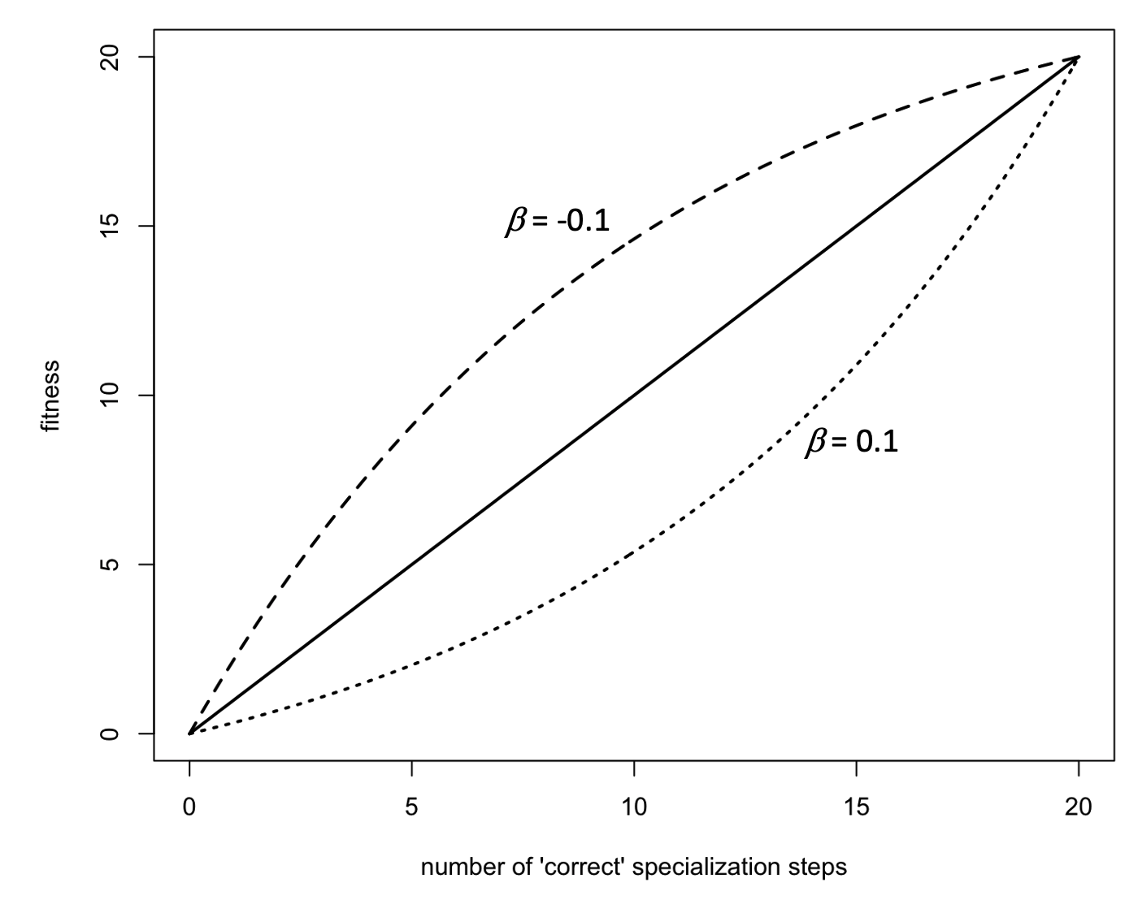
Figure A2.1. Relation between ‘correct’ specialization steps in a particular environment and fitness in the case of a linear (solid line), concave (dashed; β = -0.1), or convex (dotted; β = 0.1) fitness landscape.

Appendix 3. Figure 1 with different cue reliabilities

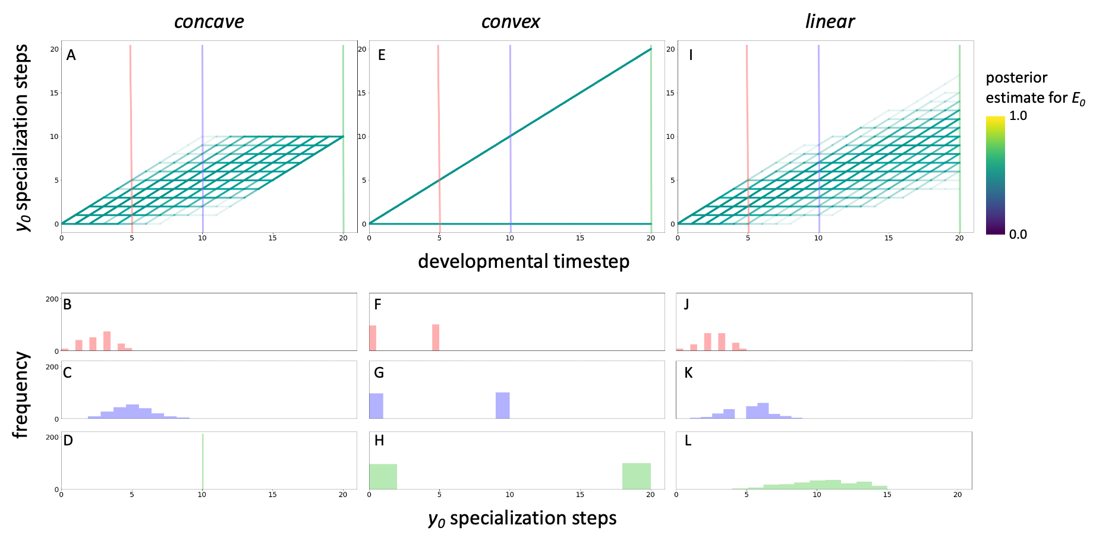

Figure A3.1. This figure corresponds to Figure 1 in the main text, but here, cue reliability is 0.5 (i.e., cues provide no information on the environmental condition).

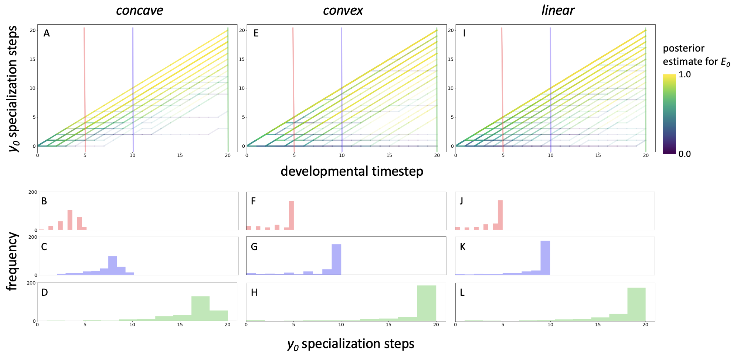

Figure A3.2. This figure corresponds to Figure 1 in the main text, but here, cue reliability is 0.7.

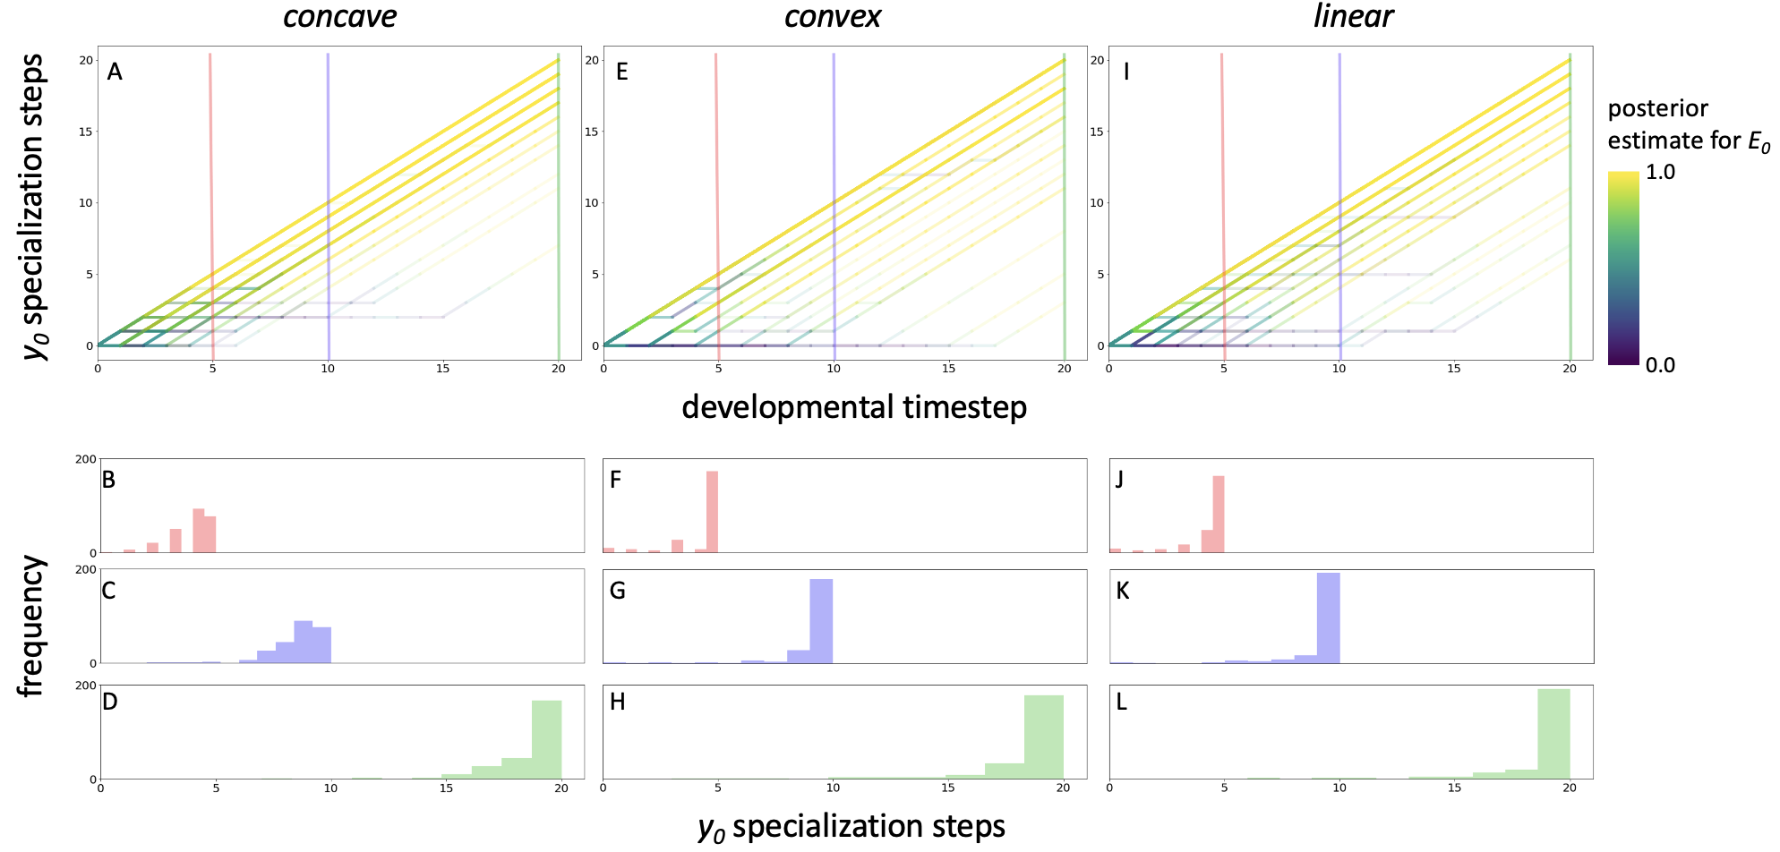

Figure A3.3. This figure corresponds to Figure 1 in the main text, but here, cue reliability is 0.8.

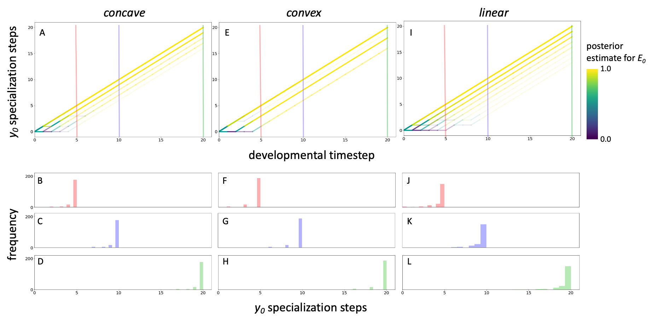
Figure A3.4. This figure corresponds to Figure 1 in the main text, but here, cue reliability is 0.9.
Appendix 4. Figure 2 with different cue reliability

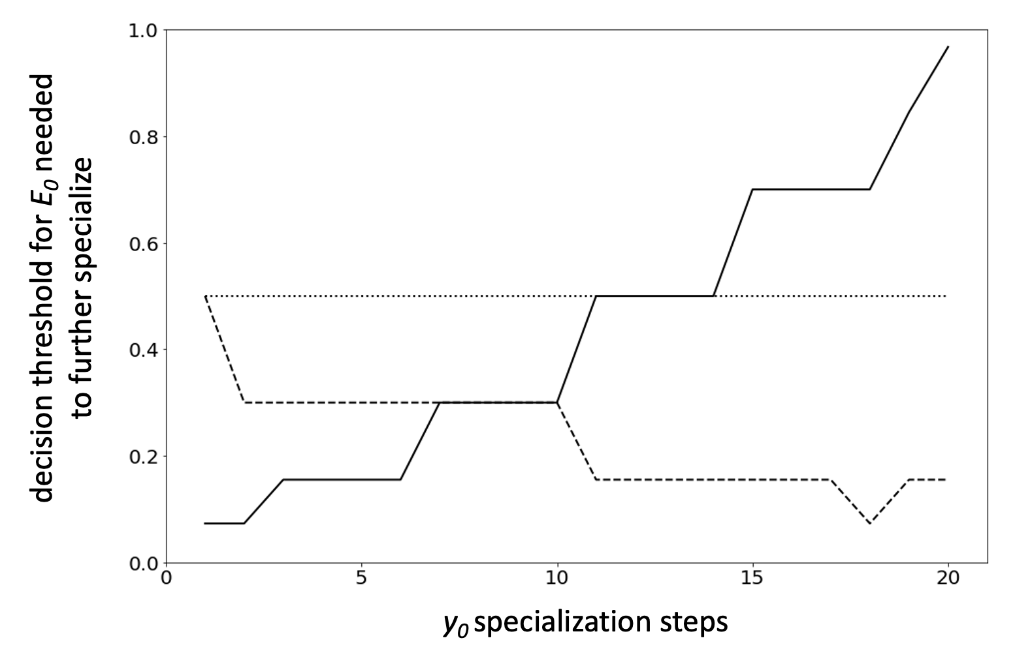

Figure A4.1. This figure corresponds to Figure 2 in the main text, but here, cue reliability is 0.7.

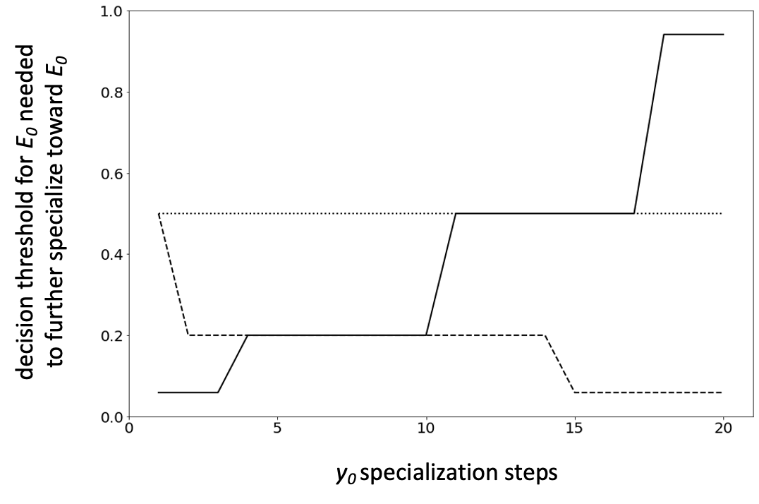
Figure A4.2. This figure corresponds to Figure 2 in the main text, but here, cue reliability is 0.8.

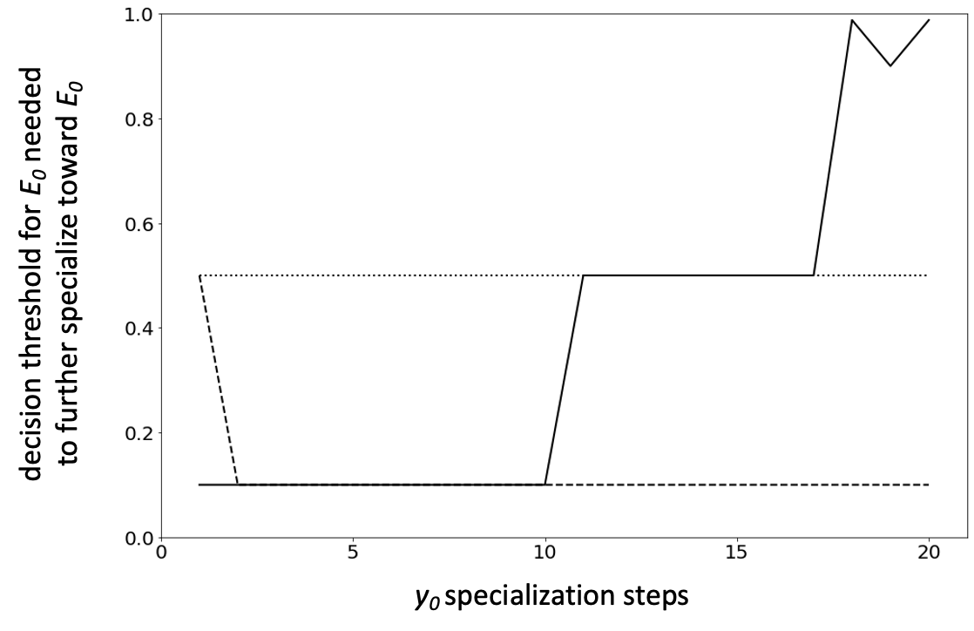
Figure A4.3. This figure corresponds to Figure 2 in the main text, but here, cue reliability is 0.9.

Appendix 5. Figure 3 with different cue reliabilities

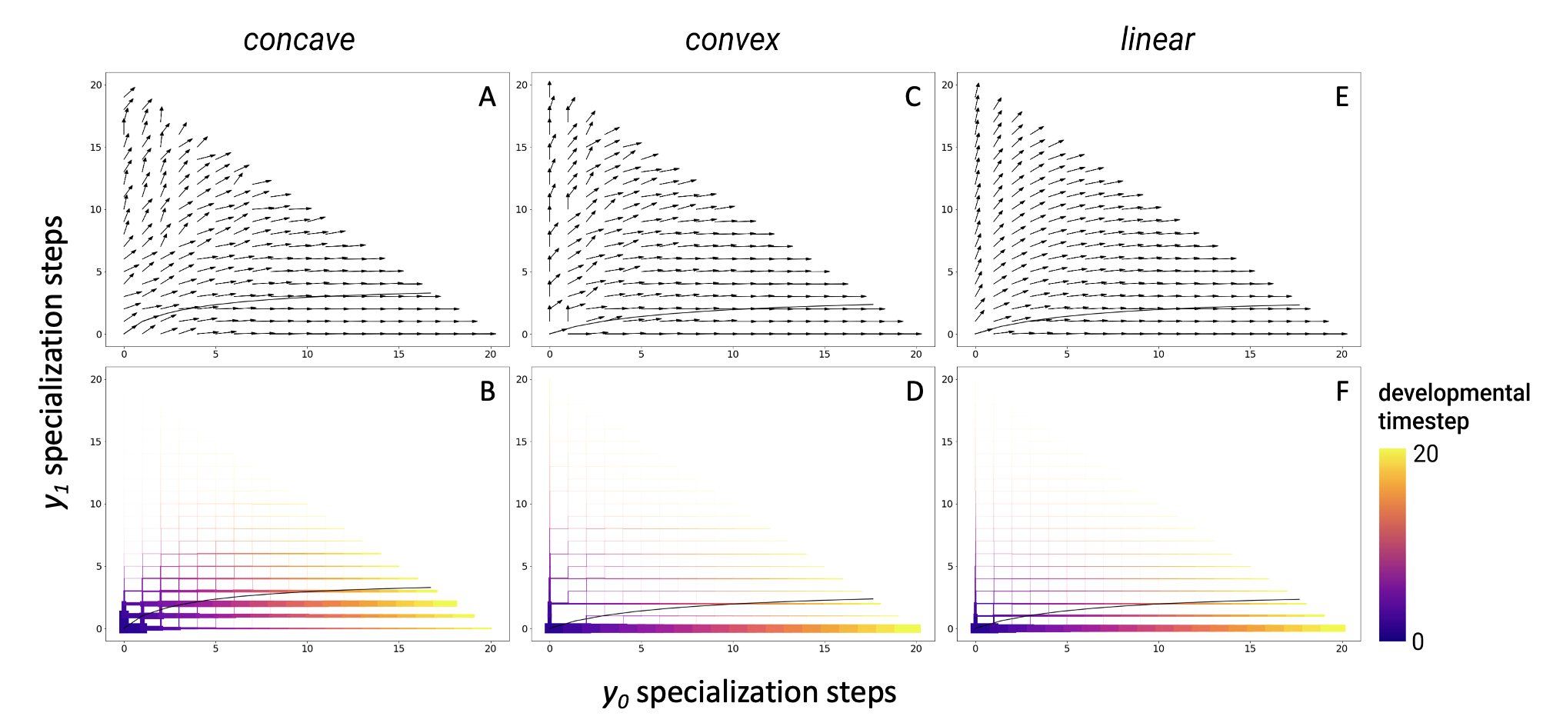

Figure A5.1. This figure corresponds to Figure 3 in the main text, but here, cue reliability is 0.7.
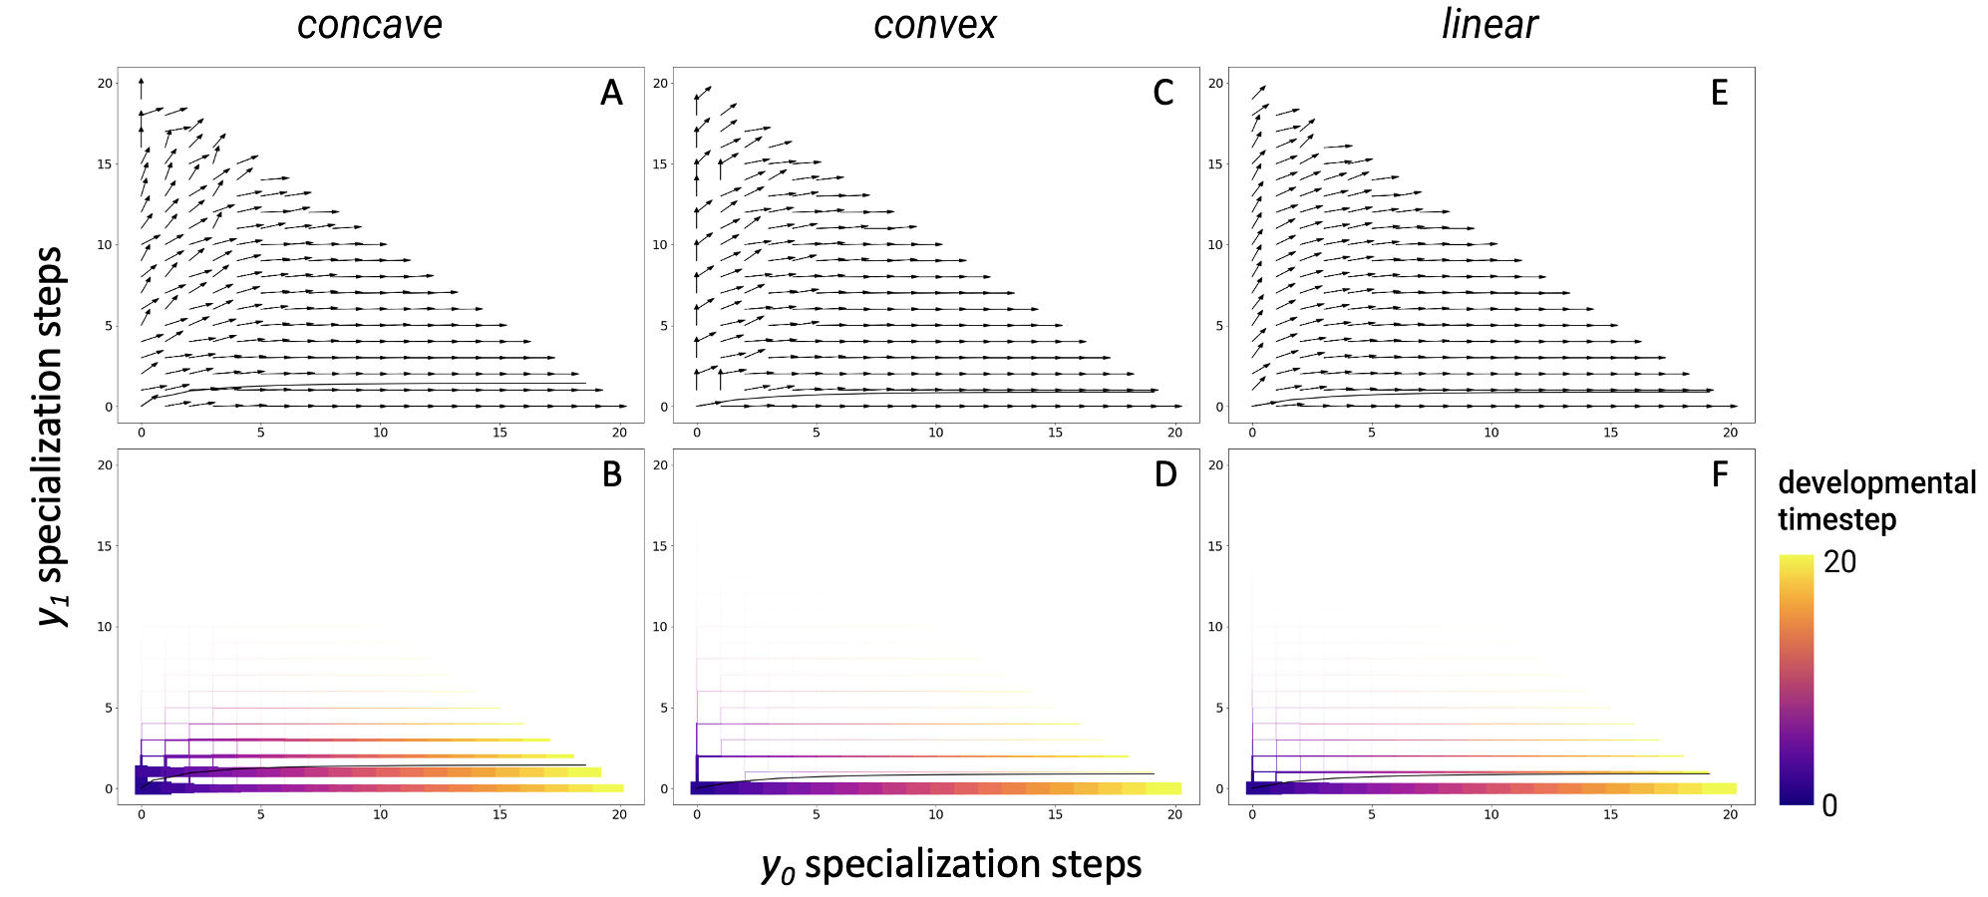

Figure A5.2. A version of Figure A5.1 (and Figure 3 in main text) with a cue reliability of 0.8.

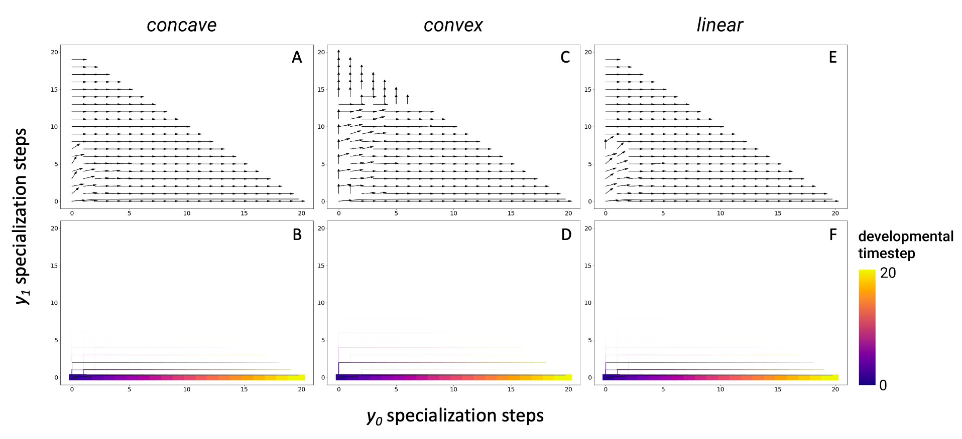
Figure A5.3. A version of Figure A5.1 (and Figure 3 in main text) with a cue reliability of 0.9.

