Supplementary Information 1

Palaeopathological evidence for intraspecific combat in ankylosaurid dinosaurs

Victoria M. Arbour, Lindsay E. Zanno, David C. Evans

Correspondence to: victoria.arbour@gmail.com

Extended Methods

Hypothesis 1: Intraspecific combat underlies the evolution of the ankylosaurid tail club.
Animals with sexually-selected weaponry often have highly ritualized intraspecific combat behaviours with repeated patterns of body alignment (e.g. Geist 1998, Pratt and Anderson 1985, Emlen 2008), and injuries are often found in concentrated areas associated with weapon deployment (e.g. Fryxell 1987, Drew 1996, Geist 1967). Consequently, if ankylosaurids used their tails for intraspecific combat, we predict that trauma would be localized to the regions of the body within range of the tail. Ankylosaurids had limited dorsoventral movement in the tail, and so the range of motion of the tail probably precluded strikes to the dorsal region of an opponent’s back and pelvis. Instead, tail strikes would have landed on the head, shoulders, flanks, hips, and/or lateral tail. Ritualized combat positions may have concentrated injuries to just one or a few of these regions.

Hypothesis 1a: ROM 75860 (Zuul crurivastator) preserves palaeopathological evidence of intraspecific combat.

ROM 75860, the holotype of Zuul crurivastator, has several severely pathological osteoderms within the in situ integument. We apply numbers and letters to mark osteoderm positions on the body. Transverse rows are indicated by letters, beginning posterior to the cervical half rings. Osteoderms closest to the midline on both the left and right sides within a single transverse row are labelled 1, with the number increasing distally from the midline. We identified osteoderms as pathological rather than taphonomically damaged based on the presence of bone remodelling or keratin sheath overgrowth of a damaged area on an osteoderm. Osteoderms were identified as pathological if they had the following features: 1) dramatic shape differences from adjacent osteoderms such as missing apices or aberrant keel shapes, 2) keratin sheath covering missing apices/aberrant keel shapes, or 3) presence of reactive bone texture. Some osteoderms were ambiguously pathological, so we ran two sets of analyses, one including only those osteoderms we were very confident were pathological, and one with an expanded dataset including potentially pathological osteoderms.
We tested the hypothesis that osteoderm pathologies were not randomly distributed across the body by dividing osteoderms into regions and using a chi-squared test of independence in PAST v4.09 (Hammer et al. 2001). In ROM 75860, the cervical region includes the two cervical half rings, the thoracic region is represented by rows A-D, the immobile pelvic region is represented by rows E-H, and the caudal region is represented by rows I to O plus the tail club knob. The dorsum includes all osteoderms in position 1, and osteoderms in positions B2-F2. The flanks include osteoderms in the A2 position, and all osteoderms in position 3 and higher. We tested the distribution of osteoderm pathologies among the cervical, thoracic, pelvic, and caudal regions, and the distribution of pathologies between the dorsum and flanks.
We also tested the hypothesis that pathologies were clustered in the thoracic/pelvic region using a runs test in PAST v4.09 (Hammer et al. 2001). A transverse row (e.g. A, B, C) without any pathological osteoderms was coded as 0, and a transverse row with at least one pathological osteoderm was coded as 1, starting with the cervical half rings and continuing to the tail club knob.
Hypothesis 1b: Ankylosaurid tail clubs show positive allometry.
Sexually-selected traits are often positively allometric (Eberhard et al. 2018, Kodric-Brown et al. 2006). In the case of ankylosaurid tail clubs, allometry in the size of the tail club knob would also support the hypothesis that tail clubs evolved as sexually-selected weapons of intraspecific combat, so we tested the relationship between knob width and femur length, and knob width and caudal vertebral width. Body mass estimates were unavailable for most ankylosaurids, and so we used femur length as a proxy for body size. Because few ankylosaurine specimens preserve both a tail club knob and a femur, we also used width of the distal caudal vertebrae as a presumably non-allometric body structure to compare against tail club knob width. We compiled a dataset including ankylosaur tail club knob widths, femur lengths, and caudal vertebral widths using information from the literature and direct measurements from specimens; some femur lengths were estimated using a linear ordinary least-squares regression of skull width across the supraorbitals and femur length (y=0.949x + 197.74; R² = 0.847) for North American ankylosaurins only. To test for allometry, we used a log-transformed ordinary least squares regression of femur length and knob width, and a log-transformed ordinary least squares regression of vertebra width and knob width, in PAST v4.09 (Hammer et al. 2001).

Hypothesis 2: Predation underlies the evolution of the ankylosaurid tail club.

If tail clubs arose as antipredator defensive structures, we may expect to see a correlation between the presence or absence of tail clubs and aspects of predator palaeobiology (such as body size or taxonomic affinity), or there could be a correlation between tail club morphology and predator morphology.

Hypothesis 2a: Ankylosaurid tail club knob size is dependent on the body size of the largest predator in the ecosystem.
Tail clubs have several variable morphological traits both within and across species, but the most easily quantifiable is knob size (as a proxy for knob volume and mass). Larger tail club knobs can deliver more forceful impacts during a tail strike (Arbour 2009), and therefore larger tail club knobs may have been more effective defensive weapons against larger predators.
We collected body mass estimates from previously published literature for the largest known predator in the same formation as a given ankylosaurid species. Some formations have more than one ankylosaurid species, such as the Dinosaur Park and Nemegt formations. Additionally, many tail clubs are dissociated from diagnostic skeletal elements and cannot be identified to specific species. For these reasons, we test predator body mass against the largest known tail club knob from the same formation, recognizing that this may not represent the true maximum knob size for any particular ankylosaurid species. Because several ankylosaurids (Liaoningosaurus, Chuanqilong, and Gobisaurus) have a handle but no tail club knob, or lack modified handle vertebrae, we included these in one set of analyses, and excluded them from another set of analyses.

Hypothesis 2b: Ankylosaurid tail club knob size is dependent on the body size of the tyrannosauroid in the ecosystem.
Ankylosaurids are often depicted in popular media wielding their tail clubs specifically against tyrannosauroid dinosaurs. As such, we test the dependence of tail club knob size on the body size of tyrannosauroids in the same formation, regardless of whether or not they would be considered the apex predator in that ecosystem. We use the largest known tail club knob from the formation.

Extended Results

Hypothesis 1:

Identification of osteoderm pathologies in ROM 75860
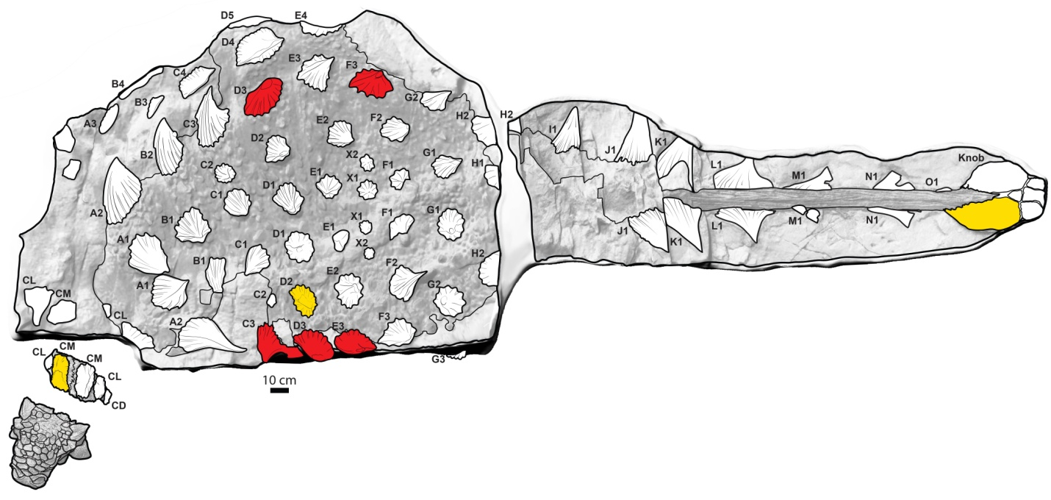
Fig. S1. Map of osteoderms in ROM 75860, Zuul crurivastator. Osteoderms marked in red are confidently pathological, osteoderms marked in yellow are ambiguously pathological. Illustration by Danielle Dufault.

ROM 75860 includes a nearly complete suite of dorsal and caudal osteoderms and integument, as well as osteoderms and skin from the right flank that have peeled away from the ribs (but remained otherwise intact) and are lying in the same plane as the dorsum. Osteoderms on the dorsal side of the body typically have oval bases and low keels or peaks. The dorsal most flank osteoderms (at the lateral edges of the dorsum) are much larger, basally compressed, triangular, and sharply pointed, with backswept apices. Osteoderms on the lateral sides of the caudals are also large and triangular, with generally straight edges. Here we provide brief descriptions of each osteoderm and a rationale for whether or not it is considered pathological or not. The numbering scheme follows that laid out in Fig S1, where each transverse row is represented by a letter and positions are numbered, with position 1 being closest to the midline.

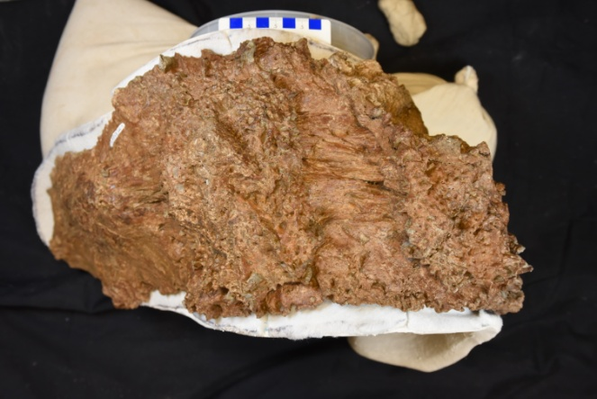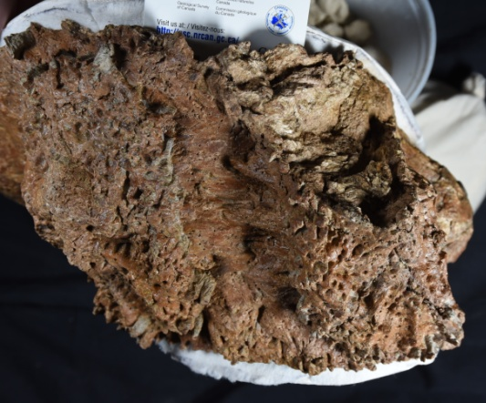
Fig. S2: First cervical half ring in dorsal view (left) and view centered on potentially pathological osteoderm (right). Photographs by Danielle Dufault.

First cervical half ring: Ankylosaurin cervical half rings have six osteoderms (medial, lateral, and distal pairs) sitting atop or coossified to a bony band composed of six roughly rectangular segments forming a U-shaped half ring (Arbour and Currie 2013). The cervical half ring of ROM 75860 is severely taphonomically compressed and it is difficult to determine the anterior and posterior sides (in undistorted specimens, the anterior side sits lower than the posterior side), and is missing one of the distal osteoderm positions. The medial osteoderms are deeply furrowed and fluted, with scalloped basal edges and a low central peak, with an overall morphology similar to that reported for Scolosaurus (Arbour and Currie 2013). One of the medial osteoderms is missing a large chunk of the anterior or posterior edge to almost the central peak. The edges of this region are variably smooth or showing internal bone texture. Within the internal broken region is a region of disorganized bone spicules. This osteoderm may be pathologically damaged.

Second cervical half ring: Second cervical half rings are more poorly known compared to first cervical half rings, but they typically mimic the morphology of the first half ring but are larger in size. It seems that osteoderms of the second cervical half ring may be less likely to fuse to the band segments or are at least less closely appressed (e.g. Arbour and Currie 2013). The second cervical half ring in ROM 75860 is partially obscured by matrix on both sides, making it difficult to determine its exact morphology. It appears to have at least partially disarticulated. None of the putative osteoderms from the second cervical half ring appear pathological.

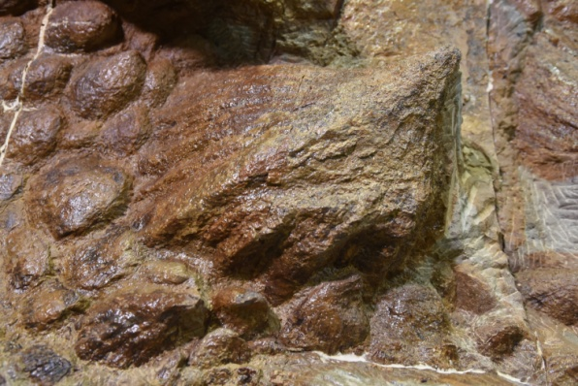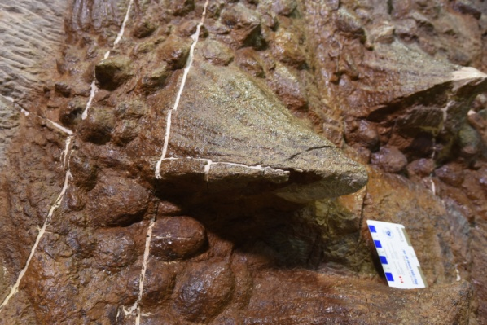
Fig. S3: Osteoderms A1 left and A1 right. Photographs by Danielle Dufault.

A1 Left: Oval base, weak keel leading to tall conical apex. No pathological, taphonomic, or preparation damage.
A1 Right: Oval base, weak keel leading to tall conical apex. No pathological damage; keel is taphonomically compressed to the side and has a small amount of matrix adhering to the left apical side.

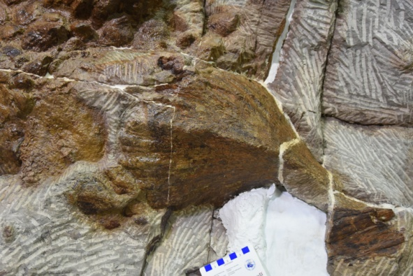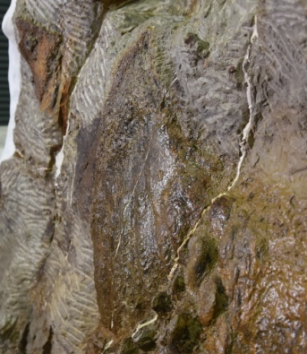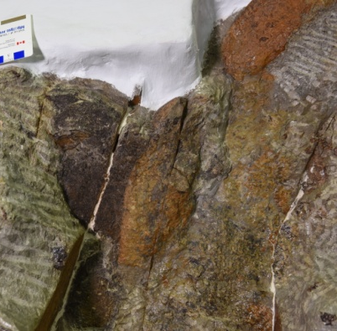
Fig. S4: Osteoderms A2 left (left), A2 right (centre), and A3 right (right). Photographs by Danielle Dufault.

A2 Left: Anteroposteriorly broad, triangular with backswept apex. No pathological damage; osteoderm is taphonomically compressed along the keel.

A2 Right: Anteroposteriorly broad, triangular with backswept apex. No pathological damage; osteoderm is taphonomically compressed and was observed in both dorsal and ventral views.

A3 Right: Oval base, sharp longitudinal keel, observed in both dorsal and ventral views. Dorsal side is partially obscured by matrix. No pathological damage.

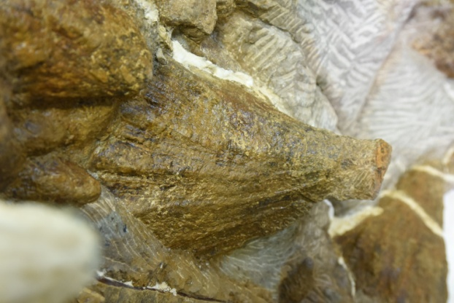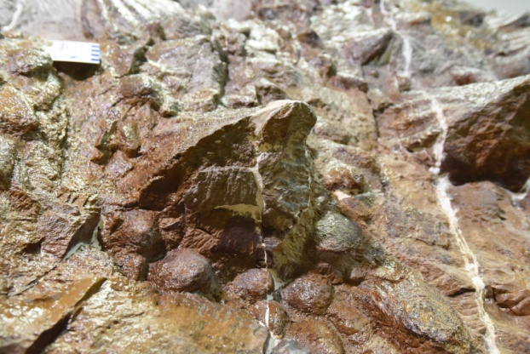
Fig. S5: Osteoderms B1 left and B1 right. Photographs by Danielle Dufault.

B1 Left: Oval base, tall conical apex. May have some carbonaceous plant material adhered to apex. No pathological damage.

B1 Right: Oval base, tall conical apex. Tip damaged during preparation so presence or absence of pathological damage cannot be assessed.

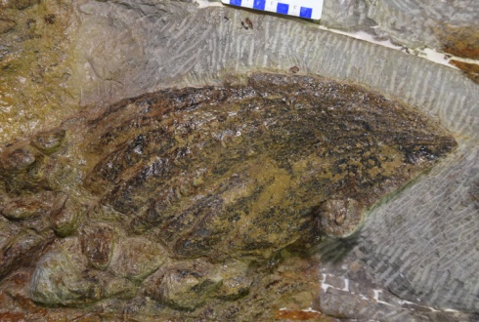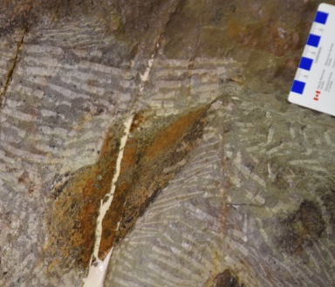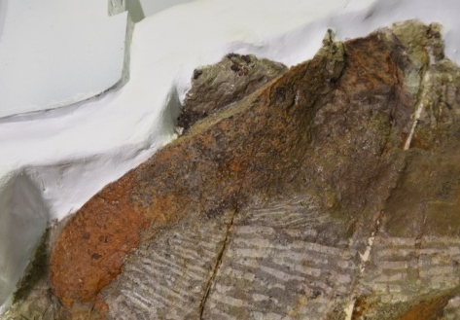
Fig. S6: Osteoderms B2 right (left), B3 right (middle), and B4 right (right). Photographs by Danielle Dufault.

B2 Right: Anteroposteriorly broad, triangular with backswept apex. No pathological damage. Osteoderm is taphonomically compressed along the keel.

B3 Right: Oval base, sharp longitudinal keel, left dorsal side of keel obscured by matrix. No pathological damage on exposed surfaces.

B4 Right: Oval base, sharp longitudinal keel, part of left dorsal side of keel obscured by matrix. No pathological damage on exposed surfaces.

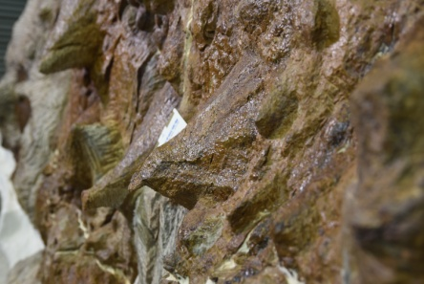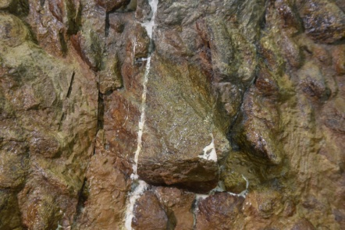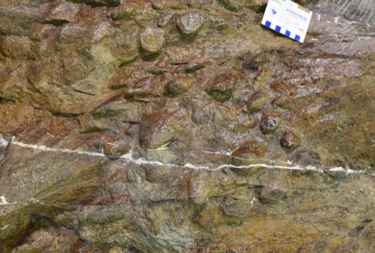
Fig. S7: Osteoderms C1 left (left), C1 right (middle), and C2 right (right). Photographs by Danielle Dufault.

C1 Left: Oval base, short conical apex. Osteoderm has undergone plastic deformation to the left lateral side. No pathological damage.

C1 Right: Oval base, short conical apex. No pathological damage.

C2 Right: Oval base, small central peak. No pathological damage.

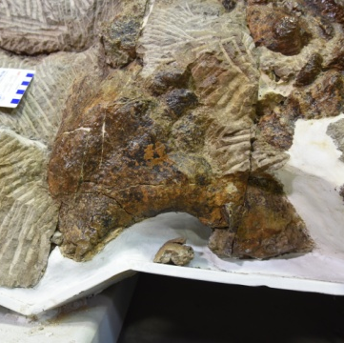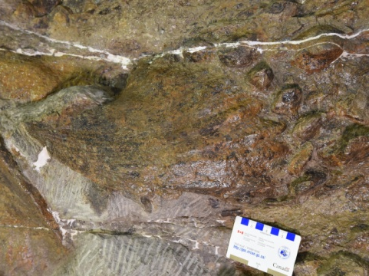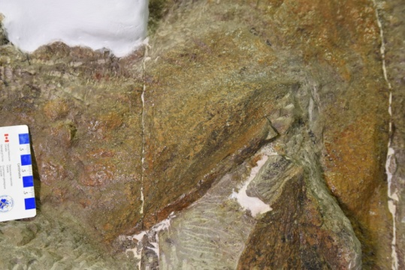
Fig. S8: Osteoderms C3 left (left), C3 right (middle), and C4 right (right). Photographs by Danielle Dufault.

C3 Left: Anteroposteriorly broad, triangular osteoderm, but major pathological damage changes the overall osteoderm shape significantly. A large portion of the trailing edge posterior to where the apex would have been located is missing and a smooth, concave edge remains. The bone appears fully remodelled with no exposed internal surface or unusual texture, and black organic material on the external surface suggests the keratinous covering extended over this region as well. Pathological osteoderm.

C3 Right: Anteroposteriorly broad, triangular with backswept apex. No pathological damage. Osteoderm is taphonomically compressed along the keel.

C4 Right: Oval base, sharp longitudinal keel, left dorsal side of keel obscured by matrix. No pathological damage on exposed surfaces.

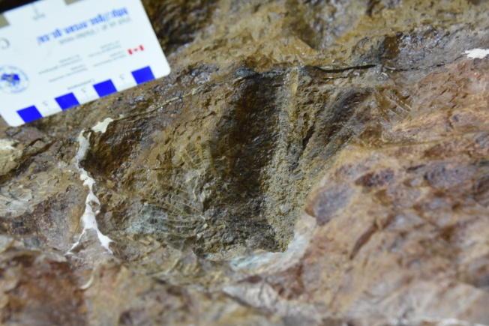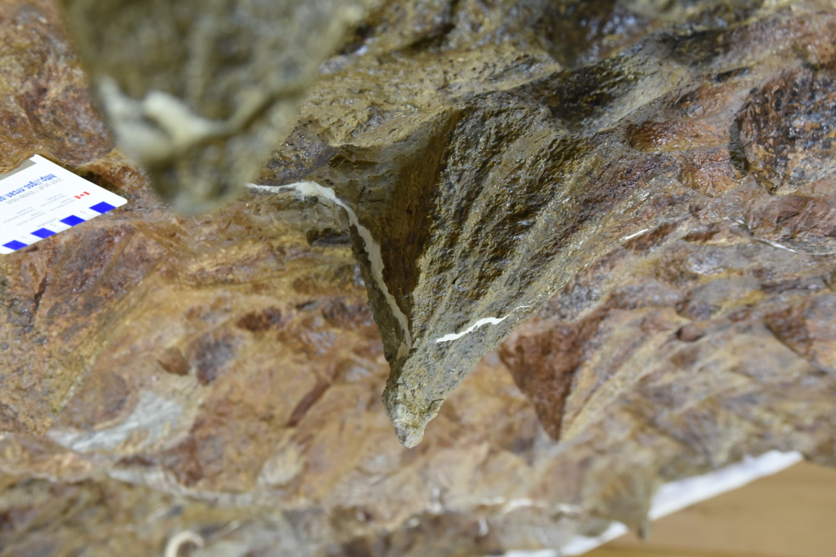
Fig. S9: Osteoderms D1 left (left), and D1 right (right). Photographs by Danielle Dufault.

D1 Left: Oval base, short conical apex. Osteoderm has undergone plastic deformation to the left lateral side, and has some matrix adhering to the left side and region around the tip. No pathological damage.

D1 Right: Oval base, short conical apex. No pathological damage.

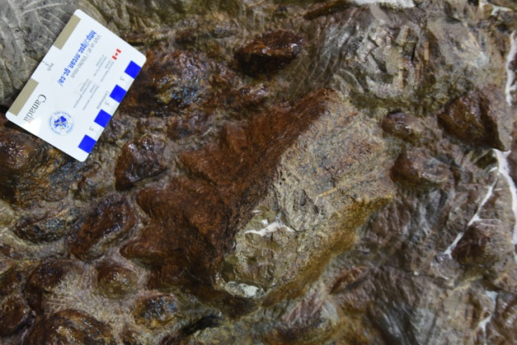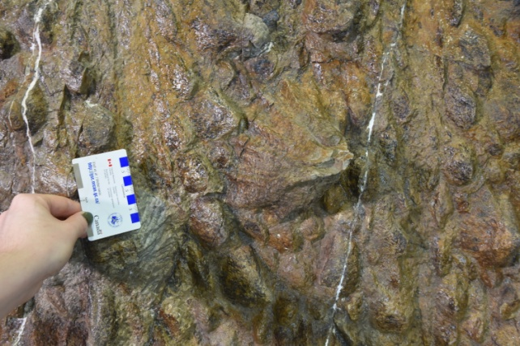
Fig. S10: Osteoderms D2 left (left), and D2 right (right). Photographs by Danielle Dufault.

D2 Left: Oval base, short conical apex. The apex region is damaged. The tip is missing, but the edges of the bone are neither particularly smooth nor sharply broken, making it unclear if there is early healed damage or just post-mortem damage. This osteoderm is treated as potentially but ambiguously pathological.

D2 Right: Oval base, short conical apex. The apex region is damaged; the sharp edges and right angles of the damaged region indicate these are recent damage during preparation, rather than pathological or post-mortem taphonomic damage.

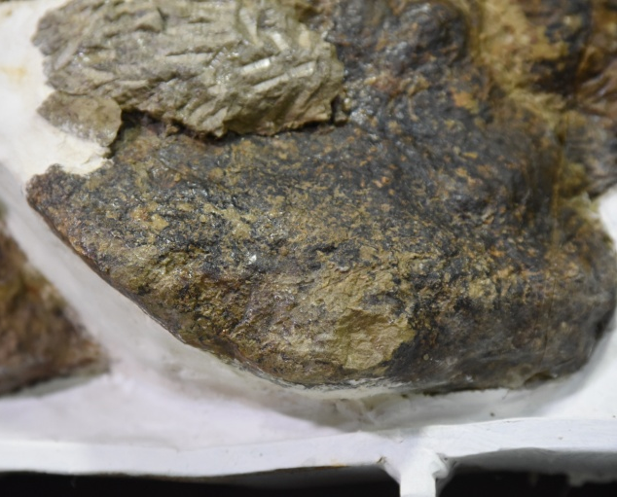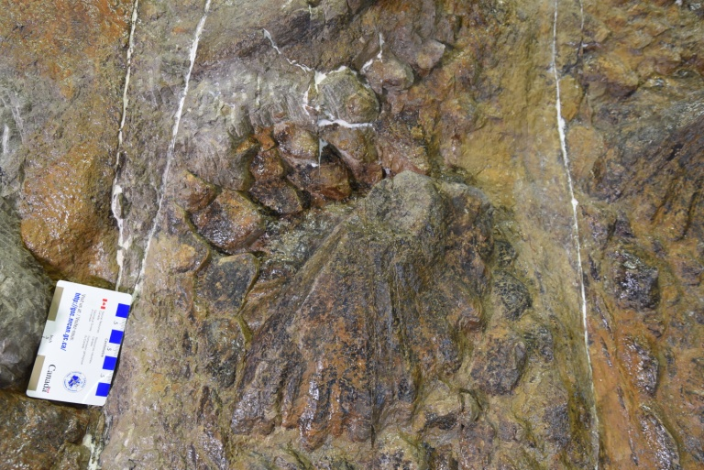
Fig. S11: Osteoderms D3 left (left), and D3 right (right). Photographs by Danielle Dufault.

D3 Left: Based on comparison with other osteoderms in the ‘3’ position, this should be an anteroposteriorly broad, triangular osteoderm, with a backswept apex. However, the tip is missing, changing the shape profile of this osteoderm. Smooth bone and dark organic material cover the blunt apex, suggesting this is a fully re-healed injury and the keratinous sheath had also covered this region. Pathological osteoderm.

D3 Right: Based on comparison with other osteoderms in the ‘3’ position, this should be an anteroposteriorly broad, triangular osteoderm, with a backswept apex. However, the tip is missing, changing the shape profile of this osteoderm. Bone around the edges of the missing tip is smooth, indicating this is not preparation or post-mortem taphonomic damage, but is instead pathological damage. Pathological osteoderm.

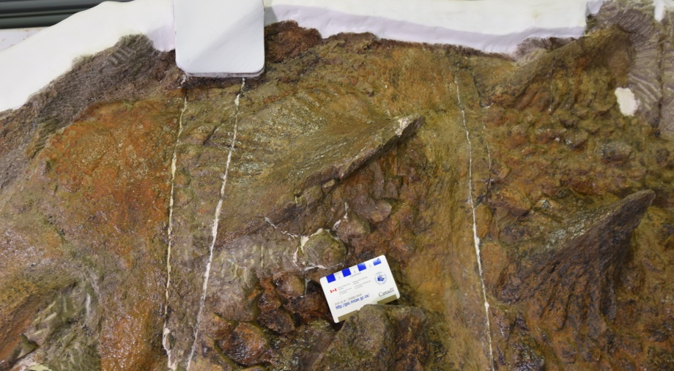
Fig. S12: Osteoderms D4 right and D5 right. Photograph by Danielle Dufault.

D4 Right: Oval base, sharp longitudinal keel. A small chunk of the anterior part of the keel was damaged during preparation. No pathological damage.

D5 Right: Oval base, sharp longitudinal keel. This osteoderm is largely obscured by matrix and the mounting materials for supporting the body block. No obvious pathological damage but difficult to observe fully.

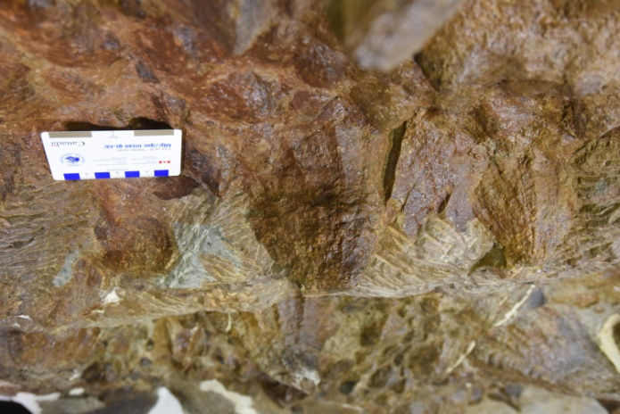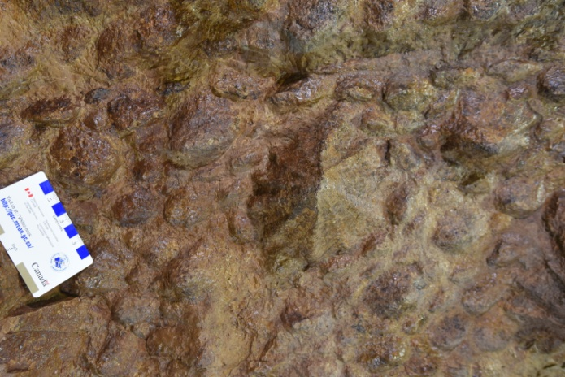
Fig. S13: Osteoderms E1 left (left) and E1 right (right). Photographs by Danielle Dufault.

E1 Left: Oval base, rounded conical apex. Osteoderm is plastically deformed to the left side. No pathological damage.

E1 Right: Oval base, rounded conical apex. No pathological damage.

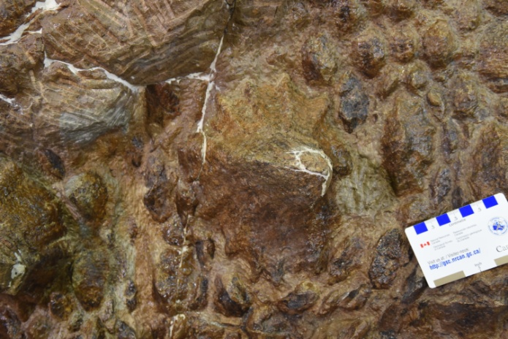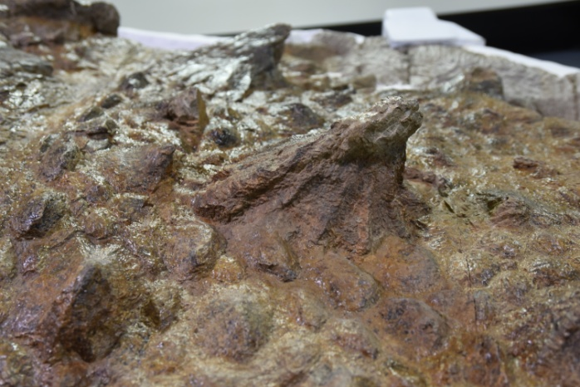 Fig. S14: Osteoderms E2 left (left) and E2 right (right). Photographs by Danielle Dufault.

E2 Left: Oval base, rounded conical apex. No pathological damage.

E2 Right: Oval base, rounded conical apex, but matrix obscures the tip slightly. No pathological damage.

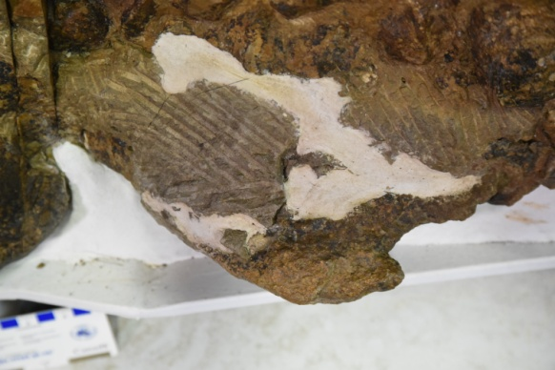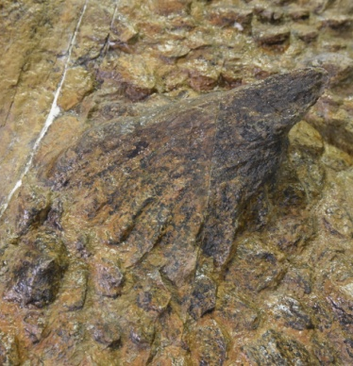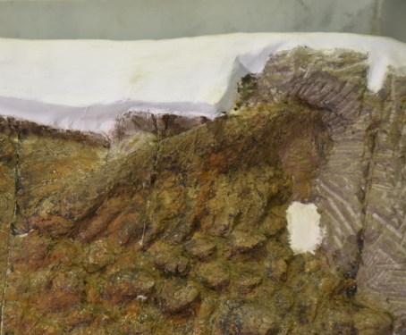
Fig. S15: Osteoderms E3 left (left), E3 right (middle), and E4 right (right). Photographs by Danielle Dufault.

E3 Left: Anteroposteriorly broad, triangular osteoderm, but major pathological damage changes the overall osteoderm shape significantly. A large portion of the trailing edge posterior to the apex is missing and a smooth, concave edge remains. The anterior, leading edge of the apex has a deep groove. The bone appears fully remodelled with no exposed internal surface or unusual texture, and black organic material on the external surface suggests the keratinous covering extended over this region as well. Part of the base of the osteoderm is obscured by matrix. Pathological osteoderm.

E3 Right: Anteroposteriorly broad, triangular with backswept apex. No pathological damage.

E4 Right: Oval base, sharp longitudinal keel. No pathological damage.

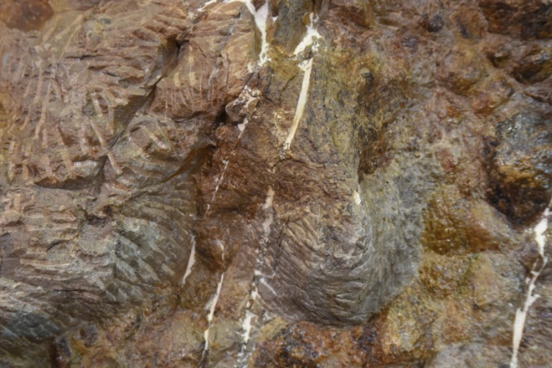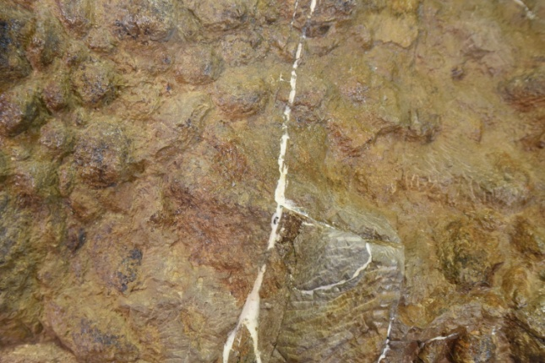
Fig. S16: Osteoderms F1 left (left) and F1 right (right). Photographs by Danielle Dufault.

F1 Left: Oval base, rounded conical apex. Left and posterior sides are obscured by matrix. No pathological damage on exposed surfaces.

F1 Right: Oval base, rounded conical apex. Part of apex, and left and posterior sides are obscured by matrix. No pathological damage on exposed surfaces.

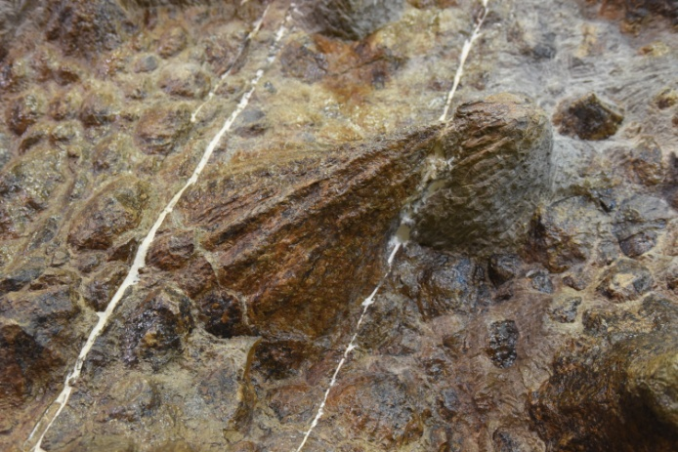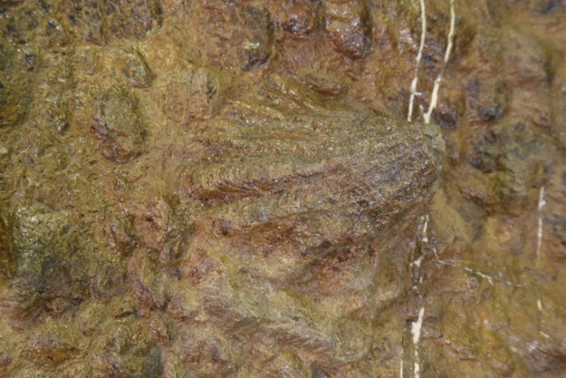
Fig. S17: Osteoderms F2 left (left) and F2 right (right). Photographs by Danielle Dufault.

F2 Left: Oval base, rounded conical apex. No pathological damage.

F2 Right: Oval base, rounded conical apex. No pathological damage.

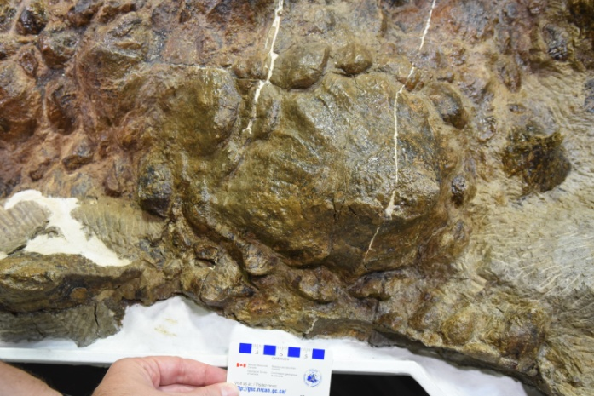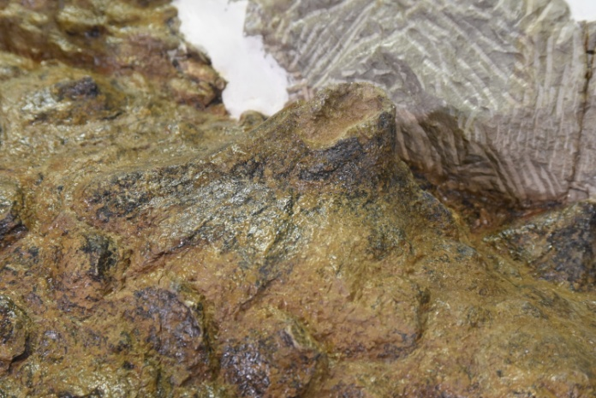
Fig. S18: Osteoderms F3 left (left) and F3 right (right). Photographs by Danielle Dufault.

F3 Left: Oval base, rounded conical apex. No pathological damage.

F3 Right : Oval base, rounded conical apex. The apex is damaged so that there is a concave region on the dorsal side. The edges of bone are smooth, indicating this is pathological damage rather than post-mortem taphonomic or preparation damage. Pathological osteoderm.

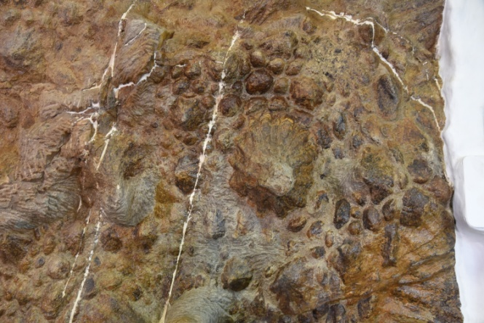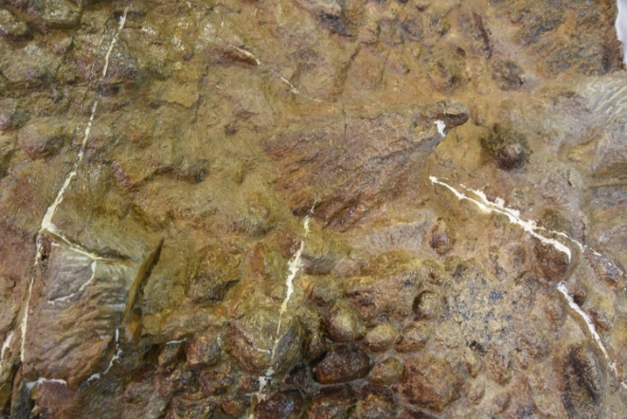
Fig. S19: Osteoderms G1 left (left) and G1 right (right). Photographs by Danielle Dufault.

G1 Left: Oval base, rounded conical apex. The apex is taphonomically deformed to the left and partially obscured by matrix. No obvious pathological damage.

G1 Right: Oval base, rounded conical apex. The apex is taphonomically deformed to the right and there is a small fresh break on the anterior surface from preparation. No obvious pathological damage.

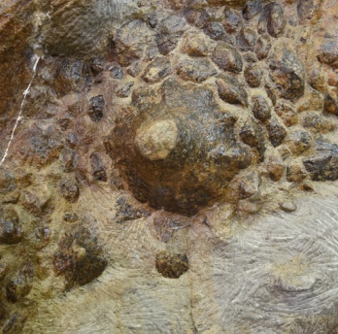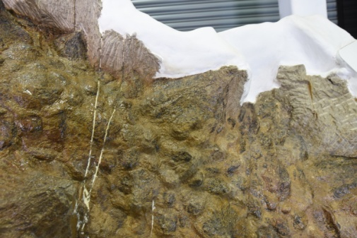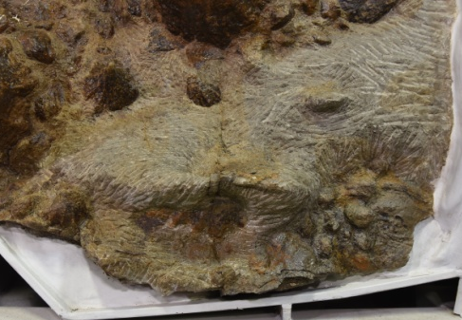
Fig. S20: Osteoderms G2 left (left), G2 right (middle), and G3 left (right). Photographs by Danielle Dufault.

G2 Left: Oval base, pointed conical apex. The apex is partially obscured by matrix. No obvious pathological damage.

G2 Right: Oval base, pointed conical apex. No pathological damage.

G3 Left: Almost completely obscured by matrix on dorsal surface, but ventral surface was fully prepared and does not show any obvious pathology like a missing apex. No pathological damage.

H1 Right, H2 Left and Right, and H3 Left: All preserve only the base within the torso block, and would have connected to the tail block prior to excavation. The tips are thus missing from all of these osteoderms and it is difficult to determine if any were pathological or not. The tip of H1 Right may be preserved as the first right osteoderm in the caudal block (co1 in Arbour and Evans 2017: Fig. 7).
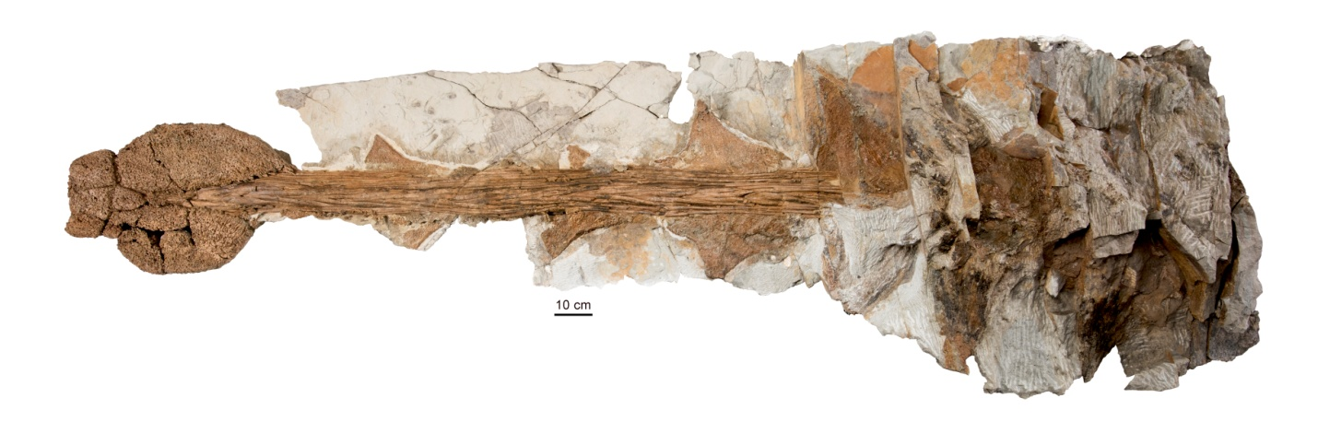
Fig. S21: Caudal osteoderms of ROM 75860, from I to O and the tail club knob. Photograph by Brian Boyle.

I1 Right: Dorsoventrally compressed triangular osteoderm with sharp apex; co2 in Arbour and Evans (2017: Fig. 7). The base is obscured by matrix. No obvious pathological damage.

J1 Right: Dorsoventrally compressed triangular osteoderm with sharp apex; co3 in Arbour and Evans (2017: Fig. 7). The base is obscured by matrix and a small portion of the apex was damaged during collection/preparation. No obvious pathological damage.

J1 Left: Dorsoventrally compressed triangular osteoderm with sharp apex; co3 in Arbour and Evans (2017: Fig. 7). The base is obscured by matrix. No pathological damage.

K1 Right: Dorsoventrally compressed triangular osteoderm with sharp apex; co4 in Arbour and Evans (2017: Fig. 7). Part of the base and dorsal surface is obscured by matrix and a small portion of the tip was lost during collection/preparation. No obvious pathological damage.

K1 Left: Dorsoventrally compressed triangular osteoderm with sharp apex; co4 in Arbour and Evans (2017: Fig. 7). No pathological damage.

L1 Right: Dorsoventrally compressed triangular osteoderm with sharp apex; co5 in Arbour and Evans (2017: Fig. 7). A small portion of the apex was lost during collection/preparation. No pathological damage.

L1 Left: Dorsoventrally compressed triangular osteoderm with sharp apex; co5 in Arbour and Evans (2017: Fig. 7). No pathological damage.

M1 Right: Dorsoventrally compressed triangular osteoderm with sharp apex; co6 in Arbour and Evans (2017: Fig. 7). Some of the trailing posterior edge was damaged during collection/preparation. No pathological damage.

M1 Left: Dorsoventrally compressed triangular osteoderm; co6 in Arbour and Evans (2017: Fig. 7). Much of the osteoderm was lost during collection and/or preparation and it is not possible to determine whether or not it was pathological.

N1 Right: Dorsoventrally compressed triangular osteoderm with sharp apex; co7 in Arbour and Evans (2017: Fig. 7). No pathological damage.

N1 Left: Dorsoventrally compressed triangular osteoderm with sharp apex; co7 in Arbour and Evans (2017: Fig. 7). No pathological damage.

O1 Right: Small dorsoventrally compressed osteoderm with rounded apex; co8 in Arbour and Evans (2017: Fig. 7). No pathological damage.

O1 Left: Dorsoventrally compressed triangular osteoderm with sharp apex; co8 in Arbour and Evans (2017: Fig. 7). Mostly obscured by the left knob osteoderms, see discussion for tail club knob.

Tail Club Knob: Ankylosaurid tail clubs are composed of two large major osteoderms located laterally and a variable number of smaller minor osteoderms located terminally. We treat the tail club knob as a two halves (left major and minor osteoderms and right major and minor osteoderms) of a single unit given the tightly coossified nature of the osteoderms involved in its composition. In ROM 75860, the left major osteoderm extends significantly further forward along the handle compared to the right major osteoderm, and appears to have overgrown O1 Right. Although this osteoderm does not have any obvious reactive bone growth or healed regions and its shape is overall similar to the right major osteoderm, the anteroposterior asymmetry between these two osteoderms is noteworthy. This asymmetry could be interpreted as resulting from repeated impacts favouring the left side; asymmetry resulting from differential mechanical loading because of handedness is well documented in humans and has also been observed in cetaceans (Galatius 2006). We consider the tail club knob ambiguously pathological.

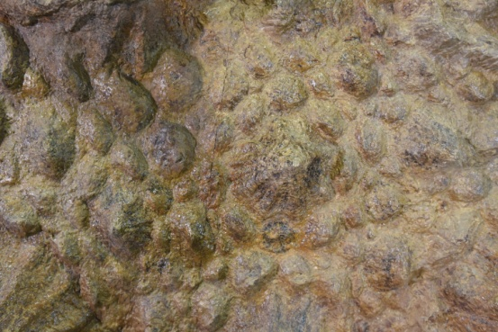
Fig. S22: Putative osteoderm X2 right.

X1 and X2: These pairs of large scales are present in the pelvic region, but it is unclear if they bear a single osteoderm underneath each scale, or if these are epidermal scales underlain by numerous ossicles as for the other scales surrounding the large osteoderms. We include these in one set of statistical analyses and exclude them from another set to account for this ambiguity. None appear pathological.
Fig. S23: Ventral view of ROM 75860 (Zuul crurivastator) during preparation, prior to removal of a section of integument on the left side of the body.

Osteoderms visible only in ventral view: ROM 75860 was preserved with the ventral side up and preparation of the ventral surface occurred first. A segment of osteoderms and integument was removed from the body block prior to flipping the block over to prepare the dorsal surface. This segment may include left osteoderms B2, C4, C5, C6, D4, D5, and E4. C5 and C6 are sandstone impressions of the external keratinous sheath and do not appear pathological. C4, D4, and D5 are either sandstone impressions of the external keratinous sheath, or may preserve part of the sheath itself, and do not appear pathological. B2 and E4 preserve the internal surface of the bony osteoderm but neither is fully prepared all the way to the apex; neither appears pathological but the presence or absence of a pathology cannot be confirmed given the available data. We do not include the osteoderms visible only in ventral view in our statistical analyses because their morphology cannot be fully assessed as preserved and prepared.
Statistical analyses of ROM 75860 pathology distributions
Chi-squared tests of the distribution of pathologies between the cervical, trunk, and caudal regions did not yield statistically significant p-values. A chi-squared test of normal vs. pathological osteoderms on the dorsum vs. the flanks yielded statistically significant p-values when ambiguous osteoderms were included or excluded. A runs test of the distribution of transverse rows with or without pathological osteoderms yielded statistically significant p-values when ambiguous osteoderms were included or excluded. Both the chi-square test of dorsum vs. flank injuries, and the runs test, reject the hypothesis that pathologies are randomly distributed across the body of ROM 75860.

Confidently pathological osteoderms only

Table S1: Contingency table of confidently pathological osteoderms in the trunk region (rows A-G). The dorsum includes A1, B1, C1-2, D1-2, E1-2, X1-2, F1-2, and G1. The flanks include osteoderms in the 3 positions and higher, plus A2, B2, and G2. We exclude the H row and left C2, right B4, right D5, and right E4 because they are very incomplete. Chi-square = 8.35, df = 1, p = 0.0039.
Body region | Normal | Injured
Dorsum | 25 | 0
Flank | 12 | 5

Table S2: Contingency table of confidently pathological osteoderms in the trunk region (rows A-G). The dorsum includes A1, B1, C1-2, D1-2, E1-2, F1-2, and G1 and excludes X1-2. The flanks include osteoderms in the 3 positions and higher, plus A2, B2, and G2. We exclude the H row and left C2, right B4, right D5, and right E4 because they are very incomplete. Chi-square = 7.11, df = 1, p = 0.0077.
Body region | Normal | Injured
Dorsum | 21 | 0
Flank | 12 | 5

Table S3: Contingency table of confidently pathological osteoderms divided by anteroposterior body region. The cervical region includes CM, CL, and CD of the first cervical half ring, and CL and CM of the second cervical half ring. The thoracic region includes rows A-D, the pelvic region includes rows E-H (including X), and the caudal region includes rows I-O and the tail club knob. We exclude left CL of the second cervical half ring, row H, and left C2, right B4, right D5, and right E4 because they are very incomplete. Chi-square = 2.91, df = 3, p = 0.44.
Body region | Normal | Injured
Cervical | 7 | 0
Thoracic | 19 | 3
Pelvic | 18 | 2
Caudal | 14 | 0

Table S4: Contingency table of confidently pathological osteoderms divided by anteroposterior body region. The cervical region includes CM, CL, and CD of the first cervical half ring, and CL and CM of the second cervical half ring. The thoracic region includes rows A-D, the pelvic region includes rows E-H (but excludes X), and the caudal region includes rows I-O and the tail club knob. We exclude left CL of the second cervical half ring, row H, and left C2, right B4, right D5, and right E4 because they are very incomplete. Chi-square = 3.03, df = 3, p = 0.39.
Body region | Normal | Injured
Cervical | 7 | 0
Thoracic: A-D | 19 | 3
Pelvic: E-H | 14 | 2
Caudal: I-Q | 14 | 0

Table S5: Contingency table of confidently pathological osteoderms divided by anteroposterior body region. The cervical region includes CM, CL, and CD of the first cervical half ring, and CL and CM of the second cervical half ring. The trunk region combines the thoracic and pelvic regions (A-H, including X), and the caudal region includes rows I-O and the tail club knob. We exclude left CL of the second cervical half ring, row H, and left C2, right B4, right D5, and right E4 because they are very incomplete. Chi-square = 2.72, df = 2, p = 0.26.
Body region | Normal | Injured
Cervical | 7 | 0
Trunk | 37 | 5
Caudal | 14 | 0

Table S6: Contingency table of confidently pathological osteoderms divided by anteroposterior body region. The cervical region includes CM, CL, and CD of the first cervical half ring, and CL and CM of the second cervical half ring. The trunk region combines the thoracic and pelvic regions (A-H, excluding X), and the caudal region includes rows I-O and the tail club knob. We exclude left CL of the second cervical half ring, row H, and left C2, right B4, right D5, and right E4 because they are very incomplete. Chi-square = 3.02, df = 2, p = 0.22.
Body region | Normal | Injured
Cervical | 7 | 0
Trunk: A-H and X | 33 | 5
Caudal: I-Q | 14 | 0

Confidently and ambiguously pathological osteoderms

Table S7: Contingency table of confidently pathological osteoderms in the trunk region (rows A-G). The dorsum includes A1, B1, C1-2, D1-2, E1-2, X1-2, F1-2, and G1. The flanks include osteoderms in the 3 positions and higher, plus A2, B2, and G2. We exclude the H row and left C2, right B4, right D5, and right E4 because they are very incomplete. Chi-square = 5.34, df = 1, p = 0.021.
Body region | Normal | Injured
Dorsum | 24 | 1
Flank | 12 | 5

Table S8: Contingency table of confidently pathological osteoderms in the trunk region (rows A-G). The dorsum includes A1, B1, C1-2, D1-2, E1-2, F1-2, and G1 and excludes X1-2. The flanks include osteoderms in the 3 positions and higher, plus A2, B2, and G2. We exclude the H row and left C2, right B4, right D5, and right E4 because they are very incomplete. Chi-square = 4.29, df = 1, p = 0.038.
Body region | Normal | Injured
Dorsum | 20 | 1
Flank | 12 | 5

Table S9: Contingency table of confidently pathological osteoderms divided by anteroposterior body region. The cervical region includes CM, CL, and CD of the first cervical half ring, and CL and CM of the second cervical half ring. The thoracic region includes rows A-D, the pelvic region includes rows E-H (including X), and the caudal region includes rows I-O and the tail club knob. We exclude left CL of the second cervical half ring, row H, and left C2, right B4, right D5, and right E4 because they are very incomplete. Chi-square = 1.13, df = 3, p = 0.77.
Body region | Normal | Injured
Cervical | 6 | 1
Thoracic | 18 | 4
Pelvic | 18 | 2
Caudal | 13 | 1

Table S10: Contingency table of confidently pathological osteoderms divided by anteroposterior body region. The cervical region includes CM, CL, and CD of the first cervical half ring, and CL and CM of the second cervical half ring. The thoracic region includes rows A-D, the pelvic region includes rows E-H (but excludes X), and the caudal region includes rows I-O and the tail club knob. We exclude left CL of the second cervical half ring, row H, and left C2, right B4, right D5, and right E4 because they are very incomplete. Chi-square = 0.91, df = 3, p = 0.82.
Body region | Normal | Injured
Cervical | 6 | 1
Thoracic: A-D | 18 | 4
Pelvic: E-H | 14 | 2
Caudal: I-Q | 13 | 1

Table S11: Contingency table of confidently pathological osteoderms divided by anteroposterior body region. The cervical region includes CM, CL, and CD of the first cervical half ring, and CL and CM of the second cervical half ring. The trunk region combines the thoracic and pelvic regions (A-H, including X), and the caudal region includes rows I-O and the tail club knob. We exclude left CL of the second cervical half ring, row H, and left C2, right B4, right D5, and right E4 because they are very incomplete. Chi-square = 0.40, df = 2, p = 0.82.
Body region | Normal | Injured
Cervical | 6 | 1
Trunk | 36 | 6
Caudal | 12 | 1

Table S12: Contingency table of confidently pathological osteoderms divided by anteroposterior body region. The cervical region includes CM, CL, and CD of the first cervical half ring, and CL and CM of the second cervical half ring. The trunk region combines the thoracic and pelvic regions (A-H, excluding X), and the caudal region includes rows I-O and the tail club knob. We exclude left CL of the second cervical half ring, row H, and left C2, right B4, right D5, and right E4 because they are very incomplete. Chi-square = 0.54, df = 2, p = 0.77.
Body region | Normal | Injured
Cervical | 6 | 1
Trunk: A-H and X | 32 | 6
Caudal: I-Q | 13 | 1

Table S13: Presence or absence of confidently pathological osteoderms by transverse row; runs test p = 0.0016.
Position | HR1 | HR2 | A | B | C | D | E | F | G | X | H | I | J | K | L | M | N | O | KNOB
Normal (0) or Pathological (1) | 0 | 0 | 0 | 0 | 1 | 1 | 1 | 1 | 0 | 0 | 0 | 0 | 0 | 0 | 0 | 0 | 0 | 0 | 0

Table S14: Presence or absence of confidently pathological osteoderms by transverse row, excluding row X; runs test p = 0.0023.
Position | HR1 | HR2 | A | B | C | D | E | F | G | H | I | J | K | L | M | N | O | KNOB
Normal (0) or Pathological (1) | 0 | 0 | 0 | 0 | 1 | 1 | 1 | 1 | 0 | 0 | 0 | 0 | 0 | 0 | 0 | 0 | 0 | 0

Table S15: Presence or absence of confidently and ambiguously pathological osteoderms by transverse row; runs test p = 0.022.
Position | HR1 | HR2 | A | B | C | D | E | F | G | X | H | I | J | K | L | M | N | O | KNOB
Normal (0) or Pathological (1) | 1 | 0 | 0 | 0 | 1 | 1 | 1 | 1 | 0 | 0 | 0 | 0 | 0 | 0 | 0 | 0 | 0 | 0 | 1

Table S16: Presence or absence of confidently pathological osteoderms by transverse row, excluding row X; runs test p = 0.028.
Position | HR1 | HR2 | A | B | C | D | E | F | G | H | I | J | K | L | M | N | O | KNOB
Normal (0) or Pathological (1) | 1 | 0 | 0 | 0 | 1 | 1 | 1 | 1 | 0 | 0 | 0 | 0 | 0 | 0 | 0 | 0 | 0 | 1

Allometry of ankylosaurid tail clubs

There is insufficient data to determine whether or not ankylosaurid tail clubs had allometric growth relative to femur length. Very few ankylosaurid specimens include both a femur and a tail club knob; our dataset included only eight data points, representing seven to eight species, and including three estimated rather than measured femur lengths. The slope of the log-transformed data was 1.19.

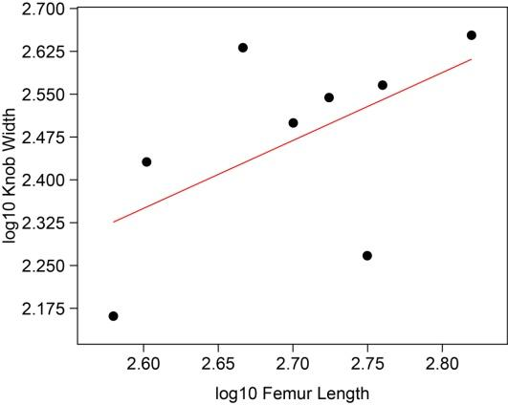
Fig. S24: OLS regression of ankylosaur femur length vs. knob width, log-transformed.

As such, we also tested knob width against distal caudal width, which was possible to measure in more specimens and which we would not predict to have allometric growth. Most tail club knobs are isolated and not associated with diagnostic skeletal material, and our total dataset potentially represents about eleven species spanning two continents and 34 million years. The slope of this regression was 1.13 with a p-value of 0.010. Despite the significant p-value, we consider this result ambiguous given the nature of the available data.

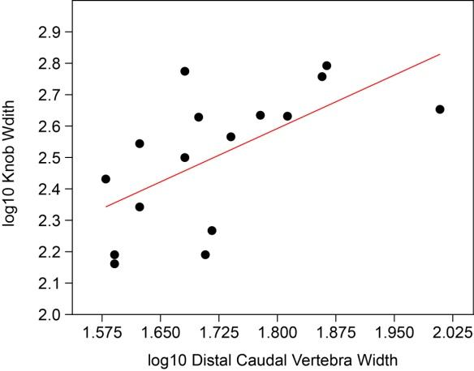
Fig. S25: OLS regression of distal caudal vertebral width vs. knob width, log-transformed.

Hypothesis 2:

We tested ankylosaurid knob widths against apex predator and tyrannosauroid body sizes. Not all ankylosaurids have a tail club (Arbour and Currie 2015): Gobisaurus has a handle but lacks a knob, Liaoningosaurus may have a handle but lacks a knob, and Chuanqilong lacks both a handle and a knob. As such, we ran two analyses, one including these taxa, and one without. In both cases, there was no correlation between ankylosaur distal tail width and theropod body size.

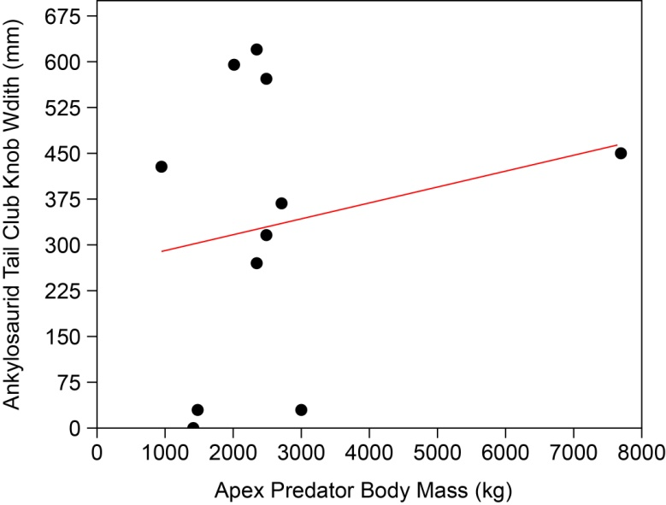
Fig. S26: OLS regression of predator body size vs. tail club knob width, including ankylosaurids without a knob. y=0.02549x+266.95, r²=0.039, p=0.56

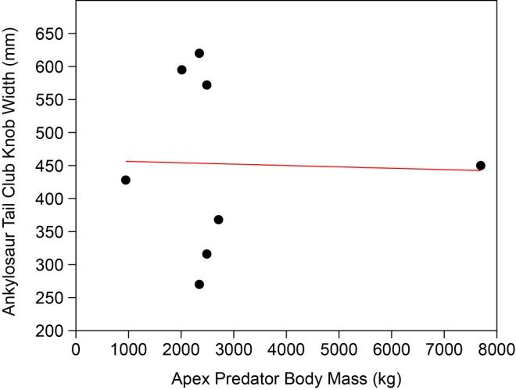
Fig. S27: OLS regression of predator body size vs. tail club knob width, excluding ankylosaurids without a knob. y=-0.0020718x + 458.34, r²=0.0010, p=0.94.

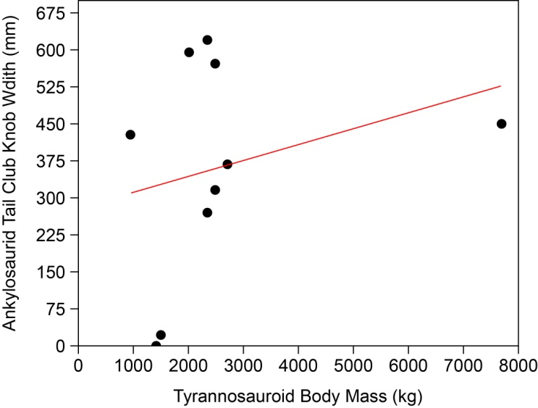

Fig. S28: OLS regression of tyrannosauroid body size vs. tail club knob width, including ankylosaurids without a knob. y=0.029483x+288.32; r² = 0.064, p=0.48

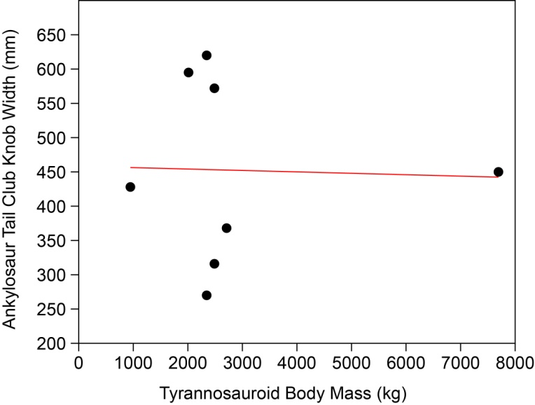
Fig. S29: OLS regression of tyrannosauroid body size vs. tail club knob width, excluding ankylosaurids lacking tail club knobs. y=-0.0020718x + 458.34, r²=0.0010, p=0.94 (same results as for apex predators vs. tail club knob width, excluding taxa with no knob).

Extended Discussion

Predator-Prey Relationships
In both the scientific literature and popular media, ankylosaurid tail clubs are typically interpreted as antipredator defensive weapons that evolved through natural selection. We informally surveyed popular depictions of ankylosaurids from 2015-2020, referencing books and media in our own collections, and soliciting contributions from social media users under the hashtag #AnkylosaurFightClub. Although this survey is not scientifically rigorous, we gleaned over 120 examples of artistic depictions of ankylosaurids wielding their tail clubs at various opponents in a variety of media. Overwhelmingly, ankylosaurids are shown using their tail clubs in defense against predators, primarily tyrannosaurids. Only a few depictions showed ankylosaurids using their tail clubs intraspecifically (we excluded any illustrations created after we began collecting examples, since our survey may have prompted artists to create new illustrations featuring this behaviour).

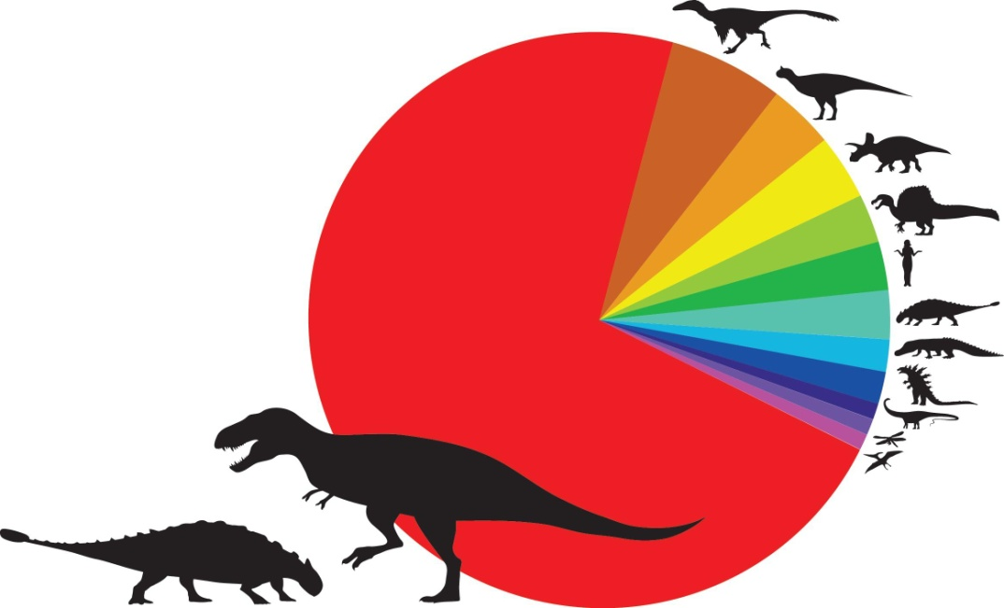
Fig. S30: Occurrences of ankylosaur opponents from an informal survey of popular depictions in various media. Tyrannosaurids n=79, dromaeosaurs n=7, other theropods (excluding Spinosaurus) n=4, other ornithischians n=4, Spinosaurus n=3, primates n=3, ankylosaurs n=3, crocodylomorphs n=2, fictional creatures n=2, sauropods n=1, invertebrates n=1, pterosaurs n=1.

Ankylosaurs coexisted alongside large apex predators for millions of years before tail clubs appear in this clade, and the other lineage of ankylosaurs, the nodosaurids, never evolved tail clubs. For example, the Brushy Basin Member of the Morrison Formation, from which the clubless basal ankylosaur Mymoorapelta is derived, included the large theropods Allosaurus (2500 kg), Saurophaganax (3700 kg), and Torvosaurus (2400 kg; masses from Benson et al. 2014). On the other hand, several ankylosaurids with tail clubs lived in environments with only moderately-sized apex predators; in the Bayanshiree Formation, Talarurus lived alongside Alectrosaurus, which only had a body mass of 630 kg (Benson et al. 2014). However, the fossil record of early ankylosaurids and their corresponding predators is extremely patchy. For example, tail club morphology is unknown for several early Late Cretaceous ankylosaurids, such as Shamosaurus, Crichtonpelta, “Zhejiangosaurus”, and Cedarpelta, and poorly known for Talarurus. Additionally, no theropods have yet been recovered from the Zuunbayan Formation (Shamosaurus), Sunjiawan Formation (Crichtonpelta), Liangtoutang Formation (Jinyunpelta), or Chaochuan formations (“Zhejiangosaurus”). Jinyunpelta is the earliest known ankylosaurid with both a stiff distal tail and a large tail club knob (Zheng et al. 2018), and the absence of taxonomic or body size information for the predator in its ecosystem is a crucial missing data point in this study. Likewise, Cedarpelta occurs in the same formation as the giant allosauroid Siats and the diminutive tyrannosauroid Moros (Zanno and Makovicky 2013, Zanno et al. 2019), but good caudal material for this genus is lacking and it is unclear if it possessed a stiff tail or knob.

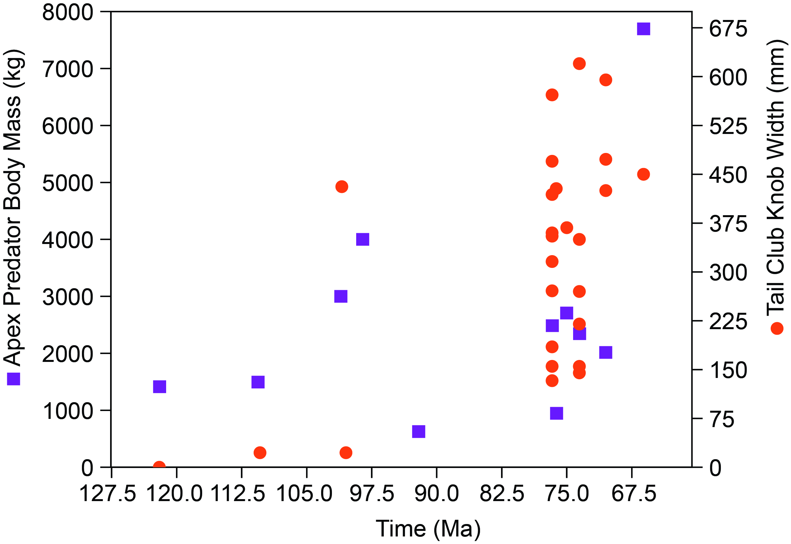
Fig. S31: Predator body mass and ankylosaurid tail club knob width over geological time.

Pathologies in Thyreophoran Dinosaurs
We consider the pathologies of the trunk osteoderms in ROM 75860 to have a traumatic origin, although infection may have played a role in the rate and level of healing of the pathological osteoderms. Ulcerative dermatosis has been identified in other ankylosaurs, but this takes the form of smaller pits that do not erode through the entire osteoderm (Matthias et al. 2016), unlike the large missing portions of osteoderms observed in ROM 75860.
Broken and healed anterior caudal vertebrae, and pathological tail club knobs, have been reported for several ankylosaurid taxa (Carpenter et al. 2011, Arbour and Currie 2011, Park et al. 2021). ROM 75860 also has a markedly asymmetric tail club knob, which could either be a developmental abnormality or a pathology stemming from injury to the knob; asymmetry resulting from differential mechanical loading because of handedness is well documented in humans and has also been observed in cetaceans (Galatius 2006). In extant bovids where both males and females bear horns, horn injuries are more common in males than females; male bovids primarily use their horns in male-male intraspecific combat, whereas female bovids use them for antipredator defense of both themselves and their calves (Packer 1983, Stankowich and Caro 2009). Tail and tail club knob pathologies in ankylosaurids thus also provide support for the hypothesis that tail clubs were actively used in intraspecific combat, but we cannot reject that tail club injuries could also be caused by antipredator defensive combat.
Several exceptional specimens of nodosaurid ankylosaurs preserve large swathes of in situ osteoderms, most notably TMP2011.033.0001 (Borealopelta markmitchelli), AMNH 6556 (Edmontonia rugosidens), and AMNH 3036 (Sauropelta edwardsorum) (Matthew 1922, Brown 2017, Brown et al. 2017). Interestingly, no osteoderm pathologies have been noted in these specimens. These nodosaurid taxa have enlarged, conical osteoderms in the cervical and pectoral regions that are much larger than equivalent osteoderms in the same regions in ankylosaurids, and both antipredator defense and an intraspecific jousting function have been proposed for nodosaurid shoulder spikes (Carpenter 2012). Nodosaurids retain a flexible tail and do not evolve a tail club. Stegosaurs, although more distantly related to ankylosaurids, have large conical spikes at the terminus of a flexible tail, which is also widely considered a weapon. Several pathological tail spikes are known for Stegosaurus (McWhinney et al. 2001), suggesting active use of the tail osteoderms as weapons; as for ankylosaurs, these weapons are typically interpreted as antipredator defenses (e.g. Mallison 2011), but a role in intraspecific combat cannot be rejected and warrants further consideration based on the results of this study.

Table S17: Artistic depictions of ankylosaurid tail club use against various opponents in popular media.

Ankylosaur | Opponent | Title | Author | Illustrator | Publisher | Format | Date
Ankylosaurus | Albertosaurus | Field Guide to Dinosaurs |  |  | Gakken [Korean] | book | unknown
Euoplocephalus | Albertosaurus | Korean version of 学研の図鑑-恐竜 |  |  |  | book | unknown
ankylosaurid | Spinosaurus |  | Steve Parker | Miles Kelly Art Bank |  | book | unknown
Ankylosaurus | Tyrannosaurus | World Book Early World of Learning |  | John Francis |  | online resource | unknown
ankylosaurid | Spinosaurus |  |  |  |  | poster | unknown
ankylosaurid | tyrannosaurid |  |  |  |  | illustration (puzzle) | unknown
Ankylosaurus | Tyrannosaurus | Ankylosaurus hits Tyrannosaurus rex with its clubbed tail in self-defense. |  | Kurt Miller | StockTrek Images | illustration (stock image) | unknown
Anguiris | Godzilla | Godzilla Raids Again, other Godzilla films |  |  |  | film | 1950s-present
Scolosaurus | Gorgosaurus | The Hot Blooded Dinosaurs | Adrian Desmond | Zdenek Burian |  | book | 1975 (original image 1956)
Ankylosaurus | Tyrannosaurus | Dinosaurs the How and Why Wonder Book | Darleine Geis | Kenyon Shannen |  | book | 1960
Scolosaurus | Gorgosaurus | Los animales prehistoricos | Zdenik Burian |  |  | illustration | 1964
ankylosaur monster | humans | Kamen Rider |  |  |  | television | 1970s-1990s
Euoplocephalus | tyrannosaurid | individual art piece |  | Bob Bakker |  | illustration (for exhibit) | 1970
Ankylosaurus | Tyrannosaurus | Album of Dinosaurs | Tom McGowen | Rod Ruth |  | book | 1972
Ankylosaurus | Tyrannosaurus | I Can Read About Dinosaurs | John Howard |  |  | book | 1972
ankylosaurid | humans | Kyōryū Daisensō Aizenbōgu (Dinosaur Great War Aizenborg) |  |  |  | television | 1977-1978
Euoplocephalus | Deinonychus | Ich erforsche die vozeit - dinosaurier | Anne McCord | Bob Hersey |  | book | 1977
Euoplocephalus | Tyrannosaurus | A Natural History of Dinosaurs | Richard Moody | Ann Baum |  | book | 1978
Ankylosaurus | Tyrannosaurus | The Collins Book of Dinosaurs | Tom McGowen | Rod Ruth |  | book | 1978
Tarchia | Chilantaisaurus | poster, Mortal Combat series |  |  |  | illustration (poster) | 1980s
Ankylosaurus | Tyrannosaurus | 64,000,000 Years Ago | Bill Maylone |  | National Film Board (short) | film | 1981
Ankylosaurus | Tyrannosaurus | Dinosaurs | Mary Packard | Christopher Santoro | Julian Messner NY | book | 1981
Talarurus | Sauroplites | The Dinosaurs | William Stout | William Stout |  | book | 1981
Ankylosaurus | Tyrannosaurus | Ankylosaurus | Rupert Oliver | Bernard Long | Rourke Publishing | book | 1984
Ankylosaurus | Tyrannosaurus | Dinosaur Days | Joyce Milton | Richard Roe | Random House | book | 1985
Euoplocephalus | tyrannosaurid | The Illustrated Encyclopedia of Dinosaurs | David Norman | John Sibbick |  | book | 1985
Euoplocephalus | Albertosaurus | TMP mounted skeletons on exhibit |  |  |  | exhibit | 1985
Euoplocephalus | tyrannosaurid | Dinosaurier Tiere der Urzeit | Dougal Dixon | Andrew Robinson and David Johnston |  | book | 1988
Ankylosaurus | Gorgosaurus | Dinosaurs | David Lambert |  | StMichael | book | 1988
Ankylosaurus | humans | Dinosaurs Attack! |  |  |  | trading card series | 1988
Ankylosaurus | Tyrannosaurus | Dinosaurs of the Land, Sea, and Air | Michael Teitlebaum |  |  | book | 1988
Ankylosaurus | Allosaurus | Kinder entdecken…Die welt der Dinosaurier (original series Japanese) |  |  |  | book | 1988
Ankylosaurus | Tyrannosaurus | Kinder entdecken…Die welt der Dinosaurier (original series Japanese) |  |  |  | book | 1988
Ankylosaurus | Tyrannosaurus | The Giant Book of Dinosaurs | Michael Benton | Martin Knowelden |  | book | 1988
Euoplocephalus | tyrannosaurid | The Illustrated Dinosaur Encyclopedia | Dougal Dixon | Andrew Robinson and David Johnston |  | book | 1988
Euoplocephalus | tyrannosaurid | Eyewitness Books Dinosaur | David Norman, Angela Milner |  |  | book | 1989
Euoplocephalus | Daspletosaurus | Prehistoric Zoobooks | R Brampton | John Sibbick |  | book | 1989
Euoplocephalus | tyrannosaurid | Sehen staunen wissen Dinosaurier | David Norman & Angela Milner | unspecified | Dorling Kindersley | book | 1989
Scolosaurus | Gorgosaurus | The Colossal Book of Dinosaurs | David White | Pam Mara |  | book | 1989
Shamosaurus | Deinonychus | The Colossal Book of Dinosaurs | Francis Swan | Pam Mara |  | book | 1989
Euoplocephalus | Gorgosaurus |  |  | Brian Franczak |  | illustration | ~1990s
Euoplocephalus | Tyrannosaurus | poster ("Take That!") |  |  | The Knowledge Company | illustration (poster) | 1990? (1999?)
Ankylosaurus | Tyrannosaurus | Die Welt der Dinosaurier | M.Tölle and B. Zander |  |  | book | 1990
Euoplocephalus | Tyrannosaurus | Dinosaurier und die prahistorische Welt | Dougal Dixon |  |  | book | 1990
Euoplocephalus | tyrannosaurid | 恐竜ファンタジーランド １けもの竜とかみなり竜恐竜ファンタジーランド | possibly 多賀もちゆき／作  金の星社 |  |  | book | 1990
Ankylosaurus | Tyrannosaurus | Ankylosaurus | Janet Riehecky | Diana Magnuson |  | book | 1991
Ankylosaurus | tyrannosaur | Dinosaur Identifier | Steve Parker |  |  | book | 1991
Ankylosaurus | Tyrannosaurus | Dinosaurier | Emilie Beaumont | Lindsey Selley |  | book | 1991
ankylosaurid | Tyrannosaurus | Dinosaurier | David Lambert | Dale A. Evans |  | book | 1991
Euoplocephalus | Tyrannosaurus | Die Welt der Dinosaurier | Dougal Dixon | Tim Hayward |  | book | 1992
Ankylosaurus | humans | Dinotopia | James Gurney | James Gurney |  | book | 1992
Euoplocephalus | Albertosaurus | The Original DINOCARDZ |  | Dave Marrs |  | trading card series | 1992
Euoplocephalus | Tyrannosaurus | Dinosaurier | Tim Gardom with Angela Milner | John Sibbick |  | book | 1993
Ankylosaurus | Tyrannosaurus | Dinosaurs! Magazine issue 1 |  | Neil Lloyd |  | book | 1993
Euoplocephalus | Albertosaurus | Dougal Dixon's Dinosaurs, 1st ed | Dougal Dixon | Dennys Ovenden |  | book | 1993
Euoplocephalus | Albertosaurus | Highlights for Children - Dinosaurs: The Real Monsters | Dougal Dixon | Dougal Dixon |  | book | 1993
Ankylosaurus | Nanotyrannus | REX 恐竜物語 (REX Dinosaur Story) | Tokoro Juzo | Tokoro Juzo |  | book | 1993
Euoplocephalus | tyrannosaurid | The Book of Dinosaurs | Tim Gardom with Angela Milner | Sibbick |  | book | 1993
ankylosaurid | tyrannosaurid | The Natural History Museum Book of Dinosaurs | Tim Gardom |  |  | book | 1993
ankylosaurid | Velociraptor | Build Your Own Dinosaurs | Dennix Schatz | Bob Griesen |  | book | 1994
Euoplocephalus | Albertosaurus | The Audubon Society Pocket Guide to Familiar Dinosaurs | National Audubon Society |  |  | book | 1994
ankylosaurid | dromaeosaur | Age of Reptiles (Tribal Warfare) | Ricardo Delgado | Ricardo Delgado | Dark Horse Comics | book | 1996
Dyoplosaurus | Albertosaurus | The Complete Dinosaur, 1st Edition | James Farlow (ed) | Ken Carpenter |  | book | 1997
Ankylosaurus | Tyrannosaurus | Dinoverse | Scott Ciencin |  |  | book | 1999
Ankylosaurus | Tyrannosaurus | Walking With Dinosaurs: A Natural History | Tim Haines |  |  | book | 1999
Ankylosaurus | Tyrannosaurus | Walking with Dinosaurs (TV series) |  |  |  | television | 1999
Ankylosaurus | Albertosaurus | Dougal Dixon's Amazing Dinosaurs | Dougal Dixon | Steve Kirk |  | book | 2000
Euoplocephalus | Tyrannosaurus | Wielkie poszukiwania dinozaurów/The Great Dinosaur Search [polish] | Rosie Heywood | Studio Galant and Inklink Firenze |  | book | 2000
Ankylosaurus | Tyrannosaurus | Dinosaurier Giganten der Vorzeit | Rachel Frith | Franco Tempesta & John Woodcock |  | book | 2001
Euoplocephalus | Albertosaurus | Albertosaurus: Death of a Predator | Monique Keiran | ?Donna Sloan |  | book | 2002
Ankylosaurus | Tyrannosaurus | Das Reich der Dinosaurier | David West | Norma Burgin |  | book | 2003
Pinacosaurus | tyrannosaurid | Dinosaurus | Steve Parker | Richard Burgess |  | book | 2004
ankylosaurid | Spinosaurus | 1000 Facts About Prehistoric Life | Andrew Campbell | unknown |  | book | 2005
ankylosaurid | tyrannosaurid | Dinosaurs | Dougal Dixon | unknown |  | book | 2005
Ankylosaurus | Tyrannosaurus | I am an Ankylosaurus | Karen Wallace | Karen Wallace |  | book | 2005
Pinacosaurus | Velociraptor | The Truth About Killer Dinosaurs/Dinosaur Face-Off |  |  |  | television | 2005
Pinacosaurus | Tarbosaurus | The Truth About Killer Dinosaurs/Dinosaur Face-Off |  |  |  | television | 2005
Ankylosaurus | Tyrannosaurus | Walking with Dinosaurs - The Arena Spectacular |  |  |  | arena show | 2007-2019
Ankylosaurus | Tyrannosaurus | Ankylosaurus Fights Back | Laura Gates Galvin | Adrian Chesterman |  | book | 2007
Tarchia | Tarbosaurus | Dinosaurs Alive! |  |  | IMAX film | film | 2007
Ankylosaurus | Tyrannosaurus | Dinosaurs: The Most Complete, Up-to-Date Encyclopedia for Dinosaur Lovers of All Ages | Thomas Holtz | Luis Rey |  | book | 2007
Ankylosaurus | lemurs | If Dinosaurs Were Alive Today | Dougal Dixon | Dougal Dixon |  | book | 2007
Euoplocephalus | tyrannosaurid | Illustrated Directory of Dinosaurs and other Prehistoric Life | ed Ingrid Cranfield |  |  | book | 2007
Ankylosaurus | Stegosaurus | Land Before Time TV series |  |  |  | television | 2007
Ankylosaurus | Tyrannosaurus | Usborne Discover - Dinosaurs | Rachel Frith | Franco Tempesta & John Woodcock |  | book | 2008 (2001)
ankylosaurid | crocodilian | Age of Reptiles Omnibus | Richard Delgado | Richard Delgado |  | book | 2008
ankylosaurid | tyrannosaurid | Age of Reptiles Omnibus | Richard Delgado | Richard Delgado |  | book | 2008
ankylosaurid | sauropod | Age of Reptiles Omnibus | Richard Delgado | Richard Delgado |  | book | 2008
ankylosaurid | ceratopsian | Age of Reptiles Omnibus | Richard Delgado | Richard Delgado |  | book | 2008
Ankylosaurus | tyrannosaurid | Dinosaurs and Other Prehistoric Animals | Carl Mehling |  |  | book | 2009
Ankylosaurus | Spinosaurus | Giant Stickers Activity Dinos [Dutch 3rd printing] |  | Miles Kelly Artwork Bank |  | book | 2009
Ankylosaurus | Spinosaurus | Visual Factfinder: Dinosaurs & Prehistoric Life | Andrew Campbell and Steve Parker |  |  | book | 2009
Ankylosaurus | Tyrannosaurus | Clash of the Dinosaurs |  |  |  | television | 2009
Ankylosaurus | tyrannosaurid | Les Dinosaures, vol 1 | Arnaud Plumeri | Bloz |  | book | 2010
Ankylosaurus | crocodilian | National Geographic Kids Ultimate Dino-Pedia | Don Lessem | Franco Tempesta |  | book | 2010
Ankylosaurus | Tyrannosaurus | Last Day of the Dinosaurs |  |  |  | television | 2010
Euoplocephalus | Triceratops | One2Play Dinowaurs tabletop game ad |  |  |  | YouTube ad | ~2011
Ankylosaurus | Tyrannosaurus | Ankylosaur Attack | Daniel Loxton | Daniel Loxton, Jim Smith |  | book | 2011
Euoplocephalus | Tyrannosaurus | First Encyclopedia of Dinosaurs and Prehistoric Life | Sam Taplin | Usborne |  | book | 2011
Ankylosaurus | dromaeosaurid | First Encyclopedia of Dinosaurs and Prehistoric Life | Sam Taplin | Usborne |  | book | 2011
Ankylosaurus | Tyrannosaurus | Dinosaur Revolution |  |  |  | television | 2011
Ankylosaurus | Acrocanthosaurus | Ankylosaurus vs. Acrocanthosaurus |  | Walter Colvin |  | illustration | ~2012
Euoplocephalus | tyannosaurid | The Complete Dinosaur, 2nd Edition | eds Michael Brett-Surman and Thomas Holtz | Ken Carpenter |  | book | 2012
Tarchia | Saurolophus | "Tarchia Vs Saurolophus" |  | atrox (Sergey Krasovskiy) |  | illustration (deviantart) | 2013
Ankylosaurus | tyrannosaurid | Can you tell a Stegosaurus from an Ankylosaurus | Buffy Silverman |  |  | book | 2013
Tarchia | Tarbosaurus | KID Symposium mounted skeletons |  |  |  | exhibit | 2013
Euoplocephalus | Daspletosaurus | Daspletosaurus vs. Euoplocephalus |  | Mohamad Haghani |  | illustration | 2013
Euoplocephalus | Tyrannosaurus | Knowledge Encyclopedia Dinosaur! | John Woodward | unspecified |  | book | 2014
Euoplocephalus | Albertosaurus | The Paleoart of Julius Csotonyi | Julius Csotonyi | Julius Csotonyi |  | book | 2014
ankylosaurid | tyrannosaurid | Downer Dinos |  |  |  | illustration (Facebook sticker) | ~2015
Euoplocephalus | dragonfly | Dino Block | Christopher Franceschelli | Peskimo |  | book | 2015
Ankylosaurus | dromaeosaur | Jurassic Farts: A Spotter's Guide | Ben Grossblatt | Evan Palmer | Chronicle Books | book | 2015
Ankylosaurus | Indominus rex | Jurassic World |  |  |  | film | 2015
ankylosaurid | Tyrannosaurus | Dinosaurs: The Grand Tour | Keiron Pim |  |  | book | 2016
Ankylosaurus | Tyrannosaurus | tattoo |  |  |  | tattoo on Dean Kalcoff, via Instagram | 2016
Ankylosaurus | Carnotaurus | The Really Big Awesome Book of Dinosaurs | Johannah Gilman Paiva |  |  | book | 2016
Euoplocephalus | Euoplocephalus | The Really Big Awesome Book of Dinosaurs | Johannah Gilman Paiva |  |  | book | 2016
ankylosaurid | ankylosaurid | Dinosaur Lands: My First Search and Find Book | Neiko Ng | Neiko Ng |  | book | 2017
ankylosaurid | oviraptorosaur | Land of Many Monsters and Many More Monster Tails | Denis St John | Denis St John | WK Books | book | 2017
ankylosaurid | pterosaur | Land of Many Monsters and Many More Monster Tails | Denis St John | Denis St John | WK Books | book | 2017
Ankylosaurus | Tyrannosaurus | Ultimate Spotlight Dinosaurs | Sandra Laboucarie | Deborah Pinto | Twirl | book | 2018
ankylosaurid | dromaeosaurid | mural at the Royal Alberta Museum |  |  |  | exhibit | pre-2016

Literature Cited

Arbour VM. 2009. Estimating impact forces of tail club strikes by ankylosaurid dinosaurs. PLOS ONE 4:e6738.
Arbour VM, Currie PJ. 2011. Tail and pelvis pathologies of ankylosaurian dinosaurs. Historical Biology 23: 375–390.
Arbour VM, Currie PJ. 2013. Euoplocephalus tutus and the diversity of ankylosaurid dinosaurs in the Late Cretaceous of Alberta, Canada, and Montana, USA. PLOS ONE 8: e62421.
Arbour VM, Currie PJ. 2015. Ankylosaurid dinosaur tail clubs evolved through stepwise acquisition of key features. Journal of Anatomy 227:514-523
Arbour VM, Evans DC. 2017. A new ankylosaurine dinosaur from the Judith River Formation of Montana, USA, based on an exceptional skeleton with soft tissue preservation. Royal Society Open Science 4:161086.
Benson RBJ, Campione NE, Carrano MT, Mannion PD, Sullivan C, Upchurch P, Evans DC. 2014. Rates of dinosaur body mass evolution indicate 170 million years of sustained ecological innovation on the avian stem lineage. PLOS Biology 12:e1001853.
Brown CM. 2017. An exceptionally preserved armored dinosaur reveals the morphology and allometry of osteoderms and their horny epidermal coverings. PeerJ 5:e4066.
Brown CM, Henderson DM, Vinther J, Fletcher I, Sistiaga A, Herrera J, Summons RE. 2017. An exceptionally preserved three-dimensional armored dinosaur reveals insights into coloration and Cretaceous predator-prey dynamics. Current Biology 27: 2514-2521.
Carpenter K, Hayashi S, Kobayashi Y, Maryańska T, Barsbold R, Sato K, Obata I. 2011. Saichania chulsanensis (Ornithischia, Ankylosauridae) from the Upper Cretaceous of Mongolia. Palaeontographica Abteilung A 293:1-61.
Carpenter K. 2012. Ankylosaurs. In: Brett-Surman MK, Holtz TR, Farlow JO (eds) The Complete Dinosaur, 2nd Edition. Indiana University Press.
Drews C. 1996. Contexts and patterns of injuries in free-ranging male baboons (Papio cynocephalus). Behaviour. 133: 443-74.
Eberhard WG, Rodríguez RL, Huber BA, Speck B, Miller H, Buzatto BA, Machado G. 2018. Sexual selection and static allometry: the importance of function. The Quarterly Review of Biology 93:207-50.
Emlen DJ. 2008. The evolution of animal weapons. Annual Review of Ecology, Evolution, and Systematics 39: 387-413.
Fryxell JM. 1987. Lek breeding and territorial aggression in white-eared kob. Ethology 75:211-220.
Geist V. 1998. Deer of the world: their evolution, behaviour, and ecology. Stackpole books.
Galatius A. 2006. Bilateral directional asymmetry of the appendicular skeleton of the White-Beaked Dolphin (Lagenorhynchus albirostris). Aquatic Mammals 32: 232-235.
Hammer, Øyvind, Harper, David A.T., and Paul D. Ryan, 2001. Past: Paleontological Statistics Software Package for Education and Data Analysis. Palaeontologia Electronica, vol. 4, issue 1, art. 4: 9pp.
Kodric-Brown A, Sibly RM, Brown JH. 2006. The allometry of ornaments and weapons. PNAS 103:8733-8738.
Matthew W. 1922. A super dreadnought of the animal world. Natural History 22: 333-342.
Mallison H. 2011. Defense capabilities of Kentrosaurus aethiopicus Hennig, 1915. Palaeontologia Electronica 14:1-25.
Matthias AE, McWhinney LA, Carpenter K. 2016. Pathological pitting in ankylosaur (Dinosauria) osteoderms. International Journal of Paleopathology 13: 82-90.
McWhinney LA, Rothschild BM, Carpenter K. 2001. Osteomyelitis in Stegosaurus dermal spikes. In: Carpenter K (ed), The Armored Dinosaurs. Indiana University Press, p. 141-156.
Packer C. 1983. Sexual dimorphism: the horns of African antelopes. Science 221:1191-1193.
Park J-Y, Lee Y-N, Kobayashi Y, Jacobs LL, Barsbold R, Lee H-J, Kim N, Song K-Y, Polcyn MJ. 2021. A new ankylosaurid from the Upper Cretaceous Nemegt Formation of Mongolia and implications for paleoecology of armoured dinosaurs. Scientific Reports 11: 22928.
Pratt DM, Anderson VH. 1985. Giraffe social behavior. Journal of Natural History 19:771-781.
Stankowich T, Caro T. 2009. Evolution of weaponry in female bovids. Proc. R. Soc. B. 276: 4329–4334.
Zanno L, Makovicky P. 2013. Neovenatorid theropods are apex predators in the Late Cretaceous of North America. Nature Communications 4:2827.
Zanno L, Tucker RT, Canoville A, Avrahami HM, Gates TA, Makovicky PJ. 2019. Diminutive fleet-footed tyrannosauroid narrows the 70-million-year gap in the North American fossil record. Communications Biology 2:64.
Zheng W, Jin X, Azuma Y, Wang Q, Miyata K, Xu X. 2018. The most basal ankylosaurine dinosaur from the Albian-Cenomanian of China, with implications for the evolution of the tail club. Scientific Reports 8:3711.

