A triple threat: high population density, high foraging intensity and flexible habitat preferences explain high impact of feral cats on prey.
ROWENA P HAMER, RIANA Z GARDINER, KIRSTIN M. PROFT, CHRISTOPHER N JOHNSON AND MENNA E JONES
Proceedings of the Royal Society B: Biological Sciences
DOI 10.1098/rspb.2020.1194

Appendix S1

Trapping results
Table S1.1 Trap results
Site | Woodland proportion* | Native proportion** | Trapping dates | Cats*** |  |  |  | ST Quolls***
 |  |  |  | M | F | ρ | M |  | F | ρ
Campbell Town | 0.35 | 0.52 | Sep 2015 – June 2016 | 14 | 8 | 0.3 ± 0.1 | 8 |  | 4 | 0.2 ± 0.1
Cressy | 0.30 | 0.39 | July – Dec 2016 | 8 | 8 | 1.0 ± 0.3 | 6 |  | 7 | 0.7 ± 0.2
Oatlands | 0.20 | 0.20 | Jan – June 2017 | 5 | 7 | 0.7 ± 0.2 | 9 |  | 2 | 0.2 ± 0.1
Ross | 0.10 | 0.21 | July – Nov 2016 | 5 | 2 | - | 0 |  | 0 | -
Total |  |  |  | 32 | 25 |  | 23 |  | 13
* Within 5km radius circle, positioned on the centroid of trap locations at each site
** As above, but includes native grassland as well as woodland
*** M – number of males trapped, F – number of females trapped, ρ – estimated population density (animals km⁻², from [1])

Tracking results
Data from GPS collars were filtered to remove initial flight behaviours (movements to and including first refuge point after (daytime) release), periods spent within traps, and points with low accuracy (fixes with horizontal dilution of precision >5, implied movement speed >2ms²). Home-range estimates are reproduced from Hamer, Andersen [1], and are calculated using movement-based kernel density estimation [2, analysis performed using adehabitatHR package in R and parameters Tmax = 1h, Lmin = 20m, hmin = 50m]. Animals which failed site fidelity or asymptote tests are also identified (see Hamer, Andersen [1] for details).
Data from one cat and one quoll were discarded completely due to collar malfunctions resulting in poor fix-rates or unreliable data. Four cats collared at the Oatlands tracking site were effectively restricted to the municipal tip which bordered the property. These cats exhibited much smaller home ranges and nightly movements than other cats, including free-ranging individuals which also visited the tip site but were not resident. These individuals were also excluded from all analyses.
Two feral cat and two quoll collars malfunctioned and recorded data for less than two weeks, or data failed the site fidelity tests due to range shifts during the tracking period. These data were used in analyses of movement states, habitat preferences and daily activities, but not in revisitation analyses which are based on home-range estimations (Tables S1.2, S1.3).
Table S1.2 Telemetry datasets used in analyses
Analysis | Dataset | Notes
- Behavioural classification of movement paths  - Habitat domain  - Diel activity | 25 cats from 4 sites  - 16 males  - 3 breeding females  - 6 non-breeding females  10 quolls from 3 sites  - 5 males  - 2 breeding females  - 3 females | Dataset excludes cats from Oatlands municipal tip, as well as one cat and one quoll due to collar malfunctions.
- Revisitation frequency | 23 cats from 4 sites  - 14 males  - 3 breeding females  - 6 non-breeding females  8 quolls from 3 sites  - 4 males  - 2 breeding females  - 2 females | Data from breeding females (3 cats, 2 quolls) used to calculate revisitation rates as shown in Figure S1.1, but not included in averaged value used to calculate encounter rates.

Table S1.3a) Tracked feral cats at each site, with home range estimates and average revisitation frequency.
mKDE estimates are given in italics for animals which failed the site fidelity or asymptote tests. Note revisitation frequency not calculated for cats which failed site fidelity tests.
Fix Rate | ID | Sex | Weight (kg) | Days of data | Asym | mKDE95  (ha) | Average revisitation (visits month⁻¹ cell⁻¹) | Site | Comments
5 m | Agusto | Male |  | 32 | n | 828 | - | C’ Town | Range shift, revisits not calculated
5 m | Barnaby | Male | 3.9 | 39 | y | 297 | 9 | C’ Town
15 m | Bronwyn | Female (lactating) | 4.5 | 28 | y | 336 | 9 | C’ Town
15 m | Donald | Male | 3.5 | 21 | y | 479 | 7 | C’ Town
15 m | Eric | Male | 3.5 | 36 | y | 413 | 6 | C’ Town
15 m | Jackie | Female | 2.4 | 0 | - | - | - | C’ Town | Collar malfunction, no data
15 m | Joe | Male | 4.9 | 32 | y | 749 | 4 | C’ Town
15 m | Mamo | Male | 2.9 | 32 | y | 452 | 6 | C’ Town
15 m | Miranda | Female | 3.9 | 0 | - | - | - | C’ Town | Cat died, no data
15 m | Pauline | Female (lactating) | 4.0 | 28 | y | 96 | 15 | C’ Town
15 m | Silvio | Male | 4.2 | 0 | - | - | - | C’ Town | Collar not retrieved
15 m | Tony | Male | 4.3 | 28 | y | 653 | 7 | C’ Town
5 m | Attilla | Male | 5.0 | 16 | y | 368 | 7 | Cressy
5 m | Bellatrix | Female | 2.1 | 18 | y | 56 | 14 | Cressy
5 m | Cruella | Female | 3.2 | 20 | y | 179 | 8 | Cressy
5 m | Jabba | Male | 5.1 | 18 | y | 468 | 6 | Cressy
5 m | Joker | Male | 4.5 | 30 | y | 510 | 6 | Cressy
5 m | Petunia | Female | 2.7 | 17 | y | 186 | 10 | Cressy
5 m | Rumpelstiltskin | Male | 4.5 | 45 | y | 732 | 5 | Cressy
5 m | Umbridge | Female | 3.5 | 20 | y | 150 | 9 | Cressy
5 m | Frankenstein | Female | 2.5 |  | - | - | - | Oatlands | Collar not retrieved
5 m | Godzilla | Male | 5.4 | 39 | y | 826 | 5 | Oatlands
5 m | Goliath | Male | 4.5 | 33 | y | 274 | 8 | Oatlands
5 m | Gomez | Male | 3.3 | 32 | y | 7 | - | Oatlands | Tip cat, excluded
5 m | Gorgon | Female | 2.0 | 35 | y | 9 | - | Oatlands | Tip cat, excluded
5 m | Gremlin | Male | 3.1 | 59 | y | 212 | 6 | Oatlands
5 m | Grinch | Male | 3.9 |  | - | - | - | Oatlands | Collar not retrieved
5 m | Medusa | Female | 3.2 | 8 | y | 10 | - | Oatlands | Tip cat, excluded
5 m | Mordred | Female | 3.0 | 41 | y | 234 | 8 | Oatlands
5 m | Morticia | Female | 4.1 | 57 | y | 14 | - | Oatlands | Tip cat, excluded
5 m | Pontiak | Female | 2.7 | 20 | y | 348 | 5 | Oatlands
5 m | Ursula | Female (lactating) | 3.8 | 42 | y | 37 | 17 | Oatlands
5 m | ChairmanMiao | Male | 4.7 | 20 | y | 154 | 9 | Ross
5 m | Kim | Male | 5.7 |  | - | - | - | Ross | Collar malfunction, no data
5 m | MadameMiao | Female (lactating) | 3.6 | 6 | n | 105 | - | Ross | Collar malfunction, data not used
5 m | Rasputin | Male | 5.3 | 11 | n | 174 | - | Ross | <2 weeks data, revisits not calculated
Table S1.3b) Tracked spotted-tailed quolls at each site, with home range estimates and average revisitation frequency.
mKDE estimates are given in italics for animals which failed site fidelity or asymptote tests. Note revisitation frequency not calculated for quolls tracked for less than 2 weeks.
Fix Rate | ID | Sex | Weight (kg) | Days of data | Asym | mKDE95  (ha) | Average revisitation (visits month⁻¹ cell⁻¹) | Site | Comments
5 m | Banzai | Female | 2.7 | 28 | y | 945 | 2 | C’ Town
5 m | Georgia | Female | 2.4 | 44 | y | 946 | 2 | C’ Town
5 m | Mufasa | Male | 2.6 | 5 | n | 820 | - | C’ Town | Collar malfunction, revisits not calculated
5 m | Pacha | Male | 2.6 | 15 | y | 885 | 4 | C’ Town
5 m | Sebastian | Male | 4.0 | - | - | - | - | C’ Town | Collar not retrieved
5 m | Xavier | Male | 3.8 | 14 | y | 799 | 3 | C’ Town
5 m | Betel | Female (lactating) | 2.5 | 38 | y | 461 | 5 | Cressy
5 m | Cashew | Female (lactating) | 2.0 | - | - | - | - | Cressy | Collar malfunction, no data
5 m | Hazelnut | Female (lactating) | 3.2 | 29 | y | 394 | 5 | Cressy
5 m | Nutmeg | Female | 3.9 | 11 | y | 418 | 6 | Cressy | <2 weeks data, revisits not calculated
5 m | Waldo | Male | 4.5 | 49 | y | 707 | 2 | Cressy
5 m | Aravis | Female | 2.0 | 36 | n | 224 | - | Oatlands | Collar malfunction, data not used
5 m | Caspian | Male | 2.4 | 18 | y | 644 | 4 | Oatlands
5 m | Drinian | Male | 4.5 | - | - | - | - | Oatlands | Collar malfunction, no data

Behavioural analysis of movement paths

Methods
For each animal, we classified steps between successive relocations into movement states based on differences in speed and tortuosity using Hidden Markov Models (HMMs). HMM analyses assume that movement path characteristics are determined by underlying behavioural states, allowing classification of steps into approximations of these states [3]. We aimed to distinguish three behavioural states: resting/denning (stationary state); foraging (assumed to comprise short, tortuous movements interspersed with brief periods of stationary behaviour); and travelling (faster, more direct movements).
Models were fitted separately for each species to allow for behavioural differences. Cats tracked with 15-minute fix schedules were also modelled separately and without interpolation, to avoid introducing artificial movement behaviours. Forty iterations with random starting values were run for each model to determine optimal parameter estimates. Models were fitted using the moveHMM package [4] in the R statistical environment. AIC values were used to compare two-state and three-state model fits.
We then repeated the calculations of encounter probability (as discussed in the main body of the manuscript) separately for each movement state.

Results
Daytime VHF tracking found that quolls were almost always in secure den sites (burrows, log/tree hollows, large woodpiles) leading to very few successful daytime fixes (Figure 3). This distinctive pattern in the data allowed models to separate quoll movement into three states: an essentially stationary resting state with some small movements consistent with GPS error (state 1); a foraging state characterised by short, relatively tortuous movements (state 2); and a fast-travelling state of long, direct movements (state 3).
Cats, however, generally rested under dense vegetation, were semi-alert and would move away on approach. Two-state models characterised cat movements into: a state in which GPS error associated with resting could not be distinguished from short, tortuous foraging movements (state 1); and a faster and more direct travelling movement state (state 3). Three-state models of cat movements were highly unstable and often failed to converge.
Both cats and quolls spent the majority of their time in state 1, averaging 18 hours day⁻¹ for cats and 16 hours day⁻¹ for quolls (Table S1.4). Movement state did not appreciably alter revisitation rate (Figure S1.1). Habitat preferences for both species were stronger during resting and foraging states than when travelling (Figure S1.2) but did not alter the direction of preferences. Movement rate therefore had minimal impact on the relative encounter rate of the species and did not appreciably alter the overall conclusions of the study (see next sections for details).
Table S1.4 HMM movement states, describing the characteristics (step length and turning angle) or each state; average burst duration; and average time spent in each state over a 24h period. Telemetry data are divided into ‘bursts’ in which the animal was consistently in the same movement state.
 | State | Description | Step length (m, ± sd) | Turning angle (radians ± concentration) | Average burst duration  (h, ± se) | Average time in state per 24h  (h, ± se)
Spotted-tailed quoll | 1 | ‘resting’ | 22 ± 16 | 3.11 ± 0.76 | 9.9 ± 0.7 | 16.4 ± 0.8
 | 2 | ‘foraging’ | 66 ± 46 | -0.18 ± 0.06 | 1.9 ± 0.3 | 3.6 ± 0.5
 | 3 | ‘travelling’ | 142 ± 77 | 0.00 ± 1.98 | 1.2 ± 0.1 | 2.7 ± 0.4
Feral cat | 1 (5m) | ‘resting/ foraging’ | 23 ± 18 | 3.13 ± 0.66 | 5.5 ± 0.4 | 18.4 ± 0.4
 | 1 (15m) |  | 17 ± 15 | -3.07 ± 0.53
 | 3 (5m) | ‘foraging/ travelling’ | 98 ± 58 | 0.00 ± 1.10 | 1.4 ± 0.1 | 5.0 ± 0.4
 | 3 (15m) |  | 187 ± 139 | -0.01 ± 1.19

Revisitation rates
Species, sex and breeding state all influenced revisitation frequency. On average, feral cats had higher revisitation rates than spotted-tailed quolls, and breeding females had higher revisitation rates for both species due to visits to dependent young (Figure S1.1). Female cats had higher revisitation rates than males: this was also true for spotted-tailed quolls but the difference is very small, so there was weak support for an interactive model (interaction model had lowest AIC value, but was lower-ranked than additive model due to larger number of parameters (Table S1.4a)).
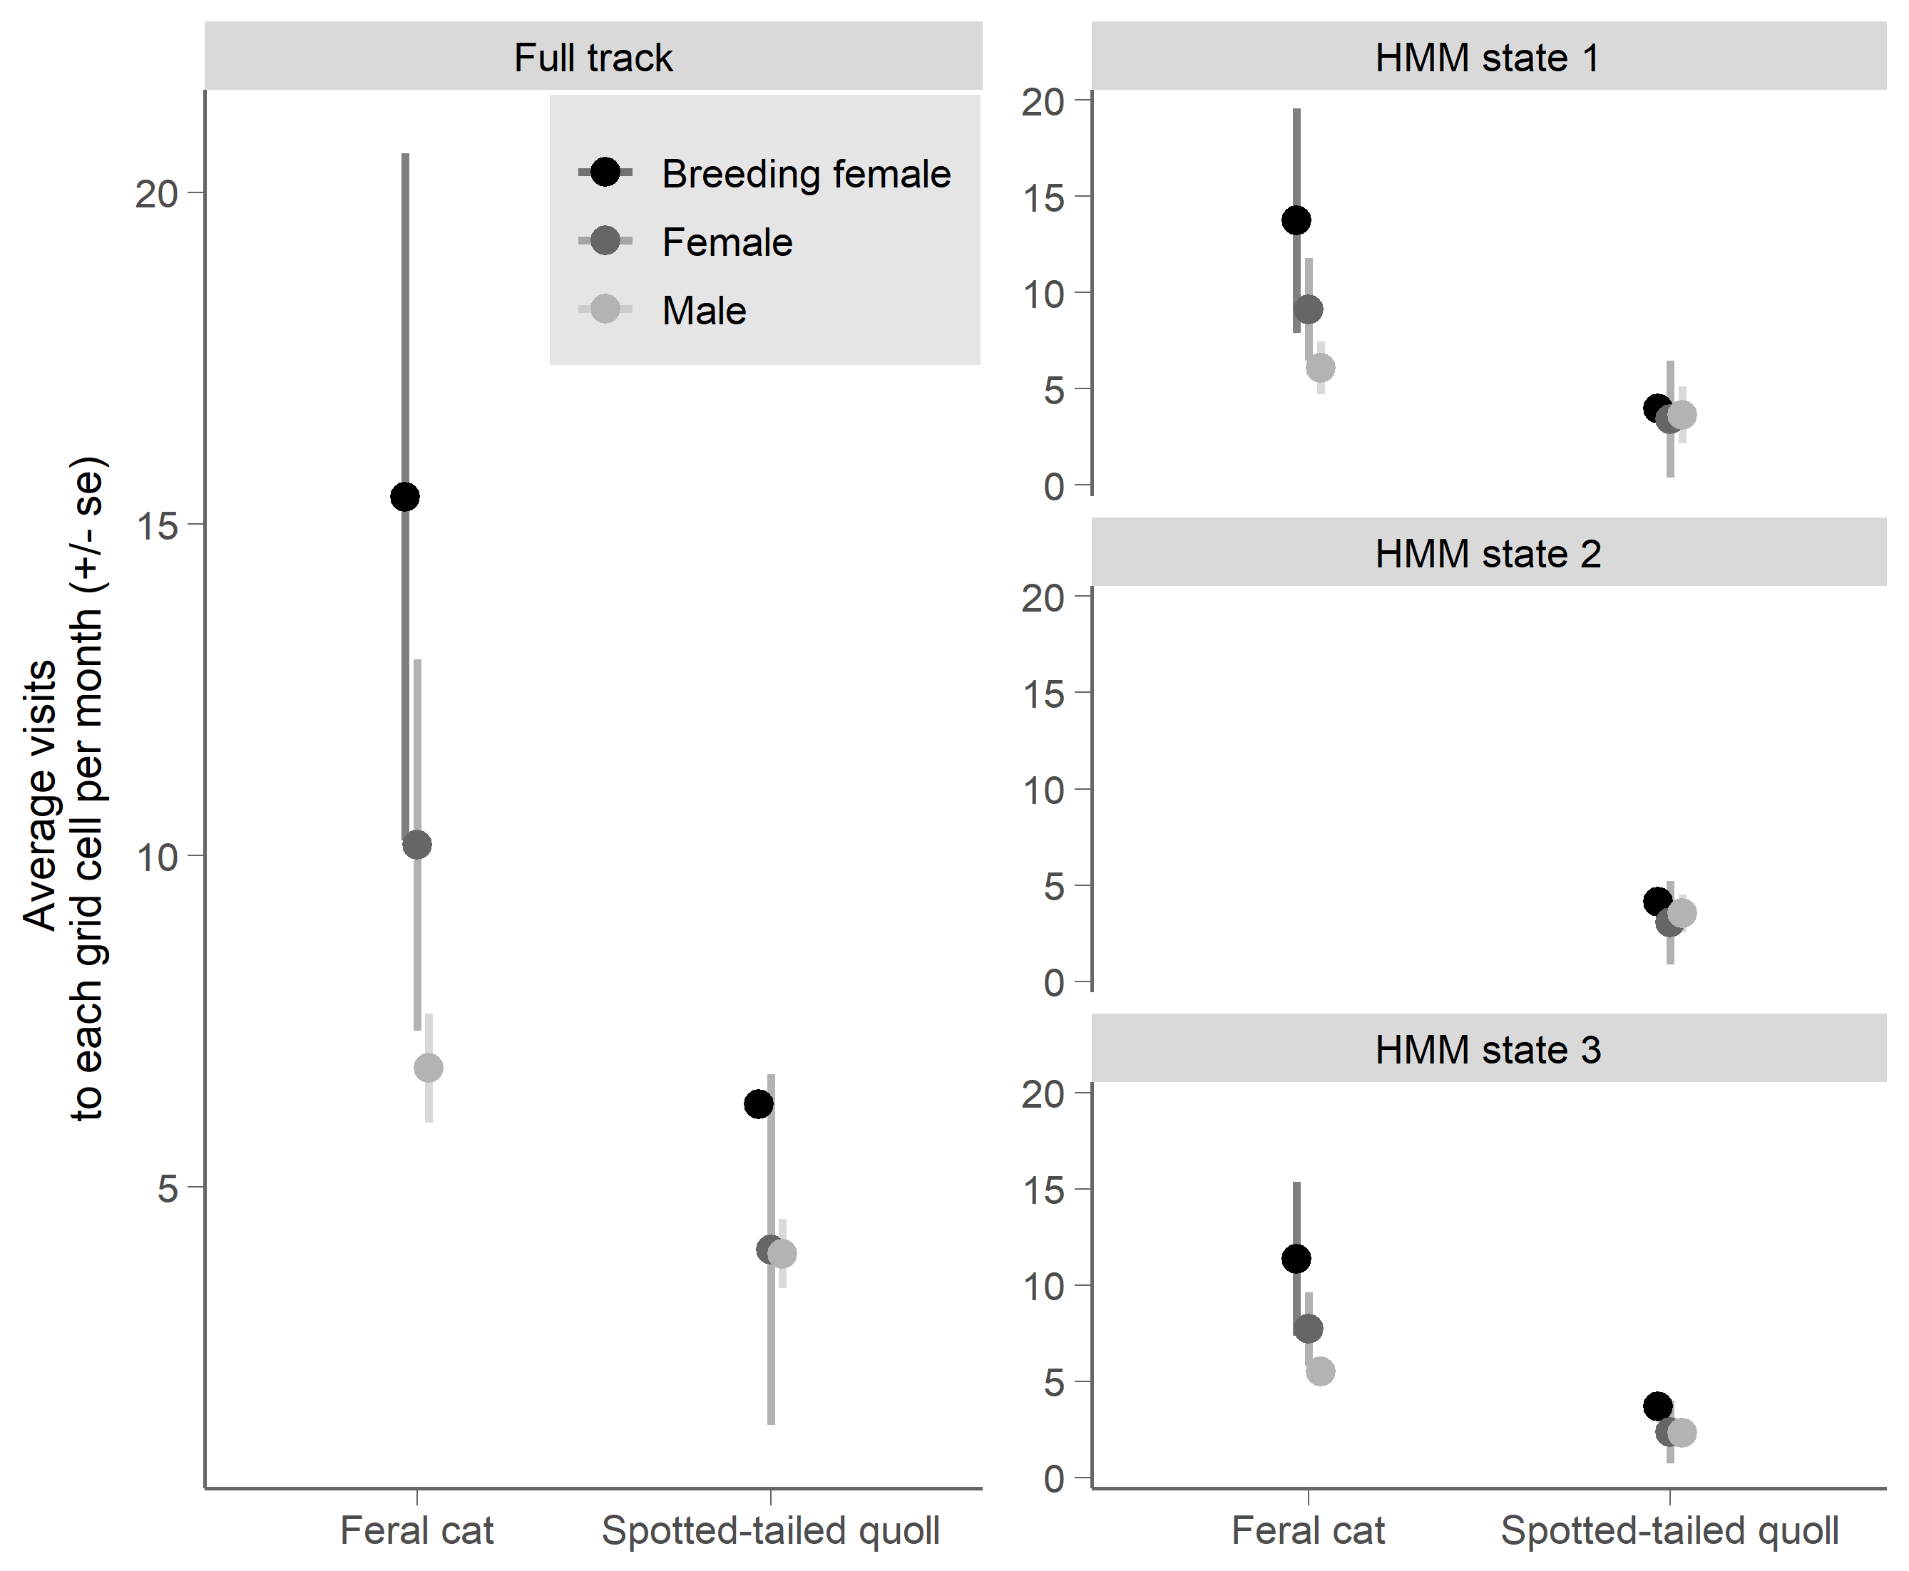
Figure S1.1 Average rates of revisitation for both species.
Visits were separated by at least 2h of activity more than 200 m from the cell, and revisitation frequency was standardised to visits per month. The left panel shows results for the full movement path of each animal, while the right panels show results for each movement state. Grid cells used in all analyses measure 30 x 30m and are snapped to the LandSAT™ raster dataset.

Movement state did not appreciably influence revisitation rate. Revisitation rates were slightly lower in state 3 (travelling) than the other two states (Figure S1.1), but the difference was non-significant and movement state was not included in the top model (Table S1.4b). Although ecologically we would expect higher revisitation rates to denning or foraging sites, animals must travel to these sites so travelling revisitations are also recorded for most areas. In addition, animals with fragmented distributions were observed to frequently use the same habitat ‘pinch-points’ (areas of cover linking habitat areas) while travelling through their home range.
Table S1.5 AIC tables for revisitation model sets, with a) full movement paths for each individual, or b) movement paths divided by HMM movement state. Top model for each set in bold (model with least parameters with dAIC <2).
Model set | K | AICc | dAICc | AICwt | LogLik
- Full movement path
log(visit) ~ species * sexb | 7 | 3.37 | 0.00 | 0.71 | 7.75
log(visit) ~ species + sexb | 5 | 5.14 | 1.77 | 1.00 | 3.63
log(visit) ~ species | 3 | 21.01 | 17.64 | 1.00 | -7.06
log(visit) ~ sexb | 4 | 36.31 | 32.94 | 1.00 | -13.38
log(visit) ~ 1 | 2 | 37.23 | 33.86 | 1.00 | -16.40
- Path divided by movement state
log(visit) ~ species * sexb | 7 | 18.06 | 0.00 | 0.51 | -1.13
log(visit) ~ species * sexb + state | 9 | 18.22 | 0.15 | 0.99 | 1.39
log(visit) ~ species + sexb | 5 | 27.22 | 9.15 | 1.00 | -8.14
log(visit) ~ species + sexb + state | 7 | 27.99 | 9.92 | 1.00 | -6.09
log(visit) ~ species + sexb * state | 11 | 32.86 | 14.80 | 1.00 | -3.15
log(visit) ~ species * sexb * state | 16 | 37.41 | 19.35 | 1.00 | 2.43
log(visit) ~ species | 3 | 48.66 | 30.60 | 1.00 | -21.15
log(visit) ~ species + state | 5 | 50.43 | 32.37 | 1.00 | -19.75
log(visit) ~ species * state | 6 | 52.57 | 34.50 | 1.00 | -19.62
log(visit) ~ sexb + state | 6 | 99.02 | 80.95 | 1.00 | -42.84
log(visit) ~ state | 4 | 100.48 | 82.42 | 1.00 | -45.93
log(visit) ~ sexb | 4 | 103.23 | 85.17 | 1.00 | -47.31
log(visit) ~ 1 | 2 | 103.40 | 85.33 | 1.00 | -49.61
log(visit) ~ sexb * state | 10 | 107.82 | 89.76 | 1.00 | -42.04

Habitat domain
An animal’s habitat domain is typically defined by spatial aspects of its behaviour, and comprises the subset of available habitats that are used by the animal [e.g. 5, 6]. The overlap in habitat domain between predator and prey therefore influences their encounter rate by determining where each species is likely to be present within the landscape. For example, species with strong preferences for woodland are more likely to encounter each other than if one species actively avoids woodland habitats.

Habitat categories
Landscapes within the tracking sites were divided into fourteen habitat categories. Data for these categories are derived from three datasets:
- Native vegetation communities (TASVEG 3.0, produced by the Tasmanian Department for Primary Industries, Parks, Water and the Environment [7]). Polygon boundaries were adjusted using field data and aerial imagery to reflect the extent of vegetation communities at the time of tracking. From this shapefile, we derived:
  - a categorical habitat raster, with 6 categories based on broad vegetation groups (native grassland, pasture and agricultural land, native woodland and forests, urban, plantations and wetlands; and
  - A raster of distance to vegetation edge, where edges are defined as the border between woodland/forest (i.e. closed communities) and open communities (grasslands and pasture).
- Topographic data for Tasmania [8], specifically transport and watercourse shapefiles which were edited as above and used to derive:
  - A raster of distance to water; and
  - A raster of distance to track (includes all vehicle and railway tracks)
- Australian woody vegetation cover raster [9]. This dataset estimates the projected foliage cover of woody vegetation, based on persistent green cover in LANDSAT data between 2000 - 2010. Within the open canopy woodland communities that characterise the Tasmanian Midlands, this data provides a useful, broad-scale index of understorey complexity (unpubl. data).

All raster datasets generated from the native vegetation and topography shapefiles were snapped to the same extent and resolution (30 x 30m grid cells) as the woody vegetation cover raster, which in turn is based on LANDSAT data.
The fourteen categories are described in Table S1.5, below. Categories were defined to try to capture observed variation in habitat complexity across the tracking landscapes, as well as representing features of known importance to these predators (e.g. linear habitat features such as tracks, creeklines and vegetation edges are often preferred foraging habitat for carnivores [e.g. 10, 11], including both cats and spotted-tailed quolls [12, 13]).
To determine appropriate cutoff values of projected foliage cover to delineate between open woodland, woodland and dense woodland habitats, we compared the mapped foliage cover values with georeferenced field data on understorey and midstorey vegetation cover within the region (unpubl. data), as well as georeferenced photopoints throughout the tracking studies. The distance cutoff at which habitats are classed as ‘edges’ is based on the underlying data resolution (30m).
Note that for each animal, selection ratios were not calculated for any habitat types with very little availability (cutoff value set at < 50 raster cells or ~ 0.45 ha: these were mostly urban or plantation habitats).
Table S1.5 Habitat categories used in calculations of selection ratios.
Category | Description
dense woodland | woodland or forest vegetation communities, foliage cover >0.5
woodland | woodland or forest vegetation communities, foliage cover 0.35 - 0.5
open woodland | woodland or forest vegetation communities, foliage cover < 0.35
woodland edge (dense) | within 30m of woodland- pasture/grassland ecotone, foliage cover > 0.5
woodland edge (open) | within 30m of woodland- pasture/grassland ecotone, foliage cover > 0.5
creekline (woodland) | within 30m of watercourse, foliage cover > 0.35
road (woodland) | within 30m of track, foliage cover > 0.35
creekline (open) | within 30m of watercourse, foliage cover < 0.35
road (open) | within 30m of track, foliage cover < 0.35
native grassland | native grassland vegetation community
pasture | pasture and agricultural land
urban | urban areas (mostly rural towns bordering the study areas)
plantation | includes both eucalypt and pine plantation areas.
wetland | bodies of open water

Results
Both spotted-tailed quolls and feral cats avoided open pasture (average selection ratio 0.1 ± 0.07 and 0.4 ± 0.05 for spotted-tailed quolls and feral cats, respectively), while wetlands and plantation habitats were rarely encountered but generally avoided (Figure S1.2). Feral cats preferred woodland-edge habitats, but generally showed large variation amongst individuals with the result that habitat selection at the population level was weak. Spotted-tailed quolls used all woodland habitats, including edges, at least in accordance with their availability, and showed stronger preferences with increasing vegetation density (Figure S1.2). They avoided urban and open areas of all types. Note that variation is higher in spotted-tailed quolls given the lower number of samples (10 vs 25 GPS collars).
For both species, habitat preference/avoidance was stronger in resting and foraging movement states than when travelling (Figure S1.2).
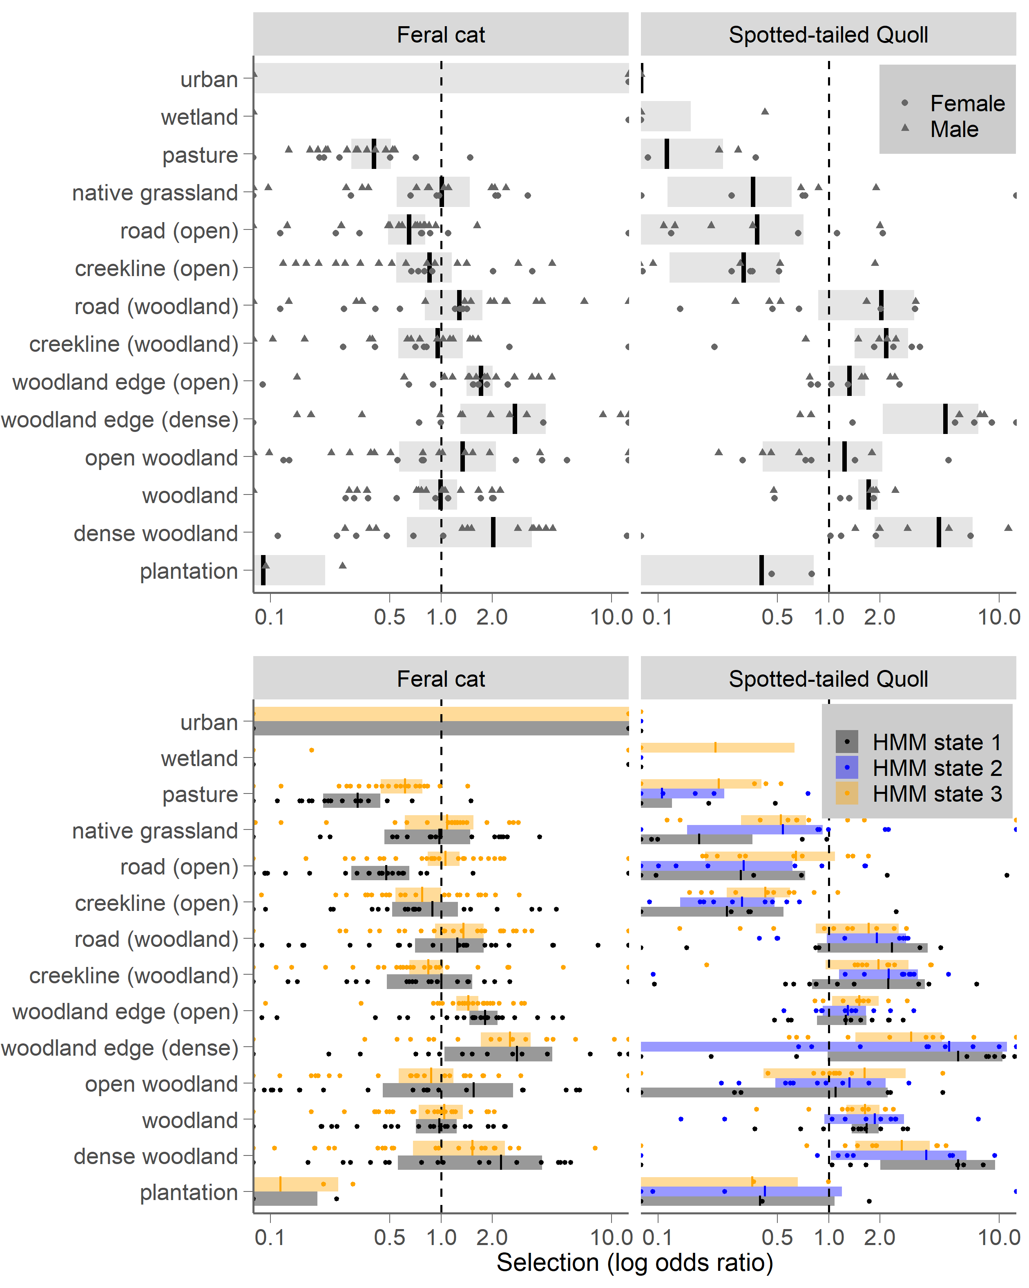
Figure S1.2 Habitat preferences of feral cats and spotted-tailed quolls.
The top panels show overall habitat selection, while the bottom panel shows habitat selection in each HMM movement state. Points represent individual tracked animals, while vertical lines and shaded rectangles represent the population average and confidence interval. The dashed central line indicates a selection ratio of 1 (neutral), where the habitat type is used in proportion to its availability. A selection ratio of 2 indicates that the habitat type was used twice as often as expected, whereas a selection ratio of 0.5 indicates the habitat type was used half as often as expected based on its availability in the landscape.

Diel activity
Just as habitat domain influences encounter rate by determining where animals are likely to be present within the landscape, temporal activity can also influence encounter rate by determining when they are likely to be present. It should be noted, however, that this is only strictly true for direct encounters. Indirect encounters, such as encounters with olfactory cues, can occur at any time.

Methods
We fitted kernel density functions to calculate the coefficient of overlap using a) all fixes, which therefore only excludes periods in which animals were underground or deep in shelter; and b) all active fixes, which were defined as excluding all fixes in HMM state 1 (stationary state). Times were converted to sun time, which expresses activity times in relation to sunset, sunrise and zenith [14]. Analyses used the overlap package [15] in the R statistical environment.

Results
The diel activity patterns of the two species were very similar (Figure S1.3), with peaks of activity at dusk and dawn. Quolls showed a stronger pattern of crepuscular/nocturnal activity and daytime rest while cats were more active during daylight hours, but differences were small (coefficient of overlap d̂ = 0.82).
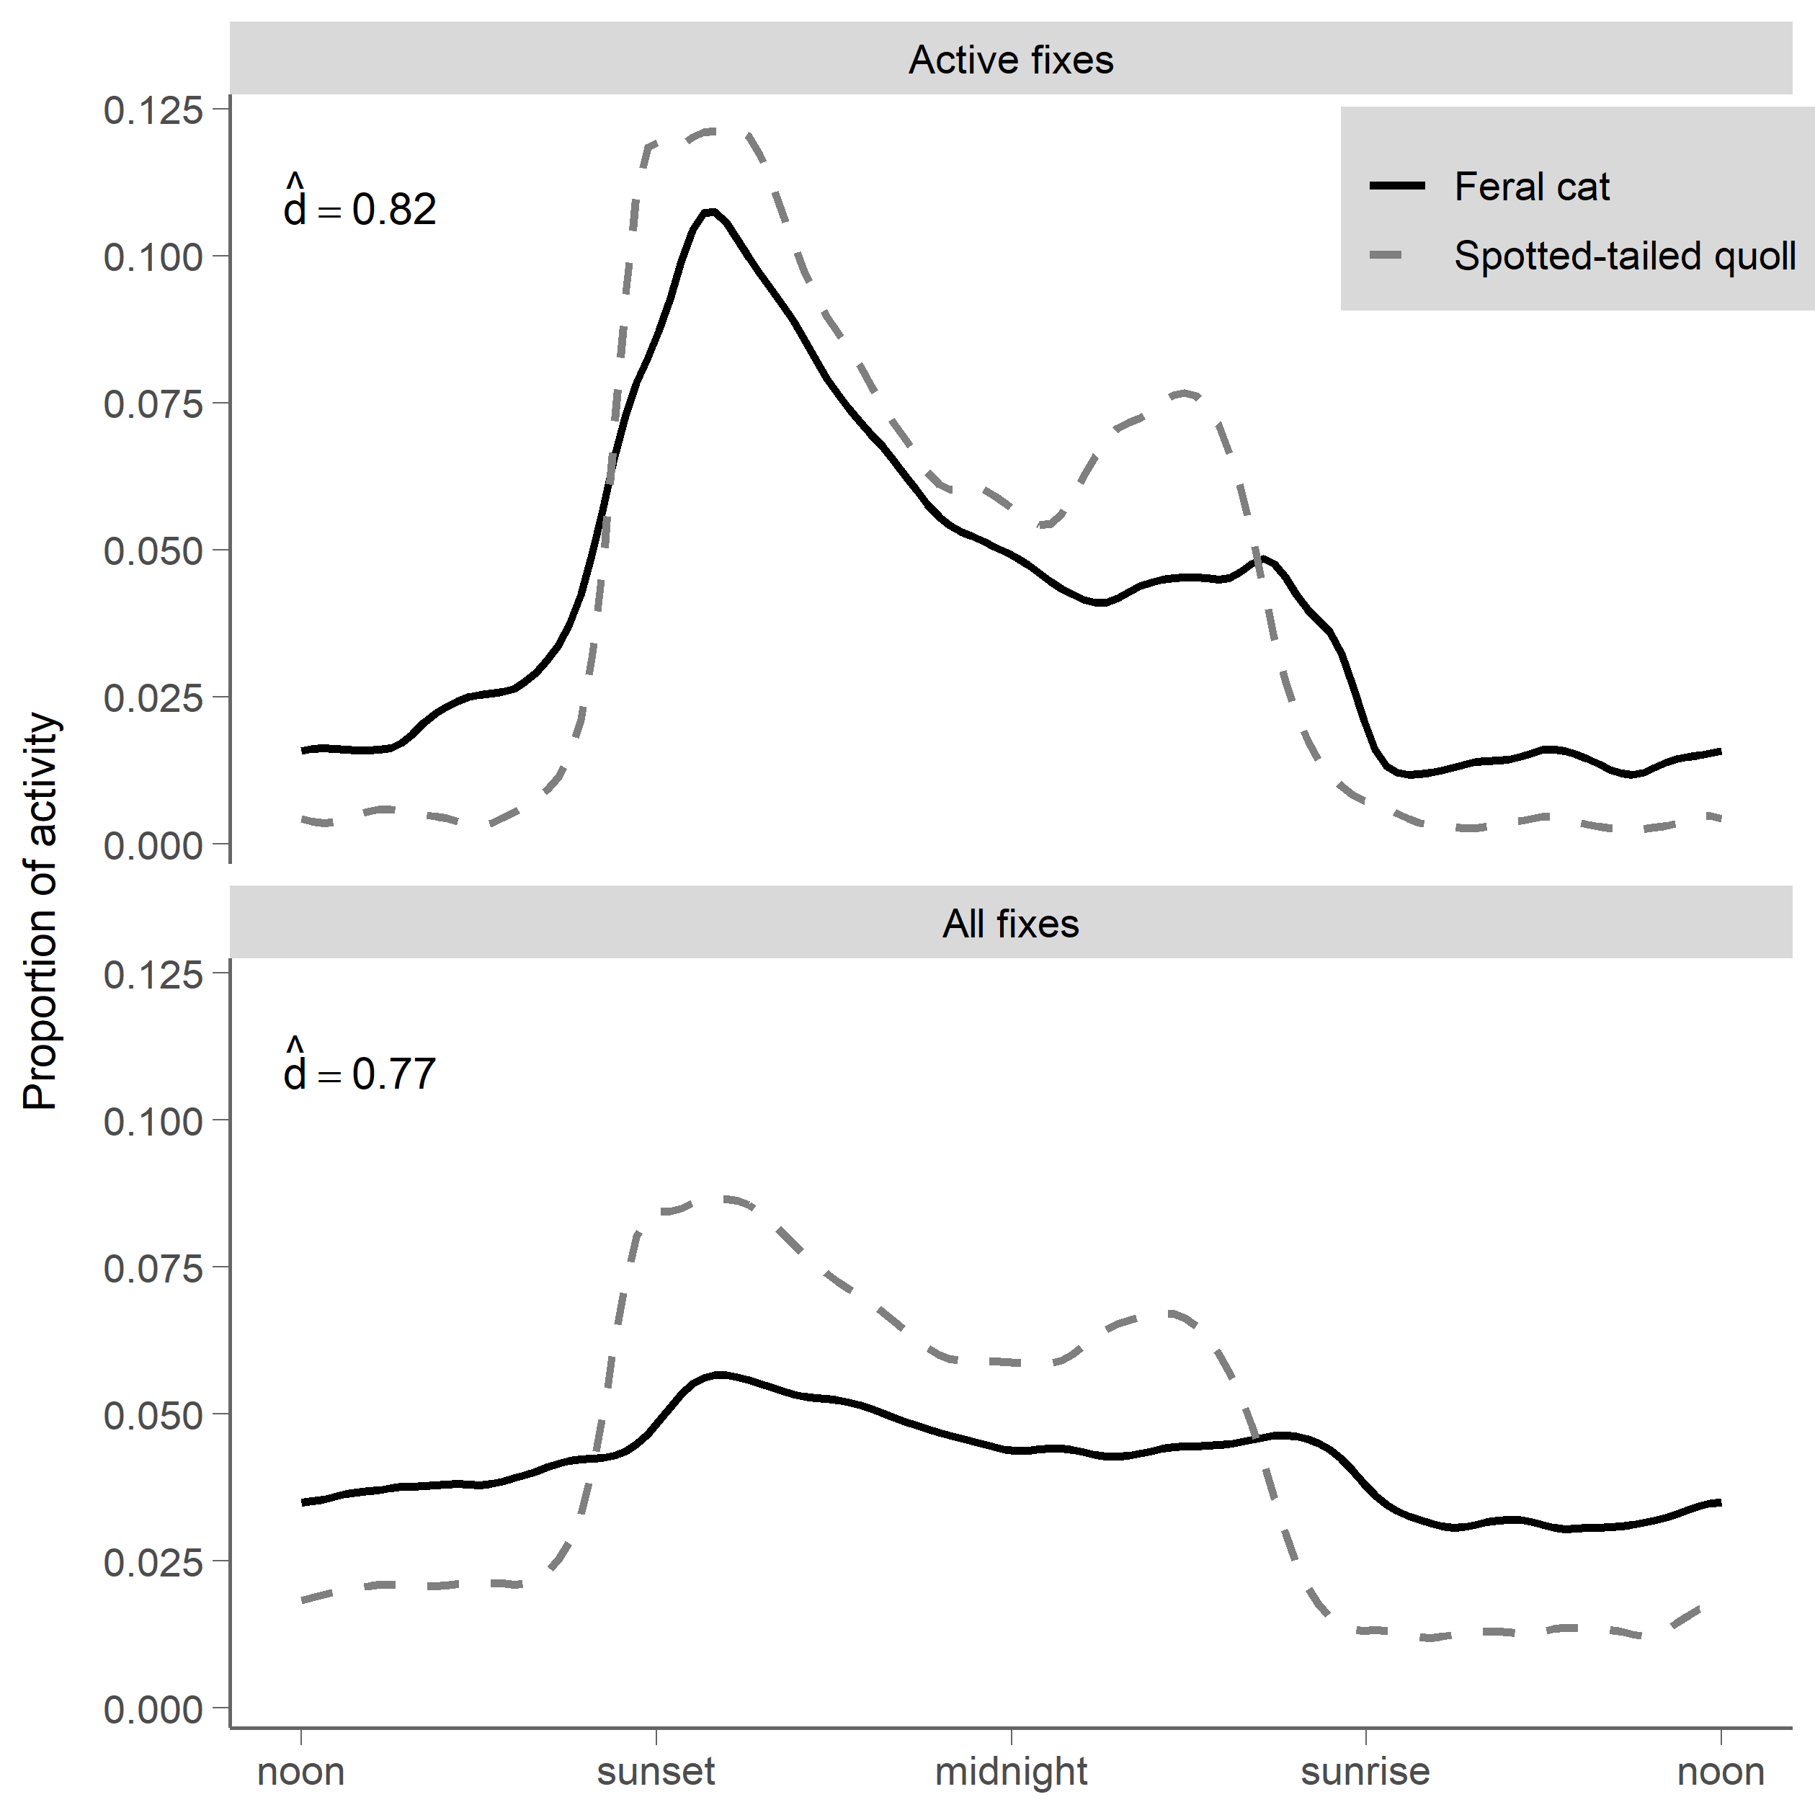
Figure S1.3 Diel activity patterns of feral cats (solid line) and spotted-tailed quolls (dashed line).
The coefficient of overlap (d̂) ranges from 0 (no overlap) to 1 (complete overlap, identical activity patterns). The top panel shows active fixes, which excludes all fixes from HMM state 1 (resting) for both species. The bottom panel shows all successful GPS fixes, as spotted-tailed quolls usually spent daylight hours in dens where GPS fixes were unsuccessful.

Relative rate of encounter
On average, the probability of encountering a cat was 0. 00016 +/- 0.00004 per night per 30m raster cell (odds of 1: 6405), compared to 0.00004 +/- 0.00001 (or 1:25778) for quolls. The weaker habitat selection of cats meant that encounter probability was more consistent across all habitat types relative to quolls (Figure S1.4). Encounter probability was also more consistent across all habitat types for both species when travelling (HMM state 3) than when resting or foraging (HMM states 1 and 2), however these differences do not appreciably alter the relative rate of encounter (Figure S1.4).
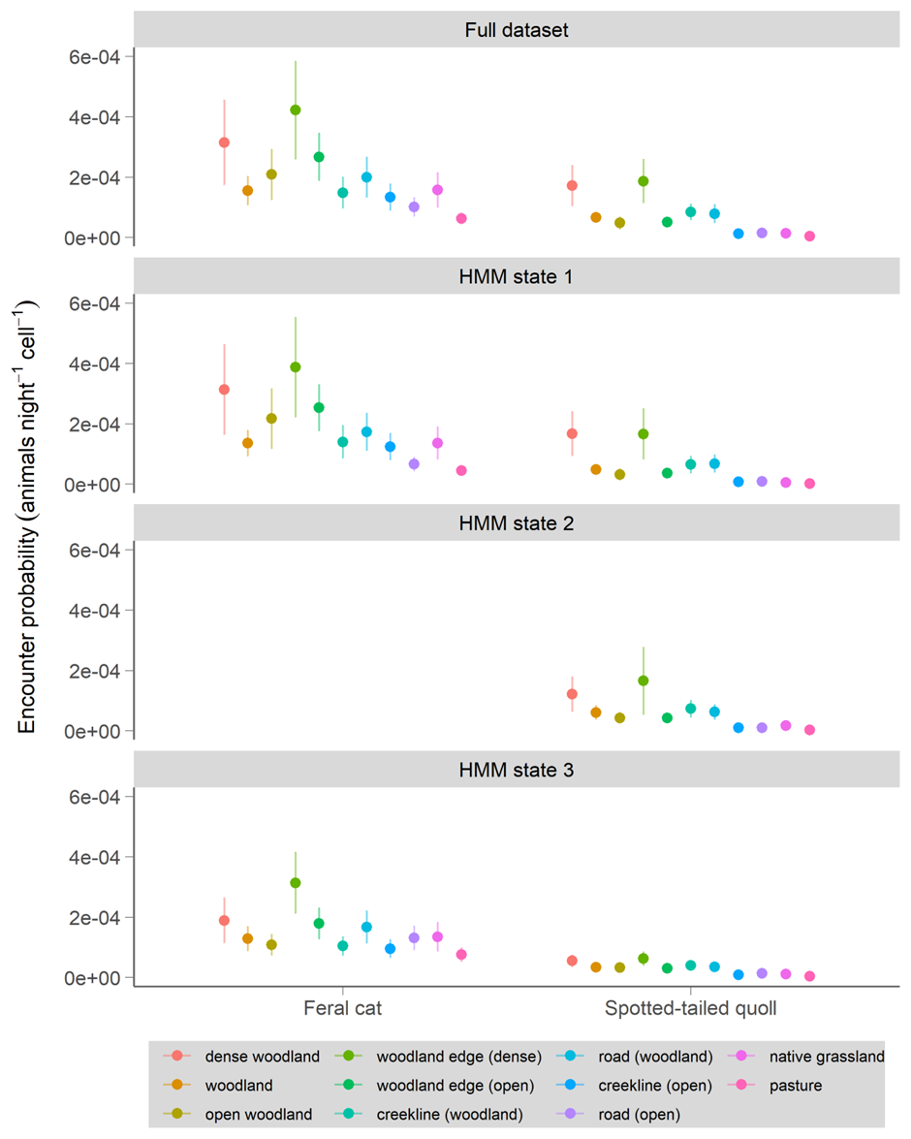
Figure S1.4 Probability of encountering feral cats and spotted-tailed quolls in different habitat types across the Tasmanian Midlands landscape. Habitat selection ratios and revisitation rates were calculated using the full dataset (top panel) or a subset of the dataset based on the HMM movement states (bottom panels). Density estimates were not adjusted for each calculation. Grid cells used in these analyses measure 30 x 30m. Note that revisitation rates for cats in urban environments (0.02 ± 0.02) are not shown on the figure due to large differences in scale.

References
[1] Hamer, R.P., Andersen, G.E., Hradsky, B.A., Troy, S.N., Gardiner, R.Z., Johnson, C.N. & Jones, M.E. 2022 Differing effects of productivity on home-range size and population density of a native and an invasive mammalian carnivore. Wildl Res 49, 158-168. (doi:10.1071/WR20134).
[2] Benhamou, S. 2011 Dynamic Approach to Space and Habitat Use Based on Biased Random Bridges. PLoS ONE 6, e14592. (doi:10.1371/journal.pone.0014592).
[3] Patterson, T.A., Parton, A., Langrock, R., Blackwell, P.G., Thomas, L. & King, R. 2017 Statistical modelling of individual animal movement: an overview of key methods and a discussion of practical challenges. Advances in Statistical Analysis 101, 399-438. (doi:10.1007/s10182-017-0302-7).
[4] Michelot, T., Langrock, R. & Patterson, T.A. 2016 moveHMM: an R package for the statistical modelling of animal movement data using hidden Markov models. Methods in Ecology and Evolution 7, 1308-1315. (doi:10.1111/2041-210X.12578).
[5] Preisser, E.L., Orrock, J.L. & Schmitz, O.J. 2007 Predator hunting mode and habitat domain alter nonconsumptive effects in predator–prey interactions. Ecology 88, 2744-2751. (doi:10.1890/07-0260.1).
[6] Schmitz, O.J., Miller, J.R.B., Trainor, A.M. & Abrahms, B. 2017 Toward a community ecology of landscapes: predicting multiple predator–prey interactions across geographic space. Ecology 98, 2281-2292. (doi:10.1002/ecy.1916).
[7] DPIPWE. 2013 TASVEG 3.0. (ed. R.M.a.C.D. Tasmanian Vegetation Monitoring and Mapping Program, Department of Primary Industries, Parks, Water and the Environment). Hobart, Tasmania.
[8] DPIPWE. 2017 Land Information Systems Tasmania: LISTdata. (Land Tasmania, Department of Primary Industries, Parks, Water and the Environment.
[9] Joint Remote Sensing Research Project. 2010 Australian woody vegetation cover (spatial dataset). (http://auscover.org.au/purl/landsat-persistent-green-2000-2010.
[10] Červinka, J., Šálek, M., Pavluvčík, P. & Kreisinger, J. 2011 The fine-scale utilization of forest edges by mammalian mesopredators related to patch size and conservation issues in Central European farmland. Biodivers Conserv 20, 3459-3475. (doi:10.1007/s10531-011-0135-8).
[11] Šálek, M., Kreisinger, J., Sedláček, F. & Albrecht, T. 2010 Do prey densities determine preferences of mammalian predators for habitat edges in an agricultural landscape? Landsc Urban Plan 98, 86-91. (doi:10.1016/j.landurbplan.2010.07.013).
[12] Andersen, G.E., Johnson, C.N., Barmuta, L.A. & Jones, M.E. 2017 Use of anthropogenic linear features by two medium-sized carnivores in reserved and agricultural landscapes. Scientific Reports 7, 11624. (doi:10.1038/s41598-017-11454-z).
[13] Doherty, T.S., Bengsen, A.J. & Davis, R.A. 2015 A critical review of habitat use by feral cats and key directions for future research and management. Wildl Res 41, 435-446. (doi:10.1071/WR14159).
[14] Nouvellet, P., Rasmussen, G.S.A., Macdonald, D.W. & Courchamp, F. 2012 Noisy clocks and silent sunrises: measurement methods of daily activity pattern. Journal of Zoology 286, 179-184. (doi:10.1111/j.1469-7998.2011.00864.x).
[15] Meredith, M. & Ridout, M. 2018 Overview of the overlap package. R package documentation, https://cran.r-project.org/web/packages/overlap/vignettes/overlap.pdf

