Supplementary data
DOI: 10.1098/rspb.2022.1394
Title: Rising floor and dropping ceiling: organ heterogeneity in response to cold acclimation of the largest extant amphibian
Wei Zhu^{1,2*,#}, Chunlin Zhao^{1,#}, Tian Zhao¹, Liming Chang^{1,2}, Qiheng Chen^{1,2}, Jiongyu Liu¹, Cheng Li¹, Feng Xie¹, Jianping Jiang^{1,2*}
1 CAS Key Laboratory of Mountain Ecological Restoration and Bioresource Utilization & Ecological Restoration Biodiversity Conservation Key Laboratory of Sichuan Province, Chengdu Institute of Biology, Chengdu, China
2 University of Chinese Academy of Sciences, Beijing 10049, China
#These authors contributed equally to this work.
*Correspondence: Wei Zhu, zhuwei@cib.ac.cn, Tel.: 86-028-82890935; Jianping Jiang, jiangjp@cib.ac.cn.

Additional information on methods and materials
2.2 Measure of thermal preference
The thermal gradient, spanning 150 cm, was generated in circulating water system (width, 30 cm; depth, 3 cm) equipped with two digital water bathes (DFY-50L/20, Gongyi Yuhua Instruments Corporation, Ltd.) with both heating and condensing functions. Thermometers were installed in the water system with intervals of 6 cm to monitor the temperature of the gradient (see the device photograph in Figure S2 and S3).
Since the dataset belonged to the category of repeated measurement at different timepoints (pseudo-replicate), the observation time should be considered as a factor in statistical model (e.g., linear mixed model). Yet, separating the variations of preferred temperature by observation time might be meaningless and unreasonable, and an alternative way was to use the average of the values (at different timepoints) as the preferred temperature of each individual, to avoid pseudo-replicate. Unfortunately, it raised the question whether the observed values at different timepoints should be treated equally, since the larva moved spontaneously and likely reached to the unfavorable thermal range during the observation periods. If their tendency to a higher temperature or lower temperature was asymmetric (either due to technique or biological reasons), the spontaneous movement may result in the deviation of the actual preferred temperatures. In fact, the values (observed temperatures at 30 timepoints) of only two individuals (out of 60 individuals) meet the normal distribution in this study. Therefore, we think the most rational way was to define the preferred temperature of each individual as the value at which the animal stays still for the longest duration. Then, the values were able to analyzed by Student’s t test or Mann-Whitney U test.
2.4.2 Comparative transcriptome analyses
After purification with poly-T oligo-attached magnetic beads, the mRNAs were fragmented. The first-strand cDNA was synthesized using random hexamer primers. Second-strand cDNA synthesis was subsequently performed using DNA Polymerase I and RNase H. The remaining overhangs were converted into blunt ends via exonuclease/polymerase activities. After adenylation of the 3΄ ends of the DNA fragments, the adaptors were ligated to the products. PCR was hen performed with a HIFI DNA polymerase, universal PCR primers, and an index (X) primer.
2.5 Untargeted metabolomics
The C18 HILIC column (ACQUITY UPLC HSS T3 1.8 μm, 2.1 × 100 mm, Waters) was equilibrated with 95% (v/v) solvent A (25 mM ammonium acetate and 25 mM ammonium hydroxide in water). Separation was performed with 40–95% solvent B (acetonitrile) at 0.3 mL/min as follows: 0–0.5 min, 95% B; 0.5–7 min, decreasing B from 95–65%; 7–8 min, decreasing B from 65–40%; 8–9 min, 40% B; 9–9.1 min, increasing B from 40–95%; 9.1–12 min, 95% B. Metabolite data were obtained in both the positive and negative ion modes with the following settings: ion source gas 1 = 60; ion source gas 2 = 60; curtain gas = 30; source temperature = 600 °C; ion spray floating voltage = ± 5500 V; TOF MS scan m/z range = 60-1200 Da; product ion scan m/z range = 25-1200 Da; TOF MS scan accumulation time = 0.15 s/spectrum; product ion scan accumulation time = 0.03 s/spectrum. The MS/MS spectra were acquired using information-dependent acquisition with high sensitivity as follows: declustering potential = ± 60 V; collision energy = 30 eV.
References
Hutchison, V.H., Hill, L.G., 1975. Thermal selection in the hellbender, Cryptobranchus alleganiensis, and the mudpuppy, Necturus maculosus. Herpetologica 32, 327-331.

Figure S1 Basic information for the aquaculture of captive-bred Chinese giant salamander. (a) A diagram showing the semi-ecological culture of A. davidianus. (b) Life cycle of these animals. (c) Timeline of the animal breeding, hatching, and sample collection. (d) Water temperature of the natural stream and the indoor hatching pool. Note that the hatching or newly hatched larvae are transferred into the indoor hatching pool at the end of October. (e) The water temperature experienced by the hatching or newly hatched larvae. Note that the water temperature is relatively stable across the five months. (f) The relationship between air temperature and water temperature. The temperatures were recorded at around 20:00 pm in 2018.

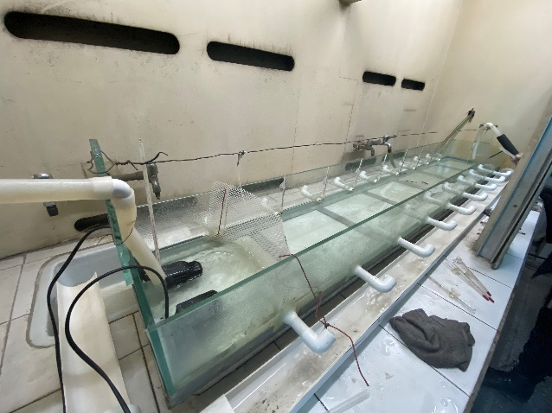
Figure S2. The photograph of the circulating water system.

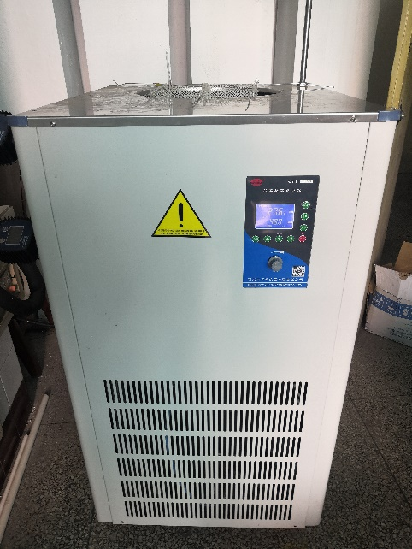
Figure S3. The photograph of the digital water bath. To determine the preferential temperature of larvae, two bathes were used to generate the thermal gradient by heating or cooling the circulating water.

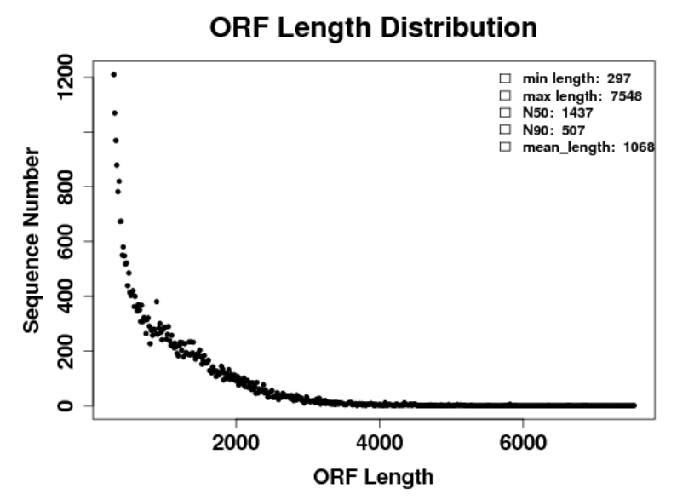
Figure S4 Length distribution of the predicted ORF.

Figure S5 PCoA scatter plots presenting the variations of organ metabolome and transcriptome in response to cold acclimation. The Bray-Curtis distances matrix was calculated for metabolome and transcriptome and used for PCoA analyses. The differences in metabolome and transcriptome between groups were assessed by PERMANOVA (permutations = 9999), with the resulted p values presented in the figures. Note that the lowest p value of PERMANOVA on transcriptome was 0.1 due to the small replicate (n = 3).

Figure S6 Variations in metabolic and transcriptional profiles after cold acclimation. (a-b) Varied metabolites shared by different organs. (c-d) Varied transcripts shared by different organs.

Figure S7 Variations of glycol-metabolites after cold acclimation.

