Supplementary Materials

Supplementary table 1(S1): Feather characteristics and reproductive parameters of the same years
Response | N | Predictor |  | Adjusted R²
Cort_{f} (pg/mm) | 134 | Elevation | χ²₁ = 0.29, p = 0.587 | 0.20
 |  | Year | χ²₂ = 28.66, p < 0.001
Feather mass (mg) | 157 | Elevation | χ²₁ = 1.34, p = 0.247 | 0.15
 |  | Year | χ²₂ = 29.37, p < 0.001
Feather length (mm) | 153 | Elevation | χ²₁ = 0.45, p = 0.503 | 0.05
 |  | Year | χ²₂ = 11.40, p = 0.003
Feather growth rate (mm/24hr) | 147 | Elevation | χ²₁ = 2.44, p = 0.118 | 0.11
 |  | Year | χ²₂ = 19.41, p < 0.001

Supplementary table 2(S2): Feather size, Cort_{f} and time of capture
Response | N | Predictor |  | Adj R²
Mass (mg) | 134 | Cort_{f} (pg) | χ²₁ = 2.76, p = 0.96 | 0.14
 |  | Elevation | χ²₁ = 3.28, p = 0.070
 |  | Year | χ²₂ = 19.44, p < 0.001
Length (mm) | 134 | Cort_{f} (pg) | χ²₁ = 0.10, p = 0.752 | 0.08
 |  | Elevation | χ²₁ = 0.40, p = 0.524
 |  | Year | χ²₂ = 14.39, p < 0.001
Feather growth rate (mm/24hr) | 129 | Cort_{f} (pg) | χ²₁ = 0.08, p = 0.773 | 0.08
 |  | Elevation | χ²₁ = 2.16, p = 0.142
 |  | Year | χ²₂ = 12.61, p = 0.002
 |  | Feather mass (mg) | χ²₁ = 0.10, p = 0.841
 |  | Feather length (mm) | χ²₁ = 2.03, p = 0.154
Cort_{f} | 134 | Capture time (Julian date) | χ²₁ = 0.08, p = 0.783 | 0.19
 |  | Elevation | χ²₁ = 0.25, p = 0.618
 |  | Year | χ²₂ = 23.78, p < 0.001

Supplementary table 3(S3): Mean location errors per trial over two spatial tasks and feather length, mass and mean feather bar width
 | Spatial learning task |  | Reversal learning task
 | Location errors/trial in the first 20 trials | Location errors/trial in the entire task | Location errors/trial in the first 20 trials | Location errors/trial in the entire task
Predictor | N = 119 |  | N = 101
Elevation | χ²₁= 0.87, p = 0.350 | χ²₁= 0.02 , p = 0.884 | χ²₁= 0.17, p = 0.683 | χ²₁= 0.06, p = 0.800
Year | χ²₂= 7.06, p = 0.029 | χ²₂= 8.07, p = 0.018 | χ²₂= 2.60, p = 0.273 | χ²₂= 1.62, p = 0.444
Feather mass (mg) | χ²₁= 1.14, p = 0.286 | χ²₁= 3.81, p = 0.051 | χ²₁= 2.96, p = 0.085 | χ²₁= 0.71, p = 0.398
Total trial number | NA | χ²₁= 85.64, p < 0.001 | NA | χ²₁= 51.40, p < 0.001
Elevation * Year | NA | NA | χ²₂= 9.04, p = 0.011 | NA
R² | 0.03 | 0.45 | 0.13 | 0.40
 | N = 115 |  | N = 99
Elevation | χ²₁= 1.21, p = 0.271 | χ²₁= 0.004, p = 0.947 | χ²₁ = 0.14, p = 0.710 | χ²₁= 0.07, p = 0.796
Year | χ²₂ = 8.16, p = 0.017 | χ²₂ = 6.50, p = 0.039 | χ²₂ = 2.04, p = 0.360 | χ²₂ = 2.19, p = 0.335
Feather length (mm) | χ²₁= 2.76, p = 0.097 | χ²₁= 2.84, p = 0.092 | χ²₁ = 7.92, p = 0.005 | χ²₁= 1.00, p = 0.318
Total trial number | NA | χ²₁= 78.35, p < 0.001 | NA | χ²₁= 46.70, p < 0.001
Elevation * Year | NA | NA | χ²₂ = 8.68, p = 0.013 | NA
R² | 0.12 | 0.48 | 0.17 | 0.40
 | N = 109 |  | N = 95
Elevation | χ²₁= 0.72, p = 0.395 | χ²₁= 0.10, p = 0.753 | χ²₁= 0.05, p = 0.830 | χ²₁= 0.10, p = 0.748
Year | χ²₂ = 2.74, p = 0.254 | χ²₂= 3.74, p = 0.154 | χ²₂ = 4.08, p = 0.130 | χ²₂ = 2.95, p = 0.229
Mean feather bar width (mm/24hr) | χ²₁= 0.11, p = 0.743 | χ²₁= 0.62, p = 0.429 | χ²₁= 1.26, p = 0.261 | χ²₁= 0.23, p = 0.632
Total trial number | NA | χ²₁= 76.89, p < 0.001 | NA | χ²₁= 40.65, p < 0.001
Elevation * Year | NA | NA | χ²₂ = 7.05, p = 0.029 | NA
R² | 0.13 | 0.48 | 0.20 | 0.41

Supplementary table 4(S4): Mean location errors/trial for the first 20 trials in the reversal task and Cort_{F}
 |  |  | Errors in the first 20 trials
Year | N | Predictor
2018 | Total: 23  Low: 0  High: 23 | Elevation | Removed due to lack of samples
 |  | Feather length (mm) | estimate = 0.01 ± 0.01, t =1.03, p = 0.317
 |  | R² | 0.002
2019 | Total: 34  Low: 11  High = 23 | Elevation | estimate = 0.23 ± 0.08, t = 2.66, p = 0.012
 |  | Feather length (mm) | estimate = 0.02 ± 0.02, t = 1.33, p = 0.193
 |  | R² | 0.17
2020 | Total: 42  Low: 22  High: 20 | Elevation | estimate = -0.05 ± 0.07, t = -0.69, p = 0.493
 |  | Feather length (mm) | estimate = 0.04 ± 0.02, t = 2.35, 0.024
 |  | R² | 0.10

Feather mass, length and growth and spatial cognition
Spatial learning task

There were no significant associations between performance in the first 20 trials of the spatial learning and memory task and feather mass (Table S3). There was a significant association between performance and year and a post hoc analysis showed only a minor difference between 2018 and 2019 with 2019 having slightly better performance associated with smaller mean number of location errors per trial (p = 0.029). There were no significant differences between 2018 and 2020 (p = 0.53) or 2019 and 2020 (p = 0.16).
There were also no significant associations between performance in the entire spatial learning and memory task and feather mass (Table S3). There was a significant effect of year and a post hoc analysis revealed a biologically minor, but significant difference in performance between only 2018 and 2019 (p = 0.02) with 2019 having slightly better performance associated with smaller mean number of location errors per trial. There were no significant differences between 2019 and 2020 (p = 0.09) or 2018 and 2020 (p = 0.61).

There were no significant associations between performance in the first 20 trials of the spatial learning and memory task and feather length (Table 5). There was a significant association between performance and year and a post hoc analysis showed a slight difference in performance but only between 2018 and 2019 (p = 0.016) with 2019 having better performance. There were no significant differences in performance between 2019 and 2020 (p = 0.18) or 2018 and 2020 (p = 0.42).
There were no significant associations between performance during the entire task of the spatial learning and memory task and feather length (Table 5). There was a significant year effect, and a post hoc analysis showed the same previous trend wherein there was a slightly better performance in 2019 compared to 2018 (p = 0.046). There were no significant differences in performance between 2019 and 2020 (p = 0.15) or 2018 and 2020 (p = 0.69).

Single reversal spatial task
There was no significant association between performance in the first 20 trials of the single spatial reversal learning task and feather mass (Table S3), but there was a significant elevation by year interaction (Table S3). However, post hoc analyses revealed no significant differences between elevations (p = 0.77) or year (2018 | 2019: p = 0.22; 2018 | 2020: p = 0.58; 2019| 2020: p = 0.29). There was no significant association between feather mass and performance over the entire reversal task (Table S3).
There was a significant association between feather length and performance in the first 20 trials of the single spatial reversal learning task as well as a significant year by elevation interaction (Table S3). We analyzed each year separately and found that there was no significant association between performance and feather length in 2018 (Table S4). However, this model only involved high elevation as low elevation was removed due to low sample size. There was no significant association between performance and feather length in 2019 but there was a significant elevation effect (Table S4). In 2020, there was a significant association between performance during the first 20 trials and feather length (Table S4); individuals with longer feathers performed worse by making more location errors per trial. This result may potentially be due to chance as it only occurred in a single year, it was in the opposite direction from expectation, as larger feathers sometimes point to better development and thus would be expected to predict better performance on the cognitive task (59).
There was no significant association between feather length and performance across the entire reversal task (Table S3).

Supplementary table 5(S5): Reproductive parameters across 2018 - 2020
Response | N | Predictor |  | R²
Clutch size (egg number) | 338* | Elevation | χ²₁ = 3.89, p < 0.048 | 0.48
 |  | Year | χ²₂ = 10.30, p = 0.006
 |  | Elevation * Year | χ²₂ = 12.67, p = 0.002
Brood size (fledgling number) | 282** | Elevation | χ²₁ = 0.11, p = 0.742 | 0.45
 |  | Year | χ²₂ = 8.36, p = 0.015
 |  | Clutch | χ²₁ = 192.27, p < 0.001
Mean nestling mass (g) | 280*** | Elevation | χ²₁ = 1.13, p = 0.287 | 0.62
 |  | Year | χ²₂ = 12.34, p = 0.002
 |  | Elevation * Year | χ²₂ = 6.17, p = 0.046
Coefficient of variation of nestling mass (g) | 280*** | Elevation | χ²₁ = 0.26, p = 0.607 | 0.17
 |  | Year | χ²₂ = 12.11, p = 0.002
*Sample sizes by elevation and year (2018: low: 67; high: 45; 2019: low: 70; high: 38; 2020: low: 64; high: 54)
**Sample sizes by elevation and year (2018: low: 53; high: 40; 2019: low: 65; high: 30; 2020: low: 53; high: 41)
*** Sample sizes by elevation and year (2018: low: 53; high: 40; 2019: low: 65; high: 30; 2020: low: 53; high: 39)

Population level year differences in reproductive parameters.
There were significant differences in clutch size between elevations and across years, with a significant elevation by year interaction (Table S5). Post hoc analyses revealed significant differences between elevations in clutch size with low elevations having larger clutches but only in 2020 (p < 0.001). There were also significant differences in mean clutch size between years with 2018 having significantly larger clutches compared to 2019 (p = 0.007).
Brood sizes showed no significant differences between elevations but were significantly different across years while controlling for clutch size (Table S5, Figure S1). Post hoc analyses showed that 2020 was associated with significantly smaller brood sizes compared to both 2018 (p = 0.032) and 2019 (p = 0.037). There was no significant difference in brood size between 2018 and 2019 (p = 1.00).

Supplementary table 6(S6): Samples sizes broken down by elevation, year and analysis
 | Total | Elevation | 2018 | 2019 | 2020
Cort_{f} ~ elevation + year:  table S1 | N = 134 | Low | 4 | 11 | 33
 |  | High | 33 | 24 | 29
Feather mass ~ elevation + year: table S1 | N = 157 | Low | 8 | 17 | 34
 |  | High | 36 | 30 | 32
Feather length ~ elevation + year: table S1 | N = 153 | Low | 7 | 17 | 34
 |  | High | 35 | 28 | 32
Feather bar width ~ elevation + year: table S1 | N = 147 | Low | 7 | 17 | 34
 |  | High | 32 | 25 | 32
Feather mass ~ Cort + elevation + year: table S2 | N = 134 | Low | 4 | 11 | 33
 |  | High | 33 | 24 | 29
Feather length ~ Cort + elevation + year: table S2 | N = 134 | Low | 4 | 11 | 33
 |  | High | 33 | 24 | 29
Feather bar width ~ Cort + elevation + year: table S2 | N = 129 | Low | 4 | 11 | 33
 |  | High | 30 | 22 | 29
Cort ~ Julian date + elevation + year: table S2 | N = 134 | Low | 4 | 11 | 33
 |  | High | 33 | 24 | 29
Location errors (spatial learning) ~ feather mass + elevation + year: table S3 | N = 119 | Low | 3 | 12 | 26
 |  | High | 29 | 27 | 22
Location errors (reversal learning) ~ feather mass + elevation + year:  table S3 | N = 101 | Low | 1 | 11 | 22
 |  | High | 23 | 24 | 20
Location errors (spatial learning) ~ feather length + elevation + year: table S3 | N = 115 | Low | 2 | 12 | 26
 |  | High | 28 | 25 | 22
Location errors (reversal learning) ~ feather length + elevation + year:  table S3 | N = 99 | Low | 1 | 11 | 22
 |  | High | 22 | 23 | 20
Location errors (spatial learning) ~  feather bar width + elevation + year: table S3 | N = 109 | Low | 2 | 12 | 26
 |  | High | 25 | 22 | 22
Location errors (reversal learning) ~ feather bar width + elevation + year: table S3 | N = 95 | Low | 1 | 11 | 22
 |  | High | 20 | 21 | 20

Supplementary figures:
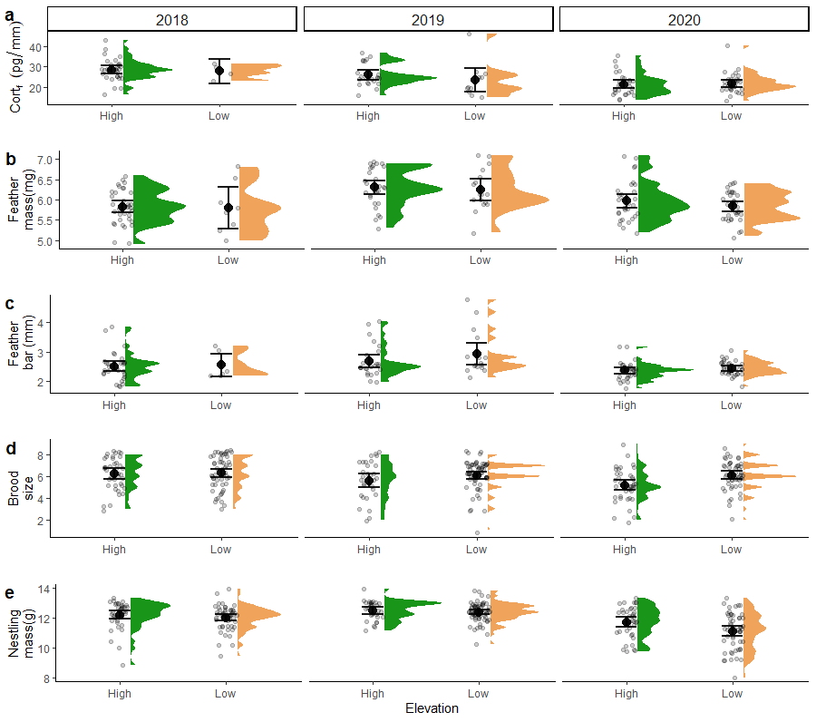
Supplementary figure 1 (S1) : The mean comparison across years and elevations for a) Cort_{f} per millimeter of feather, b) feather mass, c) mean feather bar width d) brood sizes for the same years of the study and d) mean nestling mass for the same years of the study

