Developing an empirical model for spillover and emergence: Orsay virus host range in Caenorhabditis
Supplemental Information

Supplemental Information A: Titration of virus filtrate
24-well plates were filled with 2 mL nematode growth medium (NGM) and seeded with 20 µL OP50 in LB broth [1]. OP50 lawns were allowed to grow at room temperature for approximately 24 hours. Eleven three-fold dilutions of the virus filtrate were made spanning concentrations of the original stock from 0.333 to 5.65 x 10⁻⁶. A total of 8 filtrate concentrations were used beginning with the 4th of the dilution series (where the concentration of original filtrate was 0.01234). For each filtrate concentration, 20 µL diluted filtrate was added to the top of OP50 lawns in 6 wells.
C. elegans strain JU1580 and C. briggsae strain AF16 were bleach synchronized using standard methods [1]. 50 JU1580 or AF16 L1 worms were added, respectively, to each of 4 and 2 replicate wells for each virus filtrate dilution. Worms grew in wells for 3 days at 20°C. Worms were removed from the wells by pipetting 1 mL of water into and out of the wells. Worms suspended in water were transferred to microcentrifuge tubes. Worms were pelleted by centrifuging at 1000 x g for 1 minute, and then washed once by removing 900 µL of the supernatant and adding 900 µl fresh water. Tubes were again centrifuged to pellet worms. Supernatants were removed to 500 µL and the remaining worm – water mixture was moved to 2 mL round-bottomed snap cap tubes with approximately 100 µl 0.5 mm silica beads. These tubes were shaken in a TissueLyser II (Qiagen) for 2 minutes at 30 shakes per second. Tubes were then centrifuged at 17,000 x g for 5 minutes. The supernatant was transferred to a new microcentrifuge tube which was centrifuged again at 17,000 x g for 5 minutes. This supernatant was saved as the sample. Virus was quantified in samples by qPCR (see methods in text).
This assay assigns infection ability to a particular virus dilution based on whether there is more virus in wells containing JU1580 worms than AF16 worms (modified from [2]). Since none of the wells with AF16 worms had detectable virus in this assay, we classified JU1580 wells as infected or not based on the presence or absence of detectable virus (Figure 1). We used maximum likelihood to determine the number of infectious viral doses per 20 µL of the stock viral filtrate (analogous to the median tissue culture infectious dose, TCID50, [2]). In practice, this involved calculating the likelihood of observing the data for different values of TCID50 in R [3]. Code is available on GitHub. The values reported in the main text for the concentration of the stock viral filtrate are the maximum likelihood and the 95% confidence intervals determined as the range of TCID50 values within 1.92 log likelihood units of our maximum likelihood. We find that our stock viral filtrate is 8,562 (95% CI: 3,468 - 19,446) x TCID50 per 20 µL, which equates to 428.1 (95% CI: 173.4-972.3) x TCID50 per µL (Figure 2).

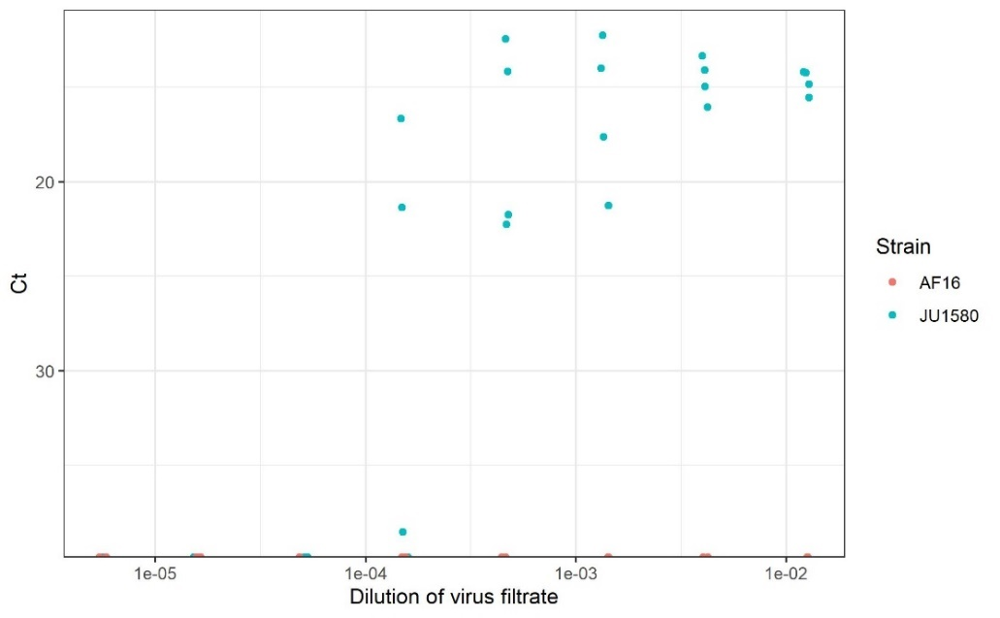
Figure A1. Quantification of infection across three-fold filtrate dilutions in C. briggsae AF16 (orange) and C. elegans JU1580 (teal). Points are slightly jittered on the x-axis to aid visualization.

References:
1. Stiernagle T. 2006 Maintenance of C. elegans. WormBook , 1–11.
2. Chen K, Franz CJ, Jiang H, Jiang Y, Wang D. 2017 An evolutionarily conserved transcriptional response to viral infection in Caenorhabditis nematodes. BMC Genomics 18, 303.
3. R Core Team. 2020 R: A Language and Environment for Statistical Computing.

Supplemental Information B: Additional experiments
We completed an experiment to confirm viral replication in three spillover strains determined to be susceptible using methods in the main text, C. latens VX80, C. tropicalis JU1428, and C. sp. 25, ZF1092. Highly susceptible C. elegans JU1580 and C. briggsae JU1264, which has been previously determined by us and others to not be susceptible, were included as positive and negative controls respectively. We initiated populations with five adults on OP50-seeded NGM plates with 3 µl of stock virus filtrate. Plates were washed with 1,800 µl of water after either 1 day of exposure or when plates were recently starved, which occurred between 4 and 9 days post exposure. The entire wash (i.e. worms, OP50, water) was pipetted into 2 mL round-bottom snap cap tubes with approximately 100 µl of 0.5 mm silica beads and shaken at 30 shakes per second for 2 minutes in a TissueLyser II (Qiagen) to lyse worms. Supernatants were centrifuged twice at 17,000 x g to remove debris (pellets were discarded at each step) and finally saved at -80 ֯C until qPCR (see main text for details on qPCR assay).
While negative control C. briggsae JU1264 plates had much less virus (i.e. higher cycle threshold (Ct) values) at starvation than at day 1 and C. sp. 25 ZF1092 had more virus at starvation than at day 1, the other strains had similar Cts at day 1 and at starvation (Figure B1, right panels). We therefore conducted an identical extraction procedure directly after adding stock virus filtrate to plates with 5 C. elegans JU1580 adults (Figure B1, left panel). Note that for C. elegans JU1580 as well as for C. latens VX80, C. tropicalis JU1428, and C. sp. 25 ZF1092, Ct values indicate more virus than day 0 Cts on day 1 and/or at starvation, demonstrating that the virus replicates in these strains.
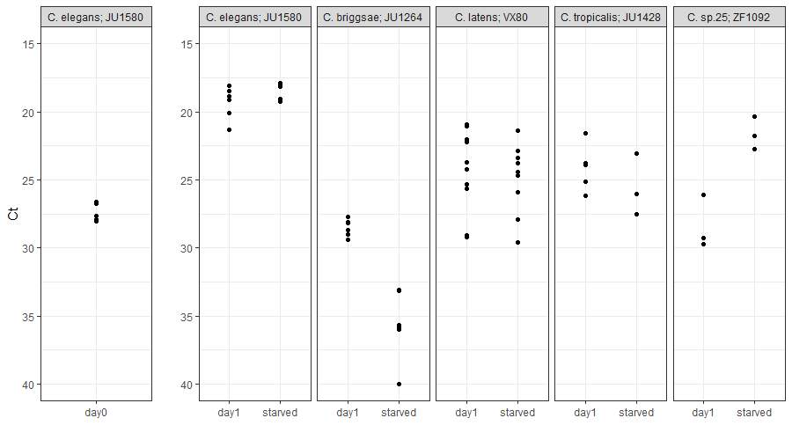
Figure B1. Plates of susceptible worm strains had more virus (smaller Cts) at day 1 and/or at starvation than plates at the time of exposure (left panel), demonstrating that Orsay virus replicates in these strains.

We performed another experiment to test the reproducibility of our transmission results for two susceptible strains, C. sulstoni SB454 and C. latens VX80. In this experiment, 20 replicate plates of each strain were initiated, passaged, extracted, and quantified as in the main text except worms were washed only 3 times instead of 5. Periodically (at passage 2 and passage 5), worms from SB454 plates were passaged to two plates instead of one, doubling the lines remaining. This was not done for VX80 plates. We found that the pattens described in the main text for these two strains were reproducible: C. sulstoni SB454, which allowed for sustained transmission in 1/3 passage lines in the experiment described in main text, again allowed for sustained transmission in a minority of lineages (2 of the 20 original lineages remained at the end of the experiment) while C. latens VX80, which allowed for only short-term persistence in the experiment described in the main text, again allowed for only short-term persistence in all replicate lines (Figure B2).
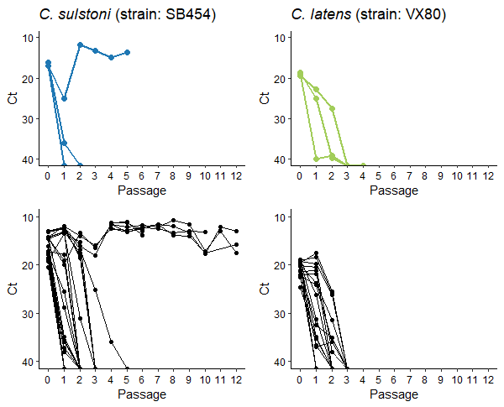
Figure B2: The top panel (reproduced from Figure 2 for ease of comparison) depicts passage trajectories for C. sulstoni strain SB454 in blue and C. latens strain VX80 in green (up to 5 passages were completed). The bottom panel shows additional replicates for these strains. For C. sulstoni SB454, 20 passage lines were started; these lines were split at passage 2 and passage 5, each time doubling the lines remaining. Some passage lines were halted when they were contaminated with bacterial growth. Passage lines from 2 of the 20 original replicates showed persistent virus transmission over 12 passages. C. latens VX80 lines were never split. These lines showed stuttering virus transmission, but persistent virus transmission did not occur in any of these replicate lines.

