Supplementary Information for

Juvenile emperor penguin range calls for extended conservation measures in the Southern Ocean

Author list
Aymeric Houstin^{1,2}*, Daniel P. Zitterbart^{3,4}, Karine Heerah⁵, Olaf Eisen^{6,7}, Víctor Planas-Bielsa¹, Ben Fabry³, Céline Le Bohec^{1,2}*

Corresponding Author information
*Correspondence is to be addressed to Aymeric Houstin houstina@gmail.com and Céline Le Bohec celine.lebohec@iphc.cnrs.fr

This PDF file includes

Figures S1 to S2
Tables S1
SI References
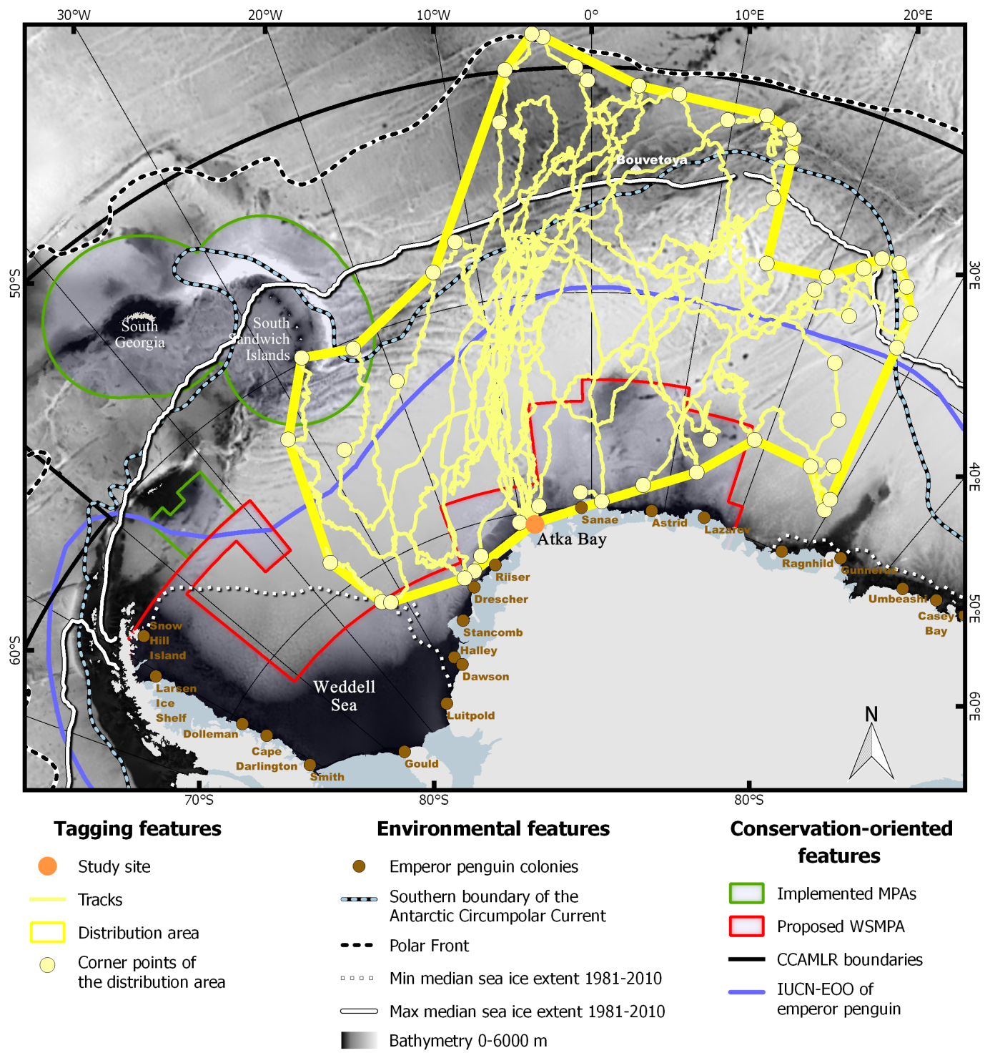

Fig. S1. Distribution over the first year at sea of the 8 juvenile emperor penguins tagged at Atka Bay in 2019. Main environmental and conservation related features of this sector of the Southern Ocean are specified in the legend. MPAs: Marine Protected Areas; WSMPA: Weddell Sea Marine Protected Area; CCAMLR: Commission for the Conservation of Antarctic Marine Living Resources; IUCN-EOO: International Union for Conservation of Nature Extent Of Occurrence (i.e. the extent of occurrence of the species considered by the IUCN ¹).

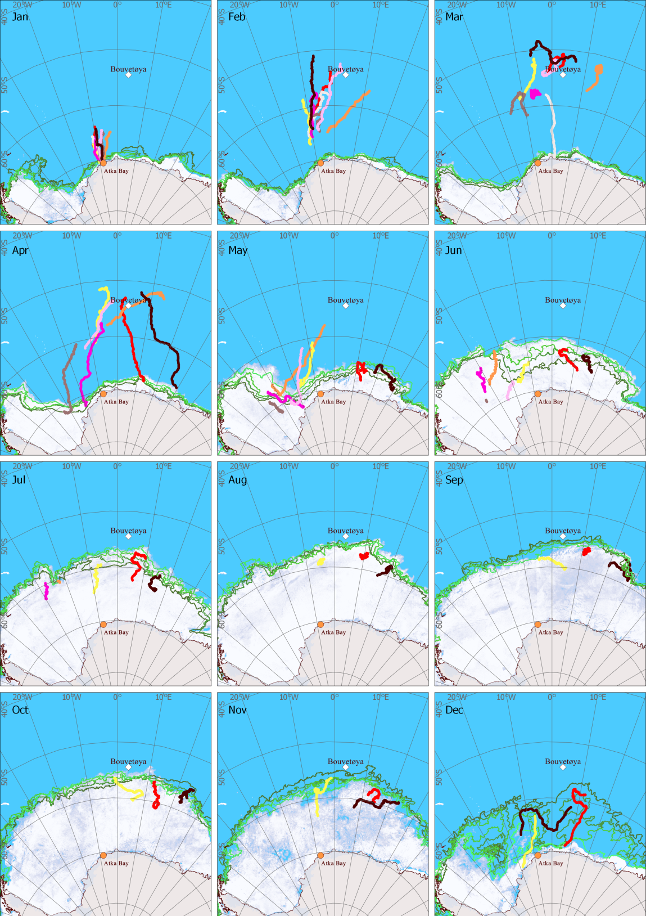

Fig. S2. Monthly tracks of the 8 juvenile emperor penguins tagged at Atka Bay in 2019. Sea ice concentration is shown for the last day of each month. Sea ice extent is indicated by the green lines for the 4th, 11th, 18th, 25th of each month as indicated by the gradient color scale from dark green (4th) to light green (25th).

Table S1. At-sea distribution metrics for the 8 juvenile emperor penguins equipped with ARGOS platforms at Atka Bay.
ID | Start trip | End trip | Trip duration (days) | Max distance from colony (km) | Date of max distance from colony | Yearly travelled distance* (km) | Mean daily distance** (km) | %** in ACC area | %** in SO - TL | %** in IUCN - EOO | %** in WSMPA | %** in SGSSI MPA
65787 | 11/01/19 | 29/12/19 | 352 | 2287 | 21/03/19 | 15593 | 44.3 | 14.4 | 59.3 | 40.1 | 16.9 | 0
65788 | 13/01/19 | 03/07/19 | 171 | 2390 | 10/04/19 | NA | NA | 28.8 | 44.4 | 36.6 | 10.7 | 5.6
65789 | 12/01/19 | 24/03/19 | 71 | 1484 | 26/02/19 | NA | NA | 0 | 18.1 | 81.6 | 29.8 | 0
65790 | 12/01/19 | 12/12/19 | 334 | 2176 | 05/04/19 | 13452 | 40.3 | 16.8 | 54.2 | 42.8 | 5.3 | 0
65791 | 12/01/19 | 01/06/19 | 140 | 1518 | 20/03/19 | NA | NA | 11.1 | 17.5 | 72.0 | 11.0 | 0
65792 | 11/01/19 | 13/07/19 | 183 | 1519 | 20/03/19 | NA | NA | 6.5 | 28.8 | 49.8 | 12.7 | 7.5
65793 | 12/01/19 | 18/06/19 | 157 | 2149 | 04/03/19 | NA | NA | 41.3 | 47.7 | 49.4 | 6.3 | 0
65794 | 10/01/19 | 01/01/20 | 356 | 2474 | 07/03/19 | 18326 | 51.5 | 19.3 | 48.5 | 50.6 | 5.3 | 0
Median (date) or Mean values | 12/01/19 | 08/07/19 | 220.5 | 1999.6 | 20/03/19 | 15790.3 | 45.4 | 18.0 | 55.3 | 48.9 | 10.6 | 1.4
sd | 0.9*** | 109.8*** | 110.4 | 421.3 | 15.1*** | 2443.0 | 5.7 | 11.3 | 15.1 | 13.3 | 7.5 | 3.8
* Yearly travelled distance was computed using one location every 6 hours (in km), ** % of time spent within the main oceanographic features (ACC, SO-TL) and conservation related areas (IUCN-EOO, MPAs) of the Southern Ocean during the trip duration, *** in days. ACC: Antarctic Circumpolar Current; SO-TL: Southern Ocean Treaty Limits (i.e. at the parallel of 60°S as defined in the Antarctic Treaty); IUCN-EOO: International Union for Conservation of Nature Extent Of Occurrence (i.e. the extent of occurrence of the species considered by the IUCN ¹; WSMPA: Weddell Sea Marine Protected Area; SGSSIMPA: South Georgia and Sandwich Islands Marine Protected Area.
SI References

- IUCN. The IUCN Red List of Threatened Species. Version 2020-1. (2020). Available at: www.iucnredlist.org.

