Supplementary material:

Preliminary evidence for one-trial social learning of vervet monkey alarm calling
Adwait Deshpande, Bas Van Boekholt and Klaus Zuberbuhler
* Correspondence:
Adwait Deshpande Email: adwait.deshpande2390@gmail.com

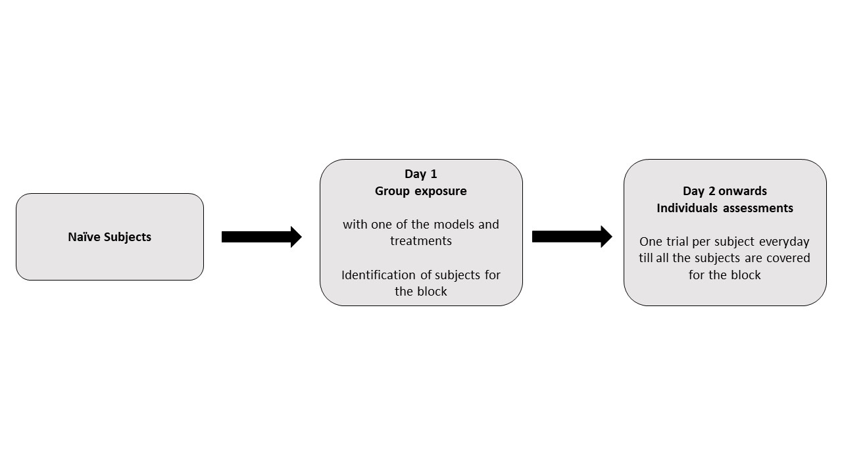
Figure S1: Design and timeline of the experimental blocks

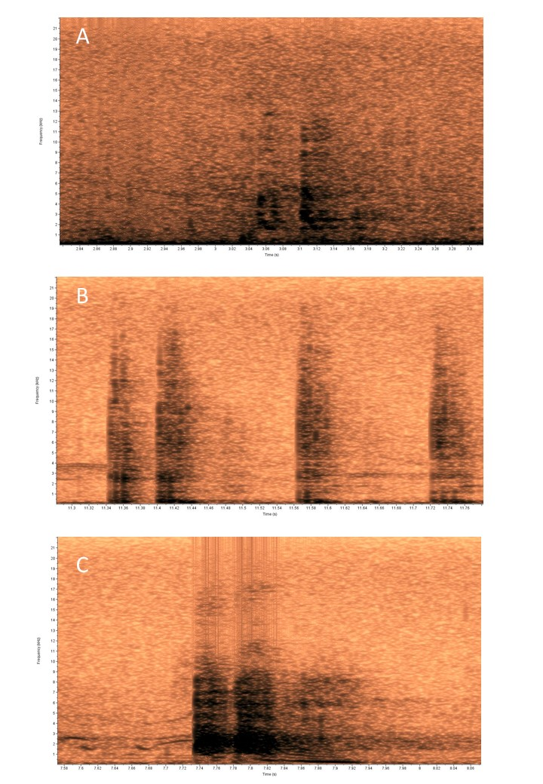
Figure S2: Spectrograms (Hamming window at 1024 DFT and 93.8% overlap) of different types of alarm calls elicited by the subjects (A) Eagle alarms (B) Snake alarms (C) Leopard alarms as described in the previous studies.
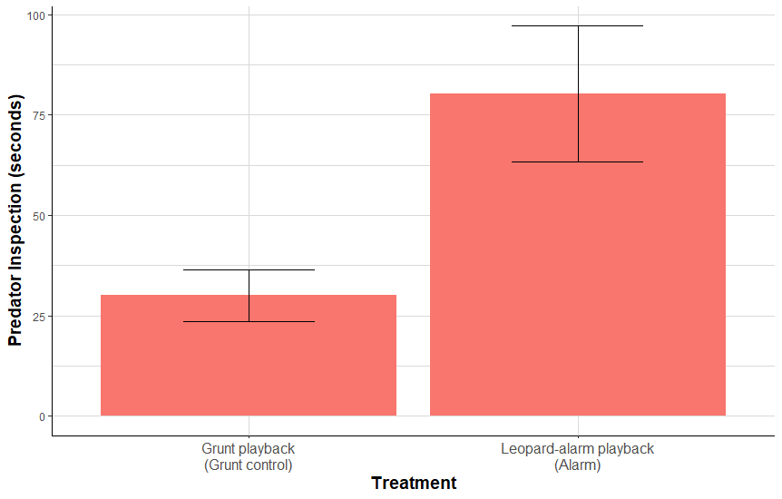
Figure S3: Mean (± SE) predator inspection of the subjects for the Grunt playback and leopard alarm playback (Alarm) treatment.

Figure S4: Mean (± SE) of snake alarms for the juvenile subjects exposed to caterpillar model
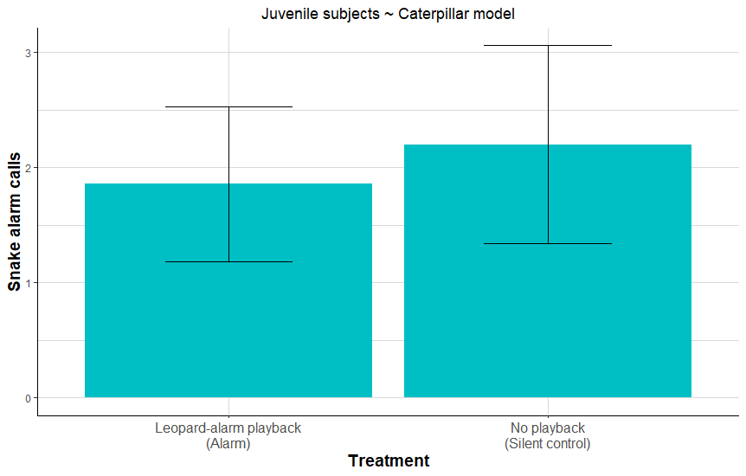

Table S1: List of acoustic parameters extracted from the alarm calls. Shaded parameters were used for the LDA classification

Acoustic parameter (unit) | Group Means from LDA Model (Scaled Data)
 | Eagle | Leopard
Number of elements | -0.0350025 | -0.3522358
Low Frequency (Hz) | 0.0736336 | -0.3854407
High Frequency (Hz) | NA | NA
Delta Time (s) | -0.0970311 | 1.89210804
Peak Frequency (Hz) | NA | NA
1st Quartile Frequency (Hz) | -0.908022 | -0.755146
3rd Quartile Frequency (Hz) | -1.298510 | -1.112019
Delta Frequency (Hz) | -0.4686237 | 0.1796256
Average Entropy (bits) | -1.5461260 | -1.2993005
Center Frequency (Hz) | -1.130832 | -0.958378
Max Entropy (bits) | -1.458680 | -1.389708
Average Power (dB) | -0.187820 | 1.892933
Average Amplitude (U) | -0.07130897 | 0.34673157
Max Amplitude (U) | NA | NA
Min Amplitude (U) | 0.3045821 | -1.5637610
Min Entropy (bits) | -0.9943584 | -1.1550906
Energy (dB) | NA | NA
Peak Amplitude (U) | NA | NA
Peak Power (dB) | NA | NA
Max Frequency (Hz) | -0.7533995 | -0.6241039
Max Power (dB) | NA | NA
Peak Frequency Contour Max Frequency (Hz) | -1.0853231 | -0.8660863
Peak Frequency Contour Average Slope (Hz/ms) | -0.038994987 | -0.008381332

