**Descriptive title and short description for each separate file in electronic supplementary materials**

Figure S1. Nitrogen absorption isotherms of GNR@mSiO2.

Fig S2 (a) UV-Vis curves of DOX at different concentrations. (b) Calibration curve used for estimation of DOX.

Figure S3. FTIR spectra of GNR@mSiO2 and GNR@mSiO2-DOX/PFP@PDA.

Figure S4. Microscopic images of microbubbles at different concentrations.

Figure S5. Release profiles from GNR@mSiO2-DOX/PFP at different pH values with or without NIR.

Figure S6. Cell cytotoxicity of normal cells (BALB/3T3) without NIR or with NIR (power density of 2 W/cm2) for 5 min.

Figure S7. (a) H&E staining images of tumor sections after different treatments. (b) H&E-stained major organ tissue slices after different treatments. (Scale bar = 150 μm)

**Supplementary Information**

**Chemodrug-gated mesoporous nanoplatform for NIR light controlled drug release and synergistic chemophotothermal therapy of tumors**

Cuiping Fua, Jialin Lua, Yihan Wua, Yong Lia, Jinliang Liua*

a School of Environmental and Chemical Engineering, Shanghai University, Shanghai, China, 200444

*Corresponding Author. Shanghai University, Shanghai, China, 200444.

E-mail address: [liujl@shu.edu.cn](mailto:liujl@shu.edu.cn) (J. L. Liu)

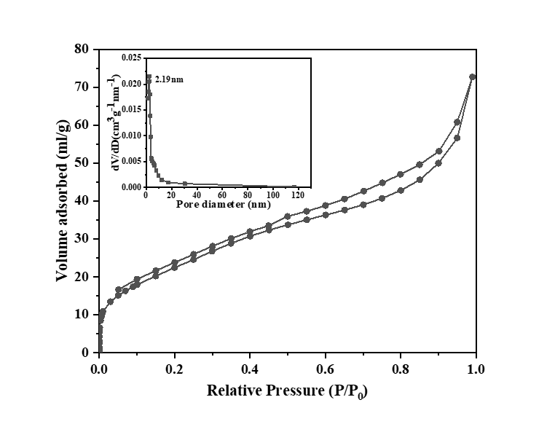

Figure S1. Nitrogen absorption isotherms of the as-synthesized GNR@mSiO2.

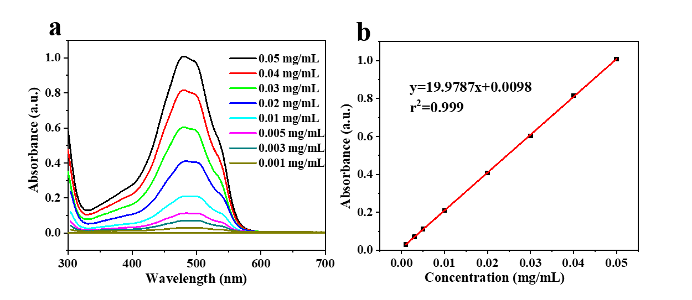

Fig S2 (a) UV-Vis curves of DOX at different concentrations. (b) Calibration curve used for estimation of DOX.

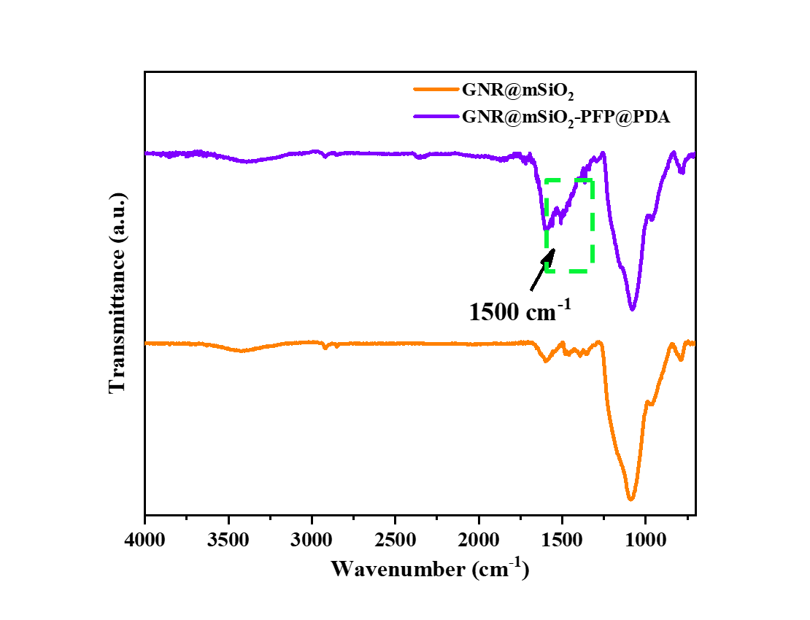

Figure S3. FTIR spectra of GNR@mSiO2 and GNR@mSiO2-DOX/PFP@PDA.

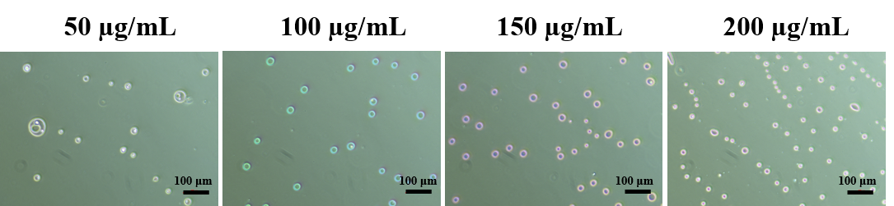

Figure S4. Microscopic images of microbubbles at different concentrations.

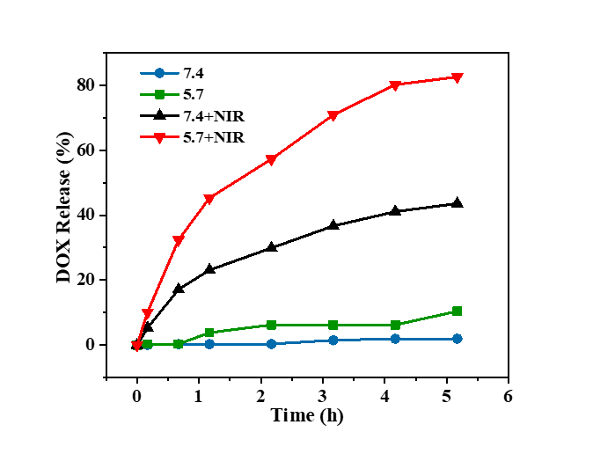

Figure S5. Release profiles from GNR@mSiO2-DOX/PFP at different pH values with or without NIR.



Figure S6. Cell cytotoxicity of normal cells (BALB/3T3) without NIR or with NIR (power density of 2 W/cm2) for 5 min.

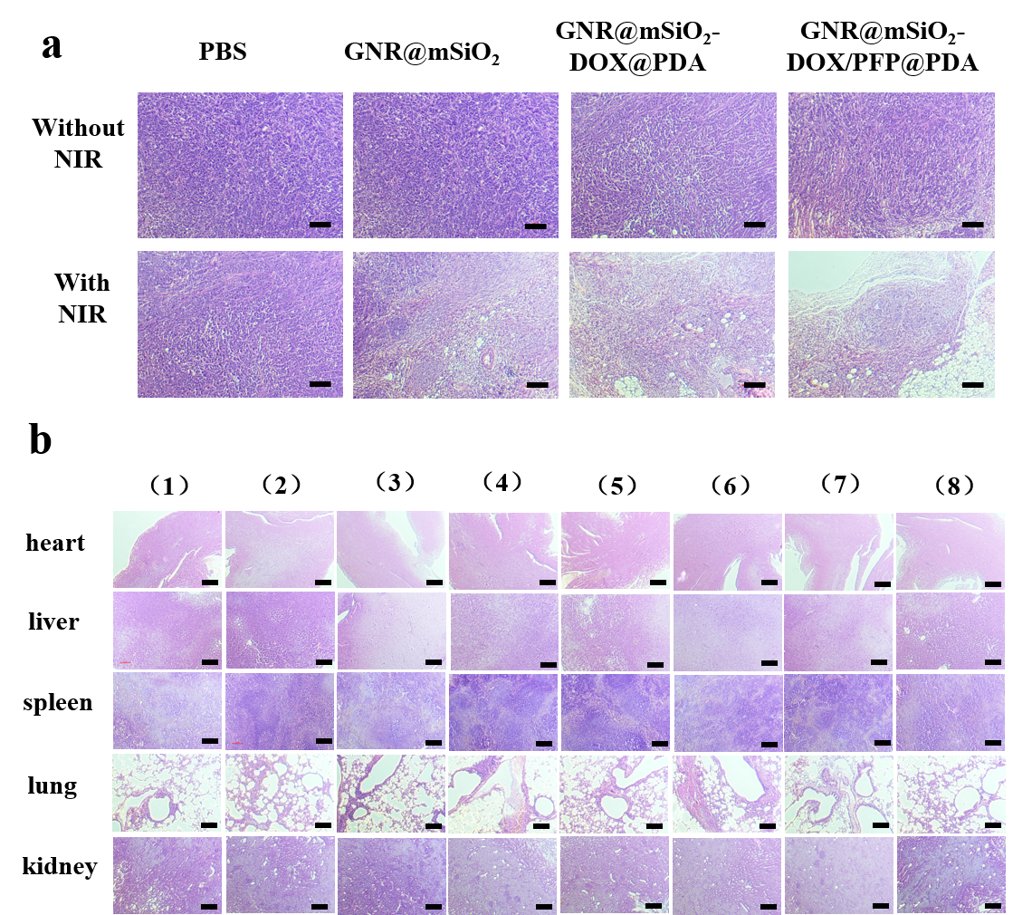

Figure S7. (a) H&E staining images of tumor sections after different treatments. (b) H&E-stained major organ tissue slices after different treatments. (Scale bar = 150 μm)