SUPPLEMENTARY MATERIAL FOR:

Diet variation in a critically-endangered marine predator revealed with stable isotope analysis
Courtney Ogilvy¹, Rochelle Constantine^{1,2}, Sarah J. Bury³, Emma L. Carroll^{1*}
¹ School of Biological Sciences, University of Auckland/Waipapa Taumata Rau, Auckland 1010, New Zealand
² Institute of Marine Science, University of Auckland/Waipapa Taumata Rau, Auckland 1010, New Zealand
³ National Institute of Water & Atmospheric Research, Greta Point, Wellington 6021, New Zealand

Indigenous rights statement
This research was done in consultation with mana whenua of the Hauāuru – Taranaki, Tainui – Waikato, Tāmaki – Auckland, and Te Tai Tokerau – Northland regions of Aotearoa – New Zealand. The authors of this work recognise the rights of Indigenous peoples to make decisions about the future use of information, biological collections, data and digital sequence information that derives from associated lands, waters and territories. To support the practice of proper and appropriate acknowledgement into the future of these rights, we request that those seeking to reuse these data contact RC r.constantine@auckland.ac.nz ahead of use and publication.

Electronic Supplementary Material 1: Standards and normalisation methods for stable isotope analysis

At Isotrace NZ Ltd, raw isotope ratios were normalised by three-point calibration to the international scales using two IAEA (International Atomic Energy Agency) reference materials and a laboratory standard, assayed with the unknown samples. The standards used were USGS-40 and USGS-41 and the given delta values of these standards are as follows:
 | ∂¹⁵N | ∂¹³C
USGS-40 | -4.52 | -26.24
USGS-41 | 47.57 | 37.76
EDTA-OAS | -0.73 | -38.52

The laboratory standard, EDTA-OAS (Elemental Microanalysis Ltd, UK) has multi-year and multi-laboratory calibration records against IAEA reference materials. EDTA-OAS was also used as a drift control material by assaying a pair of aliquots after every twelve samples of a batch. Instrumental drift corrections (when applied) are calculated from regression of the EDTA-OAS against time.

Precision was assessed from the root-mean square difference between sequential duplicates* of every 10th sample; accuracy was assessed by random inclusion of three true control materials chosen to mimic the nature of the sample materials. The typical precision for analysis of control materials was ± 0.2 ‰ for ∂¹⁵N and ± 0.1 ‰ for ∂¹³C.

At NIWA, raw ∂¹⁵N values were two point normalised following Paul et al. (2007) using isotopic data from the daily analysis of National Institute of Standards and Technology (NIST) 8573 USGS40 L-glutamic acid and NIST 8545 IAEA-N2 ammonium sulphate. Raw ∂¹³C values were two point normalised using isotopic data from the daily analysis of NIST 8573 USG40 L-glutamic acid and NIST 8542 IAEA-CH-6 Sucrose. For the NIWA laboratory, standards were always accurate to better than 0.1 ‰ for ∂¹⁵N and ∂¹³C and precision was ± 0.1 ‰ for ∂¹⁵N and ± 0.2 ‰ for ∂¹³C.

*“Uncertainty of measurement, precision and limits of detection in chemical and microbiological testing laboratories.” Technical Guide AS TG5, International Accreditation New Zealand. www.ianz.govt.nz

Paul, D., Skrzypek, G. and Fórizs, I., 2007. Normalization of measured stable isotopic compositions to isotope reference scales - a review. Rapid Communications in Mass Spectrometry 21, 3006-3014 (doi: https://10.1002/rcm.3185).

Table S1. Overview of prey data used for trophic level calculation and Bayesian mixing models.

Species | Common Name | n | Year |  |  |  | ∂¹⁵N ± s.d (‰) | ∂¹³C ± s.d (‰) | Trophic Level | Source Membership
 |  |  | 2012 | 2014 | 2015 | 2021
Aldrichetta forsteri | Yellow-eyed mullet | 14 | - | - | 14 | - | 12.6 ± 0.3 | -18.7 ± 1.2 | 4.17 | Pelagic-Tier 1
Arripis trutta | Kahawai (adult) | 7 | - | - | - | 7 | 14.7 ± 0.6 | -18.3 ± 0.4 | 5.43 | Shelf-Benthopelagic-Tier2
Arripis trutta | Kahawai (juvenile) | 6 | 6 | - | - | - | 14.6 ± 0.3 | -17.2 ± 0.5 | 5.35 | Inshore-Benthopelagic-Tier 2
Chelidonichthys kumu | Gurnard | 21 | 10 | - | - | 11 | 14.4 ± 0.4 | -17.3 ± 0.5 | 5.22 | Inshore-Benthopelagic-Tier 2
Chironemus marmoratus | Kelp fish | 2 | - | - | - | 2 | 14.6 ± 0.2 | -17.6 ± 0.1 | 5.36 | Inshore-Benthopelagic-Tier 2
Nemadactylus macropterus | Tarakihi | 11 | - | - | - | 11 | 14.3 ± 0.3 | -18.3 ± 0.5 | 5.17 | Shelf-Benthopelagic-Tier 2
Pagrus auratus | Snapper | 16 | - | 1 | 9 | 6 | 15.4 ± 1.2 | -17.5 ± 0.7 | 5.81 | Inshore-Demersal-Tier 3
Parapercis colias | Blue cod | 10 | - | 6 | 4 | - | 13.7 ± 0.2 | -18.2 ± 0.3 | 4.80 | Shelf-Benthopelagic-Tier 1
Pelotretis flavilatus | Lemon sole | 4 | - | - | - | 4 | 14.0 ± 0.4 | -18.0 ± 0.4 | 4.96 | Shelf-Benthopelagic-Tier 1
Peltorhamphus novaezeelandiae | New Zealand sole | 13 | 11 | - | - | 2 | 14.0 ± 0.4 | -17.3 ± 0.4 | 4.99 | Inshore-Benthopelagic-Tier 2
Perna canaliculus | Green lipped mussel (baseline) | 10 | - | 10 | - | - | 9.0 ± 0.2 | -17.5 ± 0.7 | 2.00 | N/A
Pseudocaranx dentex | Trevally | 6 | - | - | - | 6 | 14.8 ± 0.5 | -17.4 ± 0.4 | 5.47 | Inshore-Benthopelagic-Tier 2
Pseudolabrus miles | Scarlett wrasse | 12 |  |  | 10 | 2 | 14.1 ± 0.3 | -17.8 ± 0.4 | 5.03 | Shelf-Benthopelagic-Tier 1
Rhombosolea plebeia | Sand flounder | 12 | 12 | - | - | - | 14.1 ± 0.3 | -17.3 ± 0.5 | 5.02 | Inshore-Benthopelagic-Tier 2
Scorpis lineolata | Silver sweep | 14 | - | - | 10 | 4 | 13.1 ± 0.4 | -19.2 ± 0.5 | 4.47 | Pelagic-Tier 1
Sprattus muelleri | Sprat | 13 | - | - | - | 13 | 13.6 ± 0.7 | -18.1 ± 0.5 | 4.74 | Shelf-Benthopelagic-Tier 1
Trachurus spp. | Jack mackerel | 5 | 5 | - | - | - | 13.8 ± 0.7 | -18.0 ± 0.4 | 4.87 | Shelf-Benthopelagic-Tier 1
Total |  | 176 | 44 | 17 | 47 | 68

Table S2. Kruskal-Wallis test results comparing ∂¹³C and ∂¹⁵N values of Māui dolphin skin samples by year of sample collection. Results shown below were used to pool together sampling years which were not significantly different. Significant differences are indicated by asterisks.
Year comparison | ∂¹³C |  |  | ∂¹⁵N
 | χ² | df | p-value | χ² | df | p-value
1993-2008 | 7.06 | 5 | 0.22 | 2.21 | 5 | 0.82
2010 and 2011 | 0.47 | 1 | 0.49 | 0.41 | 1 | 0.52
2015 and 2016 | 0.17 | 1 | 0.68 | 0.44 | 1 | 0.51
2020 and 2021 | 6.22 | 1 | 0.01* | 0.02 | 1 | 0.91

Table S3. Post Hoc Dunn's multiple pairwise comparisons test comparing ∂¹⁵N values of 101 Māui dolphin skin samples by year of sample collection. Within each cell is the Dunn's pairwise z-test statistic (above) and the associated p-value (below), with significant differences indicated by asterisks.

∂¹³C | Pre-2008 | 2010-2011 | 2015-16 | 2020
Pre-2008 | - | - | - | -
2010-11 | -3.074910  (0.0011)* | - | - | -
2015-16 | -1.993600  (0.0231)* | -1.476150  (0.0700) | - | -
2020 | -4.007931  (0.0000)* | 1.640550  (0.0504) | 2.818111  (0.0024)* | -
2021 | -6.243151  (0.0000)* | 4.397845  (0.0000)* | 5.629040  (0.0000)* | 2.269202  (0.0116)*

Table S4. Post Hoc Dunn's multiple pairwise comparisons test comparing ∂¹⁵N values of 103 Māui dolphin skin samples by year of sample collection. Within each cell is the Dunn's pairwise z-test statistic (above) and the associated p-value (below), with significant differences indicated by asterisks.

∂¹⁵N | Pre-2008 | 2010-11 | 2015-16 | 2020
Pre-2008 | - | - | - | -
2010-11 | -2.394433  (0.0083)* | - | - | -
2015-16 | -1.976434  (0.0241)* | -0.570631  (0.2841) | - | -
2020 | -2.808742  (0.0025)* | 0.888819  (0.1870) | 1.344026  (0.0895) | -
2021 | -3.423855  (0.0003)* | 1.605606  (0.0542) | 2.081545  (0.0187)* | 0.572088  (0.2836)

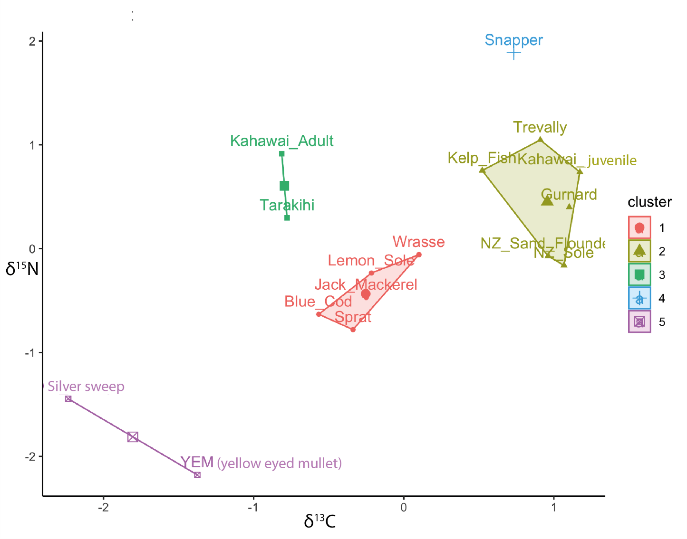
Figure S1. Scatterplot showing how mean ∂¹³C and ∂¹⁵N values for each species were grouped into five prey sources with hierarchical cluster analysis (Ward’s minimum variance method). Note the x and y axes have been standardised to make variables comparable. See Table S1 for species scientific names.

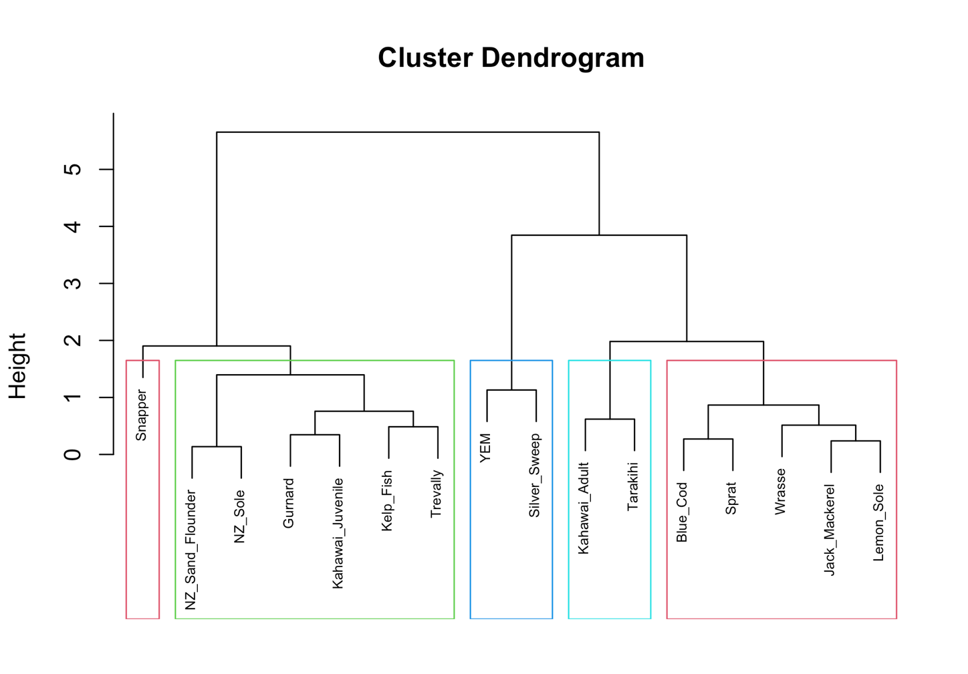
Figure S2. Dendrogram showing how mean ∂¹³C and ∂¹⁵N values for each species were grouped into five prey sources with hierarchical cluster analysis (Ward’s minimum variance method). Yellow-eyed mullet has been abbreviated to YEM.

Table S5: Complete dataset of Māui dolphin skin samples included in bulk stable isotope analysis

Indiv. ID: The unique identifier for every Māui dolphin as determined by genotyping;
Sex: Genetically determined sex; ‘Preg’ = pregnant;
Live or dead: Status of Māui dolphin at time of sample collection;
Date: The date the sample was collected, in the format dd-mmm-yy;
Sample Code: The field sample code;
∂¹⁵N: Unadjusted stable isotope ratio of ¹⁵N determined by Isotrace NZ Ltd;
∂¹³C: Unadjusted stable isotope ratio of ¹³C determined by Isotrace NZ Ltd;
C:N Ratio: Ratio of raw ¹³C to ¹⁵N, determined by Isotrace NZ Ltd and used to assess successful lipid extraction;
Latitude and Longitude: GPS-determined location of sample collection.
Indiv ID | Sex | Live or Dead | Date  dd-mmm-yy | Sample Code | ∂¹⁵N | ∂¹³C | C:N Ratio | Latitude | Longitude
Unknown 1 | F (preg) | D | 26-Aug-93 | CheNI01 | 16.41 | -15.30 | 3.1 | N/A | N/A
9 | M | L | 30-Jan-01 | NI37 | 16.09 | -15.07 | 3.0 | N/A | N/A
19 | M | L | 02-Feb-01 | NI54 | 16.78 | -14.91 | 3.0 | N/A | N/A
17 | M | L | 16-Feb-01 | NI47 | 17.91 | -13.59 | 2.9 | -36.8848 | 174.4376
27 | M | D | 21-Feb-02 | NI61 | 16.82 | -15.37 | 3.1 | -37.0443 | 174.5772
19 | M | L | 01-Jan-03 | NI72 | 18.95 | -12.73 | 2.8 | N/A | N/A
19 | M | L | 22-Mar-03 | NI80 | 16.85 | -15.15 | 3.0 | N/A | N/A
40 | M | L | 03-Apr-03 | NI84 | 16.24 | -15.30 | 3.0 | N/A | N/A
17 | M | D | 04-Jun-03 | NI92 | 16.68 | -15.34 | 3.2 | -36.8848 | 174.4376
50 | M | D | 13-Nov-06 | Chem06NZ02 | 18.26 | -15.02 | 3.2 | -37.3905 | 174.70817
51 | F | D | 03-Dec-06 | Chem06NZ04 | 16.96 | -15.13 | 3.2 | -37.28423 | 174.65421
52 | F | D | 03-Dec-06 | Chem06NZ05 | 18.88 | -14.44 | 3.2 | N/A | N/A
54 | F | D | 10-Nov-07 | Chem07NZ01 | 16.36 | -15.94 | 3.1 | -37.823 | 174.8193
55 | F | L | 04-Feb-10 | ChemNI10-01 | 16.37 | -16.00 | 3.1 | -37.1782 | 174.588017
59 | M | L | 06-Feb-10 | ChemNI10-06 | 15.94 | -16.44 | 3.1 | -37.196056 | 174.592778
60 | F | L | 06-Feb-10 | ChemNI10-09 | 16.79 | -15.66 | 3.0 | -37.274417 | 174.642028
61 | M | L | 06-Feb-10 | ChemNI10-10 | 16.86 | -15.43 | 3.0 | -37.273444 | 174.640972
22 | F | L | 07-Feb-10 | ChemNI10-14 | 15.33 | -16.46 | 3.1 | -37.228167 | 174.615667
57 | F | L | 07-Feb-10 | ChemNI10-12 | 16.41 | -16.53 | 3.2 | -37.165217 | 174.584783
64 | M | L | 07-Feb-10 | ChemNI10-16 | 15.95 | -16.39 | 3.2 | -37.20755 | 174.60445
66 | M | L | 08-Feb-10 | ChemNI10-20 | 16.38 | -16.06 | 3.1 | -36.737783 | 174.362467
67 | F | L | 09-Feb-10 | ChemNI10-21 | 16.65 | -15.96 | 3.0 | -36.652667 | 174.301667
69 | F | L | 11-Feb-10 | ChemNI10-26 | 16.72 | -15.34 | 3.0 | -37.3625 | 174.683667
70 | M | L | 11-Feb-10 | ChemNI10-27 | 15.75 | -16.23 | 3.2 | -37.3625 | 174.6875
71 | M | L | 16-Feb-10 | ChemNI10-28 | 15.35 | -16.99 | 3.1 | -37.591833 | 174.759
72 | M | L | 16-Feb-10 | ChemNI10-32 | 16.05 | -16.96 | 3.2 | -37.537467 | 174.746933
32 | M | L | 23-Feb-10 | ChemNI10-36 | 17.64 | -14.13 | 2.8 | -37.593967 | 174.766117
58 | F | L | 14-Feb-11 | ChemNI11-04 | 16.65 | -16.05 | 3.0 | -37.1307 | 174.5662
62 | F | L | 14-Feb-11 | ChemNI11-05 | 16.62 | -15.86 | 3.0 | -37.129067 | 174.564583
63 | F | L | 14-Feb-11 | ChemNI11-02 | 16.20 | -16.07 | 3.1 | -37.17615 | 174.584817
76 | F | L | 14-Feb-11 | ChemNI11-01 | 16.29 | -16.25 | 3.1 | -37.177683 | 174.583917
65 | F | L | 15-Feb-11 | ChemNI11-06 | 16.28 | -15.97 | 3.1 | -37.1382 | 174.5657
77 | M | L | 17-Feb-11 | ChemNI11-09 | 15.82 | -16.18 | 3.1 | -37.582433 | 174.76605
74 | M | L | 18-Feb-11 | ChemNI11-10 | 15.29 | -16.56 | 3.1 | -37.470867 | 174.713583
78 | F | L | 18-Feb-11 | ChemNI11-14 | 16.24 | -16.56 | 3.1 | -37.21655 | 174.607467
80 | F | L | 20-Feb-11 | ChemNI11-20 | 16.43 | -15.82 | 3.0 | -36.582167 | 174.246
9 | M | L | 21-Feb-11 | ChemNI11-26 | 16.09 | -16.80 | 3.1 | -37.255833 | 174.62835
81 | M | L | 21-Feb-11 | ChemNI11-21 | 16.23 | -16.66 | 3.1 | -37.098167 | 174.546333
84 | F | L | 21-Feb-11 | ChemNI11-25 | 15.53 | -16.73 | 3.0 | -37.25805 | 174.632483
86 | M | L | 28-Feb-11 | ChemNI11-30 | 16.00 | -15.97 | 3.0 | -37.444567 | 174.700633
71 | M | L | 09-Mar-11 | ChemNI11-35 | 16.40 | -16.34 | 3.0 | -37.459467 | 174.708267
87 | M | L | 09-Mar-11 | ChemNI11-33 | 15.74 | -16.46 | 3.0 | -37.541583 | 174.746117
67 | F | L | 10-Mar-11 | ChemNI11-36 | 17.17 | -16.04 | 3.0 | -36.5838 | 174.2371
57 | F | L | 12-Feb-15 | Chem15NZ07 | 19.20 | -13.13 | 2.8 | -37.09694 | 174.54085
65 | F | L | 12-Feb-15 | Chem15NZ05 | 15.69 | -16.99 | 3.1 | -37.09629 | 174.53978
90 | M | L | 13-Feb-15 | Chem15NZ10 | 16.19 | -16.00 | 3.0 | -37.2198 | 174.60982
95 | F | L | 14-Feb-15 | Chem15NZ17 | 15.30 | -16.58 | 3.0 | -37.14496 | 174.56761
60 | F | L | 17-Feb-15 | Chem15NZ36 | 18.35 | -14.26 | 2.8 | -37.1874 | 174.5887
62 | F | L | 17-Feb-15 | Chem15NZ24 | 15.79 | -16.38 | 3.0 | -37.12299 | 174.56125
63 | F | L | 17-Feb-15 | Chem15NZ27 | 15.72 | -16.11 | 3.0 | -37.12299 | 174.56125
64 | M | L | 17-Feb-15 | Chem15NZ26 | 15.85 | -16.30 | 3.0 | -37.12299 | 174.56125
74 | M | L | 17-Feb-15 | Chem15NZ34 | 15.46 | -16.89 | 3.0 | -37.18737 | 174.58871
77 | M | L | 17-Feb-15 | Chem15NZ35 | 16.08 | -16.48 | 3.0 | -37.18737 | 174.58871
100 | F | L | 17-Feb-15 | Chem15NZ25 | 16.63 | -16.74 | 3.1 | -37.12299 | 174.56125
61 | M | L | 27-Feb-15 | Chem15NZ43 | 18.43 | -13.86 | 2.8 | -37.21597 | 174.60443
86 | M | L | 27-Feb-15 | Chem15NZ41 | 17.94 | -13.42 | 2.8 | -37.18157 | 174.58987
104 | F | L | 27-Feb-15 | Chem15NZ39 | 17.44 | -15.13 | 2.9 | -37.18157 | 174.58987
101 | F | L | 11-Feb-16 | Chem16NZ02 | 16.17 | -16.14 | 3.1 | -37.11540 | 174.55277
78 | F | L | 12-Feb-16 | Chem16NZ04 | 16.12 | -15.92 | 3.1 | -37.17673 | 174.58388
102 | F | L | 12-Feb-16 | Chem16NZ08 | 18.57 | -14.06 | 2.8 | -37.17920 | 174.58277
110 | F | L | 12-Feb-16 | Chem16NZ07 | 15.82 | -16.26 | 3.1 | -37.17995 | 174.58860
91 | F | L | 13-Feb-16 | Chem16NZ10 | 18.47 | -14.19 | 2.8 | -37.19012 | 174.59083
107 | M | L | 14-Feb-16 | Chem16NZ17 | 15.65 | -16.60 | 3.2 | -37.16655 | 174.58230
111 | M | L | 14-Feb-16 | Chem16NZ13 | 17.77 | -14.49 | 2.9 | -37.16727 | 174.57667
69 | F | L | 15-Feb-16 | Chem16NZ24 | 16.66 | -15.43 | 3.0 | -37.15175 | 174.57302
94 | F | L | 24-Feb-16 | Chem16NZ34 | 16.05 | -16.29 | 3.0 | -37.59573 | 174.76562
103 | F | L | 24-Feb-16 | Chem16NZ32 | 15.83 | -16.28 | 3.1 | -37.41277 | 174.68930
84 | F | L | 27-Feb-16 | Chem16NZ38 | 18.12 | -13.73 | 2.8 | -37.1436 | 174.5729
55 | F | L | 03-Mar-16 | Chem16NZ39 | 16.05 | -17.01 | 3.1 | -37.13853 | 174.54922
76 | F | L | 03-Mar-16 | Chem16NZ40 | 16.12 | -16.82 | 3.3 | -37.15620 | 174.57860
3 | M | L | 05-Mar-16 | Chem16NZ42 | 16.24 | -15.60 | 3.0 | -37.09238 | 174.53830
9 | M | L | 05-Mar-16 | Chem16NZ43 | 15.98 | -16.34 | 3.0 | -37.14847 | 174.57460
115 | M | L | 05-Mar-16 | Chem16NZ47 | 18.69 | -13.77 | 2.8 | -37.12338 | 174.56175
78 | F | L | 11-Feb-20 | Chem20NZ01 | 16.02 | -16.47 | 3.1 | -37.2012 | 174.6039
102 | F | L | 12-Feb-20 | Chem20NZ06 | 15.92 | -16.81 | 3.1 | -37.1604 | 174.57730
91 | F | L | 13-Feb-20 | Chem20NZ39 | 16.25 | -16.76 | 3.0 | -36.5379 | 174.2025
100 | F | L | 13-Feb-20 | Chem20NZ11 | 17.25 | -15.81 | 3.0 | -36.5379 | 174.2025
66 | M | L | 14-Feb-20 | Chem20NZ17 | 17.24 | -15.61 | 3.0 | -36.5267 | 174.1940
69 | F | L | 17-Feb-20 | Chem20NZ32 | 15.86 | -17.53 | 3.1 | -37.2480 | 174.6263
101 | F | L | 17-Feb-20 | Chem20NZ22 | 15.49 | -16.97 | 3.1 | -37.2243 | 174.9392
103 | F | L | 17-Feb-20 | Chem20NZ33 | 17.00 | -15.96 | 2.9 | -37.2488 | 174.6267
104 | F | L | 17-Feb-20 | Chem20NZ31 | 15.50 | -17.48 | 3.0 | -37.2458 | 174.6255
115 | M | L | 17-Feb-20 | Chem20NZ24 | 16.27 | -16.64 | 3.1 | -37.1370 | 174.5632
3 | M | L | 21-Feb-20 | Chem20NZ41 | 15.51 | -17.04 | 3.1 | -37.3991 | 174.7018
107 | M | L | 21-Feb-20 | Chem20NZ40 | 16.52 | -15.74 | 2.9 | -37.4062 | 174.6986
94 | F | L | 27-Feb-20 | Chem20NZ46 | 15.84 | -16.98 | 3.0 | -37.4155 | 174.6955
95 | F | L | 27-Feb-20 | Chem20NZ50 | 15.05 | -17.76 | 3.1 | -37.4068 | 174.6980
129 | M | L | 13-Feb-21 | Chem21NZ01 | 15.93 | -17.43 | 3.0 | -37.11389 | 174.55183
77 | M | L | 14-Feb-21 | Chem21NZ13 | 16.09 | -17.30 | 3.0 | -37.16378 | 174.58189
91 | F | L | 14-Feb-21 | Chem21NZ11 | 15.85 | -17.45 | 3.1 | -37.15192 | 174.57506
98 | F | L | 14-Feb-21 | Chem21NZ05 | 16.17 | -17.06 | 3.0 | -37.14587 | 174.5639
106 | M | L | 14-Feb-21 | Chem21NZ10 | 15.79 | -17.31 | 3.0 | -37.19041 | 174.59486
133 | F | L | 14-Feb-21 | Chem21NZ04 | 16.32 | -17.32 | 3.0 | -37.14924 | 174.56798
104 | F | L | 20-Feb-21 | Chem21NZ19 | 16.16 | -17.23 | 3.1 | -37.19834 | 174.59862
135 | M | L | 20-Feb-21 | Chem21NZ21 | 15.88 | -17.32 | 3.1 | -37.13409 | 174.56316
64 | M | L | 22-Feb-21 | Chem21NZ24 | 15.98 | -17.36 | 3.1 | -37.18555 | 174.58804
101 | F | L | 22-Feb-21 | Chem21NZ23 | 15.98 | -17.07 | 3.1 | -37.18478 | 174.58699
44 | M | L | 27-Feb-21 | Chem21NZ29 | 16.01 | -17.01 | 3.0 | -36.5272 | 174.18703
66 | M | L | 27-Feb-21 | Chem21NZ28 | 16.26 | -16.84 | 3.1 | -36.538042 | 174.198166
94 | F | L | 28-Feb-21 | Chem21NZ31 | 16.01 | -17.17 | 3.1 | -37.37444 | 174.69438
32 | M | L | 13-Mar-21 | Chem21NZ32 | 15.63 | -17.31 | 3.1 | -37.59925 | 174.75858
102 | F | L | 15-Mar-21 | Chem21NZ34 | 16.11 | -17.17 | 3.1 | -37.41452 | 174.69543
134 | F | L | 15-Mar-21 | Chem21NZ33 | 15.72 | -17.34 | 3.0 | -37.41197 | 174.69478

