Moth wings as a sound absorber metasurface
Supplementary information

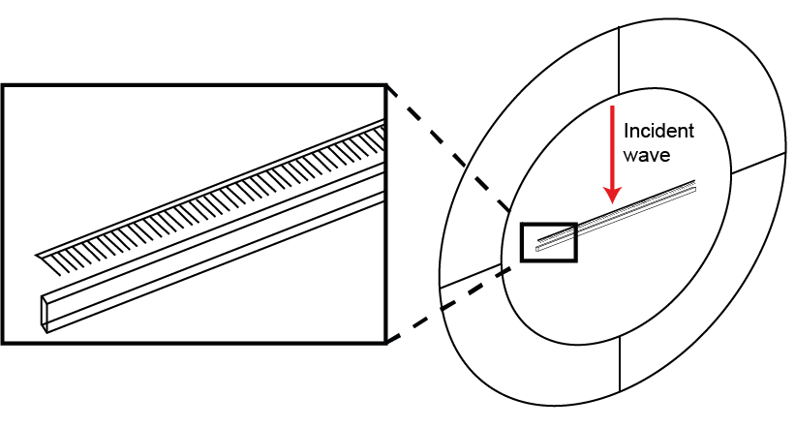
Supplementary figure 1: Scale array model to calculate the reflection directionality. The model contains a single 8 mm long row of scales with average dimensions enclosed in a disc-shaped air domain modelling the dorsal bald, dorsal ensonified condition.

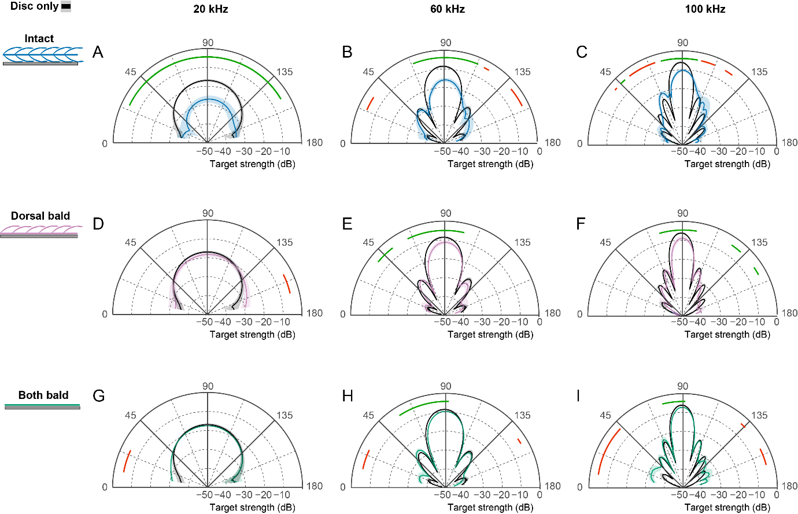
Supplementary figure 2: Target strength directionality at 20, 60 and 100 kHz (n = 5) between a metal disc (orange) and a wing covered disc (blue) when ensonified from the ventral surface, comparing A-C ‘Intact’, D-F ‘Dorsal bald’, G-I ‘Both bald’. Shaded areas represent standard error. Coloured lines indicate significant pairwise differences (p≤0.05; green lines = treatment is significantly less than metal disc, red line = metal disc is significantly less than treatment).

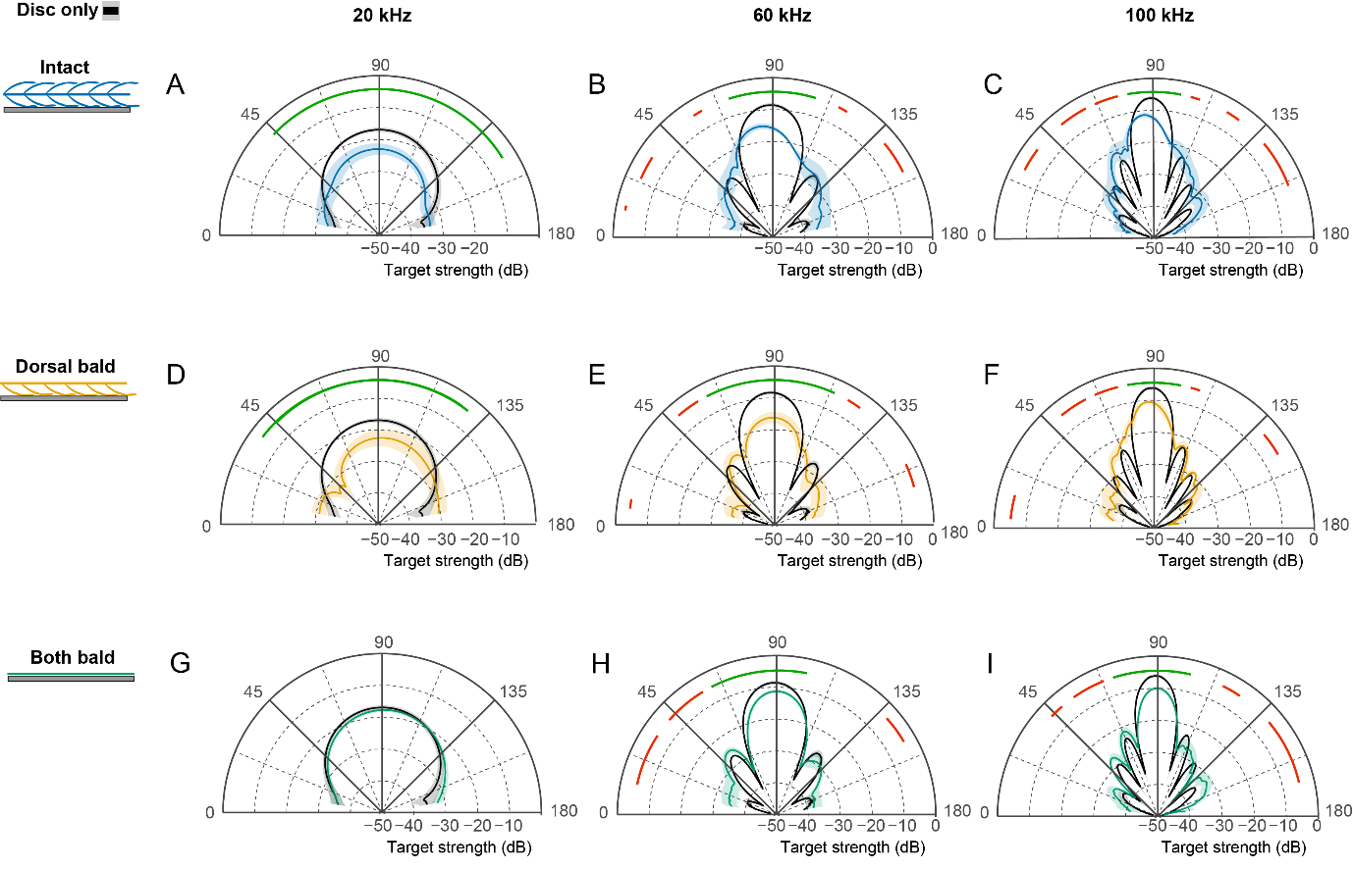
Supplementary figure 3: Target strength directionality at 20, 60 and 100 kHz (n = 5) between a metal disc (orange) and a wing covered disc (blue) when ensonified from the dorsal surface, comparing A-C ‘Intact’, D-F ‘Dorsal bald’, G-I ‘Both bald’. Shaded areas represent standard error. Coloured lines indicate significant pairwise differences (p≤0.05; green lines = treatment is significantly less than metal disc, red line = metal disc is significantly less than treatment).

Supplementary table 1: Morphometrics of scale layers and individual scales taken from the target wing section (n = 25 for scale morphometrics; five scales each from five moth individuals; n = 5 for layer thickness; one measurement from each wing section).
Dorsal surface | Base scales | Cover scales
Layer thickness (µm)  Scale length (µm) | 143.29±15.25  201.86±8.42 | 321.00±16.44  578.06±62.12
Scale width (µm) | 133.94±8.82 | 25.76±2.49
Aspect ratio | 1.53±0.13 | 25.44±2.80
Inter-ridge distance (µm) | 1.74±0.04 | 1.78±0.03
Cross-rib distance (µm) | 1.07±0.05 | 1.13±0.06
Ventral surface | Base scales | Cover scales
Layer thickness (µm)  Scale length (µm) | 155.46±6.57  200.94±4.24 | 342.79±17.96  833.15±61.28
Scale width (µm) | 110.19±5.07 | 14.61±1.77
Aspect ratio | 1.89±0.27 | 59.96±13.72
Inter-ridge distance (µm) | 1.81±0.02 | 1.79±0.03
Cross-rib distance (µm) | 1.04±0.05 | 1.09±0.04

