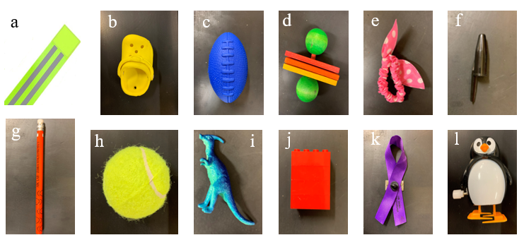

Figure 1. Detailed information about novel objects used (i.e., colour, dimensions, material, etc.). (Top row, a-f) 2016 novel objects: a) Day 1 - reflector ankle band, 33 cm long x 5 cm wide, folded in half with stripes facing up. b) Day 2 – yellow shoe, 7.62 cm long x 3.81 cm wide, toe pointed toward feeder. c) Day 3 – blue squishy football, 11.43 cm long x 6.35 cm wide, laces facing up. d) Day 4 – wooden barbell, 10.16 cm long x 8.89 cm wide, red side closest to feeder. e) Day 5 – pink bow, 11.43 cm long x 5.08 cm wide, bow closest to feeder. f) Day 6 – black pen cap taped to white cardboard (cardboard not pictured), 5.72 cm long, long end facing away from food dish. (Bottom row, g-l) 2018 novel objects: g) Day 1 – orange pencil, 18.42 cm long, eraser closest to feeder. h) Day 2 – small yellow tennis ball, 5.08 cm diameter. i) Day 3 – blue dinosaur, 3.8 cm tall x 3.cm wide, two dinosaurs on top of each other laying down facing the feeder, head pointed to feeder and stomach facing camera. j) Day 4 – red Legos, 3.18 cm wide, 3.81 cm tall, four were stacked and stood up parallel to perches. k) Day 5 – purple ribbon, 9.53 cm long, loop pointed toward back with pin facing up. l) Day 6 – black and white penguin toy, 7.62 cm tall x 6.35 cm wide, facing food dish.

