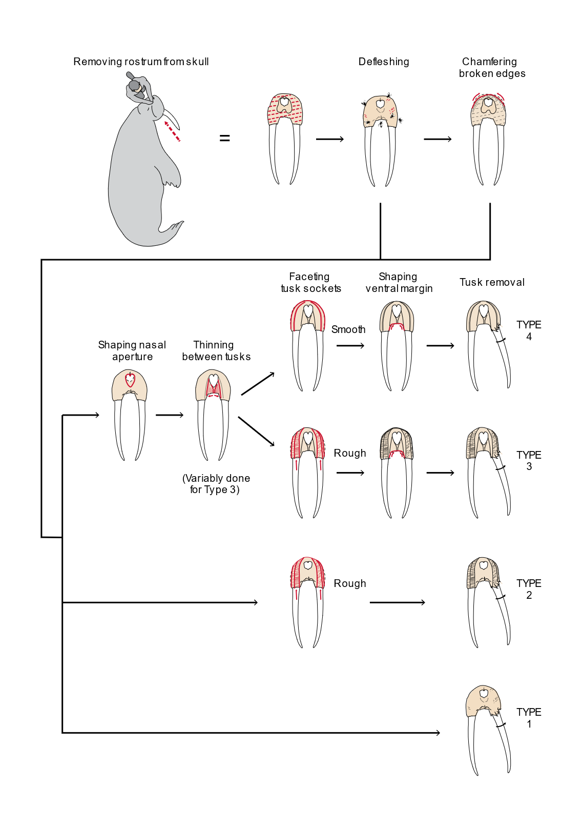
Figure S1. Chaîne opératoire typology entailing sets of increasingly elaborate steps used to remove and sculpt medieval walrus rostra found in Greenland and Europe. The Kyiv specimens have been classified using this scheme. Type 1 rostra were only modified by cut marks made during removal from the skull. In type 2, the tusk alveoli were thinned by rough parallel cuts that faceted the surface of each socket. Type 3 rostra also exhibit decorative carving of the nasal aperture. In type 4 the tusk sockets are smoothly rather than roughly facetted and the ventral margin between the tusks is always carved. Fragmentary rostra lacking some information can be attributed to broader categories (e.g. type 2/3). Image reproduced from Figure 2 of Barrett et al. [1], where it was published open access under the CC BY license (http://creativecommons.org/licenses/by/4.0/).
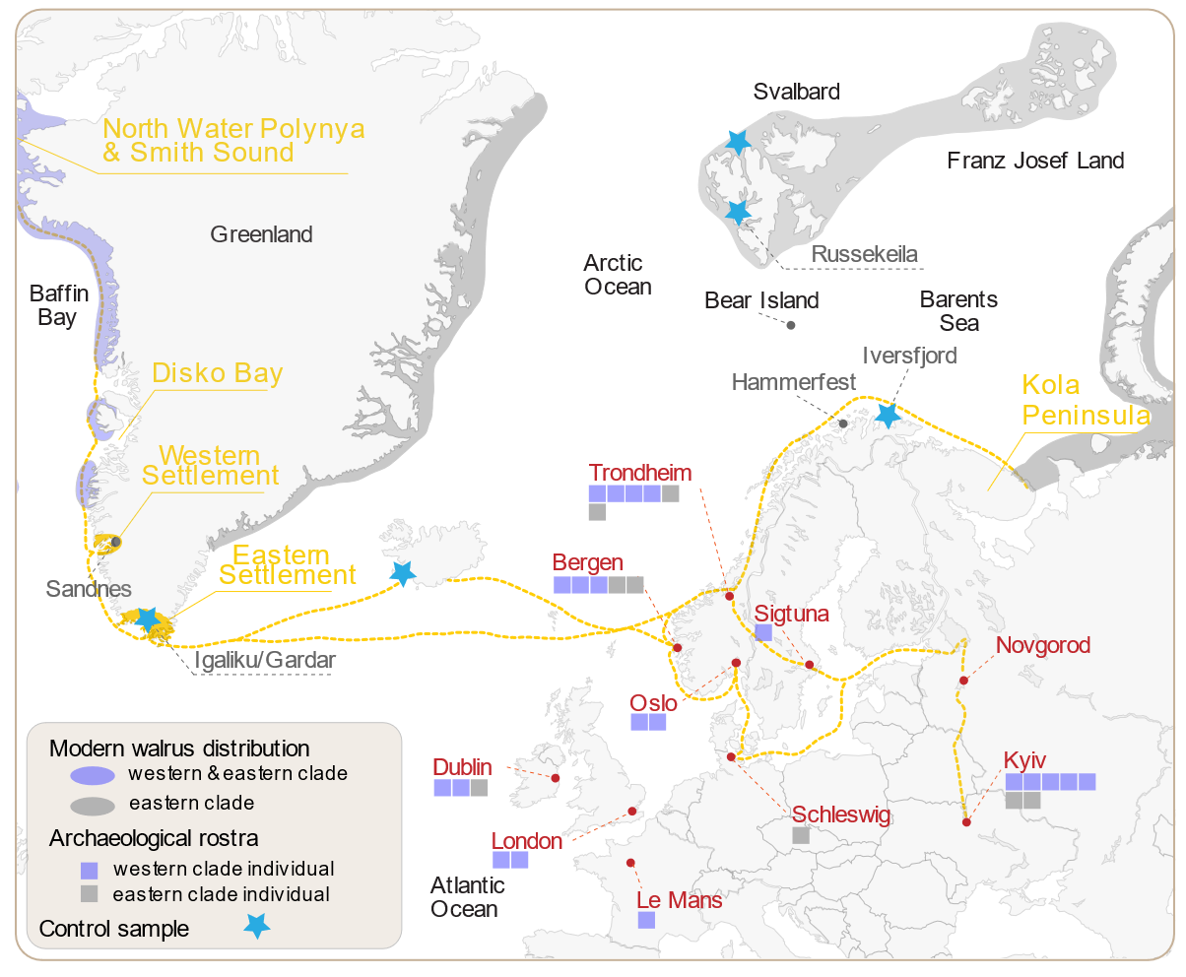

Figure S2. Distribution of medieval European finds of walrus rostra that have been genetically analysed. Potential medieval trade routes are also shown. Mitogenomic clade assignment is indicated for each specimen. Stars mark the locations of control samples from Greenland, Iceland, Finnmark and Svalbard. The modern distributions of the eastern and western genetic clades of Atlantic walrus are shaded. Base map after Barrett et al. [1] and references therein.

Reference
Barrett, J.H., Boessenkool, S., Kneale, C.J., O’Connell, T.C. & Star, B. 2020 Ecological globalisation, serial depletion and the medieval trade of walrus rostra. Quaternary Science Reviews 229, 106122. (doi:10.1016/j.quascirev.2019.106122).

