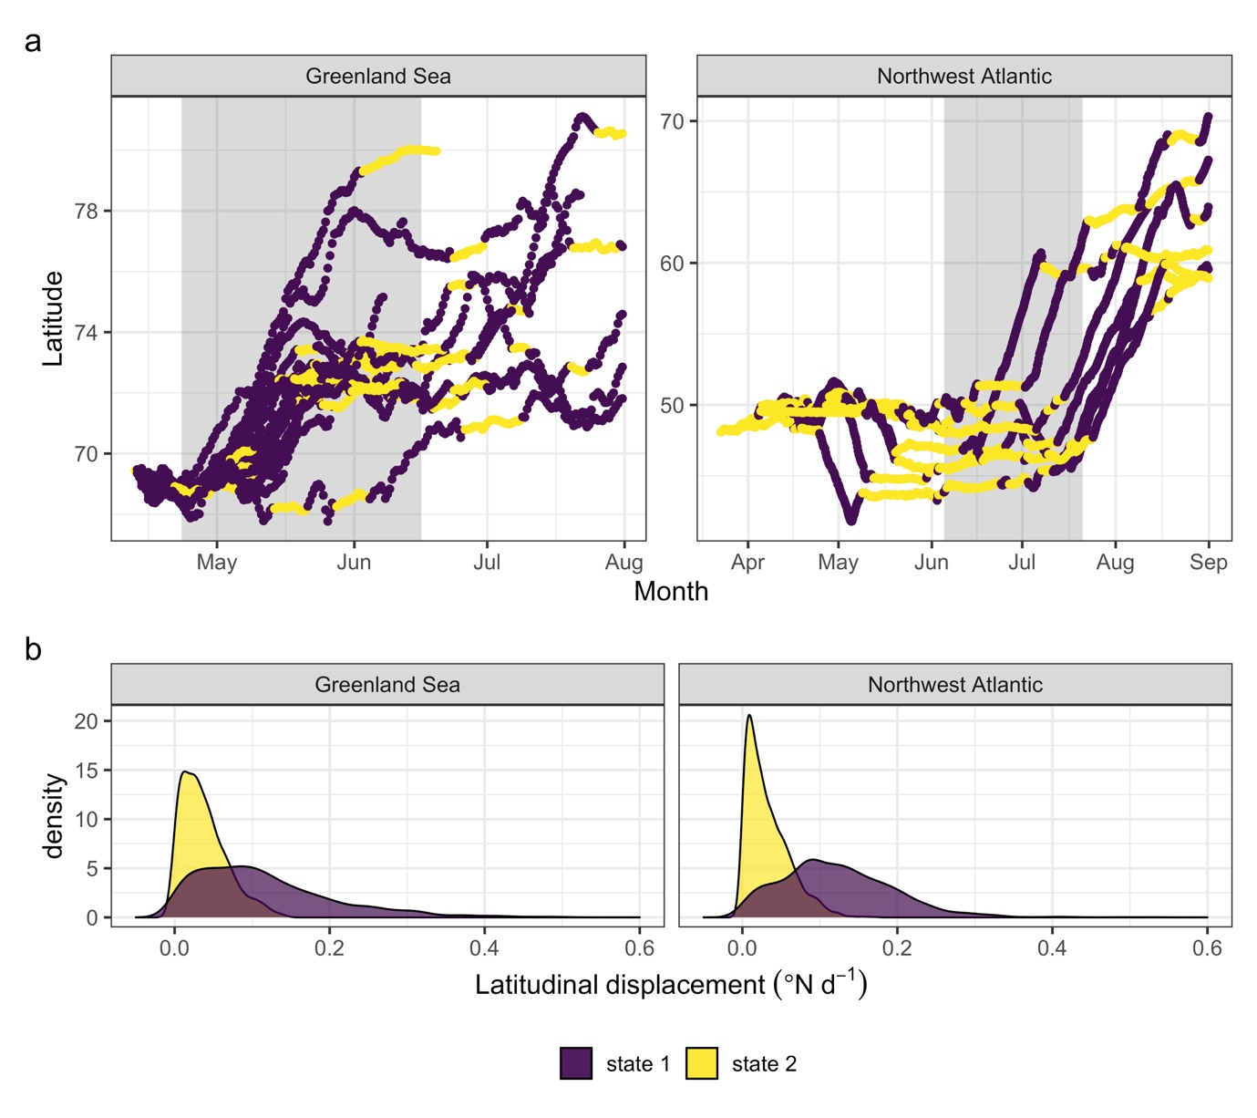
Supplementary Figure S1. Change in latitude during migration (a) for 25 juvenile harp seals tracked with satellite relay data loggers. Colours represent hidden-Markov model assigned states (see b); state one (darker colour) corresponds with larger displacements in latitude and state two (lighter colour) corresponds with smaller displacements in latitude. Commencement of migration was defined as a persistent switch to state 1, the range of departure dates is highlighted by the grey rectangle in (a).

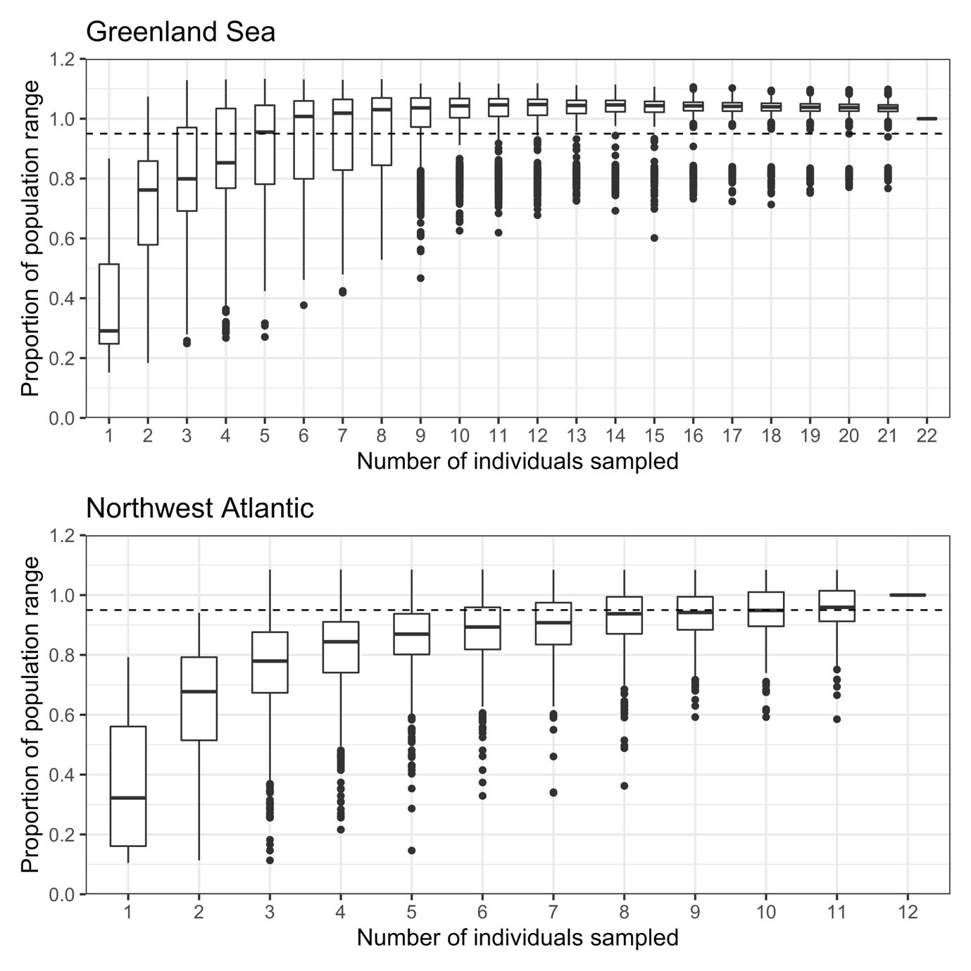
Supplementary Figure S2. Rarefaction curves for the distribution of juvenile harp seals estimated from telemetry data. The total area utilised by seals from each population was estimated from the 95% bivariate normal kernel utilisation distribution. The areas estimated from 1000 bootstrap samples of different numbers of tagged individuals were then calculated as the proportion the whole sample. Dashed line in both represents 0.95 of the population range. The asymptote in both plots indicates that deploying additional telemetry devices would be unlikely to change our estimate of the seals distribution.

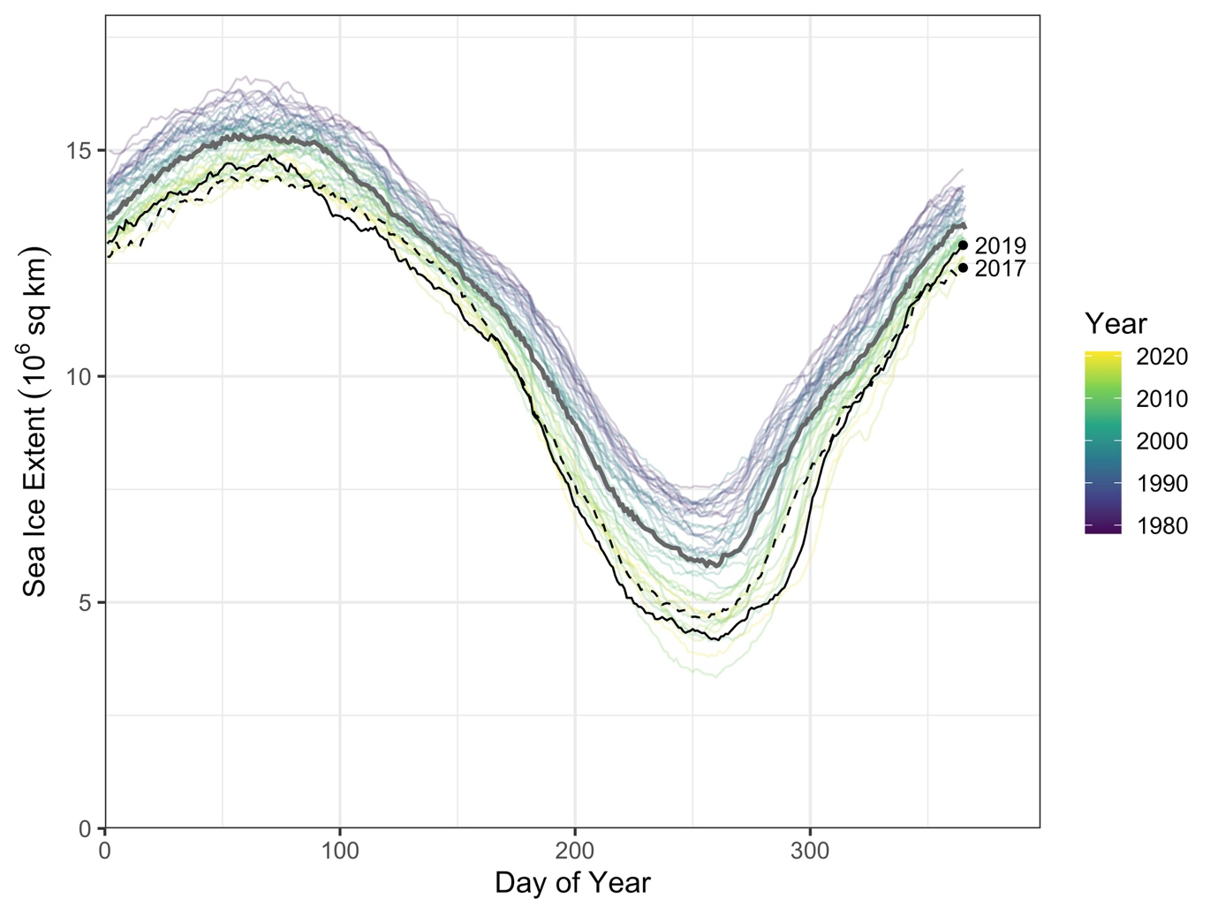
Supplementary Figure S3: Annual fluctuations in Arctic sea ice extent between 1978 and 2021. Each line represents an individual year and the median extent across years is shown as the thick grey line. The two deployment years are shown as dashed (2017) and solid (2019) black lines. The two years show similar fluctuations in sea ice and are below the long-term average in line with the long-term decline in Arctic sea ice. Data source: Fetterer F, Knowles K, Meier WN, Savoie M, Windnagel M&. 2017 Sea ice index, version 3. [2019-03-23 to 2020-02-14]. Boulder, Colorado USA: NSIDC: National Snow; Ice Data Center doi: https://doi.org/10.7265/N5K072F8

