Allee Effects and the Allee-effect Zone in Northwest Atlantic Cod
Supplementary material

Tommi Perälä^{1*}, Jeffrey A. Hutchings^{2,3,4}, Anna Kuparinen¹

¹ Department of Biological and Environmental Science, P.O. Box 35, 40014 University of Jyväskylä, Finland
² Department of Biology, Dalhousie University, 1355 Oxford Street, Halifax NS B3H 4R2, Canada
³ Institute of Marine Research, Flødevigen Marine Research Station, N-4817 His, Norway
⁴ Department of Natural Sciences, University of Agder, N-4604 Kristiansand, Norway

E-mail: Tommi Perälä tommi.a.perala@jyu.fi; Anna Kuparinen anna.k.kuparinen@jyu.fi; Jeffrey Hutchings jhutch@dal.ca

Correspondence: Tommi Perälä; tommi.a.perala@jyu.fi
Prior distributions
We use the prior distribution for the depensation parameters ($c$) developed by Perälä and Kuparinen [1], where the probability density function $π\left(c;u,q\right)$ of the distribution is a sigmoidal function bounded to the interval $[0,5]$ such that the probability of depensation equals the probability of compensation.
$$π\left(c;u,q\right)∝1+uq\frac{1-{\left(\frac{q+1}{q-1}\right)}^{2c-2}}{1+{\left(\frac{q+1}{q-1}\right)}^{2c-2}}$$
The parameter controlling the steepness of the descent is chosen to be $q=q^{*}=1.001$, and the parameter $u=u^{*}$ is then found numerically so that $\int_{0}^{1}{π\left(c;u^{*},q^{*}\right)dc}=P\left(c≤1\right)=P(c>1)=\int_{1}^{5}{π\left(c;u^{*},q^{*}\right)dc}$.

We use uniform priors for the scale parameters $σ^{2}$ of the lognormal distributions,
$$σ^{2} \sim U\left(0,σ_{upper}^{2}\right),$$
We analyzed the sensitivity of the models to the upper limit of the scale parameter by testing three different values $σ_{upper}^{2}∈\left\{1,\sqrt{2},2\right\}$. The choice of the upper limit had virtually no effect on the results, and thus we present the results only for $σ_{upper}^{2}=1$.

In the S-R data, the maximum number of recruits was $R_{max}=\max\left(R_{t}\right)=201,760,000$ and the maximum spawning stock biomass $S_{max}=\max\left(S_{t}\right)=195,870 t$. Thus, we set the upper bounds of the uniform prior distributions for the asymptotic maximum number of recruits $R_{∞}$ in BH and SBH models and maximum number of recruits $k$ in R and SL models to $R^{*}=400,000,000≈2∙R_{max}$. Similarly, we set the upper bounds of the uniform prior distributions for the spawning stock biomass which produced half of the asymptotic maximum number of recruits $S_{50}$ in BH and SBH models and the spawning stock biomass which produces the maximum number of recruits $S_{k}$ in R and SL models to $S^{*}=400,000 t≈2∙S_{max}$. To quantify the position of the Allee-effect threshold relative to observed and inferred maximum population sizes, we consider two values of $R^{*}$ and $S^{*}$. Given that St. Pierre Bank cod has been fished for several centuries [2,3], we suspect that the maximum observed S in the dataset may be less than the population’s carrying capacity. Based on a centuries-long analysis of catch data for another of Newfoundland’s cod populations [4], we set the inferred historic carrying capacity of St. Pierre Bank cod at 400,000 t, and also allowed greater recruitment than observed by setting $R^{*}=400,000,000$ and $S^{*}=400,000 t$. We also tested the sensitivity of the results by setting the values of $R^{*}$ and $S^{*}$ close to the maximum observed number or recruits and spawning stock biomass, i.e., ~200 million age-2 fish and ~200,000 tonnes, respectively.

Figures
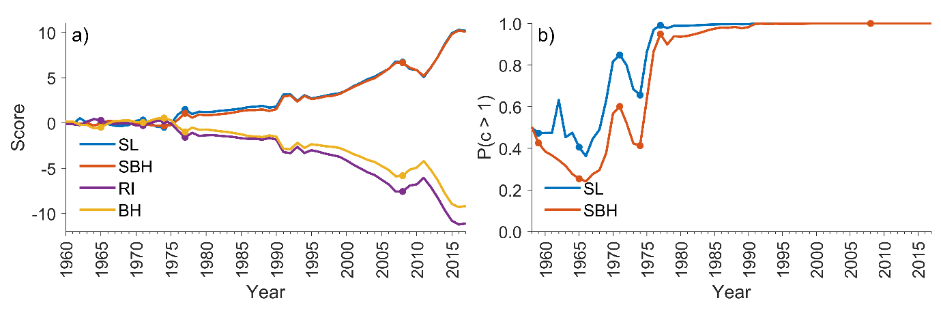
Fig. S1 Model comparison and evidence of depensation. a) Model comparison based on the Widely applicable information criterion (WAIC). WAIC is calculated for each year and for each model. The scores shown here are obtained by subtracting the mean of the models’ WAIC scores from the individual model WAIC scores. The scores for the compensatory models (RI – Ricker and BH – Beverton-Holt) start to decrease and the scores for the depensatory models (SL – Saila-Lorda and SBH – Sigmoidal Beverton-Holt) start to increase around 1976 which is the year after which the probability of depensation was greater than 0.9 for both depensatory models (panel b). b) Evidence of depensation measured using the posterior distribution of the depensation parameter $c$. Probability of the $c$ being larger than 1, which indicates depensation, is shown in the vertical axis. In both panels, the snapshot years of Fig 1 are shown with dots.

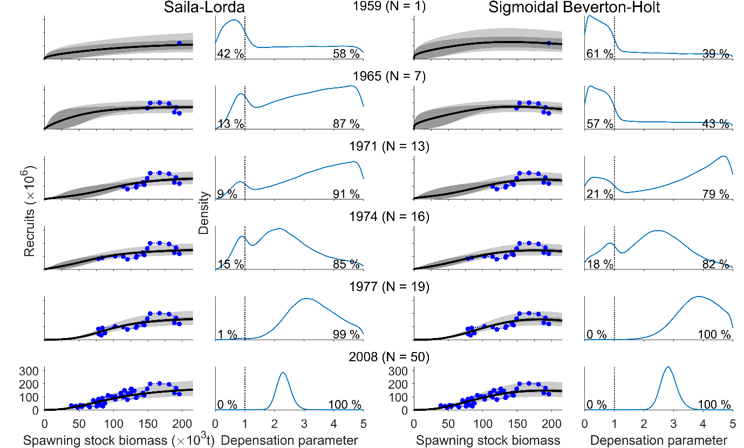
Fig. S2 Sensitivity analyses results for the snapshots of the model fitting process on selected years regarding the width of the support of the S-R model parameters using $R^{*}=200,000,000$ and $S^{*}=200,000 t$. The two leftmost columns present the snapshots for Saila-Lorda model and the two rightmost columns for Sigmoidal Beverton-Holt. For both models the column on the left shows the model fit to the data accumulated by a given year (year indicated at the top of each row). The column on the right shows the posterior probability density functions of the depensation parameter $c.$Annotations are the same as in Fig. 1.

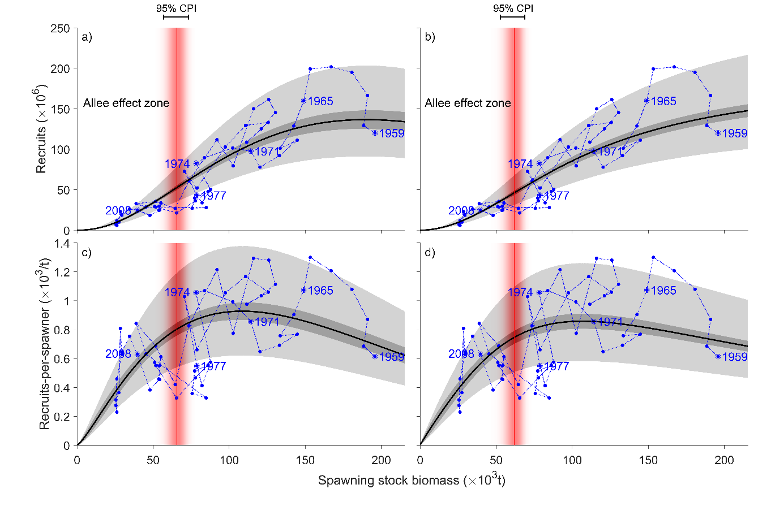
Fig. S3 Sensitivity analyses results for model fits and the Allee effect thresholds regarding the width of the support of the S-R model parameters using $R^{*}=200,000,000$ and $S^{*}=200,000 t$. The top row (panels a and b) shows recruitment versus spawning stock biomass whereas the bottom row (panels c and d) shows the number of recruits per unit of spawning stock biomass ($R/S$) versus spawning stock biomass. The left column (panels a and c) shows Saila-Lorda model, and the right column (panels b and d) shows Sigmoidal Beverton-Holt model. Annotations are the same as in Fig. 2.

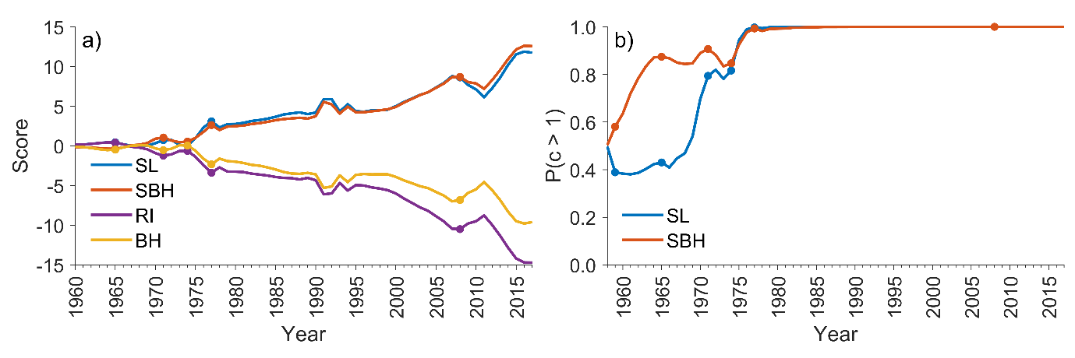
Fig. S4 Sensitivity analyses results for model comparison and evidence of depensation regarding the width of the support of the S-R model parameters using $R^{*}=200,000,000$ and $S^{*}=200,000 t$. a) Model comparison based on WAIC. b) Posterior probability of depensation. Annotations are the same as in Fig. S1.

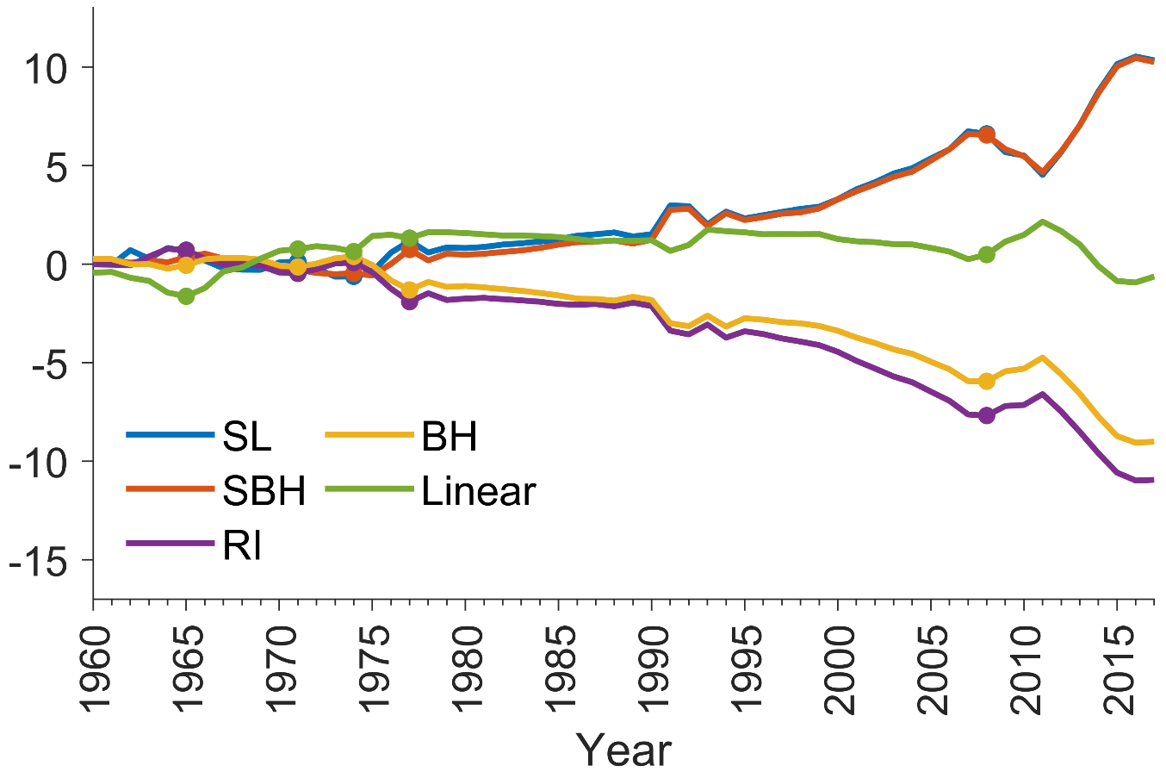Fig. S5 WAIC scores for comparing a null hypothesis of a linear model of the form $E\left(R_{t} | S_{t},α\right)=αS_{t}$ against the stock-recruitment models. The linear model outperforms the compensatory models but cannot explain the most recent years of low recruitment adequately. Here it is also noteworthy that WAIC penalizes models with high number of parameters, and that is the main reason why it seems that the linear model (1 parameter model) performs at times almost as well as the depensatory stock-recruitment models (SL and SBH, 3 parameter models).

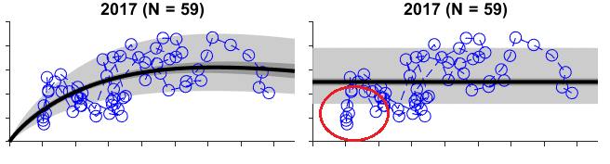Fig. S6 Poor performance of the linear model during the most recent years of low recruitment illustrated using the posterior predictive distribution of $R/S$ as a function of $S$. Even though the linear model (the right panel) fits the data relatively well on average, it drastically overestimates the recruits per spawner (vertical axis) during the years of low spawning stock biomass (horizontal axis) and low recruitment (circled with red). This is the critical zone where Allee effects might manifest and where overestimated recruitment predictions are especially dangerous. The depensatory Saila-Lorda model (the left panel) fits the data better not only on average but especially during the years of low recruitment and spawning stock biomass.
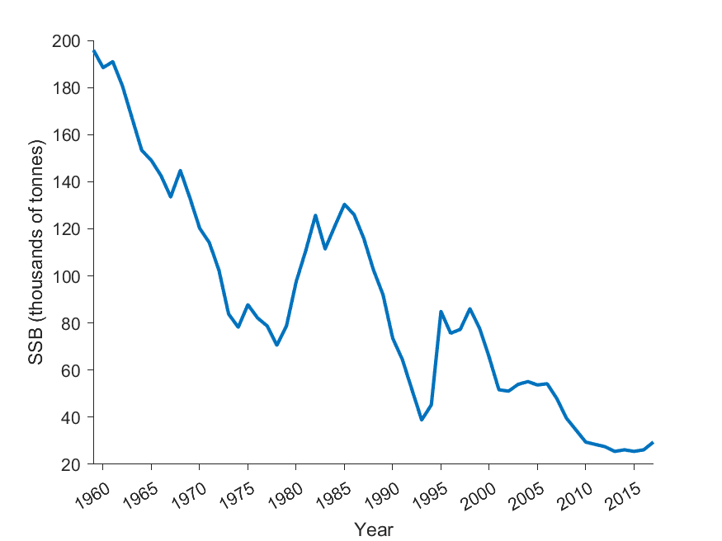
Fig. S7 Spawning stock biomass estimates of 3Ps cod extracted from the 2021 stock assessment report [5].

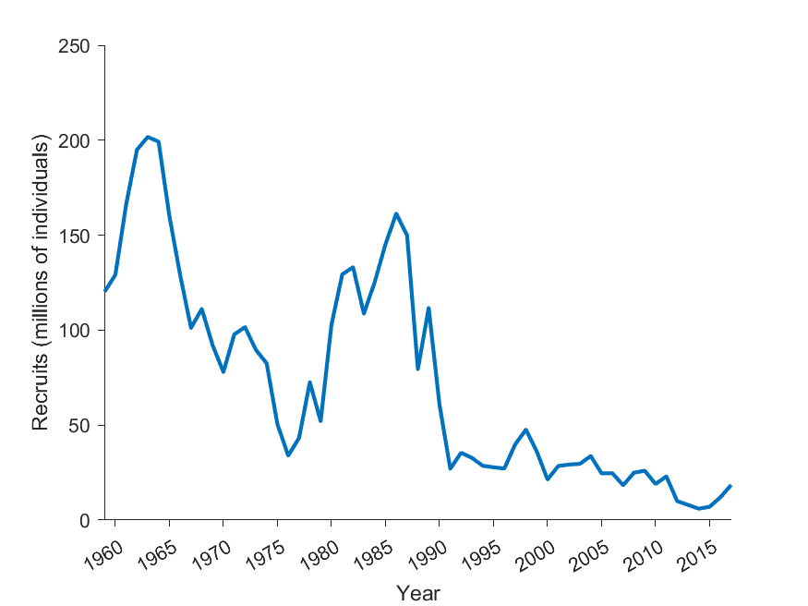
Fig. S8 The estimates for the number of recruits of 3Ps cod extracted from the 2021 stock assessment report [5].

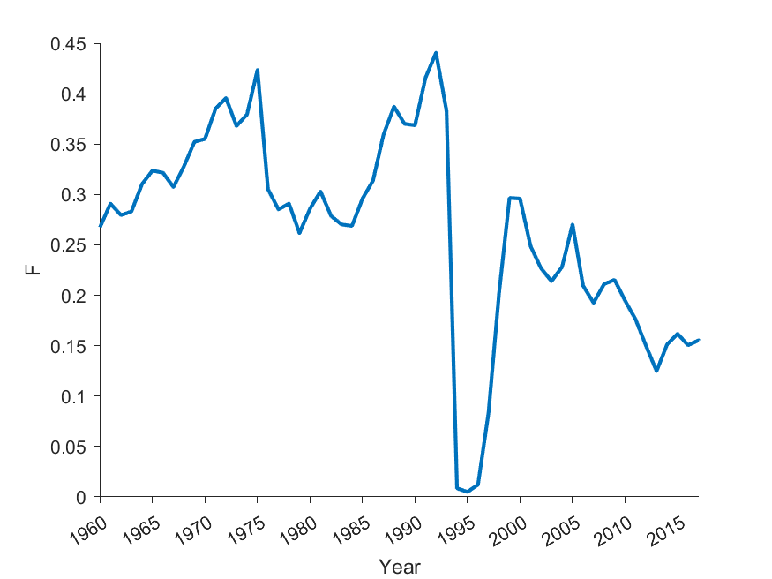
Fig. S9 Fishing mortality ($F$) estimates for 3Ps cod extracted from the 2021 stock assessment report [5].
References
1. Perälä T, Kuparinen A. 2017 Detection of Allee effects in marine fishes: analytical biases generated by data availability and model selection. Proceedings of the Royal Society B: Biological Sciences 284, 20171284. (doi:10.1098/rspb.2017.1284)
2. Castañeda RA et al. 2020 A Brief History of Fisheries in Canada. Fisheries 45, 303–318. (doi:https://doi.org/10.1002/fsh.10449)
3. Cole SC. 1990 Cod, God, country and family: the Portuguese-Newfoundland cod fishery. Maritime Anthropological Studies 3, 1–29.
4. Schijns R, Froese R, Hutchings JA, Pauly D. 2021 Five centuries of cod catches in eastern Canada. Scientific Reports
5. DFO. 2021 Stock Assessment of NAFO Subdivision 3Ps Cod.

