Supplementary Materials
from
“Comparing transmission potential networks based on social network surveys, close contacts, and environmental overlap in rural Madagascar.”
by
Kayla Kauffman^{1,4}, Courtney S. Werner¹, Georgia Titcomb⁴, Michelle Pender⁵, Rabezara Jean Yves⁶, James P. Herrera⁷, Julie Teresa Shapiro⁸, Alma Solis^{1,5}, Soarimalala Voahangy⁹, Pablo Tortosa¹⁰, Randall Kramer^{3,5}, James Moody², Peter J. Mucha¹¹, Charles Nunn^{1,5}

¹Department of Evolutionary Anthropology,
²Department of Sociology, and
³Nicholas School of the Environment, Duke University, Durham, NC 27708, USA
⁴Marine Science Institute, University of California, Santa Barbara, Santa Barbara, CA 93106, USA
⁵Duke Global Health Institute, Durham, NC 27516 USA
⁶Science de la Nature et Valorisation des Ressources Naturelles, Centre Universitaire Régional de la SAVA, Antalaha, Madagascar
⁷Duke Lemur Center SAVA Conservation, Durham NC, USA
⁸Department of Life Sciences, Ben-Gurion University of the Negev, Be'er Sheva, Israel
⁹Association Vahatra, Antananarivo, Madagascar
¹⁰UMR Processus Infectieux en Milieu Insulaire Tropical (PIMIT), Université de La Réunion, Ile de La Réunion, France.
¹¹Department of Mathematics, Dartmouth College, Hanover, NH 03755, USA

Contents
Table S1. Exponential Random Graph Model selection table.

Table S2. Summary of land use classification results

Table S3. All network characteristic comparisons.

Figure S1. The four main networks examined in the study
model ID | parametersᶧ |  |  |  |  |  |  |  |  |  |  |  |  | AICᵃ | accuracyᵇ | specificityᵇ | sensitivityᵇ
 | edges | VI 95 day¹ | VI 95 night¹ | VI 95¹ | VI 50¹ | naming network² | reciprocal naming³ | house distance⁴ | live close⁵ | gender⁶ | age⁷ | GWESP⁸ | GWNSP⁹
m14 |  |  |  |  |  |  |  |  |  |  |  | α=1 |  | 4762 | 0.78 | 0.89 | 0.54
m21 |  |  |  |  |  |  |  |  |  |  |  | α=1 |  | 4778 | 0.78 | 0.89 | 0.53
m22 |  |  |  |  |  |  |  |  |  |  |  | α=1 |  | 4781 | 0.78 | 0.89 | 0.54
m13 |  |  |  |  |  |  |  |  |  |  |  | α=1 |  | 4782 | 0.78 | 0.89 | 0.54
m15 |  |  |  |  |  |  |  |  |  |  |  | α=1 |  | 4849 | 0.78 | 0.89 | 0.54
m12.1 |  |  |  |  |  |  |  |  |  |  |  | α=1 |  | 4866 | 0.78 | 0.89 | 0.54
m19 |  |  |  |  |  |  |  |  |  |  |  | α=1 |  | 4882 | 0.78 | 0.89 | 0.54
m20 |  |  |  |  |  |  |  |  |  |  |  | α=1 |  | 4883 | 0.78 | 0.89 | 0.53
m16 |  |  |  |  |  |  |  |  |  |  |  | α=1 |  | 4906 | 0.77 | 0.88 | 0.52
m12.05 |  |  |  |  |  |  |  |  |  |  |  | α=0.5 |  | 4921 | 0.78 | 0.89 | 0.54
m12.0 |  |  |  |  |  |  |  |  |  |  |  | α=0 |  | 4949 | 0.78 | 0.89 | 0.54
m9 |  |  |  |  |  |  |  |  |  |  |  |  |  | 4951 | 0.78 | 0.89 | 0.54
m8 |  |  |  |  |  |  |  |  |  |  |  |  |  | 4952 | 0.78 | 0.89 | 0.54
m11 |  |  |  |  |  |  |  |  |  |  |  |  |  | 4954 | 0.79 | 0.89 | 0.54
m10 |  |  |  |  |  |  |  |  |  |  |  |  |  | 4954 | 0.78 | 0.89 | 0.54
m4 |  |  |  |  |  |  |  |  |  |  |  |  |  | 4954 | 0.78 | 0.89 | 0.54
m5 |  |  |  |  |  |  |  |  |  |  |  |  |  | 4954 | 0.78 | 0.89 | 0.54
m3 |  |  |  |  |  |  |  |  |  |  |  |  |  | 4955 | 0.78 | 0.89 | 0.54
m7 |  |  |  |  |  |  |  |  |  |  |  |  |  | 4956 | 0.78 | 0.89 | 0.54
m6 |  |  |  |  |  |  |  |  |  |  |  |  |  | 4956 | 0.78 | 0.89 | 0.54
m18 |  |  |  |  |  |  |  |  |  |  |  |  |  | 4958 | 0.78 | 0.89 | 0.54
m17 |  |  |  |  |  |  |  |  |  |  |  |  |  | 4958 | 0.78 | 0.89 | 0.54
m1 |  |  |  |  |  |  |  |  |  |  |  |  |  | 5067 | 0.78 | 0.89 | 0.53
m2 |  |  |  |  |  |  |  |  |  |  |  |  |  | 7454 | 0.69 | 0.81 | 0.38
m0 |  |  |  |  |  |  |  |  |  |  |  |  |  | 8582 | 0.63 | 0.76 | 0.25
ᶧparameters included in each model are shaded in grey; ¹Volume intersection (VI) of the home range (VI 95), core-use area (VI 50), and VI of the home range calculated separately for night time (VI 95 night) and daytime (VI 95 day); ²weighted full, undirected naming network (weights range 1-10); ³if both individuals named each other; ⁴distance between individuals’ houses; ⁵if the individuals lived less than 25 m apart, only applied as an interaction term with house distance; ⁶gender match; ⁷age difference; ⁸geometrically weighted edgewise shared partner with the fixed α value noted; ⁹geometrically weighted non-edgewise shared partner; ᵃAkaike information criterion; ᵇcalculated using the Held-Out Predictive Evaluation method for cross-validation
Table S1. Exponential Random Graph Model selection table.

 | SVM Classification Category
Ground-truthed Polygon ID | Bare | Other (brushy) | Rice | Secondary | Village | Water | Polygon Area (m2)
Hillside Rice (mean) |  | 0.186 |  | 0.814 |  |  | 17161
hillside rice 1 |  | 0.022 |  | 0.978 |  |  | 7832
hillside rice 2 |  | 0.484 |  | 0.516 |  |  | 5465
hillside rice 3 |  | 0.238 |  | 0.761 |  |  | 2159
hillside rice 4 |  |  |  | 1 |  |  | 1705
Rice (mean) | 0.005 | 0.034 | 0.89 | 0.018 | 0.037 | 0.015 | 49546
rice 1 |  |  | 1 |  |  |  | 4803
rice 2 |  |  | 1 |  |  |  | 1125
rice 3 |  | 0.013 | 0.602 |  | 0.384 |  | 5346
rice 4 |  |  | 1 |  |  |  | 2102
rice 5 |  | 0.029 | 0.971 |  |  |  | 3464
rice 6 |  |  | 0.981 |  | 0.018 |  | 5033
rice 7 |  |  | 0.953 |  | 0.046 |  | 4332
rice 8 |  |  | 0.941 |  |  | 0.059 | 5612
rice 9 |  | 0.022 | 0.863 | 0.115 |  |  | 3535
rice 10 |  |  | 0.809 | 0.069 |  | 0.122 | 3734
rice 11 |  | 0.25 | 0.727 | 0.022 |  |  | 4104
rice 12 | 0.063 | 0.087 | 0.836 | 0.014 |  |  | 6356
Brushy Regrowth (mean) |  | 0.321 | 0.123 | 0.546 |  | 0.009 | 11519
brushy 1 |  |  |  | 1 |  |  | 1430
brushy 2 |  | 0.759 |  | 0.24 |  |  | 1505
brushy 3 |  |  |  | 1 |  |  | 2599
brushy 4 |  | 0.063 |  | 0.937 |  |  | 2757
brushy 5 |  | 0.898 |  | 0.102 |  |  | 1964
brushy 6 |  | 0.205 | 0.74 |  |  | 0.055 | 1263
Secondary (mean) |  | 0.066 |  | 0.934 |  |  | 33343
secondary 1 |  | 0.071 |  | 0.928 |  |  | 2433
secondary 2 |  |  |  | 1 |  |  | 1754
secondary 3 |  |  |  | 1 |  |  | 1509
secondary 4 |  |  |  | 1 |  |  | 3136
secondary 5 |  |  |  | 1 |  |  | 3065
secondary 6 |  | 0.117 |  | 0.883 |  |  | 4261
secondary 7 |  | 0.042 |  | 0.957 |  |  | 4721
secondary 8 |  | 0.145 |  | 0.855 |  |  | 4511
secondary 9 |  |  |  | 1 |  |  | 3770
secondary 10 |  | 0.28 |  | 0.719 |  |  | 4182

Table S2. Summary of land use classification results within each of the ground-truth polygons created by walking a GPS around discrete land areas of a given type. Values represent the proportion of 10x10m grid cells that were assigned a given classification category by the support vector machine model in ArcGIS Pro (version 2.5.0). Cells are shaded (light to dark) by the proportion of grid cells in each polygon assigned to the respective land use category.

 |  | Network | Connected¹ | Diameter | Average distance | Density | Transitivity | Modularity² | Reciprocity
d  i  r  e  c  t  e  d | u  n  i  p  a  r  t  i  t  e | full | no | 22 | 5.205 | 0.021 | 0.163 | - | 0.429
 |  | free time | no | 15 | 6.293 | 0.011 | 0.142 | - | 0.380
 |  | help you farm | no | 7 | 2.145 | 0.006 | 0.229 | - | 0.227
 |  | you help farm | no | 6 | 2.008 | 0.007 | 0.352 | - | 0.317
 |  | help you food | no | 6 | 2.005 | 0.006 | 0.105 | - | 0.176
 |  | you help food | no | 6 | 2.008 | 0.007 | 0.352 | - | 0.317
 |  | farm | no | 12 | 3.544 | 0.009 | 0.254 | - | 0.355
 |  | food | no | 14 | 3.580 | 0.009 | 0.080 | - | 0.211
u  n  d  i  r  e  c  t  e  d |  | full | no | 20 | 3.875 | 0.032 | 0.163 | 0.707 | -
 |  | free time | no | 18 | 5.736 | 0.017 | 0.142 | 0.774 | -
 |  | help you farm | no | 13 | 4.575 | 0.010 | 0.229 | 0.820 | -
 |  | you help farm | no | 8 | 2.553 | 0.011 | 0.352 | 0.866 | -
 |  | help you food | no | 23 | 8.651 | 0.011 | 0.105 | 0.832 | -
 |  | you help food | no | 20 | 6.460 | 0.011 | 0.034 | 0.861 | -
 |  | farm | no | 21 | 5.385 | 0.015 | 0.254 | 0.811 | -
 |  | food | no | 21 | 6.284 | 0.017 | 0.080 | 0.792 | -
 |  | close contact³ | yes (n=66) | 0.114 ± 0.057 | 1.758 ± 0.023 | 0.275 ± 0.006 | 0.473 ± 0.008 | 0.630 ± 0.003 | -
 |  |  | no (n=934)
 |  | environmental, full | yes | 0.000 | 1.033 | 0.967 | 0.984 | 0.538 | -
 |  | environmental, rice | yes | 0.000 | 1.412 | 0.589 | 0.762 | 0.551 | -
 | b  i  p  a  r  t  i  t  e | environmental, full | yes | 0.150 | 3.737 | 0.001 | 0.000 | 0.548 | -
 |  | environmental, rice | yes | 0.045 | 3.548 | 0.006 | 0.000 | 0.753 | -
¹ strong connectivity, ² modularity calculated using the Louvain method for the unipartite networks and the bipartite method for the bipartite networks ³ the mean ± standard deviation for each of the 1000 simulated close contact networks

Table S3. All network characteristic comparisons.

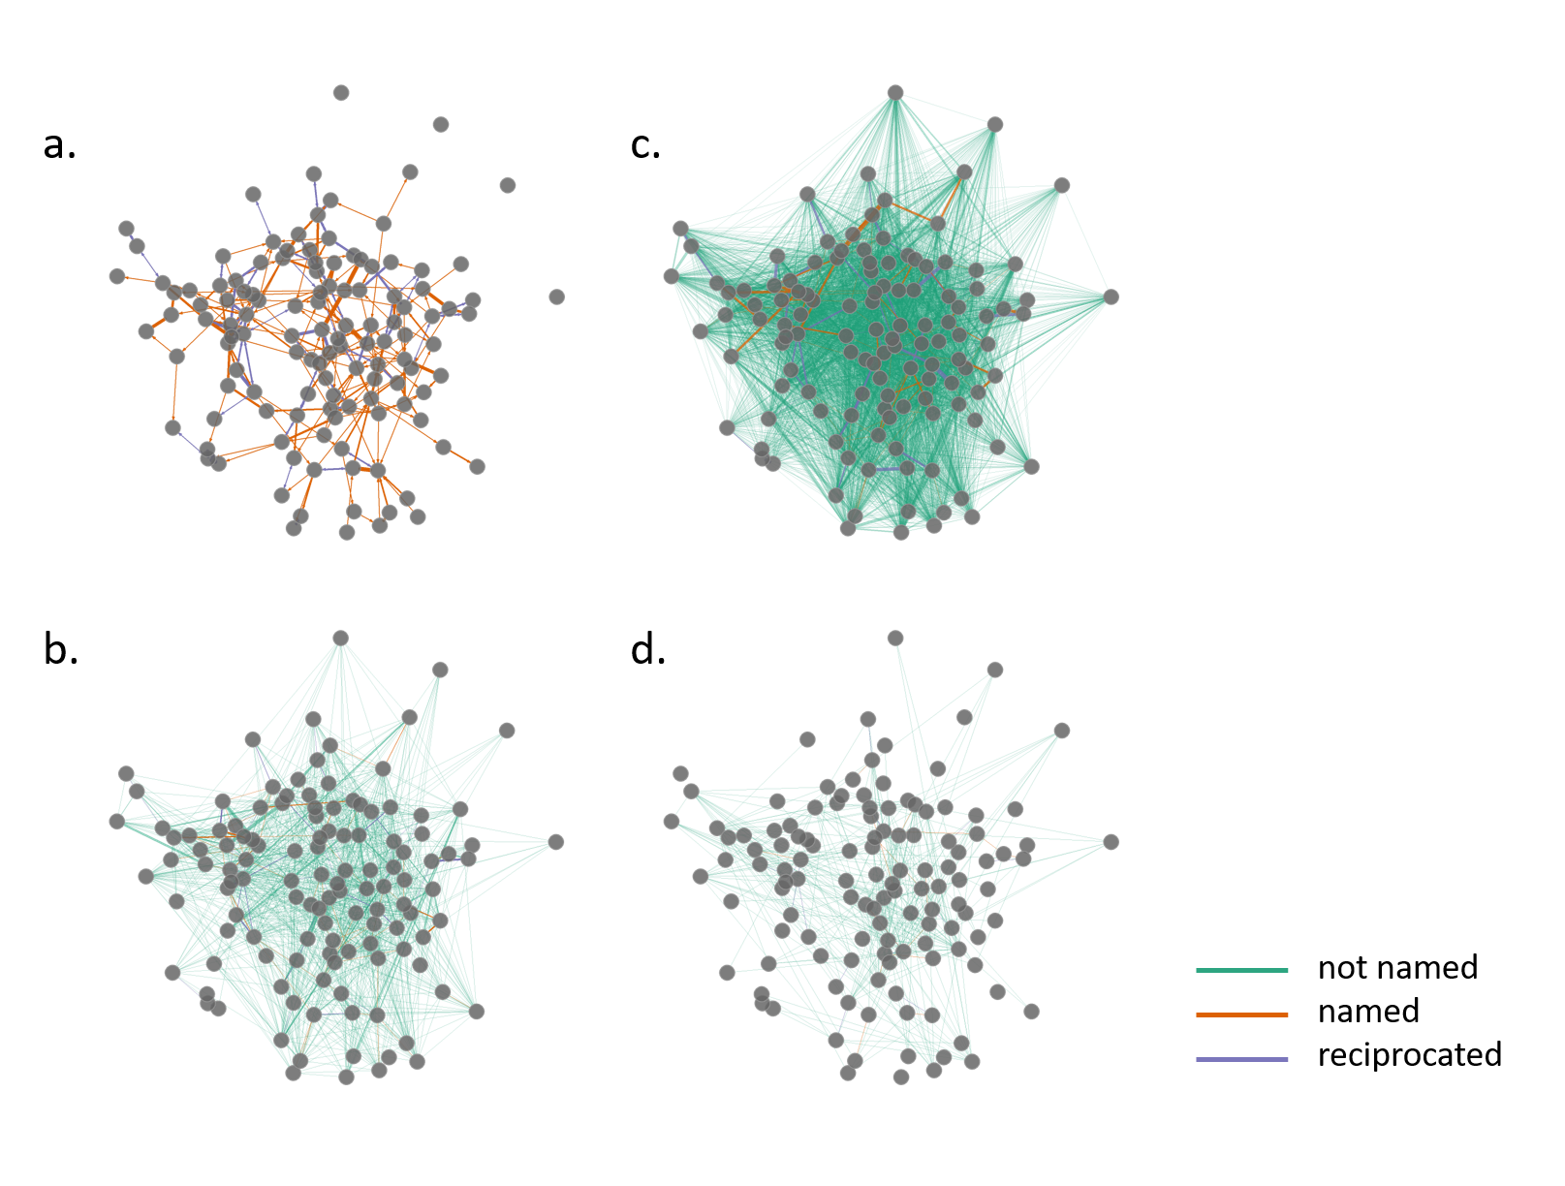
Figure S1. The four main networks examined in the study: (a) the full naming network, with edges weighted by the number of times one individual named the other, (b) the close-contact network, with edges weighted by the predicted proportion of close contacts, (c) the full environmental overlap network, with edges weighted by the sum-product of each dyad’s utilization distribution overlap in all shared spaces regardless of land-use type, and (d) the rice-field overlap network, with edges weighted by the sum product of each dyad’s utilization distribution overlap in flooded rice fields. Network vertices are consistent across all panels (based on the Fruchterman Reingold layout of the full, directed naming network (a)). Edges are colored according to naming network responses: green lines connect individuals who did not name each other for any question, orange lines connect pairs in which only one individual named the other, and purple lines connect reciprocally named individuals.
Low edge weights were omitted to improve network visualization: (b) fewer than 20 contacts per week, (c) less than 1% of both individuals’ utilization distributions (UDs), and (d) less than 0.1% of both individuals’ UDs.

