Supplemental materials for: Into the wild – a field study on the evolutionary and ecological importance of thermal plasticity in ectotherms across temperate and tropical regions
Journal: Philosophical Transactions of the Royal Society B
Authors and affiliations
¹Natasja Krog Noer, ²Michael Ørsted, ³Michele Schiffer, ⁴Ary A. Hoffmann, ¹Simon Bahrndorff* and ¹Torsten N. Kristensen*
* shared last-authorship
1 Department of Chemistry and Bioscience, Aalborg University, Aalborg 9220, Denmark
2 Zoophysiology, Department of Biology, Aarhus University, Aarhus C 8000, Denmark.
3 Daintree Rainforest Observatory, James Cook University, Cape Tribulation, Douglas, QLD 4873, Australia
4 School of BioSciences, Bio21 Institute, the University of Melbourne, Parkville, Victoria 3010, Australia

(A) Time bins
(B) Time windows

Figure S1: Extraction of the microclimate variables ‘mean’ and ‘coefficient of variation’ from recorded temperature and humidity data. The variables were extracted as (A) ‘time bins’, where variables were extracting in rolling, non-overlapping, 1 or 24 h bins, and (B) ‘time windows’, where variables were extracted in expanding windows that increased by 1 h intervals in the first 24 hours and in intervals of 24 hours and up to 14 days.

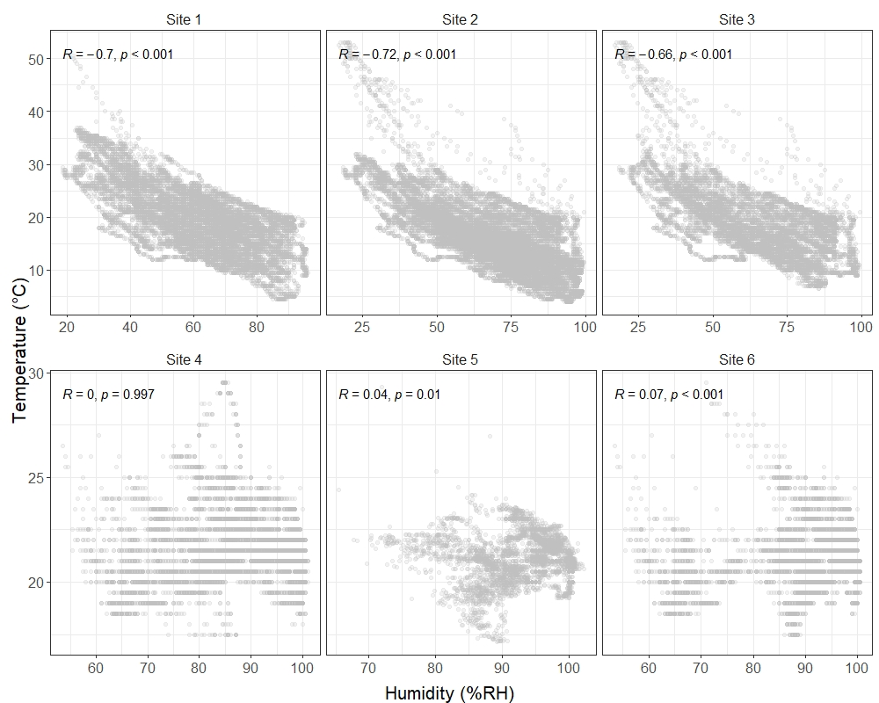
Tropical
Temperate
Figure S2: Relationship between temperature and humidity in the study sites in temperate (top panel) and tropical (bottom panel) sites. Pearson’s correlations were used to examine the relationship between temperature and humidity at each study site. Correlation coefficients and significance of correlations are displayed in the plots. All climate recordings from each location are presented, thus, the temperate sites had more data points due to the longer period of field work which appears as finer resolution of the data. However, the resolution and recording interval was the same for each site, except for Site 5. At site 5, an iButton (DS1923-F5#, Hygrochron, iButtonLink) was used to record data (back-up) because the Easylog malfunctioned. The iButton had a resolution of 0.1°C, whereas Easylogs record with 0.5°C resolution.

a
Figure S3: Heatmap showing correlations between knockdown time for each species and the mean and CV of microclimate temperature (A) and humidity (B) extracted in short-term (< 24 h) and long-term (2-14 days) windows. The species are grouped into origin from either temperate or tropical Australia.

Table S1 – Overview of insect sampling dates and times (Excel Spreadsheet)

Table S2 Summary of monthly temperature and humidity measures during the field experiment. The mean, coefficient of variation (CV), minimum, and maximum values recorded are given over varying number of days (n_{obs}) for each month/sampling site.
2019 |  |  | Temperature (°C) |  |  |  |  | Humidity (%RH)
Month | Region | Site | Mean | CV | Min_{absolute} | Max_{absolute} | n_{obs} | Mean | CV | Min_{absolute} | Max_{absolute} | n_{obs}
Feb | Temperate | Site 1 | 21.30 | 0.19 | 10.50 | 50.50 | 15 | 60.90 | 0.19 | 22.00 | 87.50 | 15
Mar | Temperate | Site 1 | 19.93 | 0.18 | 7.00 | 37.00 | 31 | 61.94 | 0.18 | 18.50 | 95.50 | 31
Mar | Temperate | Site 2 | 19.36 | 0.24 | 7.00 | 53.00 | 18 | 67.23 | 0.23 | 17.00 | 99.50 | 18
Apr | Temperate | Site 1 | 15.90 | 0.27 | 4.50 | 30.00 | 12 | 64.61 | 0.22 | 26.50 | 96.00 | 12
Apr | Temperate | Site 2 | 16.27 | 0.25 | 4.50 | 38.50 | 30 | 63.84 | 0.21 | 22.50 | 96.50 | 30
May | Temperate | Site 2 | 13.10 | 0.21 | 4.00 | 23.50 | 31 | 75.42 | 0.14 | 36.50 | 99.50 | 31
Jun | Tropical | Site 3 | 21.53 | 0.05 | 17.50 | 29.50 | 26 | 86.86 | 0.05 | 53.50 | 101.00 | 26
Jun | Tropical | Site 4 | 21.14 | 0.04 | 17.14 | 29.33 | 17 | 93.04 | 0.03 | 65.45 | 102.25 | 17
Jun | Tropical | Site 5 | 21.04 | 0.04 | 17.50 | 29.50 | 25 | 90.48 | 0.04 | 53.50 | 100.50 | 25

Table S3: Summary of 3-way ANOVAs. The analyses were run on rank inverse transformed HKDT values as dependent variable and ‘Day’, ‘Time of day’, and ‘Sex’ as independent variables. The p-values were corrected for multiple testing using Benjamini-Hochberg False Discovery Rate adjustments (FDR).
Species | Variables | Df | Sum Sq | Mean Sq | F value | p.value | FDR
D. melanogaster | Day | 5 | 340.283 | 68.057 | 123.806 | < 0.001 | < 0.001
 | Time of day | 3 | 22.918 | 7.639 | 13.897 | < 0.001 | < 0.001
 | Sex | 1 | 10.508 | 10.508 | 19.116 | < 0.001 | < 0.001
 | Day : Time of day | 15 | 36.979 | 2.465 | 4.485 | < 0.001 | < 0.001
 | Day : Sex | 5 | 4.699 | 0.940 | 1.710 | 0.130 | 0.193
 | Time of day : Sex | 3 | 2.754 | 0.918 | 1.670 | 0.172 | 0.234
 | Day : Time of day : Sex | 15 | 21.207 | 1.414 | 2.572 | 0.001 | < 0.01
 | Residuals | 872 | 479.340 | 0.549
N. caledoniae | Day | 7 | 109.740 | 15.677 | 20.791 | < 0.001 | < 0.001
 | Time of day | 3 | 30.889 | 10.296 | 13.655 | < 0.001 | < 0.001
 | Sex | 1 | 75.856 | 75.856 | 100.597 | < 0.001 | < 0.001
 | Day : Time of day | 20 | 66.018 | 3.301 | 4.378 | < 0.001 | < 0.001
 | Day : Sex | 7 | 10.172 | 1.453 | 1.927 | 0.062 | 0.109
 | Time of day : Sex | 3 | 1.255 | 0.418 | 0.555 | 0.645 | 0.687
 | Day : Time of day : Sex | 20 | 14.413 | 0.721 | 0.956 | 0.515 | 0.587
 | Residuals | 1007 | 759.333 | 0.754
S. macreta | Day | 4 | 16.100 | 4.025 | 4.731 | 0.001 | < 0.01
 | Time of day | 3 | 25.943 | 8.648 | 10.163 | <0.001 | < 0.001
 | Sex | 1 | 9.205 | 9.205 | 10.819 | 0.001 | < 0.01
 | Day : Time of day | 9 | 27.828 | 3.092 | 3.634 | < 0.001 | < 0.001
 | Day : Sex | 4 | 4.411 | 1.103 | 1.296 | 0.271 | 0.340
 | Time of day : Sex | 3 | 1.532 | 0.511 | 0.600 | 0.615 | 0.674
 | Day : Time of day : Sex | 9 | 13.444 | 1.494 | 1.756 | 0.075 | 0.118
 | Residuals | 441 | 375.234 | 0.851
Cicadellidae sp. | Day | 6 | 313.596 | 52.266 | 97.490 | < 0.001 | < 0.001
 | Time of day | 3 | 3.728 | 1.243 | 2.318 | 0.074 | 0.118
 | Sex | 1 | 4.510 | 4.510 | 8.413 | 0.004 | < 0.01
 | Day : Time of day | 11 | 47.505 | 4.319 | 8.055 | < 0.001 | < 0.001
 | Day : Sex | 6 | 0.875 | 0.146 | 0.272 | 0.950 | 0.950
 | Time of day : Sex | 3 | 2.915 | 0.972 | 1.813 | 0.143 | 0.207
 | Day : Time of day : Sex | 11 | 18.728 | 1.704 | 3.176 | < 0.001 | < 0.001
 | Residuals | 757 | 405.842 | 0.536
P. guttus | Day | 6 | 191.230 | 31.872 | 43.594 | < 0.001 | < 0.001
 | Time of day | 3 | 0.615 | 0.205 | 0.280 | 0.840 | 0.857
 | Sex | 1 | 51.754 | 51.754 | 70.789 | < 0.001 | < 0.001
 | Day : Time of day | 14 | 17.227 | 1.230 | 1.683 | 0.054 | 0.098
 | Day : Sex | 6 | 5.932 | 0.989 | 1.352 | 0.231 | 0.306
 | Time of day : Sex | 3 | 2.995 | 0.998 | 1.365 | 0.252 | 0.325
 | Day : Time of day : Sex | 14 | 16.529 | 1.181 | 1.615 | 0.069 | 0.117
 | Residuals | 891 | 651.414 | 0.731
S. novoguineensis | Day | 5 | 200.464 | 40.093 | 54.377 | < 0.001 | < 0.001
 | Time of day | 3 | 10.032 | 3.344 | 4.535 | 0.004 | < 0.01
 | Sex | 1 | 0.095 | 0.095 | 0.129 | 0.719 | 0.750
 | Day : Time of day | 15 | 54.195 | 3.613 | 4.900 | < 0.001 | < 0.001
 | Day : Sex | 5 | 2.602 | 0.520 | 0.706 | 0.619 | 0.674
 | Time of day : Sex | 3 | 3.894 | 1.298 | 1.760 | 0.153 | 0.214
 | Day : Time of day : Sex | 15 | 11.308 | 0.754 | 1.022 | 0.429 | 0.500
 | Residuals | 898 | 662.107 | 0.737
D. rubida | Day | 5 | 28.778 | 5.756 | 7.901 | < 0.001 | < 0.001
 | Time of day | 3 | 12.186 | 4.062 | 5.576 | 0.001 | < 0.01
 | Sex | 1 | 206.750 | 206.750 | 283.824 | < 0.001 | < 0.001
 | Day : Time of day | 15 | 22.435 | 1.496 | 2.053 | 0.010 | < 0.05
 | Day : Sex | 5 | 4.003 | 0.800 | 1.099 | 0.359 | 0.440
 | Time of day : Sex | 3 | 2.101 | 0.700 | 0.961 | 0.410 | 0.490
 | Day : Time of day : Sex | 15 | 16.471 | 1.098 | 1.507 | 0.096 | 0.146
 | Residuals | 906 | 659.972 | 0.728

Table S4: Summary of 2-way ANOVAs. The analyses were run on rank inverse transformed HKDT values as dependent variable and ‘Day’, ‘Time of day’, and ‘Sex’ as independent variables. The p-values were corrected for multiple testing using Benjamini-Hochberg False Discovery Rate adjustments (FDR).
Species | Variables | Df | Sum Sq | Mean Sq | F value | p-value | FDR
Psyllidae sp. | Day | 5 | 28.012 | 5.602 | 6.379 | < 0.001 | < 0.001
 | Time of day | 3 | 14.836 | 4.945 | 5.631 | 0.001 | < 0.01
 | Day : Time of day | 4 | 9.754 | 2.439 | 2.777 | 0.027 | < 0.05
 | Residuals | 336 | 295.089 | 0.878
U. sonchi | Day | 4 | 83.146 | 20.786 | 30.785 | < 0.001 | < 0.001
 | Time of day | 3 | 25.110 | 8.370 | 12.396 | < 0.001 | < 0.001
 | Day : Time of day | 11 | 27.337 | 2.485 | 3.681 | < 0.001 | < 0.001
 | Residuals | 363 | 245.103 | 0.675
H. lactucae | Day | 3 | 53.101 | 17.701 | 25.620 | < 0.001 | < 0.001
 | Time of day | 3 | 13.551 | 4.517 | 6.538 | < 0.001 | < 0.001
 | Day : Time of day | 9 | 21.312 | 2.368 | 3.427 | 0.001 | < 0.001
 | Residuals | 237 | 163.738 | 0.691
A. nerii | Day | 1 | 3.367 | 3.3674 | 5.093 | 0.026 | < 0.05
 | Time of day | 3 | 43.788 | 14.600 | 22.073 | < 0.001 | < 0.001
 | Day : Time of day | 2 | 2.599 | 1.299 | 1.965 | 0.144 | 0.1546
 | Residuals | 130 | 85.961 | 0.661
O. smaragdina | Day | 4 | 46.545 | 11.636 | 13.416 | < 0.001 | < 0.001
 | Time of day | 3 | 2.267 | 0.756 | 0.8712 | 0.456 | 0.4557
 | Day : Time of day | 12 | 45.164 | 3.764 | 4.339 | < 0.001 | < 0.001
 | Residuals | 572 | 496.113 | 0.867

